# Testing Environment

## Server IP: 192.168.0.12

## Client IP: 192.168.0.15

# Part I

## Source code:

#import socket module

**from** socket **import** **\***

serverSocket **=** socket**(**AF_INET**,** SOCK_STREAM**)**

#Prepare a sever socket

#Fill in start

serverSocket**.**setsockopt**(**SOL_SOCKET**,** SO_REUSEADDR**,** 1**)**

port**=**12209

serverSocket**.**bind**((**''**,** port**))**

serverSocket**.**listen**(**1**)**

#Fill in end

**while** **True:**

#Establish the connection

**print** 'Ready to serve...'

connectionSocket**,** addr **=** serverSocket**.**accept**()**

**try:**

message **=** connectionSocket**.**recv**(**1024**).**decode**()**#Fill in start #Fill in end

filename**=**message**.**split**()[**1**]**

f**=**open**(**filename**[**1**:])**

outputdata**=**f**.**readlines**()**#Fill in start #Fill in en

length**=**0

**for** i **in** range**(**0**,** len**(**outputdata**)):**

length**+=**len**(**outputdata**[**i**])**

#Send one HTTP header line into socket

#Fill in start

header**=**"HTTP/1.1 200 OK\r\n"**+**\

"Content-Type: text/html; charset=utf-8\r\n"**+**\

"Content-Length: %d\r\n\r\n"

connectionSocket**.**send**(**header **%** **(**length**))**

#Fill in end

#Send the content of the requested file to the client

**for** i **in** range**(**0**,** len**(**outputdata**)):**

connectionSocket**.**send**(**outputdata**[**i**])**

connectionSocket**.**send**(**"\r\n"**)**

connectionSocket**.**close**()**

**except** IOError**:**

#Send response message for file not found

#Fill in start

body**=**"HTTP/1.1 404 Not Found\r\n"**+**\

"Content-Type: text/plain; charset=utf-8\r\n"**+**\

"Content-Length: %d\r\n\r\n%s"

outputdata**=**"404 Not Found."

connectionSocket**.**send**(**body **%** **(**len**(**outputdata**),**outputdata**))**

#Fill in end

#Close client socket

#Fill in start

connectionSocket**.**close**()**

#Fill in end

serverSocket**.**close**()**

## HTML source:

<html>

<body>

<h1>**Hello World**</h1>

<h2>**Author: Tianpeng Xia**</h2>

<body/>

</html>

## What is in the folder:



## Start running the server:



## Try to access something not there:

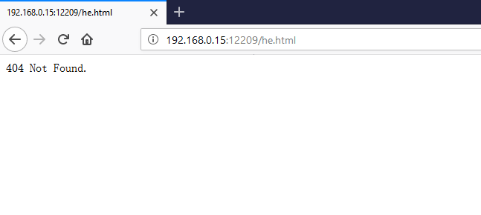

## Try to access “HelloWorld.HTML”:

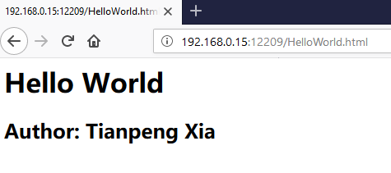

# Part II

## Source code:

#import socket module

**from** socket **import** **\***

**from** threading **import** **\***

serverSocket **=** socket**(**AF_INET**,** SOCK_STREAM**)**

#Prepare a sever socket

#Fill in start

serverSocket**.**setsockopt**(**SOL_SOCKET**,** SO_REUSEADDR**,** 1**)**

port**=**12209

serverSocket**.**bind**((**''**,** port**))**

serverSocket**.**listen**(**1**)**

#Fill in end

#BOF function to process a request

**def** do_request**(**connectionSocket**,**addr**):**

**try:**

message **=** connectionSocket**.**recv**(**1024**).**decode**()**#Fill in start #Fill in end

filename**=**message**.**split**()[**1**]**

f**=**open**(**filename**[**1**:])**

outputdata**=**f**.**readlines**()**#Fill in start #Fill in end

runtime_filename**=**'HelloWorldPort_%s.html' **%** **(**addr**[**1**],)**

runtime_file**=**open**(**runtime_filename**,**'w'**)**

**for** i **in** range**(**0**,** len**(**outputdata**)):**

runtime_file**.**write**(**outputdata**[**i**])**

f**.**close**()**

runtime_content**=**"<p><b>YOUR IP IS: %s</b></p><p><b>THE PORT USED BY YOUR BROWSER IS: %s</b></p>" **%** **(**addr**[**0**],**addr**[**1**])**

runtime_file**.**write**(**runtime_content**);**

runtime_file**.**close**();**

#open the newly created file

f**=**open**(**runtime_filename**)**

outputdata**=**f**.**readlines**()**

f**.**close**()**

length**=**0

**for** i **in** range**(**0**,** len**(**outputdata**)):**

length**+=**len**(**outputdata**[**i**])**

#Send one HTTP header line into socket

#Fill in start

header**=**"HTTP/1.1 200 OK\r\n"**+**\

"Content-Type: text/html; charset=utf-8\r\n"**+**\

"Content-Length: %d\r\n\r\n"

connectionSocket**.**send**(**header **%** **(**length**))**

#Fill in end

#Send the content of the requested file to the client

**for** i **in** range**(**0**,** len**(**outputdata**)):**

connectionSocket**.**send**(**outputdata**[**i**])**

connectionSocket**.**send**(**"\r\n"**)**

connectionSocket**.**close**()**

**except** IOError**:**

#Send response message for file not found

#Fill in start

body**=**"HTTP/1.1 404 Not Found\r\n"**+**\

"Content-Type: text/plain; charset=utf-8\r\n"**+**\

"Content-Length: %d\r\n\r\n%s"

outputdata**=**"404 Not Found."

connectionSocket**.**send**(**body **%** **(**len**(**outputdata**),**outputdata**))**

#Fill in end

#Close client socket

#Fill in start

connectionSocket**.**close**()**

#Fill in end

#EOF function to process a request

**while** **True:**

#Establish the connection

**print** 'Ready to serve...'

connectionSocket**,** addr **=** serverSocket**.**accept**()**

t**=**Thread**(**target**=**do_request**,**args**=(**connectionSocket**,**addr**))**

t**.**start**()**

serverSocket**.**close**()**

## HTML source:

<html>

<body>

<h1>**Hello World**</h1>

<h2>**Author: Tianpeng Xia**</h2>

<body/>

</html>

## What is the folder before the test:



## Start running the server:



## Try to access something not there:

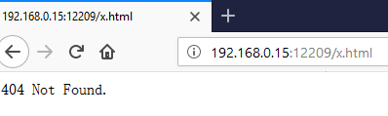

## Try to access “HelloWorld.html”:

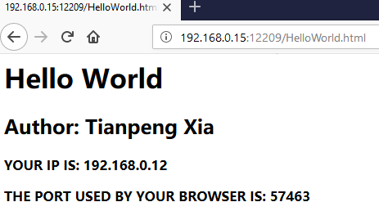

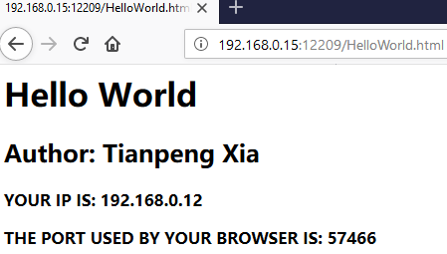

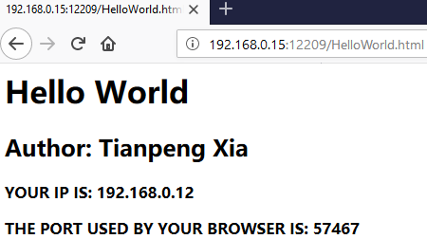

## What files are added after the test:

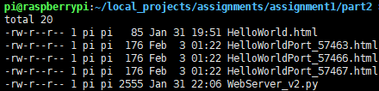

**All the HelloWorldPort_XXXXX files were created at runtime.**