# Testing Environment

## Server IP: 192.168.0.15

# Part I

## Source code:

**from** socket **import** **\***

**import** time

serverName **=** '192.168.0.15'

serverPort **=** 12000

clientSocket **=** socket**(**AF_INET**,** SOCK_DGRAM**)**

clientSocket**.**setsockopt**(**SOL_SOCKET**,** SO_REUSEADDR**,** 1**)**

message**=**'lower case'

result**=[[**0 **for** i **in** xrange**(**25**)]** **for** i **in** xrange**(**5**)]**

**for** m **in** xrange**(**5**):**

**print** 'm=%s for this round' **%** **(**m**+**1**,)**

clientSocket**.**settimeout**(**m**+**1**)**

**for** n **in** xrange**(**25**):**

valid_count**=**0

**for** i **in** xrange**(**n**+**1**):**

**try:**

start_time**=**time**.**time**()**

**print** 'clientPing_v1 %s %s %s' **%** **(**n**+**1**,**i**+**1**,**start_time**)**

clientSocket**.**sendto**(**message**.**encode**(),** **(**serverName**,** serverPort**))**

modifiedMessage**,** serverAddress **=** clientSocket**.**recvfrom**(**2048**)**

end_time**=**time**.**time**()**

delta**=**end_time**-**start_time

result**[**m**][**n**]+=**delta

valid_count**+=**1

**print** "message from server: " **+** modifiedMessage**.**decode**()**

**print** "RTT: %f" **%** **(**delta**,)**

**except** timeout **as** e**:**

**print** 'Request time out'

**if** valid_count**:**

result**[**m**][**n**]/=**valid_count

**for** r **in** result**:**

**print** r

clientSocket**.**close**()**

## A screenshot of runs

#### Starting the client



#### Since the output is too long, it was directed to a text file

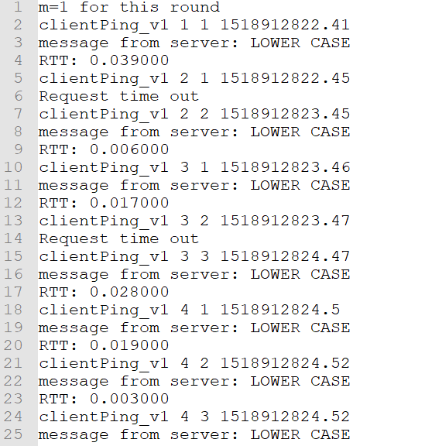

## Five graphs

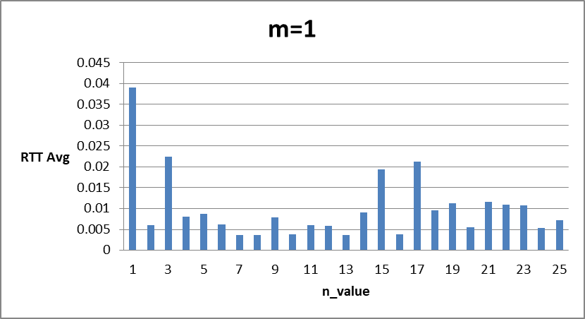

**Number of lost messages: 84**

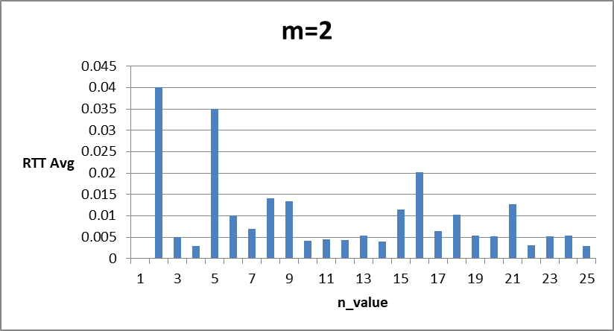

**Number of lost messages: 86**

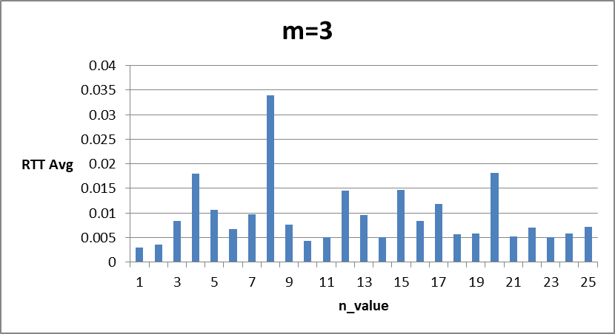

**Number of lost messages: 91**

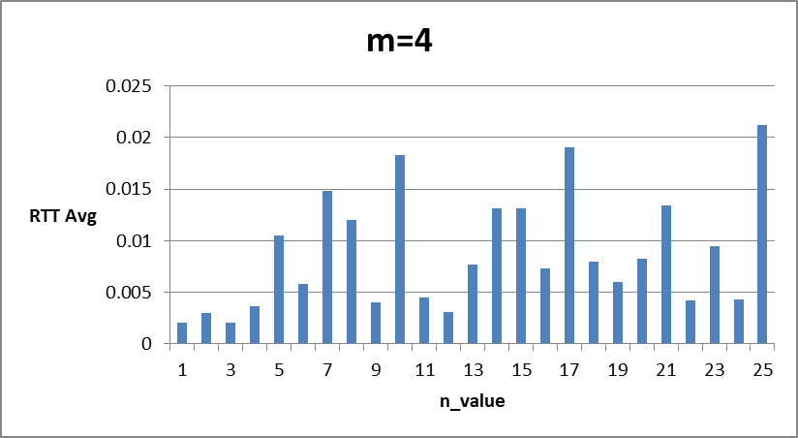

**Number of lost messages: 104**

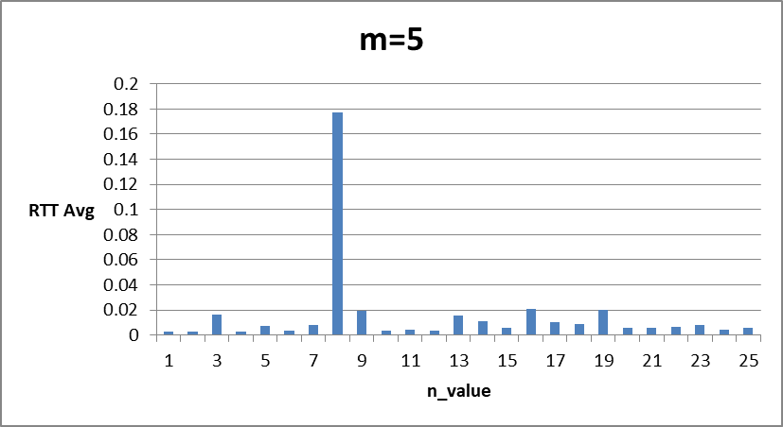

**Number of lost messages: 91**

## Discussion of the result

According to the 5 graphs, we can see that:

1. The number of messages lost is not related to the timeout value
2. RRTs are quite small within a subnet, mostly less than 200ms
3. Connection check and retry mechanism are crucial for any internet softwares, whether server-side or client-side, especially when servers and clients are located in different spots geographically.