**Assignment 1**

1. Write a program to print **Hello** Students on the screen.

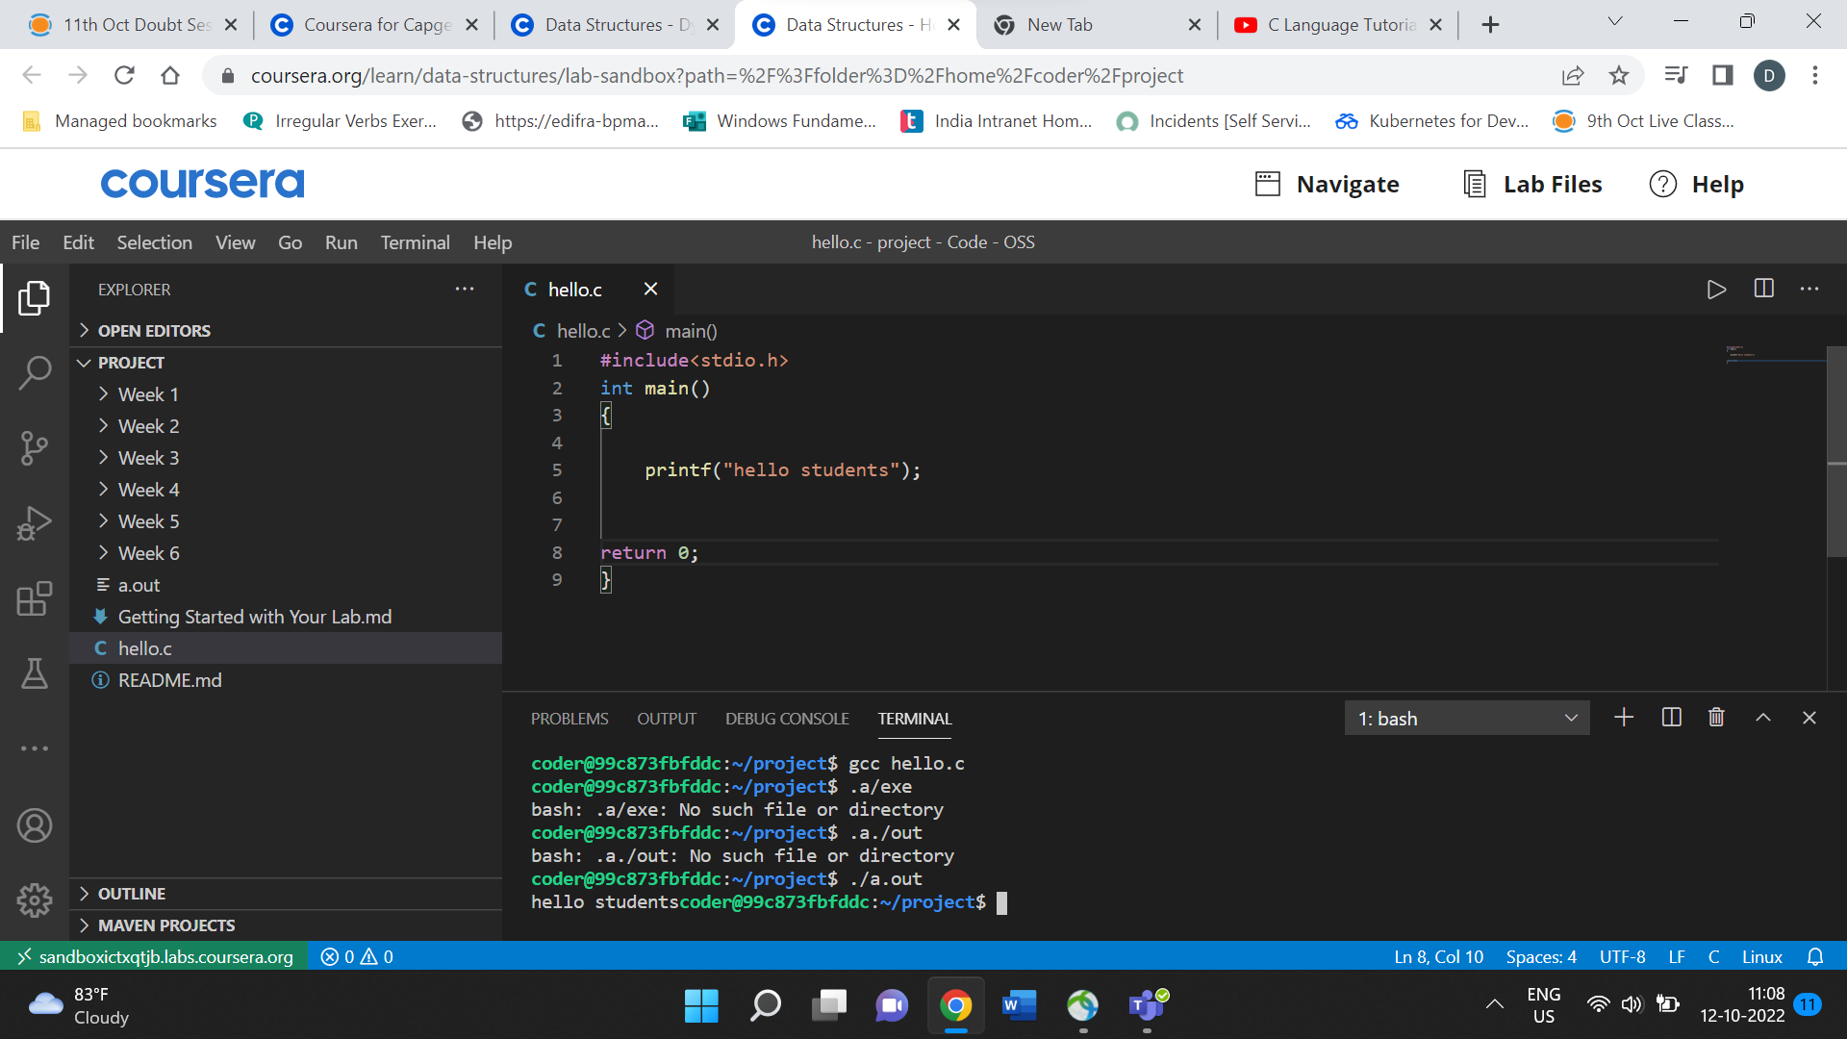

2. Write a program to print **Hello** in the first line and **Students** in the second line.

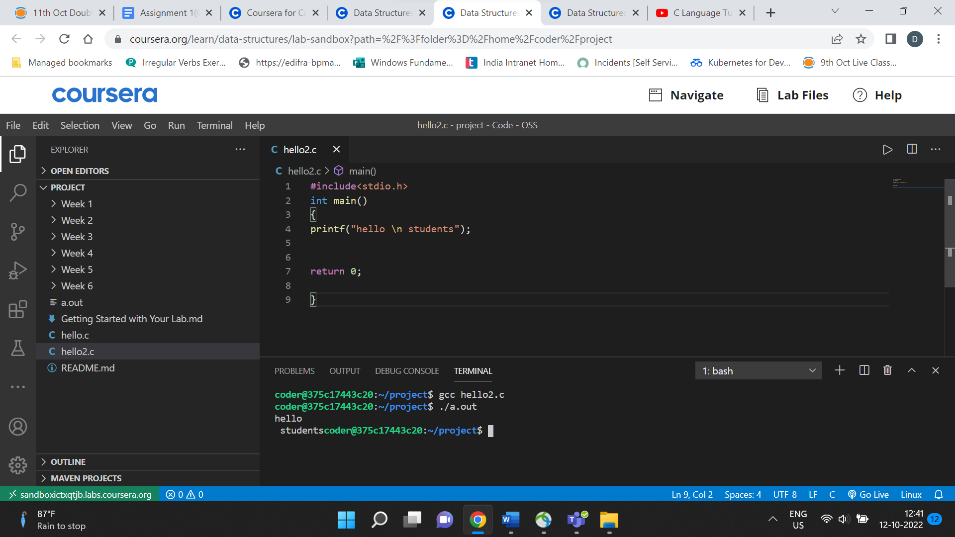

3. Write a program to print **“iNeuron”** on the screen. (Remember to print in double quotes)

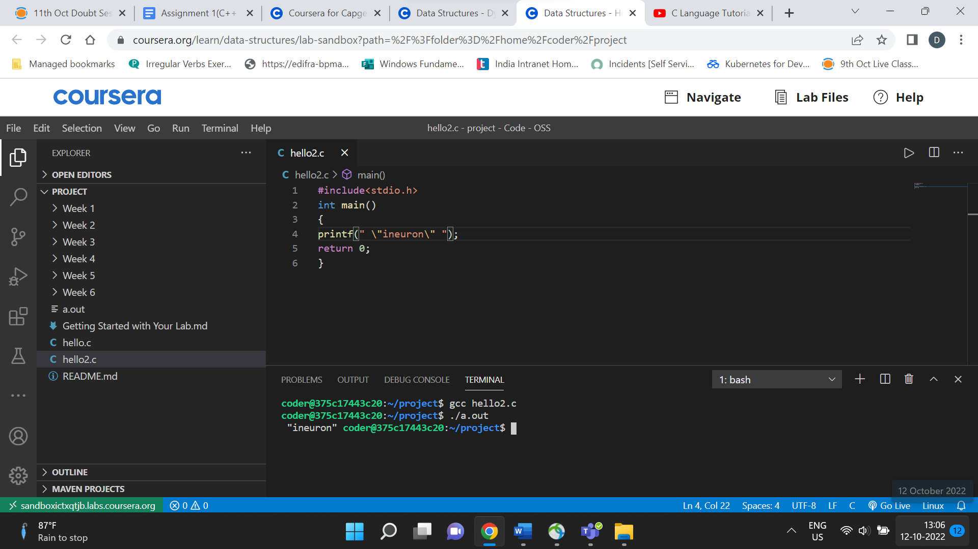

7. WAP to print “%d” on the screen.

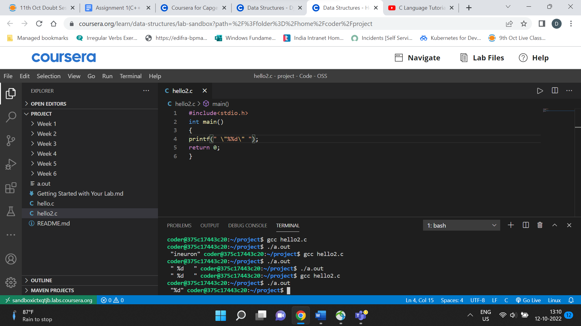

8. WAP to print “\n” on the screen.

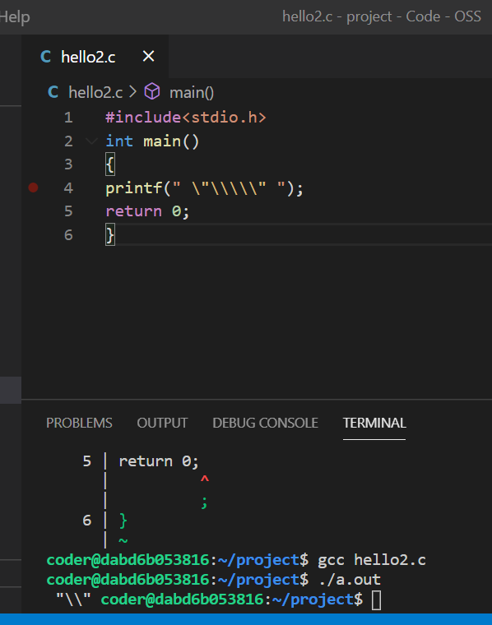

5. WAP to calculate the length of String using printf function.

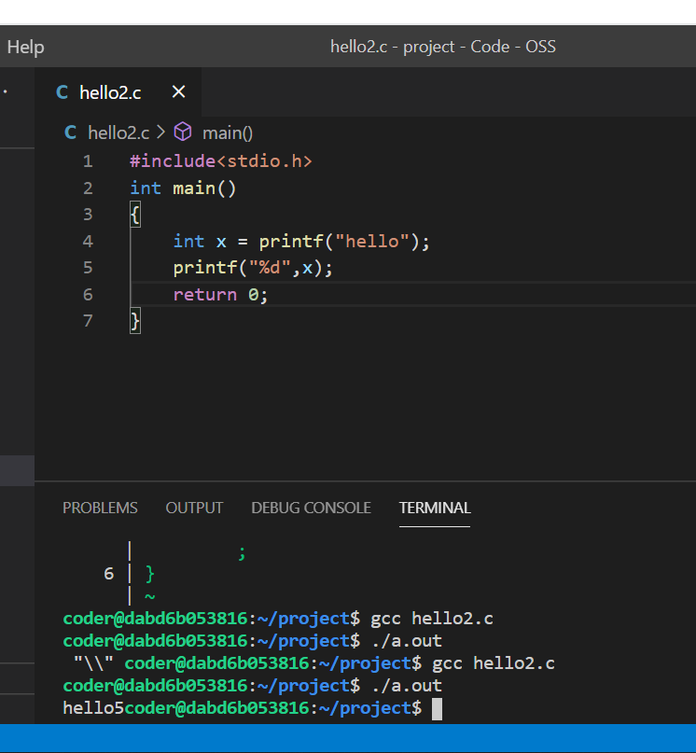

6. WAP to print the name of the user in double quotes.

Expected output format – “Hello , Amit Kumar”

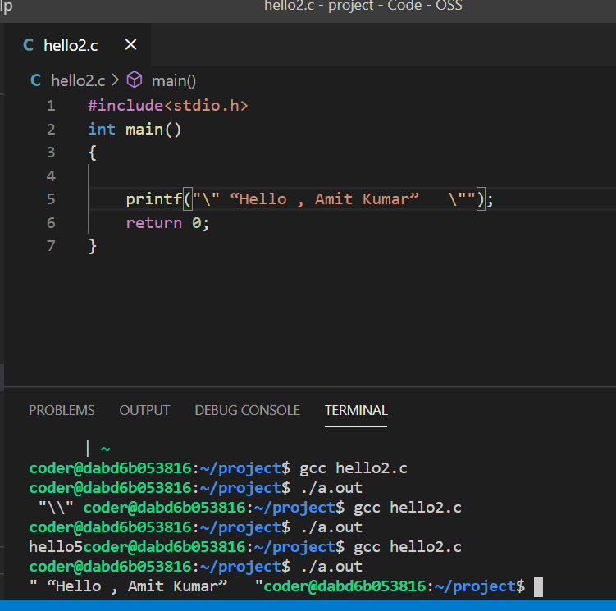

12. Find output of below code:

*int main()*

*{*

*int x = printf(“ineuron”);*

*printf(“%d”,x);*

*return0;*

*}*

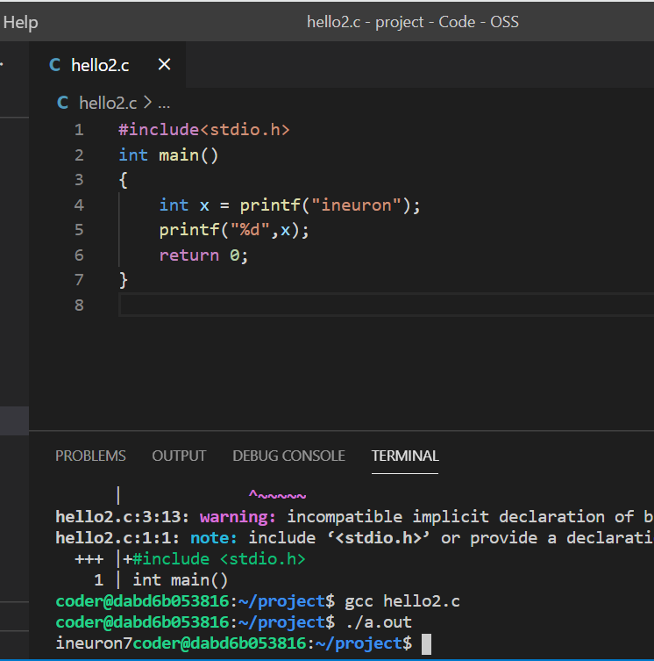

4. WAP to find the area of the circle. Take radius of circle from user as input and print the result in below given format.

**Expected output format** – “Area of circle is A having the radius R”. Replace A with area & R with radius.

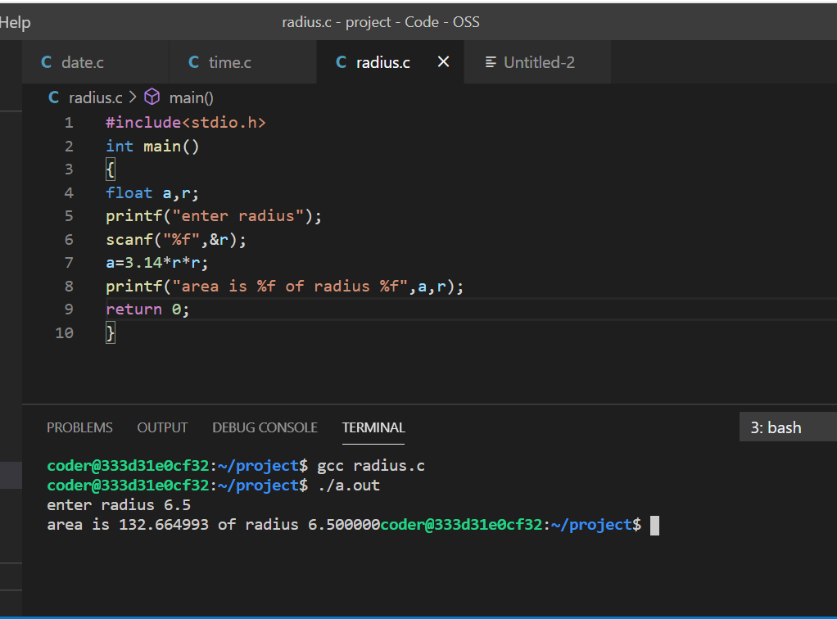

10. WAP to take date as an input in below given format and convert the date format and

display the result as given below.

**User Input date format** – “DD/MM/YYYY” (27/11/2022)

**Output format –**

“Day – DD , Month – MM , Year – YYYY” (Day – 27 ,Month – 07 , Year – 2022)

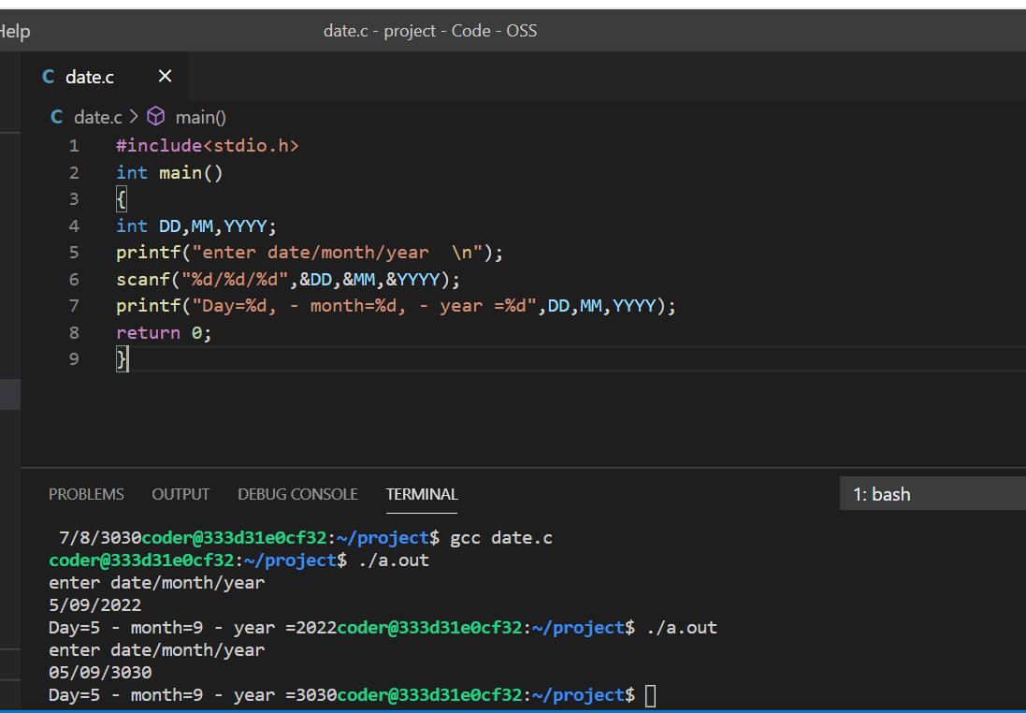

11. WAP to take time as an input in below given format and convert the time format and

display the result as given below.

**User Input date format** – “HH:MM”

**Output format** – “HH hour and MM Minute”

