November 17, 2000

Mr. Pete Zoulek
Kirby Company of Petoskey
1098-C Bayview Road
Petoskey, Michigan 49770

Dear Mr. Zoulek:

After our recent phone discussion, I sat down to write about my experience with my Kirby vacuum cleaner as you suggested. Six years ago when I purchased the Kirby I was having bouts of bronchitis and my doctor was becoming concerned. He asked me if I smoked, which I don’t, but my children do and my daughter was living with me at the time. I also had a dog and cat in the house. Right at this time I saw the Kirby demonstration. I was so impressed with the demo that I felt it would help with my upper respiratory problems and decided to purchase the top of the line with the shampoo kit. I have never regretted that decision.

Within six weeks of banning smoke from my home and using the Kirby, I was breathing normally. I have never had bronchitis since that time. Up until six months ago I always had a cat in the house as well. The dog belonged to my daughter and went with her when she moved. At the time I bought the Kirby my carpeting was about six months old and I had never shampooed it. In order to carpet the entire house I chose a less expensive carpet than I had ever used before—not very much nap. My Kirby is the only shampooer I ever used on this carpet. The carpet throughout the house looks as good today as it did when I installed it. That carpet throughout the house looks as good today as it did when I installed it. That surprised me. I never expected it to hold up as well as it did, and I give all the credit to Kirby. I am a confirmed believer that water rots and foam cleans.

Kirby vacuum cleaners are not inexpensive; however, I am convinced from my own experience that the improvement in my health and the long life of my carpeting has more than compensated for the cost. Additionally, shampooing with a Kirby is far easier than using the commercial water soaking machines. It cuts the shampooing time in half and the drying time in half. You are selling a great product!

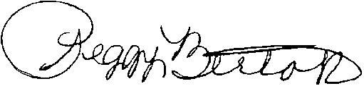
Sincerely,

Peggy Bertok
P.O. Box 343
Cheyboygan, Michigan 49721
231-627-7818

