HOUSE DUST ALLERGY

Allergy to house dust is an important cause of allergic symptoms. Decreasing one’s exposure to house dust can decrease or eliminate these symptoms. These instructions will tell you how.

What is house dust?

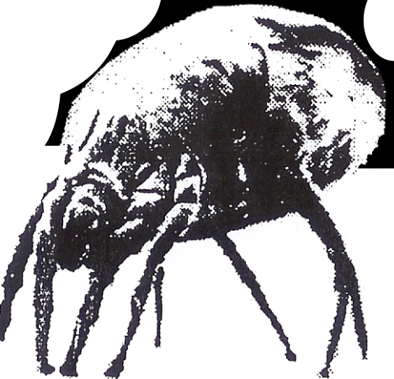Although there are many components in house dust to which people may be allergic, the most important is the dust mite. This is a microscopic, insect-like creature that is found in homes. It lives primarily in mattresses, carpets, and upholstered furniture, and thrives in humid and warm conditions. Its diet consists of shed scales from human skin! Waste product particles produced by these mites are the main substances in house dust to which allergic people react. Each mite produces about 20 of these waste particles every day. These particles continue to cause allergic symptoms even
after the mite that produced them has died.
Where do dust mites live?

The greatest source of dust mite exposure in the home is the bedroom mattress, which provides the best conditions of warmth, humidity, and food for their growth. They are also present in pillows, blankets, carpets, upholstered furniture, curtains, and similar fabrics. Female mites can lay 25 to 50 eggs, with a new generation produced every three weeks. It is easy to see why mattresses contain large numbers of living and dead dust mites.
What can be done to control dust mites?

Scientific studies of dust allergic patients have show that taking steps to minimize dust mite exposure in the bedroom leads to a decrease in allergic symptoms and a decrease in medication requirements. Emphasis is placed on the bedroom, since people spend one third of their life or more there, and because it is the room with the greatest number of dust mites. The mattress, box spring, and pillows should be encased in zippered, airtight covers. Other important dust control measures are noted on the other side of this page.

Scanning Electron Micrograph
Of the House Dust Mite (X300)
Compliments of Fisons.

Allergy Control Products © 1984

