**Theater Analysis**

*Overview*

This analysis contains campaign outcomes based on their launch dates and goals for this Theaters fundraiser based on all the plays.

*Analysis*

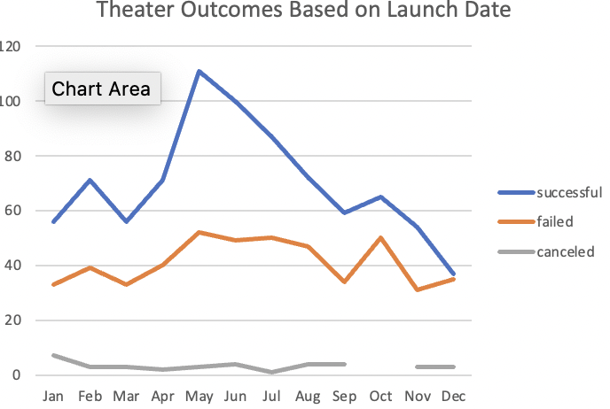

Above is the line chart for Theater Outcomes Based on Launch Date’s. As you can see there is a significantly higher percentage of successful outcomes rather than failed and canceled. While there is a drop in the months May-September there was a small increase but dropping down after October. There is a rise of failed goals beginning in the month of March until June while having a steady decline/rise for the following months.

Above is the chart of Outcomes Based on Goals. I came to find that out of all of the data I was given with the total projects that the number of success outweighs the failure.

*Challenges*

I faced multiple challenges with formula for finding out the different percentages of success, failed and canceled. I also found it hard trying to clean up my chart for Outcomes Based on Goals.