**SOFTWARE MODEL**

For this Project we will implement **waterfall model:**

"The Waterfall" approach, the whole process of software development is divided into separate phases. In this Waterfall model, typically, the outcome of one phase acts as the input for the next phase sequentially

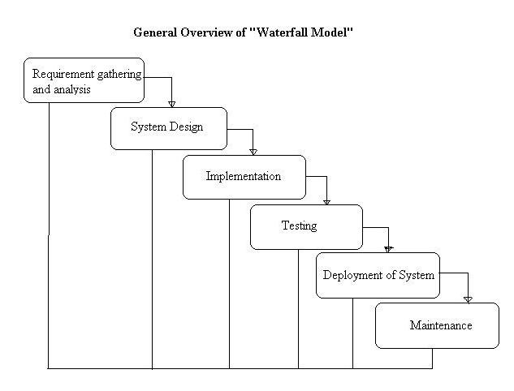

At the end of each phase, a review takes place to determine if the project is on the right path and whether or not to continue or discard the project.

### **Requirements Gathering and Analysis**

In this phase the requirements are gathered by the university teachers and they are analyzed by the team. Requirements are documented during this phase and clarifications can be sought.

### **System Design**

The architect and senior members of the team work on the software architecture, high level and low level design for the project.

It is decided that the examination management application needs to have redundant backup and failover capabilities such that system is accessible at all times.

### **Implementation**

The development team works on coding the project.

They take the design documents / artifacts and ensure that their solution follows the design finalized by the architect.

Since the application is a examination management application So student and teachers data security and consistency was a high priority in the application requirements, they implement several security checks, logging features in the application.

They also perform several other activities like a senior developer reviewing the other developers code for any issues. Some developers perform static analysis of the code.

### **Testing**

The testing team tests the complete application and identifies any [defects](http://tryqa.com/what-is-defect-or-bugs-or-faults-in-software-testing/)in the application.

These defects are fixed by the developers and the testing team tests the fixes to ensure that the defect is fixed.

### **Deployment**

The team builds and installs the application on the servers which were procured for the examination management.

Some of the high level activities include Integerating data of student and teachers, installing security patches, hardening the servers, installing web servers and application servers, installing the database etc.

They also co-ordinate with network and IT administrative teams etc to finally get the application up and running on the production servers.

### **Maintenance**

During the maintenance phase, the team ensures that the application is running smoothly on the servers without any downtime.

Issues that are reported after going live are fixed by the team and tested by the testing team.