**AnsProject 4: Regression Analysis**

**Team Members:**

**Rachel Menezes: 905508013**

**Diplav : 605627748**

**Evyn Chiappe : 605201321**

We decided to work on the **Diamonds** dataset

Prior to question 1.1 the cut, color and clarity columns which are currently categorical are given numeric values. The code for the same can be seen in the notebook.

**QUESTION 1.1:**

Plot a heatmap of the Pearson correlation matrix of the dataset columns. Report which features have the highest absolute correlation with the target variable. In the context of either dataset, describe what the correlation patterns suggest.

**ANS:**

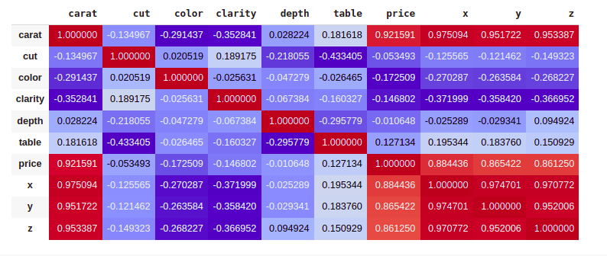

Price is the target variable if we look at the row/column of the price variable we can see the features that have the highest absolute correlation with price are carat(0.921591), and then x(0.884436), y(0.865422) & z(0.861250). The other features have an absolute correlation coefficient of less than 0.2 with respect to price  
  
Carat is the weight of the diamond & x,y,z are the dimensions and the larger the diamond dimensionally and in weight the more expensive it is makes sense.

**QUESTION 1.2:**  
Plot the histogram of numerical features. What preprocessing can be done if the distribution of a feature has high skewness?

**ANS:**

The histogram of the numerical features, i.e., 'carat', 'depth', 'table', 'price', 'x', 'y', 'z' are plotted.  
We see that the histograms of depth and x are centrally distributed. The histograms of carat, table, price, y and z are more right skewed.

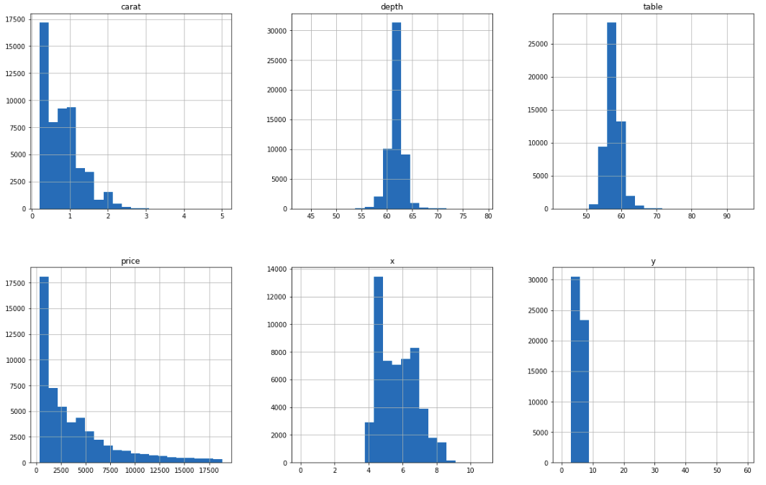

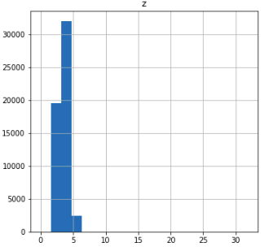

In regression modeling, features that exhibit high skewness are undesirable because many data analysis tools, such as regression analysis, require the dependent variable's distribution to be Gaussian. Models are more likely to converge when the features follow a Gaussian distribution. When using squared error to train the model, parameter estimation on skewed distributions can lead to disproportionate influence on the parameter estimates.

To eliminate skewness, one can perform several transformations on the dataset, including log transformation for right-skewed data (a strong transformation) and left-skewed data (a weak transformation) (excluding values of 0), square root transformation for right-skewed data (a weak transformation) and left-skewed data (a strong transformation), Box-Cox transformation, cube root transformation, reciprocal transformation (excluding values of 0), and transformations combined with min-max or z-score normalization and scaling. Removing outliers can also help by removing points that are far from the distribution's mean.

**QUESTION 1.3:**  
Construct and inspect the box plot of categorical features vs target variable. What do you find?  
  
**ANS:**

Below are the box plots for price versus the categorical features (cut, color, and clarity).

For price versus cut, the median value is similar across all categories except for "ideal," which has a slightly lower value. The maximum price for each category is roughly the same. Data points for each category exhibit a right-skewed distribution, and there are outliers at one end of each category.

In the case of price versus color, the median value varies across categories, with color J having the highest median price. Median price increases from category D (best) to category J (worst). The maximum price for each category is roughly the same. Data points for each category exhibit a right-skewed distribution, and there are outliers at one end of each category.

For price versus clarity, the median value decreases as clarity increases. The maximum price for each category is roughly the same. Data points for each category exhibit a right-skewed distribution, and there are outliers at one end of each category.

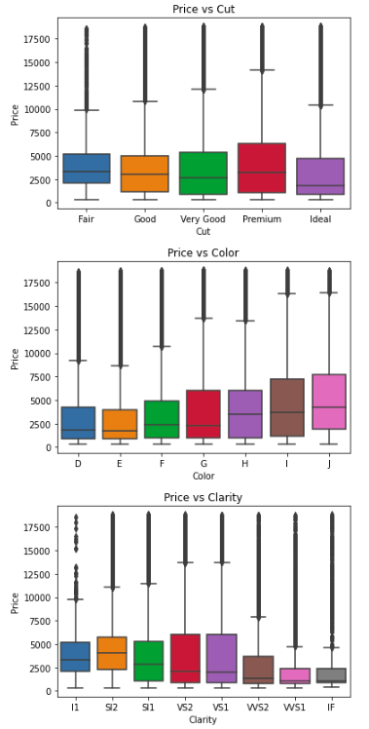

**QUESTION 1.4:**

For the Diamonds dataset, plot the counts by color, cut and clarity.

**ANS**:

Plots for the counts by color, cut and clarity are shown below:

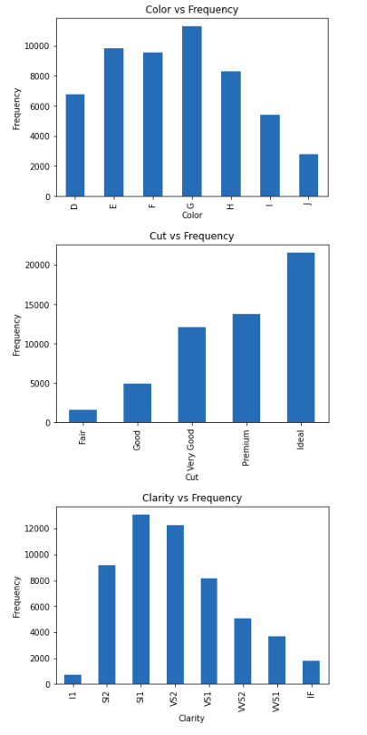

**QUESTION 2.1:**Standardize feature columns and prepare them for training.

**ANS:**While there is a separate function written to standardize across all 10 folds in thw pipeline. Here is a snippet showing standardiation of feature columns.  
  
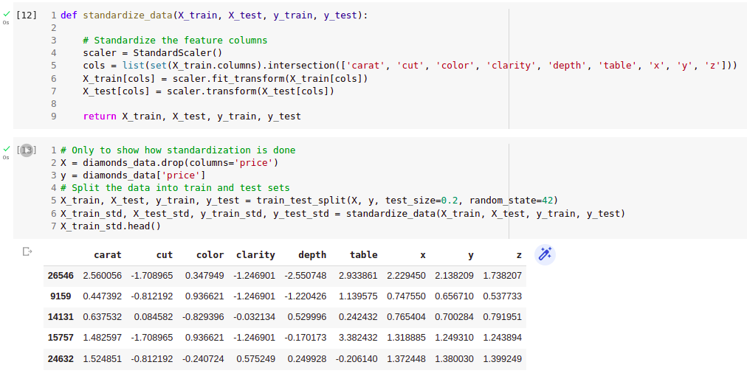

**QUESTION 2.2:**

**sklearn.feature selection.mutual_info_regression** function

returns estimated mutual information between each feature and the label.

**sklearn.feature selection.f_regression** function provides F scores

You **may** use these functions to select features that yield better regression results (especially in the classical models). Describe how this step qualitatively affects the performance of your models in terms of test RMSE. Is it true for all model types? Also list two features for either dataset that has the lowest MI w.r.t to the target.

**ANS:**Feature selection involves selecting a subset of features from the original set of variables that are most relevant to the target variable.

By selecting the most informative features, we can reduce the noise in the data and improve the generalizability and interpretability of the model. This step can significantly affect the performance of the models in terms of test RMSE. Typically, selecting informative features leads to a decrease in test RMSE because the model is trained on a more relevant and less noisy set of features. However, in some cases, selecting too many features can lead to overfitting and an increase in test RMSE.

This step is not necessarily true for all model types. For example, some models such as decision trees and random forests can handle irrelevant features without compromising their performance. However, in classical models such as linear regression, Lasso regression, and Ridge regression, feature selection can have a significant impact on performance.

For the diamond characteristics dataset, two features that have the lowest MI w.r.t the target are "table" and "depth".

The graph below shows the test RMSE vs the top k features for (linear, lasso, and ridge regression) using F-Score and mutual information. For the diamond characteristics dataset we see that test RMSE improvement is not a lot after k=6, F-Score and MI converge to similar test-RMSE values when k equals 1, 3, 4, 6, 8, and 9. When k equals 2, F-Score outperforms MI for all three models, while MI outperforms F-Score when k equals 5 and 7.

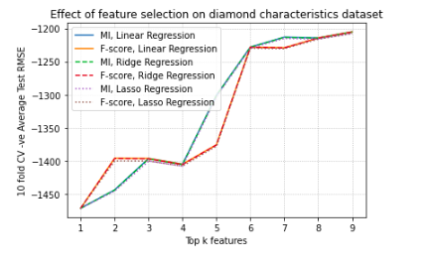

**QUESTION 3:**

For random forest model, measure “Out-of-Bag Error” (OOB) as well as explain what OOB error and R2 score means given this link.  
  
**ANS**:  
The Out-of-Bag (OOB) error is a way to estimate the performance of a random forest model without the need for a separate validation dataset. The OOB error is calculated by training each tree in the forest using a bootstrap sample of the original dataset, leaving out around one-third of the data. This left-out data is called the OOB sample. The OOB error is then calculated by predicting the OOB samples using the trees that were not trained on them and calculating the mean squared error between the predicted and actual values. The OOB error gives an estimate of the generalization error of the model.

The R2 score is a metric used to evaluate the performance of regression models. It measures the proportion of variance in the target variable that is explained by the model. An R2 score of 1 indicates that the model explains all the variance in the target variable, while an R2 score of 0 indicates that the model does not explain any variance.

**3.3.1 Linear Regression**

What is the objective function? Train three models: (a) ordinary least squares (linear regression without regularization), (b) Lasso and (c) Ridge regression, and answer the following questions.

**QUESTION 4.1:**Explain how each regularization scheme affects the learned parameter set.

**ANS:**

**QUESTION 4.2:**Report your choice of the best regularization scheme along with the optimal penalty parameter and explain how you computed it.

**QUESTION 4.3:**Does feature standardization play a role in improving the model performance (in the cases with ridge regularization)? Justify your answer.

**ANS:**

**QUESTION 4.4:**Some linear regression packages return p-values for different features. What is the meaning of these p-values and how can you infer the most significant features?

**ANS:**

**3.3.2 Polynomial Regression**

Perform polynomial regression by crafting products of features you selected in part 3.1.4 up to a certain degree (max degree 6) and applying ridge regression on the compound features. You can use scikit-learn library to build such features. Avoid overfitting by proper regularization. ANSwer the following:

**QUESTION 5.1:**What are the most salient features? Why?

**ANS:**

**QUESTION 5.2**

What degree of polynomial is best? How did you find the optimal degree? What

does a very high-order polynomial imply about the fit on the training data? What about its performance on testing data?

**ANS**

**3.3.3 Neural Network**

You will train a multi-layer perceptron (fully connected neural network). You can simply use the sklearn implementation:

**QUESTION 6.1**

Adjust your network size (number of hidden neurons and depth), and weight decay as regularization. Find a good hyper-parameter set systematically (no more than 20 experiments in total).

**ANS**

**QUESTION 6.2**

How does the performance generally compare with linear regression? Why?

**ANS**

**QUESTION 6.3**

What activation function did you use for the output and why? You may use none.

**ANS**

**QUESTION 6.4**

What is the risk of increasing the depth of the network too far?

**ANS**

**QUESTION 9:**

**About the Data:**

**9.1 Report the following statistics for each hashtag:**

**ANS:**

**Average number of tweets per hour:**

Average number of tweets per hour #goHwaks: 292.09326424870466

Average number of tweets per hour #gopatriots: 40.888695652173915

Average number of tweets per hour #nfl: 396.97103918228277

Average number of tweets per hour #patriots: 750.6320272572402

Average number of tweets per hour #sb49: 1275.5557461406518

Average number of tweets per hour #superbowl: 2067.824531516184

**Average number of followers:**

Average number of followers of users posting tweet #goHwaks: 2217.9237355281984

Average number of followers of users posting tweet #gopatriots: 1427.2526051635405

Average number of followers of users posting tweet #nfl: 4662.37544523693

Average number of followers of users posting tweet #patriots: 3280.4635616550277

Average number of followers of users posting tweet #sb49: 10374.160292019487

Average number of followers of users posting tweet #superbowl: 8814.96799424623

**Average number of retweets per tweet:**

Average number of retweets per tweet #goHwaks: 2.01320939913198

Average number of retweets per tweet #gopatriots: 1.408191910169

Average number of retweets per tweet #nfl: 1.534460265554

Average number of retweets per tweet #patriots: 1.78528712884

Average number of retweets per tweet #sb49: 2.5271344411

Average number of retweets per tweet #superbowl: 2.3911895819207

**9.2 Plot “number of tweets in hour” over time for #SuperBowl and #NFL:**

**ANS:**

**QUESTION 10:**

**ANS:**

I have performed following task on the provided twitter dataset.

1. Fan Base analysis before, during and after the match.
2. Analyzing the average Sentiment trend during the game.
3. Identifying the Key Moment and Key Player in a Game at different duration
4. Predicting Fanbase from Tweet whether Massachusetts or Washington.

Fan Base analysis before, during and after the match

**Describe your task?**

The aim for this task was to find which team has better fanbase in term of volume by analyzing the volume of tweet in support for both the teams at different time interval before, during and after the game.

**Explore the data and any metadata?**

