WEB TECHNOLOGY
MICRO PROJECT REPORT
TITLE: SMART CANTEEN

NAME: ARAVINDAN V
ROLL NO: 24ADR011
NAME: DIVYA T
ROLL NO: 24ADR043

OBJECTIVE:
To design and develop a full-stack web-based campus food ordering system, KonguBites, that enables Kongu Engineering College students to browse a categorized menu and place orders online. The system implements secure JWT-based authentication restricted to official @kongu.edu email addresses, ensuring only authorized college members can access the platform. It provides a seamless ordering experience through a persistent shopping cart, real-time order placement, and a detailed order history with status tracking. The project demonstrates practical proficiency in the MERN-inspired stack — React.js, Node.js, Express.js, and MongoDB — by delivering a responsive, production-ready application that solves a real campus problem.
SOFTWARES USED:
Frontend
- React.js + Vite – For building a fast and modern front-end interface.
- React Router – For handling navigation between different pages.
- Visual Studio Code – For writing and managing the front-end code. Backend
- Node.js – JavaScript runtime environment to run the backend server.
- Express.js – Web framework for building the RESTful API.
- Visual Studio Code – For writing and managing the back-end code.
Database
- MongoDB Compass – GUI tool for visualizing and managing MongoDB data.

MODULES USED:
Frontend Modules
- React.js – Library for building user interfaces.
- React Router – For handling routing and navigation between different pages.
- Vite – Build tool for fast and modern development setup.
Backend Modules
- Node.js – JavaScript runtime environment to run the backend server.
- Express.js – Web framework for building the RESTful API.
Database Modules
- mongoose – MongoDB ODM (Object Data Modeling) library for interacting with MongoDB. Other Modules
- cors – Middleware for enabling Cross-Origin Resource Sharing (CORS) for the backend.
- path – Node.js module for handling and transforming file paths.

SAMPLE CODING: index.js
require('dotenv').config();
const express = require('express');
const mongoose = require('mongoose');
const cors = require('cors');
const authRoutes = require('./routes/auth');
const itemRoutes = require('./routes/items');
const orderRoutes = require('./routes/orders');
const cartRoutes = require('./routes/cart');
const seedItems = require('./seed');
const app = express();
app.use(cors({ origin: 'http://localhost:3000', credentials: true }));
app.use(express.json());
app.use('/api/auth', authRoutes);
app.use('/api/items', itemRoutes);
app.use('/api/orders', orderRoutes);
app.use('/api/cart', cartRoutes);
app.get('/api/health', (req, res) => res.json({ status: 'OK' }));
const PORT = process.env.PORT || 5000;
const MONGO_URI = process.env.MONGO_URI || 'mongodb://localhost:27017/foodapp';
mongoose.connect(MONGO_URI)
.then(async () => {
console.log('MongoDB connected');
await seedItems();
app.listen(PORT, () => console.log(`Server running on port ${PORT}`));
})
.catch(err => console.error('MongoDB connection error:', err));
Seed.js:
const Item = require('./models/Item');
const foodItems = [
{ name: 'Paneer Butter Masala', category: 'Veg', price: 120, description: 'Creamy paneer in rich tomato gravy', imageUrl: 'https://images.unsplash.com/photo-1603894584373-5ac82b2ae398?w=400' },
{ name: 'Veg Biryani', category: 'Veg', price: 100, description: 'Fragrant basmati rice with mixed vegetables', imageUrl: 'https://images.unsplash.com/photo-1563379091339-03b21ab4a4f8?w=400' },
{ name: 'Masala Dosa', category: 'Veg', price: 60, description: 'Crispy dosa with spiced potato filling', imageUrl: 'https://images.unsplash.com/photo-1589301760014-d929f3979dbc?w=400' },
{ name: 'Dal Tadka', category: 'Veg', price: 80, description: 'Yellow lentils tempered with spices', imageUrl: 'https://images.unsplash.com/photo-1546833999-b9f581a1996d?w=400' },
{ name: 'Veg Fried Rice', category: 'Veg', price: 90, description: 'Stir-fried rice with fresh vegetables', imageUrl: 'https://images.unsplash.com/photo-1512058564366-18510be2db19?w=400' },
{ name: 'Chicken Biryani', category: 'Non-Veg', price: 150, description: 'Aromatic biryani with tender chicken', imageUrl: 'https://images.unsplash.com/photo-1574653853027-5382a3d23a15?w=400' },
{ name: 'Butter Chicken', category: 'Non-Veg', price: 160, description: 'Classic murgh makhani in buttery sauce', imageUrl: 'https://images.unsplash.com/photo-1603894584373-5ac82b2ae398?w=400' },
{ name: 'Egg Fried Rice', category: 'Non-Veg', price: 100, description: 'Wok-tossed rice with scrambled eggs', imageUrl: 'https://images.unsplash.com/photo-1518779578993-ec3579fee39f?w=400' },
{ name: 'Chicken 65', category: 'Non-Veg', price: 130, description: 'Spicy deep-fried chicken starter', imageUrl: 'https://images.unsplash.com/photo-1567188040759-fb8a883dc6d8?w=400' },
{ name: 'Fish Curry', category: 'Non-Veg', price: 170, description: 'Tangy South Indian style fish curry', imageUrl: 'https://images.unsplash.com/photo-1565557623262-b51c2513a641?w=400' },
{ name: 'Samosa', category: 'Snacks', price: 20, description: 'Crispy pastry with spiced potato filling', imageUrl: 'https://images.unsplash.com/photo-1601050690597-df0568f70950?w=400' },
{ name: 'Vada Pav', category: 'Snacks', price: 25, description: 'Mumbai street food with spicy potato fritter', imageUrl: 'https://images.unsplash.com/photo-1606491956689-2ea866880c84?w=400' },
{ name: 'French Fries', category: 'Snacks', price: 60, description: 'Golden crispy salted fries', imageUrl: 'https://images.unsplash.com/photo-1576107232684-1279f390859f?w=400' },
{ name: 'Pav Bhaji', category: 'Snacks', price: 70, description: 'Spiced vegetable mash with buttered bread rolls', imageUrl: 'https://images.unsplash.com/photo-1606491956689-2ea866880c84?w=400' },
{ name: 'Bread Pakora', category: 'Snacks', price: 30, description: 'Batter-fried bread with masala filling', imageUrl: 'https://images.unsplash.com/photo-1601050690597-df0568f70950?w=400' },
{ name: 'Mango Lassi', category: 'Drinks', price: 50, description: 'Chilled mango yogurt drink', imageUrl: 'https://images.unsplash.com/photo-1623065422902-30a2d299bbe4?w=400' },
{ name: 'Masala Chai', category: 'Drinks', price: 20, description: 'Spiced Indian tea with milk', imageUrl: 'https://images.unsplash.com/photo-1561336313-0bd5e0b27ec8?w=400' },
{ name: 'Fresh Lime Soda', category: 'Drinks', price: 30, description: 'Refreshing sparkling lime drink', imageUrl: 'https://images.unsplash.com/photo-1621263764928-df1444c5e859?w=400' },
{ name: 'Cold Coffee', category: 'Drinks', price: 60, description: 'Blended iced coffee with milk', imageUrl: 'https://images.unsplash.com/photo-1461023058943-07fcbe16d735?w=400' },
{ name: 'Tender Coconut Water', category: 'Drinks', price: 40, description: 'Natural fresh coconut water', imageUrl: 'https://images.unsplash.com/photo-1558642891-54be180ea339?w=400' }
];
async function seedItems() {
const count = await Item.countDocuments();
if (count === 0) {
await Item.insertMany(foodItems);
console.log('Food items seeded!');
}
}
module.exports = seedItems;
auth.js:
const jwt = require('jsonwebtoken');
const JWT_SECRET = process.env.JWT_SECRET || 'food_app_secret_key_2024';

module.exports = (req, res, next) => {
const token = req.headers.authorization?.split(' ')[1];
if (!token) return res.status(401).json({ message: 'No token provided' });
try {
const decoded = jwt.verify(token, JWT_SECRET);
req.userId = decoded.userId;
next();
} catch {
res.status(401).json({ message: 'Invalid token' });
}
};

Cart.js:
const mongoose = require('mongoose');

const cartSchema = new mongoose.Schema({
user: { type: mongoose.Schema.Types.ObjectId, ref: 'User', required: true, unique: true },
items: [{
item: { type: mongoose.Schema.Types.ObjectId, ref: 'Item' },
name: String,
price: Number,
quantity: { type: Number, default: 1 },
category: String,
imageUrl: String
}]
}, { timestamps: true });

module.exports = mongoose.model('Cart', cartSchema);

Item.js:
const mongoose = require('mongoose');
const itemSchema = new mongoose.Schema({
name: { type: String, required: true },
category: { type: String, enum: ['Veg', 'Non-Veg', 'Snacks', 'Drinks'], required: true },
price: { type: Number, required: true },
description: { type: String },
imageUrl: { type: String }
});
module.exports = mongoose.model('Item', itemSchema);

Order.js:
const mongoose = require('mongoose');

const orderSchema = new mongoose.Schema({
user: { type: mongoose.Schema.Types.ObjectId, ref: 'User', required: true },
items: [{
item: { type: mongoose.Schema.Types.ObjectId, ref: 'Item' },
name: String,
price: Number,
quantity: Number,
category: String,
imageUrl: String
}],
totalAmount: { type: Number, required: true },
status: { type: String, default: 'Placed', enum: ['Placed', 'Preparing', 'Ready', 'Delivered'] },
orderedAt: { type: Date, default: Date.now }
});

module.exports = mongoose.model('Order', orderSchema);

User.js:
const mongoose = require('mongoose');

const userSchema = new mongoose.Schema({
name: { type: String, required: true },
rollNumber: { type: String, required: true, unique: true },
email: {
type: String, required: true, unique: true,
validate: {
validator: v => v.endsWith('@kongu.edu'),
message: 'Email must end with @kongu.edu'
}
},
password: { type: String, required: true }
}, { timestamps: true });

module.exports = mongoose.model('User', userSchema);

auth.js:
const express = require('express');
const bcrypt = require('bcryptjs');
const jwt = require('jsonwebtoken');
const User = require('../models/User');

const router = express.Router();
const JWT_SECRET = process.env.JWT_SECRET || 'food_app_secret_key_2024';
router.post('/signup', async (req, res) => {
try {
const { name, rollNumber, email, password } = req.body;
if (!email.endsWith('@kongu.edu'))
return res.status(400).json({ message: 'Email must end with @kongu.edu' });

const exists = await User.findOne({ $or: [{ email }, { rollNumber }] });
if (exists) return res.status(400).json({ message: 'User already exists' });

const hashed = await bcrypt.hash(password, 10);
const user = await User.create({ name, rollNumber, email, password: hashed });
const token = jwt.sign({ userId: user._id }, JWT_SECRET, { expiresIn: '7d' });
res.status(201).json({ token, user: { id: user._id, name: user.name, email: user.email, rollNumber: user.rollNumber } });
} catch (err) {
res.status(500).json({ message: err.message });
}
});

router.post('/login', async (req, res) => {
try {
const { email, password } = req.body;
const user = await User.findOne({ email });
if (!user) return res.status(400).json({ message: 'Invalid credentials' });

const match = await bcrypt.compare(password, user.password);
if (!match) return res.status(400).json({ message: 'Invalid credentials' });

const token = jwt.sign({ userId: user._id }, JWT_SECRET, { expiresIn: '7d' });
res.json({ token, user: { id: user._id, name: user.name, email: user.email, rollNumber: user.rollNumber } });
} catch (err) {
res.status(500).json({ message: err.message });
}
});

module.exports = router;

cart.js:
const express = require('express');
const Cart = require('../models/Cart');
const auth = require('../middleware/auth');
const router = express.Router();
router.get('/', auth, async (req, res) => {
try {
const cart = await Cart.findOne({ user: req.userId }) || { items: [] };
res.json(cart);
} catch (err) { res.status(500).json({ message: err.message }); }
});
router.post('/add', auth, async (req, res) => {
try {
const { itemId, name, price, category, imageUrl } = req.body;
let cart = await Cart.findOne({ user: req.userId });
if (!cart) cart = new Cart({ user: req.userId, items: [] });

const existing = cart.items.find(i => i.item.toString() === itemId);
if (existing) existing.quantity += 1;
else cart.items.push({ item: itemId, name, price, quantity: 1, category, imageUrl });

await cart.save();
res.json(cart);
} catch (err) { res.status(500).json({ message: err.message }); }
});

router.put('/update', auth, async (req, res) => {
try {
const { itemId, quantity } = req.body;
const cart = await Cart.findOne({ user: req.userId });
if (!cart) return res.status(404).json({ message: 'Cart not found' });

if (quantity <= 0) cart.items = cart.items.filter(i => i.item.toString() !== itemId);
else {
const item = cart.items.find(i => i.item.toString() === itemId);
if (item) item.quantity = quantity;
}
await cart.save();
res.json(cart);
} catch (err) { res.status(500).json({ message: err.message }); }
});
router.delete('/remove/:itemId', auth, async (req, res) => {
try {
const cart = await Cart.findOne({ user: req.userId });
if (!cart) return res.status(404).json({ message: 'Cart not found' });
cart.items = cart.items.filter(i => i.item.toString() !== req.params.itemId);
await cart.save();
res.json(cart);
} catch (err) { res.status(500).json({ message: err.message }); }
});
router.delete('/clear', auth, async (req, res) => {
try {
await Cart.findOneAndUpdate({ user: req.userId }, { items: [] });
res.json({ message: 'Cart cleared' });
} catch (err) { res.status(500).json({ message: err.message }); }
});

module.exports = router;

items.js:
const express = require('express');
const Item = require('../models/Item');
const auth = require('../middleware/auth');
const router = express.Router();

router.get('/', auth, async (req, res) => {
try {
const items = await Item.find();
res.json(items);
} catch (err) {
res.status(500).json({ message: err.message });
}
});

module.exports = router;

orders.js
const express = require('express');
const Order = require('../models/Order');
const Cart = require('../models/Cart');
const auth = require('../middleware/auth');
const router = express.Router();
router.post('/place', auth, async (req, res) => {
try {
const cart = await Cart.findOne({ user: req.userId });
if (!cart || cart.items.length === 0)
return res.status(400).json({ message: 'Cart is empty' });

const totalAmount = cart.items.reduce((sum, i) => sum + i.price * i.quantity, 0);
const order = await Order.create({
user: req.userId,
items: cart.items,
totalAmount
});

cart.items = [];
await cart.save();

res.status(201).json(order);
} catch (err) { res.status(500).json({ message: err.message }); }
});

router.get('/my', auth, async (req, res) => {
try {
const orders = await Order.find({ user: req.userId }).sort({ orderedAt: -1 });
res.json(orders);
} catch (err) { res.status(500).json({ message: err.message }); }
});

module.exports = router;

index.html:
<!DOCTYPE html>
<html lang="en">
<head>
<meta charset="utf-8" />
<meta name="viewport" content="width=device-width, initial-scale=1" />
<title>KonguBites – Campus Food Ordering</title>
<meta name="description" content="Order food at Kongu Engineering College" />
</head>
<body>
<noscript>You need to enable JavaScript to run this app.</noscript>
<div id="root"></div>
</body>
</html>

App.css:
@import url('https://fonts.googleapis.com/css2?family=Playfair+Display:wght@400;600;700;900&family=DM+Sans:wght@300;400;500;600&display=swap');

:root {
--saffron: #F97316;
--saffron-dark: #EA580C;
--saffron-light: #FED7AA;
--cream: #FFFBF5;
--warm-white: #FFF8F0;
--charcoal: #1C1917;
--stone: #44403C;
--muted: #78716C;
--border: #E7E5E4;
--success: #16A34A;
--red: #DC2626;
--card-bg: #FFFFFF;
--shadow: 0 4px 24px rgba(28,25,23,0.08);
--shadow-lg: 0 8px 40px rgba(28,25,23,0.14);
}

*, *::before, *::after { box-sizing: border-box; margin: 0; padding: 0; }

body {
font-family: 'DM Sans', sans-serif;
background: var(--cream);
color: var(--charcoal);
min-height: 100vh;
}

h1, h2, h3, .brand { font-family: 'Playfair Display', serif; }

.btn {
display: inline-flex; align-items: center; justify-content: center; gap: 8px;
padding: 12px 28px; border-radius: 50px; font-family: 'DM Sans', sans-serif;
font-weight: 600; font-size: 0.95rem; cursor: pointer; border: none;
transition: all 0.25s ease; text-decoration: none;
}

.btn-primary {
background: var(--saffron); color: white;
box-shadow: 0 4px 16px rgba(249,115,22,0.35);
}
.btn-primary:hover { background: var(--saffron-dark); transform: translateY(-2px); box-shadow: 0 6px 24px rgba(249,115,22,0.45); }

.btn-outline {
background: transparent; color: var(--saffron); border: 2px solid var(--saffron);
}
.btn-outline:hover { background: var(--saffron-light); }

.btn-ghost {
background: transparent; color: var(--stone); border: 2px solid var(--border);
}
.btn-ghost:hover { background: var(--border); }

.btn-sm { padding: 8px 18px; font-size: 0.85rem; }
.btn-lg { padding: 16px 40px; font-size: 1.05rem; }

.input-field {
width: 100%; padding: 14px 18px; border: 2px solid var(--border);
border-radius: 14px; font-family: 'DM Sans', sans-serif; font-size: 0.95rem;
background: var(--warm-white); color: var(--charcoal);
transition: border-color 0.2s; outline: none;
}
.input-field:focus { border-color: var(--saffron); }
.input-field::placeholder { color: var(--muted); }

.card {
background: var(--card-bg); border-radius: 20px;
box-shadow: var(--shadow); overflow: hidden;
}

.badge {
display: inline-flex; align-items: center; padding: 4px 12px;
border-radius: 50px; font-size: 0.75rem; font-weight: 600;
}
.badge-veg { background: #DCFCE7; color: #15803D; }
.badge-nonveg { background: #FEE2E2; color: #B91C1C; }
.badge-snacks { background: #FEF3C7; color: #B45309; }
.badge-drinks { background: #DBEAFE; color: #1D4ED8; }

.page-container { max-width: 1200px; margin: 0 auto; padding: 32px 20px; }

.spinner {
width: 40px; height: 40px; border: 4px solid var(--saffron-light);
border-top: 4px solid var(--saffron); border-radius: 50%;
animation: spin 0.8s linear infinite; margin: 40px auto;
}
@keyframes spin { to { transform: rotate(360deg); } }

.fade-in { animation: fadeIn 0.4s ease; }
@keyframes fadeIn { from { opacity: 0; transform: translateY(12px); } to { opacity: 1; transform: none; } }

.empty-state { text-align: center; padding: 80px 20px; }
.empty-state .empty-icon { font-size: 4rem; margin-bottom: 16px; }
.empty-state h3 { font-size: 1.5rem; margin-bottom: 8px; }
.empty-state p { color: var(--muted); }

App.js:
import React from 'react';
import { BrowserRouter as Router, Routes, Route, Navigate } from 'react-router-dom';
import { AuthProvider, useAuth } from './context/AuthContext';
import HomePage from './pages/HomePage';
import MenuPage from './pages/MenuPage';
import CartPage from './pages/CartPage';
import MyOrdersPage from './pages/MyOrdersPage';
import Navbar from './components/Navbar';
import './App.css';

const PrivateRoute = ({ children }) => {
const { user } = useAuth();
return user ? children : <Navigate to="/" />;
};

function AppRoutes() {
return (
<>
<Navbar />
<Routes>
<Route path="/" element={<HomePage />} />
<Route path="/menu" element={<PrivateRoute><MenuPage /></PrivateRoute>} />
<Route path="/cart" element={<PrivateRoute><CartPage /></PrivateRoute>} />
<Route path="/my-orders" element={<PrivateRoute><MyOrdersPage /></PrivateRoute>} />
</Routes>
</>
);
}

function App() {
return (
<AuthProvider>
<Router>
<AppRoutes />
</Router>
</AuthProvider>
);
}

export default App;

index.js:
import React from 'react';
import ReactDOM from 'react-dom/client';
import App from './App';

const root = ReactDOM.createRoot(document.getElementById('root'));
root.render(<React.StrictMode><App /></React.StrictMode>);

Navbar.css:
.navbar {
position: sticky; top: 0; z-index: 100;
background: rgba(255,251,245,0.95);
backdrop-filter: blur(12px);
border-bottom: 1px solid var(--border);
box-shadow: 0 2px 12px rgba(28,25,23,0.06);
}

.navbar-inner {
max-width: 1200px; margin: 0 auto;
padding: 0 20px; height: 70px;
display: flex; align-items: center; justify-content: space-between;
}

.navbar-brand {
display: flex; align-items: center; gap: 10px;
text-decoration: none;
}
.brand-icon { font-size: 1.6rem; }
.brand-name {
font-family: 'Playfair Display', serif;
font-size: 1.5rem; font-weight: 700;
color: var(--saffron);
letter-spacing: -0.5px;
}

.navbar-links {
display: flex; align-items: center; gap: 8px;
}

.nav-link {
padding: 8px 16px; border-radius: 50px;
text-decoration: none; color: var(--stone);
font-weight: 500; font-size: 0.9rem;
transition: all 0.2s;
}
.nav-link:hover, .nav-link.active {
background: var(--saffron-light); color: var(--saffron-dark);
}

.nav-cart {
display: flex; align-items: center; gap: 6px;
padding: 8px 18px; border-radius: 50px;
text-decoration: none; color: var(--stone);
font-weight: 500; font-size: 0.9rem;
background: var(--warm-white); border: 2px solid var(--border);
position: relative; transition: all 0.2s;
}
.nav-cart:hover, .nav-cart.active {
border-color: var(--saffron); color: var(--saffron);
}
.cart-badge {
position: absolute; top: -6px; right: -6px;
background: var(--saffron); color: white;
width: 20px; height: 20px; border-radius: 50%;
font-size: 0.7rem; font-weight: 700;
display: flex; align-items: center; justify-content: center;
}

.nav-user {
display: flex; align-items: center; gap: 8px;
padding: 6px 14px; border-radius: 50px;
background: var(--saffron-light);
}
.user-avatar {
width: 28px; height: 28px; border-radius: 50%;
background: var(--saffron); color: white;
display: flex; align-items: center; justify-content: center;
font-weight: 700; font-size: 0.8rem;
}
.user-name { font-weight: 500; color: var(--saffron-dark); font-size: 0.9rem; }

.mobile-menu-btn {
display: none; background: none; border: none;
font-size: 1.4rem; cursor: pointer; padding: 8px;
}

@media (max-width: 768px) {
.mobile-menu-btn { display: block; }
.navbar-links {
display: none; position: absolute; top: 70px;
left: 0; right: 0; background: var(--cream);
flex-direction: column; padding: 20px;
border-bottom: 1px solid var(--border);
box-shadow: var(--shadow); gap: 12px;
}
.navbar-links.open { display: flex; }
.nav-link, .nav-cart { width: 100%; justify-content: center; }
}

Navbar.js:
import React, { useState } from 'react';
import { Link, useNavigate, useLocation } from 'react-router-dom';
import { useAuth } from '../context/AuthContext';
import './Navbar.css';

export default function Navbar() {
const { user, logout, cartCount } = useAuth();
const navigate = useNavigate();
const location = useLocation();
const [menuOpen, setMenuOpen] = useState(false);

const handleLogout = () => {
logout();
navigate('/');
setMenuOpen(false);
};

return (
<nav className="navbar">
<div className="navbar-inner">
<Link to="/" className="navbar-brand">
<span className="brand-icon">🍽️</span>
<span className="brand-name">KonguBites</span>
</Link>

{user && (
<div className={`navbar-links ${menuOpen ? 'open' : ''}`}>
<Link to="/menu" className={`nav-link ${location.pathname === '/menu' ? 'active' : ''}`} onClick={() => setMenuOpen(false)}>Menu</Link>
<Link to="/my-orders" className={`nav-link ${location.pathname === '/my-orders' ? 'active' : ''}`} onClick={() => setMenuOpen(false)}>My Orders</Link>
<Link to="/cart" className={`nav-cart ${location.pathname === '/cart' ? 'active' : ''}`} onClick={() => setMenuOpen(false)}>
<span>🛒</span>
{cartCount > 0 && <span className="cart-badge">{cartCount}</span>}
<span>Cart</span>
</Link>
<div className="nav-user">
<span className="user-avatar">{user.name?.charAt(0).toUpperCase()}</span>
<span className="user-name">{user.name.split(' ')[0]}</span>
</div>
<button className="btn btn-ghost btn-sm" onClick={handleLogout}>Logout</button>
</div>
)}

{user && (
<button className="mobile-menu-btn" onClick={() => setMenuOpen(!menuOpen)}>
{menuOpen ? '✕' : '☰'}
</button>
)}
</div>
</nav>
);
}

AuthContext.js:
import React, { createContext, useContext, useState, useEffect } from 'react';
import axios from 'axios';

const AuthContext = createContext();

export const AuthProvider = ({ children }) => {
const [user, setUser] = useState(null);
const [token, setToken] = useState(localStorage.getItem('token'));
const [cart, setCart] = useState({ items: [] });

useEffect(() => {
const savedUser = localStorage.getItem('user');
if (token && savedUser) {
setUser(JSON.parse(savedUser));
axios.defaults.headers.common['Authorization'] = `Bearer ${token}`;
fetchCart();
}
}, []);

const fetchCart = async () => {
try {
const res = await axios.get('/api/cart');
setCart(res.data);
} catch {}
};

const login = async (email, password) => {
const res = await axios.post('/api/auth/login', { email, password });
const { token: t, user: u } = res.data;
setToken(t); setUser(u);
localStorage.setItem('token', t);
localStorage.setItem('user', JSON.stringify(u));
axios.defaults.headers.common['Authorization'] = `Bearer ${t}`;
await fetchCart();
return u;
};

const signup = async (name, rollNumber, email, password) => {
const res = await axios.post('/api/auth/signup', { name, rollNumber, email, password });
const { token: t, user: u } = res.data;
setToken(t); setUser(u);
localStorage.setItem('token', t);
localStorage.setItem('user', JSON.stringify(u));
axios.defaults.headers.common['Authorization'] = `Bearer ${t}`;
return u;
};

const logout = () => {
setToken(null); setUser(null); setCart({ items: [] });
localStorage.removeItem('token'); localStorage.removeItem('user');
delete axios.defaults.headers.common['Authorization'];
};

const addToCart = async (item) => {
const res = await axios.post('/api/cart/add', {
itemId: item._id, name: item.name, price: item.price,
category: item.category, imageUrl: item.imageUrl
});
setCart(res.data);
};

const updateCartItem = async (itemId, quantity) => {
const res = await axios.put('/api/cart/update', { itemId, quantity });
setCart(res.data);
};

const removeFromCart = async (itemId) => {
const res = await axios.delete(`/api/cart/remove/${itemId}`);
setCart(res.data);
};

const placeOrder = async () => {
const res = await axios.post('/api/orders/place');
setCart({ items: [] });
return res.data;
};

const cartCount = cart.items.reduce((sum, i) => sum + i.quantity, 0);

return (
<AuthContext.Provider value={{
user, token, cart, cartCount,
login, signup, logout, addToCart, updateCartItem, removeFromCart, placeOrder, fetchCart
}}>
{children}
</AuthContext.Provider>
);
};

export const useAuth = () => useContext(AuthContext);

CartPage.css:
.cart-title { font-size: 2.2rem; margin-bottom: 6px; }
.cart-subtitle { color: var(--muted); margin-bottom: 32px; }

.cart-layout { display: grid; grid-template-columns: 1fr 360px; gap: 32px; align-items: start; }

.cart-items { display: flex; flex-direction: column; gap: 16px; }

.cart-item { display: flex; align-items: center; gap: 16px; padding: 16px; transition: box-shadow 0.2s; }
.cart-item:hover { box-shadow: var(--shadow-lg); }

.cart-item-img { width: 80px; height: 80px; object-fit: cover; border-radius: 14px; flex-shrink: 0; }

.cart-item-info { flex: 1; }
.cart-item-info h3 { font-size: 1rem; font-weight: 700; margin-bottom: 4px; }
.cart-item-cat { font-size: 0.8rem; color: var(--muted); }
.cart-item-price { font-size: 0.9rem; color: var(--stone); margin-top: 4px; }

.cart-item-controls { display: flex; flex-direction: column; align-items: flex-end; gap: 8px; }

.qty-controls {
display: flex; align-items: center; gap: 8px;
background: var(--warm-white); border: 2px solid var(--border);
border-radius: 50px; padding: 4px 8px;
}
.qty-btn {
width: 28px; height: 28px; border-radius: 50%; border: none;
background: var(--saffron); color: white; font-size: 1rem;
cursor: pointer; display: flex; align-items: center; justify-content: center;
font-weight: 700; transition: background 0.2s;
}
.qty-btn:hover { background: var(--saffron-dark); }
.qty-val { font-weight: 700; font-size: 1rem; min-width: 24px; text-align: center; }

.cart-item-total { font-weight: 700; font-size: 1.1rem; color: var(--saffron); }

.remove-btn { background: none; border: none; cursor: pointer; font-size: 1.1rem; padding: 4px; opacity: 0.6; transition: opacity 0.2s; }
.remove-btn:hover { opacity: 1; }

.cart-summary { padding: 28px; position: sticky; top: 90px; }
.summary-title { font-size: 1.4rem; margin-bottom: 20px; }

.summary-rows { display: flex; flex-direction: column; gap: 8px; margin-bottom: 8px; }
.summary-row { display: flex; justify-content: space-between; font-size: 0.9rem; color: var(--stone); padding: 4px 0; }

.summary-divider { height: 1px; background: var(--border); margin: 12px 0; }

.total-row { font-size: 1.15rem !important; font-weight: 700; color: var(--charcoal) !important; }

@media (max-width: 768px) {
.cart-layout { grid-template-columns: 1fr; }
.cart-summary { position: static; }
.cart-item { flex-wrap: wrap; }
}

CartPage.js:
import React, { useState } from 'react';
import { useNavigate, Link } from 'react-router-dom';
import { useAuth } from '../context/AuthContext';
import './CartPage.css';

export default function CartPage() {
const { cart, updateCartItem, removeFromCart, placeOrder } = useAuth();
const navigate = useNavigate();
const [placing, setPlacing] = useState(false);
const [error, setError] = useState('');

const items = cart?.items || [];
const subtotal = items.reduce((sum, i) => sum + i.price * i.quantity, 0);
const tax = Math.round(subtotal * 0.05);
const total = subtotal + tax;

const handleQty = async (itemId, qty) => {
if (qty < 1) { await removeFromCart(itemId); return; }
await updateCartItem(itemId, qty);
};

const handlePlaceOrder = async () => {
setError('');
setPlacing(true);
try {
await placeOrder();
navigate('/my-orders');
} catch (err) {
setError(err.response?.data?.message || 'Failed to place order');
} finally {
setPlacing(false);
}
};

if (items.length === 0) {
return (
<div className="page-container">
<div className="empty-state fade-in">
<div className="empty-icon">🛒</div>
<h3>Your cart is empty</h3>
<p>Add some delicious items from our menu!</p>
<Link to="/menu" className="btn btn-primary" style={{ marginTop: 24 }}>Browse Menu</Link>
</div>
</div>
);
}

return (
<div className="cart-page page-container fade-in">
<h1 className="cart-title">Your Cart</h1>
<p className="cart-subtitle">{items.length} item{items.length !== 1 ? 's' : ''} in your cart</p>

<div className="cart-layout">
<div className="cart-items">
{items.map(item => (
<div key={item.item} className="cart-item card">
<img
src={item.imageUrl}
alt={item.name}
className="cart-item-img"
onError={e => { e.target.src = 'https://images.unsplash.com/photo-1546069901-ba9599a7e63c?w=200'; }}
/>
<div className="cart-item-info">
<h3>{item.name}</h3>
<span className="cart-item-cat">{item.category}</span>
<div className="cart-item-price">₹{item.price} each</div>
</div>
<div className="cart-item-controls">
<div className="qty-controls">
<button className="qty-btn" onClick={() => handleQty(item.item, item.quantity - 1)}>−</button>
<span className="qty-val">{item.quantity}</span>
<button className="qty-btn" onClick={() => handleQty(item.item, item.quantity + 1)}>+</button>
</div>
<div className="cart-item-total">₹{item.price * item.quantity}</div>
<button className="remove-btn" onClick={() => removeFromCart(item.item)}>🗑️</button>
</div>
</div>
))}
</div>

<div className="cart-summary card">
<h2 className="summary-title">Order Summary</h2>
<div className="summary-rows">
{items.map(item => (
<div key={item.item} className="summary-row">
<span>{item.name} ×{item.quantity}</span>
<span>₹{item.price * item.quantity}</span>
</div>
))}
</div>
<div className="summary-divider" />
<div className="summary-row"><span>Subtotal</span><span>₹{subtotal}</span></div>
<div className="summary-row"><span>Tax (5%)</span><span>₹{tax}</span></div>
<div className="summary-divider" />
<div className="summary-row total-row"><span>Total</span><span>₹{total}</span></div>

{error && <div className="alert alert-error" style={{ marginTop: 16 }}>⚠️ {error}</div>}

<button className="btn btn-primary" style={{ width: '100%', marginTop: 24 }} onClick={handlePlaceOrder} disabled={placing}>
{placing ? 'Placing Order...' : '🍽️ Place Order'}
</button>

<Link to="/menu" className="btn btn-ghost" style={{ width: '100%', marginTop: 12, textAlign: 'center' }}>
← Continue Shopping
</Link>
</div>
</div>
</div>
);
}

HomePage.css:
.home-page { min-height: calc(100vh - 70px); }

.hero {
display: grid; grid-template-columns: 1fr 1fr;
align-items: center; gap: 40px;
max-width: 1200px; margin: 0 auto;
padding: 80px 20px 60px;
}

.hero-badge {
display: inline-flex; align-items: center; gap: 8px;
background: var(--saffron-light); color: var(--saffron-dark);
padding: 6px 16px; border-radius: 50px;
font-size: 0.85rem; font-weight: 600; margin-bottom: 24px;
}

.hero-title {
font-size: clamp(2.4rem, 5vw, 3.8rem);
font-weight: 900; line-height: 1.1;
color: var(--charcoal); margin-bottom: 20px;
}
.accent { color: var(--saffron); }

.hero-subtitle {
font-size: 1.1rem; color: var(--muted);
line-height: 1.7; margin-bottom: 36px; max-width: 440px;
}

.hero-actions { display: flex; align-items: center; gap: 16px; flex-wrap: wrap; }
.welcome-msg { font-size: 1rem; color: var(--stone); }
.welcome-msg strong { color: var(--saffron-dark); }

.hero-visual { display: flex; justify-content: center; align-items: center; }

.food-orbit { position: relative; width: 340px; height: 340px; }

.orbit-center {
position: absolute; top: 50%; left: 50%;
transform: translate(-50%, -50%);
width: 90px; height: 90px;
background: var(--saffron); border-radius: 50%;
display: flex; align-items: center; justify-content: center;
font-size: 2.4rem;
box-shadow: 0 8px 32px rgba(249,115,22,0.4);
animation: pulse 2.5s ease-in-out infinite;
}
@keyframes pulse {
0%, 100% { transform: translate(-50%,-50%) scale(1); }
50% { transform: translate(-50%,-50%) scale(1.07); }
}

.orbit-item {
position: absolute; top: 50%; left: 50%;
width: 60px; height: 60px;
background: white; border-radius: 50%;
display: flex; align-items: center; justify-content: center;
font-size: 1.6rem;
box-shadow: var(--shadow);
animation: orbit calc(12s + var(--i) * 1.5s) linear infinite;
transform-origin: 0 0;
}
.orbit-item:nth-child(odd) { animation-direction: reverse; }

@keyframes orbit {
0% { transform: rotate(calc(var(--i) * 60deg)) translateX(130px) rotate(calc(var(--i) * -60deg)); }
100% { transform: rotate(calc(var(--i) * 60deg + 360deg)) translateX(130px) rotate(calc(var(--i) * -60deg - 360deg)); }
}

.features-row {
display: grid; grid-template-columns: repeat(3, 1fr);
gap: 24px; max-width: 1200px; margin: 0 auto;
padding: 0 20px 80px;
}

.feature-card {
background: white; border-radius: 20px; padding: 32px 24px;
text-align: center; box-shadow: var(--shadow);
transition: transform 0.25s, box-shadow 0.25s;
}
.feature-card:hover { transform: translateY(-4px); box-shadow: var(--shadow-lg); }
.feature-icon { font-size: 2.5rem; display: block; margin-bottom: 16px; }
.feature-card h3 { font-size: 1.1rem; margin-bottom: 8px; color: var(--charcoal); }
.feature-card p { font-size: 0.9rem; color: var(--muted); line-height: 1.5; }

.auth-section { max-width: 480px; margin: 0 auto; padding: 0 20px 80px; }
.auth-card { padding: 0; overflow: hidden; }

.auth-tabs { display: flex; border-bottom: 2px solid var(--border); }
.auth-tab {
flex: 1; padding: 18px; background: none; border: none;
font-family: 'DM Sans', sans-serif; font-size: 1rem;
font-weight: 600; cursor: pointer; color: var(--muted);
transition: all 0.2s; border-bottom: 3px solid transparent;
margin-bottom: -2px;
}
.auth-tab.active { color: var(--saffron); border-bottom-color: var(--saffron); }

.auth-form { padding: 36px; }
.auth-title { font-size: 1.8rem; margin-bottom: 6px; }
.auth-subtitle { color: var(--muted); margin-bottom: 28px; font-size: 0.95rem; }

.form-group { margin-bottom: 18px; }
.form-group label { display: block; font-weight: 500; font-size: 0.9rem; color: var(--stone); margin-bottom: 8px; }

.alert { padding: 12px 16px; border-radius: 12px; font-size: 0.9rem; margin-bottom: 16px; font-weight: 500; }
.alert-error { background: #FEE2E2; color: #B91C1C; }
.alert-success { background: #DCFCE7; color: #15803D; }

.auth-switch { text-align: center; margin-top: 20px; font-size: 0.9rem; color: var(--muted); }
.link-btn {
background: none; border: none; color: var(--saffron);
font-weight: 600; cursor: pointer; font-size: inherit;
font-family: inherit; padding: 0;
}
.link-btn:hover { text-decoration: underline; }

@media (max-width: 768px) {
.hero { grid-template-columns: 1fr; text-align: center; padding: 40px 20px; }
.hero-visual { display: none; }
.features-row { grid-template-columns: 1fr; }
.hero-subtitle { margin: 0 auto 32px; }
}

HomePage.js:
import React, { useState } from 'react';
import { useNavigate } from 'react-router-dom';
import { useAuth } from '../context/AuthContext';
import './HomePage.css';

export default function HomePage() {
const { user, login, signup } = useAuth();
const navigate = useNavigate();
const [mode, setMode] = useState('login');
const [form, setForm] = useState({ name: '', rollNumber: '', email: '', password: '' });
const [error, setError] = useState('');
const [loading, setLoading] = useState(false);
const [success, setSuccess] = useState('');

const handle = (e) => setForm({ ...form, [e.target.name]: e.target.value });

const handleSubmit = async (e) => {
e.preventDefault();
setError(''); setSuccess('');
if (!form.email.endsWith('@kongu.edu')) {
setError('Email must end with @kongu.edu'); return;
}
setLoading(true);
try {
if (mode === 'login') {
await login(form.email, form.password);
setSuccess('Welcome back! 🎉');
} else {
await signup(form.name, form.rollNumber, form.email, form.password);
setSuccess('Account created! Welcome 🎉');
}
} catch (err) {
setError(err.response?.data?.message || 'Something went wrong');
} finally {
setLoading(false);
}
};

return (
<div className="home-page">
{/* Hero Section */}
<section className="hero">
<div className="hero-content">
<div className="hero-badge">🎓 Kongu Engineering College</div>
<h1 className="hero-title">
Campus Food,<br />
<span className="accent">Delivered Fast</span>
</h1>
<p className="hero-subtitle">
Order your favourite meals from the college canteen — hot, fresh, and right to you.
</p>
{user ? (
<div className="hero-actions">
<p className="welcome-msg">Welcome back, <strong>{user.name}</strong>! 👋</p>
<button className="btn btn-primary btn-lg" onClick={() => navigate('/menu')}>
🍽️ Order Now
</button>
</div>
) : (
<div className="hero-actions">
<button className="btn btn-primary btn-lg" onClick={() => document.getElementById('auth-section').scrollIntoView({ behavior: 'smooth' })}>
Get Started
</button>
</div>
)}
</div>
<div className="hero-visual">
<div className="food-orbit">
{['🍛', '🍗', '🥗', '🧋', '🥟', '🍚'].map((emoji, i) => (
<div key={i} className="orbit-item" style={{ '--i': i }}>
<span>{emoji}</span>
</div>
))}
<div className="orbit-center">🍽️</div>
</div>
</div>
</section>

{/* Features Row */}
<section className="features-row">
{[
{ icon: '⚡', title: 'Fast Ordering', desc: 'Place your order in under a minute' },
{ icon: '🔒', title: 'Secure Login', desc: 'Only @kongu.edu emails allowed' },
{ icon: '📦', title: 'Track Orders', desc: 'Check your order history anytime' },
].map((f, i) => (
<div key={i} className="feature-card">
<span className="feature-icon">{f.icon}</span>
<h3>{f.title}</h3>
<p>{f.desc}</p>
</div>
))}
</section>

{/* Auth Section */}
{!user && (
<section className="auth-section" id="auth-section">
<div className="auth-card card">
<div className="auth-tabs">
<button className={`auth-tab ${mode === 'login' ? 'active' : ''}`} onClick={() => { setMode('login'); setError(''); }}>Login</button>
<button className={`auth-tab ${mode === 'signup' ? 'active' : ''}`} onClick={() => { setMode('signup'); setError(''); }}>Sign Up</button>
</div>

<form className="auth-form" onSubmit={handleSubmit}>
<h2 className="auth-title">{mode === 'login' ? 'Welcome Back' : 'Create Account'}</h2>
<p className="auth-subtitle">{mode === 'login' ? 'Sign in to order food' : 'Join the campus food community'}</p>

{mode === 'signup' && (
<>
<div className="form-group">
<label>Full Name</label>
<input className="input-field" name="name" placeholder="Your full name" value={form.name} onChange={handle} required />
</div>
<div className="form-group">
<label>Roll Number</label>
<input className="input-field" name="rollNumber" placeholder="e.g. 20CS001" value={form.rollNumber} onChange={handle} required />
</div>
</>
)}

<div className="form-group">
<label>Email Address</label>
<input className="input-field" name="email" type="email" placeholder="yourname@kongu.edu" value={form.email} onChange={handle} required />
</div>

<div className="form-group">
<label>Password</label>
<input className="input-field" name="password" type="password" placeholder="Enter password" value={form.password} onChange={handle} required />
</div>

{error && <div className="alert alert-error">⚠️ {error}</div>}
{success && <div className="alert alert-success">✅ {success}</div>}

<button className="btn btn-primary" type="submit" disabled={loading} style={{ width: '100%', marginTop: 8 }}>
{loading ? 'Please wait...' : mode === 'login' ? 'Login' : 'Create Account'}
</button>

<p className="auth-switch">
{mode === 'login' ? "Don't have an account? " : 'Already have an account? '}
<button type="button" className="link-btn" onClick={() => { setMode(mode === 'login' ? 'signup' : 'login'); setError(''); }}>
{mode === 'login' ? 'Sign Up' : 'Login'}
</button>
</p>
</form>
</div>
</section>
)}
</div>
);
}

MenuPage.css:

Menu.menu-header { display: flex; justify-content: space-between; align-items: flex-start; margin-bottom: 32px; }
.menu-title { font-size: 2.4rem; color: var(--charcoal); margin-bottom: 6px; }
.menu-subtitle { color: var(--muted); font-size: 1rem; }

.category-tabs { display: flex; gap: 10px; flex-wrap: wrap; margin-bottom: 40px; }
.cat-tab {
padding: 10px 22px; border-radius: 50px; border: 2px solid var(--border);
background: white; font-family: 'DM Sans', sans-serif;
font-weight: 600; font-size: 0.9rem; cursor: pointer;
color: var(--stone); transition: all 0.2s;
}
.cat-tab:hover { border-color: var(--saffron); color: var(--saffron); }
.cat-tab.active { background: var(--saffron); color: white; border-color: var(--saffron); box-shadow: 0 4px 12px rgba(249,115,22,0.3); }

.category-section { margin-bottom: 56px; }

.category-heading {
display: flex; align-items: center; gap: 12px; margin-bottom: 24px;
padding-bottom: 14px; border-bottom: 2px solid var(--border);
}
.cat-emoji { font-size: 1.8rem; }
.category-heading h2 { font-size: 1.6rem; color: var(--charcoal); }
.cat-count { margin-left: auto; background: var(--saffron-light); color: var(--saffron-dark); padding: 4px 12px; border-radius: 50px; font-size: 0.8rem; font-weight: 600; }

.items-grid { display: grid; grid-template-columns: repeat(auto-fill, minmax(260px, 1fr)); gap: 24px; }

.item-card { transition: transform 0.25s, box-shadow 0.25s; display: flex; flex-direction: column; }
.item-card:hover { transform: translateY(-6px); box-shadow: var(--shadow-lg); }

.item-img-wrap { position: relative; height: 180px; overflow: hidden; }
.item-img { width: 100%; height: 100%; object-fit: cover; transition: transform 0.4s; }
.item-card:hover .item-img { transform: scale(1.05); }

.item-badge { position: absolute; top: 12px; left: 12px; }

.qty-pill {
position: absolute; top: 12px; right: 12px;
background: rgba(28,25,23,0.75); color: white;
padding: 3px 10px; border-radius: 50px;
font-size: 0.75rem; font-weight: 600;
backdrop-filter: blur(4px);
}

.item-body { padding: 18px; flex: 1; display: flex; flex-direction: column; }
.item-name { font-size: 1.05rem; font-weight: 700; margin-bottom: 6px; color: var(--charcoal); }
.item-desc { font-size: 0.85rem; color: var(--muted); line-height: 1.5; flex: 1; margin-bottom: 14px; }

.item-footer { display: flex; align-items: center; justify-content: space-between; }
.item-price { font-size: 1.2rem; font-weight: 700; color: var(--saffron); }

.btn-added { background: var(--success) !important; color: white; box-shadow: 0 4px 12px rgba(22,163,74,0.3); }

@media (max-width: 600px) {
.items-grid { grid-template-columns: repeat(auto-fill, minmax(200px, 1fr)); }
}

MenuPage.js:
import React, { useState, useEffect } from 'react';
import axios from 'axios';
import { useAuth } from '../context/AuthContext';
import './MenuPage.css';

const CATEGORIES = ['All', 'Veg', 'Non-Veg', 'Snacks', 'Drinks'];

const CATEGORY_META = {
Veg: { icon: '🥗', color: 'badge-veg' },
'Non-Veg': { icon: '🍗', color: 'badge-nonveg' },
Snacks: { icon: '🥟', color: 'badge-snacks' },
Drinks: { icon: '🧋', color: 'badge-drinks' },
};

export default function MenuPage() {
const { addToCart, cart } = useAuth();
const [items, setItems] = useState([]);
const [loading, setLoading] = useState(true);
const [activeCategory, setActiveCategory] = useState('All');
const [addedMap, setAddedMap] = useState({});

useEffect(() => {
axios.get('/api/items').then(r => {
setItems(r.data);
setLoading(false);
}).catch(() => setLoading(false));
}, []);

const handleAdd = async (item) => {
try {
await addToCart(item);
setAddedMap(prev => ({ ...prev, [item._id]: true }));
setTimeout(() => setAddedMap(prev => ({ ...prev, [item._id]: false })), 1500);
} catch (err) { console.error(err); }
};

const getCartQty = (itemId) => {
const found = cart?.items?.find(i => i.item === itemId || i.item?._id === itemId);
return found ? found.quantity : 0;
};

const filtered = activeCategory === 'All' ? items : items.filter(i => i.category === activeCategory);

const grouped = CATEGORIES.slice(1).reduce((acc, cat) => {
const catItems = filtered.filter(i => i.category === cat);
if (catItems.length) acc[cat] = catItems;
return acc;
}, {});

if (loading) return <div className="page-container"><div className="spinner" /></div>;

return (
<div className="menu-page page-container fade-in">
<div className="menu-header">
<div>
<h1 className="menu-title">Our Menu</h1>
<p className="menu-subtitle">Fresh food, made with love 🤍</p>
</div>
</div>

<div className="category-tabs">
{CATEGORIES.map(cat => (
<button
key={cat}
className={`cat-tab ${activeCategory === cat ? 'active' : ''}`}
onClick={() => setActiveCategory(cat)}
>
{cat !== 'All' && CATEGORY_META[cat]?.icon + ' '}
{cat}
</button>
))}
</div>

{Object.entries(grouped).map(([category, catItems]) => (
<div key={category} className="category-section">
<div className="category-heading">
<span className="cat-emoji">{CATEGORY_META[category]?.icon}</span>
<h2>{category}</h2>
<span className="cat-count">{catItems.length} items</span>
</div>
<div className="items-grid">
{catItems.map(item => {
const qty = getCartQty(item._id);
const justAdded = addedMap[item._id];
return (
<div key={item._id} className="item-card card fade-in">
<div className="item-img-wrap">
<img
src={item.imageUrl}
alt={item.name}
className="item-img"
onError={e => { e.target.src = 'https://images.unsplash.com/photo-1546069901-ba9599a7e63c?w=400'; }}
/>
<span className={`badge ${CATEGORY_META[item.category]?.color} item-badge`}>
{item.category}
</span>
{qty > 0 && <div className="qty-pill">×{qty} in cart</div>}
</div>
<div className="item-body">
<h3 className="item-name">{item.name}</h3>
<p className="item-desc">{item.description}</p>
<div className="item-footer">
<span className="item-price">₹{item.price}</span>
<button
className={`btn btn-sm ${justAdded ? 'btn-added' : 'btn-primary'}`}
onClick={() => handleAdd(item)}
>
{justAdded ? '✓ Added!' : qty > 0 ? '+ Add More' : '+ Add'}
</button>
</div>
</div>
</div>
);
})}
</div>
</div>
))}

{filtered.length === 0 && (
<div className="empty-state">
<div className="empty-icon">🍽️</div>
<h3>No items found</h3>
<p>Try a different category</p>
</div>
)}
</div>
);
}

MyOrdersPage.css:
.orders-header { display: flex; justify-content: space-between; align-items: flex-start; margin-bottom: 32px; }
.orders-title { font-size: 2.2rem; margin-bottom: 6px; }
.orders-subtitle { color: var(--muted); }

.orders-list { display: flex; flex-direction: column; gap: 16px; }

.order-card { overflow: hidden; transition: box-shadow 0.25s; }
.order-card.open { box-shadow: var(--shadow-lg); }

.order-header {
display: flex; justify-content: space-between; align-items: center;
padding: 20px 24px; cursor: pointer; transition: background 0.2s;
}
.order-header:hover { background: var(--warm-white); }

.order-id { font-weight: 700; font-size: 1rem; color: var(--charcoal); font-family: 'Playfair Display', serif; }
.order-date { font-size: 0.82rem; color: var(--muted); margin-top: 2px; }

.order-info { display: flex; align-items: center; gap: 16px; }
.order-items-count { font-size: 0.85rem; color: var(--muted); }
.order-amount { font-weight: 700; font-size: 1.05rem; color: var(--charcoal); }
.order-status { padding: 5px 14px; border-radius: 50px; font-size: 0.82rem; font-weight: 600; }
.expand-icon { color: var(--muted); font-size: 0.75rem; }

.order-details { padding: 0 24px 24px; border-top: 2px solid var(--border); }

.order-items-grid { margin-top: 20px; display: flex; flex-direction: column; gap: 12px; }

.order-item-row {
display: flex; align-items: center; gap: 14px;
padding: 10px; background: var(--warm-white); border-radius: 14px;
}
.order-item-img { width: 52px; height: 52px; object-fit: cover; border-radius: 10px; flex-shrink: 0; }
.order-item-info { flex: 1; }
.order-item-name { display: block; font-weight: 600; font-size: 0.95rem; }
.order-item-cat { font-size: 0.78rem; color: var(--muted); }
.order-item-qty { font-weight: 600; color: var(--muted); font-size: 0.9rem; }
.order-item-price { font-weight: 700; color: var(--saffron); font-size: 1rem; min-width: 60px; text-align: right; }

.order-totals { margin-top: 16px; padding: 16px; background: var(--warm-white); border-radius: 14px; }
.total-line { display: flex; justify-content: space-between; font-size: 0.9rem; color: var(--stone); padding: 4px 0; }
.grand { font-size: 1rem !important; font-weight: 700; color: var(--charcoal) !important; border-top: 1px solid var(--border); margin-top: 8px; padding-top: 10px; }

.order-status-track {
display: flex; align-items: center;
margin-top: 24px; padding: 16px;
background: var(--warm-white); border-radius: 14px;
}

.track-step {
display: flex; flex-direction: column; align-items: center;
gap: 6px; flex: 1; position: relative;
font-size: 0.78rem; color: var(--muted); font-weight: 500;
}
.track-step.done { color: var(--charcoal); }

.track-dot {
width: 32px; height: 32px; border-radius: 50%;
background: var(--border); color: white;
display: flex; align-items: center; justify-content: center;
font-size: 0.95rem; z-index: 1;
}

.track-line {
position: absolute; top: 16px; left: calc(50% + 16px);
width: calc(100% - 32px); height: 2px; background: var(--border);
}
.track-line.done { background: var(--saffron); }

@media (max-width: 600px) {
.order-header { flex-direction: column; gap: 12px; align-items: flex-start; }
.order-info { flex-wrap: wrap; }
.order-status-track { flex-direction: column; }
.track-line { display: none; }
.orders-header { flex-direction: column; gap: 16px; }
}

MyOrdersPage.js:

import React, { useState, useEffect } from 'react';
import axios from 'axios';
import { Link } from 'react-router-dom';
import './MyOrdersPage.css';

const STATUS_CONFIG = {
Placed: { color: '#3B82F6', bg: '#DBEAFE', icon: '📋' },
Preparing: { color: '#F59E0B', bg: '#FEF3C7', icon: '👨‍🍳' },
Ready: { color: '#10B981', bg: '#D1FAE5', icon: '✅' },
Delivered: { color: '#6B7280', bg: '#F3F4F6', icon: '🎉' },
};

export default function MyOrdersPage() {
const [orders, setOrders] = useState([]);
const [loading, setLoading] = useState(true);
const [expanded, setExpanded] = useState(null);

useEffect(() => {
axios.get('/api/orders/my').then(r => {
setOrders(r.data);
if (r.data.length > 0) setExpanded(r.data[0]._id);
setLoading(false);
}).catch(() => setLoading(false));
}, []);

if (loading) return <div className="page-container"><div className="spinner" /></div>;

if (orders.length === 0) {
return (
<div className="page-container">
<div className="empty-state fade-in">
<div className="empty-icon">📦</div>
<h3>No orders yet</h3>
<p>Place your first order to see it here!</p>
<Link to="/menu" className="btn btn-primary" style={{ marginTop: 24 }}>Order Now</Link>
</div>
</div>
);
}

return (
<div className="orders-page page-container fade-in">
<div className="orders-header">
<div>
<h1 className="orders-title">My Orders</h1>
<p className="orders-subtitle">{orders.length} order{orders.length !== 1 ? 's' : ''} placed</p>
</div>
<Link to="/menu" className="btn btn-outline">+ New Order</Link>
</div>

<div className="orders-list">
{orders.map(order => {
const status = STATUS_CONFIG[order.status] || STATUS_CONFIG.Placed;
const isOpen = expanded === order._id;
const date = new Date(order.orderedAt).toLocaleString('en-IN', {
day: 'numeric', month: 'short', year: 'numeric',
hour: '2-digit', minute: '2-digit'
});

return (
<div key={order._id} className={`order-card card ${isOpen ? 'open' : ''}`}>
<div className="order-header" onClick={() => setExpanded(isOpen ? null : order._id)}>
<div className="order-meta">
<div className="order-id">Order #{order._id.slice(-6).toUpperCase()}</div>
<div className="order-date">{date}</div>
</div>
<div className="order-info">
<div className="order-items-count">{order.items.length} item{order.items.length !== 1 ? 's' : ''}</div>
<div className="order-amount">₹{order.totalAmount}</div>
<div className="order-status" style={{ background: status.bg, color: status.color }}>
{status.icon} {order.status}
</div>
<span className="expand-icon">{isOpen ? '▲' : '▼'}</span>
</div>
</div>

{isOpen && (
<div className="order-details fade-in">
<div className="order-items-grid">
{order.items.map((item, idx) => (
<div key={idx} className="order-item-row">
<img
src={item.imageUrl}
alt={item.name}
className="order-item-img"
onError={e => { e.target.src = 'https://images.unsplash.com/photo-1546069901-ba9599a7e63c?w=100'; }}
/>
<div className="order-item-info">
<span className="order-item-name">{item.name}</span>
<span className="order-item-cat">{item.category}</span>
</div>
<div className="order-item-qty">×{item.quantity}</div>
<div className="order-item-price">₹{item.price * item.quantity}</div>
</div>
))}
</div>

<div className="order-totals">
<div className="total-line"><span>Subtotal</span><span>₹{Math.round(order.totalAmount / 1.05)}</span></div>
<div className="total-line"><span>Tax (5%)</span><span>₹{order.totalAmount - Math.round(order.totalAmount / 1.05)}</span></div>
<div className="total-line grand"><span>Total Paid</span><span>₹{order.totalAmount}</span></div>
</div>

<div className="order-status-track">
{['Placed', 'Preparing', 'Ready', 'Delivered'].map((s, i) => {
const statuses = ['Placed', 'Preparing', 'Ready', 'Delivered'];
const currentIdx = statuses.indexOf(order.status);
const isDone = i <= currentIdx;
const sc = STATUS_CONFIG[s];
return (
<div key={s} className={`track-step ${isDone ? 'done' : ''}`}>
<div className="track-dot" style={isDone ? { background: sc.color } : {}}>
{isDone ? sc.icon : '○'}
</div>
<span>{s}</span>
{i < 3 && <div className={`track-line ${isDone && i < currentIdx ? 'done' : ''}`} />}
</div>
);
})}
</div>
</div>
)}
</div>
);
})}
</div>
</div>
);
}

OUTPUT SCREENSHOTS:

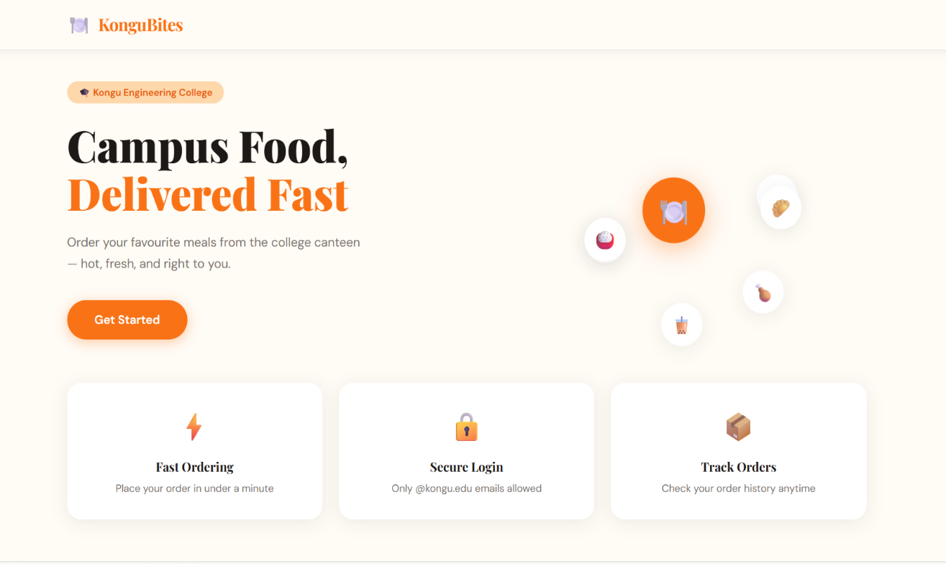
HomePage
OUTPUT SCREENSHOTS:
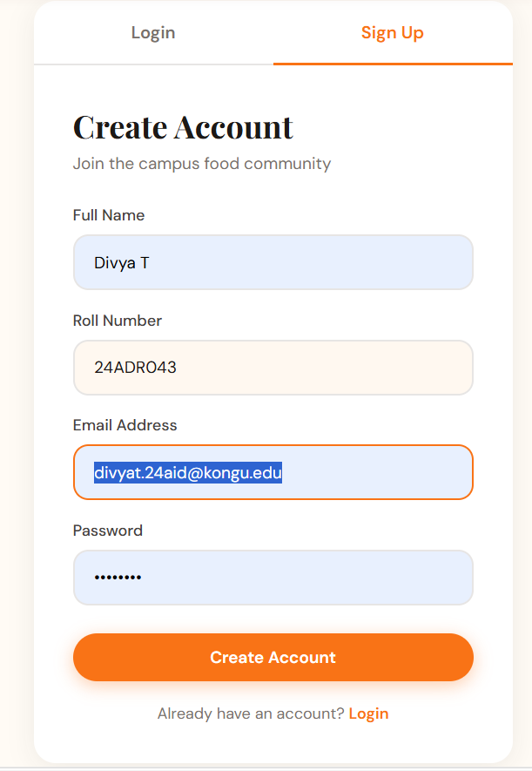
SignUp Page

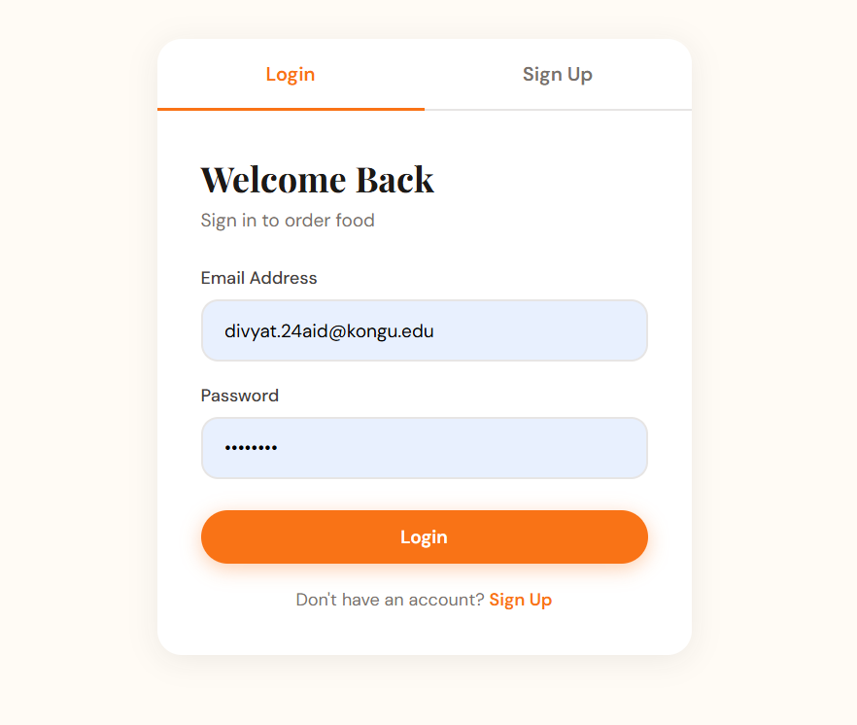
Login Page

OUTPUT SCREENSHOTS:

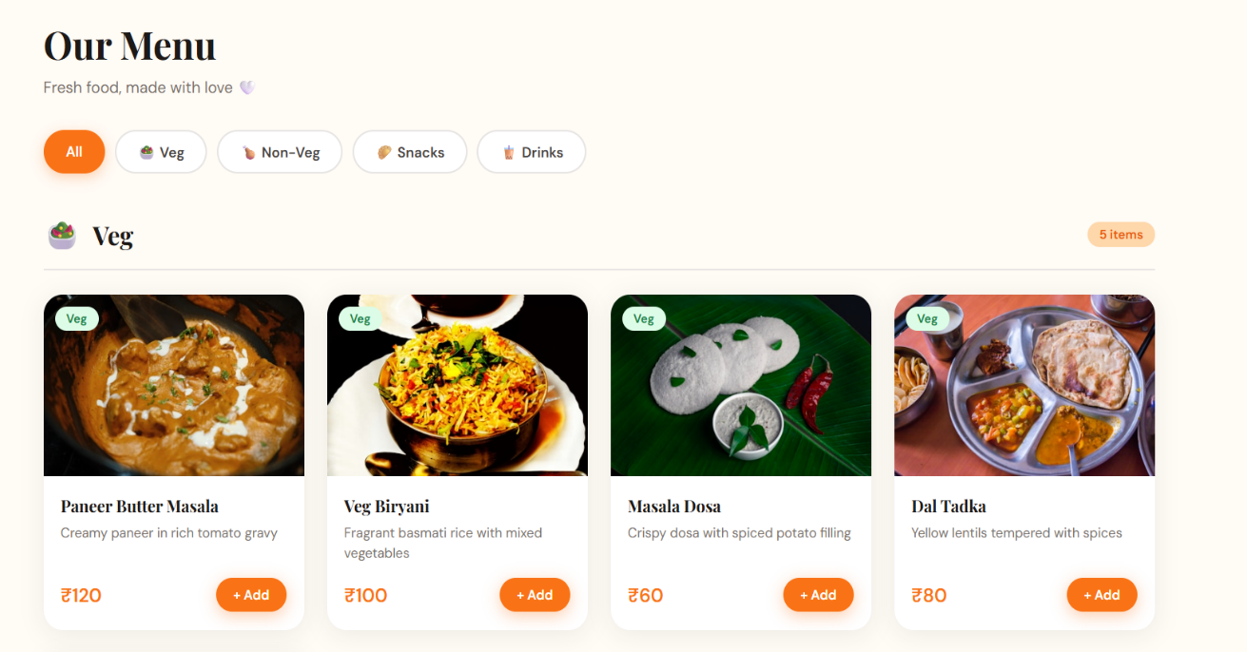
MenuPage

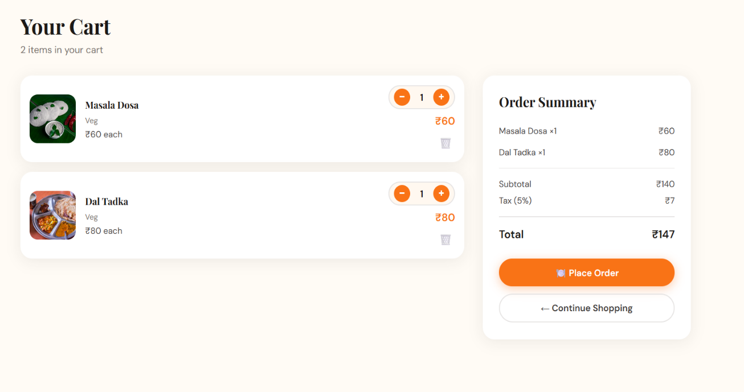
Cart Page

OUTPUT SCREENSHOTS:

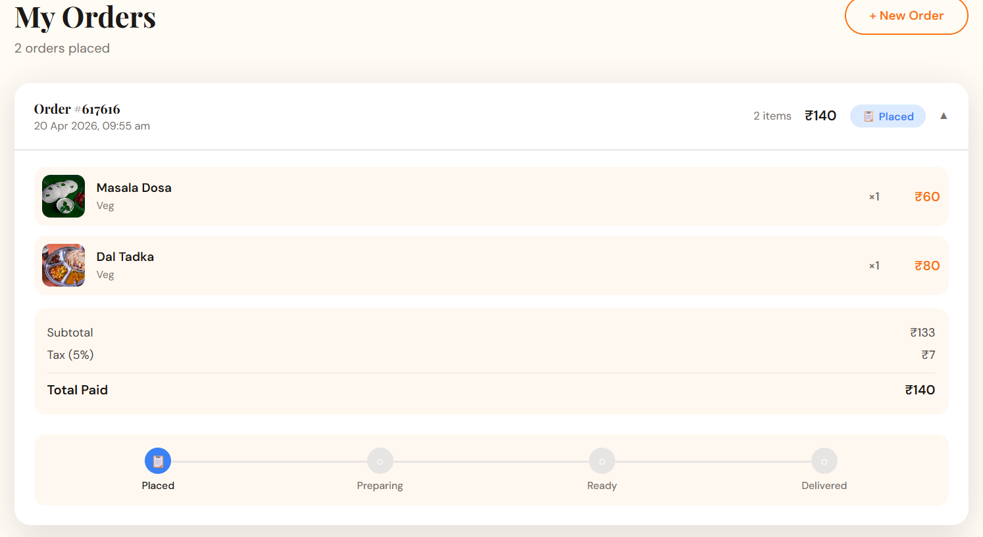
MyOrders Page

MONGO COMPASS:
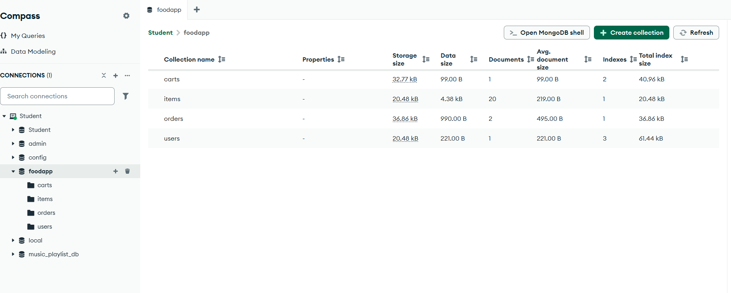

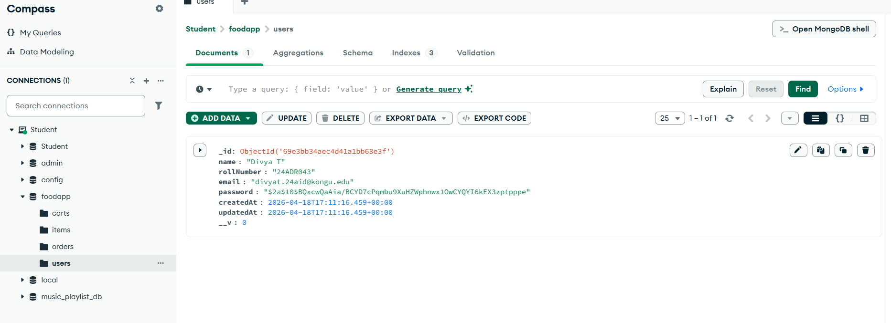

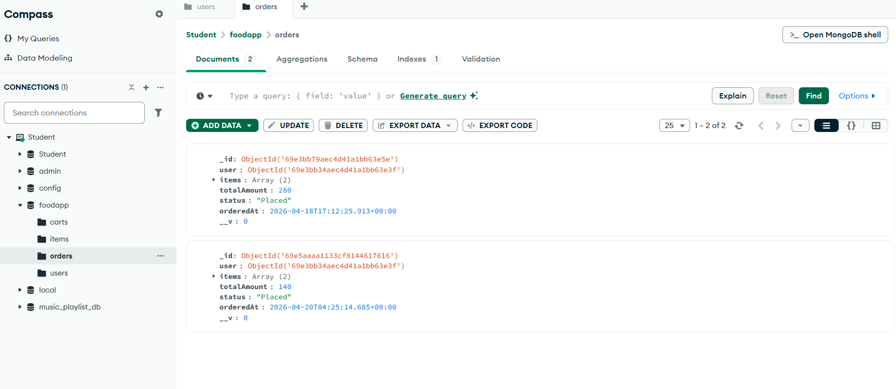

CONCLUSION:
The KonguBites Campus Food Ordering System was successfully developed as a full-stack web application that simplifies the food ordering process for Kongu Engineering College students. The system effectively integrates React.js on the frontend with Node.js, Express.js, and MongoDB on the backend to deliver a smooth and responsive user experience. It achieves its core objectives of secure authentication, categorized menu browsing, cart management, and order tracking through a clean and intuitive interface. Overall, the project demonstrates the practical application of modern web technologies to solve a real-world campus problem and serves as a strong foundation for future enhancements such as payment integration and real-time order updates.

