**Project title : Restaurant management**

**Group members : 19BCE166 (Patel Dipkumar Hareshkumar),**

**19BCE177 (Patel Jalpan Sharmilkumar),**

**19BCE184 (Patel Kashyap Laxmikant)**

**Subject : PSC**

**Course_code : 2CS404**

**Date : 10-04-2021**

**Package to be install**

1. Pillow :

Command : pip install Pillow

Note : All other features required to run this code is already in python 3.0

**Libraries imported(already present in python 3.0):**

* Tkinter
* functools

**Which file to run first:**

File Name : psc.py

Command : python psc.py (in command prompt)

**Features :**

* Display menu and details or image of menu items
* Takes order
* Generate Bill
* Display the info about restaurant

**Input / Output :**

Initial Window

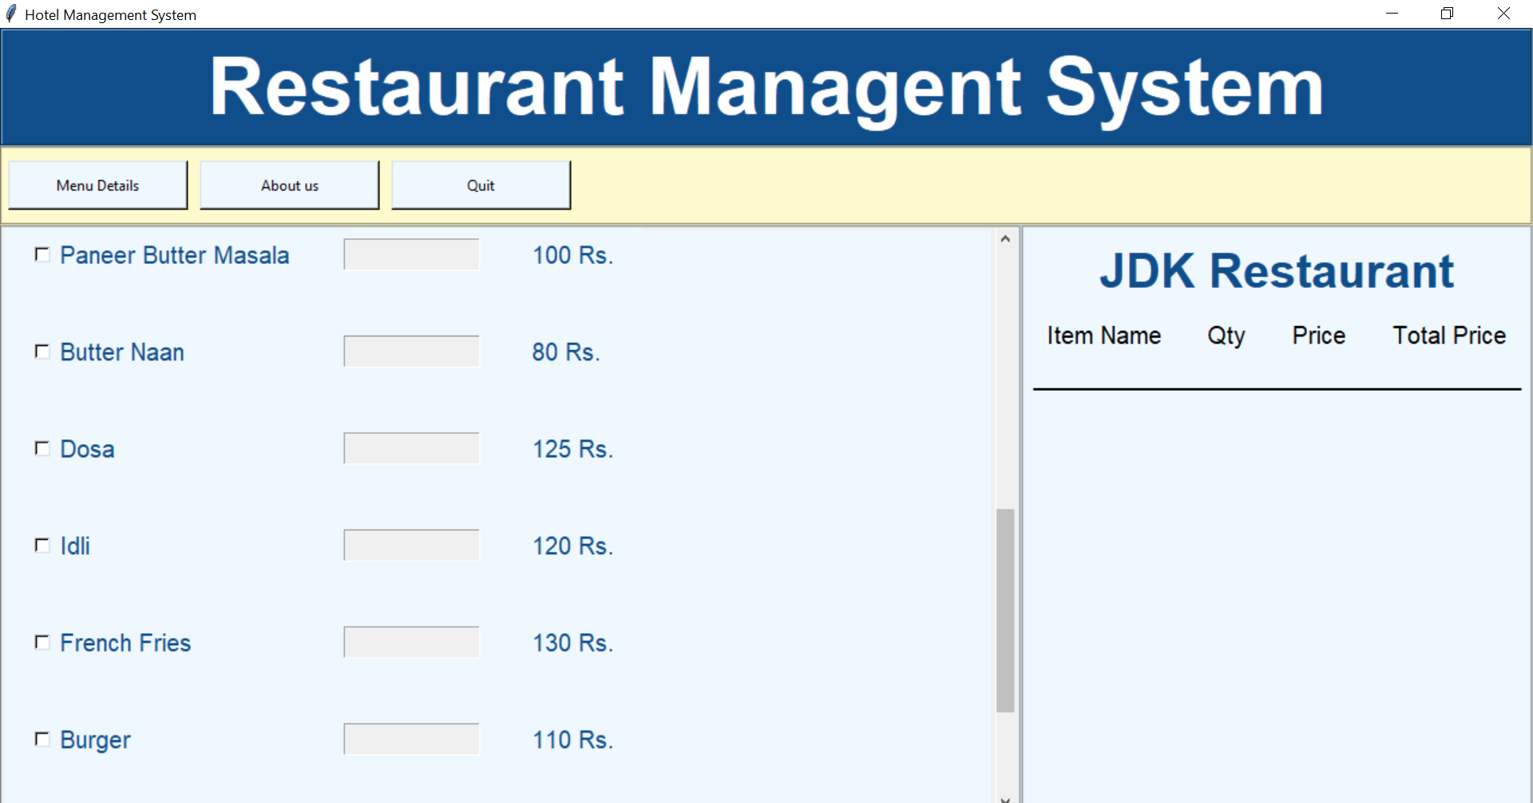

About us :

After pessing “About us” button.

By pressing the “Back to home” button, window of About us will get closed.

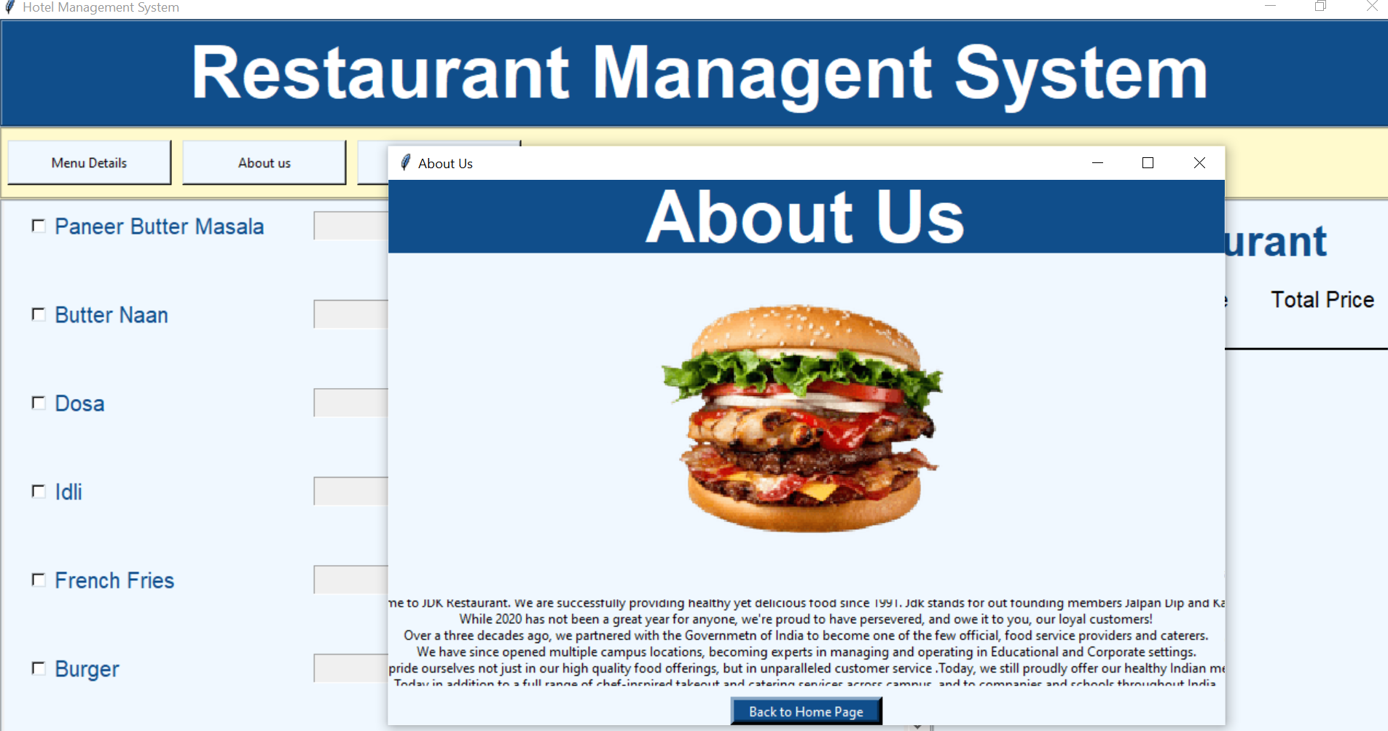

Menu items :

By pressing the “Menu Details” button you can see the interface like below.

By clicking the name of the item given in the Left side of that window you can see the image of that particular item.

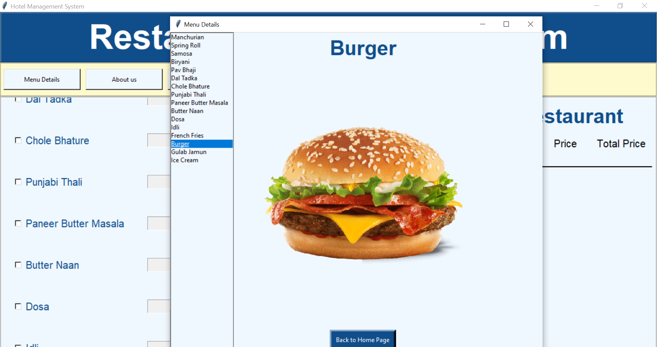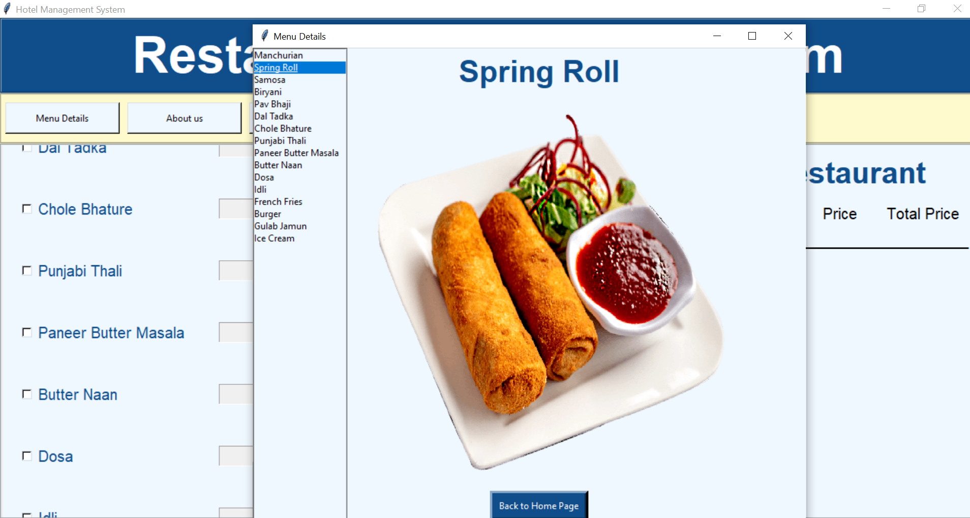

Taking Order:

By clicking on the checkbox the textbox for taking the quantity for that item will be enabled.

You can take any item with any quantity and also uncheck the item and to give order you have to press the “Submit order” button at the end.

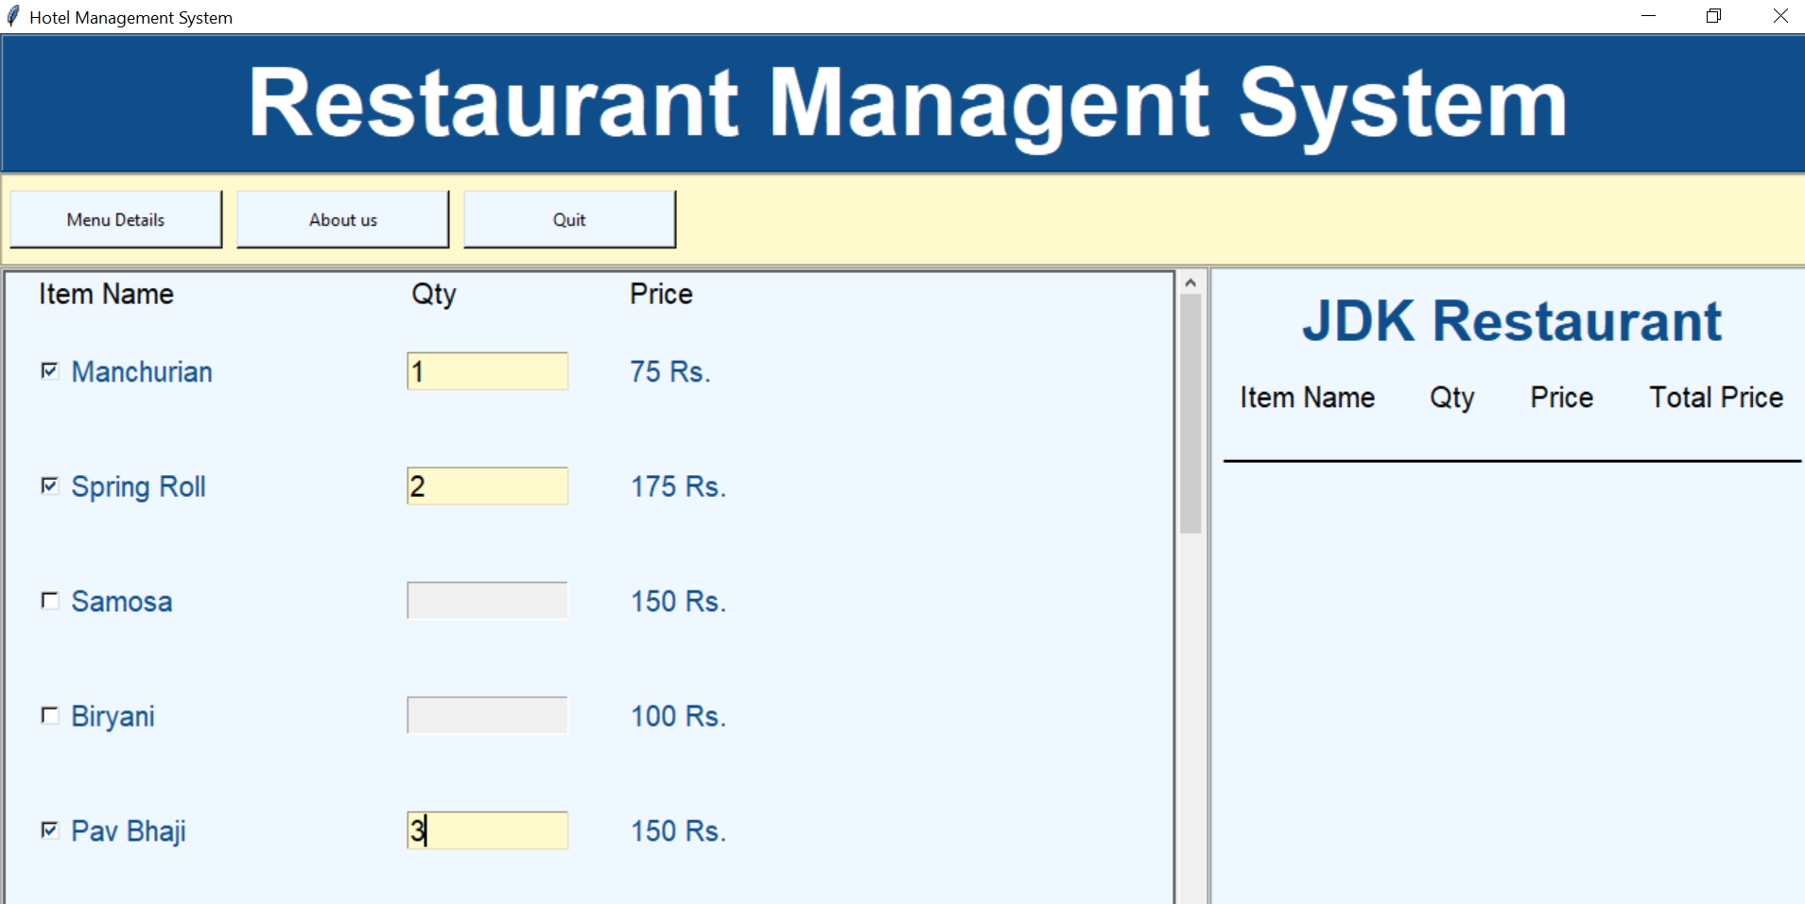

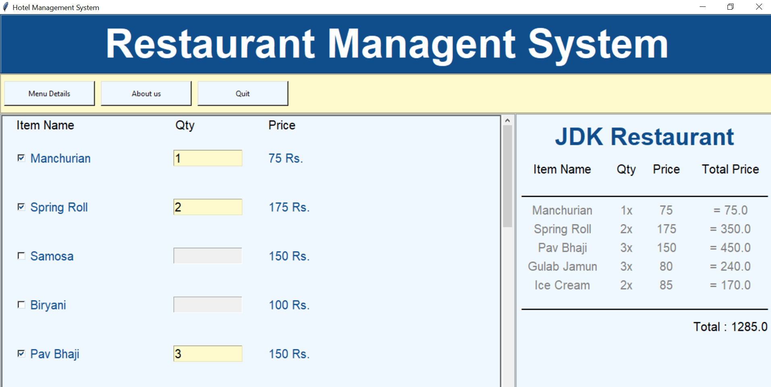

Input Error :

If you enter Invalid Quantity(not int or negative) It will generate an error message in a pop up window.

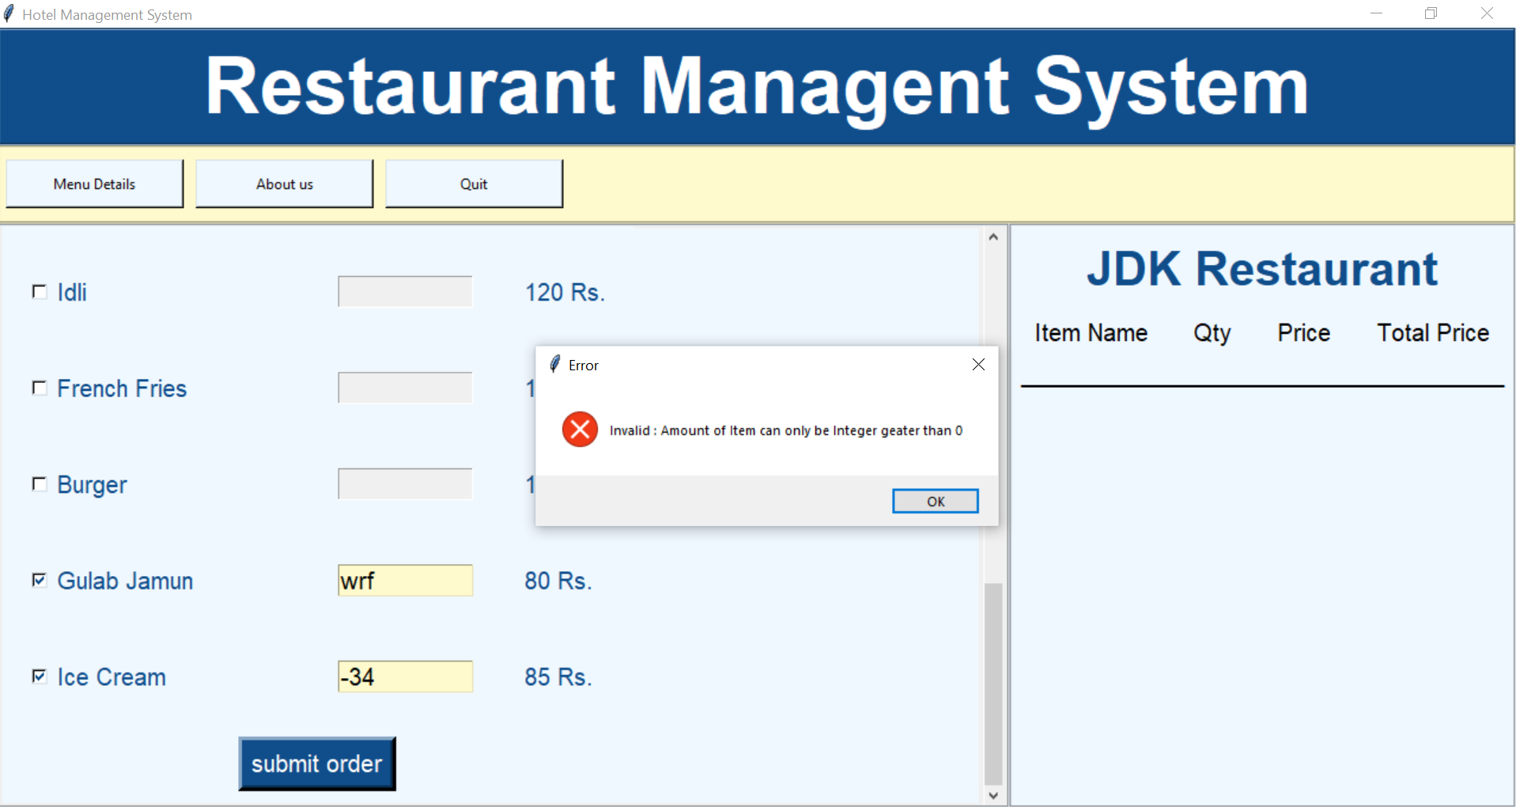

To exit Press “Quit”.