Design document

Members:
- Alessandro Brucato alessandro.brucato@mail.polimi.it
- Lorenzo Cannone lorenzo.cannone@mail.polimi.it
- Matteo Di Pierro matteo.dipierro@mail.polimi.it

Delivery date:
- 16/05/2018

In this document we illustrate how the website is organized, through schemes that show different levels of abstraction. We also put the most significant screens that give a general idea of the website. We also included scenarios that show possible uses of the service.

Index
Graphical representations 3
C-IDM 3
L-IDM 4
P-IDM 5
Comments 6
Scenarios 7
Design-in-the small 8
Home 8
People 9
Events 10
Location 11
DB Design 12

Graphical representations

C-IDM

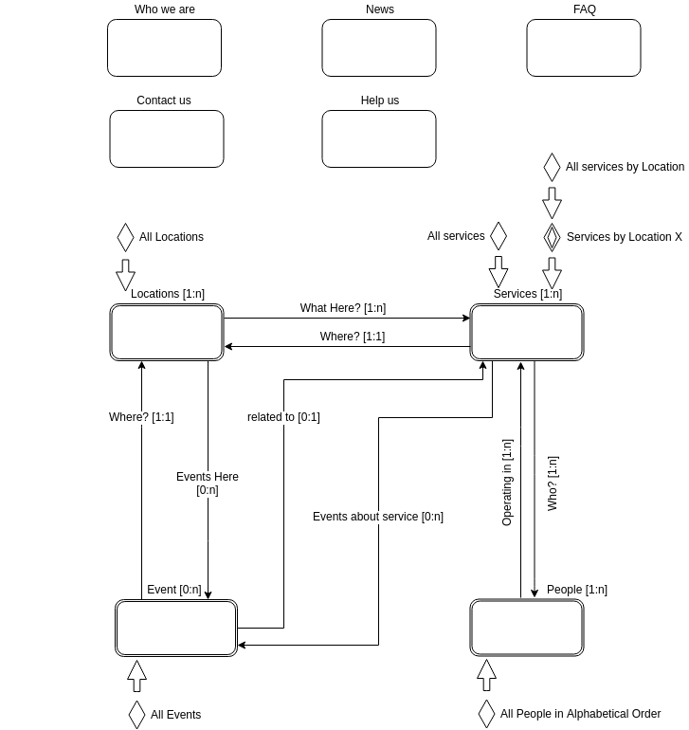

L-IDM

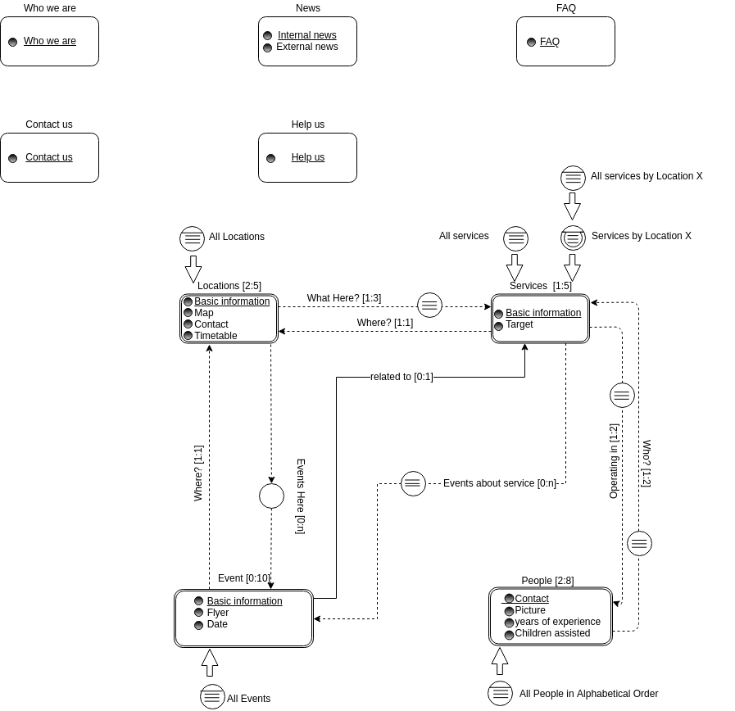

P-IDM

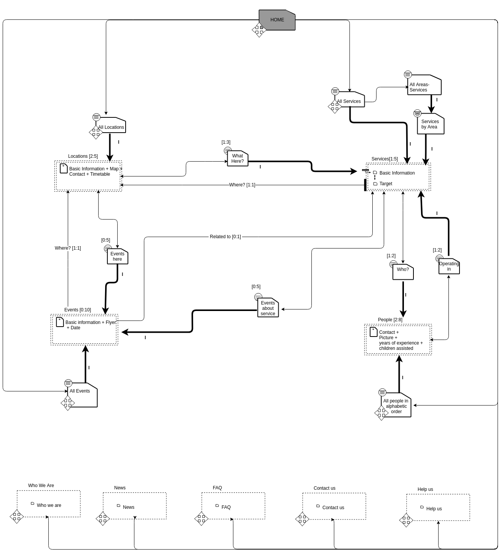

Comments

In addition to the assigned specifications, we have found opportune to add the relationships between events and locations and between events and services (bidirectional relationship). In fact it is useful to know where an event will take place (and vice versa, to know the events held at a location) and whether the event is associated with a service.

Scenarios

- Mirko is a 10 years old child, who loves watching movies and imitating his favorite actors, trying to act like them. His autism is an obstacle when it comes to acting in front of someone else; he refuses to do it. He does not even act in front of his parents. His only allowed spectator is his teddy bear.Mirko’s mother would like him to go to an acting school in order to improve his skill, but she knows well that Mirko would never collaborate with the teachers and the other children. So she used Google to look for care centers where acting is one of the planned activities. This brought her to Dibecare’s website, in particular in the “Services” section, where her attention focused on the title “Theater”. After reading the description she thought that this was the perfect choice for his son. She was also curious about the location, so she clicked on “Details” and then on the photo of the building, which redirected her to the page of the location, that shows other photos.When she proposed this idea to Mirko, he was not very excited. But then he saw the photo of the supervisor responsible of the “Theater” activity he found him very reassuring and friendly. But in order to be completely convinced he wanted to listen to the supervisor’s voice. His mother saw at the bottom of the page the phone icon and by clicking on it she got the number of Dibecare. So she called and asked if it was possible to speak with the responsible of “Theater”. After some minutes she managed to make him talk to Mirko. By the end of the phone call Mirko was happy about the idea to learn acting with him, therefore his mother contacted Dibecare to enroll him.
- Davide and Gloria are two 20 years old guys who are in a relationship. They dance since they were kids, despite their physical disabilities. Their dream is to make people aware that people with disabilities can be excellent dancers, even better than many “normal” people. And they think that this awareness will push more and more people like them to begin dancing in public contexts, like disco pubs.Gloria daily looked for opportunities that can help to fulfill their dream. She already knew Dibecare and one day the last article of the “News” section caught her attention: “Public show of our dancers in Parco Sempione. It will be on TV!”. By clicking on “More” she read that Dibecare was launching a new dancing course in which by the end of the season the best students will perform publicly and the show will be transmitted on television. So that was exactly what she was looking for. As soon as she informed Davide about this news, he was so excited that he immediately called Dibecare to enroll them in that course.

Design-in-the small

Home

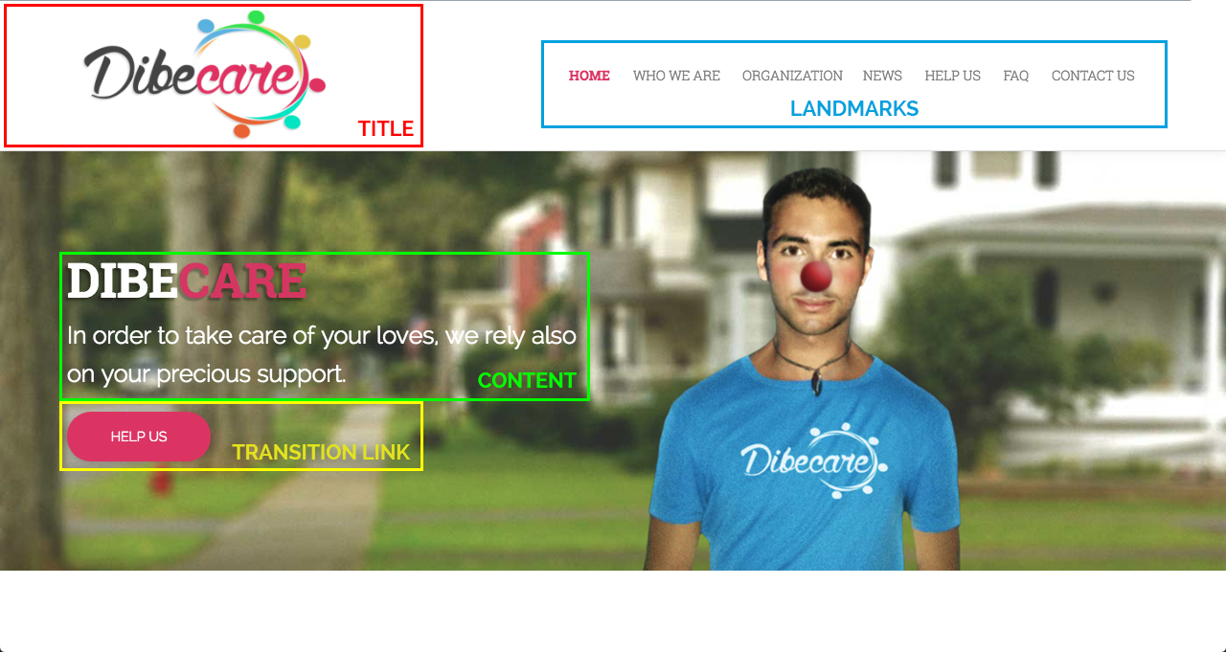
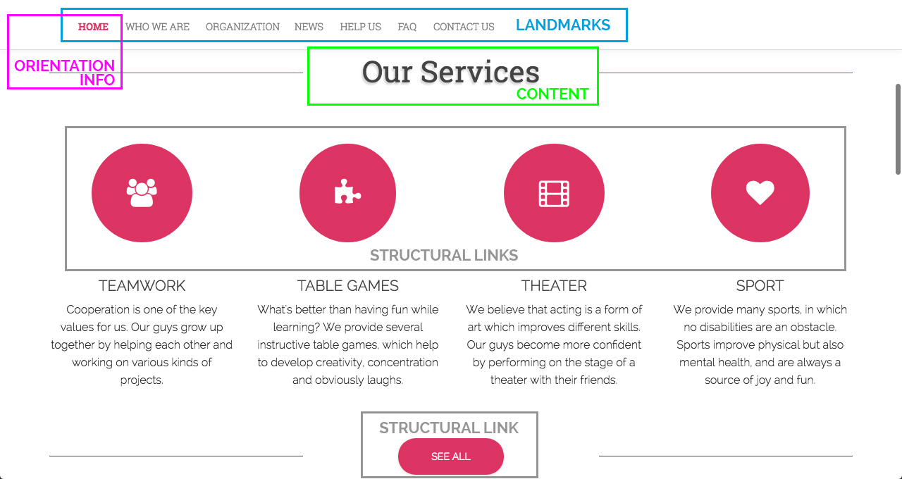
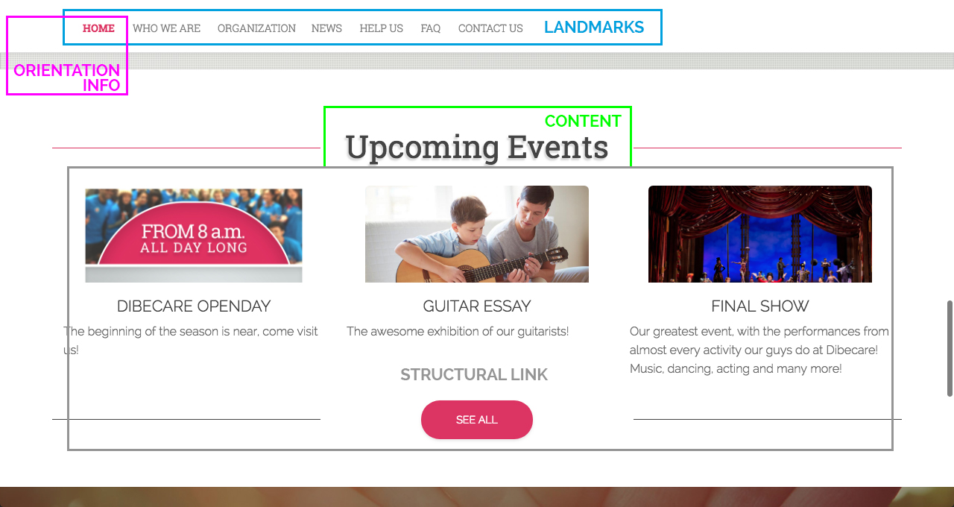

People

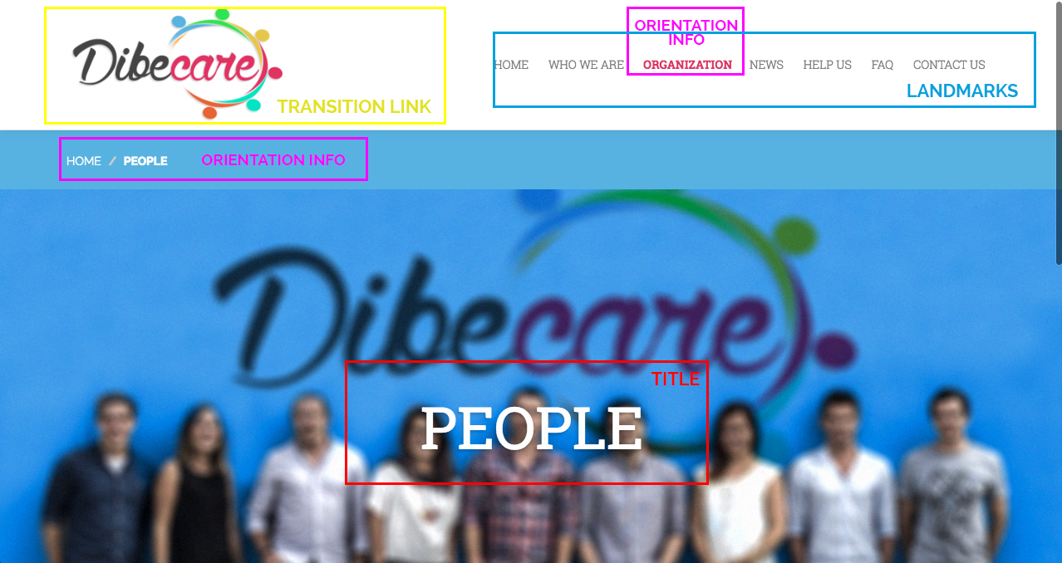
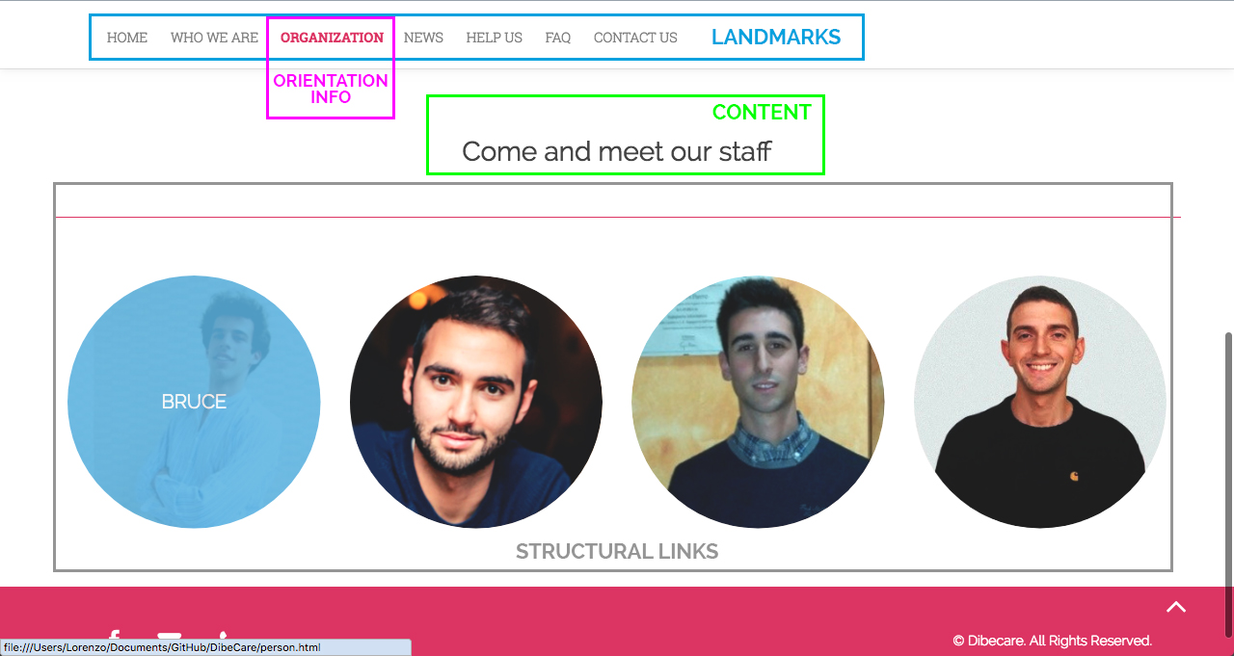

Events

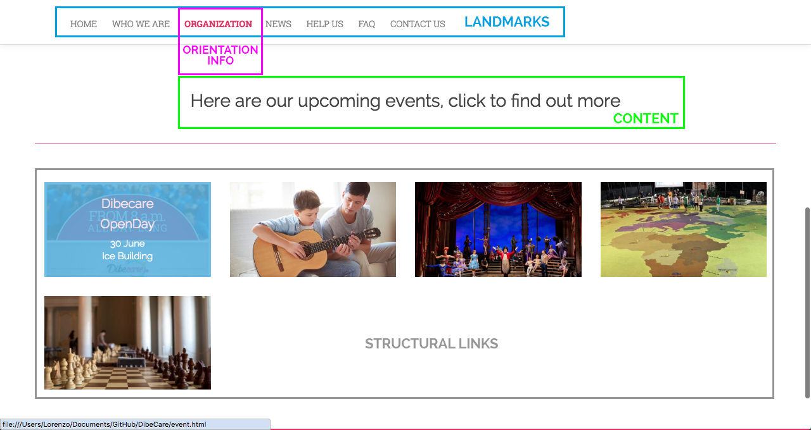

Location

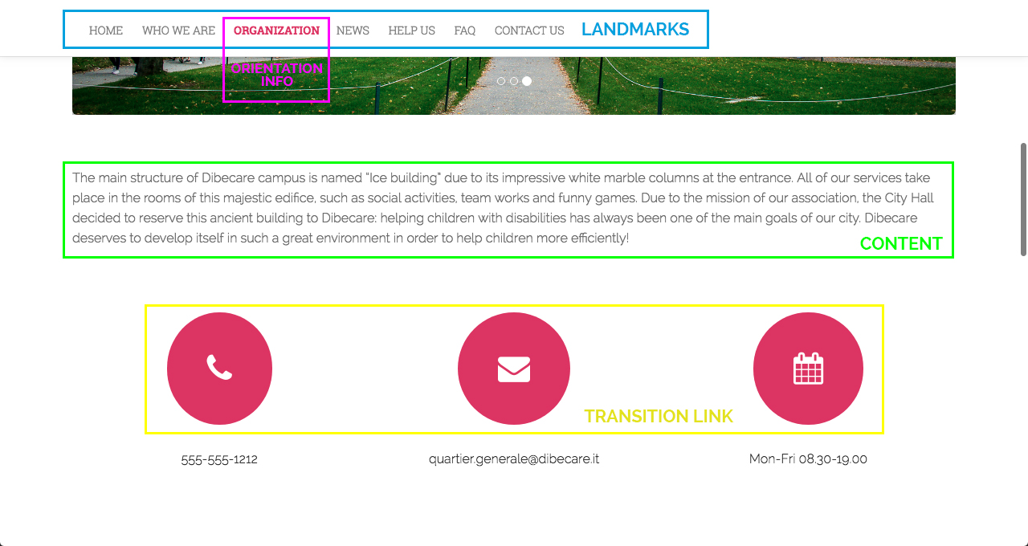
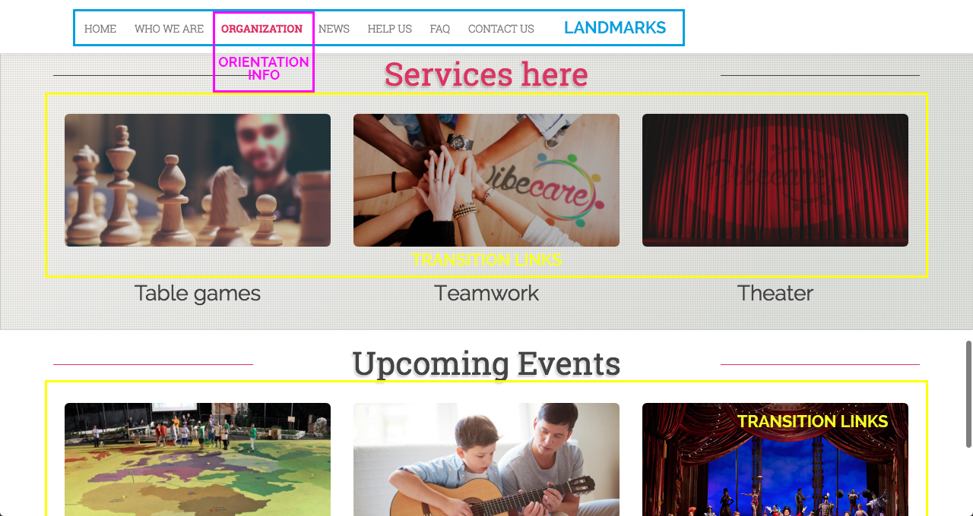

DB Design
