Varol 2017

user:

- dimensione: 2573
- features: user_id
- target: 0/1 (human/bot)
- algorithm: human annotation

possibile utilizzo: arricchimento ds per clustering

Caverlee 2011

Six text files are in the package:

• “content polluters.txt”
- size: 22,223
- features: UserID, CreatedAt, CollectedAt, NumerOfFollowings,
NumberOfFollowers, NumberOfTweets, LengthOfScreenName,
LengthOfDescriptionInUserProfile
- target: missing (everyone with the same label: bot)
- algorithm: honeypot

• “content polluters followings.txt”
- size: 22,223
- features: UserID, SeriesOfNumberOfFollowings
- target: missing (everyone with the same label: bot)
- algorithm: honeypot

• “content polluters tweets.txt”
- size: 2,353,473
- features: UserID, TweetID, Tweet, CreatedAt.
- target: missing (everyone with the same label: bot)
- algorithm: honeypot

• “legitimate users.txt”
- size: 19,276
- features: UserID, CreatedAt, CollectedAt, NumerOfFollowings,
NumberOfFollowers, NumberOfTweets, LengthOfScreenName,
LengthOfDescriptionInUserProfile
- target: missing (everyone with the same label: human)
- algorithm: honeypot

• “legitimate users followings.txt”
- size: 19,276
- features: UserID, SeriesOfNumberOfFollowings
- target: missing (everyone with the same label: human)
- algorithm: honeypot

• “legitimate users tweets.txt”
- size: 3,259,693
- features: UserID, TweetID, Tweet, CreatedAt.
- target: missing (everyone with the same label: human)
- algorithm: honeypot

Cresci 2015

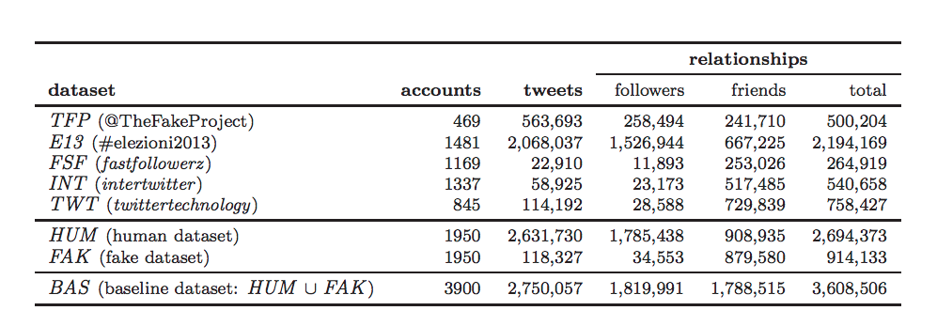
Users:
- features:
"id","name","screen_name","statuses_count","followers_count","friends_count","favourites_count","listed_count","created_at","url","lang","time_zone","location","default_profile","default_profile_image","geo_enabled","profile_image_url","profile_banner_url","profile_use_background_image","profile_background_image_url_https","profile_text_color","profile_image_url_https","profile_sidebar_border_color","profile_background_tile","profile_sidebar_fill_color","profile_background_image_url","profile_background_color","profile_link_color","utc_offset","protected","verified","description","updated","dataset"

Tweet:
- features:
"created_at","id","text","source","user_id","truncated","in_reply_to_status_id","in_reply_to_user_id","in_reply_to_screen_name","retweeted_status_id","geo","place","retweet_count","reply_count","favorite_count","num_hashtags","num_urls","num_mentions","timestamp"

Followers:
-

Friends:
-
Cresci 2017

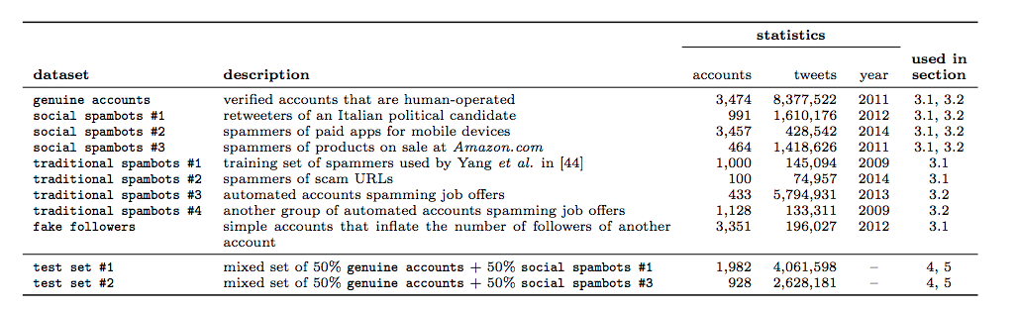
Users:
- features: "id","name","screen_name","statuses_count","followers_count","friends_count","favourites_count","listed_count","url","lang","time_zone","location","default_profile","default_profile_image","geo_enabled","profile_image_url","profile_banner_url","profile_use_background_image","profile_background_image_url_https","profile_text_color","profile_image_url_https","profile_sidebar_border_color","profile_background_tile","profile_sidebar_fill_color","profile_background_image_url","profile_background_color","profile_link_color","utc_offset","is_translator","follow_request_sent","protected","verified","notifications","description","contributors_enabled","following","created_at","timestamp","crawled_at","updated","test_set_1"

Tweets:
- features:
"id","text","source","user_id","truncated","in_reply_to_status_id","in_reply_to_user_id","in_reply_to_screen_name","retweeted_status_id","geo","place","contributors","retweet_count","reply_count","favorite_count","favorited","retweeted","possibly_sensitive","num_hashtags","num_urls","num_mentions","created_at","timestamp","crawled_at","updated"

