Early Dispute Detection and Chargeback Management
Generated: 2026-07-01 16:30:38
This document explains the end-to-end operational process, decisioning workflow, system components, and visual dashboard context for dispute and chargeback handling.

1. Process Objectives
- Detect dispute signals before formal chargebacks are filed.
- Prioritize response using risk tiers (Critical, High, Medium, Low).
- Coordinate customer, merchant, and admin workflows with clear handoffs.
- Keep audit-ready records for status transitions, evidence, and outcomes.

2. End-to-End Operational Process
1) Evidence Intake
- Capture chat transcripts in evidence/CASEID/chat_CASEID.txt.

2) Signal Detection and Scoring
- Analyze conversation text for dispute indicators.
- Compute weighted risk score and classify risk tier.

3) Triage and Assignment
- Route cases to customer and merchant resolution workflows.
- Prioritize high-risk cases for immediate action.

4) Negotiation and Evidence Handling
- Track notes, amount context, evidence requests, and response outcomes.

5) Escalation and Chargeback Handling
- Escalate unresolved or rejected disputes into chargeback processing.

6) Closure and Reporting
- Record final outcomes, update dashboards, and publish reporting artifacts.

3. Application Layers and Functions
- Data Layer: generate_chargeback_dataset.py creates normalized chargeback records.
- Detection Layer: early_dispute_detection.py extracts signals and computes risk.
- Orchestration Layer: run_analysis.py runs complete generation flow.
- Reporting Layer: HTML dashboards, JSON output, PDF/PPT deliverables.
- Governance Layer: merchant admin controls, intervention and escalation actions.

4. Decisioning Workflow (Agent Loop)
- Input event enters the agent orchestrator with case context.
- LLM planner decides whether tool calls are needed.
- Tools execute for signal extraction, evidence checks, policy checks, and scoring.
- LLM reasoner composes recommendation and rationale.
- Confidence and policy gate decides auto-action vs human review.
- Final decision is executed, logged, and looped back until case closure.

5. Outputs Produced
- output/early_dispute_detection.html: case-level risk and recommendations.
- output/dispute_detection_results.json: machine-readable analysis output.
- output/chargeback_records.xlsx: operations dataset.
- output/TOOL_OVERVIEW.pdf: visual process summary.
- output/TOOL_OVERVIEW_PRESENTATION.pptx: stakeholder presentation.

6. Screenshot and Diagram Walkthrough

6.1 Application Context: Entry and Navigation
System portal showing role-based entry points and workflow access.
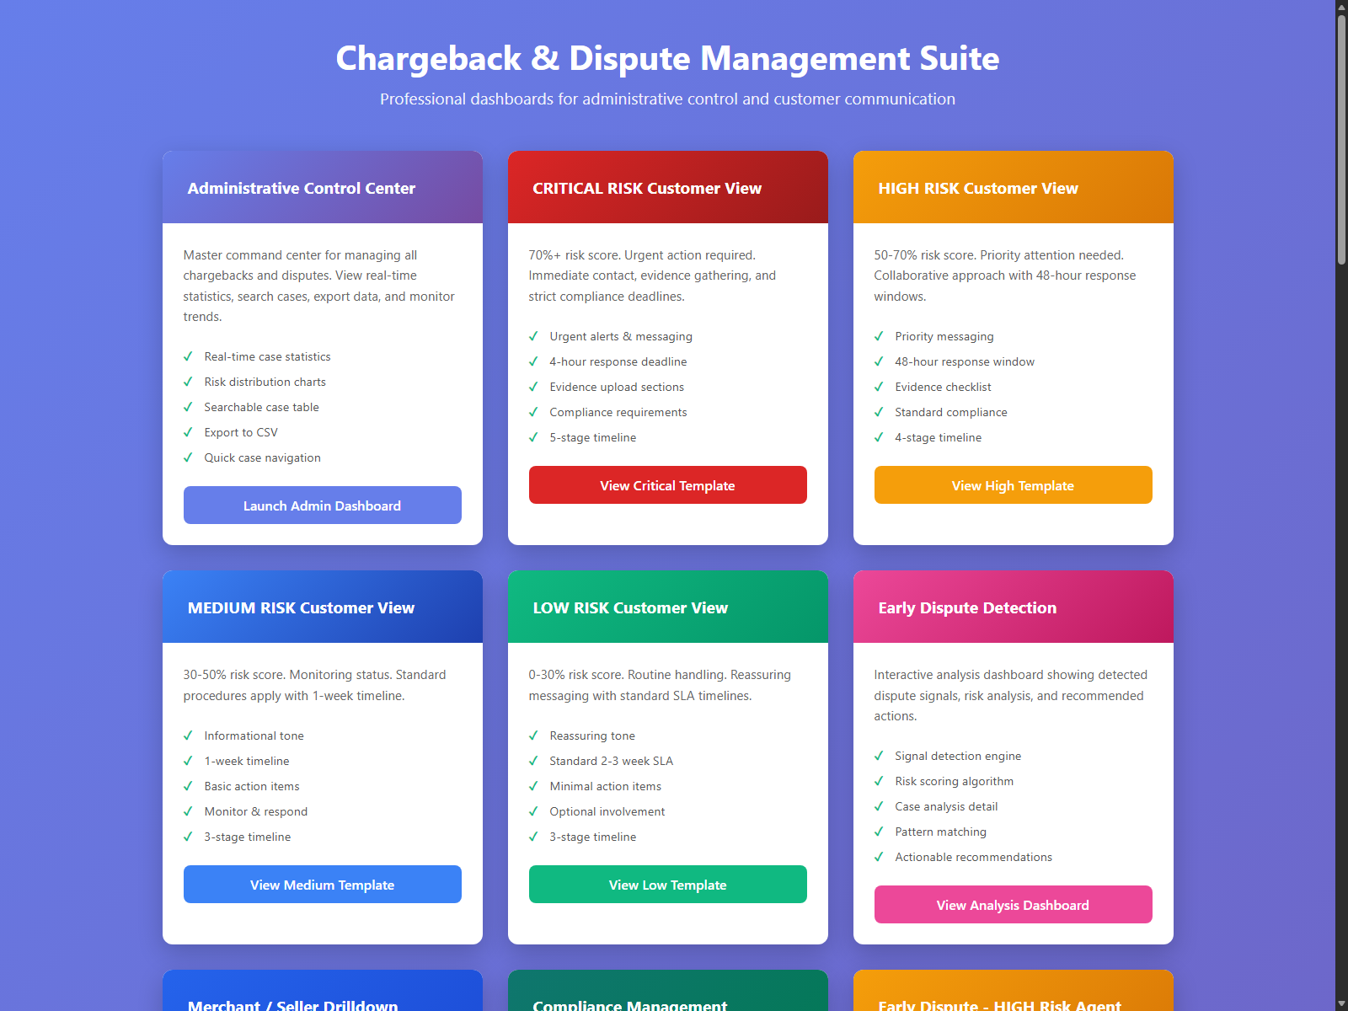

6.2 Merchant Admin Dashboard
Merchant-focused operations view for case workflow, evidence readiness, and issuer simulation.
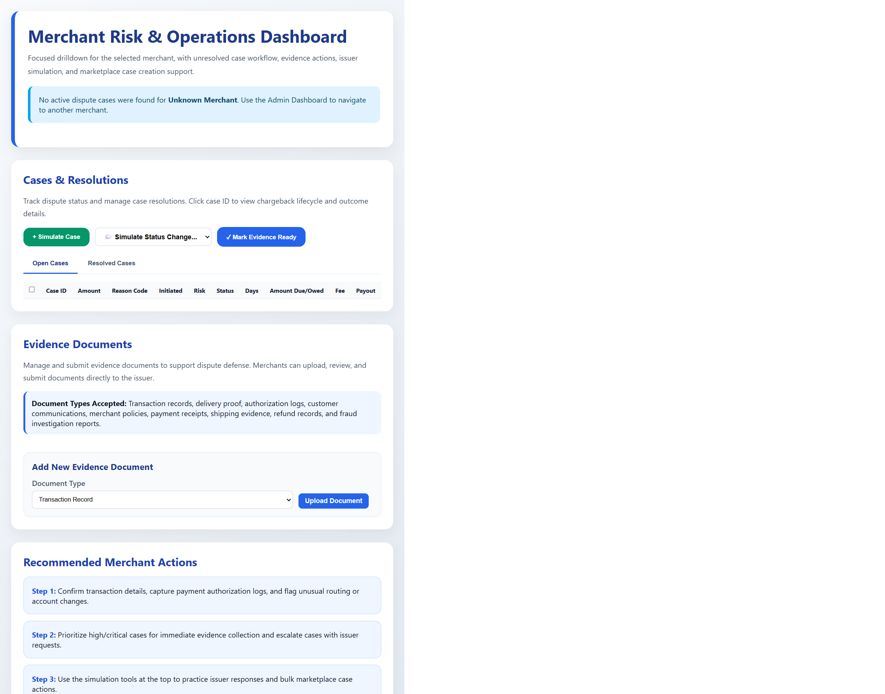

6.3 Early Dispute Detection Dashboard
Risk-ranked detection view with signal traceability and triage guidance.
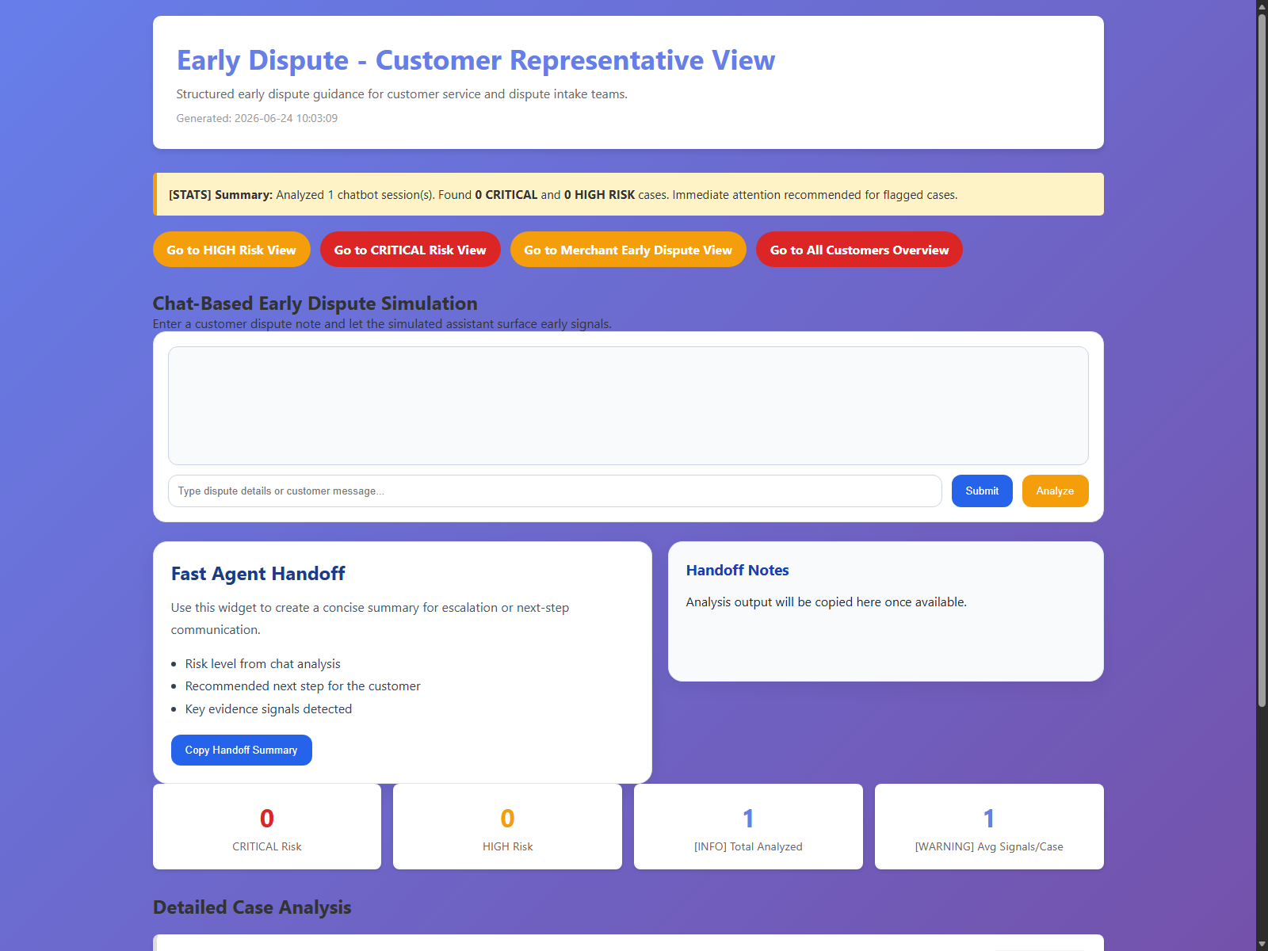

6.4 Resolution Center: Customer
Customer-side actions including notes, evidence, amount context, and decision response.
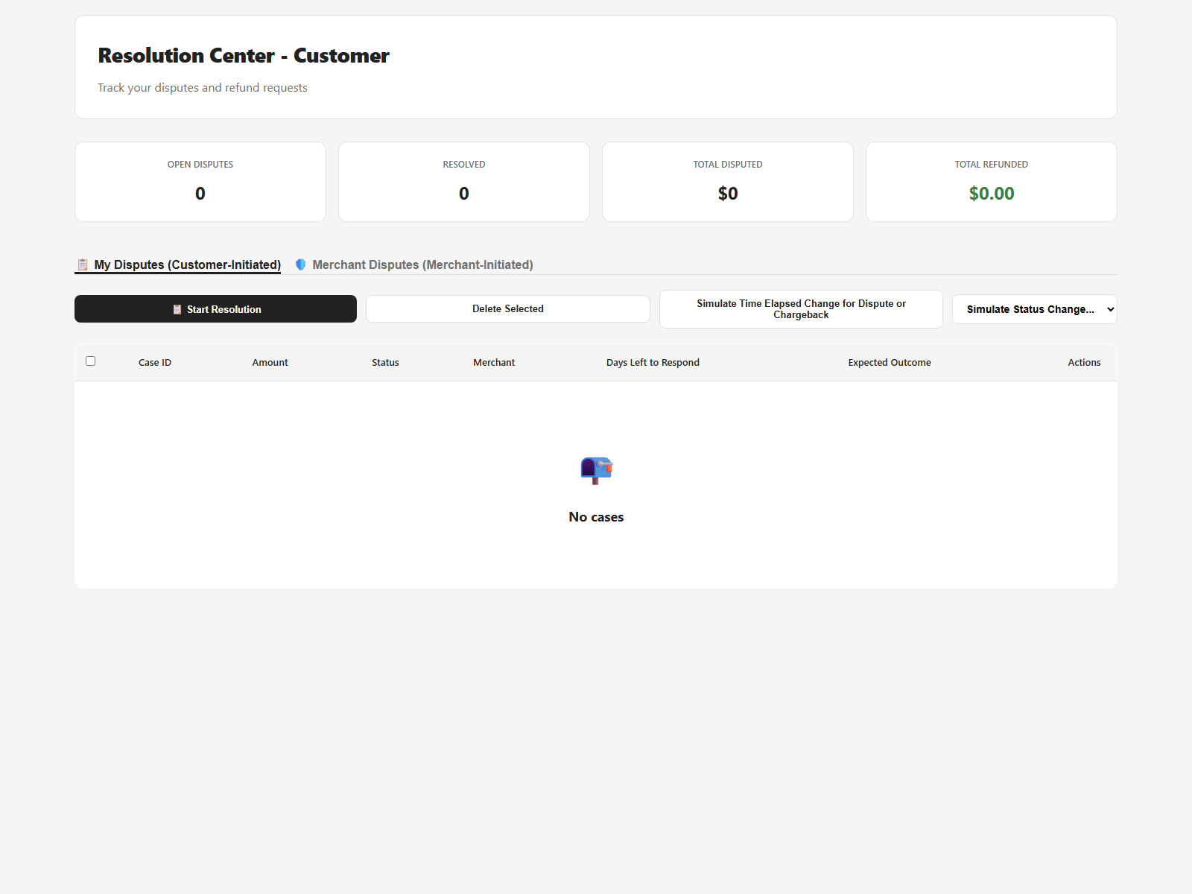

6.5 Resolution Center: Merchant
Merchant-side representment and settlement progression with workflow state tracking.
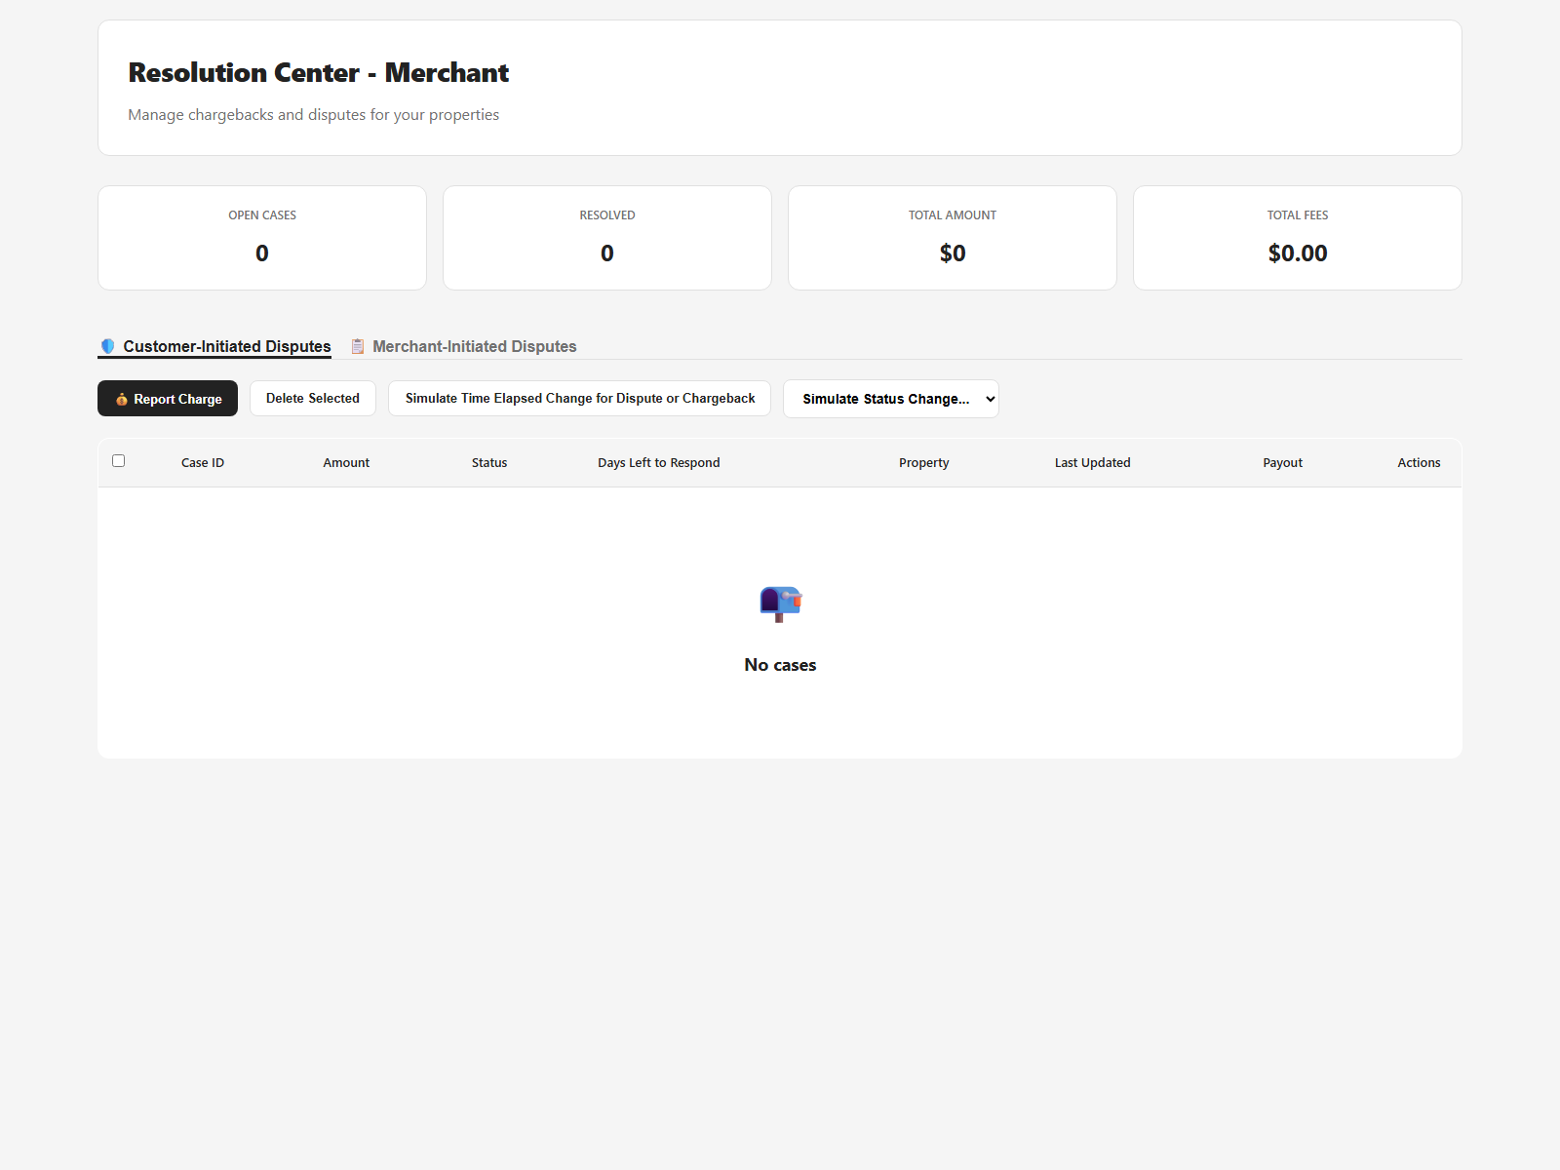

6.6 Workflow Diagram: Agentic Detection Flow
Detection flow from chat input through weighted scoring, risk classification, and outputs.
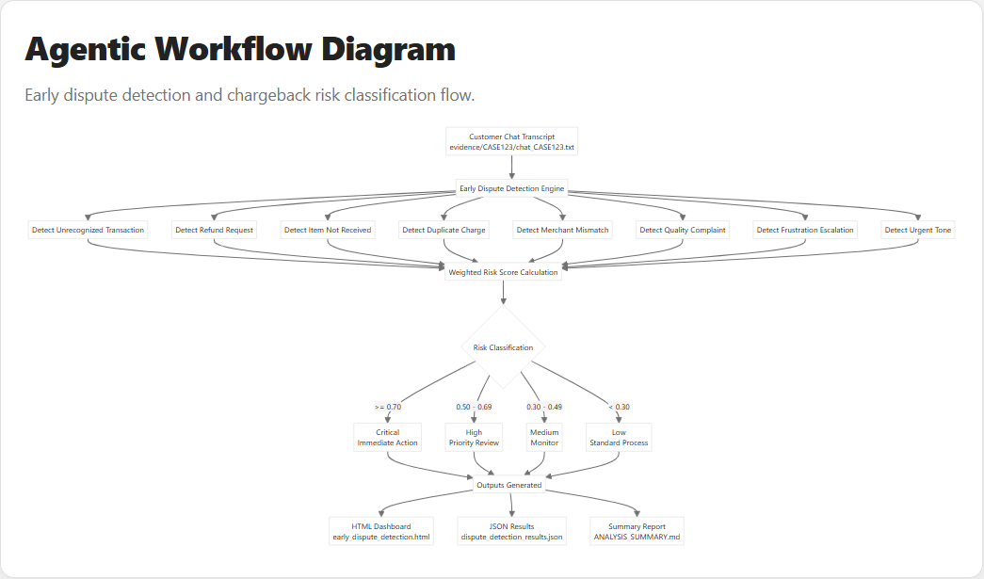

6.7 Workflow Diagram: Agent Loop (LLM + Tools)
Agent-loop decisioning with tool routing, confidence gates, human fallback, and state persistence.
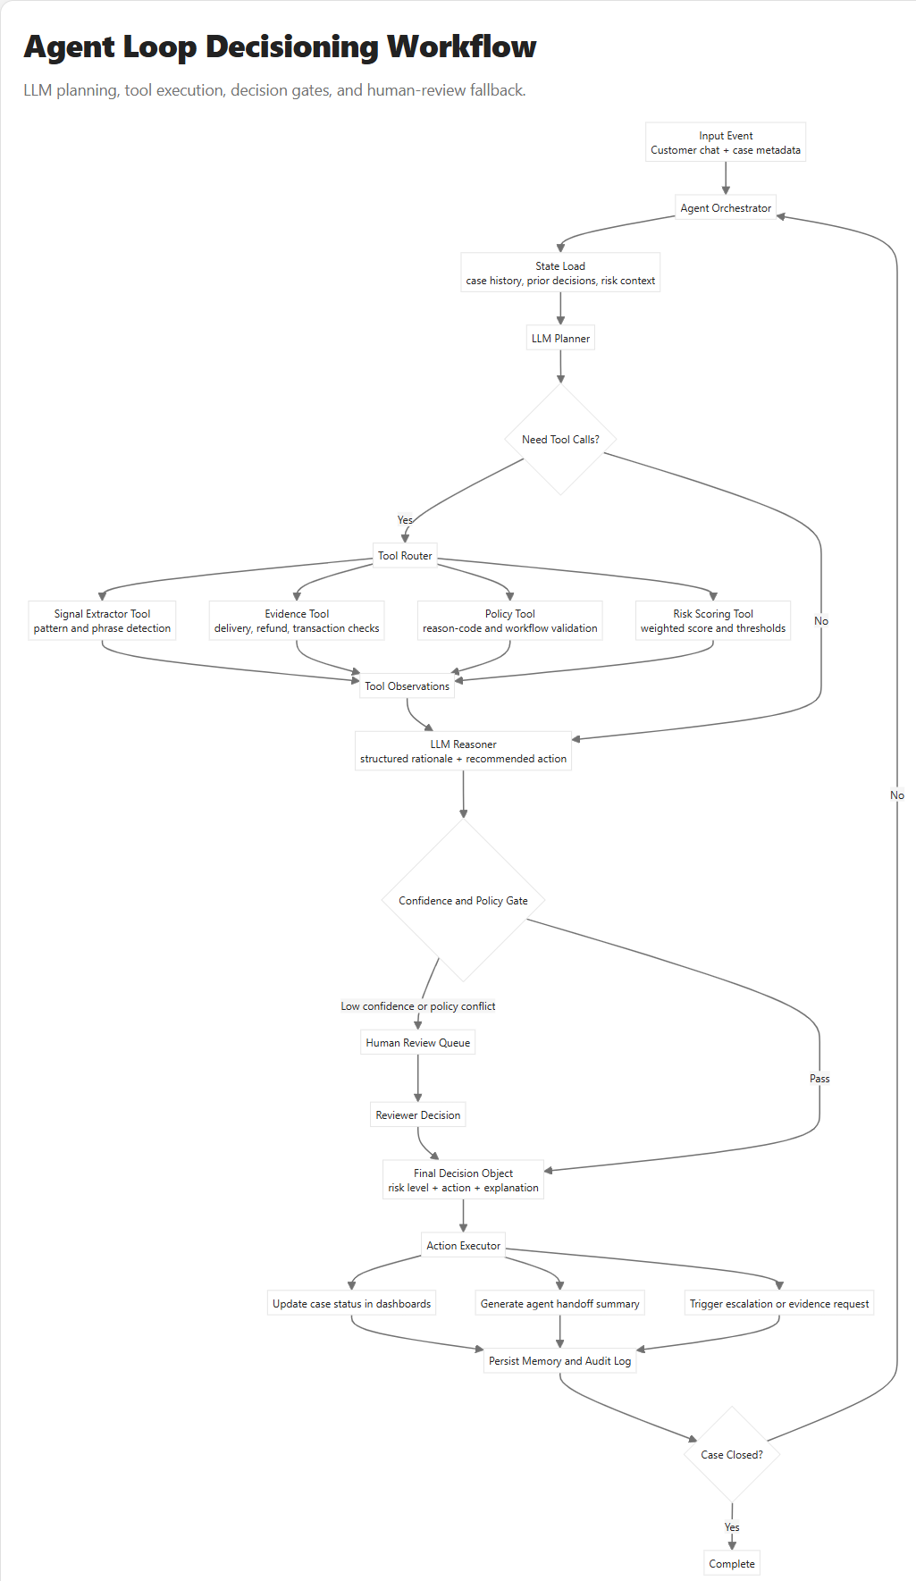

7. Recommended Operating Cadence
- Daily: run analysis and review high/critical cases first.
- Weekly: review trend shifts and false-positive patterns.
- Monthly: tune thresholds, policy mappings, and intervention rules.

