LABO / MAINTAIN PROJECT

HIGH LEVEL SYSTEM ANALYSIS
Output #1 — Existing System Understanding

Project Name | [PROJECT_NAME]
Customer | [CUSTOMER_NAME]
Target System | [WEB / ADMIN / API / OTHER]
Analysis Inputs | Existing Source Code / Running System / Database (if available)
Generated Date | [YYYY/MM/DD]
Version | v0.1

Purpose
This document is the high-level baseline generated after analyzing an existing LABO/Maintain system. The Agent may inspect the running website with Playwright, read the existing source code, and analyze the database schema when database information is available. The output is intended to give the team enough system context to receive and analyze future modification requests.

0. Analysis Scope & Source
Input | Availability | Analysis Method | Notes
Running Website | Yes / No | Playwright navigation, screen/behavior observation | [URL / environment]
Source Code | Yes / No | Repository structure, routes, services, business logic | [Repository / branch]
Database | Yes / No / Optional | Schema, tables, relations, key fields | [DB type / dump / ERD]
Existing Documents | Yes / No | Cross-check existing specifications | [Document list]
Rule: Clearly distinguish Confirmed facts, AI Inference, and Unknown items. Do not present inferred behavior as confirmed.

1. Product Overview
[AI-generated summary: Describe what the product/system does, its target users, core business purpose, main operational context, and the value it provides. Keep this section understandable for a new BrSE/BA/Developer.]

1.1 Target Users / Actors
Actor | Role | Main Usage
End User | [e.g. Customer / Member] | [Main actions]
Administrator | [e.g. Operations staff] | [Manage data / approve / configure]
External System | [e.g. Payment / Email / SSO] | [Integration purpose]

1.2 System Composition
• Frontend: [Framework / main modules / detected routes]
• Backend: [Language / framework / API structure]
• Database: [DB engine / availability]
• External integrations: [Services detected]
• Authentication / authorization: [High-level mechanism]

2. Functional Overview
List the main functions detected from UI behavior, routes, source modules, APIs, and existing documentation. Group functions by business domain rather than by source-code folder only.
Function ID | Module | Function | Primary Actor | Description | Evidence | Status
F-001 | Authentication | Login | User | Authenticate user and create session. | UI + Source | Confirmed
F-002 | User Management | Profile | User | View/update profile information. | UI + API | Confirmed
F-003 | Administration | User Search | Admin | Search and review registered users. | Source only | To verify
F-004 | Notification | Email Notice | System | Send email after a defined business event. | Code inference | Inferred

2.1 Key Business Rules
BR-001: [Rule detected from validation/business logic]
BR-002: [Permission or status transition rule]
BR-003: [Data condition / calculation / restriction]
Unknown: [Items that cannot be confirmed from available inputs]

3. Database Detail
This section is mandatory only when database information is available. If DB access/schema is not provided, state 'Database not available' and list any entities inferred from source code separately.

3.1 Database Summary
DBMS: [MySQL / PostgreSQL / SQL Server / etc.]
Schema/Database: [NAME]
Estimated table count: [N]
Migration/ORM: [Detected technology]
Important notes: [soft delete / audit columns / multi-tenant / encoding / etc.]

3.2 Main Table List
Table | Purpose | Primary Key | Main Foreign Keys | Important Columns | Related Function IDs
users | Stores user accounts | id | - | email, status, created_at | F-001, F-002
profiles | Stores user profile detail | id | user_id → users.id | name, phone, address | F-002
notifications | Stores notification history | id | user_id → users.id | type, sent_at, status | F-004

3.3 Table Detail Sample
Table: users — [Short purpose]
Column | Type | PK | FK | Nullable | Meaning | Source/Confidence
id | BIGINT | Yes | - | No | User identifier | DB schema / High
email | VARCHAR(255) | No | - | No | Login email | DB + Source / High
status | VARCHAR(20) | No | - | No | Account status | Source / Medium
created_at | DATETIME | No | - | No | Created timestamp | DB schema / High

3.4 Main Relationships
users 1 — 1 profiles
users 1 — N notifications
[Add other high-value relationships. For a large DB, keep this high-level document focused on tables relevant to business behavior.]

4. Overall System Flow
Generate a high-level flow from observed UI navigation, source-code behavior, API calls, database interactions, batch processing, and external integrations. Insert the generated PNG below.
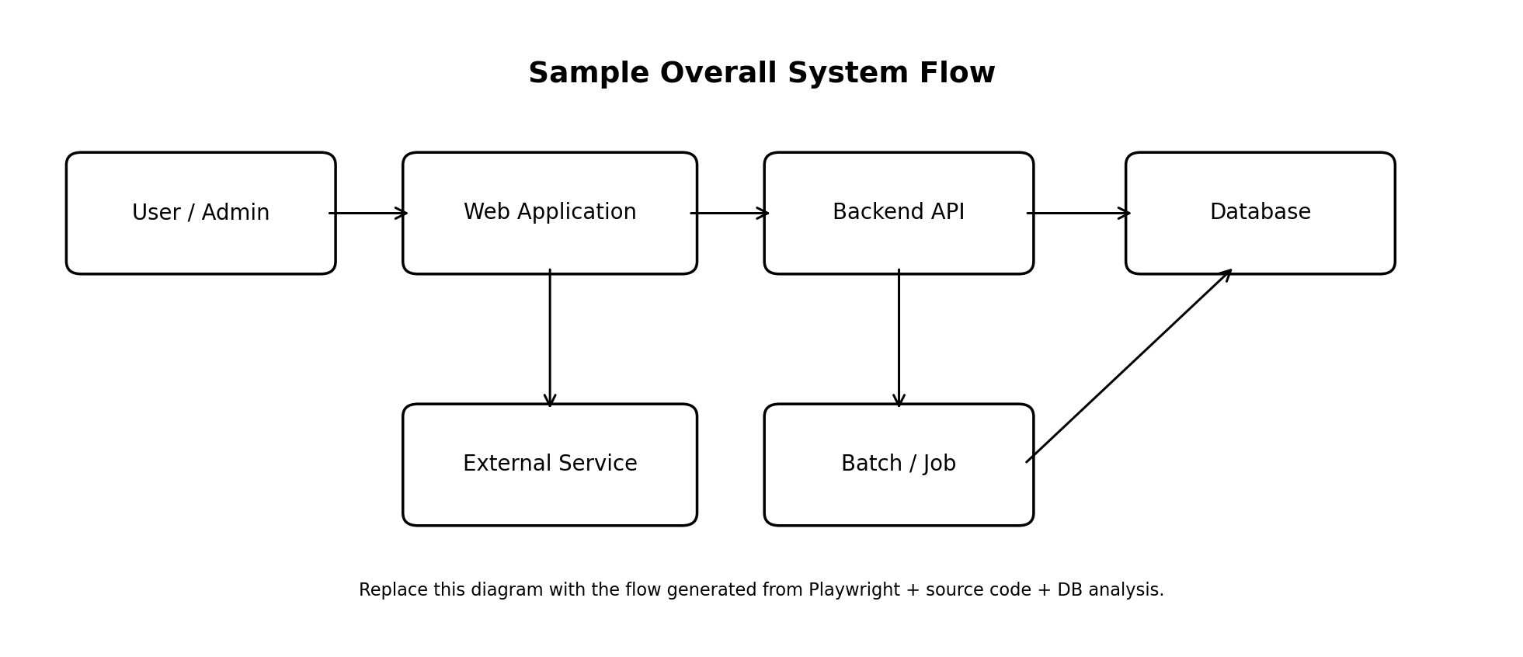
Figure 1. Overall System Flow — Sample

4.1 Flow Explanation
1. User/Admin accesses the Web Application.
2. The Web Application calls Backend APIs for business operations.
3. Backend APIs read/write the Database according to business rules.
4. External services are invoked where required.
5. Batch/Job processing may update data or trigger downstream actions.

Appendix A. AI Analysis Notes / Open Questions
ID | Type | Item | Reason / Evidence | Required Action
Q-001 | Unknown | [Example: exact status transition] | Not observable from UI/source path reviewed | Confirm with customer
Q-002 | Inference | [Example: nightly batch purpose] | Job name and SQL suggest this behavior | Verify with maintainer
Q-003 | Risk | [Example: legacy dependency] | Old package/version detected | Technical investigation

Appendix B. Recommended Generation Rules for the Agent
• Use Playwright to inspect screens, navigation, labels, validation, and observable behavior.
• Read source code to identify routes, modules, APIs, business logic, permissions, jobs, and integrations.
• Read DB schema when available; never invent tables/columns that cannot be confirmed.
• Map functions to evidence and confidence/status.
• Mark unknown or conflicting findings explicitly.
• Keep Output #1 high-level enough for rapid onboarding, but detailed enough to support impact analysis for future modification requests.
• Regenerate/update this baseline when major system structure changes.

