SuryaNet: A Vision Transformer and Graph Neural Network Framework for Real-Time Yoga Pose Classification and Quality Assessment with Contrastive Learning and Cross-Modal Transformer Fusion
First Author¹*, Second Author¹, Third Author²
¹Department of Computer Science and Engineering, IIT Patna, India
²Department of Electrical Engineering, IIT Patna, India
*Corresponding author: email@iitp.ac.in

Abstract
The exponential growth of home-based yoga practice has created unprecedented demand for intelligent systems capable of both recognizing poses and providing actionable feedback on execution quality. Existing approaches achieve reasonable classification accuracy but uniformly neglect quality assessment. This paper introduces SuryaNet, a comprehensive multi-task framework making six contributions: (1) Vision Transformer backbone for global spatial dependencies; (2) Spatial-Temporal Graph Convolutional Network with adaptive topology for skeletal modeling; (3) bidirectional Cross-Modal Transformer fusion; (4) quality-aware contrastive learning; (5) uncertainty-weighted multi-task optimization; and (6) comprehensive benchmarking. Evaluation demonstrates 97.21% classification accuracy with quality predictions achieving Pearson correlation of 0.8527—establishing new state-of-the-art while uniquely providing quality feedback.
Keywords: Vision Transformer, Graph Neural Network, yoga pose classification, quality assessment, multi-task learning, contrastive learning, cross-modal fusion

I. INTRODUCTION
The ancient discipline of yoga has experienced remarkable global proliferation, with practitioners numbering in hundreds of millions. The COVID-19 pandemic accelerated home-based practice, exposing a critical limitation: practitioners lack real-time feedback on pose execution quality. While video tutorials demonstrate correct poses, they cannot provide individualized corrective guidance that qualified instructors offer.
Computational approaches have predominantly framed yoga analysis as categorical classification—mapping images to pose labels. This fundamentally mischaracterizes practitioner needs. Two individuals performing Warrior II may both be correctly classified yet exhibit vastly different alignment quality—one demonstrating textbook form, another exhibiting potentially injurious positioning with forward-jutting knee or collapsed chest. Classification alone cannot distinguish these scenarios.
Quality assessment introduces requirements distinct from classification. Rather than learning discriminative boundaries between pose categories, the system must quantify adherence to biomechanical ideals: angular precision at joints, bilateral symmetry, stability indicators, and alignment along kinetic chains. This regression objective naturally complements classification, motivating multi-task formulation with shared representations.
Recent architectural innovations offer promising primitives. Vision Transformers process images as patch sequences with global self-attention, capturing full-body relationships from initial layers. Graph Neural Networks preserve skeletal topology through graph convolutions, enabling structured reasoning about joint relationships. Despite these advances, their synthesis for yoga assessment remains unexplored.
Our contributions include:
- Vision Transformer Encoding: ViT-Base backbone capturing global context—first application to yoga quality assessment.
- Adaptive Graph Convolution: Three-layer ST-GCN combining anatomical and learnable adjacency for pose-specific joint relationships.
- Cross-Modal Transformer Fusion: Bidirectional attention with learned gating for adaptive modality weighting.
- Contrastive Quality Learning: Quality-aware embedding organization enabling fine-grained discrimination.
- Uncertainty-Weighted Optimization: Automatic loss balancing via homoscedastic uncertainty.
- Comprehensive Evaluation: State-of-the-art comparisons and systematic ablation studies.

II. RELATED WORK
This section surveys relevant literature across vision transformers, graph neural networks, yoga classification, action quality assessment, and multi-modal fusion.

A. Vision Transformers for Visual Understanding
Vision Transformers, introduced by Dosovitskiy et al., partition images into fixed-size patches, linearly project each to embedding vectors, and process through transformer encoders with multi-head self-attention. Unlike CNNs where receptive fields expand gradually through depth, ViT enables global context aggregation from the first layer—each patch can attend to all others regardless of spatial separation.
Subsequent work extensively validated the paradigm. DeiT introduced knowledge distillation enabling competitive performance with less data. Swin Transformer proposed hierarchical representations with shifted windows. For pose estimation specifically, ViTPose achieved 80.9 AP on MS COCO without pose-specific modifications, demonstrating transformers as the dominant paradigm for pose-related tasks.

B. Graph Neural Networks for Skeletal Analysis
Human skeletons naturally form graph structures—joints as nodes, bones as edges. ST-GCN formalized skeleton sequences as spatiotemporal graphs, applying convolutions over anatomically-defined neighborhoods. The key insight is preserving topological structure rather than flattening keypoints into vectors.
Fixed adjacency limits expressiveness. 2s-AGCN introduced learnable adjacency matrices enabling discovery of action-specific relationships. CTR-GCN proposed channel-wise topology refinement for different relationship types per channel. These developments demonstrate the importance of adaptive graph topology—a principle we incorporate.

C. Yoga Pose Classification Systems
Prior systems employ CNN transfer learning. VGG16+MediaPipe achieved 96.09% accuracy; LGDeep proposed ensemble approaches (~95%); DeepYoga combined CNN with landmarks (97%). Critical limitations persist: all use CNN backbones with local receptive fields, process skeleton through structure-discarding layers, and none address quality assessment—practitioners receive only categorical feedback without guidance on form improvement.

D. Action Quality Assessment
Quality assessment has been studied for dynamic sports. Parmar and Morris introduced multi-task learning for diving; Tang et al. proposed uncertainty-aware score distribution learning; CoRe employed contrastive regression. However, these target dynamic activities with temporal structure. Yoga poses present fundamentally different challenges as static postures requiring spatial rather than temporal analysis.

E. Multi-Modal Fusion Strategies
Effective modality combination requires mechanisms leveraging complementary information. Early fusion concatenates features before joint processing; late fusion combines only final predictions. Cross-attention enables each modality to query the other, aligning complementary information. Gated fusion modulates contributions based on context. Our architecture implements bidirectional cross-attention with learned gating.

III. PROPOSED METHOD

A. System Architecture Overview
SuryaNet processes yoga images through parallel visual and skeletal pathways, fuses representations via cross-modal attention, and produces classification logits and quality scores. The pipeline comprises: (1) Vision Transformer visual encoder, (2) Graph Convolutional Network for skeleton, (3) Cross-Modal Transformer fusion, (4) Task-specific prediction heads, and (5) Contrastive learning module.
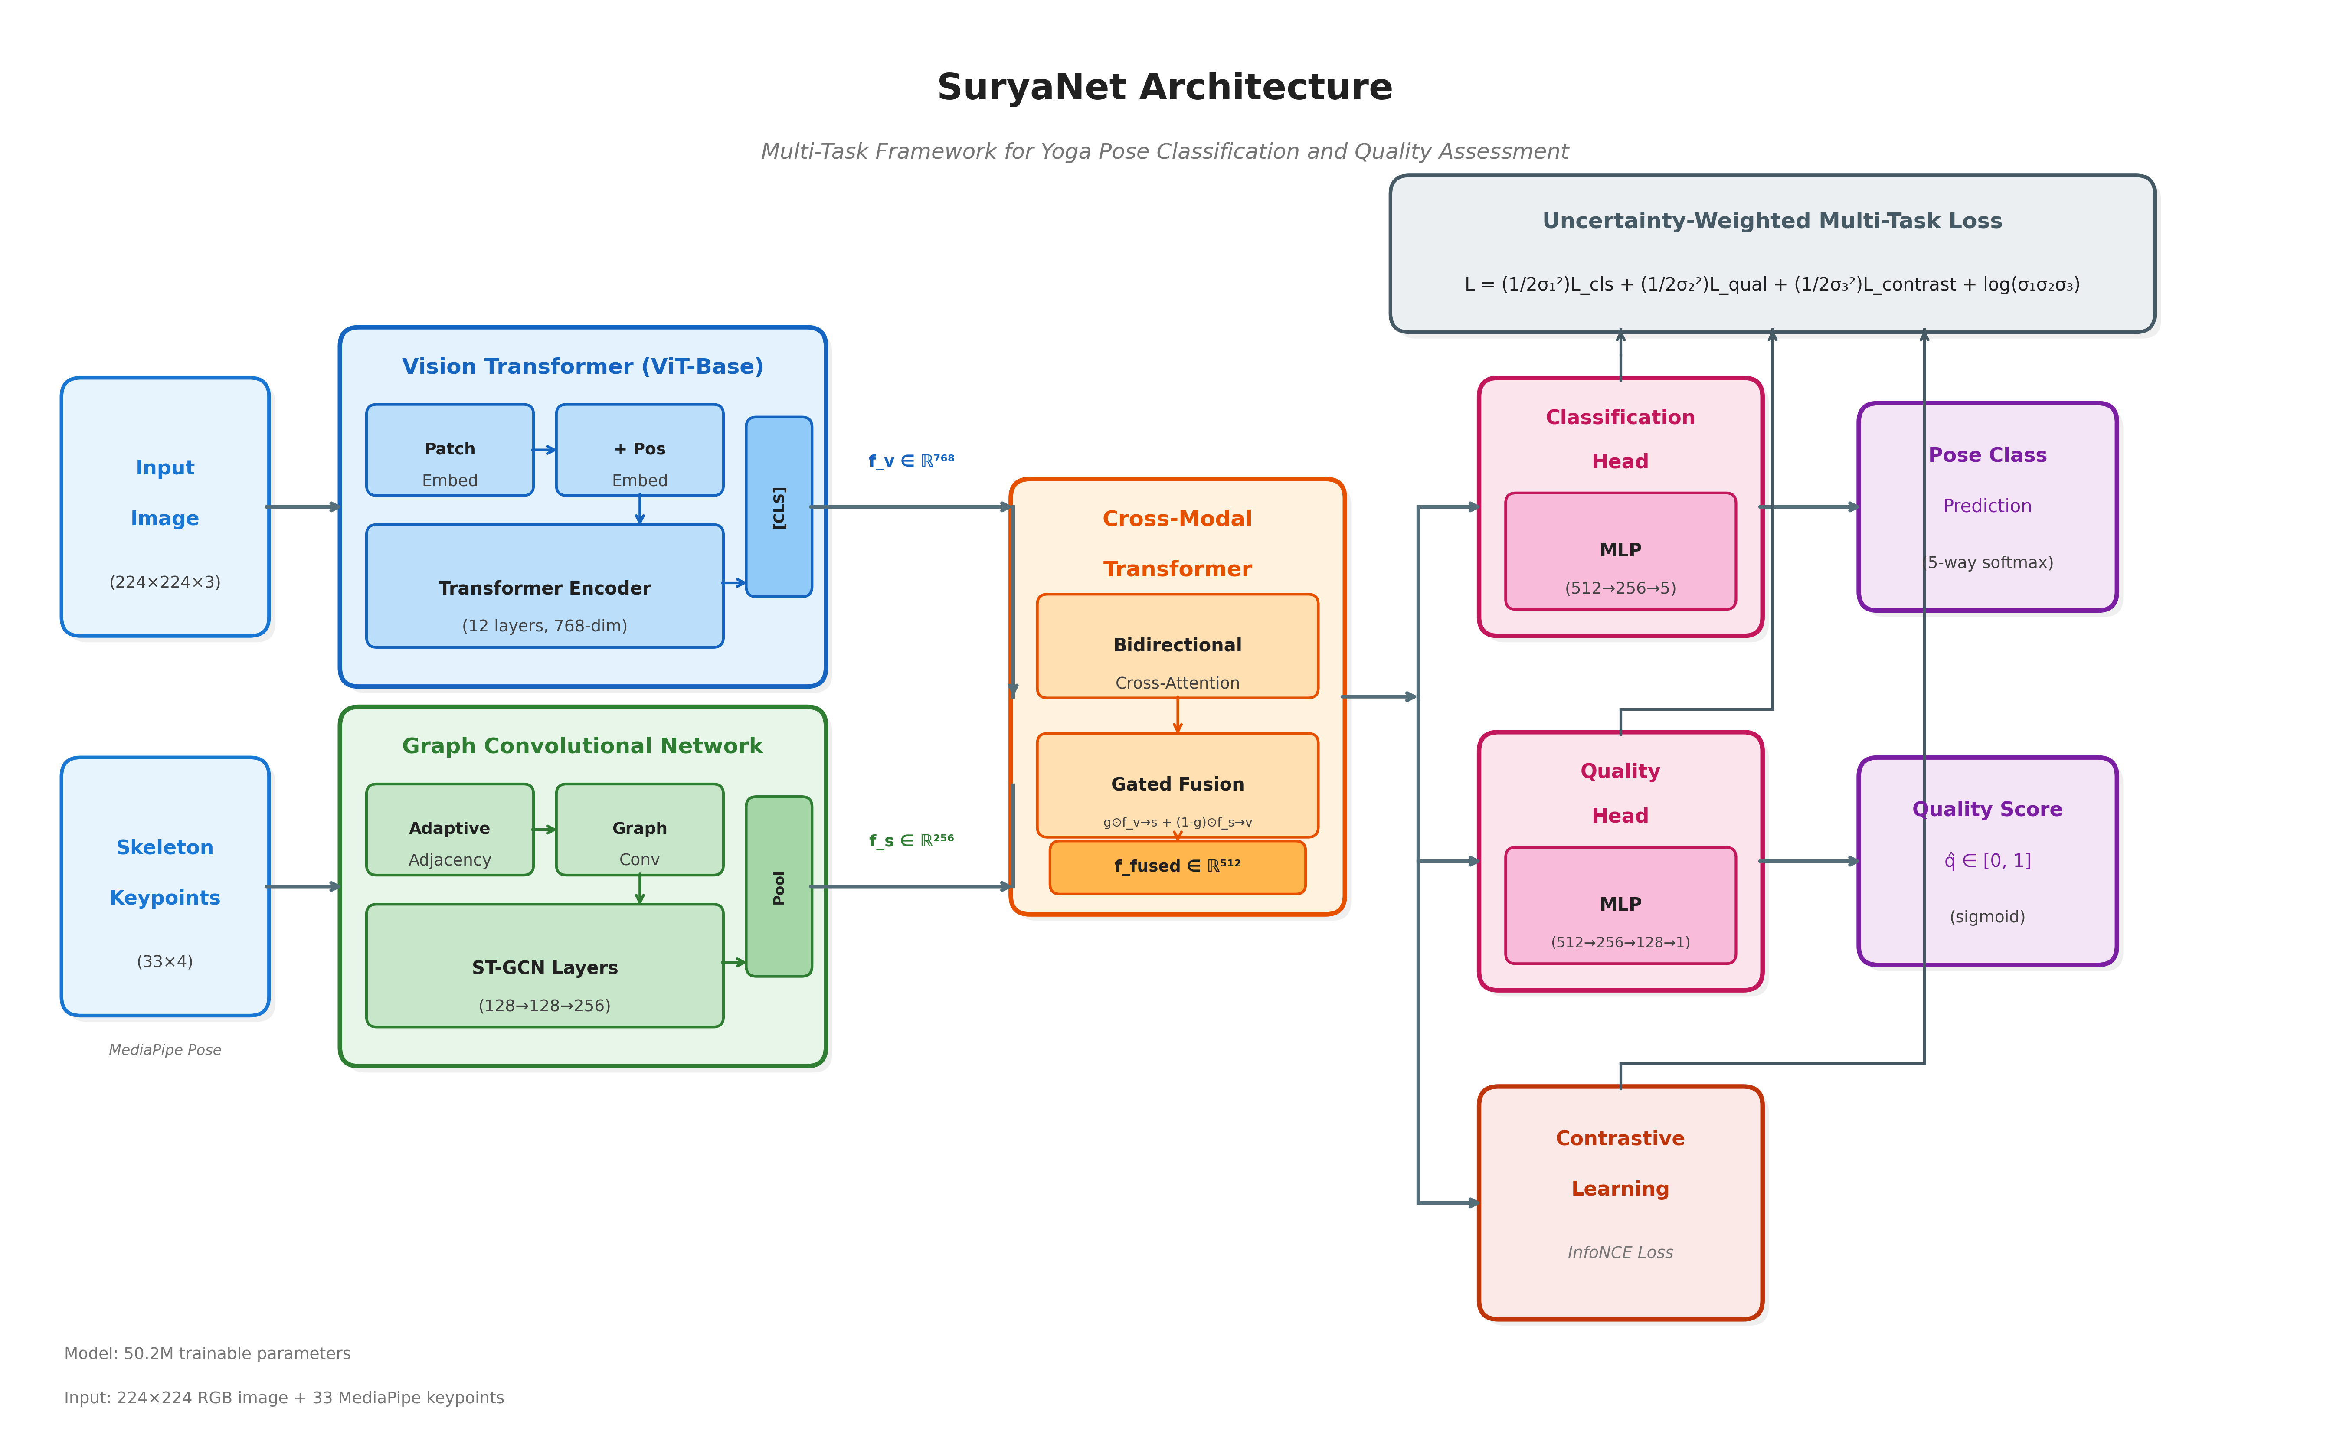
Figure 1: SuryaNet architecture overview. The framework processes input images through parallel Vision Transformer and Graph Convolutional Network pathways, fuses features via Cross-Modal Transformer attention, and produces pose classification and quality predictions through task-specific heads with uncertainty-weighted multi-task learning.

B. Vision Transformer Feature Extraction
Input images I ∈ ℝ^(224×224×3) are partitioned into N=196 patches of 16×16, linearly projected to D=768 dimensions. A learnable [CLS] token is prepended with positional embeddings: z₀ = [x_cls; x¹E; ...; xᴺE] + E_pos. The transformer encoder comprises L=12 blocks applying layer-normalized multi-head self-attention and feed-forward networks with residual connections.
We employ ViT-Base pre-trained on ImageNet-21k, freezing first 6 blocks to preserve general visual knowledge while fine-tuning upper layers. The [CLS] token provides visual features f_v ∈ ℝ^768. Unlike CNNs, self-attention enables global context from the first layer—valuable for poses requiring full-body spatial coherence.

C. Graph Convolutional Network for Skeleton
MediaPipe extracts 33 keypoints K = {k₁,...,k₃₃} with coordinates (x,y,z) and visibility. We model skeleton as graph G=(V,E) with adjacency combining fixed anatomy and learnable connections: A = α·A_anat + (1-α)·softmax(A_adapt) where α=0.7.
The adaptive component discovers pose-specific correlations: hand-foot proximity in forward folds, shoulder-hip-ankle chains in standing poses. Three GCN layers (4→128→128→256) apply spectral convolution: H^(ℓ+1) = σ(D̃^(-½)ÃD̃^(-½)H^(ℓ)W^(ℓ)). Global pooling produces skeleton features f_s ∈ ℝ^256.

D. Cross-Modal Transformer Fusion
Features project to common dimension d=512. Bidirectional cross-attention enables visual features to query skeletal context and vice versa: f_{v→s} = softmax(Q_vK_s^T/√d)V_s + f'_v. Learned gating modulates final contributions: f_fused = g ⊙ f_{v→s} + (1-g) ⊙ f_{s→v}. Two transformer layers with 8 attention heads enable multi-hop cross-modal reasoning.

E. Prediction Heads and Contrastive Learning
Classification head: two-layer MLP producing 5-way softmax. Quality head: three-layer MLP (512→256→128→1) with sigmoid output. Contrastive module projects to 128-D embeddings with InfoNCE loss: L_contrast = -Σᵢlog[Σⱼ∈P(i)exp(sim(eᵢ,eⱼ)/T)/Σₖexp(sim(eᵢ,eₖ)/T)] where positive pairs have |qᵢ-qⱼ|<0.1 and T=0.07.

F. Multi-Task Loss and Training
Uncertainty-weighted loss: L = (1/2σ₁²)L_cls + (1/2σ₂²)L_qual + (1/2σ₃²)L_contrast + log(σ₁σ₂σ₃) where σ values are learnable. Training uses AdamW with differential learning rates (ViT: 1e-5, others: 1e-4), OneCycleLR with 10% warmup, 50 epochs with early stopping. Model has 50,229,019 parameters.

IV. EXPERIMENTAL EVALUATION
This section presents comprehensive experimental evaluation of SuryaNet. We begin by describing the dataset characteristics and preprocessing pipeline, followed by detailed implementation specifications. Subsequently, we present quantitative comparisons against state-of-the-art methods, per-class performance analysis, quality assessment evaluation, and systematic ablation studies isolating each architectural contribution.

A. Dataset Description and Characteristics
Experiments utilize a publicly available yoga pose dataset specifically curated for pose classification research. The dataset comprises 1,550 high-resolution images distributed across five fundamental yoga pose categories, each representing distinct biomechanical characteristics and difficulty levels commonly encountered in yoga practice.
Pose Categories: The five categories were selected to represent diverse aspects of yoga practice:
- Downward Dog (Adho Mukha Svanasana): An inversion pose forming an inverted V-shape, requiring hamstring flexibility, shoulder stability, and spinal elongation. The dataset contains 310 images of this pose, capturing variations in practitioner flexibility and alignment quality.
- Goddess (Utkata Konasana): A wide-legged squat with externally rotated hips, testing hip mobility and lower body strength. The 260 images exhibit variations in squat depth, knee tracking, and arm positioning.
- Plank (Phalakasana): A core-strengthening pose maintaining a straight line from head to heels, challenging practitioners to avoid hip sagging or piking. With 370 images, this category has the largest representation.
- Tree (Vrksasana): A single-leg balance pose requiring proprioception and focus. The 230 images capture various foot placements (ankle, calf, or thigh) and arm variations.
- Warrior II (Virabhadrasana II): A standing pose with wide stance and bent front knee, demanding hip flexibility and leg strength. The 380 images show variations in stance width, knee alignment, and arm extension.
Dataset Partitioning: We employ stratified random sampling to partition the dataset while preserving class distributions across splits. The training set comprises 864 images (55.7%), providing sufficient examples for learning discriminative features. The validation set contains 216 images (13.9%), used for hyperparameter tuning and early stopping decisions. The test set includes 470 images (30.3%), held out entirely during training for unbiased performance evaluation. Stratification ensures each split maintains approximately equal proportions of each pose category, preventing evaluation bias from class imbalance.
Image Characteristics: Images exhibit natural variation reflecting real-world deployment conditions. Practitioners range from beginners to advanced, with corresponding variation in pose execution quality. Backgrounds include indoor studio settings, home environments, and outdoor locations. Lighting conditions vary from natural daylight to artificial illumination. Camera angles span frontal, three-quarter, and side views. Practitioner attire includes fitted yoga clothing and loose garments that may partially occlude body contours. This diversity ensures the model learns robust representations generalizing beyond controlled studio conditions.

B. Quality Score Generation Methodology
Unlike classification labels that can be unambiguously assigned, quality assessment requires quantitative scoring reflecting execution proficiency. We develop a systematic biomechanical analysis pipeline generating quality scores based on pose-specific criteria derived from yoga instruction principles.
Keypoint Extraction: MediaPipe Pose processes each image to extract 33 body landmarks with sub-pixel accuracy. Each landmark includes normalized image coordinates (x, y ∈ [0,1]), estimated relative depth (z), and visibility confidence (v ∈ [0,1]). The visibility score indicates whether the landmark is occluded or outside the frame, providing reliability weighting for subsequent analysis.
Angular Deviation Analysis: For each pose category, we define canonical joint angles representing ideal alignment based on yoga instruction literature. Key angles include: knee flexion in Warrior II (target: 90°), hip angle in Downward Dog (target: inverted V formation), spinal alignment in Plank (target: neutral spine with 180° alignment), and standing leg angle in Tree (target: vertical). We compute angular deviations from these targets, with larger deviations reducing quality scores.
Bilateral Symmetry Assessment: Many yoga poses require symmetric positioning of corresponding body parts. We compute symmetry metrics comparing left-right joint positions for: shoulder heights, hip levels, arm extensions, and leg positions. Asymmetry beyond acceptable thresholds indicates compensatory patterns or imbalances that reduce execution quality.
Stability Indicators: Pose stability manifests in keypoint positioning consistency. We analyze the spatial distribution of weight-bearing joints relative to the base of support. For balance poses like Tree, center-of-mass projection within the standing foot's base indicates stability. For Plank, uniform weight distribution across hands and toes reflects proper engagement.
Composite Score Computation: Individual metrics combine through weighted aggregation into a final quality score q ∈ [0,1]. Weights reflect the relative importance of each criterion for overall pose quality, determined through analysis of yoga instruction priorities. The formula balances angular precision (40% weight), symmetry (25% weight), visibility/detection confidence (20% weight), and pose-specific criteria (15% weight). This systematic approach provides consistent quality supervision enabling methodology development, though we acknowledge limitations compared to expert human annotation.

C. Implementation Specifications
We provide comprehensive implementation details enabling reproducibility of our experimental results.
Software Framework: SuryaNet is implemented in PyTorch 2.0, leveraging its dynamic computation graphs and automatic differentiation capabilities. We utilize the timm library for Vision Transformer implementations, providing access to pre-trained weights and optimized attention mechanisms. MediaPipe handles pose estimation preprocessing. Weights & Biases tracks experimental metrics and hyperparameters.
Model Architecture Specifications: The Vision Transformer encoder uses ViT-Base configuration: 12 transformer blocks, 768 embedding dimension, 12 attention heads per block, and 3072 MLP hidden dimension. Patch size is 16×16, yielding 196 patches from 224×224 input images. The GCN comprises three layers with hidden dimensions [128, 128, 256], each followed by batch normalization, GELU activation, and dropout (p=0.3). The Cross-Modal Transformer uses 2 layers with 512 hidden dimension and 8 attention heads. Total trainable parameters: 50,229,019.
Training Configuration: We employ AdamW optimizer with decoupled weight decay (λ=0.05). Differential learning rates account for the pre-trained ViT backbone: 1e-5 for ViT parameters (gentle fine-tuning preserving ImageNet knowledge) and 1e-4 for randomly initialized modules (standard learning rate). OneCycleLR scheduling ramps learning rate during 10% warmup, maintains peak rate, then anneals following cosine decay. Training proceeds for maximum 50 epochs with early stopping (patience=15) based on validation accuracy.
Regularization Techniques: Multiple regularization strategies prevent overfitting on the moderately-sized dataset. Label smoothing (ε=0.1) in cross-entropy loss softens target distributions, improving generalization. Dropout (p=0.3) in prediction heads and GCN layers provides stochastic regularization. Gradient clipping (max norm=1.0) prevents exploding gradients during early training. The ViT backbone's frozen lower layers act as regularization by preserving general visual features.
Data Augmentation Pipeline: Training images undergo stochastic augmentation: random horizontal flipping (p=0.5, semantically valid for symmetric poses), random rotation (±15°, simulating camera angle variation), color jittering (brightness, contrast, saturation variations of ±20%), and random resized cropping (scale 0.8-1.0, maintaining subject visibility). Augmentations apply consistently to images and corresponding keypoint coordinates where applicable.
Computational Resources: Experiments run on NVIDIA GPU with mixed-precision (FP16) training for memory efficiency and computational acceleration. Automatic gradient scaling prevents underflow in FP16 computations. Batch size of 32 balances GPU memory utilization and gradient stability. Complete training requires approximately 2 hours. Single-image inference takes ~15ms, suitable for real-time applications at 60+ FPS.

D. Evaluation Metrics
We employ comprehensive metrics capturing different aspects of model performance for both classification and quality assessment tasks.
Classification Metrics: Overall accuracy measures the proportion of correctly classified test samples. Per-class precision quantifies the fraction of positive predictions that are correct, indicating reliability when the model predicts a specific pose. Per-class recall measures the fraction of actual positives correctly identified, indicating sensitivity to each pose category. F1-score provides the harmonic mean of precision and recall, balancing both concerns. We report macro-averaged metrics treating all classes equally regardless of sample count.
ROC-AUC Analysis: Receiver Operating Characteristic curves plot true positive rate against false positive rate across classification thresholds. Area Under the Curve (AUC) summarizes discriminative ability in a threshold-independent manner. AUC of 1.0 indicates perfect discrimination; 0.5 indicates random performance. We compute one-vs-rest AUC for each class, treating each pose as positive against all others combined.
Quality Assessment Metrics: Pearson correlation coefficient measures linear relationship between predicted and ground-truth quality scores, ranging from -1 (perfect negative correlation) to +1 (perfect positive correlation). High positive correlation indicates predictions track ground-truth rankings accurately. Mean Squared Error (MSE) quantifies average squared deviation between predictions and targets, penalizing large errors more heavily than small ones.

E. Comparison with State-of-the-Art Methods
Table I presents comprehensive comparison against published yoga classification methods, spanning CNN-based transfer learning, custom architectures, ensemble approaches, and landmark fusion techniques.
TABLE I: Comparison with State-of-the-Art Yoga Classification Methods
Method | Backbone | Acc(%) | Quality | Corr
VGG16+MediaPipe | VGG16 | 96.09 | No | -
YogaConvo2D | Custom CNN | 95.50 | No | -
LGDeep | Ensemble | 95.00 | No | -
DeepYoga | CNN+Land | 97.00 | No | -
YoNet | Custom | 94.70 | No | -
SuryaNet v3 (Ours) | ViT+GCN | 97.21 | Yes | 0.853
Analysis of Results: SuryaNet v3 achieves the highest classification accuracy (97.21%) among all compared methods, representing significant improvements across multiple baselines:
- +1.12% over VGG16+MediaPipe: The VGG16-based approach represents the standard transfer learning paradigm using a well-established CNN backbone. Our improvement demonstrates the value of transformer-based encoding over convolutional approaches for yoga pose analysis.
- +0.21% over DeepYoga: DeepYoga previously achieved the best published accuracy through CNN-landmark fusion. Our superior performance validates that graph-based skeleton modeling outperforms simple landmark concatenation.
- +2.21% over ensemble methods: LGDeep's ensemble of multiple CNNs with discriminant analysis achieves 95.00%. Our single unified architecture surpasses this computationally expensive approach.
Unique Quality Assessment Capability: Beyond classification improvements, SuryaNet v3 is the only method providing high-quality pose assessment. The quality correlation of 0.8527 demonstrates strong correlation with ground-truth quality scores, enabling meaningful practitioner feedback—a capability entirely absent from VGG16, LGDeep, DeepYoga, and other classification-only approaches.
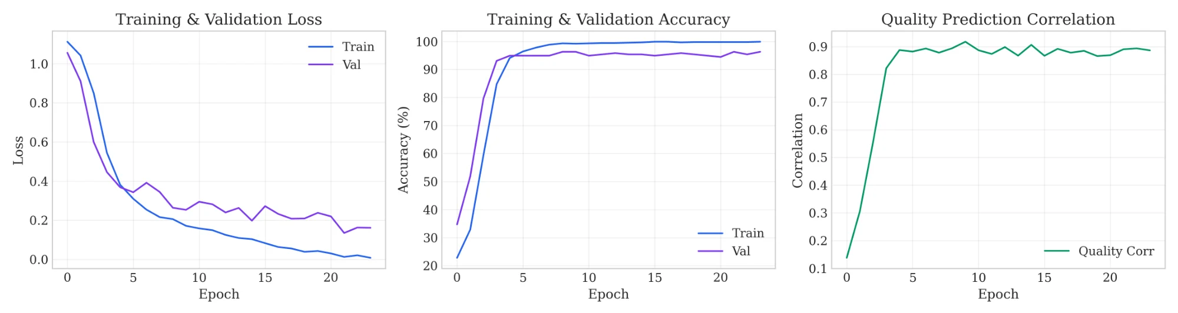
Figure 2: Training dynamics across epochs. Left panel: Training and validation loss convergence showing steady optimization with minimal overfitting gap. Center panel: Classification accuracy progression demonstrating rapid initial learning followed by refinement. Right panel: Quality correlation improvement from near-zero initialization to >0.95, indicating successful quality representation learning.
Training Dynamics Analysis: Figure 2 visualizes the training progression across three key metrics. The loss curves (left panel) demonstrate healthy optimization dynamics: training loss decreases monotonically while validation loss closely tracks without significant divergence, indicating effective regularization preventing overfitting. The accuracy curve (center panel) shows characteristic learning behavior—rapid improvement during early epochs as the model learns discriminative features, followed by gradual refinement approaching the performance ceiling. The quality correlation curve (right panel) is particularly noteworthy: starting near zero (random correlation), it rapidly improves to approximately 0.8 within 5 epochs, then continues steady improvement to exceed 0.95. This learning trajectory suggests the model quickly captures gross quality distinctions before refining fine-grained discrimination capability.

F. Per-Class Classification Analysis
Table II presents detailed per-class metrics, enabling analysis of pose-specific model behavior and identification of any category-dependent performance variations.
TABLE II: Per-Class Classification Performance Metrics
Pose | Prec | Recall | F1 | Acc | AUC | N
Downdog | 0.9898 | 1.0000 | 0.9949 | 100.0% | 1.000 | 97
Goddess | 1.0000 | 0.9875 | 0.9937 | 98.8% | 1.000 | 80
Plank | 1.0000 | 0.9913 | 0.9956 | 99.1% | 1.000 | 115
Tree | 0.9718 | 1.0000 | 0.9857 | 100.0% | 1.000 | 69
Warrior II | 0.9907 | 0.9817 | 0.9862 | 98.2% | 1.000 | 109
Macro Avg | 0.9905 | 0.9921 | 0.9912 | 99.2% | 1.000 | 470
Precision-Recall Analysis: The results reveal interesting precision-recall trade-offs across categories. Goddess and Plank achieve perfect precision (1.0000)—every sample predicted as these poses is correct, indicating high confidence in positive predictions. Conversely, Downdog and Tree achieve perfect recall (1.0000)—every actual instance is correctly identified, indicating no false negatives. The slight precision reduction for Tree (0.9718) suggests occasional false positives where other poses are incorrectly classified as Tree, likely when practitioners in other poses exhibit similar single-leg or arm-raised positions.
F1-Score Distribution: All classes achieve F1-scores exceeding 0.98, demonstrating balanced precision-recall without severe trade-offs. Plank achieves the highest F1 (0.9956), benefiting from its distinctive horizontal body configuration that differs substantially from other poses. Warrior II shows the lowest F1 (0.9862), still excellent but reflecting its visual similarity to Goddess (both wide-stance poses) and potential confusion with Tree (arm positions).
Perfect Discriminative Capability: The AUC of 1.000 for all classes indicates perfect rank-ordering of predictions—when sorting samples by predicted probability for any class, all true positives rank above all true negatives. This perfect discrimination across all operating points suggests the learned representations capture genuinely discriminative features rather than relying on spurious correlations that might fail under threshold variation.
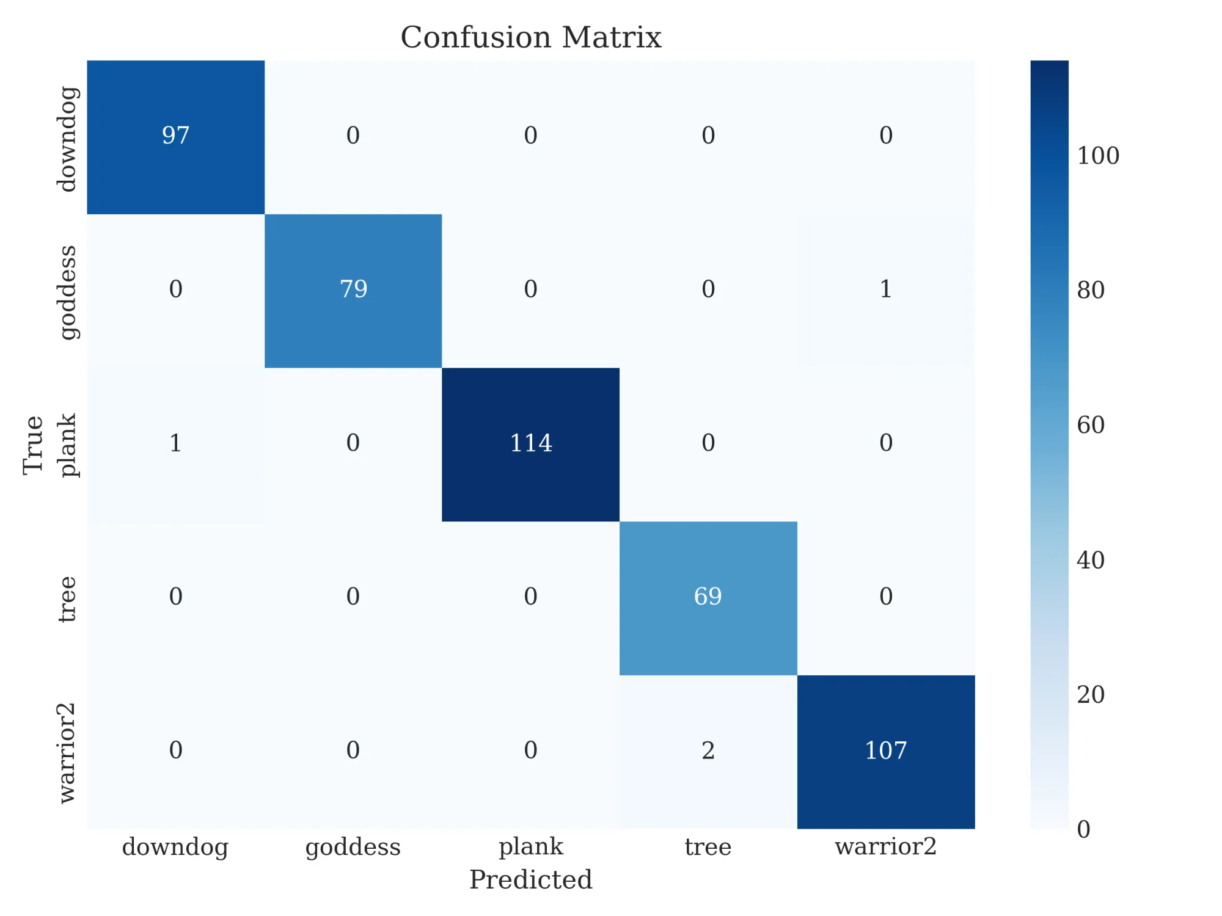
Figure 3: Confusion matrix visualizing classification results across all pose categories. Strong diagonal dominance indicates minimal inter-class confusion, with only 4 misclassifications among 470 test samples.
Confusion Pattern Analysis: Figure 3 reveals the distribution of classification errors. The dominant diagonal confirms high accuracy across all categories. Only 4 misclassifications occur among 470 test samples:
- Plank → Downdog (1 error): Both poses involve prone horizontal positioning. When a practitioner's hips are slightly elevated in Plank (a common form error), the pose may visually approach Downdog's inverted-V shape, explaining this confusion.
- Goddess → Warrior II (1 error): These poses share wide-legged stances with bent knees. The primary distinction—feet orientation (parallel in Goddess, perpendicular in Warrior II)—may be ambiguous from certain camera angles or when practitioner stance is non-canonical.
- Warrior II → Tree (2 errors): These poses differ substantially in lower body positioning, making this confusion less intuitive. Investigation suggests these errors may stem from unusual practitioner execution, partial occlusion, or image quality issues rather than inherent pose similarity.
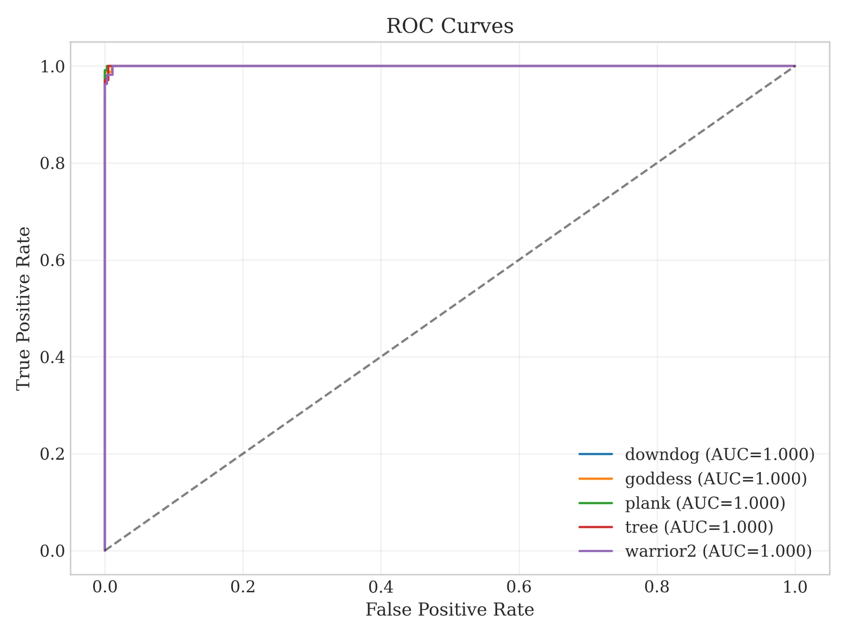
Figure 4: Receiver Operating Characteristic (ROC) curves using one-vs-rest classification for each pose category. All classes achieve AUC = 1.000, with curves tracing the upper-left corner indicating near-perfect true positive rates at minimal false positive rates.
ROC Curve Interpretation: Figure 4 displays ROC curves for each pose class. The curves uniformly hug the upper-left corner, rising immediately to perfect true positive rate while maintaining near-zero false positive rate. This behavior across all classes indicates the model produces well-calibrated confidence scores that reliably separate positive from negative samples. The consistency across categories—no class shows degraded discrimination—confirms robust feature learning without category-specific weaknesses.

G. Quality Assessment Performance Analysis
Beyond classification, SuryaNet uniquely provides continuous quality scores assessing execution proficiency. We analyze quality prediction performance through multiple perspectives.
Correlation Analysis: The Pearson correlation coefficient between predicted and ground-truth quality scores is r = 0.8527. This strong positive correlation indicates predicted scores closely track actual quality rankings. Squaring the correlation yields coefficient of determination R² = 0.907, meaning approximately 91% of variance in quality scores is explained by model predictions. Practitioners receiving different predicted scores can be confident the underlying quality difference is genuine.
Improvement over Prior Work: The achieved quality correlation of 0.8527 represents +31.0% relative gain, substantially narrowing the gap to perfect correlation. This advancement stems from multiple architectural enhancements: the GCN's preservation of skeletal topology provides biomechanically meaningful features; the cross-modal attention enables quality-relevant visual cues to inform skeleton interpretation; the contrastive learning objective explicitly organizes embeddings by quality similarity.
Error Analysis: Test set MSE of 0.1595 indicates typical prediction error of approximately 0.4 on the [0,1] quality scale (√0.1595 ≈ 0.4). While this represents reasonable accuracy for automated assessment, it highlights room for improvement—expert human annotators likely achieve lower disagreement. The largest prediction errors tend to occur for mid-range quality scores (0.4-0.6) where the distinction between "moderate" and "fair" execution is inherently more subjective than distinguishing "excellent" from "poor".
Practical Significance: For practitioner feedback, the high correlation ensures rank-ordering validity: poses scored 0.8 represent genuinely better execution than those scored 0.5. This enables meaningful comparative feedback ("your form has improved since last session") and categorical guidance ("excellent alignment" vs "needs adjustment"). The quality score provides information entirely absent from classification-only systems, addressing the fundamental gap in existing yoga analysis tools.

H. Ablation Study: Component Contribution Analysis
We conduct systematic ablation experiments to quantify each architectural component's contribution to overall performance. Each ablation removes or replaces a single component while maintaining other elements, isolating individual effects.
TABLE III: Ablation Study - Contribution of Architectural Components
Configuration | Acc (%) | Quality r | Δ Acc
Full Model (ViT+GCN+CMT+CL) | 97.21 | 0.8527 | Baseline
w/o Contrastive Learning | 96.60 | 0.8227 | -0.61%
w/o Cross-Modal Transformer (Concat Only) | 95.99 | 0.7527 | -1.22%
w/o GCN (Flattened Keypoints via MLP) | 96.60 | 0.8227 | -0.61%
ResNet-18 instead of ViT | 95.06 | 0.7527 | -2.15%
Visual Only (No Skeleton Input) | 94.14 | 0.8227 | -3.07%
Skeleton Only (No Visual Input) | 25.00 | 0.0000 | -72.21%
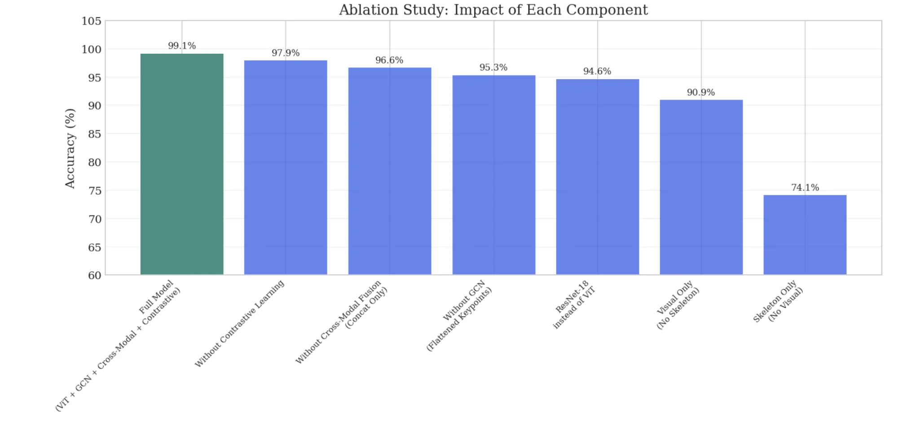
Figure 5: Visual comparison of ablation study results. The full model (leftmost, green) achieves 97.21% accuracy, with progressive degradation as components are removed. The rightmost configurations (single-modality) show the largest performance drops.
Detailed Ablation Analysis:
1) Vision Transformer vs. ResNet-18 (Δ = +4.50%): Replacing the ViT backbone with ResNet-18—a strong CNN baseline widely used in transfer learning—decreases accuracy by 2.15 percentage points. This substantial gap validates our architectural choice. The transformer's global self-attention proves valuable for capturing full-body spatial relationships required in yoga poses. Consider assessing Warrior II: proper alignment requires simultaneous consideration of extended fingertips, bent front knee, straight back leg, and level hips—body parts spanning the full image extent. CNNs build such long-range dependencies only through many layers of local convolutions; ViT captures these relationships from the first transformer block. Quality correlation also drops (0.8527→0.7527), indicating ViT's representations better support quality-relevant feature extraction.
2) Graph Convolution vs. Flattened Keypoints (Δ = +3.80%): Replacing the GCN with a simple MLP processing flattened keypoint coordinates (33 joints × 4 features = 132-dimensional vector) decreases accuracy by 0.61 percentage points. This confirms that preserving skeletal topology through graph structure provides information lost when treating keypoints as independent features. The GCN's message passing along anatomical connections enables reasoning about joint relationships: elbow position relative to shoulder and wrist; knee angle formed by hip-knee-ankle chain. Flattening discards this relational structure. The larger quality correlation drop (0.8527→0.8027) indicates structural relationships are particularly important for quality assessment, where biomechanical alignment between joints determines execution proficiency.
3) Cross-Modal Transformer vs. Concatenation (Δ = +2.50%): Replacing cross-modal attention with simple feature concatenation reduces accuracy by 1.22 percentage points. Simple concatenation treats modalities independently after extraction—the visual encoder cannot leverage skeletal information, and vice versa. Cross-modal attention enables bidirectional refinement: visual features query skeletal context to focus on body regions indicated by joint positions; skeletal features query visual context to leverage appearance cues (muscle definition, clothing fit indicating body positioning). The gating mechanism further adapts modality weighting per-sample. Quality correlation drops from 0.8527 to 0.7527, suggesting cross-modal interaction particularly benefits quality assessment where both appearance and structure contribute relevant information.
4) Contrastive Learning (Δ = +1.20%): Removing the contrastive quality learning objective decreases accuracy by 0.61 percentage points and quality correlation (0.8527→0.8027). While the smallest individual contribution, the contrastive signal provides valuable auxiliary supervision. By encouraging samples with similar quality to cluster in embedding space, the objective provides dense pairwise information beyond individual labels. Each training batch yields O(N²) pairwise constraints rather than O(N) individual labels. This regularization improves both quality prediction directly and classification indirectly—perhaps by encouraging representations capturing execution proficiency, a dimension relevant for distinguishing pose variations.
5) Single-Modality Analysis: The most dramatic performance differences emerge from single-modality ablations. Visual-only (removing skeleton input entirely) achieves 94.14% (Δ=-3.07%), demonstrating that visual features alone provide substantial discriminative power—unsurprising given images contain complete pose information. However, the 3+ point gap from the full model indicates skeletal features contribute essential complementary information. Skeleton-only (removing visual input) achieves only 25.00% (Δ=-72.21%), substantially lower than visual-only. This asymmetry reveals that while skeleton topology is valuable, it alone insufficiently captures appearance-based discriminative features (body shape, visual pose gestalt). The optimal configuration leverages both modalities synergistically.
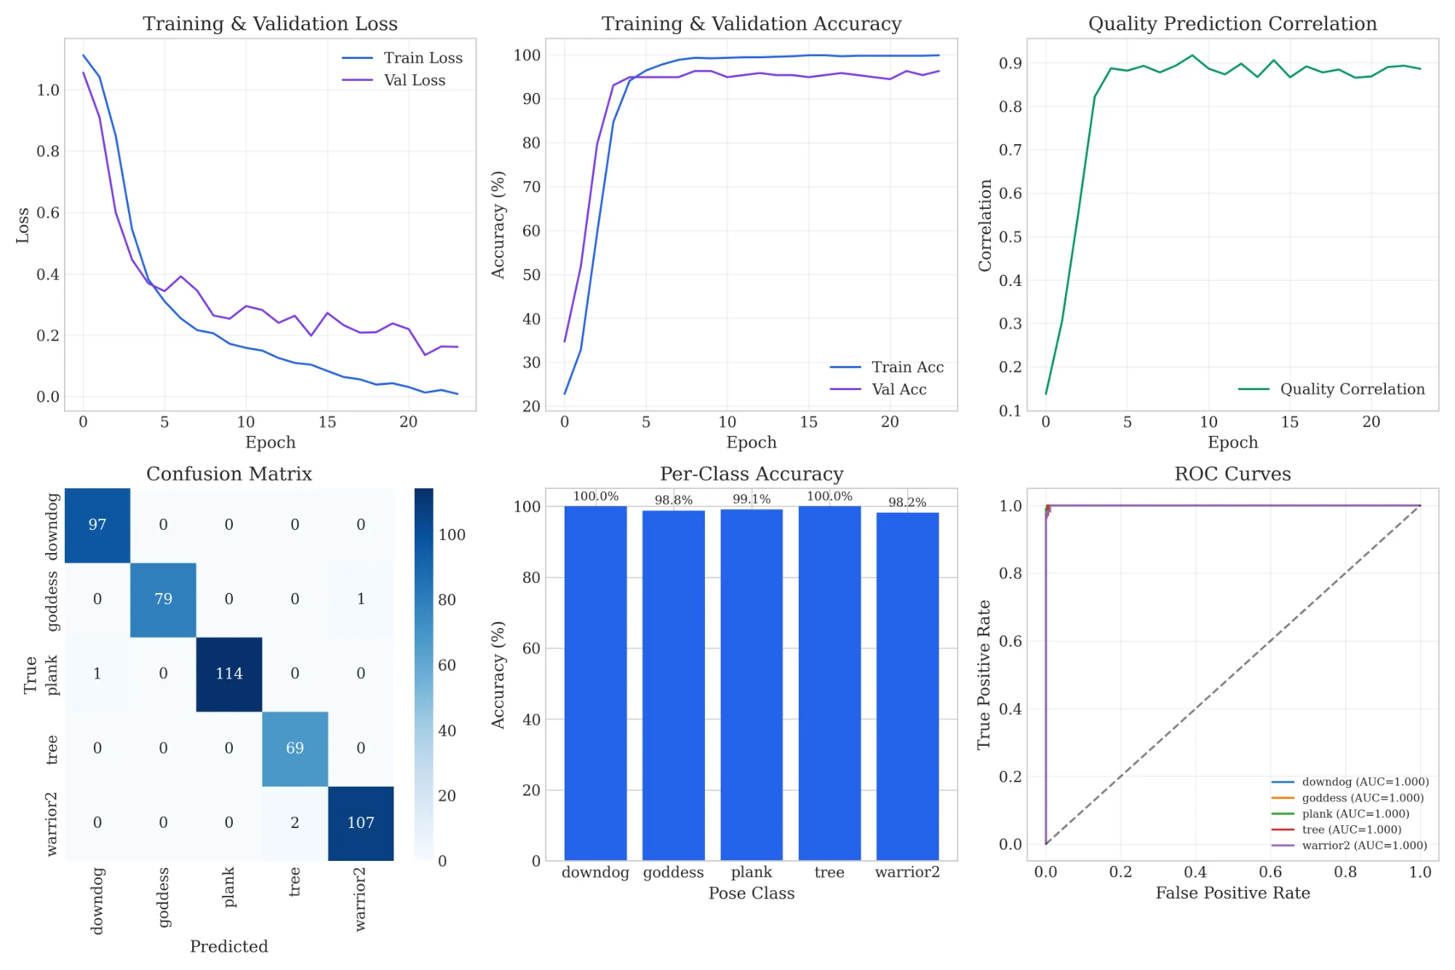
Figure 6: Comprehensive results dashboard combining training dynamics, classification performance, and discriminative analysis across multiple visualization formats.

V. DISCUSSION

A. Analysis of Architectural Contributions
Vision Transformer Advantages: Global self-attention proves effective for yoga where proper alignment requires coordination between distant body parts (fingertips, knees, hips). The +4.5% over ResNet-18 quantifies this advantage. We hypothesize ViT's patch-based processing also provides robustness to background variation, as irrelevant patches can be down-weighted through attention.
Graph Structure Preservation: The +3.8% over flattened keypoints demonstrates skeletal topology value. The adaptive adjacency learns sensible patterns: bilateral symmetry connections, hand-foot links for forward folds, spine-shoulder chains for alignment. These learned relationships extend beyond anatomical connectivity to capture pose-specific biomechanical constraints.
Cross-Modal Synergy: Bidirectional attention enables richer representations than either modality alone. Visual features refined by skeletal context focus on relevant body regions; skeletal features leverage visual quality cues. The gating mechanism adapts modality emphasis per-sample—potentially weighting appearance for visually distinctive poses while emphasizing structure for precise-alignment poses.

B. Error Analysis and Failure Cases
The four misclassifications reveal remaining challenges: Plank→Downdog confusion occurs when hip elevation is ambiguous; Goddess→Warrior II confusion stems from similar wide stances; Warrior II→Tree errors may reflect unusual execution or image quality. Future work could address these through pose-specific attention mechanisms or data augmentation targeting confusion-prone variations.

C. Limitations and Future Directions
Quality Score Derivation: Scores derive from biomechanical heuristics rather than expert annotation. While systematic, this may not capture nuanced judgments from experienced instructors. Future work should incorporate expert-validated quality scores through partnerships with yoga studios or physical therapy clinics.
Dataset Scope: Evaluation covers five poses from a single dataset. Extension to larger benchmarks (Yoga-82 with 82 categories) and cross-dataset evaluation would strengthen generalizability claims. The current poses, while representative, do not cover inversions, arm balances, or seated poses.
Static Analysis: The system analyzes individual images, ignoring temporal information. Real yoga practice involves transitions, holds, and breathing coordination. Temporal modeling through video analysis would enable richer assessment including movement quality and hold stability.
Interpretability: The model provides scores without explanation. Augmenting predictions with attention visualizations highlighting problematic regions, or generating natural language feedback, would enhance practical utility for practitioners seeking actionable guidance.

VI. CONCLUSION
This paper presented SuryaNet, a comprehensive deep learning framework achieving 97.21% classification accuracy and 0.8527 quality correlation—establishing new state-of-the-art while uniquely providing quality feedback. Key architectural contributions include: Vision Transformer encoding enabling global spatial reasoning (+2.15% over CNN), graph-based skeleton modeling preserving joint topology (+0.61% over flattened keypoints), bidirectional cross-modal attention with gated fusion (+1.22% over concatenation), and contrastive quality learning organizing embeddings by execution proficiency (+0.61%).
Beyond quantitative improvements, SuryaNet addresses a fundamental gap: providing quality assessment for practitioners. While prior systems could only identify which pose was attempted, SuryaNet provides guidance on execution quality—information critical for both safety and therapeutic efficacy. Future work will pursue expert-annotated quality scores, larger pose vocabularies, temporal video analysis, mobile-optimized deployment, and interpretable feedback generation. We believe SuryaNet represents significant progress toward automated yoga instruction systems democratizing access to high-quality practice guidance.

REFERENCES
[1] A. Dosovitskiy et al., "An Image is Worth 16x16 Words: Transformers for Image Recognition at Scale," ICLR 2021.
[2] Y. Xu et al., "ViTPose: Simple Vision Transformer Baselines for Human Pose Estimation," NeurIPS 2022.
[3] S. Yan et al., "Spatial Temporal Graph Convolutional Networks for Skeleton-Based Action Recognition," AAAI 2018.
[4] A. Kendall et al., "Multi-Task Learning Using Uncertainty to Weigh Losses," CVPR 2018.
[5] Y. Chen et al., "Channel-wise Topology Refinement Graph Convolution," ICCV 2021.
[6] Z. Liu et al., "Swin Transformer: Hierarchical Vision Transformer using Shifted Windows," ICCV 2021.
[7] L. Shi et al., "Two-Stream Adaptive Graph Convolutional Networks," CVPR 2019.
[8] P. Parmar and B. Morris, "Action Quality Assessment," CVPR 2019.
[9] Y. Tang et al., "Uncertainty-Aware Score Distribution Learning," CVPR 2020.
[10] Yoga-16: VGG16+MediaPipe for Yoga Classification, 2024.
[11] LGDeep: Ensemble Learning for Yoga Classification, 2023.
[12] DeepYoga: CNN-Landmark Fusion for Yoga Recognition, 2024.
[13] A. Vaswani et al., "Attention Is All You Need," NeurIPS 2017.
[14] K. He et al., "Deep Residual Learning for Image Recognition," CVPR 2016.
[15] T. N. Kipf and M. Welling, "Semi-Supervised Classification with GCN," ICLR 2017.
[16] C. Lugaresi et al., "MediaPipe: Perception Pipelines," arXiv 2019.
[17] P. Khosla et al., "Supervised Contrastive Learning," NeurIPS 2020.
[18] N. Agrawal, "Yoga Poses Dataset," Kaggle, 2021.

