**Cloud Hands-on 1**

1. **Creating a resource group**

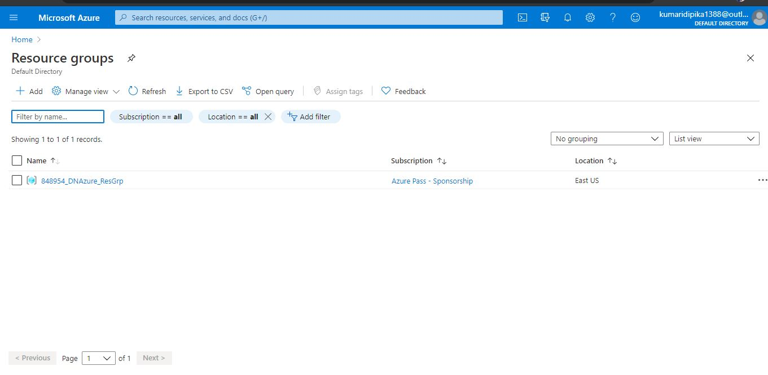

1. **Creating a container registry**

