**DOM (Document object model)**

**What is the DOM?**

* **The DOM is a W3C (World Wide Web Consortium) standard.**
* **The DOM defines a standard for accessing documents .**
* **"The W3C Document Object Model (DOM) is a platform and language-neutral interface that allows programs and scripts to dynamically access and update the content, structure, and style of a document."**
* **The W3C DOM standard is separated into 3 different parts:**
  + **Core DOM - standard model for all document types**
  + **XML DOM - standard model for XML documents**
  + **HTML DOM - standard model for HTML documents**

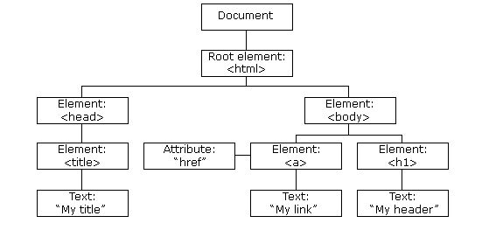

**For Example:**

**<html>**

**<body>**

**<p id="demo"></p>**

**<script>**

**document.getElementById("demo").innerHTML = "Hello World!";**

**</script>**

**</body>**

**</html>**

In the example above, getElementById is a method, while innerHTML is a property.

The getElementById Method

The most common way to access an HTML element is to use the id of the element.

In the example above the getElementById method used id="demo" to find the element.

The innerHTML Property

The easiest way to get the content of an element is by using the innerHTML property.

The innerHTML property is useful for getting or replacing the content of HTML elements.

The innerHTML property can be used to get or change any HTML element, including <html> and <body>.