TEAM 2- Deepika, Jatin, Gautam, Karthikeyan Ganesan

**Search for a tabular dataset**

Dataset created in azure**: heart-failures**

**Define a problem statement (outcomes: Regression or Classification)**

Create a classification system that aids healthcare professionals in diagnosing heart disease by analyzing patient data such as cholesterol, age, cp, medical history, and diagnostic test results, thereby improving accuracy and efficiency in clinical decision-making.

.**Use the following to work on your problem statement.**

We have used **Automated ML**

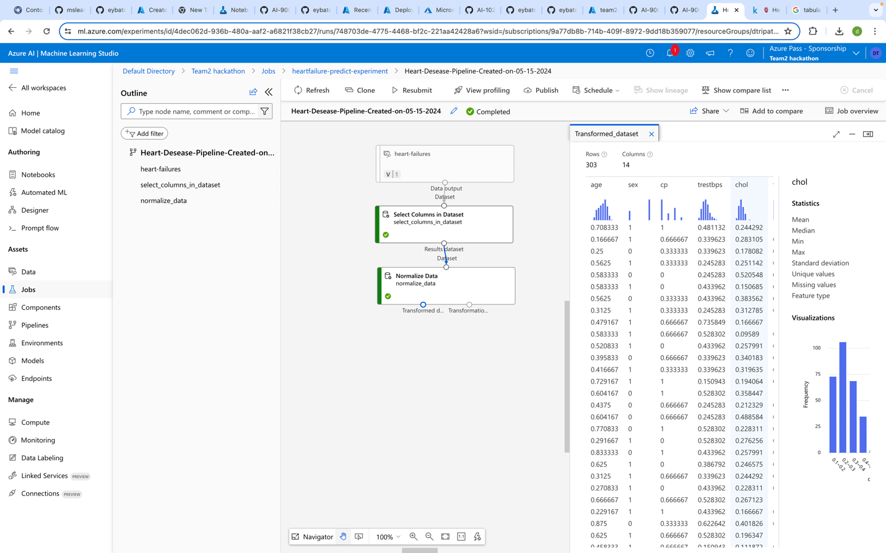

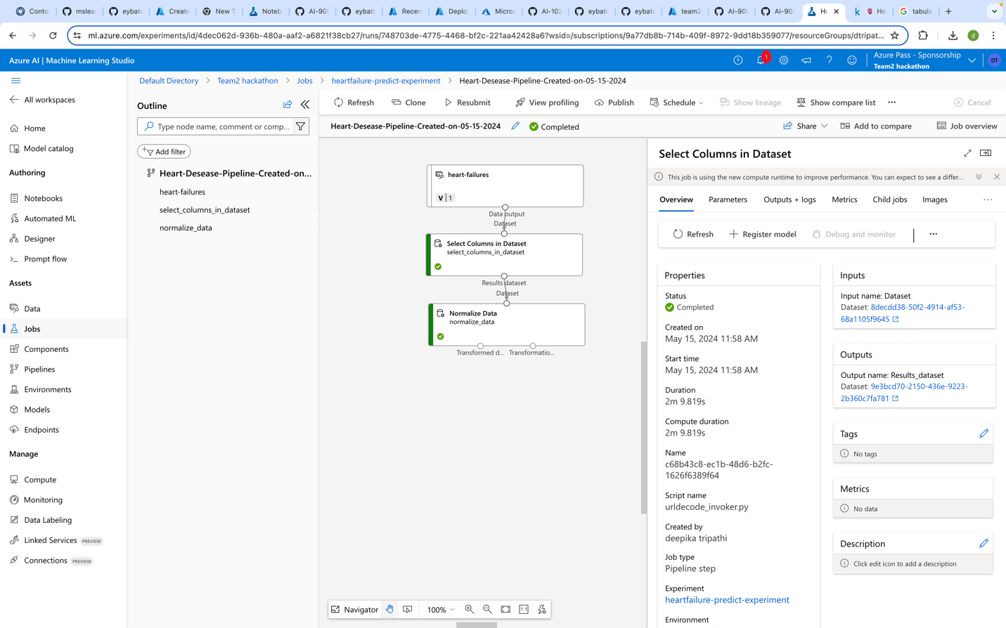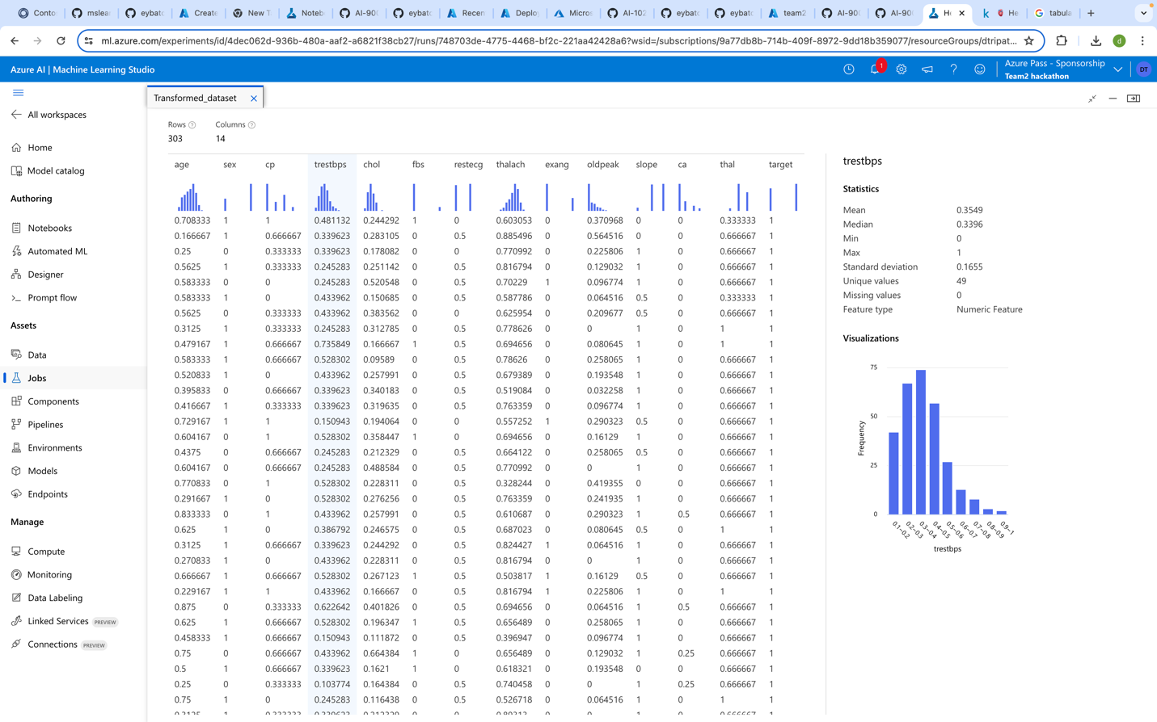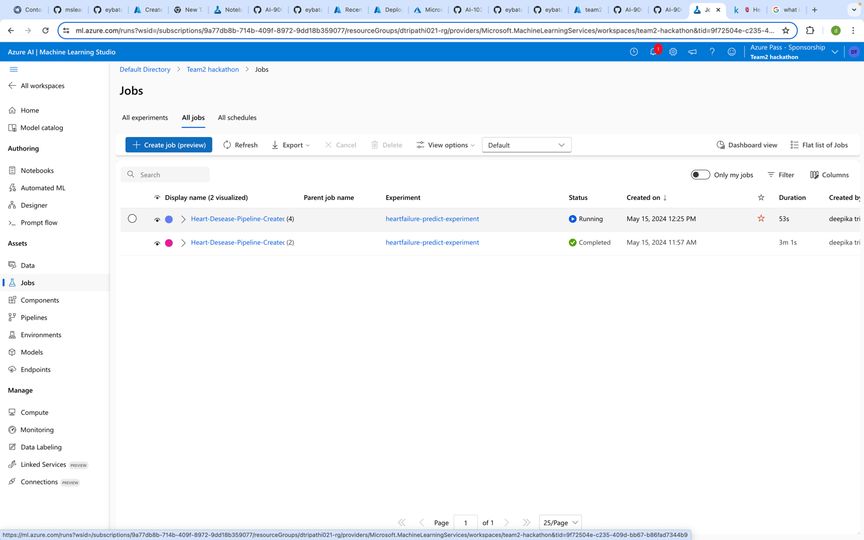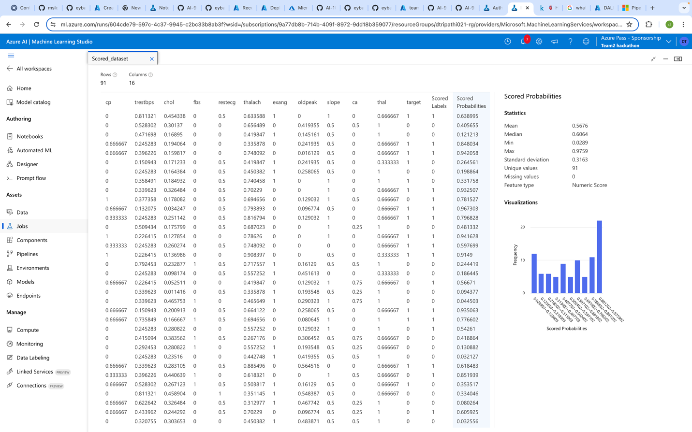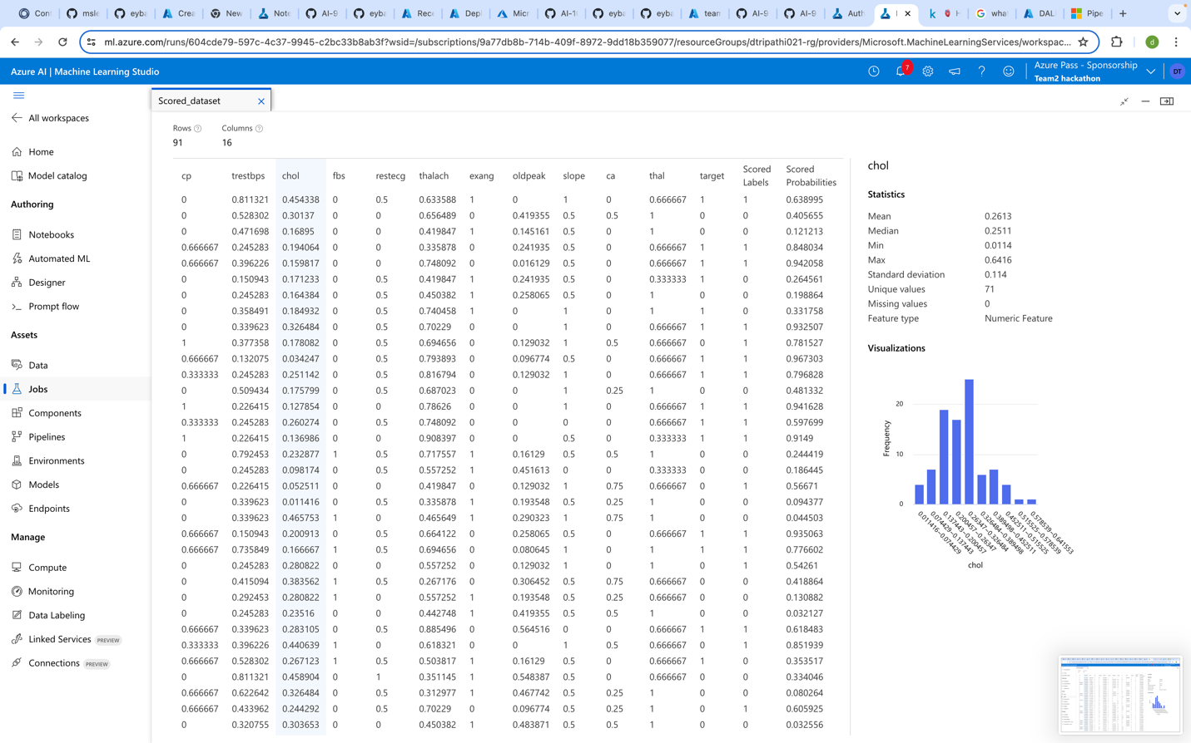

**Metrics selection for evaluation**

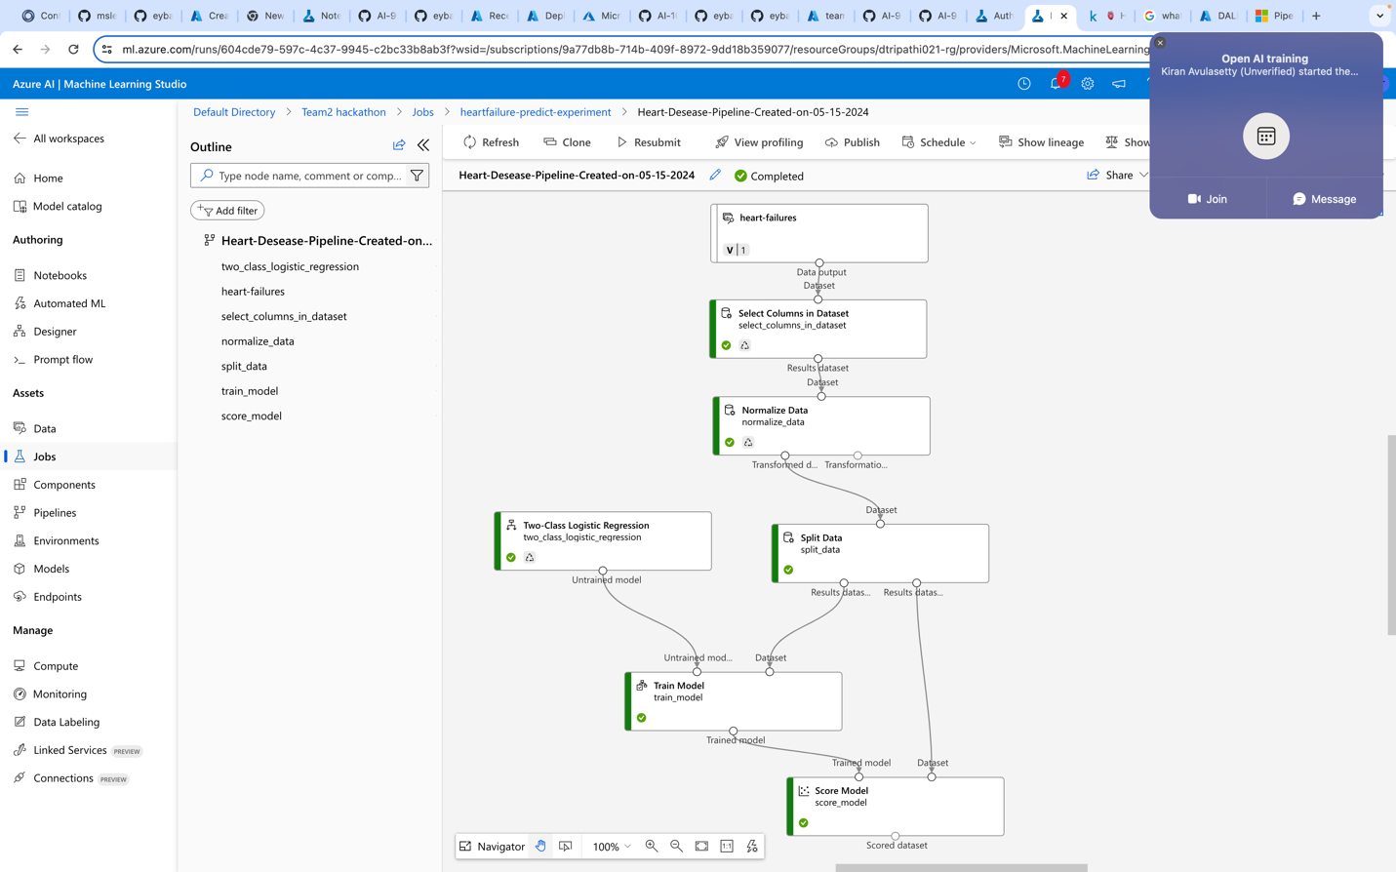

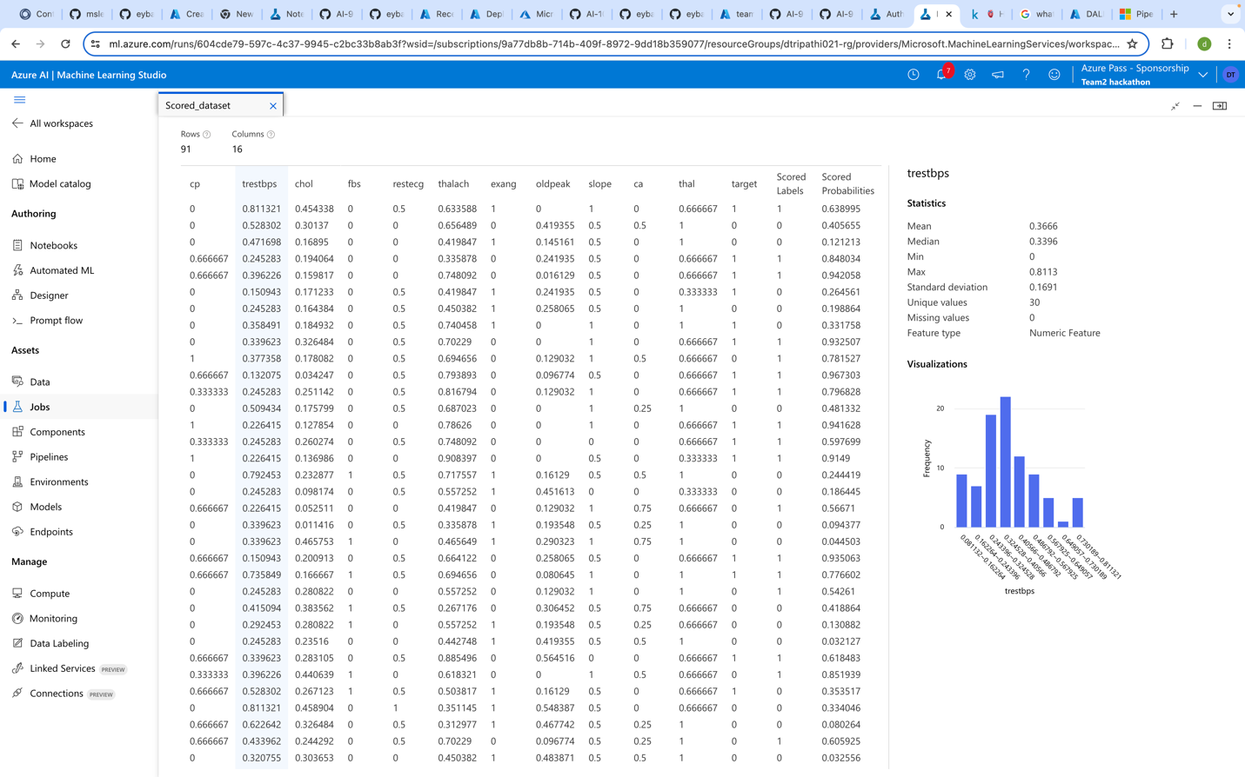

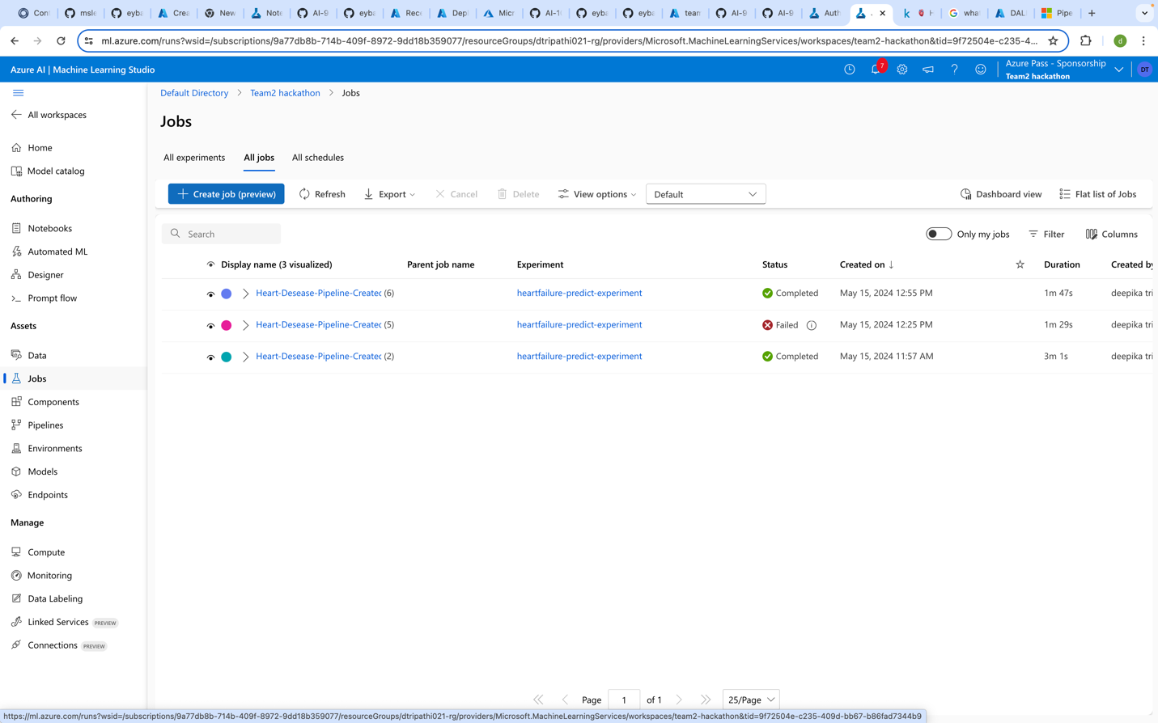

**Additionally, use following AI services for any problem statement or dataset in Python**

**Usecase**: We have a sample text file with some data in it and we have to perform analysis on it.

We have used text Analysis using python on a sample text file **gautam.txt**