1. We have created Employee Microservice which exposed four endpoints

* Insert/update employee details
* Fetch employee details based on employeeID
* Fetch all employeedetails
* Delete employee details

1. We have tested the below webservices. We have inserted couple of dummy data in our H2 database. Below is the screenshot for the same :

Insert/Update Employee Details :

URL : <http://localhost:8191/api/employee>

Type : POST

Request :

{

   "empid":1441,

    "firstname":"John",

    "lastname":"Doe",

    "mailid":"John.Doe@ibm.com",

    "designation":"Senior Analyst",

    "dept":"GBS",

    "address":"NewYork"

}

Response :

Employee details saved successfully

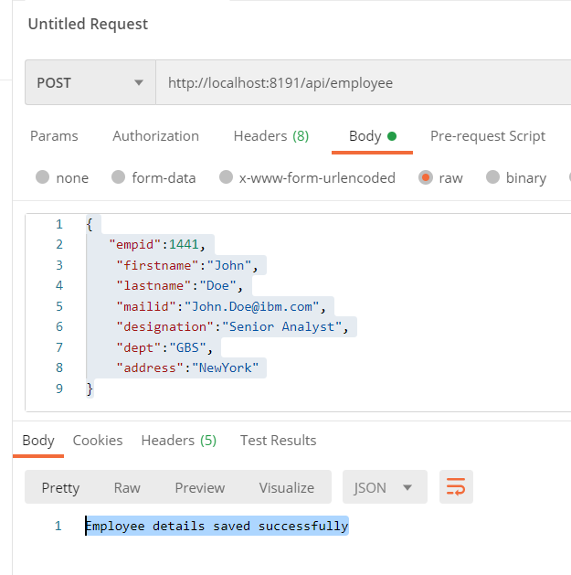

Employee Details By ID :

<http://localhost:8191/api/employee/1445>

Method : GET

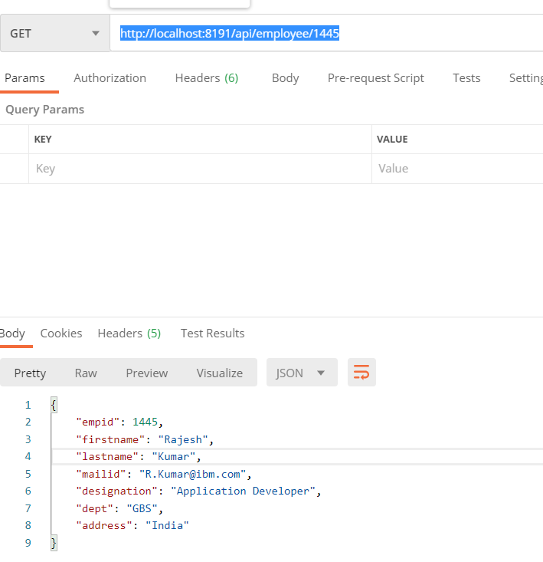

All Employee Details :

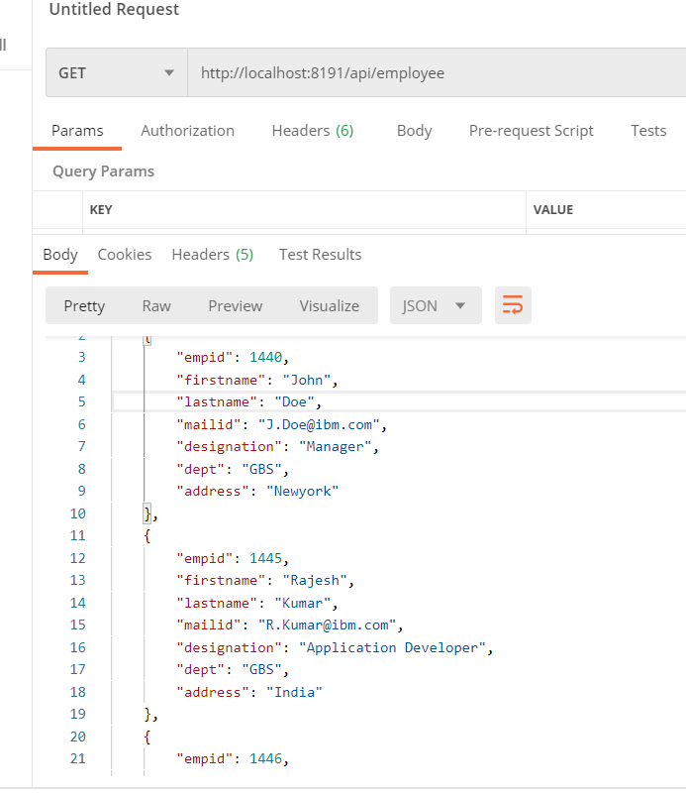

Delete Employee :

