Software Requirements Specification (SRS)

SoundScript – Client-Side Music Streaming Platform
Prepared by: Dipsana Roy
Version: v1.0.2

1. Introduction

1.1 Purpose
SoundScript is a lightweight, frontend-only music streaming application built with modular Vanilla JavaScript. It provides a responsive, event-driven music playback experience without requiring a backend server or user accounts. The application is designed to demonstrate scalable frontend architecture, efficient state management, and clean modular software engineering while maintaining a minimal deployment footprint.

1.2 Scope
SoundScript enables users to browse albums, play music, manage playback, and maintain personal listening statistics entirely within the browser.
The application:
- Streams media from configurable static assets (GitHub CDN or local assets)
- Automatically discovers albums without hardcoded configuration
- Maintains playback statistics locally using LocalStorage
- Provides responsive layouts across desktop and mobile devices
- Uses an event-driven playback engine for synchronized UI updates
- Operates without authentication, databases, or backend services
The platform is designed as a logic plane separated from its media plane using a dedicated CDN repository.

1.3 Definitions
Term | Description
CDN | External static media repository (soundscript-cdn)
Queue | Ordered track list currently loaded
Media Plane | CDN asset layer (audio, images, metadata)
Logic Plane | SoundScript app layer (HTML, CSS, JS)
Mini Bar | Draggable compact playback control UI
Seek Bar | Audio timeline controller with gradient sync
Event Emitter | Custom publish-subscribe system for player events

2. Overall Description

2.1 Architecture Overview
SoundScript follows a modular frontend architecture where each module has a single responsibility and communicates through controlled interfaces and custom events. Critical application state is privately managed and exposed only through getter functions, preventing accidental mutation by other modules.

2.2 Product Perspective
SoundScript is a standalone single-page application (SPA) built entirely with HTML, CSS, and Vanilla JavaScript. Media assets are delivered through configurable static sources, allowing deployment either with local assets or a static CDN.
No backend infrastructure is required.

2.3 Product Functions
- Dynamic album discovery
- Event-driven playback engine
- Queue management
- Responsive player interface
- Floating mini player (Precise 2D mini-bar drag)
- Playback statistics
- LocalStorage persistence
- Partial title search
- Touch-enabled card sliders
- Automatic UI synchronization
- Configurable media source
- SPA navigation
- Track plays using heuristic logic (≥2 min or ≥80% listened)
- Animate and adapt UI dynamically (gradient shifts, transitions)
- Instant section loading

2.4 User Classes
The application targets users seeking a lightweight local music player as well as developers interested in studying modular frontend architecture and event-driven UI design.

2.5 Constraints
- Frontend-only architecture
- No backend dependencies
- Browser LocalStorage availability
- JavaScript enabled
- Static hosting compatibility

2.6 Assumptions
- Browser supports ES6 Modules
- Browser supports ResizeObserver
- Browser supports LocalStorage
- Browser supports CSS Grid and Flexbox
- Audio playback APIs are available

2.7 Operating Environment
Component | Description
Browser | Modern Chromium / Gecko (Chrome, Firefox, Edge)
Hosting | Localhost, GitHub Pages, any static host
CDN | GitHub Raw (raw.githubusercontent.com)

3. System Features

3.1 Functional Requirements

FR-1 Album Discovery
The system shall automatically discover available albums without requiring hardcoded album registration.

FR-2 Music Playback
The system shall provide:
- Play
- Pause
- Next
- Previous
- Seek
- Repeat
- Queue management

FR-3 Playback Statistics
The system shall maintain:
- Play count
- Likes
- Dislikes
- Trending songs
- Loved songs
- Hated songs
using LocalStorage.

FR-4 Navigation
The system shall:
- Navigate without page reloads
- Synchronize playback state
- Preserve player state across navigation

FR-5 Responsive Interface
The interface shall automatically adapt to:
- Desktop
- Laptop
- Tablet
- Mobile

FR-6 Search
The application shall support partial title searching with automatic result focusing.

3.2 Album Discovery Module
The Album Discovery Module dynamically detects music albums and generates their user interface without requiring manual registration.
Capabilities
- Automatically discovers albums from the configured media directory
- Loads album metadata from info.js
- Dynamically generates album and song cards
- Binds playback events to generated tracks

3.3 Playback Engine
The Playback Engine controls all audio playback operations through a modular event-driven architecture.
Capabilities
- Event-driven playback controller
- Queue management
- Play, pause, next, previous and repeat controls
- Playback state synchronization
- O(1) runtime access after initialization
- Volume and playback persistence

3.4 Seek Bar System
The Seek Bar provides synchronized playback navigation.
Capabilities
- Real-time playback synchronization
- Desktop drag seeking
- Mobile touch seeking
- Gradient synchronization with the background engine
- Continuous playback position updates

3.5 Responsive User Interface
The interface adapts automatically to different screen sizes while maintaining consistent interaction.
Capabilities
- Mobile-first responsive layout
- CSS-only hamburger navigation
- Floating draggable mini player
- Touch-enabled card sliders
- Smooth layout transitions

3.6 Playback Statistics Engine
The Statistics Engine maintains persistent playback information locally.
Capabilities
- Play count tracking
- Like and dislike tracking
- Trending, loved and hated song calculation
- LocalStorage persistence
- No external data transmission

3.7 Navigation & Loading System
The Navigation System provides SPA-like transitions without page reloads.
Capabilities
- Instant section switching
- Manual loading controller
- Flash-free page transitions
- Persistent playback during navigation
- Lazy generation of additional content

4. Non-Functional Requirements

Performance
- Initial UI loads in under 2 seconds on modern broadband.
- Album generation is lazy-loaded.
- Playback transitions occur without perceptible delay.

Reliability
- Playback statistics survive browser restarts.
- Invalid slider calculations are safely ignored.
- UI state remains synchronized during navigation.

Maintainability
- Modular JavaScript architecture
- Private state encapsulation
- Event-driven communication
- Consistent naming conventions

Portability
Runs on
- Chrome
- Firefox
- Edge
- Brave
- Opera
without additional installation.

5. System Architecture
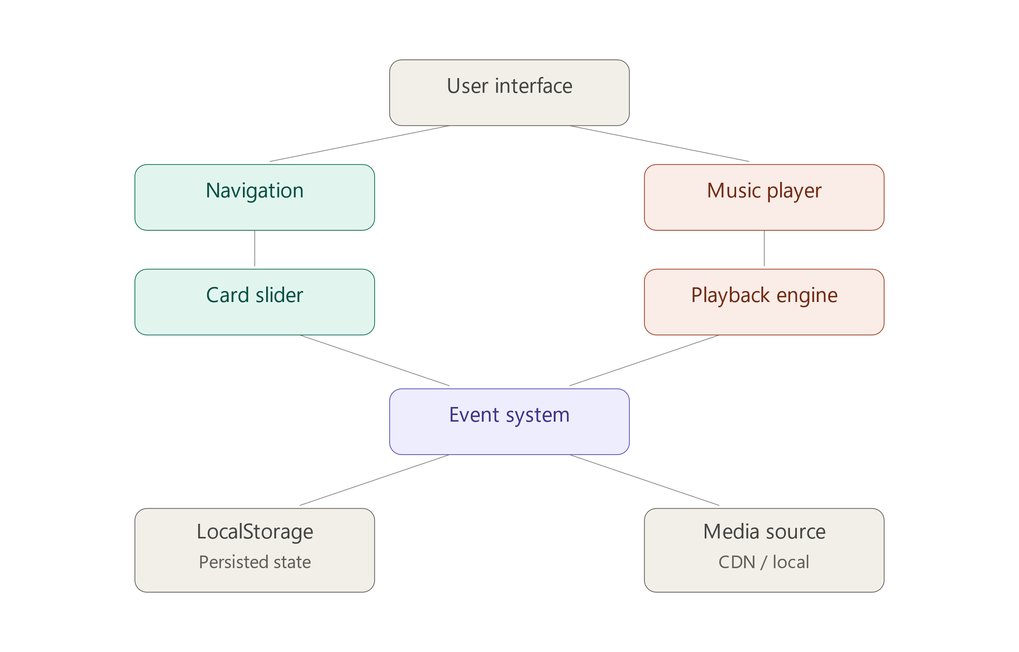

6. Data Storage
Data | Storage
Playback Statistics | LocalStorage
Queue State | Memory
Player State | Memory
Albums | JSON
Media | Static Assets

7. Security
SoundScript stores only non-sensitive playback information locally. No personally identifiable information is collected or transmitted. Because the application has no backend services or authentication system, its attack surface remains intentionally minimal.

8. Future Enhancements
- Custom playlist creation
- Shuffle playback
- Enhanced search and filtering
- Automatic local music library discovery
- Automatic metadata generation
- Album artwork generation
- Mobile UI refinements
- SVG icon system

9. Version History
Version | Date | Highlights
v1.0.2 | 2026-08-04 | Synchronization, responsive fixes, configurable media delivery, improved slider stability
v1.0.1 | 2026-01-05 | Mobile drag fixes, swipe logic, loader refactor, UI polish, bug squashing
v1.0.0 | 2026-01-04 | Initial stable production release with full CDN architecture

10. Conclusion
SoundScript demonstrates that a modern music streaming experience can be achieved using a fully client-side architecture without backend infrastructure or third-party frameworks. Through modular Vanilla JavaScript, dynamic album discovery, event-driven playback, and persistent local storage, the application provides a responsive and maintainable platform while preserving user privacy by keeping all playback data on the user's device. Future versions will continue to enhance usability, accessibility, and local media management while maintaining the project's lightweight, frontend-only design.

