**Confluent-kafka-upgrade :**

<https://docs.confluent.io/current/installation/cp-ansible/ansible-upgrade.html>

Connect-worker-upgrade:

1. Make sure existing cluster connect worker is running healthy.
2. Check jolokia agent is running on connect worker or not (ps -ef | grep jolokia)
3. Jolokia agent needs to be there for upgrade if not installed install jolokia manually by override.conf and place the file jolokia-agent.jar to /opt/jolokia

**Connect** : Environment="KAFKA_OPTS=-javaagent:/opt/jolokia/jolokia-jvm-1.6.2-agent.jar=port=7773,host=0.0.0.0"

1. Delete older package version of rpm file from worker node /opt/packages so that no conflict may occur . during the installation script will copy the upgrade version packages to /opt/packages and install on the worker node.

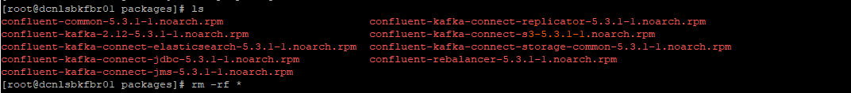

1. Create a git branch for upgrade version and make it from master .
2. We do not merge the code here as all the branches codes are different and we ae using cp-ansible where we don’t update the playbook with confluent team day by day due to internet restriction .
3. Delete the contents of upgrade version branch and paste the newly modified script over the upgrade branch .
4. Change the hosts in host.yaml
5. Clone the repository with git clone -b <upgrade-branch-name>< url of the repository. .
6. Check ansible able to reach all the hosts . by ansible -i /path/to/hosts.yml all -m ping

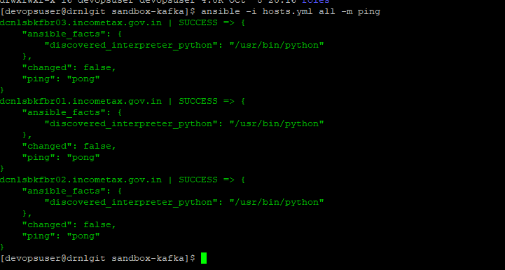

1. Check which version of kafka running now by checking the rpm file.

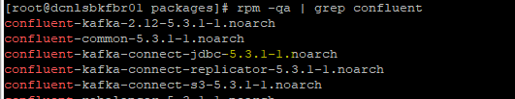

1. So our starting version will be 5.3.1 and will upgrade it to 5.5.1

**ansible-playbook -i /path/to/hosts.yml upgrade_kafka_connect.yml -e kafka_connector_upgrade_start_version=5.3.1**

