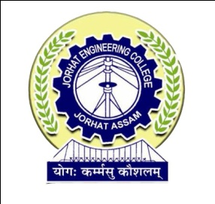

**DEPARTMENT OF COMPUTER APPLICATION**

**JORHAT ENGINEERING COLLEGE, JORHAT**

**CERTIFICATE**

This is to certify that the project work entitled “**e-PANJEEYAN FOR REVENUE & DISASTER MANAGEMENT, GOVT OF ASSAM**”, has been carried out by **DIPSIKHA PHUKAN (Roll No- MCA 12/16, Reg-No: 13931934 of 2013-2014),** a student of MCA 6th semester from Jorhat Engineering College, Jorhat at **National Informatics Centre**, Assam State Centre, Guwahati during January-June 2019 under my supervision and guidance. This work has been prepared as a partial fulfillment of requirements for the award of the degree of Master of Computer Application (MCA) under Dibrugarh University.

I also certify that the reported work has not been submitted as part of any other project work.

The conduct and behavior of the student has been good throughout. I wish her a bright and prosperous future.

(Hiramoni Goswami)

Senior Technical Director

National Informatics Centre

Assam State Unit

**Date:**

**Place: Guwahati**