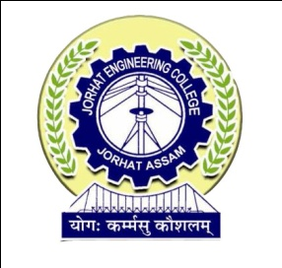

**DEPARTMENT OF COMPUTER APPLICATION**

**JORHAT ENGINEERING COLLEGE, JORHAT**

**CERTIFICATE**

This is to certify that **DIPSIKHA PHUKAN (Roll No- MCA 12/16, Reg-No: 13931934 of 2013-2014),** a student of MCA 6th semester from Jorhat Engineering College, Jorhat, under Dibrugarh University has successfully completed the project work entitled “**e-PANJEEYAN FOR REVENUE & DISASTER MANAGEMENT, GOVT OF ASSAM**”, as a partial fulfillment of requirements in Master of Computer Application(MCA) degree of Dibrugarh University under the guidance of Hiramani Goswami, Senior Technical Director, National Informatics Centre, Assam State Centre Guwahati.

The duration of the project was from January to June 2019 and is completed in all respects. I also certify that the reported work has not been submitted as part of any other project work.

The conduct and behavior of the student has been good throughout. I wish her a bright and prosperous future.

(Suchitra Pyarelal)

State Informatics Officer &

Senior Technical Director

National Informatics Centre

Assam State Unit

**Date:**

**Place: Guwahati**