Agent Action Manifest
  - Workflow and definition
Independent reference
AAM connects product-defined agent permissions to enforced actions, understandable approval and verified outcomes. People define standing authority; agents request individual actions; a trusted gate checks and executes them. Aggregate budgets and reviewed signals may tighten operation, but never grant new authority. The extended controls bind cumulative and orchestrated activity to trusted host context.
Assume the agent, its runtime, plugins/tools, and authenticated session can be compromised. The gate must independently enforce authority and must not rely on the agent’s own claim that it is trusted or uncompromised.

1 The whole workflow
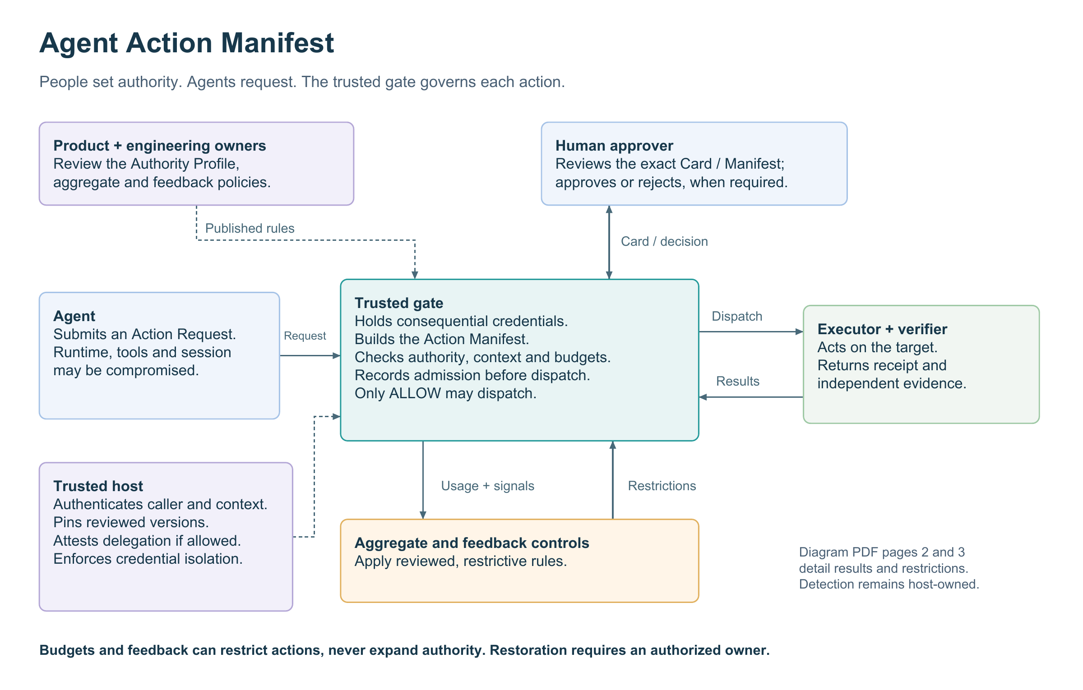
Artifact | Purpose | Created / reviewed by
Agent Authority Profile | Standing permissions, targets, limits, prohibitions, approvals, verification and recovery. | Product defines intent; engineering binds it to actual controls. Both review the published version.
Action Manifest | One immutable proposal: exact operation, effect target, parameters, evidence, approval and outcome checks. | The trusted gate builds it from the active Profile and Action Request—not from agent-authored authority.
Action Assurance Card | The Manifest shown in plain language, with evidence, uncertainty, consequence and current review context. | The system renders it; a permitted human approves, rejects or requests more evidence.

Reviewed Aggregate Execution and Feedback Policies are bound to the Profile. They specify budgets, signals, permitted restrictions and restoration rules; neither permits the controller to rewrite or expand the Profile.

2 From the worksheet to an attempted action
Publish. Product completes the worksheet; engineering supplies versioned tools, scopes, credentials, checks and evidence sources. Each reviews the exact product or engineering read-back. Publish the reviewed Profile and bound Aggregate Execution and Feedback Policies. Pin behaviorally material model routes and fallbacks, instructions, skills, persistent memory, orchestration and adapter versions; context changes require review and invalidate outstanding proposals.
Propose and review. The agent submits an Action Request—not authority, actor grouping, program, delegation or campaign state. The host supplies authenticated context; the gate builds the Manifest and checks the exact target and parameters. When required, approval binds the exact Card/Manifest once and cannot override a hard denial or unresolved check.
Admit and dispatch. Refresh live authority, credentials, approval, restrictions, campaign holds and aggregate usage. Only ALLOW executes. Commit approval use, action and aggregate reservations, and audit before calling the adapter. A changed action, execution context or relevant aggregate ledger view requires a fresh proposal and applicable approval.
Verify. Compare the required postconditions with fresh evidence bound to this execution, Manifest, target and test. All-mode covers every declared postcondition; designated mode names the required independent tests. An adapter receipt alone cannot establish completion.

A worked approval Card
Synthetic accounts-payable example. A live Card also includes the actual draft text, binding identifiers and linked evidence.
Review question | What the approver sees
Action and target | Draft—not send—an email to ap@northwind-supply.example about the $312 variance on invoice 48211 ($4,812) against PO 77102. The recipient is the effect target; the invoice is the subject.
Evidence and boundary | Invoice, PO, match result and proposed draft. Unit price differs; quantity matches. PDFs, OCR and vendor text are untrusted. One draft only; no sending, payment, bank edits or off-file recipients. AP-manager approval is required even in NORMAL mode.
Success and recovery | Verify the unsent draft and recipient, correct invoice/PO references, and invoice still in review with no payment scheduled. The AP platform lead owns recovery; an unexpected send is escalated, not silently “undone.”

3 What returned results mean
Result | Trusted gate response
Adapter receipt | Record ACKNOWLEDGED; await independent outcome verification.
Required outcomes pass | Complete only if execution is ACKNOWLEDGED or terminally reconciled COMMITTED. Existing restrictions remain.
False, missing or invalid evidence | Withhold completion and retain reasons; emit VERIFICATION_FAILED. Missing evidence is not proof of an incorrect effect.
Conflicting admissible evidence | Any test conflict emits EVIDENCE_CONFLICT. Withhold completion when a required test conflicts.
Timeout or ambiguous adapter failure | Record EXECUTION_UNKNOWN; retain the duplicate block. Use terminal transaction evidence for this execution/idempotency key to reconcile; positive postconditions alone are insufficient.
Explicit no-attempt assertion | Record NOT_ATTEMPTED only for a trusted adapter’s pre-attempt rejection. Retain reservations and consumed approvals; do not retry automatically.

Reconciliation settles COMMITTED or NOT_COMMITTED; the latter does not mean NOT_ATTEMPTED. COMMITTED still needs outcome verification. No settlement authorizes redispatch.

4 Audit evidence feeds governed responses
The gate retains linked requests, authority, decisions, approvals, reservations, receipts, verification, reconciliation and control changes. Protect sensitive artifacts separately from redacted exports; retain the underlying evidence, not just its digest. Metrics show health and backlog, not proof that an action succeeded.
Recorded result → typed signal → reviewed rule → scoped restriction → check at the next dispatch admission.
Match authenticated source, affected version, threshold, window and scope. Lifecycle rules count distinct executions; campaign rules count distinct observation IDs. The host must map repeated observations to incidents. Reviewed controls restrict actor groups, programs, operations or Profiles and aggregate admissions, in-flight work, targets, objects and bounded egress. New IDs or credentials do not reset shared budgets. These controls never authorize.
External signal examples include runtime or plugin integrity failure; a revoked or vulnerable tool/plugin version; a compromised identity or session; and connector/integration compromise. Under reviewed policy, authenticated signals from trusted sources may trigger existing scoped REQUIRE_APPROVAL or SUSPENDED controls, but can never expand authority or weaken verification. Detection and integration with supported signal or observation inputs are host responsibilities; these categories are not built-in detectors.
Operational mode | Effect on otherwise permitted work
NORMAL | No added restriction. All standing Profile checks and approvals still apply.
REQUIRE_APPROVAL | Add review without widening permitted approver roles or bypassing a prohibition.
SUSPENDED | Block matching new admissions. This does not recall an already-admitted effect or authorize a physical shutdown.

Example policy—not a universal threshold. An uncertain dispatch may hold that action; one evidence conflict may suspend the affected operation; two distinct verification failures in an hour may require review. Policy specifies the actual response, rather than letting free-text logs or the agent choose it.
Restoration is separate. An authorized, authenticated owner supplies the exact hold revision, reason and evidence. Feedback restoration blocks matching DISPATCHED or EXECUTION_UNKNOWN work and advances an epoch. Campaign restoration lacks that unresolved-execution check; its active-hold digest can return to a pre-hold value. The host must check unresolved work and invalidate earlier campaign proposals. Clear only the specified hold; other holds, consumed approvals and reservations remain. Success never clears a restriction automatically.
Improvement is a reviewed release. Investigate incidents, propose a correction, add regression tests, obtain owner approval and publish a versioned change. Analysis may assist; it does not directly change authority, deploy a fix or retrain the agent.

5 Essential enforcement and operating boundaries
Requirement | What must remain true
A real enforcement boundary | Route in-scope reads and consequential calls through the credential-holding gate. The security boundary is not “sidecar” itself. The agent must not be able to bypass the gate or directly use consequential credentials. The gate may be deployed as a sidecar or separate gateway. Use bounded, typed operations; generic shell/browser/SQL/HTTP needs stronger wrappers or sandboxing.
Exact authority and evidence | Validate the active Profile, exact request, authenticated approvers, short-lived execution authority, context attestation, cumulative limits and independent evidence. Reject stale or cross-execution proofs. Treat logged source content as untrusted, even in an authentic record.
Persistence and failure handling | Local admission commits before dispatch. Required recording failure blocks new admissions; a post-attempt failure stays uncertain. Restart preserves reservations. Export retries deliver events, never actions. Diagnostics do not override mandatory audit controls.
Clear ownership | The host supplies authentication, accountable-program and identity checks, cross-session aggregation, isolation, real adapters, trusted evidence, storage protection and scheduling for verification, reconciliation, the watchdog and export. A restriction committed before admission wins; no local transaction guarantees a remote commit.

Reference scope. The optional Python managed gate supplies single-owner aggregate admission, authenticated context, attenuated delegation and restrictive campaign observations. Context digests are host assertions: the host pins material versions and detects drift. Gate and ManagedGate retain the v0.3.7 compatibility path. This is not a production server, detector fleet, distributed coordinator, certification, safety assessment or exactly-once guarantee. Authentication does not prove legitimate purpose or evidence truth.
Use the accompanying worksheet to define one workflow and record readiness evidence. The extended reference adds opt-in schemas and controls; setup, API details and migration limits remain with the code documentation.

