MS.NET
PLP
Blood Bank Management System
(BMS)

Document Revision History

Date | Revision No. | Author | Summary of Changes
28-June-2017 | 1.0 | Vijay Vishwakarma | Initial Draft

Table of Contents
Introduction 4
Setup Checklist 4
Instructions 4
Problem Statement 5
Objective 5
Abstract of the project 5
Functional components of the project 5
Technology used: 8
Implementation 9
Summary of the functionality to be built: 9
Guidelines on the functionality to be built: 9

Introduction
This document outlines a mini project for the .NET Line of Technology (LOT). The project is to develop Blood Bank Management System. This document contains the requirements, work flow of the system and gives guidelines on how to build the functionality gradually in each of the course modules of the .NET LOT.

Setup Checklist
Minimum System Requirements
- Intel Pentium 4 and above Windows 2007, 2008 and 2010
- Memory 4 GB
- Internet Explorer 8.0 or higher
- SQL Server 2012 client and access to SQL Server 2012 server
- Visual Studio 2013

Instructions
- The code modules in the mini project should follow all the coding standards.
- Create a directory by your name in drive <drive>. In this directory, create a subdirectory MiniProject. Store your Project here.
- You can refer to your course material.
- You may also look up the help provided in the MSDN
- Since this project work will span over couple of months, you will need to take care of maintaining the code

Problem Statement

Objective

Development of Blood Bank Management System
Abstract of the project
Blood Bank Management System allows to store, process, retrieve and analyze information with respective to the administrative and inventory management within a blood bank.
Blood Bank Management system will have following features:
- Blood Donation Camp Management
- Blood Donor Management – Donor Registration, Managing donor information, recording their physical and medical details
- Blook Bank Stock Management
- Transferring blood online from one blood bank to another
Users of the System will be : Blood Bank Administrator
Role of Blood Bank Administrator :
- Login to System
- Arrange Blood Donation Camp
- Register the Donor either in the blood donation camp or in any hospital
- Add the blood details in inventory
- Update the blood details in inventory, if it is given to any hospital or other blood bank
- Delete the blood details in case it is expired, unsuitable
- Transfer the blood from one blood bank to another blood bank
- View Blood Bank Inventory details
- View Donor List

Functional components of the project
Application Architecture:
Distributed web applications traditionally to be designed and built across three logical tiers:
- Database Access Layer (DAL)
- Business Logic Layer (BLL)
- Presentation Layer
The DAL refers to the database itself, the stored procedures, and the component that provides an interface to the database. The BLL refers to the component that encapsulates all the business logic of the application. And, the Presentation layer refers to the web application pages.
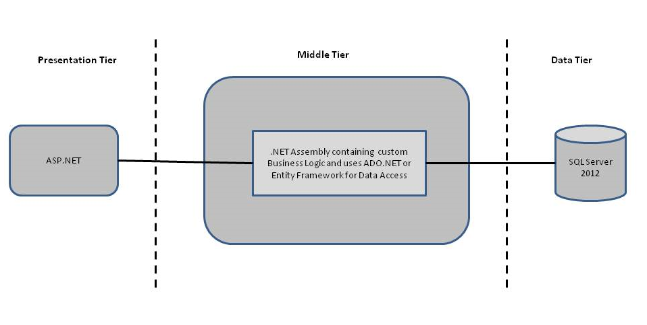
Design guidelines
- All the exceptions/errors to be captured and user friendly message to be displayed on the CommonError page.
- Data access layer of 3-tier use ADO.NET data access using SQL stored procedures - All the database interaction would be performed using Data Access Component. Most common methods in Data Access Component would be –
- Create Connection to the Database
- Create Command Object
- Set Command Type to Stored Procedure
- Create and Populate Parameters
- Execute the Command
- Close the Connection

Technology used:
    - Presentation Layer
      - Asp.Net 4.5
      - jQuery
    - Business Layer
      - Business Logic Components and Services :-
        - C# 5.0
    - Database Layer
      - Databases:-
        - SQL Server 2012
Sr. No | Course | Duration | Functionality to be built
Sr. No | Course | (in PDs) | Functionality to be built
1 | Introduction to jQuery | 1 | Creating Interactive web pages
2 | Asp.Net 4.5 | 6 | Designing User interface.Implementing new Features of ASP.Net 4.5
3 | Asp.Net MVC | 3 | Building application using MVC architecture
4 | Asp.Net Web API | 1 | Creating RestFul web Services
5 | PLP & PLP Presentation | 8 | PLP Presentation will be given to BU Members

Implementation

Summary of the functionality to be built:
The participants need to develop the Blood Bank Management System by building the functionality incrementally in each of the course modules of .NET LOT.

Note: Saturday half day will be devoted for mini project

Guidelines on the functionality to be built:
The functionality and components to be built in each of the course modules of .NET LOT

- Course: SQL Server 2012
    - Use the tables created at the time of Mini Project

- Course: Asp.Net 4.5
    - Use the existing Winforms,WPF screens and migrate to ASP.Net 4.5
  - Design a WCF service which will Search for software asset entered by the user in the database table
  - Any other service provided by ITIM can be included in the project assuming your own table and forms creation.
  - In this course you need to develop the user interface using HTML and document the flow of your application including the images of html page in a word document. The screens/web pages should include the fields as per the functionality mentioned above. Also, include client-side validations using JavaScript in each of these screens

- Course: C# 5.0
    - Use the existing BLL classes prepared at the time of Mini Project

- Course: ADO.NET 4.5 and ASP.NET 4.5
  - Convert all the screens developed in Winforms/WPF to ASP.NET
  - Integrate all screens (ASP.NET pages) with business components (C# classes) to complete the entire functionality
  - Build the web application and deploy on the IIS server and test the application.

