LearnITy Framework User Reference Manual

1. Uses of Different Classes in interface.xml :
The different classes are used in interface.xml for creating different fields.The details are described below :

Field Name | Class | Attributes
Label | label | - id
Image | image | - id  - style
Text with hyper linked | textlink | - id
Unordered List Items | list (for main topic under which subtopics are listed) | None
Unordered List Items | listitem (For sub topics) | None
Text Box | inputtext | - type  - tabindex  - name  - maxLength  - size  - style  - id
Text Area | textarea | - type  - name  - maxLength  - size  - cols  - rows  - id  - style
Combo Box | combo | - name  - id  - style
Button | button | - type  - id  - name  - style
Form | form | - id  - name
I frame | iframe | - Width  - height  - frameborder  - allowtransparency  - scrolling  - background-color  - name  - id  - style
AjaxComponent | ajaxcomponent | javaclass(deprecated)
Applet | applet | - archieve  - codebase  - mayscript
Simple Grid | DBgrid | - loadurl  - editurl  - caption  - sortname  - sortorder  - gridnavbar  - autoencode  - generateExcel  - onSelectRow  - resetSearchOnClose  - multipleSearch  - toolbarSearch  - searchOperators  - showsearchboxonload  - searchboxtop
Grid with Combo | Conditionalgrid | - loadurl  - editurl  - caption  - sortname  - sortorder  - gridnavbar  - autoencode  - generateExcel  - onSelectRow  - resetSearchOnClose  - multipleSearch  - toolbarSearch  - searchOperators  - showsearchboxonload  - searchboxtop
Tree Structure | tree | - Id  - treedataremotefunction  - onselectremotefunction  - autocollapse  - initialiseonload
Tree Structure | statictree | - Id  - lazynode  - tooltip  - onselectremotefunction  - initialiseonload
Tree Structure | dynamictree | - Id  - lazynode  - tooltip  - onselectremotefunction  - initialiseonload  - autocollapse  - parentquery  - childquery  - parameter
DBform | DBform | - id
reportwindow | reportwindow | - id
report | report | - id
chart | chart | - Id
Flash Component | flashcomponent | Structure Attribute  - id  - class  Layout Attributes  - height  - width  - top  - left  - position  Content Attributes  - id  - value type  - value  In content section one small node structure is there which id describe below.

2. Program Code & snapshot of interface.xml using classes of different fields :
- Use of class label & image
Class "label" is used for a div. When we want to use an image in the web page, we have to use class as "image" for that part id, and we have to add that image in the <resource></resource> tag in the interface.xml, and the id of the resourceitem has to be included in the value in the <content> tag and mention the valuetype property as reference.
- Program code for class label and image

<interface id="home" title="home" type="Interface">
<configuration createsession="true" checkrole="false" >
</configuration>
<structure>
<part id="homemain" class="label"></part>
<part id="center" class="label"></part>
<part id="centerimage" class="image"></part>
</structure>
<layout id="defaultlayout">
<part id="homemain" height="420px" width="99.5%" left="1px" top="1px" position="absolute"></part>
<part id="center" height="240px" width="63%" left="165px" top="2px" position="absolute" parent_id="homemain"></part>
<part id="centerimage" height="200px" width="99.9%" left="1px" top="34px" position="absolute" parent_id="center"></part>
</layout>
<content id="defaultcontent">
<part id="homemain" value="" valuetype=""></part>
<part id="center" value="" valuetype="inline"></part>
<part id="centerimage" value="companymotoimager" valuetype="reference"></part>
</content>
<style id="defaultstyle">
<part id="homemain" value="stylesheet1" valuetype="reference"></part>
<part id="center" value="[CDATA[border-style:solid;border-color:#0080FF;border-width:1px;]]" valuetype="inline"></part>
<part id="centerimage" value="" valuetype="inline"></part>
</style>
<behaviour id="defaultbehaviour">
<part id="homemain">
<event name="" type="simple" function="" callback="" javaclass="" target="" valuetype="" resourceid=""></event>
</part>
</behaviour>
<resource>
<resourceitem id="stylesheet1" href="homestyle.css" valuetype="css"></resourceitem>
<resourceitem id="companymotoimager" href="LearnITy.jpg" valuetype="image"></resourceitem>
</resource>
</interface>
--------------------------------------************-----------------------------------------

Snapshot of the above xml :
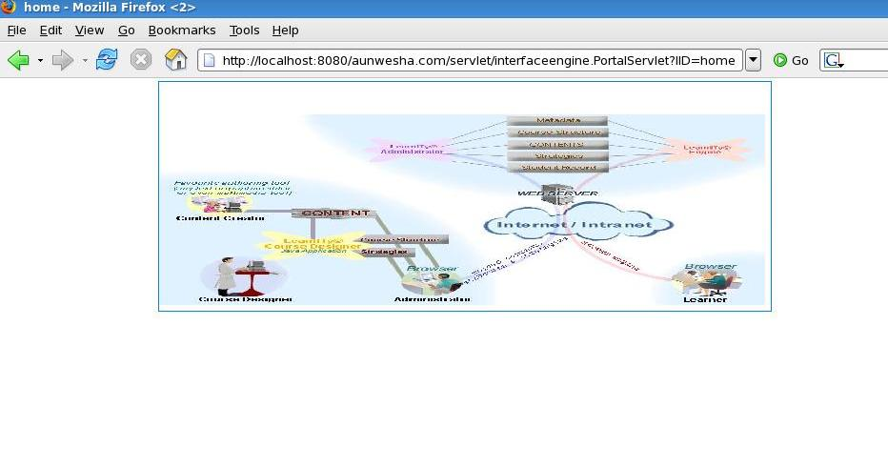
- Use of class textlink
When we want to use a text with hyper link, we have to use class as textlink, and in the <behavior> part we have to mention the url in the function attribute for that part id.
- Program code for class textlink

<interface id="home" title="home" type="Interface">
<configuration createsession="true" checkrole="false" >
</configuration>
<structure>
<part id="homemain" class="label"></part>
<part id="center" class="label"></part>
<part id="centerimage" class="image"></part>
<part id="GoTo" class="textlink"></part>
</structure>
<layout id="defaultlayout">
<part id="homemain" height="420px" width="99.5%" left="1px" top="1px" position="absolute"></part>
<part id="center" height="240px" width="63%" left="165px" top="2px" position="absolute" parent_id="homemain"></part>
<part id="centerimage" height="200px" width="99.9%" left="1px" top="34px" position="absolute" parent_id="center"></part>
<part id="GoTo" height="20px" width="10%" left="430px" top="280px" position="absolute" parent_id="homemain"></part>
</layout>
<content id="defaultcontent">
<part id="homemain" value="" valuetype=""></part>
<part id="center" value="" valuetype="inline"></part>
<part id="centerimage" value="companymotoimager" valuetype="reference"></part>
<part id="GoTo" value="Visit our site..." valuetype="inline"></part>
</content>
<style id="defaultstyle">
<part id="homemain" value="stylesheet1" valuetype="reference"></part>
<part id="center" value="[CDATA[border-style:solid;border-color:#0080FF;border-width:1px;]]" valuetype="inline"></part>
<part id="centerimage" value="" valuetype="inline"></part>
<part id="GoTo" value="[CDATA[border-style:solid;border-color:#0080FF;border-width:1px;font-weight:bold;font-size:11pt;text-align:center;]]" valuetype="inline"></part>
</style>
<behaviour id="defaultbehaviour">
<part id="homemain">
<event name="" type="simple" function="" callback="" javaclass="" target="" valuetype="" resourceid=""></event>
</part>
<part id="GoTo">
<event name="onclick" type="simple" function="http://aunwesha.com/" callback="" javaclass="" target="self" valuetype="inline" resourceid=""></event>
</part>
</behaviour>
<resource>
<resourceitem id="stylesheet1" href="homestyle.css" valuetype="css"></resourceitem>
<resourceitem id="companymotoimager" href="LearnITy.jpg" valuetype="image"></resourceitem>
</resource>
</interface>
---------------------------------------*****************--------------------------------------------------

Snapshot of the above xml :
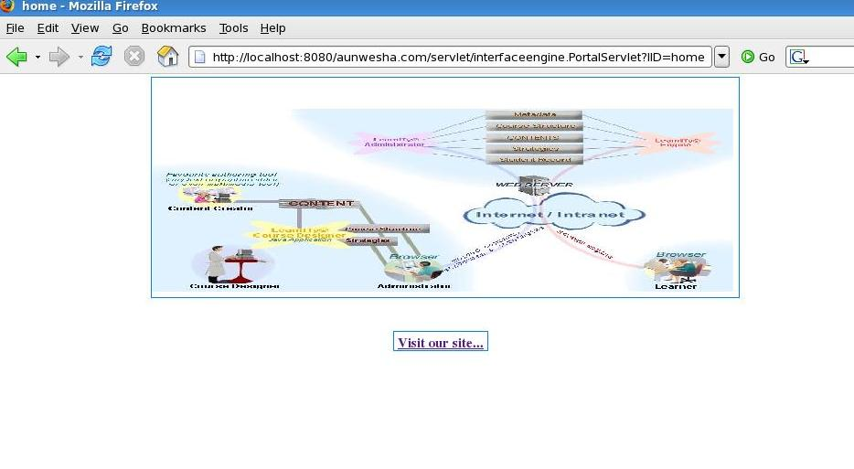
- Use of class list & listitem :
When we want to use unordered bullet to a text, we have to use class "list" for parent topic and use class "listitem" for their child topic.
- Program code for class list & listitem :
<interface id="home" title="home" type="Interface">
<configuration createsession="true" checkrole="false" >
</configuration>
<structure>
<part id="homemain" class="label"></part>
<part id="center" class="label"></part>
<part id="corporate" class="list"></part>
<part id="corporatechild1" class="listitem"></part>
<part id="corporatechild2" class="listitem"></part>
<part id="corporatechild3" class="listitem"></part>
<part id="corporatechild4" class="listitem"></part>
<part id="GoTo" class="textlink"></part>
</structure>
<layout id="defaultlayout">
<part id="homemain" height="420px" width="99.5%" left="1px" top="1px" position="absolute"></part>
<part id="center" height="240px" width="63%" left="165px" top="2px" position="absolute" parent_id="homemain"></part>
<part id="GoTo" height="20px" width="10%" left="430px" top="280px" position="absolute" parent_id="homemain"></part>
<part id="corporate" position="absolute" parent_id="center"></part>
<part id="corporatechild1" parent_id="corporate"></part>
<part id="corporatechild2" parent_id="corporate"></part>
<part id="corporatechild3" parent_id="corporate"></part>
<part id="corporatechild4" parent_id="corporate"></part>
</layout>
<content id="defaultcontent">
<part id="homemain" value="" valuetype=""></part>
<part id="center" value="" valuetype="inline"></part>
<part id="corporate" value="Capabilities for CORPORATE" valuetype="inline"></part>
<part id="corporatechild1" value="Exhaustive Skill Management" valuetype="inline"></part>
<part id="corporatechild2" value="Extensive reporting with configurable dashboards" valuetype="inline"></part>
<part id="corporatechild3" value="Brand and customize the LearnITy portal" valuetype="inline"></part>
<part id="corporatechild4" value="Track training requirements" valuetype="inline"></part>
<part id="GoTo" value="Visit our site..." valuetype="inline"></part>
</content>
<style id="defaultstyle">
<part id="homemain" value="stylesheet1" valuetype="reference"></part>
<part id="center" value="[CDATA[background-color: #FCFFE5;color:#006699;font-family:Verdana,Arial;border-style:solid;border-color:#0080FF;border-width:1px;]]" valuetype="inline"></part>
<part id="GoTo" value="[CDATA[border-style:solid;border-color:#0080FF;border-width:1px;font-weight:bold;font-size:11pt;text-align:center;]]" valuetype="inline"></part>
</style>
<behaviour id="defaultbehaviour">
<part id="homemain">
<event name="" type="simple" function="" callback="" javaclass="" target="" valuetype="" resourceid=""></event>
</part>
<part id="GoTo">
<event name="onclick" type="simple" function="http://aunwesha.com/" callback="" javaclass="" target="self" valuetype="inline" resourceid=""></event>
</part>
</behaviour>
<resource>
<resourceitem id="stylesheet1" href="homestyle.css" valuetype="css"></resourceitem>
</resource>
</interface>
------------------------------------****************-------------------------------------

Snapshot of the above xml :
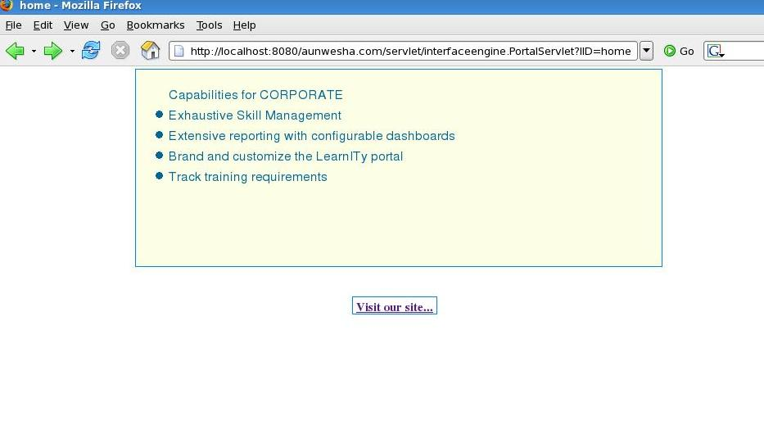
- Use of class inputtext & button
When we want to use text box in the web page, we have to use class as inputtext in the interface.xml, and when we want to use any button we have to use class as button.
- Program code for the class inputtext & button
<interface id="home" title="home" type="Interface">
<configuration createsession="true" checkrole="false" >
</configuration>
<structure>
<part id="homemain" class="label"></part>
<part id="login" class="label"></part>
<part id="UserId" class="label"></part>
<part id="UserIdtext" class="inputtext" size="20"></part>
<part id="passwd" class="label"></part>
<part id="passwdtext" class="inputtext" size="20"></part>
<part id="loginbutton" class="button" size="20" jscontrol="custom"></part>
</structure>
<layout id="defaultlayout">
<part id="homemain" height="420px" width="99.5%" left="1px" top="1px" position="absolute"></part>
<part id="login" height="240px" width="63%" left="165px" top="2px" position="absolute" parent_id="homemain"></part>
<part id="loginbutton" height="20px" width="10px" left="300px" top="100px" position="absolute" parent_id="login"></part>
<part id="UserId" height="20px" width="100px" left="200px" top="15px" position="absolute" parent_id="login"></part>
<part id="UserIdtext" height="20px" width="10px" left="285px" top="15px" position="absolute" parent_id="login"></part>
<part id="passwd" height="20px" width="100px" left="200px" top="45px" position="absolute" parent_id="login"></part>
<part id="passwdtext" height="20px" width="10px" left="285px" top="45px" position="absolute" parent_id="login"></part>
</layout>
<content id="defaultcontent">
<part id="homemain" value="" valuetype=""></part>
<part id="login" value="" valuetype=""></part>
<part id="UserId" value="User Id" valuetype="inline"></part>
<part id="passwd" value="Password" valuetype="inline"></part>
<part id="loginbutton" value="Login" valuetype="inline"></part>
</content>
<style id="defaultstyle">
<part id="homemain" value="stylesheet1" valuetype="reference"></part>
<part id="login" value="[CDATA[background-color:#E6E6FF;font-size:10pt;]]" valuetype="inline"></part>
<part id="UserId" value="[CDATA[font-size:10pt;font-weight:bold;]]" valuetype="inline"></part>
<part id="passwd" value="[CDATA[font-size:10pt;font-weight:bold;]]" valuetype="inline"></part>
<part id="loginbutton" value="[CDATA[background-color:#006699;color:#FFFFFF;font-size:10pt;font-weight:bold;width:90px;]]" valuetype="inline"></part>
</style>
<behaviour id="defaultbehaviour">
<part id="homemain">
<event name="" type="simple" function="" callback="" javaclass="" target="" valuetype="" resourceid=""></event>
</part>
<part id="loginbutton">
<event name="onclick" type="simple" function="submit_onclick" callback="" javaclass="" target="" valuetype="jsevent" resourceid=""></event>
</part>
</behaviour>
<resource>
<resourceitem id="stylesheet1" href="homestyle.css" valuetype="css"></resourceitem>
</resource>
</interface>

Snapshot of the above xml :
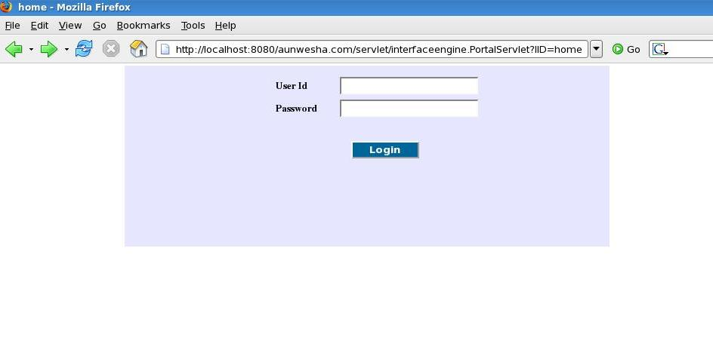
- Use of class combo
When we use class combo in the interface.xml, the options which are to be included in the combo box, have to be mentioned in the name and value attribute of the <combooption> under <content> tag and the valuetype for that part id is to be fixed and we want to use a combo box whose values are to be fetched by a select query from a database, the valuetype of the combo class is to be "query". We use class textarea when we want to use "Text Area".
- Program code for class textarea & combo
<interface id="home" title="home" type="Interface">
<configuration createsession="true" checkrole="false" >
</configuration>
<structure>
<part id="homemain" class="label"></part>
<part id="login" class="label"></part>
<part id="addr" class="label"></part>
<part id="addrtext" class="textarea" rows="2" cols="23"></part>
<part id="country" class="label"></part>
<part id="countrytext" class="combo"></part>
</structure>
<layout id="defaultlayout">
<part id="homemain" height="420px" width="99.5%" left="1px" top="1px" position="absolute"></part>
<part id="login" height="240px" width="63%" left="165px" top="2px" position="absolute" parent_id="homemain"></part>
<part id="addr" height="20px" width="100px" left="200px" top="15px" position="absolute" parent_id="login"></part>
<part id="addrtext" height="20px" width="10px" left="285px" top="15px" position="absolute" parent_id="login"></part>
<part id="country" height="20px" width="100px" left="200px" top="85px" position="absolute" parent_id="login"></part>
<part id="countrytext" height="20px" width="10px" left="285px" top="85px" position="absolute" parent_id="login"></part>
</layout>
<content id="defaultcontent">
<part id="homemain" value="" valuetype=""></part>
<part id="login" value="" valuetype=""></part>
<part id="addr" value="Address" valuetype="inline"></part>
<part id="country" value="Country" valuetype="inline"></part>
<part id="countrytext" valuetype="fixed">
<combooption name="Afghanistan" value="Afghanistan"></combooption>
<combooption name="Algeria" value="Albania"></combooption>
<combooption name="Georgia" value="Georgia"></combooption>
<combooption name="Germany" value="Germany"></combooption>
<combooption name="Ghana" value="Ghana"></combooption>
<combooption name="India" value="India"></combooption>
</part>
</content>
<style id="defaultstyle">
<part id="homemain" value="stylesheet1" valuetype="reference"></part>
<part id="login" value="[CDATA[background-color:#E6E6FF;font-size:10pt;]]" valuetype="inline"></part>
<part id="addr" value="[CDATA[font-size:10pt;font-weight:bold;]]" valuetype="inline"></part>
<part id="country" value="[CDATA[font-size:10pt;font-weight:bold;]]" valuetype="inline"></part>
</style>
<behaviour id="defaultbehaviour">
<part id="homemain">
<event name="" type="simple" function="" callback="" javaclass="" target="" valuetype="" resourceid=""></event>
</part>

</behaviour>
<resource>
<resourceitem id="stylesheet1" href="homestyle.css" valuetype="css"></resourceitem>
</resource>
</interface>

Snapshot of the above xml :
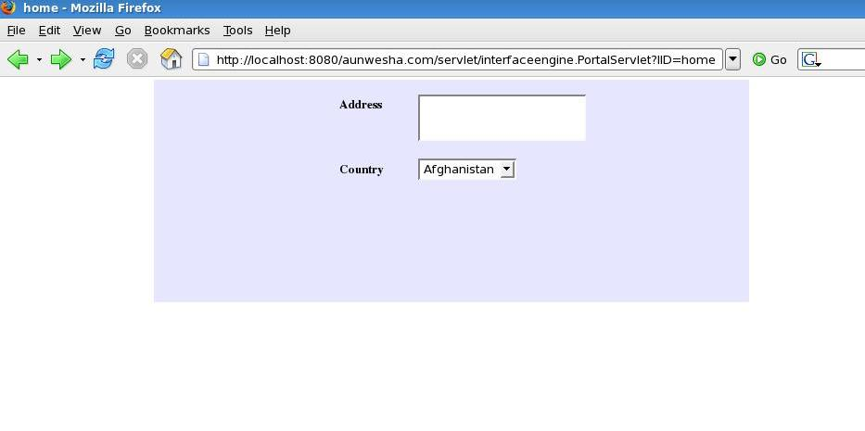
- Program code of the class combo with valuetype query
<interface id="SCORMInitialization" title="SCORMInitialization" type="Interface">
<structure>
<part id="scormInitializeMain" class="label"/>
<part id="scormInitializeAjax" class="ajaxcomponent"/>
<part id="ee1" class="ajaxcomponent"/>
<part id="scormUnitName" class="label"/>
<part id="scormType" class="label"/>
<part id="scormUnitUser" class="label"/>
<part id="CourseID" class="combo"></part>
<part id="selectype" class="combo"></part>
<part id="UserID" class="combo"></part>
<part id="iframegridframe" class="label"/>
<part id="modifydiv" class="label"/>
<part id="mode" class="label"/>
<part id="ModeSelect" class="combo"></part>
<part id="entry" class="label"/>
<part id="EntrySelect" class="combo"></part>
<part id="suspend" class="label"/>
<part id="SuspendSelect" class="combo"></part>
<part id="status" class="label"/>
<part id="StatusSelect" class="combo"></part>
<part id="credit" class="label"/>
<part id="CreditSelect" class="combo"></part>
<part id="exit" class="label"/>
<part id="ExitSelect" class="combo"></part>
<part id="launch" class="label"/>
<part id="LaunchSelect" class="combo"></part>
<part id="totaltime" class="label"/>
<part id="TimeSelect" class="inputtext" size="10px"></part>
<part id="modifybuttondiv" class="label"/>
<part id="modifybutton" class="button"/>
<part id="SCORMInitializationUserGrid" class="DBgrid" loadurl="" editurl="" caption="User SCO Information" sortname="" sortorder="" gridnavbar="true">
<column head="scoid" name="scoid" index="1" width="150" editable="true" hidden="true" key="true" required="true" minval="" maxval="">
<edit type="text" size="50" rows="" cols="" editdomaintype="" value="" > </edit>
</column>
<column head="Title" name="title" index="2" width="150" editable="true" hidden="false" key="false" required="true" minval="" maxval="">
<edit type="text" size="50" rows="" cols="" editdomaintype="true" value=""> </edit>
</column>
<column head="Lesson Status" name="lessonstatus" index="3" width="150" editable="true" hidden="false" key="false" required="true" minval="" maxval="">
<edit type="text" size="50" rows="" cols="" editdomaintype="true" value=""> </edit>
</column>
<column head="Lesson Mode" name="lessonmode" index="4" width="100" editable="true" hidden="false" key="false" required="true" minval="" maxval="">
<edit type="text" size="50" rows="" cols="" editdomaintype="true" value=""> </edit>
</column>
<column head="Entry" name="entry1" index="5" width="100" editable="true" hidden="false" key="false" required="true" minval="" maxval="">
<edit type="text" size="50" rows="" cols="" editdomaintype="" value=""> </edit>
</column>
<column head="Exit" name="exit1" index="6" width="100" editable="true" hidden="false" key="false" required="true" minval="" maxval="">
<edit type="text" size="50" rows="" cols="" editdomaintype="" value=""> </edit>
</column>
<column head="Total Time" name="totaltime" index="7" width="100" editable="true" hidden="false" key="false" required="true" minval="" maxval="">
<edit type="text" size="50" rows="" cols="" editdomaintype="" value=""> </edit>
</column>
<loadquery value="select scoid,title,lessonstatus,lessonmode,entry1,exit1,totaltime from temp_scorm_initialization"></loadquery>
</part>
</structure>
<layout id="scormInitializelayout">
<part id="scormInitializeMain" height="100%" width="100%" left="0px" top="0px" position="absolute" />
<part id="scormUnitName" height="20px" width="150px" left="20px" top="20px" position="absolute" parent_id="scormInitializeMain" />
<part id="CourseID" height="" width="150px" left="170px" top="20px" position="absolute" parent_id="scormInitializeMain" />
<part id="scormType" height="" width="150px" left="20px" top="50px" position="absolute" parent_id="scormInitializeMain" />
<part id="selectype" height="" width="150px" left="170px" top="50px" position="absolute" parent_id="scormInitializeMain" />
<part id="scormUnitUser" height="20px" width="150px" left="400px" top="50px" position="absolute" parent_id="scormInitializeMain" />
<part id="UserID" height="" width="150px" left="550px" top="50px" position="absolute" parent_id="scormInitializeMain" />
<!-- <part id="scormInitializeGrid" height="" width="" left="10px" top="100px" position="absolute" parent_id="scormInitializeMain" /> -->
<part id="scormInitializeAjax" height="" width="" left="20px" top="40px" position="" parent_id="scormInitializeMain" />
<part id="ee1" height="" width="" left="20px" top="40px" position="" parent_id="scormInitializeMain" />
<part id="iframegridframe" height="250px" width="100%" left="1px" top="90px" position="absolute" parent_id="scormInitializeMain"></part>
<part id="modifydiv" height="140px" width="700px" left="15px" top="350px" position="absolute" parent_id="scormInitializeMain"></part>
<part id="mode" height="" width="80px" left="5px" top="2px" position="absolute" parent_id="modifydiv" />
<part id="ModeSelect" height="" width="100px" left="80px" top="5px" position="absolute" parent_id="modifydiv" />
<part id="entry" height="" width="80px" left="250px" top="2px" position="absolute" parent_id="modifydiv" />
<part id="EntrySelect" height="" width="150px" left="320px" top="5px" position="absolute" parent_id="modifydiv" />
<part id="suspend" height="" width="80px" left="500px" top="2px" position="absolute" parent_id="modifydiv" />
<part id="SuspendSelect" height="" width="150px" left="580px" top="5px" position="absolute" parent_id="modifydiv" />
<part id="status" height="" width="80px" left="5px" top="47px" position="absolute" parent_id="modifydiv" />
<part id="StatusSelect" height="" width="100px" left="80px" top="50px" position="absolute" parent_id="modifydiv" />
<part id="credit" height="" width="80px" left="250px" top="47px" position="absolute" parent_id="modifydiv" />
<part id="CreditSelect" height="" width="150px" left="320px" top="50px" position="absolute" parent_id="modifydiv" />
<part id="exit" height="" width="80px" left="500px" top="47px" position="absolute" parent_id="modifydiv" />
<part id="ExitSelect" height="" width="150px" left="580px" top="50px" position="absolute" parent_id="modifydiv" />
<part id="launch" height="" width="80px" left="5px" top="97px" position="absolute" parent_id="modifydiv" />
<part id="LaunchSelect" height="" width="150px" left="80px" top="100px" position="absolute" parent_id="modifydiv" />
<part id="totaltime" height="" width="80px" left="250px" top="97px" position="absolute" parent_id="modifydiv" />
<part id="TimeSelect" height="" width="150px" left="320px" top="100px" position="absolute" parent_id="modifydiv" />
<part id="modifybuttondiv" height="" width="" left="20px" top="500px" position="absolute" parent_id="scormInitializeMain"></part>
<part id="modifybutton" height="" width="" left="1px" top="1px" position="absolute" parent_id="modifybuttondiv"></part>
<part id="SCORMInitializationUserGrid" height="" width="" left="1px" top="2px" position="absolute" parent_id="iframegridframe"></part>
</layout>
<content id="scormInitializeContent">
<part id="CourseID" valuetype="query" value="select a.course_id, a.course_name from course a, course_creation_details b where a.course_id=b.course_id"></part>
<part id="selectype" valuetype="fixed">
<combooption name="0" value="All Users Registered"></combooption>
<combooption name="1" value="Group Registered"></combooption>
<combooption name="2" value="Users Registered"></combooption>
</part>
<part id="UserID" valuetype="" value=""></part>
<part id="scormUnitName" valuetype="cdata"><![CDATA[Unit Name :]]></part>
<part id="scormType" valuetype="cdata"><![CDATA[Select Type :]]></part>
<part id="scormUnitUser" valuetype="cdata"><![CDATA[User Name :]]></part>
<part id="ModeSelect" valuetype="fixed">
<combooption name="normal" value="normal"></combooption>
<combooption name="review" value="review"></combooption>
<combooption name="browse" value="browse"></combooption>
</part>
<part id="EntrySelect" valuetype="fixed">
<combooption name="ab-initio" value="ab-initio"></combooption>
<combooption name="resume" value="resume"></combooption>
<combooption name="empty string" value="empty string"></combooption>
</part>
<part id="SuspendSelect" valuetype="fixed">
<combooption name="0" value="empty string"></combooption>
</part>
<part id="StatusSelect" valuetype="fixed">
<combooption name="not attempted" value="not attempted"></combooption>
<combooption name="incomplete" value="incomplete"></combooption>
<combooption name="completed" value="completed"></combooption>
<combooption name="passed" value="passed"></combooption>
<combooption name="faild" value="faild"></combooption>
<combooption name="browsed" value="browsed"></combooption>
</part>
<part id="CreditSelect" valuetype="fixed">
<combooption name="credit" value="credit"></combooption>
<combooption name="no-credit" value="no-credit"></combooption>
</part>
<part id="ExitSelect" valuetype="fixed">
<combooption name="empty string" value="empty string"></combooption>
<combooption name="time-out" value="time-out"></combooption>
<combooption name="suspend" value="suspend"></combooption>
<combooption name="logout" value="logout"></combooption>
</part>
<part id="LaunchSelect" valuetype="fixed">
<combooption name="empty string" value="empty string"></combooption>
</part>
<part id="mode" valuetype="cdata"><![CDATA[Lesson Mode :]]></part>
<part id="entry" valuetype="cdata"><![CDATA[Entry :]]></part>
<part id="suspend" valuetype="cdata"><![CDATA[Suspend Data :]]></part>
<part id="status" valuetype="cdata"><![CDATA[Lesson Status :]]></part>
<part id="credit" valuetype="cdata"><![CDATA[Credit :]]></part>
<part id="exit" valuetype="cdata"><![CDATA[Exit :]]></part>
<part id="launch" valuetype="cdata"><![CDATA[Launch Data :]]></part>
<part id="totaltime" valuetype="cdata"><![CDATA[Total Time :]]></part>
<part id="modifybutton" value="Modify" valuetype="inline"></part>
</content>
<style id="scormInitializeStyle">
<part id="iframegridframe" value="[CDATA[background-color: #FFFFFF]]" valuetype="inline"></part>
<part id="modifydiv" value="[CDATA[background-color: #FFFFFF;border-style:solid;border-color:coffe;border-width:1px]]" valuetype="inline"></part>
</style>
<behaviour id="scormInitializeBehaviour">
<part id="root">
<event name="onload_click()" type="simple" function="" callback="" javaclass="" target="" valuetype="jsevent" resourceid="SCORMInitializationjs"></event>
</part>
<part id="scormInitializeAjax">
<event name="" type="simple" function="" callback="" javaclass="PortalEngine" target="" valuetype="" resourceid=""></event>
</part>
<part id="ee1">
<event name="" type="simple" function="" callback="" javaclass="ladminTree" target="" valuetype="" resourceid=""></event>
</part>
<part id="CourseID">
<event name="onchange" type="simple" function="unit_onchange()" callback="" javaclass="" target="" valuetype="inline" resourceid=""></event>
</part>
<part id="selectype">
<event name="onchange" type="simple" function="selectype_onchange()" callback="" javaclass="" target="" valuetype="inline" resourceid=""></event>
</part>
<part id="UserID">
<event name="onchange" type="simple" function="UserID_onchange()" callback="" javaclass="" target="" valuetype="inline" resourceid=""></event>
</part>
<part id="modifybutton">
<event name="onclick" type="simple" function="modify_onclick" callback="" javaclass="" target="" valuetype="jsevent" resourceid=""></event>
</part>
<resource>
<resourceitem id="SCORMInitializationjs" href="SCORMInitialization.js" valuetype="js"></resourceitem>

</resource>
</behaviour>
</interface>

Snapshot of the above xml :
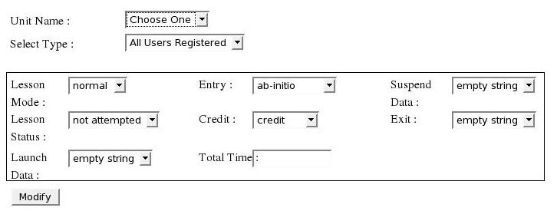

- Use of class form
This is the same as the use of form in html page. When we need to use a form in a web page, we have to use class form. The fields which have to be included in the form are the children of the form. i.e. The parent_id of those fields is the part id of class form.
- Program code for the class form
<interface id="feedback" title="feedback" type="Interface">
<configuration createsession="true" checkrole="false" >
</configuration>
<structure>
<part id="feedbackmain" class="label"></part>
<part id="feedback" class="label"></part>
<part id="form1" class="form"></part>
<part id="visitorname" class="label"></part>
<part id="visitornametext" class="inputtext" size="20"></part>
<part id="address" class="label"></part>
<part id="addresstextarea" class="textarea" rows="2" cols="23"></part>
<part id="city" class="label"></part>
<part id="citytext" class="inputtext" size="20"></part>
<part id="state" class="label"></part>
<part id="statetext" class="inputtext" size="20"></part>
<part id="pin" class="label"></part>
<part id="pintext" class="inputtext" size="20"></part>
<part id="organisation" class="label"></part>
<part id="organisationtext" class="inputtext" size="20"></part>
<part id="designation" class="label"></part>
<part id="designationtext" class="inputtext" size="20"></part>
<part id="country" class="label"></part>
<part id="countrytext" class="combo"></part>
<part id="telno" class="label"></part>
<part id="telnotext" class="inputtext" size="20"></part>
<part id="comment" class="label"></part>
<part id="commenttextarea" class="textarea" size="30" rows="7" cols="65"></part>
<part id="submitbutton" class="button" size="20" jscontrol="custom"></part>
<part id="resetbutton" class="button" size="20" jscontrol="custom"></part>
</structure>
<layout id="defaultlayout">
<part id="feedbackmain" height="400px" width="99.5%" left="1px" top="1px" position="absolute"></part>
<part id="feedback" height="405px" width="77.5%" left="12.5%" top="12px" position="absolute" parent_id="feedbackmain"></part>
<part id="form1" parent_id="feedback"></part>
<part id="visitorname" height="20px" width="100px" left="10px" top="15px" position="absolute" parent_id="form1"></part>
<part id="visitornametext" height="20px" width="10px" left="115px" top="15px" position="absolute" parent_id="form1"></part>
<part id="address" height="20px" width="100px" left="52%" top="25px" position="absolute" parent_id="form1"></part>
<part id="addresstextarea" height="20px" width="10px" left="68%" top="15px" position="absolute" parent_id="form1"></part>
<part id="city" height="20px" width="100px" left="10px" top="45px" position="absolute" parent_id="form1"></part>
<part id="citytext" height="20px" width="10px" left="115px" top="45px" position="absolute" parent_id="form1"></part>
<part id="state" height="20px" width="100px" left="52%" top="75px" position="absolute" parent_id="form1"></part>
<part id="statetext" height="20px" width="10px" left="68%" top="75px" position="absolute" parent_id="form1"></part>
<part id="pin" height="20px" width="100px" left="10px" top="75px" position="absolute" parent_id="form1"></part>
<part id="pintext" height="20px" width="10px" left="115px" top="75px" position="absolute" parent_id="form1"></part>
<part id="country" height="20px" width="100px" left="52%" top="105px" position="absolute" parent_id="form1"></part>
<part id="countrytext" height="20px" width="10px" left="68%" top="105px" position="absolute" parent_id="form1"></part>
<part id="organisation" height="20px" width="100px" left="10px" top="165px" position="absolute" parent_id="form1"></part>
<part id="organisationtext" height="20px" width="10px" left="115px" top="165px" position="absolute" parent_id="form1"></part>
<part id="designation" height="20px" width="100px" left="52%" top="165px" position="absolute" parent_id="form1"></part>
<part id="designationtext" height="20px" width="10px" left="68%" top="165px" position="absolute" parent_id="form1"></part>
<part id="telno" height="20px" width="100px" left="10px" top="105px" position="absolute" parent_id="form1"></part>
<part id="telnotext" height="20px" width="10px" left="115px" top="105px" position="absolute" parent_id="form1"></part>
<part id="comment" height="20px" width="100px" left="10px" top="315px" position="absolute" parent_id="form1"></part>
<part id="commenttextarea" height="20px" width="10px" left="115px" top="270px" position="absolute" parent_id="form1"></part>
<part id="submitbutton" height="20px" width="10px" left="660px" top="310px" position="absolute" parent_id="form1"></part>
<part id="resetbutton" height="20px" width="10px" left="660px" top="340px" position="absolute" parent_id="form1"></part>
</layout>
<content id="defaultcontent">
<part id="feedbackmain" value="" valuetype=""></part>
<part id="visitorname" value="*Name" valuetype="inline"></part>
<part id="address" value="Address" valuetype="inline"></part>
<part id="city" value="City" valuetype="inline"></part>
<part id="state" value="State" valuetype="inline"></part>
<part id="pin" value="Pin" valuetype="inline"></part>
<part id="country" value="Country" valuetype="inline"></part>
<part id="countrytext" valuetype="fixed">
<combooption name="Afghanistan" value="Afghanistan"></combooption>
<combooption name="Algeria" value="Albania"></combooption>
<combooption name="American Samoa" value="American Samoa"></combooption>
<combooption name="Hungary" value="Hungary"></combooption>
<combooption name="Italy" value="Italy"></combooption>
<combooption name="Ivory Coast (Cote dIvoire)" value="Ivory Coast (Cote dIvoire)"></combooption>
<combooption name="India" value="India"></combooption>
<combooption name="Japan" value="Japan"></combooption>
<combooption name="Jordan" value="Jordan"></combooption>
</part>
<part id="organisation" value="Organisation" valuetype="inline"></part>
<part id="designation" value="Designation" valuetype="inline"></part>
<part id="telno" value="Telephone No." valuetype="inline"></part>
<part id="comment" value="Comment" valuetype="inline"></part>
<part id="submitbutton" value="Submit" valuetype="inline"></part>
<part id="resetbutton" value="Reset" valuetype="inline"></part>
</content>
<style id="defaultstyle">
<part id="feedbackmain" value="stylesheet1" valuetype="reference"></part>
<part id="visitorname" value="[CDATA[font-size:10pt;font-weight:bold;]]" valuetype="inline"></part>
<part id="visitorname" value="[CDATA[font-size:10pt;font-weight:bold;]]" valuetype="inline"></part>
<part id="address" value="[CDATA[font-size:10pt;font-weight:bold;]]" valuetype="inline"></part>
<part id="city" value="[CDATA[font-size:10pt;font-weight:bold;]]" valuetype="inline"></part>
<part id="state" value="[CDATA[font-size:10pt;font-weight:bold;]]" valuetype="inline"></part>
<part id="pin" value="[CDATA[font-size:10pt;font-weight:bold;]]" valuetype="inline"></part>
<part id="country" value="[CDATA[font-size:10pt;font-weight:bold;]]" valuetype="inline"></part>
<part id="organisation" value="[CDATA[font-size:10pt;font-weight:bold;]]" valuetype="inline"></part>
<part id="designation" value="[CDATA[font-size:10pt;font-weight:bold;]]" valuetype="inline"></part>
<part id="telno" value="[CDATA[font-size:10pt;font-weight:bold;]]" valuetype="inline"></part>
<part id="comment" value="[CDATA[font-size:10pt;font-weight:bold;]]" valuetype="inline"></part>
<part id="howdidu" value="[CDATA[font-size:10pt;font-weight:bold;]]" valuetype="inline"></part>
<part id="submitbutton" value="[CDATA[background-color:#006699;color:#FFFFFF;font-size:10pt;font-weight:bold;width:90px;]]" valuetype="inline"></part>
<part id="resetbutton" value="[CDATA[background-color:#006699;color:#FFFFFF;font-size:10pt;font-weight:bold;width:90px;]]" valuetype="inline"></part>
</style>
<behaviour id="defaultbehaviour">
<part id="feedbackmain">
<event name="" type="simple" function="" callback="" javaclass="" target="" valuetype="" resourceid=""></event>
</part>
<part id="submitbutton">
<event name="onclick" type="simple" function="submit_onclick" callback="" javaclass="" target="" valuetype="jsevent" resourceid=""></event>
</part>
<part id="root">
<event name="" type="" function="" callback="" javaclass="" target="" valuetype="" resourceid="feedbackjs"></event>
</part>
<part id="resetbutton">
<event name="onclick" type="simple" function="formReset" callback="" javaclass="" target="" valuetype="jsevent" resourceid=""></event>
</part>
</behaviour>
<resource>
<resourceitem id="stylesheet1" href="feedbackstyle.css" valuetype="css"></resourceitem>
<resourceitem id="feedbackjs" href="feedbackjs.js" valuetype="js"></resourceitem>
</resource>
</interface>
-------------------------------------***********************-------------------------------------------

Snapshot of the above xml :
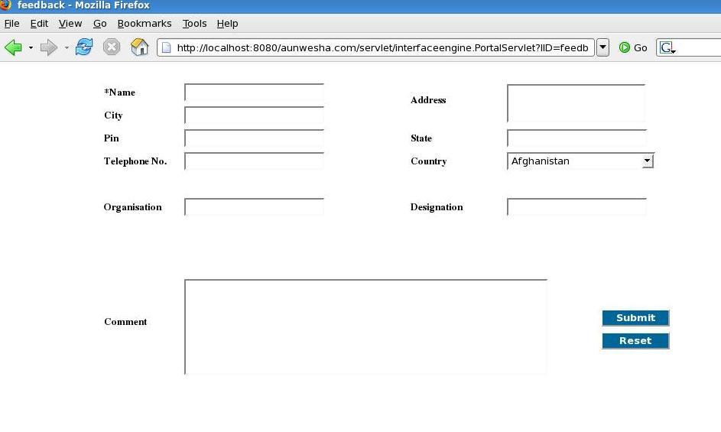

Program Code of the class iframe
<interface id="home" title="home" type="Interface">
<configuration createsession="true" checkrole="false" >
</configuration>
<structure>
<part id="homemain" class="label"></part>
<part id="left_frame" class="iframe"></part>
<part id="right_frame" class="iframe"></part>
</structure>
<layout id="defaultlayout">
<part id="homemain" height="420px" width="99.5%" left="1px" top="1px" position="absolute"></part>
<part id="left_frame" height="440px" width="40%" left="1px" top="2px" scrolling="yes" position="absolute" parent_id="homemain"></part>
<part id="right_frame" height="440px" width="85%" left="230px" top="2px" scrolling="yes" position="absolute" parent_id="homemain"></part>
</layout>
<content id="defaultcontent">
<part id="homemain" value="" valuetype=""></part>
<part id="left_frame" value="" valuetype=""></part>
<part id="right_frame" value="" valuetype=""></part>
</content>
<style id="defaultstyle">
<part id="homemain" value="stylesheet1" valuetype="reference"></part>
<part id="left_frame" value="[CDATA[border:0px solid #ff0000;]]" valuetype="inline"></part>
<part id="right_frame" value="[CDATA[overflow:auto;]]" valuetype="inline"></part>
</style>
<behaviour id="defaultbehaviour">
<part id="homemain">
<event name="" type="simple" function="" callback="" javaclass="" target="" valuetype="" resourceid=""></event>
</part>
<part id="left_frame">
<event name="invokeurl" type="simple" function="http://aunwesha.com" callback="" javaclass="" target="left_frame" valuetype="inline" resourceid=""></event>
</part>
<part id="right_frame">
<event name="invokeurl" type="simple" function="./interfaceengine.PortalServlet?IID=feedback" callback="" javaclass="" target="right_frame" valuetype="inline" resourceid=""></event>
</part>
</behaviour>
<resource>
<resourceitem id="stylesheet1" href="homestyle.css" valuetype="css"></resourceitem>
</resource>
</interface>
----------------------------------***********************---------------------------------------------

Snapshot of the above xml :

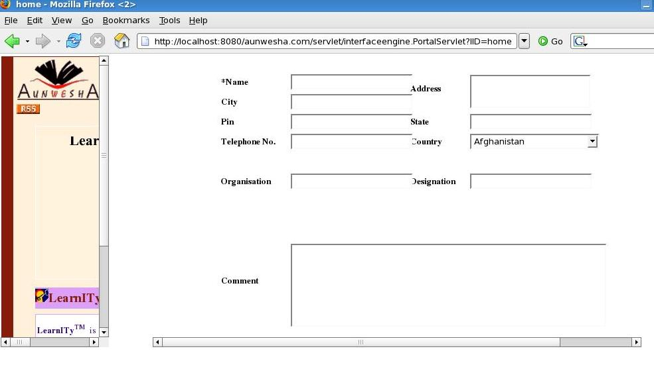

- Program Code of the class applet

<part id="APIAdapter" class="applet" archieve="cmidatamodel.jar,lmsclient.jar,debug.jar" codebase="../html/" mayscript="true"></part>

Applet class generate html code for applet.

Program Code of the class DBGrid

Structure | Attributes | Comment | value
Structure | Loadurl |  | User given
Structure | Editurl |  | User given
Structure | Caption | Grid heading | User given
Structure | Sortname | Show records order by name | User given
Structure | Sordorder | Show records in order desc or asc | User given
Structure | Gridnavbar | Control over navbar like add,modify,delete | true/false
Structure | Multiselect | Use for select multiple record | true/false
Structure | Rownum | Show maximum data in one page | User given
Structure | Rowlist |  | User given e,g 15,20,40,60
Structure | Resetsearchonclose |  | true/false
Structure | Multiplesearch | For Multiple Search | true/false
Structure | Customeditbutton |  | true/false

Layout | Attribute | Comment | value
Layout | height | For grid height  Height=”200”  not required any unit like px | User given
Layout | Other attributes are same like other classes

Behaviour | Attribute | value
Behaviour | event name="ondblClickRow" | User given
Behaviour | event name="gridComplete" | User given
Behaviour | event name="loadComplete" | User given

<interface id="UserGroupAdmin" title="UserGroupAdmin" type="Interface">
<structure>
<part id="BodyDiv" class="label"></part>
<part id="UserGroupAdminGrid" class="DBgrid" loadurl="" editurl="" caption="Currently Defined Groups" sortname="group_id" sortorder="desc">

<column head="Group Id" name="group_id" index="1" width="0" editable="true" hidden="true" key="true" required="" minval="" maxval="">
<edit type="text" size="30" rows="" cols="" editdomaintype="" value="" > </edit>
</column>
<column head="Group Name" name="group_name" index="2" width="150" editable="true" hidden="false" key="false" required="true" minval="" maxval="">
<edit type="text" size="30" rows="" cols="" editdomaintype="" value=""> </edit>
</column>
<column head="Created By" name="group_created_by" index="3" width="125" editable="false" hidden="false" key="false" required="" minval="" maxval="">
<edit type="text" size="30" rows="" cols="" editdomaintype="" value=""> </edit>
</column>
<column head="Date Of Creation" name="group_created_date" index="4" width="135" editable="false" hidden="false" key="false" required="" minval="" maxval="">
<edit type="text" size="60" rows="" cols="" editdomaintype="" value=""> </edit>
</column>

<column head="Last Modified" name="last_modification_date" index="5" width="120" editable="false" hidden="false" key="false" required="" minval="" maxval="">
<edit type="text" size="60" rows="" cols="" editdomaintype="" value=""> </edit>
</column>
<column head="No Of Members" name="group" index="6" width="135" editable="false" hidden="false" key="false" required="" minval="" maxval="">
<edit type="text" size="60" rows="" cols="" editdomaintype="" value=""> </edit>
</column>
<column head="Self" name="self_regis" index="7" width="50" editable="true" hidden="false" key="false" required="" minval="" maxval="">
<edit type="select" size="" rows="" cols="" editdomaintype="fixed" value="T:True;F:False"> </edit>
</column>

<loadquery value="select a.group_id, a.group_name,concat(b.first_name,\' \', b.middle_name,\' \',b.sname),a.group_created_date,a.last_modification_date, count(c.group_id), a.self_regis from (student_group a inner join student_details b on a.group_created_by=b.student_id) left join student_group_association c on a.group_id = c.group_id group by c.group_id, a.group_name, a.group_id"></loadquery>

<delete>
<queries>
<query id="1" sql="[CDATA[delete FROM student_group where group_id=%group_id% and group_id Not In(select group_id from course_group_association) and group_id Not In(select group_id from course_group_association) and group_id Not In(select group_id from group_forum_association) and group_id Not In(select group_id from groupaccessmanagement)]]" parameter="group_id"></query>
</queries>
</delete>

<add>
<queries>
<query id="1" sql="[CDATA[insert into student_group (group_name, group_created_date, group_created_by,last_modification_date, self_regis) values (%group_name%,sysdate(),%current_login_user_id%,sysdate(),%self_regis%)]]" parameter="group_name,current_login_user_id,self_regis"></query>
</queries>
</add>

<modify>
<queries>
<query id="1" sql="[CDATA[update student_group set group_name =%group_name% ,last_modification_date = sysdate(),self_regis =%self_regis% where group_id =%group_id%]]" parameter="group_name,self_regis,group_id"></query>
</queries>
</modify>
</part>
</structure>

<layout id="UserGroupAdminLayout">
<part id="BodyDiv" height="" width="" left="" top="" position="" parent_id=""></part>
<part id="UserGroupAdminGrid" height="" width="" left="" top="" position="" parent_id="BodyDiv"></part>

</layout>

</interface>
----------------------------------***********************---------------------------------------------

Snapshot of the above xml :
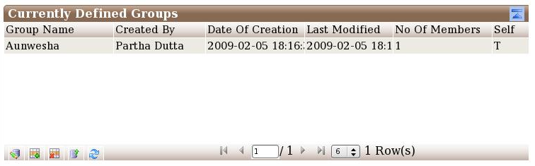

- Details of code for class DBGrid
Class “DBGrid” is used to generate simple grid that access the data from database using the query defined inside the <loadquery></loadquery> tag.
“Add”, “Modify” and “Delete” actions can be done in this grid by the queries defined inside <add></add>, <modify></modify> and <delete></delete> tags respectively. Inside the above tags queries are defined in the following way

<queries>
<query id="1" sql="[CDATA[delete from forum where forum_id=%forum_id% ]]" parameter="forum_id"></query>
</queries>

The “id” will be changed depending upon the number of queries. One can add validation query before insert, edit or delete data to check whether the data is valid to insert, edit or delete respectively or not. Validation is of two types – “query” and “custom”. For query type, the validation query is defined in the following way

<validations>
<validation type="query">
<validationquery id="1" sql="[CDATA[select group_id from course_group_association where group_id=%group% and course_id=%course_id%]]" parameter="group,course_id" message="This Group Is Already Associated With The Above Unit."></validationquery>
</validation>
</validations>

If the data is not valid, then message is returned to the user.

Custom validations are given in the following way

<validations>
<validation type="custom">
<validationquery id="1" classname="learnitycms.CmsDateValidator" message="Start Date is Less than End Date"></validationquery>
</validation>
</validations>

In this type of validations one should write java file. In the above example the CmsDateValidator class file is called from learnitycms package. The java is as follows

package learnitycms;

import java.io.*;
import java.text.*;
import java.util.*;
import javax.servlet.*;
import javax.servlet.http.*;
import org.grlea.log.*;
import interfaceengine.ValidatorFunction;

public class CmsDateValidator extends ValidatorFunction {
public static final SimpleLogger log = new SimpleLogger(CmsDateValidator.class, true);// Create a SimpleLogger:
public String validateadd(HttpServletRequest request){

String validity = "";
String message = "";

String startdate = request.getParameter("sdate");
String enddate = request.getParameter("edate");

String year_startdate = startdate.substring(0,startdate.indexOf("-"));
String year_enddate = enddate.substring(0,enddate.indexOf("-"));

String remaining_startdate = startdate.substring(startdate.indexOf("-")+1);
String remaining_enddate = enddate.substring(enddate.indexOf("-")+1);

String month_startdate = remaining_startdate.substring(0,remaining_startdate.indexOf("-"));
String month_enddate = remaining_enddate.substring(0,remaining_enddate.indexOf("-"));

String day_startdate = remaining_startdate.substring(remaining_startdate.indexOf("-")+1);
String day_enddate = remaining_enddate.substring(remaining_enddate.indexOf("-")+1);

int startdate_day = Integer.parseInt(day_startdate);
int enddate_day = Integer.parseInt(day_enddate);
int startdate_month = Integer.parseInt(month_startdate);
int enddate_month = Integer.parseInt(month_enddate);
int startdate_year = Integer.parseInt(year_startdate);
int enddate_year = Integer.parseInt(year_enddate);

if(startdate_year>enddate_year)
{
validity = "false";
message = "Year of End Date must be greater than or equal to year of Start Date";
}
else
{
if(startdate_month>enddate_month && startdate_year==enddate_year)
{
validity = "false";
message = "Month of End Date must be greater than or equal to month of Start Date startdate_year"+startdate_year+"enddate_year"+enddate_year;
}
else
{
if(startdate_day>enddate_day && startdate_month==enddate_month && startdate_year==enddate_year)
{
validity = "false";
message = "End Date must be greater than Start Date";
}
else
{
validity = "true";
message = "OK";
}
}
}

String returnstring = validity+","+message;
return returnstring;
}

public String validateedit(HttpServletRequest request){

String validity = "";
String message = "";

String startdate = request.getParameter("sdate");
String enddate = request.getParameter("edate");

String year_startdate = startdate.substring(0,startdate.indexOf("-"));
String year_enddate = enddate.substring(0,enddate.indexOf("-"));

String remaining_startdate = startdate.substring(startdate.indexOf("-")+1);
String remaining_enddate = enddate.substring(enddate.indexOf("-")+1);

String month_startdate = remaining_startdate.substring(0,remaining_startdate.indexOf("-"));
String month_enddate = remaining_enddate.substring(0,remaining_enddate.indexOf("-"));

String day_startdate = remaining_startdate.substring(remaining_startdate.indexOf("-")+1);
String day_enddate = remaining_enddate.substring(remaining_enddate.indexOf("-")+1);

int startdate_day = Integer.parseInt(day_startdate);
int enddate_day = Integer.parseInt(day_enddate);
int startdate_month = Integer.parseInt(month_startdate);
int enddate_month = Integer.parseInt(month_enddate);
int startdate_year = Integer.parseInt(year_startdate);
int enddate_year = Integer.parseInt(year_enddate);

if(startdate_year>enddate_year)
{
validity = "false";
message = "Year of End Date must be greater than or equal to year of Start Date";

}
else
{
if(startdate_month>enddate_month && startdate_year==enddate_year)
{
validity = "false";
message = "Month of End Date must be greater than or equal to month of Start Date";
}
else
{
if(startdate_day>enddate_day && startdate_month==enddate_month && startdate_year==enddate_year)
{
validity = "false";
message = "End Date must be greater than Start Date";
}
else
{
validity = "true";
message = "OK";
}
}
}
String returnstring = validity+","+message;
return returnstring;
}

}

This custom validation class is always a subclass of ValidatorFunction. “validateadd” is for custom validation for add, “validateedit” is for modify and “validatedelete” is for delete.

There is another tag named <action></action> for add, modify or delete. If there is some other conditions for adding, editing or deleting then a java file is required. Action is written in the following way.

<action sequence="after" actionname="learnitycms.customGroupCourseReg"></action>

Here customGroupCourseReg class is called from learnitycms package. In action action type the sequence attribute is of three types – before, after and replace. If sequence is before then the action class is called before the query. If after, the action class is called after the query. If replace, then action class is called replacing the query, i.e., query is not executed.

The customGroupCourseReg is as follows

package learnitycms;

import java.io.*;
import java.text.*;
import java.util.*;
import com.aunwesha.param.*;
import javax.servlet.*;
import javax.servlet.http.*;
import org.grlea.log.*;
import org.directwebremoting.ScriptBuffer ;
import org.directwebremoting.WebContext;
import org.directwebremoting.WebContextFactory;
import org.directwebremoting.ScriptSession ;
import interfaceengine.CustomEditAction;

public class customGroupCourseReg extends CustomEditAction
{
public static final SimpleLogger log = new SimpleLogger(customGroupCourseReg.class, true);// Create a SimpleLogger:
public boolean AddAction(HttpServletRequest request){
boolean flag=true;

javax.servlet.http.HttpSession mysession = request.getSession(true);

String user_id = (String) mysession.getAttribute("user_id");
String course_id=request.getParameter("course_id");
String group_id=request.getParameter("group_id");
String tat=request.getParameter("total_access_time");
String aat=request.getParameter("access_allowed_till");
DataBaseLayer.insertGroupCourseReg(course_id,group_id,tat,aat,user_id);
return flag;

}
public boolean EditAction(HttpServletRequest request){
boolean flag=true;
javax.servlet.http.HttpSession mysession = request.getSession(true);
String user_id = (String) mysession.getAttribute("user_id");
String course_id=request.getParameter("course_id");
String group_id=request.getParameter("group_id");
String tat=request.getParameter("total_access_time");
String aat=request.getParameter("access_allowed_till");
DataBaseLayer.modifyGroupCourseReg(course_id,group_id,tat,aat,user_id);
return flag;

}

}

This action class is always a subclass of CustomEditAction. “AddAction” is for custom validation for add, “EditAction” is for modify and “DeleteAction” is for delete.

In all query there is some name is in % % and the names are written in the parameter attribute. This is for the values written in the corresponding field (textbox, textarea etc.) The name should be similar to the column name and exactly this name should be written in the parameter attribute.

Program Code of the class Conditionalgrid

Structure | Attributes | Comment | value
Structure | Loadurl |  | User given
Structure | Editurl |  | User given
Structure | Caption | Grid heading | User given
Structure | Sortname | Show records order by name | User given
Structure | Sordorder | Show records in order desc or asc | User given
Structure | Gridnavbar | Control over navbar like add,modify,delete | true/false
Structure | Multiselect | Use for select multiple record | true/false
Structure | Rownum | Show maximum data in one page | User given
Structure | Rowlist |  | User given
Structure | Resetsearchonclose |  | true/false
Structure | Multiplesearch | For Multiple Search | true/false
Structure | Customeditbutton |  | true/false

Layout | Attribute | Comment | value
Layout | height | For grid height  Height=”200”  not required any unit like px | User given
Layout | Other attributes are same like other classes

Behaviour | Attribute | value
Behaviour | event name="ondblClickRow" | User given
Behaviour | event name="gridComplete" | User given
Behaviour | event name="loadComplete" | User given

<interface id="scDesktopServPort" title="Desktop Sharing Port for Server" type="Interface">
<structure>
<part id="scDesktopServPortMain" class="label"></part>
<part id="selectorContent" class="label"></part>
<part id="desktopServPortAjax" class="ajaxcomponent"></part>
<part id="desktopServPortGrid" class="Conditionalgrid" loadurl="" editurl="" caption=" DESKTOP SHARING SERVER PORT" sortname="sc_id" sortorder="desc" gridhidden="" gridnavbar="true">
<selector id="sc_id" class="combo" contentid="scDesktopServPortPrimeContent" behaviourid="scDesktopServPortPrimeBehaviour" domaintype="query" value="select id, name from synchronous_collaboration" gridrefresh="true" influence="" />
<column head="SCE ID" name="sce_id" index="1" width="100" editable="true" hidden="true" key="true" required="" minval="" maxval="">
<edit type="text" size="20" rows="" cols="" editdomaintype="" value=""></edit>
</column>
<column head="PORT NUMBER" name="port_number" index="2" width="155" editable="true" hidden="false" key="false" required="" minval="" maxval="">
<edit type="text" size="40" rows="" cols="" editdomaintype="" value=""></edit>
</column>
<column head="REFLECTOR" name="mode" index="3" width="100" editable="true" hidden="false" key="false" required="" minval="" maxval="">
<edit type="select" size="40" rows="" cols="" editdomaintype="fixed" value="R:Reflector;D:Direct"></edit>
</column>
<column head="REFLECTOR IP" name="ip" index="4" width="155" editable="true" hidden="false" key="false" required="" minval="" maxval="">
<edit type="text" size="40" rows="" cols="" editdomaintype="" value=""></edit>
</column>
<column head="VIEW ONLY" name="VorF" index="5" width="100" editable="true" hidden="false" key="false" required="" minval="" maxval="">
<edit type="select" size="40" rows="" cols="" editdomaintype="fixed" value="View Only:View Only;Fully:Fully"></edit>
</column>
<loadquery value="select sc_id,port_number,mode,ip,VorF from mentor_port where sc_id=%sc_id%"></loadquery>
<delete>
<queries>
<query id="1" sql="[CDATA[delete from mentor_port where sc_id=%sc_id%]]" parameter="sc_id"></query>
</queries>
</delete>
<add>
<validations>
<validation type="query">
<validationquery id="1" sql="[CDATA[select sc_id from mentor_port where sc_id=%sc_id%]]" parameter="sc_id" message="Desktop Sharing Server is already configured."></validationquery>
</validation>
</validations>
<queries>
<query id="1" sql="[CDATA[insert into mentor_port(sc_id,port_number,mode,ip,VorF) values(%sc_id%,%port_number%,%mode%,%ip%,%VorF%)]]" parameter="sc_id,port_number,mode,ip,VorF"></query>
</queries>
</add>
<modify>
<queries>
<query id="1" sql="[CDATA[update mentor_port set port_number=%port_number%, mode=%mode%,ip=%ip%,VorF=%VorF% where sc_id=%sc_id%]]" parameter="sc_id,port_number,mode,ip,VorF"></query>
</queries>
</modify>
</part>
</structure>
<layout id="scDesktopServPortPrime">
<part id="scDesktopServPortMain" height="100%" width="100%" left="0px" top="0px" position="absolute"></part>
<part id="sc_id" height="" width="" left="130px" top="10px" position="absolute" parent_id="scDesktopServPortMain"></part>
<part id="selectorContent" height="" width="100px" left="20px" top="15px" position="absolute" parent_id="scDesktopServPortMain"></part>
<part id="desktopServPortAjax" height="" width="" left="" top="" position="" parent_id="scDesktopServPortMain"></part>
<part id="desktopServPortGrid" height="" width="212px" left="10px" top="60px" position="absolute" parent_id="scDesktopServPortMain"></part>
</layout>
<content id="scDesktopServPortPrimeContent">
<part id="scDesktopServPortMain" valuetype=""></part>
<part id="selectorContent" value="Select SCE" valuetype="inline"></part>
</content>
<behaviour id="scDesktopServPortPrimeBehaviour">
<part id="desktopServPortAjax">
<event name="" type="simple" function="" callback="" javaclass="PortalEngine" target="" valuetype="" resourceid=""></event>
</part>
</behaviour>
</interface>
----------------------------------***********************---------------------------------------------

Snapshot of the above xml :

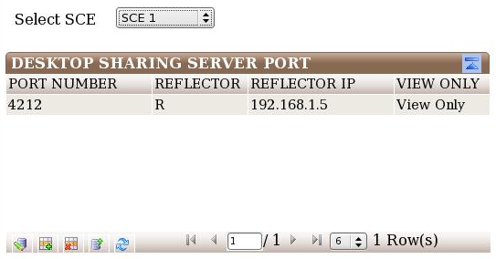
- Details of code for class Conditionalgrid
Conditional grid is very much similar of DBGrid. Only difference is that Conditional grid has one or more drop downs called selector. The selector is defined in the following way

<selector id="forum_id" class="combo" contentid="ForumMsgMgmtAdminContent" behaviourid="ForumMsgMgmtAdminBehaviour" domaintype="query" value="select forum_id,forum_name from forum" gridrefresh="true" influence="thread_id"></selector>

<selector id="thread_id" class="combo" contentid="ForumMsgMgmtAdminContent" behaviourid="ForumMsgMgmtAdminBehaviour" domaintype="query" value="select thread_id,thread_title from forum_thread where forum_id=%forum_id%" gridrefresh="true" influence=""></selector>

The domaintype of selector is either query or fixed. If the domaintype is query then the query is written in the value attribute, Otherwise the options are defined in the following way

<selectoroption name="student_id" value="User Id"></selectoroption>
<selectoroption name="name" value="User Name"></selectoroption>
<selectoroption name="marks" value="Marks Obtained"></selectoroption>

contententid and behaviourid is the id attribute of <content> and <behaviour> respectively. If the value of one selector affects the another selector, then affected selector id is given to the influence attribute of the first selector.

selector id should be added to the layout.

Class Tree
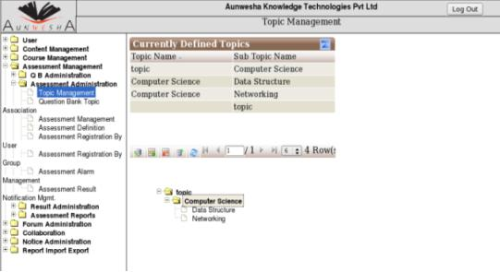

class tree is need for create tree structure.

Program Code of the class tree

<interface id="DeliveryEngine" title="DeliveryEngine" type="Interface">
<structure>

<part id="deliverymain" class="label"></part>
<part id="deliverytop" class="label"></part>
<part id="poweredbylearnity" class="label"></part>
<part id="notebooklink" class="label"></part>
<part id="quitlink" class="label"></part>
<part id="deliverytopstrip" class="label"></part>
<part id="showhidetoc" class="imagelink"></part>
<part id="showhidetoclabel" class="textlink"></part>
<part id="deliverysearchlabel" class="label"></part>
<part id="query" class="inputtext"></part>
<part id="deliverysearchgo" class="button"></part>
<part id="showtree" class="label"></part>
<part id="coursename" class="label"></part>
<part id="treediv" class="tree" treedataremotefunction="launchcourse.treeConstruct" onselectremotefunction="f1" autocollapse="true" initialiseonload="true"></part>
<part id="nodeKey" class="hidden"></part>
<part id="deliveryIframe" class="iframe"></part>
<part id="ee" class="ajaxcomponent" ></part>
<part id="previousitem" class="imagelink" ></part>
<part id="topitem" class="imagelink" ></part>
<part id="nextitem" class="imagelink" ></part>
<part id="unitedit" class="button" ></part>
<part id="APIAdapter" class="applet" archieve="cmidatamodel.jar,lmsclient.jar,debug.jar" codebase="../html/" mayscript="true"></part>
<part id="maxresults" class="inputtext" size="5"></part>
<part id="contentsearchlabel" class="label"></part>
<part id="contensearchform" class="form"></part>
</structure>
<layout id="DeliveryEnginelayout">

<part id="deliverymain" height="100%" width="100%" left="0px" top="0px" position="absolute"></part>
<part id="deliverytop" height="100px" width="900px" left="0px" top="0px" position="absolute" parent_id="deliverymain"></part>
<part id="deliverytopstrip" height="40px" width="900px" left="0px" top="100px" position="absolute" parent_id="deliverymain"></part>
<part id="showhidetoc" height="30px" width="25px" left="10px" top="5px" position="absolute" parent_id="deliverytopstrip"></part>
<part id="showhidetoclabel" height="20px" width="70px" left="40px" top="10px" position="absolute" parent_id="deliverytopstrip"></part>
<part id="showtree" height="490px" width="250px" left="0px" top="140px" position="absolute" parent_id="deliverymain"></part>
<part id="coursename" height="" width="" left="" top="" position="" parent_id="showtree"></part>
<part id="treediv" height="490px" width="250px" left="0px" top="0px" position="absolute" parent_id="showtree"></part>
<part id="deliveryIframe" height="490px" width="650px" left="250px" top="140px" position="absolute" parent_id="deliverymain"></part>
<part id="poweredbylearnity" height="40%" width="" left="50%" top="5%" position="absolute" parent_id="deliverytop"></part>
<part id="notebooklink" height="20%" width="10%" left="60%" top="70%" position="absolute" parent_id="deliverytop"></part>
<part id="quitlink" height="20%" width="5%" left="95%" top="70%" position="absolute" parent_id="deliverytop"></part>
<part id="ee" height="" width="" left="" top="" position="" parent_id="deliverymain"></part>
<part id="previousitem" height="28px" width="28px" left="10px" top="50%" position="absolute" parent_id="deliverytop"></part>
<part id="topitem" height="28px" width="28px" left="40px" top="50%" position="absolute" parent_id="deliverytop"></part>
<part id="nodeKey" height="" width="" left="" top="" position="" parent_id="deliverymain"></part>
<part id="nextitem" height="28px" width="28px" left="70px" top="50%" position="absolute" parent_id="deliverytop"></part>
<part id="APIAdapter" height="" width="" left="" top="" position="absolute" parent_id="deliverymain"></part>
<part id="contensearchform" parent_id="deliverytopstrip"></part>
<part id="deliverysearchgo" height="30px" width="45px" left="610px" top="5px" position="absolute" parent_id="contensearchform"></part>
<part id="deliverysearchlabel" height="20px" width="50px" left="150px" top="10px" position="absolute" parent_id="contensearchform"></part>
<part id="query" height="40px" width="70px" left="205px" top="5px" position="absolute" parent_id="contensearchform"></part>
<part id="maxresults" height="40px" width="30px" left="530px" top="5px" position="absolute" parent_id="contensearchform"></part>
<part id="contentsearchlabel" height="30px" width="130px" left="400px" top="5px" position="absolute" parent_id="contensearchform"></part>

</layout>
<layout id="DeliveryEnginelayoutContentEditor">

<part id="deliverymain" height="100%" width="100%" left="0px" top="0px" position="absolute"></part>
<part id="deliverytop" height="100px" width="900px" left="0px" top="0px" position="absolute" parent_id="deliverymain"></part>
<part id="deliverytopstrip" height="40px" width="900px" left="0px" top="100px" position="absolute" parent_id="deliverymain"></part>
<part id="showhidetoc" height="30px" width="25px" left="10px" top="5px" position="absolute" parent_id="deliverytopstrip"></part>
<part id="showhidetoclabel" height="20px" width="70px" left="40px" top="10px" position="absolute" parent_id="deliverytopstrip"></part>
<part id="showtree" height="490px" width="250px" left="0px" top="140px" position="absolute" parent_id="deliverymain"></part>
<part id="coursename" height="" width="" left="" top="" position="" parent_id="showtree"></part>
<part id="treediv" height="490px" width="250px" left="0px" top="0px" position="absolute" parent_id="showtree"></part>
<part id="deliveryIframe" height="490px" width="650px" left="250px" top="140px" position="absolute" parent_id="deliverymain"></part>
<part id="poweredbylearnity" height="40%" width="" left="50%" top="5%" position="absolute" parent_id="deliverytop"></part>
<part id="notebooklink" height="20%" width="10%" left="60%" top="70%" position="absolute" parent_id="deliverytop"></part>
<part id="quitlink" height="20%" width="5%" left="95%" top="70%" position="absolute" parent_id="deliverytop"></part>
<part id="ee" height="" width="" left="" top="" position="" parent_id="deliverymain"></part>
<part id="previousitem" height="28px" width="28px" left="10px" top="50%" position="absolute" parent_id="deliverytop"></part>
<part id="topitem" height="28px" width="28px" left="40px" top="50%" position="absolute" parent_id="deliverytop"></part>
<part id="nodeKey" height="" width="" left="" top="" position="" parent_id="deliverymain"></part>
<part id="nextitem" height="28px" width="28px" left="70px" top="50%" position="absolute" parent_id="deliverytop"></part>
<part id="unitedit" height="60%" width="" left="570px" top="30%" position="absolute" parent_id="deliverytop"></part>
<part id="APIAdapter" height="" width="" left="" top="" position="absolute" parent_id="deliverymain"></part>
<part id="contensearchform" parent_id="deliverytopstrip"></part>
<part id="deliverysearchgo" height="30px" width="45px" left="610px" top="5px" position="absolute" parent_id="contensearchform"></part>
<part id="deliverysearchlabel" height="20px" width="50px" left="150px" top="10px" position="absolute" parent_id="contensearchform"></part>
<part id="query" height="40px" width="70px" left="205px" top="5px" position="absolute" parent_id="contensearchform"></part>
<part id="maxresults" height="40px" width="30px" left="530px" top="5px" position="absolute" parent_id="contensearchform"></part>
<part id="contentsearchlabel" height="30px" width="130px" left="400px" top="5px" position="absolute" parent_id="contensearchform"></part>

</layout>
<content id="DeliveryEnginecontent">
<part id="deliverymain" value="" valuetype=""></part>
<part id="deliverytop" value="" valuetype=""></part>
<part id="deliverytopstrip" value="" valuetype=""></part>
<part id="showhidetoc" value="hidetoc" valuetype="reference"></part>
<part id="showhidetoclabel" value="Hide toc" valuetype="inline"></part>
<part id="deliverysearchlabel" value="Search" valuetype="inline"></part>
<part id="query" value="" valuetype=""></part>
<part id="deliverysearchgo" value="GO" valuetype="inline"></part>
<part id="showtree" value="" valuetype=""></part>
<part id="treediv" value="" valuetype=""></part>
<part id="poweredbylearnity" value="" valuetype="cdata"><![CDATA[<font size="2"><b><i>Powered By</i></b><font color=\"#FF0000\"><b>&nbsp;&nbsp;LearnITy&#8482;</b></font></font>]]></part>
<part id="notebooklink" value="" valuetype="cdata"><![CDATA[<a href="javascript:launchNoteBook()" style="text-decoration:none"><font size="2">NoteBook</font></a>]]></part>
<part id="quitlink" value="" valuetype="cdata"><![CDATA[<a href="javascript:doConfirm()" style="text-decoration:none"><font size="2">Quit</font></a>]]></part>
<part id="previousitem" value="previousitem" valuetype="reference"></part>
<part id="topitem" value="topitem" valuetype="reference"></part>
<part id="nextitem" value="nextitem" valuetype="reference"></part>
<part id="APIAdapter" value="" valuetype=""></part>
<part id="contentsearchlabel" value="Results Per Page" valuetype="inline"></part>
</content>
<content id="DeliveryEnginecontentEditor">
<part id="deliverymain" value="" valuetype=""></part>
<part id="deliverytop" value="" valuetype=""></part>
<part id="deliverytopstrip" value="" valuetype=""></part>
<part id="showhidetoc" value="hidetoc" valuetype="reference"></part>
<part id="showhidetoclabel" value="Hide toc" valuetype="inline"></part>
<part id="deliverysearchlabel" value="Search" valuetype="inline"></part>
<part id="query" value="" valuetype=""></part>
<part id="deliverysearchgo" value="GO" valuetype="inline"></part>
<part id="showtree" value="" valuetype=""></part>
<part id="treediv" value="" valuetype=""></part>
<part id="poweredbylearnity" value="" valuetype="cdata"><![CDATA[<font size="2"><b><i>Powered By</i></b><font color=\"#FF0000\"><b>&nbsp;&nbsp;LearnITy&#8482;</b></font></font>]]></part>
<part id="notebooklink" value="" valuetype="cdata"><![CDATA[<a href="javascript:launchNoteBook()" style="text-decoration:none"><font size="2">NoteBook</font></a>]]></part>
<part id="quitlink" value="" valuetype="cdata"><![CDATA[<a href="javascript:doConfirm()" style="text-decoration:none"><font size="2">Quit</font></a>]]></part>
<part id="previousitem" value="previousitem" valuetype="reference"></part>
<part id="topitem" value="topitem" valuetype="reference"></part>
<part id="nextitem" value="nextitem" valuetype="reference"></part>
<part id="unitedit" value="Edit" valuetype="inline"></part>
<part id="APIAdapter" value="" valuetype=""></part>
<part id="contentsearchlabel" value="Results Per Page" valuetype="inline"></part>
</content>
<style id="DeliveryEnginestyle">
<part id="deliverymain" value="[CDATA[background-color: #FFFFFF]]" valuetype="inline"></part>
<part id="deliverytop" value="[CDATA[background-color: #FFF7E5]]" valuetype="inline"></part>
<part id="deliverytopstrip" value="[CDATA[background-color: #6699CC]]" valuetype="inline"></part>
<part id="showhidetoclabel" value="[CDATA[color: #FFFFFF;text-decoration:none;font-size: 12px;]]" valuetype="inline"></part>
<part id="deliverysearchlabel" value="[CDATA[color: #FFFFFF;text-decoration:none;font-size: 12px;]]" valuetype="inline"></part>
<part id="showtree" value="[CDATA[background-color: #D6D6C0;overflow:auto]]" valuetype="inline"></part>
<part id="coursename" value="[CDATA[background-color: #D6D6C0]]" valuetype="inline"></part>
<part id="treediv" value="" valuetype=""></part>
<part id="poweredbylearnity" value="[CDATA[background-color: #FFF7E5]]" valuetype="inline"></part>
<part id="notebooklink" value="[CDATA[background-color: #FFF7E5]]" valuetype="inline"></part>
<part id="quitlink" value="[CDATA[background-color: #FFF7E5]]" valuetype="inline"></part>
<part id="previousitem" value="" valuetype=""></part>
<part id="topitem" value="" valuetype=""></part>
<part id="nextitem" value="" valuetype=""></part>
<part id="deliveryIframe" value="[CDATA[background-color: #FFFFFF]]" valuetype="inline"></part>
<part id="contentsearchlabel" value="[CDATA[color: #FFFFFF;text-decoration:none;font-size: 14px;]]" valuetype="inline"></part>
</style>

<behaviour id="DeliveryEnginebehaviour">

<part id="root">
<event name="onload_onclick();init()" type="simple" function="" callback="" javaclass="" target="" valuetype="" resourceid="deliveryjs"></event>
</part>
<part id="ee">
<event name="" type="simple" function="" callback="" javaclass="launchcourse" target="" valuetype="" resourceid=""></event>
</part>
<part id="treeDiv">
<event name="" type="simple" function="" callback="" javaclass="" target="" valuetype="" resourceid="treejs"></event>
</part>
<part id="deliveryIframe">
<event name="invokeurl" type="simple" function="./interfaceengine.PortalServlet?IID=DeliveryHomePage" callback="" javaclass="" target="" valuetype="inline" resourceid=""></event>
</part>
<part id="previousitem">
<event name="onclick" type="simple" function="previousitem1" callback="" javaclass="" target="" valuetype="jsevent" resourceid=""></event>
</part>
<part id="topitem">
<event name="onclick" type="simple" function="topitem_onclick" callback="" javaclass="" target="" valuetype="jsevent" resourceid=""></event>
</part>
<part id="nextitem">
<event name="onclick" type="simple" function="nextitem1" callback="" javaclass="" target="" valuetype="jsevent" resourceid=""></event>
</part>
<part id="nextitem">
<event name="onclick" type="simple" function="show_hide_toc" callback="" javaclass="" target="" valuetype="jsevent" resourceid=""></event>
</part>
<part id="showhidetoc">
<event name="onclick" type="simple" function="show_hide_toc" callback="" javaclass="" target="" valuetype="jsevent" resourceid=""></event>
</part>
<part id="showhidetoclabel">
<event name="onclick" type="simple" function="show_hide_toc" callback="" javaclass="" target="" valuetype="jsevent" resourceid=""></event>
</part>
<part id="deliverysearchgo">
<event name="onclick" type="simple" function="delivery_search_onclick" callback="" javaclass="" target="" valuetype="jsevent" resourceid=""></event>
</part>
<part id="APIAdapter">
<event name="" type="simple" function="org.adl.samplerte.client.APIAdapterApplet.class" callback="" javaclass="" target="" valuetype="" resourceid=""></event>
</part>
</behaviour>
<behaviour id="DeliveryEnginebehaviourContentEditor">

<part id="root">
<event name="onload_onclick();init()" type="simple" function="" callback="" javaclass="" target="" valuetype="" resourceid="deliveryjs"></event>
</part>
<part id="ee">
<event name="" type="simple" function="" callback="" javaclass="launchcourse" target="" valuetype="" resourceid=""></event>
</part>
<part id="treeDiv">
<event name="" type="simple" function="" callback="" javaclass="" target="" valuetype="" resourceid="treejs"></event>
</part>
<part id="deliveryIframe">
<event name="invokeurl" type="simple" function="./interfaceengine.PortalServlet?IID=DeliveryHomePage" callback="" javaclass="" target="" valuetype="inline" resourceid=""></event>
</part>
<part id="previousitem">
<event name="onclick" type="simple" function="previousitem1" callback="" javaclass="" target="" valuetype="jsevent" resourceid=""></event>
</part>
<part id="topitem">
<event name="onclick" type="simple" function="topitem_onclick" callback="" javaclass="" target="" valuetype="jsevent" resourceid=""></event>
</part>
<part id="nextitem">
<event name="onclick" type="simple" function="nextitem1" callback="" javaclass="" target="" valuetype="jsevent" resourceid=""></event>
</part>
<part id="unitedit">
<event name="onclick" type="simple" function="launch_editor" callback="" javaclass="" target="" valuetype="jsevent" resourceid=""></event>
</part>
<part id="showhidetoc">
<event name="onclick" type="simple" function="show_hide_toc" callback="" javaclass="" target="" valuetype="jsevent" resourceid=""></event>
</part>
<part id="showhidetoclabel">
<event name="onclick" type="simple" function="show_hide_toc" callback="" javaclass="" target="" valuetype="jsevent" resourceid=""></event>
</part>
<part id="deliverysearchgo">
<event name="onclick" type="simple" function="delivery_search_onclick" callback="" javaclass="" target="" valuetype="jsevent" resourceid=""></event>
</part>
<part id="APIAdapter">
<event name="" type="simple" function="org.adl.samplerte.client.APIAdapterApplet.class" callback="" javaclass="" target="" valuetype="" resourceid=""></event>
</part>
</behaviour>
<resource>
<resourceitem id="deliveryjs" href="deliveryjs.js" valuetype="js"></resourceitem>
<resourceitem id="previousitem" href="PreviousArrow.gif" valuetype="image"></resourceitem>
<resourceitem id="topitem" href="TOCIcon.gif" valuetype="image"></resourceitem>
<resourceitem id="nextitem" href="NextArrow.gif" valuetype="image"></resourceitem>
<resourceitem id="hidetoc" href="hidetoc.gif" valuetype="image"></resourceitem>
<resourceitem id="treejs" href="dynatree.js" valuetype="js"></resourceitem>
</resource>
</interface>

Snapshot of the above xml :

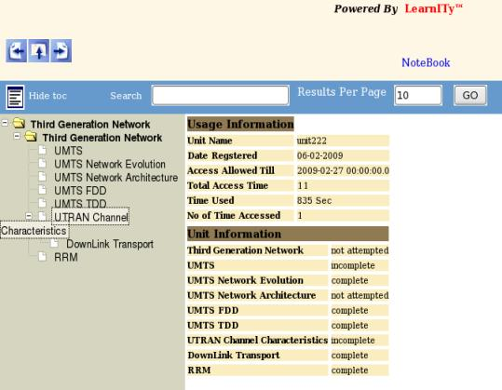

Generating Javascript code for tree class inside source code:

function GenerateTree()
{
launchcourse.treeConstruct
(function(data){
setValue('treediv',data);
$("#treediv").dynatree({
title: "Sample",
autoCollapse: true,
keyboard: true,
onSelect: function(dtnode) {
f1(dtnode)
} });});
}
function f1(dtnode){

var url1=dtnode.data.url;
var length1=url1.length;
var s1=url1.substring(length1-4,length1);
var browserName = navigator.appName;
var browserVersion = parseInt(navigator.appVersion);
if(s1!='asmt'){
//alert(s1);
document.getElementById("deliveryIframe").src = dtnode.data.url;
$("#nodeKey").val(dtnode.data.key);
launchcourse.onselectTitle(dtnode.data.key,dtnode.data.tooltip,function(data) {
var b=data;
//alert("..."+b);

if(b=='true')
{
location.href="./interfaceengine.PortalServlet?IID=LoginPage";
}
});
}
else{
$("#nodeKey").val(dtnode.data.key);
launchcourse.getEmbeddedAssessment(dtnode.data.url,function(data){
var filename1=data[0];
var cid=data[1];
if(browserName == 'Microsoft Internet Explorer' && browserVersion >=4){
document.getElementById("deliveryIframe").src = "./learnityasmtserver.assessmentportal.embeddedasmt.Assessment?s="+filename1+"&cid="+cid+"&identifier="+dtnode.data.key;
}
else {
document.getElementById("deliveryIframe").src = "./learnityasmtserver.assessmentportal.embeddedasmt.AssessmentXHTML?s="+filename1+"&cid="+cid+"&identifier="+dtnode.data.key;
}
});

}
}

The Procedure of defining tree class in interface.xml is
<part id="treediv" class="tree" treedataremotefunction="launchcourse.treeConstruct" onselectremotefunction="f1" autocollapse="true" initialiseonload="true"></part>
here launchcourse is pojo class name and treeConstruct is function name of the pojo class name. For on select event in tree links if you want to call any function please write function name, here f1 is the function name. After that what ever you want to write inside function f1, please write in a js file and define it in interface.xml file using resource tag.
<behaviour>
<part id="treeDiv">
<event name="" type="simple" function="" callback="" javaclass="" target="" valuetype="" resourceid="treejs"></event>
</part>
</behaviour>
<resource>
<resourceitem id="treejs" href="dynatree.js" valuetype="js"></resourceitem>
</resource>

here dynatree.js is the js file and it is define here using resourceitem id treejs.
When interface engine reads the name of the js file it finds that file and read contents from it and in generating code paste inside of function f1 in source code.
autocollapse="true" means tree nodes will automatic collapse.
initialiseonload="true" means GenerateTree function will call at the time of page loading otherwise write false and call GenerateTree function from anywhere else as you need.

Class Static Tree
statictree class is require to create a tree whose nodes are fixed and known to application programmer.
Structure | Attribute | Comment | Value
Structure | lazynode
Structure | tooltip
Structure | onselectremotefunction
Structure | initialiseonload

Program Code of the class statictree
Code in interface.xml
Structure
<structure>
<part id="lex-admin-menu" class="statictree" lazynode="" tooltip="true" onselectremotefunction="f12" initialiseonload="true">
<treedata>
<node key="1" title="Lexicographer Admin" isFolder="true" url="">
<node key="1a" title="Lexicographer Load Summary" url="./interfaceengine.PortalServlet?IID=loadSummary" isFolder="false"></node>
<node key="2a" title="Lexicographer Load Management" url="./interfaceengine.PortalServlet?IID=individualLoadSummary" isFolder="false"></node>
<node key="3a" title="Lexicographer Assign Words" url="./interfaceengine.PortalServlet?IID=AssignWords" isFolder="false"></node>
<node key="4a" title="Lexicographer Auto Load Assignment" url="./interfaceengine.PortalServlet?IID=AutoLoadAssignments" isFolder="false"></node>
<node key="5a" title="Tl Lexicographer Association" url="./interfaceengine.PortalServlet?IID=TlLexAssociation" isFolder="false"></node>
<node key="6a" title="Word Completion Criteria" url="./interfaceengine.PortalServlet?IID=wordcompletioncriteria" isFolder="false"></node>
<node key="7a" title="Export Management" url="./interfaceengine.PortalServlet?IID=crawlerexport" isFolder="false"></node>
<node key="8a" title="Import Management" url="./interfaceengine.PortalServlet?IID=crawlerimport" isFolder="false"></node>
<node key="9a" title="Performance Dashboard" url="./interfaceengine.PortalServlet?IID=performancedashboard" isFolder="false"></node>
<node key="10a" title="Browse" url="" isFolder="true">
<node key="10a1" title="Sentence Queue" url="./interfaceengine.PortalServlet?IID=BrowseSentenceQueue" isFolder="false"></node>
<node key="10a2" title="Image Queue" url="./interfaceengine.PortalServlet?IID=BrowseImageQueue" isFolder="false"></node>
<node key="10a3" title="Video Queue" url="./interfaceengine.PortalServlet?IID=BrowseVideoQueue" isFolder="false"></node>
<node key="10a4" title="Pronunciation Queue" url="./interfaceengine.PortalServlet?IID=BrowsePronunQueue" isFolder="false"></node>
</node>
<node key="11a" title="Lex Status Export" url="./interfaceengine.PortalServlet?IID=LexStatusExport" isFolder="false"></node>
<node key="12a" title="Reports" url="" isFolder="true">
<node key="12a1" title="View Report" url="./interfaceengine.PortalServlet?IID=Reports" isFolder="false"></node>
</node>
</node>
</treedata>

</part>
<part id="lex-tl-menu" class="statictree" lazynode="true" tooltip="true" onselectremotefunction="f12" initialiseonload="true">
<treedata>
<node key="1" title="Team Leader" isFolder="true" url="">
<node key="1a" title="View Unapproved Item" url="./interfaceengine.PortalServlet?IID=ViewItem" isFolder="false"></node>
<node key="1aa" title="View Approved Item" url="./interfaceengine.PortalServlet?IID=Production" isFolder="false"></node>
<node key="11a" title="View Discarded Item" url="./interfaceengine.PortalServlet?IID=ViewDiscardedItem" isFolder="false"></node>
</node>
</treedata>
</part>
</structure>
Behaviour
<behaviour id="lex-admin-behaviour">
<part id="lex-admin-menu">
<event name="" type="simple" function="" callback="" javaclass="" target="" valuetype="" resourceid="treejs"/>
</part>
<part id="lex-mn-menu">
<event name="" type="simple" function="" callback="" javaclass="" target="" valuetype="" resourceid="treejs"/>
</part>
</behaviour>
<resource>
<resourceitem id="treejs" href="tree.js" valuetype="js"/>
</resource>

lazynode attribute defines, is all node will create or only root node will create at the time of initialization. lazynode="true" means only root node will create at the time of initialization and after loading page, when you click a node its child nodes will be created. lazynode="false" means all node will create at the time of initialization.
tooltip="true" will show tooltip of a node .
Onselectremotefunction attribute defines a function name. This function is called when you
click a node.
onselectremotefunction="f12", Here f12 is the function name.
autocollapse="true" means tree nodes will automatic collapse.
initialiseonload="true" means GenerateTree function will call at the time of page loading otherwise write false and call GenerateTree function from anywhere else as you need.
<resourceitem id="treejs" href="tree.js" valuetype="js"/>
here treejs.js is the js file and it is define here using resourceitem id treejs.
When interface engine reads the name of the js file it finds that file and read contents from it and in generating code paste inside of function f12 in source code.
In given example node Browse is one of parent the parent node and Sentence Queue, Image Queue, Video Queue all are child node of node Browse.
Write xml structure of nodes inside tag <treedata></treedata>
Such as,
<treedata>
<node key="1" title="Team Leader" isFolder="true" url="">
<node key="1a" title="View Unapproved Item" url="./interfaceengine.PortalServlet?IID=ViewItem" isFolder="false"></node>
</node>
</treedata>
Attribute title is the node name and key is it's unique identity. Node Team Leader is the parent node of node View Unapproved Item.

Generated javascript code inside for statictree class inside source code
When lazynode is true.
function GenerateTree()
{
$("#lex-tl-menu").dynatree({
initAjax: {url: "./interfaceengine.jsonWriter?interface_id=lexAdmin&part_id=lex-tl-menu&islazynode=true&tooltip=true&classname=statictree",
data: {key: "root"}
},
onActivate: function(dtnode) {
f12(dtnode);
}
,onLazyRead: function(dtnode){
dtnode.appendAjax(
{url: "./interfaceengine.jsonWriter?interface_id=lexAdmin&part_id=lex-tl-menu&islazynode=true&tooltip=true&classname=statictree",
data: {key: dtnode.data.key
}
});
}
});
}
function f12(dtnode){
document.getElementById('lex-admin-iframe').src = dtnode.data.url;
$("#lex-admin-header-page").text(dtnode.data.title);
when lazynode is false

function GenerateTree()
{
$("#lex-mn-menu").dynatree({
initAjax: {url: "./interfaceengine.jsonWriter?interface_id=lexAdmin&part_id=lex-mn-menu&islazynode=&tooltip=true&classname=statictree",
data: {key: "root"}
},
onActivate: function(dtnode) {
f12(dtnode);
}
});
}
function f12(dtnode){
document.getElementById('lex-admin-iframe').src = dtnode.data.url;
$("#lex-admin-header-page").text(dtnode.data.title);
}

Class Dynamictree
dynamictree class is require to create a tree whose nodes will be dynamically generated from database.

Program Code of the class dynamictree
Code in interface.xml
<structure>
<part id="lex-admin-menu" class="dynamictree" autocollapse="true" lazynode="false" tooltip="false" onselectremotefunction="f12" initialiseonload="true" parentquery="select a.c_id,a.topic_name from admintree a,admintree_main m where a.p_id='0' and a.course_id=m.course_id and m.course_id=%course_id%" childquery="select a.c_id,a.topic_name from admintree a,admintree_main m where a.p_id=? and a.course_id=m.course_id and m.course_id=%course_id%" parameter="course_id"></part>
</structure>
<behaviour id="lex-admin-behaviour">
<part id="lex-admin-menu">
<event name="" type="simple" function="" callback="" javaclass="" target="" valuetype="" resourceid="treejsadmin"/>
</part>
</behaviour>
<resource>
<resourceitem id="treejsadmin" href="tree1.js" valuetype="js"/>
</resource>
lazynode attribute defines, is all node will create or only root node will create at the time of initialization. lazynode="true" means only root node will create at the time of initialization and after loading page, when you click a node its child nodes will be created. lazynode="false" means all node will create at the time of initialization.
tooltip="true" will show tooltip of a node .
Onselectremotefunction attribute defines a function name. This function is called when you
click a node.
onselectremotefunction="f12", Here f12 is the function name.
autocollapse="true" means tree nodes will automatic collapse.
initialiseonload="true" means GenerateTree function will call at the time of page loading otherwise write false and call GenerateTree function from anywhere else as you need.
<resourceitem id="treejsadmin" href="tree1.js" valuetype="js"/>
here tree1.js is the js file and it is define here using resourceitem id treejsadmin.
When interface engine reads the name of the js file it finds that file and read contents from it and in generating code paste inside of function f12 in source code.
parentquery attribute defines a query to access root nodes from database. childquery attribute defines a query to access child nodes from database. parameter defines parameters of the both queries.
In given example course_id is a parameter name.

Generated javascript code inside for dynamictree class inside source code
When lazynode is true.
function GenerateTree()
{
$("#lex-tl-menu").dynatree({
initAjax: {url: "./interfaceengine.jsonWriter?interface_id=lexAdmin&part_id=lex-tl-menu&islazynode=true&tooltip=true&classname=statictree",
data: {key: "root"}
},
onActivate: function(dtnode) {
f12(dtnode);
}
,onLazyRead: function(dtnode){
dtnode.appendAjax(
{url: "./interfaceengine.jsonWriter?interface_id=lexAdmin&part_id=lex-tl-menu&islazynode=true&tooltip=true&classname=statictree",
data: {key: dtnode.data.key
}
});
}
});
}
function f12(dtnode){
document.getElementById('lex-admin-iframe').src = dtnode.data.url;
$("#lex-admin-header-page").text(dtnode.data.title);
when lazynode is false

function GenerateTree()
{
$("#lex-mn-menu").dynatree({
initAjax: {url: "./interfaceengine.jsonWriter?interface_id=lexAdmin&part_id=lex-mn-menu&islazynode=&tooltip=true&classname=statictree",
data: {key: "root"}
},
onActivate: function(dtnode) {
f12(dtnode);
}
});
}
function f12(dtnode){
document.getElementById('lex-admin-iframe').src = dtnode.data.url;
$("#lex-admin-header-page").text(dtnode.data.title);
}

- Use of class DBform
When we want to use a form, we have to use class DBform, and in the <structure> part we have to mention the elements of the entire form. Using this class we can access the data from database using the query defined inside the <select></selects> tag.
“Add”, and “Modify” actions can be done in this class by the queries defined inside <add></add> and <modify></modify> tags respectively.

Structure | Attribute | Comment | value
Structure | class
Structure | type | Define element type | auto/entered
Structure | selectindex | Indexing for select query | User given like 1,2,3...
Structure | modifyindex | Indexing for modify query | User given like 1,2,3...
Structure | insertindex | Indexing for add query | User given like 1,2,3...
Structure | required |  | true/false
Structure | minlength | Minimum value length | User given
Structure | maxlength | Maximum value length | User given
Structure | equalto | Compare to one element value to another element value | equalto=another elemnt_id
Structure | number | Value must be a number | true/false
Structure | email | Value must be a valid email like abc@aunwesha.com | true/false
Structure | requiredmess | Use for required message entered by user | User given
Structure | minlengthmess | Minimum length message
Structure | maxlengthmess | Maximum length message
Structure | equaltomess
Structure | numbermess
Structure | emailmess
Structure | size | Element size

- Program code for class DBform

interface id="kBagParagraphEditor" title="kBagParagraphEditor" type="Interface">
<configuration createsession="true" checkrole="true" />
<structure>
<part id="kBagParagraphEditorMain" class="label" />
<part id="kBagParagraphEditorFormDiv" class="label" />
<part id="kBagParagraphEditorEditForm" class="DBform">
<element id="kbagHeadingLevel" class="label" />
<element id="kbagParentLevel" class="label" />
<element id="unit_id" class="hidden" type="entered" selectindex="1" insertindex="1" />
<element id="node_id" class="hidden" type="entered" selectindex="2" />
<element id="parent_node_id" class="combo" type="entered" tabindex="2" selectindex="3" insertindex="2" modifyindex="2" />
<element id="node_type" class="hidden" type="entered" selectindex="4" insertindex="3" />
<element id="kbagHeadingText" class="textarea" rows="10" cols="70" size="100" tabindex="4" type="entered" selectindex="5" insertindex="4" modifyindex="1"/>

<select>
<query id="1" sql="select unit_id,node_id,parent_node_id,node_type,node_content from rksknowledgebag.unit_content where node_id=%node_id% and unit_id=%unit_id%" parameter="node_id,unit_id" /></select>
<modify>
<query id="1" sql="update rksknowledgebag.unit_content set node_content=%kbagHeadingText%, parent_node_id=%parent_node_id% where unit_id=%unit_id% and node_id=%node_id%" parameter="kbagHeadingText,parent_node_id,unit_id,node_id" />
</modify>
<add>
<query id="1" sql="insert into rksknowledgebag.unit_content(unit_id,parent_node_id,node_type,node_content) values(%unit_id%,%parent_node_id%,%node_type%,%kbagHeadingText%)" parameter="unit_id,parent_node_id,node_type,kbagHeadingText" />
</add>
</part>
<part id="kBagParagraphEditorFormControl" class="label" />
<part id="kBagErrorMessage" class="label" />
<part id="kBagParagraphEditorSubmit" class="button" tabindex="3" />
<part id="kBagParagraphEditorDelete" class="button" tabindex="4" />
<part id="kBagParagraphEditorAjaxComp" class="ajaxcomponent" />
<part id="kBagParagraphEditorAuxAjax" class="ajaxcomponent" />
</structure>
<layout id="kBagParagraphEditorLayout">
<part id="kBagParagraphEditorMain" height="350px" width="500px" left="0px" top="0px" position="absolute" />
<part id="kBagParagraphEditorFormDiv" height="auto" width="450px" left="0px" top="20px" position="absolute" parent_id="kBagParagraphEditorMain" />
<part id="kBagParagraphEditorEditForm" parent_id="kBagParagraphEditorFormDiv" />
<part id="kbagHeadingLevel" height="20px" width="150px" left="20px" top="0px" position="absolute" parent_id="kBagParagraphEditorEditForm" />
<part id="kbagHeadingText" height="30px" width="500px" left="20px" top="30px" position="absolute" parent_id="kBagParagraphEditorEditForm" />
<part id="parent_node_id" height="30px" width="100px" left="180px" top="240px" position="absolute" parent_id="kBagParagraphEditorEditForm" />
<part id="node_type" height="" width="" left="" top="" position="" parent_id="kBagParagraphEditorEditForm" />
<part id="kbagParentLevel" height="20px" width="150px" left="20px" top="240px" position="absolute" parent_id="kBagParagraphEditorEditForm" />
<part id="unit_id" height="" width="" left="" top="" position="" parent_id="kBagParagraphEditorEditForm" />
<part id="node_id" height="" width="" left="" top="" position="" parent_id="kBagParagraphEditorEditForm" />
<part id="kBagErrorMessage" height="40px" width="560px" left="20px" top="330px" position="absolute" parent_id="kBagParagraphEditorMain" />
<part id="kBagParagraphEditorFormControl" height="40px" width="560px" left="20px" top="350px" position="absolute" parent_id="kBagParagraphEditorEditForm" />
<part id="kBagParagraphEditorSubmit" height="" width="60px" left="10px" top="10px" position="absolute" parent_id="kBagParagraphEditorFormControl" />
<part id="kBagParagraphEditorDelete" height="" width="60px" left="75px" top="10px" position="absolute" parent_id="kBagParagraphEditorFormControl" />
<part id="kBagParagraphEditorAjaxComp" height="" width="" left="" top="" position="" parent_id="kBagParagraphEditorMain" />
<part id="kBagParagraphEditorAuxAjax" height="" width="" left="" top="" position="" parent_id="kBagParagraphEditorMain" />
</layout>
<content id="kBagParagraphEditorContent">
<part id="kbagHeadingLevel" value="Paragraph" valuetype="inline" />
<part id="kBagParagraphEditorSubmit" value="Save" valuetype="inline" />
<part id="kBagParagraphEditorDelete" value="Delete" valuetype="inline" />
<part id="kbagParentLevel" value="Under Topic" valuetype="inline" />
</content>
<style id="kBagParagraphEditorStyle">
<part id="kBagParagraphEditorMain" value="[CDATA[font-family : Trebuchet MS, Arial, Helvetica, sans-serif;]]" valuetype="inline" />
<part id="kbagHeadingLevel" value="[CDATA[font-size: x-medium;]]" valuetype="inline" />
<part id="kBagErrorMessage" value="[CDATA[color: red; font-size: 14px;]]" valuetype="inline" />
<part id="kBagParagraphEditorFormControl" value="[CDATA[background-color: #FFFFFF;border-top: 1px solid silver;]]" valuetype="inline" />
</style>
<behaviour id="kBagParagraphEditorBehaviour">
<part id="root">
<event name="onload_click()" type="simple" function="" callback="" javaclass="" target="" valuetype="reference" resourceid="paragrapheditjs" />
</part>
<part id="kBagParagraphEditorDelete">
<event name="onclick" type="simple" function="delete_onclick" callback="" javaclass="" target="" valuetype="inline" resourceid="" />
</part>
<part id="kBagParagraphEditorSubmit">
<event name="onclick" type="simple" function="submit_onclick" callback="" javaclass="" target="" valuetype="inline" resourceid="" />
</part>
<part id="kBagParagraphEditorAuxAjax">
<event name="" type="simple" function="" callback="" javaclass="ContentWriterPortal" target="" valuetype="" resourceid="" />
</part>
<part id="kBagParagraphEditorAjaxComp">
<event name="" type="simple" function="" callback="" javaclass="PortalEngine" target="" valuetype="" resourceid="" />
</part>
</behaviour>
<resource>
<resourceitem id="paragrapheditjs" href="paragraphedit.js" valuetype="js" />
</resource>
</interface>

- Program code of the js ( paragraphedit.js) for select, add and modify operation

var currentNode = 0;
function onload_click() {
ContentWriterPortal.getParentNodeList(function(data) {
$("select#parent_node_id").html(data);
currentNode = 0;

});
PortalEngine.getFromSession("loader", function(data) {
switch(data) {
case "tree" :
case "navbar" :
PortalEngine.getFromSession("unit_id", function(data1) {
setValue('unit_id',data1);
});
PortalEngine.getFromSession("node_id", function(data2) {
setValue('node_id',data2);
currentNode = 1;
kBagParagraphEditorEditForm_Select();
});
PortalEngine.WritetoSession("loader","" ,function(data){});
break;
default:
$("input#node_id").val("0");
PortalEngine.WritetoSession("node_id","" ,function(data){});
//alert("default case " + currentNode);
}
});
}
function submit_onclick() {
PortalEngine.getFromSession("unit_id", function(data) {
setValue('unit_id',data);
document.getElementById("node_type").value = "Paragraph";
//alert("unit_id " + (document.getElementById("unit_id")).value);
var valid = validateform("kBagParagraphEditorEditForm");
if(valid == true) {
var txtTopic = getValue("kbagHeadingText");
if(currentNode == 0) {
kBagParagraphEditorEditForm_Insert_with_Callback(appendNode);
setValue("kBagErrorMessage","Paragraph saved Successfully");
currentNode = 1;
} else {
kBagParagraphEditorEditForm_Modify_with_Callback(modifyNode);
setValue("kBagErrorMessage","Paragraph modified Successfully");
}
} else {
setValue("kBagErrorMessage","Data submission unsuccessful");
}
});
//alert('uuuuuuuuu'+document.getElementById("node_type").value);
}
function delete_onclick() {
var nodeid=document.getElementById("node_id").value;
// alert("nodeid " + nodeid);
doyou = confirm("Are you Sure want to Delete the Paragraph?");
if (doyou ==true){

ContentWriterPortal.deleteContent(nodeid, function(data) {
window.location="./interfaceengine.PortalServlet?IID=blankEditor";
//setValue("kBagErrorMessage","Delete successfully");
});
}
else{}

}
function appendNode() {
var difficultyLevel = (window.parent.document.getElementById("kbagDifficultyLevel")).value;
ContentWriterPortal.setBookmark(function (data) {
setValue("kBagErrorMessage","Bookmark saved successfully");
});
ContentWriterPortal.assignDifficultyLevel(difficultyLevel, function (data) {
setValue("kBagErrorMessage","Paragraph and it's metadata saved successfully");
});
ContentWriterPortal.getParentNodeList(function(data) {
$("select#parent_node_id").html(data);
});
ContentWriterPortal.getRecentNodeOnInsert(function(data) {
//$("#node_id").val(data);
//alert(data);
document.getElementById("node_id").value =data;
//alert("newly inserted node : " + (document.getElementById("node_id")).value);
});
}
function modifyNode() {
var difficultyLevel = (window.parent.document.getElementById("kbagDifficultyLevel")).value;
ContentWriterPortal.setBookmark(function (data) {
setValue("kBagErrorMessage","Bookmark saved successfully");
});
ContentWriterPortal.assignDifficultyLevel(difficultyLevel, function (data) {
setValue("kBagErrorMessage","Paragraph and it's metadata saved successfully");
});
}

Snapshot of the above xml :
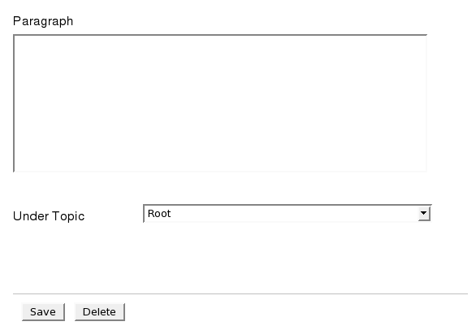

Custom Validation

In certain cases you may need to use custom action against a button like custom validation and custom database operations. In such cases the following steps would be helpful:
- Add the following tag inside the add, edit or delete tag where ever you need it
<action sequence="replace" actionname="package-name.POJO-Name"></action>
E.g.
<add>
<queries>
<query id="1" sql="[CDATA[insert into program_seat values (%course_id,%no_of_seat%)]]" parameter="course_id,no_of_seat" />
</queries>
<action sequence="replace" actionname="preadmissionadmin.CustomAction"></action>
</add>
- Create a java class as mentioned in the action tag and extend CustomEditAction.
- import the following :
java.io.*; java.text.*; java.util.*; com.aunwesha.param.*; javax.servlet.*; javax.servlet.http.*;
org.grlea.log.*; org.directwebremoting.ScriptBuffer ; org.directwebremoting.WebContext;
org.directwebremoting.WebContextFactory; org.directwebremoting.ScriptSession ;
interfaceengine.CustomEditAction;

- Implement the following methods from the super class CustomEditAction
public boolean AddAction(HttpServletRequest request)
public boolean EditAction(HttpServletRequest request)
public boolean DeleteAction(HttpServletRequest request)
- Define your custom validations and operations as needed in the required methods mentioned above.

Eg.
public boolean AddAction(HttpServletRequest request){
show("===========INSIDE AddAction ======== ");
String interface_id=request.getParameter("interface_id");
show("=============interface_id============= "+interface_id);

if(interface_id.equals("preadProgramSeat"))
addProgramSeat(request);
return true;
}

public void addProgramSeat(HttpServletRequest request)
{
String faculty_id=request.getParameter("faculty_id");
String academic=request.getParameter("academic_unit_id");
String program=request.getParameter("program_id");
String course=request.getParameter("course_id");
String session=request.getParameter("academic_session_id");
String seats=request.getParameter("no_of_seat");
boolean valid=false;
if(faculty_id==null || faculty_id.equals("") || faculty_id.equals("0")) valid=false;
else if (academic==null || academic.equals("0")) valid=false;
else if (program==null || program.equals("0")) valid=false;
else if (course==null || course.equals("0")) valid=false;
else if (session==null || session.equals("0")) valid=false;
else if (seats==null || seats.equals("") || seats.equals("0")) valid=false;
else valid=true;
if(valid)
DataBaseLayer.addProgramSeat(faculty_id,academic,program,course,session,seats);
else
show("=======Please select all the options========");

}

Report:

- Use of class report/reportwindow
When we want to execute a report(.rptdesign) on same page (i iframe), we have to use class as "report" for that part id,
<part id="reportframe" class="report" />

(if we need open the report in new window then we have to use class as "reportwindow" for that part id in place of report )
<part id="reportframe" class="reportwindow" />

and we have to add that report(.rptdesign) on “rpt_file” on content tag in the
interface.xml.
<part id="reportframe" viewer_type="html" rpt_file="tl_productivity_metrics.rptdesign">.
Also we have to add the report parameters in the <report_parameters></report_parameters> tag .

<part id="reportframe" viewer_type="html" rpt_file="tl_productivity_metrics.rptdesign">
<report_parameters>
<!-- <report_parameter name="currentDate" value="currentdate()" value_type="function"></report_parameter> -->
<report_parameter name="tl_id" value="tl_id()" value_type="function"></report_parameter>
</report_parameters>
</part>
In behaviour we have to write LoadReport in function from where we need to run report and this j LoadReport method will be generated.

<part id="showreport">
<event name="onclick" type="simple" function="LoadReport" callback="" javaclass="" target="" valuetype="jsevent" resourceid="" />
</part>
If we need run the report against combo we have to add “LoadReport” in function of that part , like this
<part id="reporttype">
<event name="onchange" type="simple" function="LoadReport" callback="" javaclass="" target="" valuetype="inline" resourceid=""/>
</part>

If there exists already a method name then we have to call “LoadReport” from that method in Java Script,
///////////////////////////////////// interface ///////////////////////////////////////
<part id="reporttype">
<event name="onchange" type="simple" function="tlselect_onchange()" callback="" javaclass="" target="" valuetype="inline" resourceid=""/>
</part>
////////////////////////////////////////////////////////////////////////////////////////////
//////////////js //////////////////////////////////////
function tlselect_onchange() {
var tlid=getValue("reporttype");
$.blockUI({ message: 'please wait........' });
Admin.insertTLProductivityMatrics(tlid,LoadReport);
}
/////////////////////////////////////////////////////////

- Program code for class report and reportwindow

<interface id="TLProdictivityMetrics" title="TLProdictivityMetrics" type="Interface">
<configuration createsession="true" checkrole="true" />
<structure>
<part id="reportsmain" class="label" />
<part id="reporttypelabel" class="label" />
<part id="reporttype" class="combo" />
<part id="reportframe" class="report" />
<part id="showreport" class="button" />
<part id="accloginajax" class="ajaxcomponent" />
</structure>
<layout id="TLProdictivityMetricsLayout">
<part id="reportsmain" height="500px" width="768px" left="0px" top="0px" position="absolute" />
<part id="reporttypelabel" height="30px" width="100px" left="20px" top="20px" position="absolute" parent_id="reportsmain" />
<part id="reporttype" height="30px" width="150px" left="130px" top="20px" position="absolute" parent_id="reportsmain" />
<part id="reportframe" height="400px" width="700px" left="1px" top="50px" position="absolute" parent_id="reportsmain" />
<part id="showreport" height="30px" width="50px" left="160px" top="110px" position="absolute" parent_id="reportsmain" />
<part id="accloginajax" height="" width="" left="" top="" position="" parent_id="reportsmain" />
</layout>
<content id="TLProdictivityMetricsContent">
<part id="reporttypelabel" value="Select report" valuetype="inline" />
<part id="reporttype" valuetype="query" value="Select u.user_id,concat(u.first_name,\' \',u.sname) from user_details u, user_role ur, role r where u.user_id=ur.user_id and ur.role_id=r.role_id and r.title=\'TEAMLEADER\'">

</part>
<part id="reportframe" viewer_type="html" rpt_file="tl_productivity_metrics.rptdesign">
<report_parameters>
<!-- <report_parameter name="currentDate" value="currentdate()" value_type="function"></report_parameter> -->
<report_parameter name="tl_id" value="tl_id()" value_type="function"></report_parameter>

</report_parameters>
</part>
<part id="showreport" value="Show Report" valuetype="inline" />
</content>
<style id="TLProdictivityMetricsStyle">
<part id="reportsmain" value="[CDATA[font: 12px Arial Bold;]]" valuetype="inline"/>
</style>
<behaviour id="TLProdictivityMetricsBehaviour">
<part id="root">
<event name="" type="simple" function="" callback="" javaclass="" target="" valuetype="reference" resourceid="reportsjs"/>
</part>
<part id="reporttype">
<event name="onchange" type="simple" function="tlselect_onchange()" callback="" javaclass="" target="" valuetype="inline" resourceid=""/>
</part>
<part id="accloginajax">
<event name="" type="simple" function="" callback="" javaclass="Admin" target="" valuetype="" resourceid=""/>
</part>
<part id="showreport">
<event name="onclick" type="simple" function="LoadReport" callback="" javaclass="" target="" valuetype="jsevent" resourceid="" />
</part>

</behaviour>
<resource>
<resourceitem id="reportsjs" href="reports.js" valuetype="js"/>
<resourceitem id="tlproductivitycss" href="tlproductivity.css" valuetype="css"></resourceitem>
</resource>
</interface>

Snapshot of the above xml :

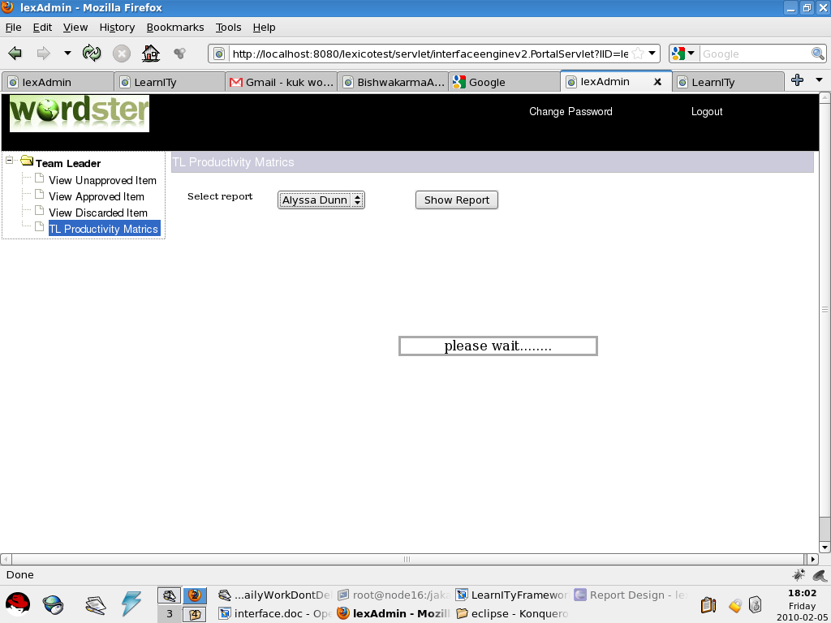

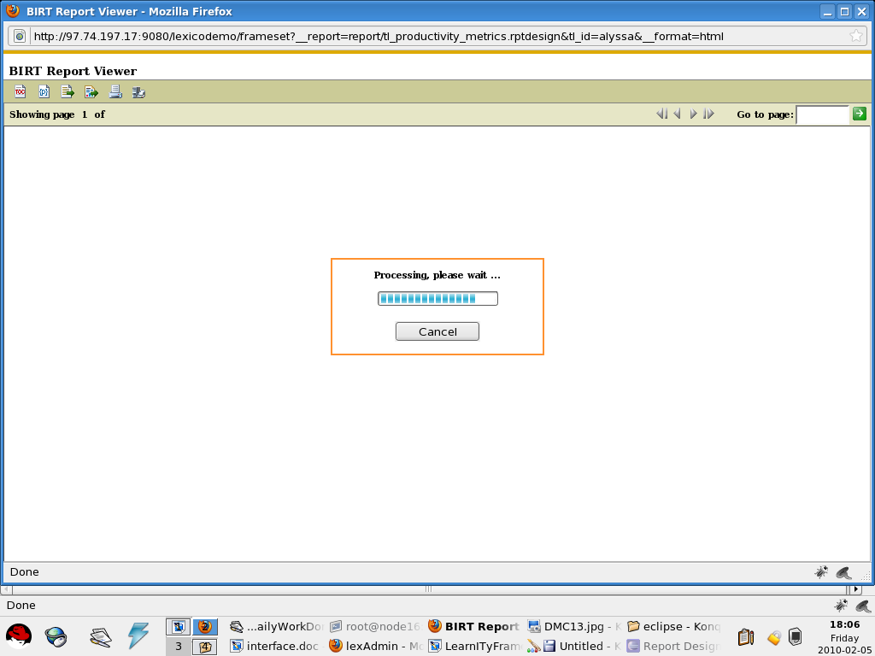

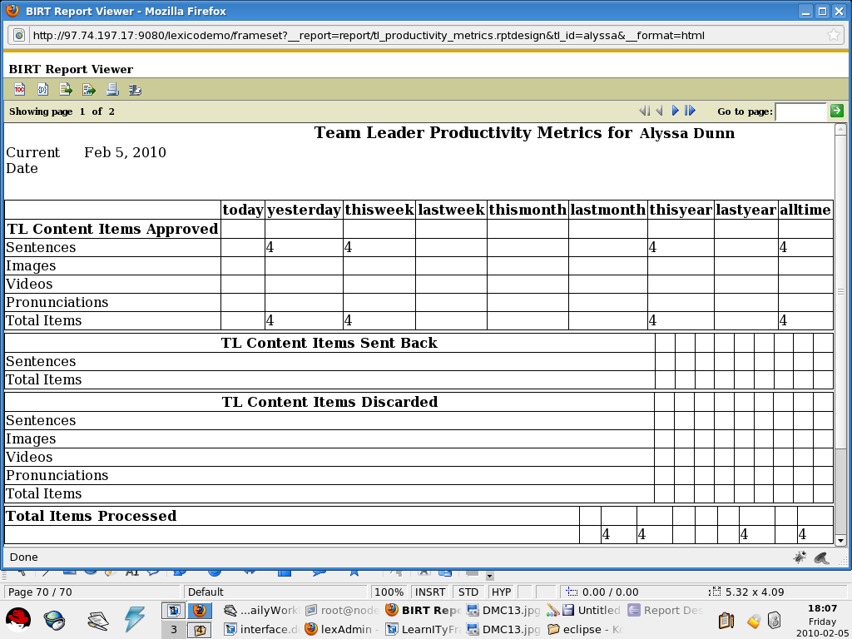

- Program code for class report and reportwindow with report_chooser

<interface id="ReportLink" title="ReportLink" type="Interface">
<configuration createsession="true" checkrole="true" />
<structure>
<part id="reportlinkmain" class="label" />
<part id="reporttypelabel" class="label" />
<part id="reporttype" class="combo" />
<part id="reportframe" class="report" />

</structure>
<layout id="ReportLinkLayout">
<part id="reportlinkmain" height="500px" width="768px" left="0px" top="0px" position="absolute" />
<part id="reporttypelabel" height="30px" width="130px" left="10px" top="20px" position="absolute" parent_id="reportlinkmain" />
<part id="reporttype" height="30px" width="150px" left="140px" top="20px" position="absolute" parent_id="reportlinkmain" />
<part id="reportframe" height="380px" width="750px" left="1px" top="50px" position="absolute" parent_id="reportlinkmain" />
</layout>
<content id="ReportLinkContent">
<part id="reporttypelabel" value="Select Report Type" valuetype="inline" />
<part id="reporttype" valuetype="fixed">
<combooption name="product_inventory.rptdesign" value="Product Inventory"></combooption>
</part>
<part id="reportframe" viewer_type="html" report_chooser="reporttype">
<report_parameters>
<report_parameter name="title" value="reporttype_onchange()" value_type="function"></report_parameter>

</report_parameters>

</part>
</content>
<style id="ReportLinkStyle">
<part id="reportlinkmain" value="reportlinkcss" valuetype="reference"></part>
</style>
<behaviour id="ReportLinkBehaviour">
<part id="root">
<event name="onload_click()" type="simple" function="" callback="" javaclass="" target="" valuetype="" resourceid="reportlinkjs"></event>
</part>
<part id="reporttype">
<event name="onchange" type="simple" function="LoadReport()" callback="" javaclass="" target="" valuetype="inline" resourceid=""></event>
</part>
</behaviour>
<resource>
<resourceitem id="reportlinkjs" href="reportlink.js" valuetype="js"/>
<resourceitem id="reportlinkcss" href="reportlink.css" valuetype="css"></resourceitem>
</resource>
</interface>

In case of report_chooser , first create drop down which will be chooser(ie, report dropdown).
<part id="reporttype" class="combo" />

<part id="reporttype" valuetype="fixed">
<combooption name="product_inventory.rptdesign" value="Product Inventory"></combooption>
</part>

copy report combo in report_chooser.
<part id="reportframe" viewer_type="html" report_chooser="reporttype">

- Program code for class report and reportwindow with Simple report(without parameter and chooser):
xml:

<interface id="BatchReport" title="BatchReport" type="Interface">
<configuration createsession="true" checkrole="true" />
<structure>
<part id="reportlinkmain" class="label" />
<part id="showreport" class="button" />
<part id="reportframe" class="report" />

</structure>
<layout id="ReportLinkLayout">
<part id="reportlinkmain" height="500px" width="768px" left="0px" top="0px" position="absolute" />
<part id="showreport" height="30px" width="150px" left="140px" top="20px" position="absolute" parent_id="reportlinkmain" />
<part id="reportframe" height="380px" width="750px" left="1px" top="50px" position="absolute" parent_id="reportlinkmain" />
</layout>
<content id="ReportLinkContent">
<part id="reportframe" viewer_type="html" rpt_file="batchdetails_report.rptdesign" />
<part id="showreport" value="Show Batch Report" valuetype="inline" />
</content>
<style id="ReportLinkStyle">

</style>
<behaviour id="ReportLinkBehaviour">
<part id="root">
<event name="" type="simple" function="" callback="" javaclass="" target="" valuetype="reference" resourceid="reportsjs"/>
</part>
<part id="showreport">
<event name="onclick" type="simple" function="run_report" callback="" javaclass="" target="" valuetype="jsevent" resourceid="" />
</part>
</behaviour>
<resource>
<resourceitem id="reportsjs" href="batch_report.js" valuetype="js"/>
</resource>
</interface>

JS:

function run_report()
{
LoadReport();
}

Chart:
- Use of class chart
Class "chart" is used for create a chart . When we want to create a chart in the web page, we have to use class as "chart" for that part id.
<part id="chart1" class="chart"></part>

In content part we have to add all parameters for that chart in between <chartstructure></chartstructure> tag.
<part id="chart1">
<chartstructure>
<matric_title>Active User</matric_title>
<description>Active User</description>
<X_axis_query>select account_status from student_details group by account_status</X_axis_query>
<series1_query>select count(account_status) from student_details group by account_status</series1_query>
<series2_query>2</series2_query>
<series3_query>3</series3_query>
<legenddata1>User Type</legenddata1>
<legenddata2>2l</legenddata2>
<legenddata3>3l</legenddata3>
<chart_type>pie</chart_type>
<subtype>0</subtype>
<width>700</width>
<height>700</height>
<yaxis_label>Active User</yaxis_label>
<color>3</color>
<transpose></transpose>
<stacked></stacked>
<chart_dimension>TwoDimensionalwithdepth</chart_dimension>
</chartstructure>
</part>

- Program code for class chart
<interface id="userChart" title="userChart" type="Interface">
<configuration createsession="true" checkrole="true" >
</configuration>
<structure>
<part id="mainpage" class="label"></part>
<part id="chart1" class="chart"></part>
<part id="Passajaxcomp" class="ajaxcomponent"></part>

</structure>
<layout id="userChartLay">

<part id="mainpage" height="100%" width="100%" left="0px" top="0px" position="absolute" > </part>
<part id="chart1" height="96%" width="96%" left="5px" top="10px" position="absolute" parent_id="mainpage"></part>
<part id="Passajaxcomp" height="" width="" left="" top="" position="" parent_id="mainpage"></part>

</layout>
<content id="userChartCont">
<part id="mainpage" value="" valuetype=""></part>

<part id="chart1">
<chartstructure>
<matric_title>Active User</matric_title>
<description>Active User</description>
<X_axis_query>select account_status from student_details group by account_status</X_axis_query>
<series1_query>select count(account_status) from student_details group by account_status</series1_query>
<series2_query>2</series2_query>
<series3_query>3</series3_query>
<legenddata1>User Type</legenddata1>
<legenddata2>2l</legenddata2>
<legenddata3>3l</legenddata3>
<chart_type>pie</chart_type>
<subtype>0</subtype>
<width>700</width>
<height>700</height>
<yaxis_label>Active User</yaxis_label>
<color>3</color>
<transpose></transpose>
<stacked></stacked>
<chart_dimension>TwoDimensionalwithdepth</chart_dimension>
</chartstructure>
</part>

</content>

</interface>
Sample User Chart:
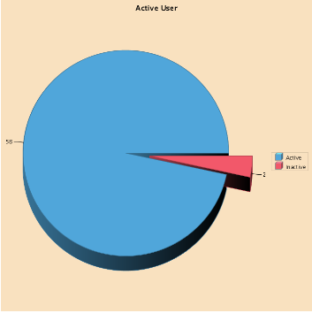

MULTIPLE BEHAVIOUR OF AN ELEMENT:

Sample source code :

<behaviour id="ApprovedSenetecebehaviour">

<part id="root">
<event name="onliad()" type="simple" function="" callback="" javaclass="" target="" valuetype="" resourceid=""></event>
</part>

<part id="accloginajax">
<event name="" type="simple" function="" callback="" javaclass="Portal" target="" valuetype="" resourceid=""></event>
</part>

<part id="creategrid">
<event name="ondblClickRow" type="simple" function="edit_onclick" callback="" javaclass="" target="" valuetype="inline" resourceid=""></event>
</part>

<part id="submitapp">
<event name="onclick" type="simple" function="submitapp_onclick" callback="" javaclass="" target="" valuetype="inline" resourceid="approvedsentence"></event>
</part>
<part id="discard">
<event name="onclick" type="simple" function="discard_onclick" callback="" javaclass="" target="" valuetype="inline" resourceid=""></event>
<event name="onkeypress" type="simple" function="checkEnter(event)" callback="" javaclass="" target="" valuetype="inline" resourceid=""></event>
</part>
</behaviour>

Here discard is a Button .We are defining two functions for the two events, discard_onclick for onclick event and checkEnter(event) for onkeypress event.

List of events :
Attribute | Value | Description
onblur | script | Script to be run when an element loses focus
onchange | ,, | Script to be run when an element change
onclick | ,, | Script to be run on a mouse click
ondblclick | ,, | Script to be run on a mouse double-click
onfocus | ,, | Script to be run when an element gets focus
onmousedown | ,, | Script to be run when mouse button is pressed
onmousemove | ,, | Script to be run when mouse pointer moves
onmouseout | ,, | Script to be run when mouse pointer moves out of an element
onkeypress | ,, | Script to be run when a key is pressed and released
onkeyup | ,, | Script to be run when a key is released
onselect | ,, | Script to be run when an element is selected

DESCRIPTION OF THEMES
The purpose of theme in framework for manage style in a page.You can create a different style for group elements in total application.For Example
<theme id="indiafirst">
<themeselement class="button" type="reference" cssclasses="c2 c3"></themeselement>
<themeselement class="inputtext" type="reference" cssclasses="c1" ></themeselement>

<cssfile>
<file name="themes1.css"></file>
<file name="themes2.css"></file>
</cssfile>
</theme>
The <theme>, <themeselement>, <cssfile>,< file> tags support the following standard attributes:
Attributes | Value | Description
id | User Given | For e.g indiafirst is a themes title.
Class | User Given | Class type like inputtext,inputbutton.
Type | reference/inline
cssclasses | User Given | Class name which you Specifies in your css file  N.B(you can use same class in different type of element)
name | User Given | In where you create all style class with properties.

Code generate by Theme
<div style="" id="CourseAssignment_CourseAssignmentUploadButtonbutton"><input type="button" value="Upload" style="" onclick="upload_onclick()" name="CourseAssignment_CourseAssignmentUploadButton" id="CourseAssignment_CourseAssignmentUploadButton" class="c2 c3"></div>
here you can see ,theme attribute Class add in html code as a button class attribute,if button has own style attribute ,then all properties of style attribute overrides on class attributes properties.

DESCRIPTION OF TEMPLATE
The purpose of template is to globally set up for configuration section,element structure section and it also embed all external resources like js,css in a page .
(you can use same template in different pages and different template in defferent pages)

<application-template title="Default">
<application-defaults>
<configuration-section>
<attribute name="ThemeID" defaultvalue=""></attribute>
<attribute name="Enable_Caching" defaultvalue=""></attribute>
<attribute name="CacheName" defaultvalue=""></attribute>
<attribute name="CacheDynamicJS" defaultvalue=""></attribute>
<attribute name="CacheDynamicCSS" defaultvalue=""></attribute>
<attribute name="CacheDynamicImage" defaultvalue=""></attribute>
</configuration-section>
<class name="inputtext">
<section name="structure">
<attribute name="size" defaultvalue="120"></attribute>
</section>
</class>
<class name="DBGrid">
<section name="structure">
<attribute name="CustomEditButton" defaultvalue="false"></attribute>
</section>
</class>
</application-defaults>

<framework-asset-delivery>
<asset type="js" deliverymode="URIPath" pagelocation="BOH" deliverysequence="1" filename="jquery.js" assetpath="../coreadmin/js/js/"/>
<asset type="css" deliverymode="URIPath" pagelocation="BOH" deliverysequence="7" filename="ui.datepicker.css" assetpath="../coreadmin/themes/"/>
</framework-asset-delivery>
</application-template>

The <application-template title>, <application-defaults>, <configuration-section>,< attribute>, <class>, <section >,<framework-asset-delivery >,<asset> tags support the following standard attributes:
Tag | Attributes | Value | Description
application-template | title | User Given | For e.g Default is template title.
Configuration-section  attribute | name | i)ThemeID=User Given  ii)Enable_Caching=T/F  iii)CacheName=User Input  iv)CacheDynamicJS=T/F  v)CacheDynamicCSS=T/F  vi)CacheDynamicImage=T/F | i) used theme in template.  ii)caching required or not.  iii)cache name.  iv)caching required for used js or not.  v)caching required for used css or not.  vi)caching required for used images or not.
class | name | User given,for e.g inputtext,dbgrid,inputbutton etc.
section | name | structure
asset | type | Js ,css
asset | deliverymode | URIPath,Inline,Dynamic
asset | pagelocation | BOB,EOB,BOH,EOH
asset | deliverysequence | 1,2,3,4 .......etc
asset | filename | For e.g jquery.js | It is required while deliverymode=URIPATH
asset | assetpath | For e.g ../coreadmin/themes/ | It is required while deliverymode=URIPATH

Template Asset Location:
1.BOB: Begining of Body
2.EOB:End of Body.
3.BOH:Begining of Head.
4.EOH:End of Head.

N.B( when you use delivery mode URIPath, you should copy your js and css file in proper assetpath. If delivery mode Inline or Dynamic it necessary to upload your js and css file from Asset File Management in coreadmin).
N.B(when you change any in your template xml ,first you upload your update xml after that in coreadmin InterfaceManagement link select your interface and click on refresh button fig:12)

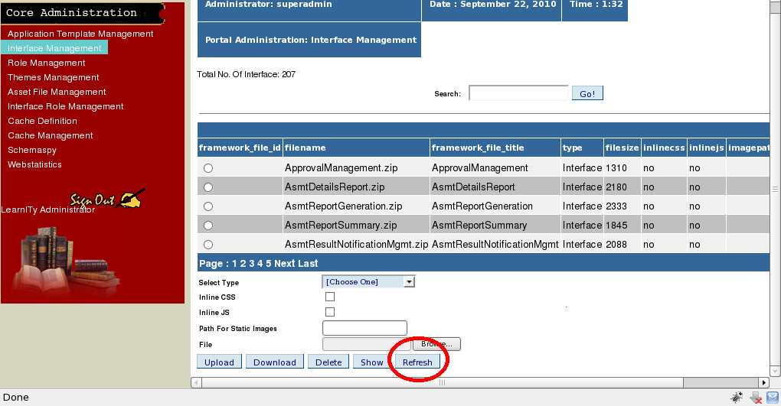
fig:12

DESCRIPTION OF CONFIGURATION ITEM
This block is use for individual set up for a particular page like role,themes etc........
<configuration createsession="true" checkrole="false" TemplateID="AT001" ThemeID="" Enable_Caching="true" CacheName="true" CacheDynamicJS="false" CacheDynamicCSS="true" CacheDynamicImage=""></configuration>

Different type of attributes are used for this block.
Attribute Name | Value | Description
createsession | true/false | If value is true ,it create new session,if value is false its working with existing session.
checkrole | true/false | If value is true that means the page first check role and gives the o/p according to role.
TemplateID | User given | If template attribute is not blank then all the properties are added in a page which is specify in Template XML.
ThemeID | User given | If themes attribute is not blank then all the properties are added in a page which is specify in THEMES XML.
Enable_Caching | true/false | It means whether the page is shown from cache or not.
CacheName | Uesr given | It used for name of the cache.
CacheDynamicJS | true/false | It means all used js in page are shown from cache or not
CacheDynamicCSS | true/false | It means all used css in page are shown from cache or not
CacheDynamicImage | true/false | It means all used images in page are shown from cache or not

Use of class Flash Component
The purpose of this class flash component is that swf file embed in your html page.It has mainly three section in interface.xml.Structure,Layout,Content.

Section | Attributes | Desc
Structure | - Id  - Class | Id is use for element id in dom standard.
Layout | - Id  - height  - width  - position  - parentid  - top  - left | Id is use for element id in dom standard.  Width is use for internal div width.  Height is use for internal div height.  Positon is two type absolute or relative
Content | - Id  - Value type  - Value  One small node structure is used for this class in content section.describe below | Id is use for element id in dom standard.  Value type only use for this class is reference.  Value means resource id .

In content section :

<part id="accportallogo" value="portallogo" valuetype="reference">
<parameters>
<parameter name="classid"></parameter>
<parameter name="codebase"></parameter>
<parameter name="align"></parameter>
<parameter name="swLiveConnect"></parameter>
<parameter name="allowScriptAccess"></parameter>
<parameter name="type"></parameter>
<parameter name="pluginspage"></parameter>
<parameter name="bgcolor" value="#D4D4C5"></parameter>
<parameter name="width" value="210"></parameter>
<parameter name="height" value="60"></parameter>
</parameters>
</part>

Parameter Attributes | Default Value(It means it is initialize in Template)Except width,height,bgcolor attributes.
classid | clsid:d27cdb6e-ae6d-11cf-96b8-444553540000
codebase | http://fpdownload.macromedia.com/pub/shockwave/cabs/flash/swflash.cab#version=8,0,0,0
align | middle
swLiveConnect | true
allowScriptAccess | always
type | application/x-shockwave-flash
pluginspage | http://www.macromedia.com/go/getflashplayer
bgcolor | User Given
width | User Given(It is use for object width)
height | User Given(It is use for object height)

How to connect from your javascript to Flex Action Script .
Javascript to Action Script
function JSToAC1(s)
{
getFlashObject("accinputouter").JSToAC(s);
}
here JSToAC1(s) is javacscript function name.JSToAC is flex callback function name.getFlashObject is return swf type of object with parameter part_id.S is parameter value which you send in your swf .

Remove Class ajaxcomponent
Ajaxcomponet does not require in framework.You can write javaclass name within any other part_id in your xml in behaviour section.
Class may be button,iframe,image etc.............
Old syntax.
<part id="ajaxcom">
<event name="" type="simple" function="" callback="" javaclass="Portal" target="" valuetype="inline" resourceid=""></event>
</part>
where ajaxcom is class type ajaxcomponent.

New Syntax

<part id="accsigninbutton">
<event name="onclick" type="simple" function="login_onclick" callback="" javaclass="Portal" target="" valuetype="inline" resourceid=""></event>
</part>
where accsigninbutton is class type button.

