**Pune Institute Of Computer Technology Dhankawadi,**

**Pune – 43.**

Assignment No. 1

PSDL

**SE-IT-10 ACADEMIC YEAR :- 3636-3621**

**Name :- Diptesh Ravindra Varule Roll No :- 23277**

**Problem Statement :**

Write a program to read 2 numbers in Port B and C. calculate their sum/difference and store the result in Port D. Use the registers PORTx, TRISx and LATx. Demostrate the program by changing the values of these registers. Screen shot (program+SFR) of every possible scenario should be attached

**Source Code** :

/*

* File: newmain.c

* Author: Diptesh Varule

* Roll No : 23277

* Batch : H10

* Created on March 6, 3621, 2:59 PM

*/

#include <xc.h>

#include<stdio.h>

#include<stdlib.h>

#include<pic18f458.h>

int a=10,b=15,c; //assigning values to the global variables

int main(int argc, char** argv) {

TRISB=0;

TRISC=0;

TRISD=0;

PORTB=a;

PORTC=b;

c=a+b;

PORTD=PORTC+PORTB;

return (EXIT_SUCCESS);

}

Initial Program :

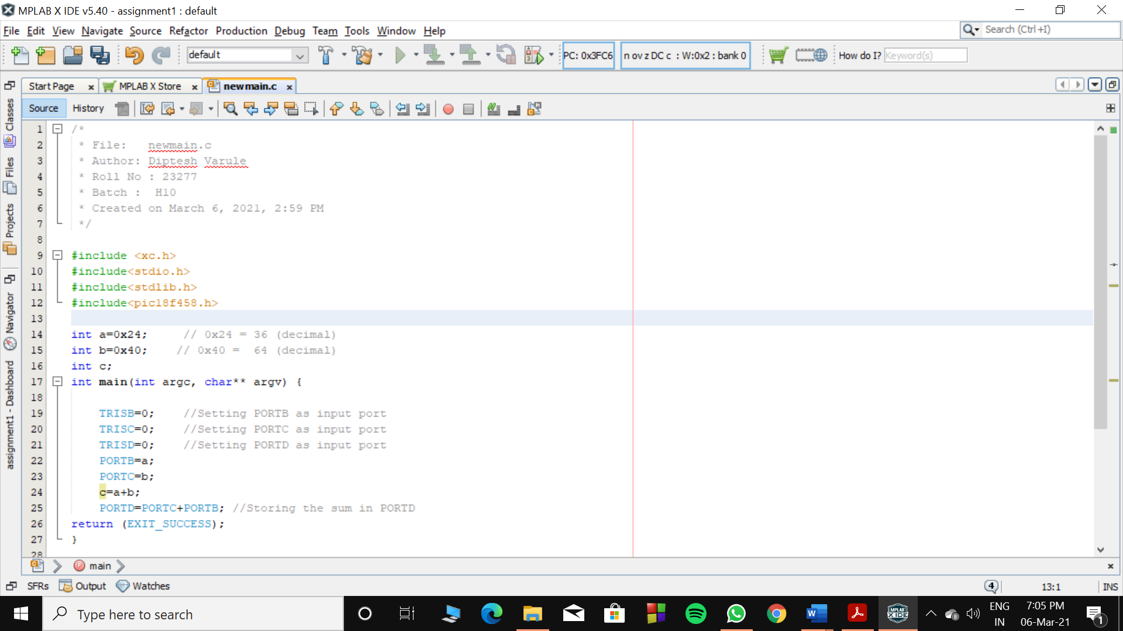

Operation 1: Simple addition of two numbers

|  |  |  |  |  |  |  |  |  |  |  |  |
| --- | --- | --- | --- | --- | --- | --- | --- | --- | --- | --- | --- |
|  | Num1 | Num2 | TRISB | TRISC | TRISD | LATB | LATC | LATD | PORTB | PORTC | PORTD |
| Hex | 0x24 | 0x40 | 0 | 0 | 0 | 0x24 | 0x40 | 0x64 | 0x24 | 0x40 | 0x64 |
| Decimal | 36 | 64 | 0 | 0 | 0 | 36 | 64 | 100 | 36 | 64 | 100 |

Program + SFR:

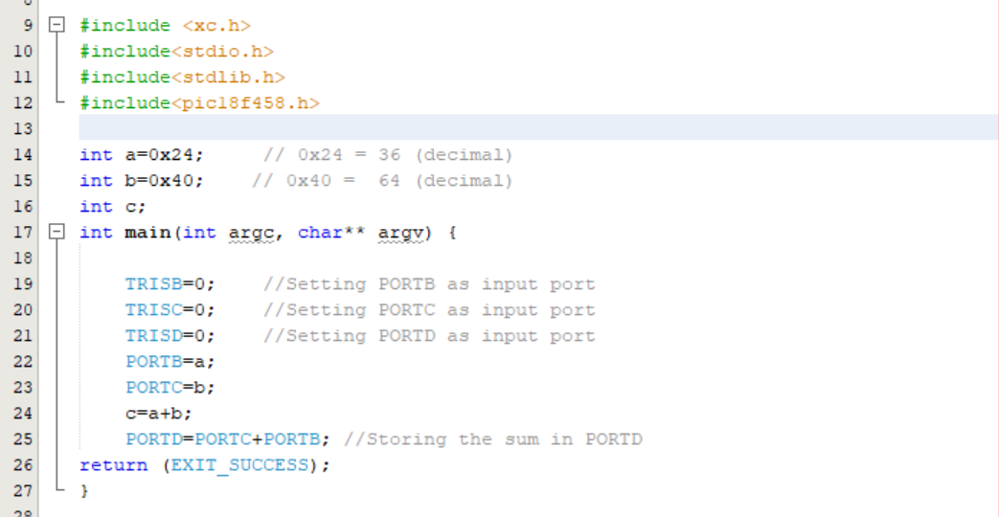

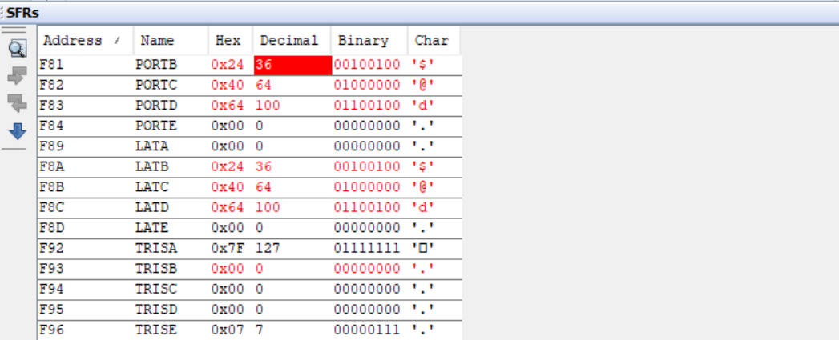

Operation 2: Not accepting second number as port is in input mode

|  |  |  |  |  |  |  |  |  |  |  |  |
| --- | --- | --- | --- | --- | --- | --- | --- | --- | --- | --- | --- |
|  | Num1 | Num2 | TRISB | TRISC | TRISD | LATB | LATC | LATD | PORTB | PORTC | PORTD |
| Hex | 0x24 | 0x40 | 0 | 0xFF | 0 | 0x24 | 0x40 | 0x24 | 0x24 | 0 | 0x24 |
| Decimal | 36 | 64 | 0 | 255 | 0 | 36 | 64 | 36 | 36 | 0 | 36 |

Program + SFR: 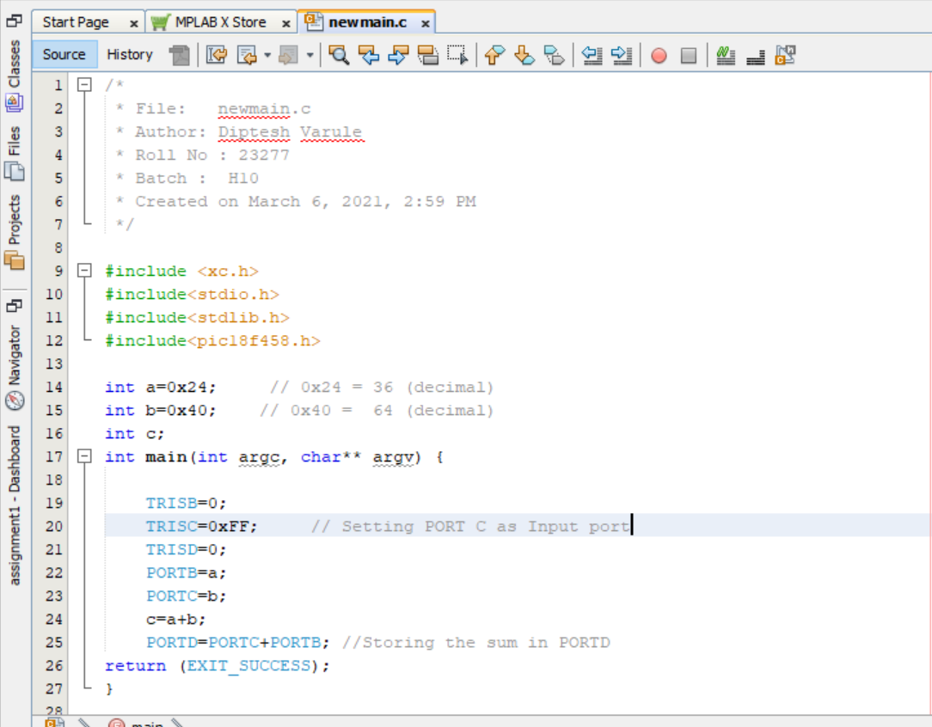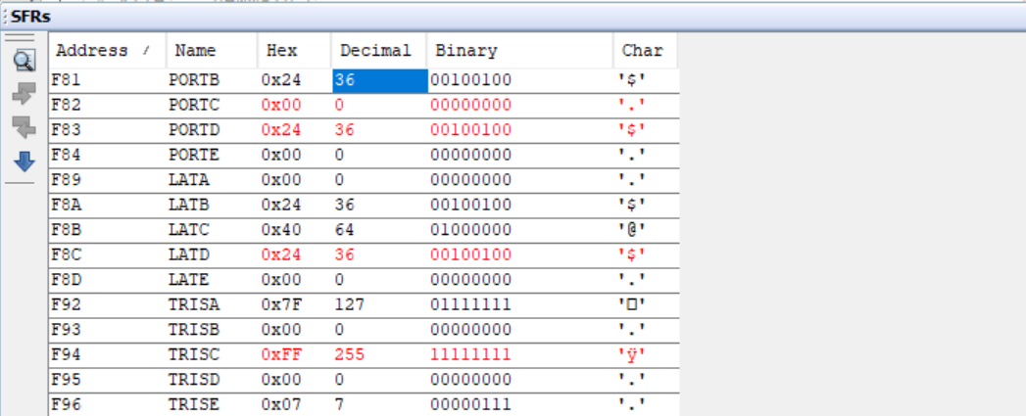

Operation 3: Changing the TRISB to reflect changes in the stored value in PORTB

|  |  |  |  |  |  |  |  |  |  |  |  |
| --- | --- | --- | --- | --- | --- | --- | --- | --- | --- | --- | --- |
|  | Num1 | Num2 | TRISB | TRISC | TRISD | LATB | LATC | LATD | PORTB | PORTC | PORTD |
| Hex | 0x24 | 0x40 | 0x10 | 0 | 0 | 0x24 | 0x40 | 0x64 | 0x24 | 0x40 | **0x64** |
| Decimal | 36 | 64 | 16 | 0 | 0 | 36 | 64 | 100 | 36 | 64 | 100 |

Program + SFR:

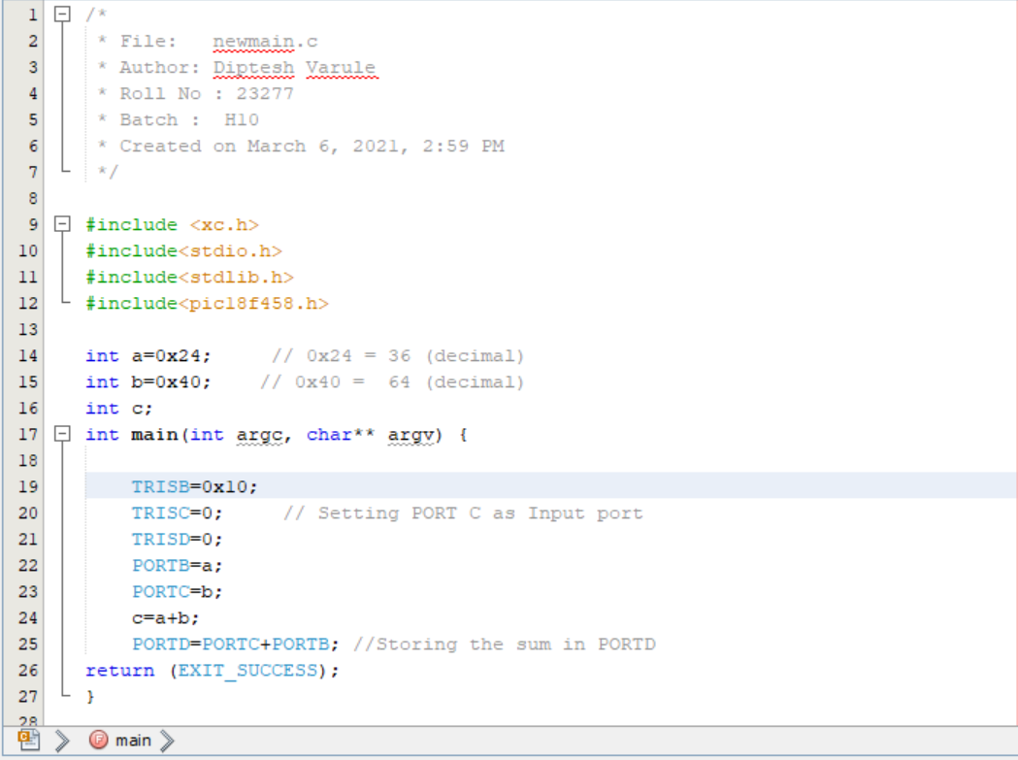

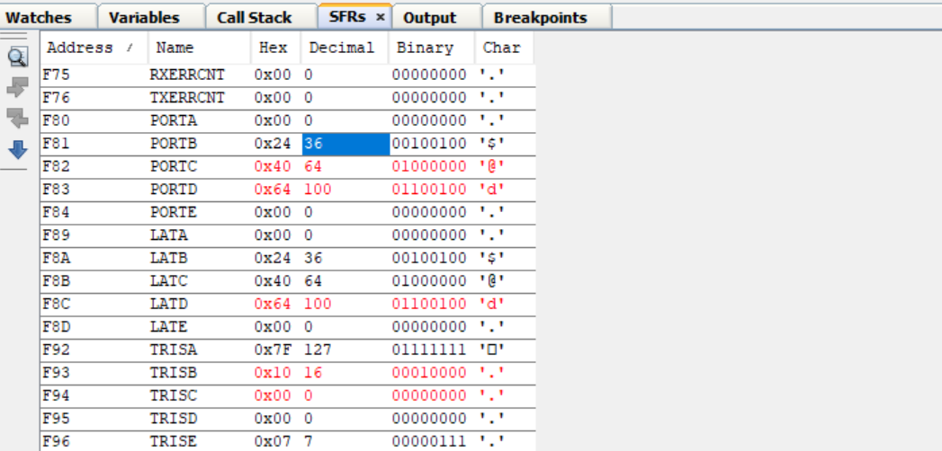

Operation 4: Changing the TRISB to reflect changes in the stored value in PORTB

|  |  |  |  |  |  |  |  |  |  |  |  |
| --- | --- | --- | --- | --- | --- | --- | --- | --- | --- | --- | --- |
|  | Num1 | Num2 | TRISB | TRISC | TRISD | LATB | LATC | LATD | PORTB | PORTC | PORTD |
| Hex | 0x24 | 0x40 | 0x7A | 0 | 0 | 0x24 | 0x40 | 0x44 | 0x04 | 0x40 | **0x44** |
| Decimal | 36 | 64 | 122 | 0 | 0 | 36 | 64 | 68 | 4 | 64 | 68 |

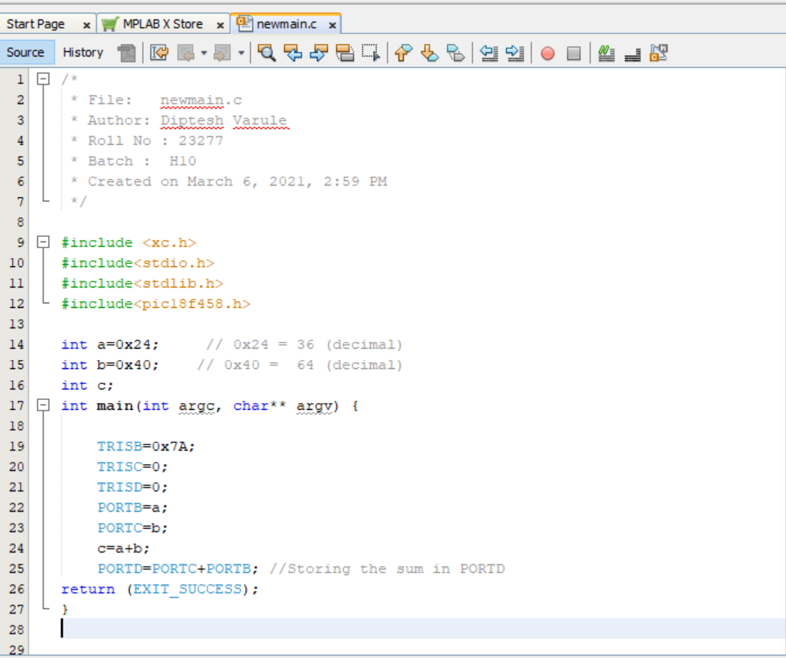

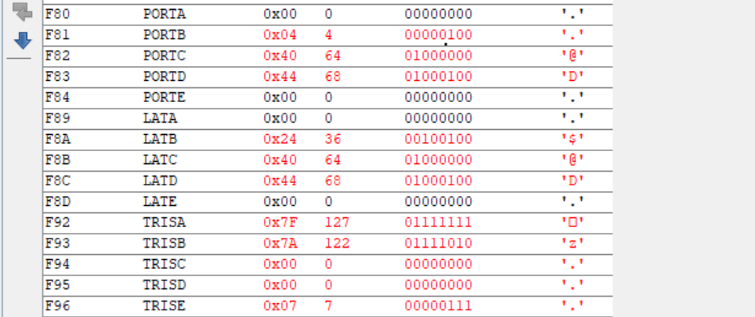

Operation 5 : Changing LATB to 0x45 and reflect changes in addition operation:

|  |  |  |  |  |  |  |  |  |  |  |  |
| --- | --- | --- | --- | --- | --- | --- | --- | --- | --- | --- | --- |
|  | Num1 | Num2 | TRISB | TRISC | TRISD | LATB | LATC | LATD | PORTB | PORTC | PORTD |
| Hex | 0x24 | 0x40 | 0 | 0 | 0 | 0x45 | 0x40 | 0x85 | 0x45 | 0x40 | 0x85 |
| Decimal | 36 | 64 | 0 | 0 | 0 | 69 | 64 | 133 | 69 | 64 | 133 |

