**Pune Institute Of Computer Technology Dhankawadi,**

**Pune – 43.**

Assignment No. 2

PSDL

**SE-IT-10 ACADEMIC YEAR :- 3636-3621**

**Name :- Diptesh Ravindra Varule Roll No :- 23277**

**Problem Statement :**

1. Write an embedded C program to transfer the elements from one location to another (array copy). Take the screenshots of
   1. addresses of both arrays (watches)
   2. memory, before and after copy.

**Source Code** :

1. Array Copy

/*

* File: newmain.c

* Author: Diptesh Varule

* Roll No : 23277

* Batch : H10

* 1. Write an embedded C program to transfer the elements from one location to another (array copy). Take the screenshots of

a. addresses of both arrays (watches)

b. memory, before and after copy.

*

* Created on March 18, 2021, 11:52 AM

*/

#include <xc.h>

#include<stdio.h>

#include<stdlib.h>

#include<pic18f458.h>

int a[5]={12,16,8,10,9};

int b[10];

void main(void) {

int size=5;

for(int i=0;i<size;i++)

{

b[i]=a[i];

}

return;

}

**Address of Both the arrays :**

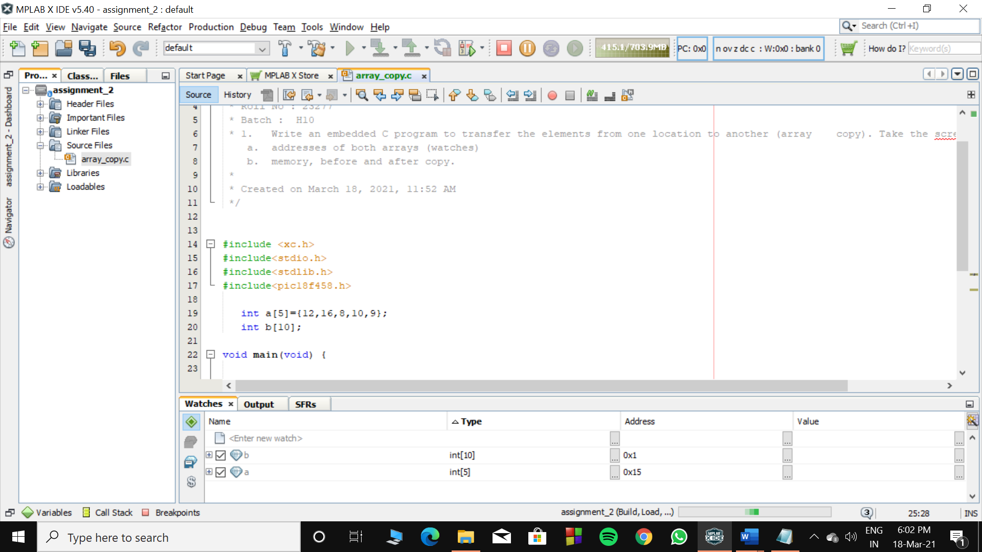

**Memory before copying array A to array B :**

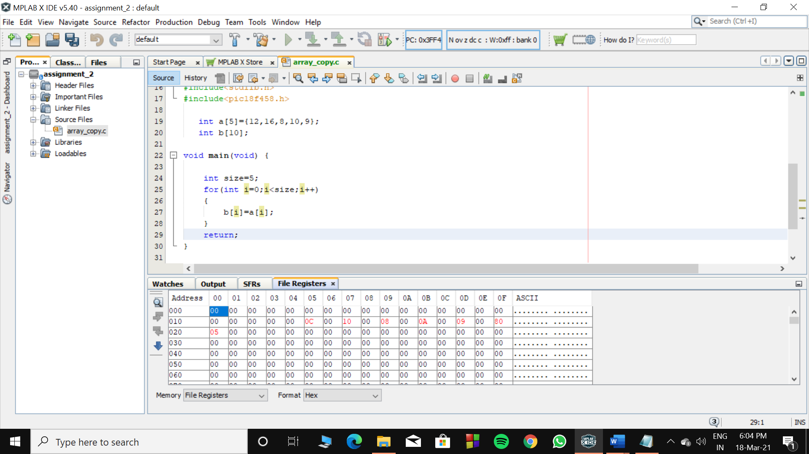

**Memory after copying array A to array B :**

