Pune Institute Of Computer Technology Dhankawadi, Pune – 43.

Assignment No. 3

PSDL

SE-IT-10 ACADEMIC YEAR :- 2020-2021

Name :- Diptesh Ravindra Varule Roll No :- 23277

Problem Statement :

Write an Embedded C menu driven program for : i) Multiply 8 bit number by 8 bit number

ii) Divide 8 bit number by 8 bit number

Source Code :

/\*

* File: newmain4.c
* Author: Diptesh Varule

\*

* Created on May 21, 2021, 1:23 PM

\*/

#include <xc.h>

#include<stdio.h>

#include<pic18f458.h>

int A,B,product,c;

void main(void) {

c=1;

TRISB=0;

TRISC=0;

TRISD=0;

while(1){ while (c==1){ PORTB=31;

TMR0L=21;

WREG=TMR0L;

product=PORTB\*TMR0L;

PORTD=product%256;

B=PORTD;

PORTC=product/256;

A=PORTC;

}

while (c==2)

{

PORTB=120;

TMR0L=230;

PORTD=TMR0L%PORTB;

B=PORTD;

PORTC=TMR0L/PORTB;

A=PORTC;

}

}

return; }

Output :

Multiplication :

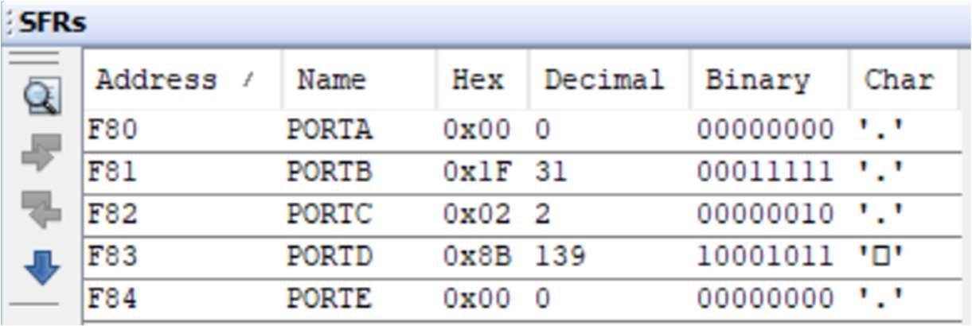

Division :

