**Pune Institute Of Computer Technology Dhankawadi,**

**Pune – 43.**

Assignment No. 2

PSDL

**SE-IT-10 ACADEMIC YEAR :- 3636-3621**

**Name :- Diptesh Ravindra Varule Roll No :- 23277**

**Problem Statement :**

1. Write an embedded C program for sorting the numbers in ascending or descending order by using insertion sort. Take the screenshots before sorting and after every phase of sorting. Write comment for every screenshot.

**Source Code** :

1. Insertion Sort on array:

/*

* File: newmain.c

* Author: Diptesh Varule

* Roll No : 23277

* Batch : H10

* 2. Write an embedded C program for sorting the numbers in ascending or descending order by using insertion sort.

* Take the screenshots before sorting and after every phase of sorting. Write comment for every screenshot.

*

* Created on March 18, 2021, 7:29 PM

*/

#include <xc.h>

#include<stdio.h>

#include<stdlib.h>

#include<pic18f458.h>

int arr[5]={12,16,8,10,9};

void main(void) {

int size=5;

int i, key, j;

for (i = 1; i < size; i++) {

key = arr[i];

j = i - 1;

while (j >= 0 && arr[j] > key) {

arr[j + 1] = arr[j];

j = j - 1;

}

arr[j + 1] = key;

}

return;

}

**Program Flow:**

1. Before sorting

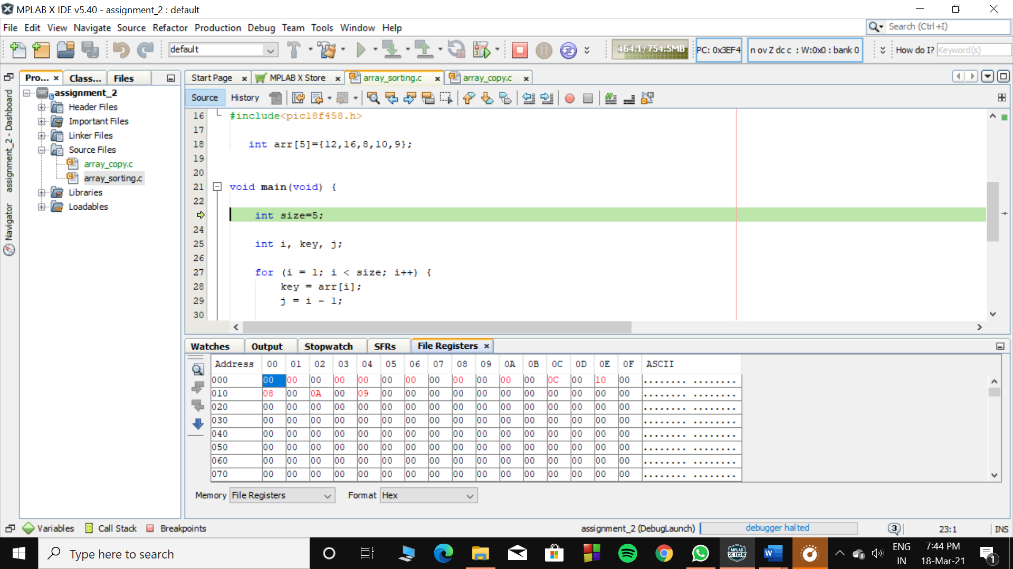

1. Outer Loop is set to first pass i.e., i=1

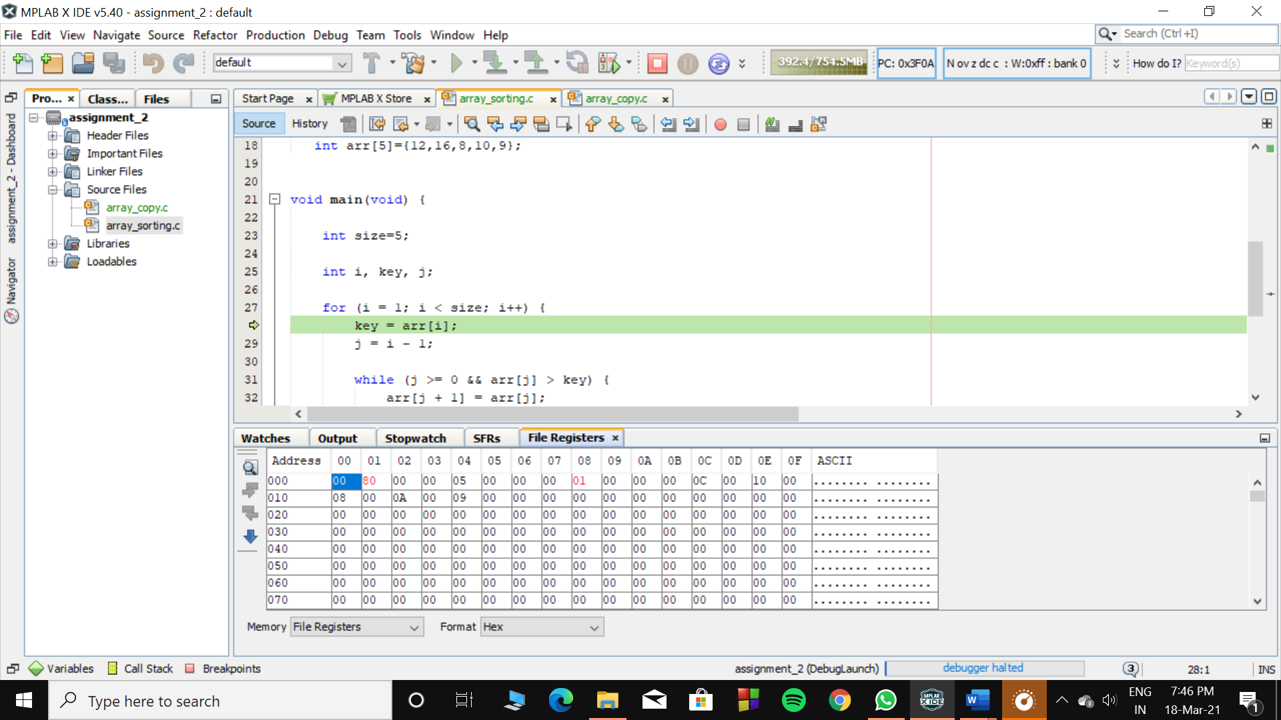

1. Second Pass :

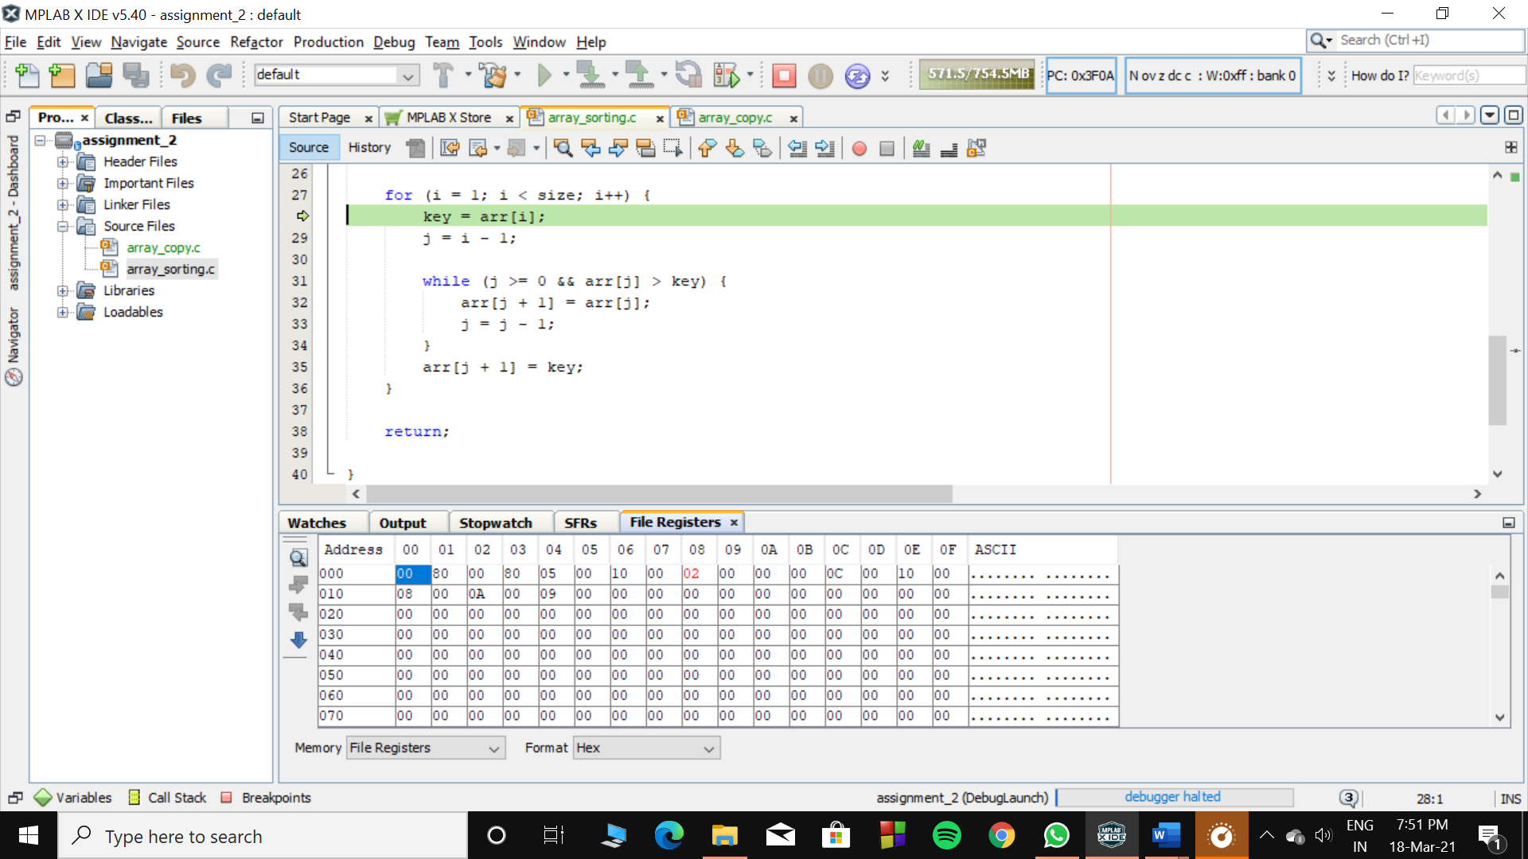

1. 8 gets placed to first position :

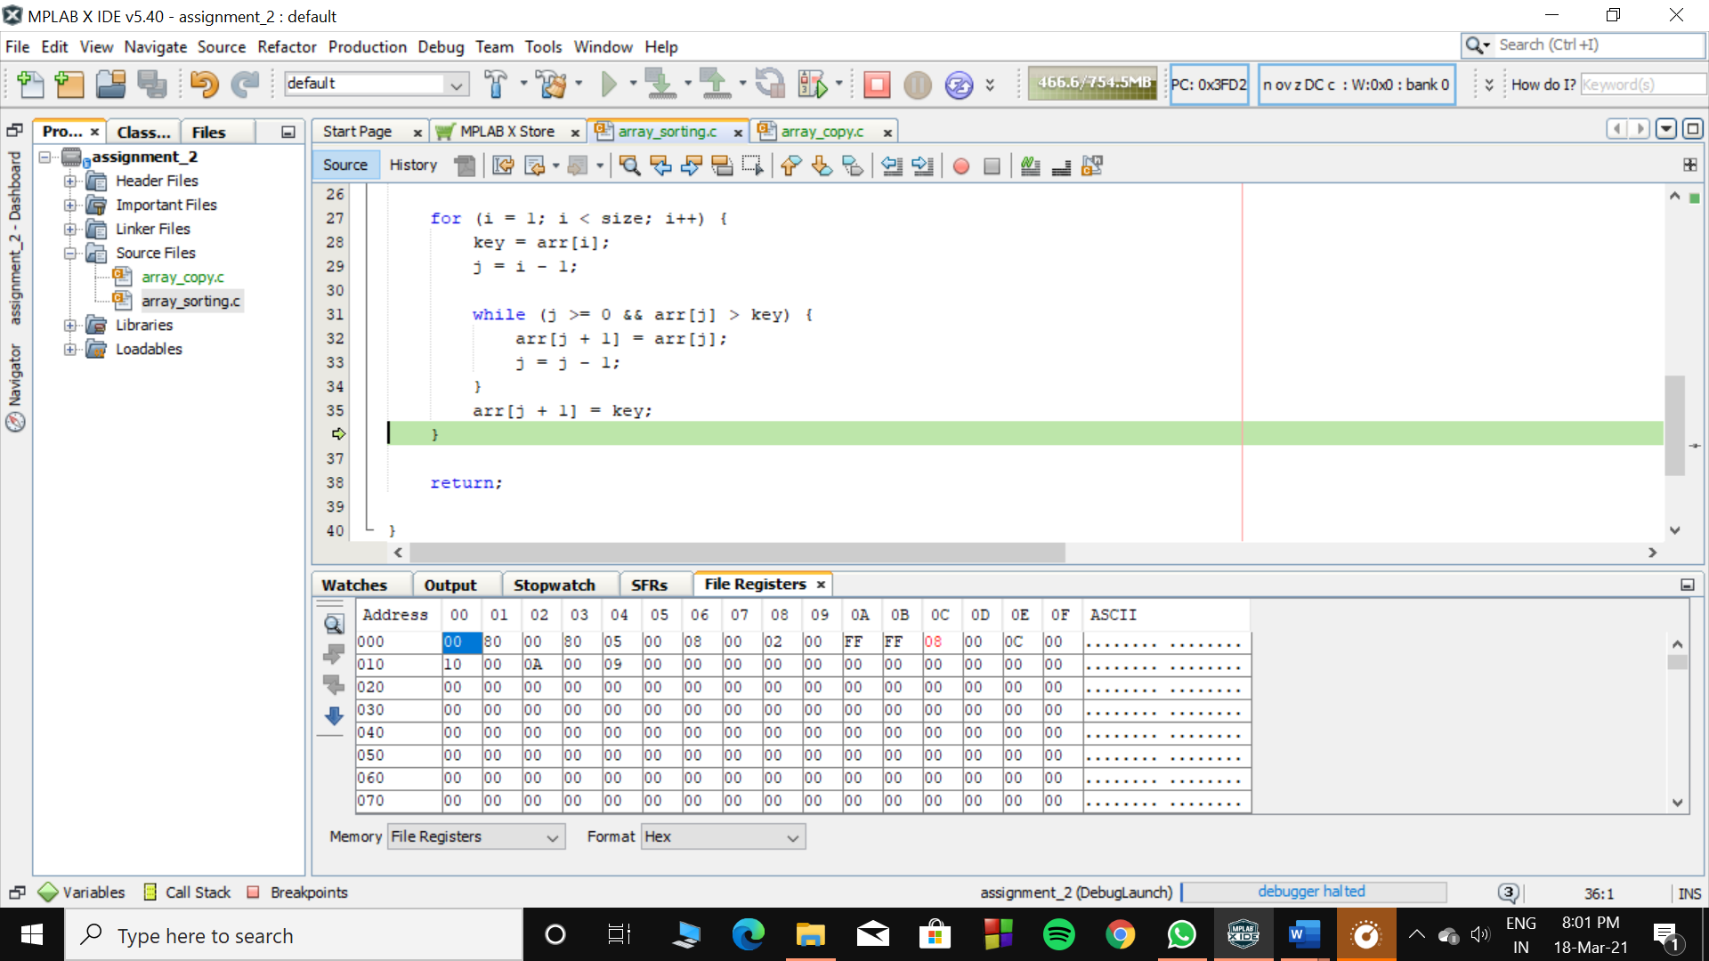

1. Third Pass :

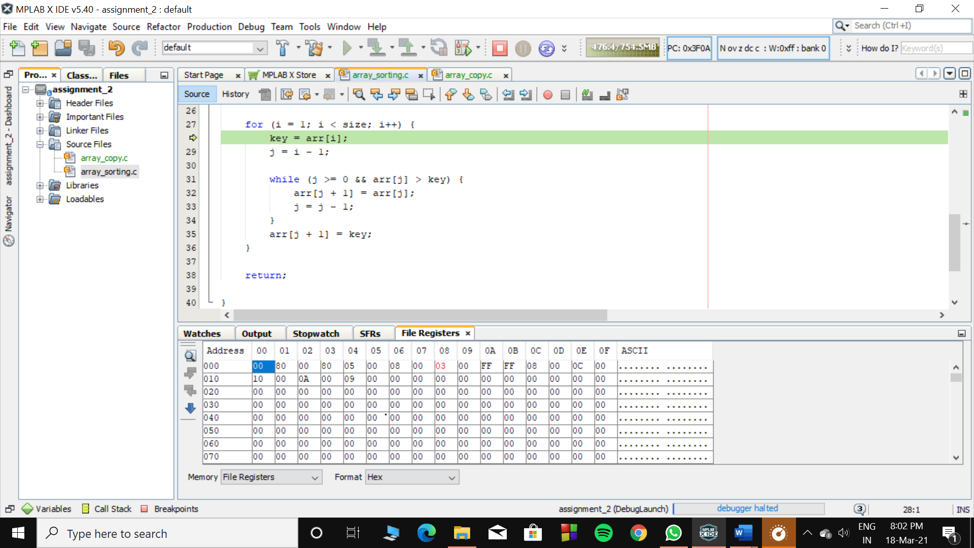

1. 10 gets placed after 8 and before 12 :

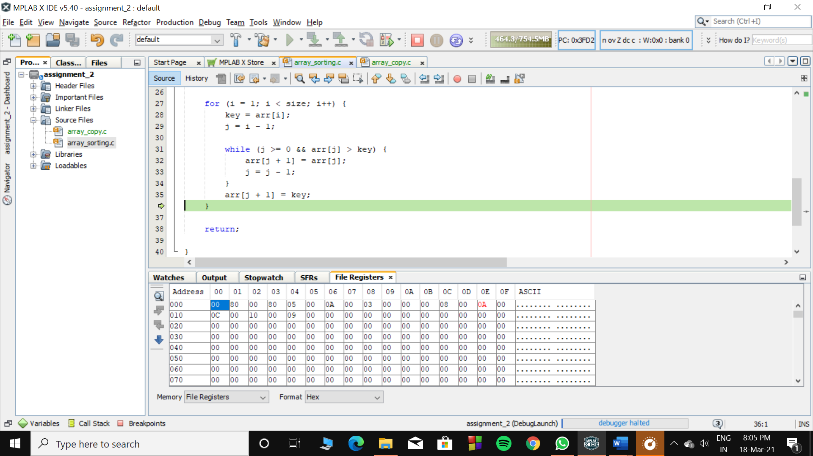

1. Fourth Pass :

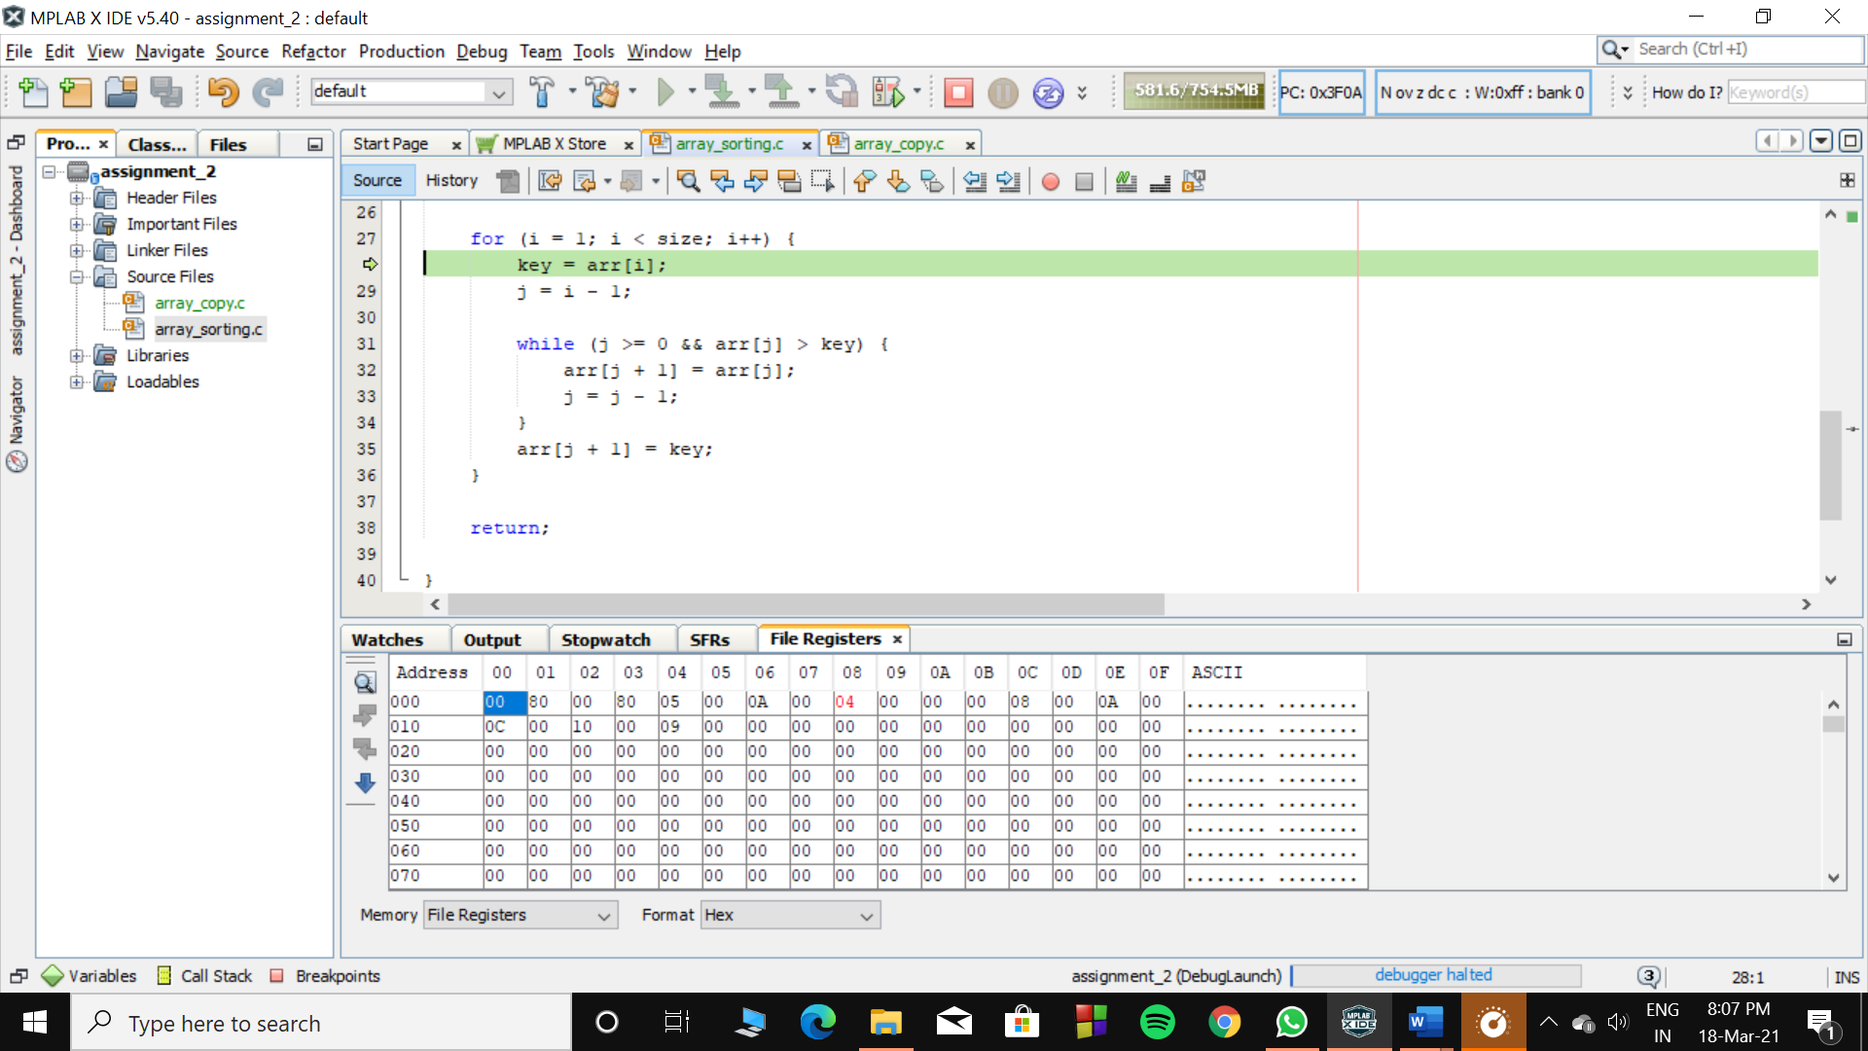

1. 9 gets placed at its correct position :

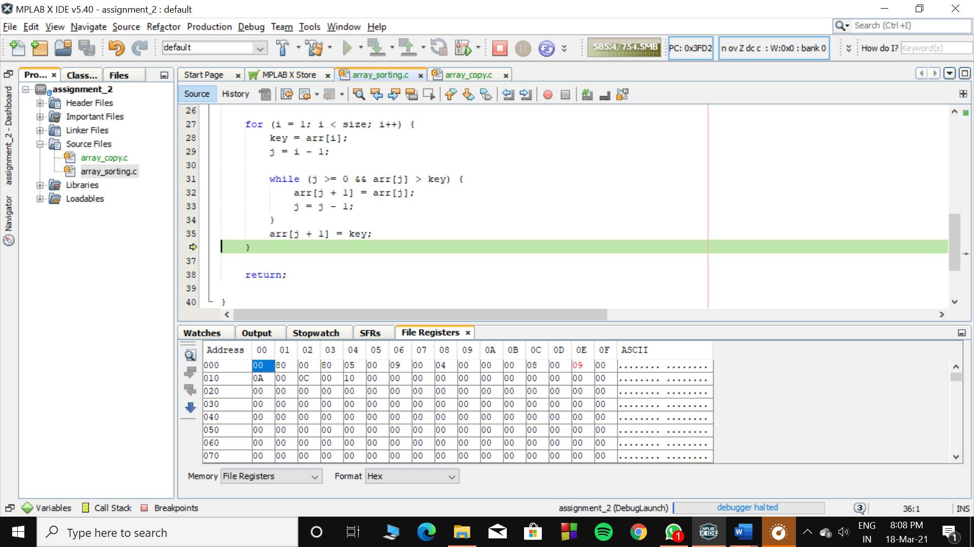

1. The data is sorted :

