Shruti Baravkar

SYCOA067

* Fuzzy Inference System(FIS) Plot

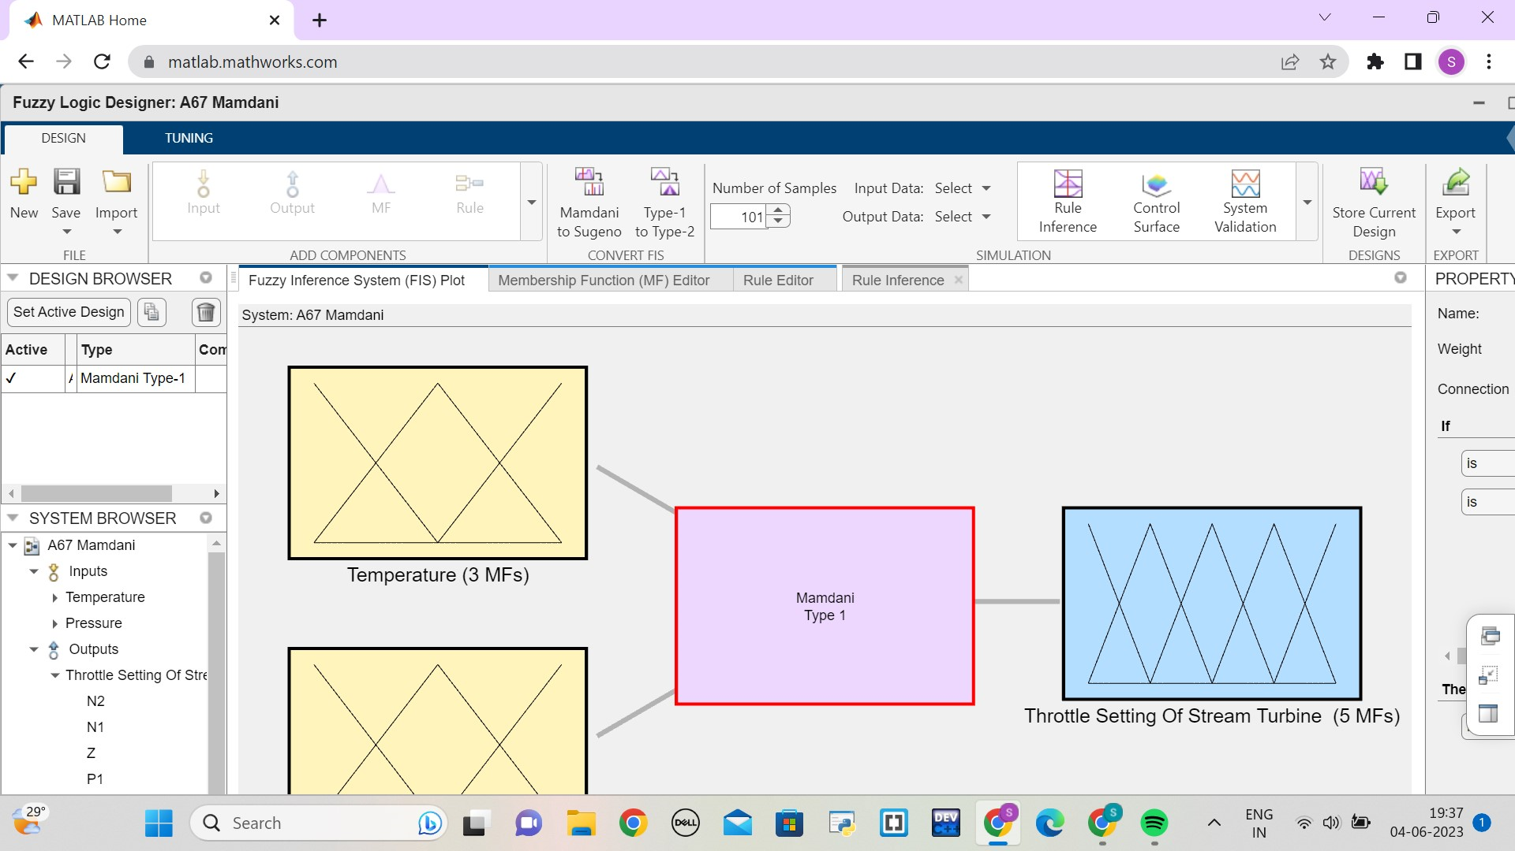

* Rule Editor

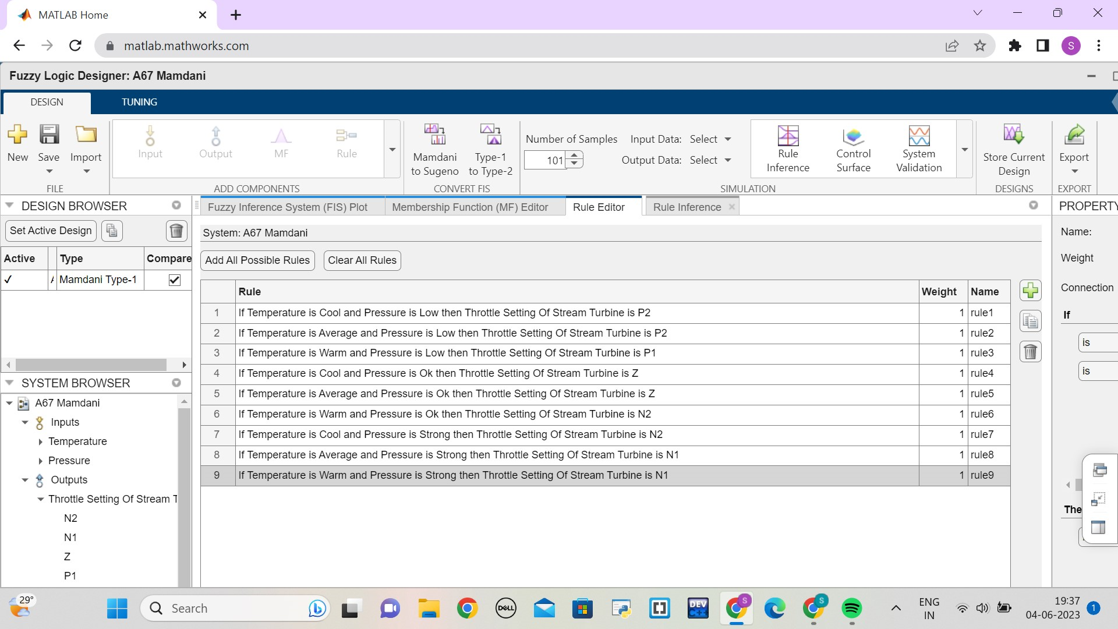

* Rule Inference

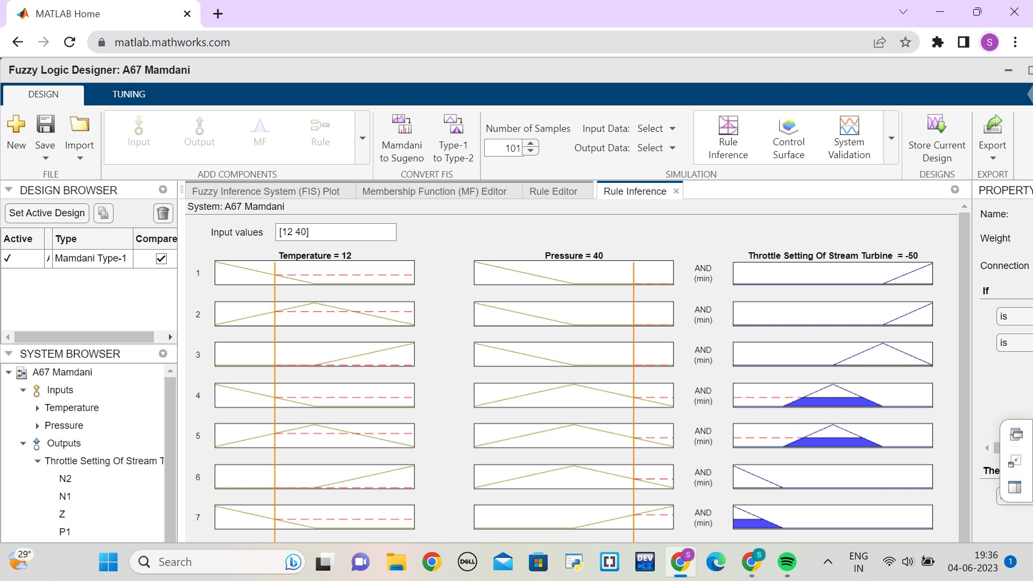

* Control Surface

