1> What is the difference between truncate, delete, drop?

delete=we can use it as per the requirement or the condition using the Where clause. It is comparatively slower than the TRUNCATE command.

drop=It is used to drop the whole table.it removes the named elements of the schema. By using this command the existence of the whole table is finished or say lost.

truncate=it removes the named elements of the schema. By using this command the existence of the whole table is finished or say lost.

2> What are alias in MySQL?

Aliases are the temporary names given to table or column for the purpose of a particular SQL query. It is used when name of column or table is used other than their original names, but the modified name is only temporary.

3> How do you display even rows of the any table?

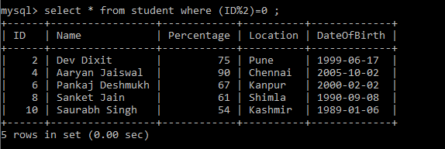

4>How can you remove duplicates from a table(distinct and other way)

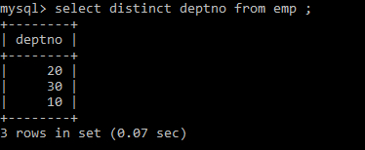

5>How you can find 5th max salary?(Do it by all 3 ways)

