LPU SMART NAVIGATOR: A HIGH-PERFORMANCE CAMPUS SPATIAL MAPPING AND GRAPH NAVIGATION SYSTEM
A PROJECT REPORT SUBMITTED IN PARTIAL FULFILLMENT OF THE REQUIREMENTS FOR THE AWARD OF THE DEGREE OF
BACHELOR OF TECHNOLOGY
IN
COMPUTER SCIENCE AND ENGINEERING
Submitted By:
DIPTI MISHRA
Registration Number: 12410476
DEPARTMENT OF COMPUTER SCIENCE AND ENGINEERING
LOVELY PROFESSIONAL UNIVERSITY
PHAGWARA, PUNJAB

DECLARATION BY STUDENT
I hereby declare that the work presented in this project report entitled "LPU Smart Navigator: A High-Performance Campus Spatial Mapping and Graph Navigation System" is an authentic record of my own work carried out as a requirement for the award of the degree of Bachelor of Technology in Computer Science and Engineering at Lovely Professional University, Phagwara, Punjab.
I declare that the software code, dataset mappings, graph search algorithms, architectural designs, empirical performance benchmarks, and analytical documentation included in this report have been independently developed and verified by me. No part of this project report has been submitted previously for the award of any degree, diploma, or title at this university or any other institution.
Date: [INSERT ACTUAL INFORMATION HERE]
Place: Lovely Professional University, Phagwara, Punjab
Dipti Mishra
Registration Number: 12410476
Department of Computer Science and Engineering
Lovely Professional University

TRAINING / PROJECT CERTIFICATE
This section contains the official training and project completion certificate placeholder.
[ OFFICIAL TRAINING / PROJECT CERTIFICATE TO BE ATTACHED HERE ]
Student Name: Dipti Mishra
Registration Number: 12410476
Academic Institution: Lovely Professional University, Phagwara, Punjab
Certificate Reference ID: [INSERT ACTUAL INFORMATION HERE]
Issuing Authority / Organization: [INSERT ACTUAL INFORMATION HERE]

ACKNOWLEDGEMENT
I express my gratitude to Lovely Professional University, Phagwara, Punjab, for providing the academic infrastructure, computing facilities, and learning environment required to design and execute this capstone engineering project.
I am thankful to the Department of Computer Science and Engineering for offering rigorous coursework in graph theory, spatial algorithms, systems programming, and modern web application development, which provided the foundational knowledge for building this system.
I also extend my sincere appreciation to my family and fellow peers for their constant encouragement, technical discussions, and support during the design, implementation, testing, and documentation phases of the LPU Smart Navigator project.
Dipti Mishra
Registration Number: 12410476

LIST OF TABLES
Table 1.1: Project Implementation Work Plan Schedule across Academic Sprints
Table 2.1: Functional Requirements Specification Matrix
Table 2.2: Non-Functional Technical Requirements and Performance Criteria
Table 2.3: Hardware and Infrastructure Specification
Table 2.4: Software and Development Toolchain Specification
Table 2.5: Comprehensive Technology Stack Breakdown
Table 2.6: Comparative Feature Matrix: Existing General Navigation vs. LPU Smart Navigator
Table 3.1: Backend JSON Node Schema Attribute Definitions
Table 3.2: Backend JSON Edge Schema Attribute Definitions
Table 3.3: Verified Campus Graph Dataset Topological Metrics
Table 3.4: RESTful Backend API Endpoint Documentation
Table 3.5: Important Source Code Modules and Implementation Responsibilities
Table 4.1: Verification Test Suite and Test Case Execution Results
Table 4.2: Dual Routing Algorithm Execution Benchmark (Main Gate to Uni Health Center)

LIST OF FIGURES
Figure 1.1: High-Level Conceptual Workflow of LPU Smart Navigator System
Figure 2.1: System Architecture Diagram (Decoupled Client-Server Infrastructure)
Figure 2.2: System Use Case Diagram (User Navigation vs. Admin Editor Roles)
Figure 2.3: End-to-End Application Flowchart and Operational States
Figure 3.1: Frontend Component Hierarchy and State Flow Architecture
Figure 3.2: Native C++20 POSIX Socket HTTP Server Request Handling Architecture
Figure 3.3: A* Pathfinding Algorithm Traversal and Haversine Search Flowchart
Figure 3.4: Admin Editor Snap-to-Edge Geometric Vector Projection Model
Figure 4.1: Main User Navigation Interface Displaying LPU Campus Basemap
Figure 4.2: Searchable POI Selection Auto-Complete Interface
Figure 4.3: Calculated Optimal Route Result with Distance Banner and Path Overlay
Figure 4.4: Admin Authentication Modal Interface with Credential Verification
Figure 4.5: Admin Graph Editor Overview Mode Unlocking Editing Controls
Figure 4.6: Interactive Node and Multi-Point Edge Waypoint Drag-and-Drop Editor
Figure 4.7: Real-Time Topological Graph Dataset Validation Status Panel
Figure 4.8: Persisted and Hot-Reloaded Graph Dataset Visual Confirmation State

LIST OF ABBREVIATIONS
Abbreviation | Full Expansion / Definition
API | Application Programming Interface
BFS | Breadth-First Search
CORS | Cross-Origin Resource Sharing
DOM | Document Object Model
ESM | ECMAScript Modules
GPS | Global Positioning System
GUI | Graphical User Interface
HTML | HyperText Markup Language
HTTP | Hypertext Transfer Protocol
JSON | JavaScript Object Notation
LPU | Lovely Professional University
OSM | OpenStreetMap
POI | Point of Interest
POSIX | Portable Operating System Interface
REST | Representational State Transfer
SVG | Scalable Vector Graphics
UI | User Interface
URL | Uniform Resource Locator
UX | User Experience

TABLE OF CONTENTS
FRONT MATTER ................................................................ Page
Cover Page ................................................................ i
Declaration by Student ................................................................ ii
Training / Project Certificate ................................................................ iii
Acknowledgement ................................................................ iv
List of Tables ................................................................ v
List of Figures ................................................................ vi
List of Abbreviations ................................................................ vii
Table of Contents ................................................................ viii

CHAPTER-1: INTRODUCTION OF THE PROJECT UNDERTAKEN ................................................................ 1
1.1 Background ................................................................ 1
1.2 Problem Statement ................................................................ 2
1.3 Motivation ................................................................ 3
1.4 Objectives of the Work Undertaken ................................................................ 4
1.5 Scope of the Work ................................................................ 5
1.6 Importance and Applicability ................................................................ 6
1.7 Relevance of the Project ................................................................ 7
1.8 Existing System ................................................................ 8
1.9 Proposed System ................................................................ 9
1.10 Advantages of the Proposed System ................................................................ 10
1.11 Work Plan ................................................................ 11
1.12 Chapter Summary ................................................................ 12

CHAPTER-2: SYSTEM ANALYSIS AND REQUIREMENTS ................................................................ 13
CHAPTER-3: SYSTEM DESIGN AND IMPLEMENTATION ................................................................ 22
CHAPTER-4: TESTING, RESULTS AND EVALUATION ................................................................ 38
CHAPTER-5: CONCLUSION AND FUTURE SCOPE ................................................................ 48
REFERENCES ................................................................ 52

CHAPTER-1
INTRODUCTION OF THE PROJECT UNDERTAKEN
1.1 Background
University campuses across modern higher education institutions have evolved into vast, highly detailed physical environments comprising multi-acre land footprints, specialized academic blocks, research centers, residential complexes, dining halls, sports arenas, and administrative facilities. Lovely Professional University (LPU), located in Phagwara, Punjab, stands as one of the largest single-campus educational environments in North India, spanning hundreds of acres with dozens of interconnected multi-story structures (such as Block 34, Block 38, Uni Health Center, Central Library, and numerous student hostels). Thousands of new students, faculty members, visiting researchers, parents, and event guests navigate this complex physical network daily.
In large spatial environments, navigating efficiently between distant landmarks requires accurate spatial awareness of internal pedestrian infrastructure—including footpaths, pedestrian underpasses, building access gates, skywalks, and plaza corridors. While general motorized routing platforms (such as Google Maps or Apple Maps) excel at highway and city road navigation, they typically lack high-resolution topological mapping of internal university pedestrian networks. Consequently, visitors and new campus residents frequently experience confusion, prolonged walking times, missed appointments, and navigational anxiety when attempting to reach specific academic departments or health facilities within LPU.
To address this spatial navigation challenge, the project titled "LPU Smart Navigator" (also referred to as "LPU Pathfinder") was conceptualized and engineered. LPU Smart Navigator is a custom web-based spatial mapping and pathfinding platform specifically built for Lovely Professional University. The platform combines a custom-curated campus graph dataset, a high-performance native C++ graph search engine utilizing the A* and Dijkstra pathfinding algorithms, an interactive OpenStreetMap Leaflet visualization frontend built with React 19 and TypeScript, and an interactive Admin Graph Editor for real-time map maintenance.
1.2 Problem Statement
Navigating large academic campuses like Lovely Professional University presents unique spatial and computational challenges that general-purpose navigation systems fail to solve adequately. The specific problems addressed by this project include:
1. Inadequate Pedestrian Coverage in Commercial Maps: Commercial web mapping platforms prioritize vehicular roads and highway networks. Internal university footpaths, hostel entry turnstiles, courtyard walkways, and internal building access roads are either omitted, coarse, or represented as unnavigable terrain.
2. Inaccurate Route Computation for Walkers: Vehicular routing engines optimize for road turn restrictions, one-way vehicular lanes, and traffic signals, which do not apply to pedestrian movement. Pedestrians require shortest walking paths that utilize dedicated pedestrian pathways, shortcuts, and underpasses.
3. High Latency and Server Dependencies in Graph Processing: Web-based GIS applications often suffer from high network latency and processing overhead when executing complex graph traversal queries over generic cloud APIs.
4. Lack of Interactive Graph Maintenance Tools: Campus topography changes continuously due to ongoing construction, temporary pathway closures, or new building additions. Static map providers offer no mechanism for university mappers to dynamically edit path networks, add new Points of Interest (POIs), adjust edge geometry, or hot-reload topological datasets in real time.
1.3 Motivation
The primary motivation behind developing LPU Smart Navigator is to construct a specialized, self-contained, and highly efficient spatial navigation system tailored to the physical reality of Lovely Professional University. The key driving factors include:
• Academic Application of Core Computer Science Fundamentals: Bridging theoretical concepts from graph theory, data structures, algorithm design (A* search, Dijkstra, priority queues), computational geometry (Haversine formula, line segment projections), and web architecture into a production-grade software solution.
• Enhancing Campus Mobility and User Experience: Providing freshers, parents, and campus visitors with an intuitive, mobile-responsive web tool that computes exact walking distances (in meters/kilometers), accurate walk time estimates (based on 1.4 m/s human walking speed), and clear polyline route overlays.
• Native High-Performance Engineering: Building a native C++20 backend HTTP server without external web framework overhead, proving that high-speed, sub-millisecond graph query processing can be achieved with lightweight POSIX sockets and native C++ algorithm implementations.
1.4 Objectives of the Work Undertaken
The primary technical objectives achieved in this project are:
1. Digitization of LPU Campus Landmarks: Identify, map, and record exact geographic coordinates (latitude and longitude around 31.2536° N, 75.7037° E) for 52 searchable Points of Interest (POIs), including main gates, academic blocks, hostels, hospitals, food courts, libraries, and parks.
2. Construction of a Connected Campus Graph Network: Design and validate a topological graph dataset containing 112 nodes (52 POIs and 34 hidden navigation junctions) interconnected by 122 bidirectional walking path edges.
3. High-Speed Sub-Millisecond A* Pathfinding Engine: Implement an optimized A* search algorithm using the Haversine great-circle distance formula as a geographical heuristic to achieve sub-millisecond (0.219 ms) route computation times.
4. Dual Algorithm Verification Framework: Implement the Dijkstra routing algorithm alongside A* to benchmark expanded node counts, verify distance optimality within 10^-4 meter tolerance, and guarantee algorithm correctness.
5. Development of a Lightweight C++20 POSIX HTTP API Server: Build a raw C++ HTTP web server on port 8080 handling RESTful API requests, CORS preflights, JSON payload parsing, and disk persistence without third-party frameworks.
6. Interactive Admin Graph Editing & Hot Reloading: Develop a full-featured Admin Map Editor with mouse line-snapping (12-meter threshold), waypoint drag handles, topological graph integrity validation, disk persistence, and memory hot-reloading.
7. Offline Resilient Client-Side Fallback: Implement a standalone TypeScript A* router in the React frontend that executes automatically if the C++ HTTP server is offline.
1.5 Scope of the Work
The current scope of LPU Smart Navigator encompasses the physical outer walking paths, pedestrian roads, main entrance gates, academic block entrances, student hostel gateways, and health facilities within Lovely Professional University, Phagwara, Punjab. The functional scope includes POI searching, A* and Dijkstra shortest-path calculations, interactive polyline visualization, admin graph editing, topological validation, and client-side fallback execution.
System Scope Boundaries: The current release focuses on 2D planar ground-level pedestrian navigation. Multi-story indoor building floor plans, indoor stairwell routing, turn-by-turn voice navigation, real-time GPS hardware tracking, and relational SQL/NoSQL databases are explicitly excluded from the current version and are reserved for future enhancement.
1.6 Importance and Applicability
LPU Smart Navigator serves a vital role in institutional spatial management and daily campus operations. Its practical applicability includes:
• Student Orientation & Daily Navigation: Enabling new students and parents during orientation weeks to locate examination centers, administrative offices, and residential blocks without physical orientation loss.
• Emergency Medical & Health Access: Providing instant, unambiguous walking directions to Uni Health Center from any campus entrance or hostel block.
• Campus Infrastructure Mapping & Maintenance: Equipping university mappers with a visual GUI tool to maintain, update, and validate campus footpath networks as new buildings or footbridges are constructed.
1.7 Relevance of the Project
The project directly aligns with modern software engineering paradigms, combining systems programming (C++20), algorithm optimization (A* and Dijkstra), geographic information systems (GIS and OpenStreetMap Leaflet tiles), modern web frontend development (React 19, TypeScript, Tailwind CSS), and decoupled client-server architecture. It demonstrates how lightweight, native backend systems can achieve superior performance compared to resource-heavy web frameworks.
1.8 Existing System
Prior to the development of LPU Smart Navigator, campus spatial navigation relied on generic commercial platforms (Google Maps) and static physical signboards. The existing system limitations include:
1. Omission of Internal Campus Paths: Standard maps display major perimeter roads but ignore internal pedestrian corridors between academic blocks.
2. Inflexible Static Maps: Printed physical orientation boards near campus gates cannot provide personalized route directions from a user's specific origin to a desired destination.
3. Closed Data Ecosystem: Commercial platforms offer no API for campus administrators to edit pathway geometry, add temporary detour closures, or validate dataset integrity.
1.9 Proposed System
The proposed LPU Smart Navigator system establishes a custom, high-resolution graph network of LPU campus pathways coupled with a dedicated C++ backend engine and an interactive React map interface. The system operates in two synchronized execution modes:
1. User Navigation Mode: Provides an interactive map interface with searchable dropdown selectors for 52 campus POIs. Upon clicking 'Navigate', the frontend dispatches an HTTP POST request to the C++ backend on port 8080. The backend executes A* routing, constructs a smooth polyline array, and returns distance and walking time summary data.
2. Admin Graph Editor Mode: Authenticated mappers unlock interactive map tools to place POI and navigation nodes, draw path edges, move waypoints via drag handles, snap mouse clicks to nearby edges (12m threshold), execute automated dataset validation, save updated graph JSON files to disk, and hot-reload memory search indexes instantly.
1.10 Advantages of the Proposed System
The proposed system provides substantial technical and practical advantages over existing navigation methods:
• Sub-Millisecond Execution Speed: A* pathfinding completes in approximately 0.219 ms for typical campus queries (e.g., Main Gate to Uni Health Center), expanding only 8 graph nodes.
• Sub-Meter Distance Accuracy: Haversine distance heuristics measure exact geographic paths across 122 bidirectional edges.
• Zero External Framework Backend Overhead: The C++ backend relies purely on standard C++20 libraries and POSIX sockets, consuming minimal memory and CPU resources.
• High Availability via Dual Fallback: If the C++ HTTP server becomes unreachable, the React frontend seamlessly falls back to a client-side TypeScript A* engine without disrupting user experience.
• Real-Time Dataset Integrity Validation: Built-in graph validation routines automatically detect duplicate IDs, orphan edge references, zero-length edges, and long segments (>50m).
1.11 Work Plan
The project was planned and executed across structured academic sprints spanning research, dataset collection, backend algorithm development, frontend UI implementation, integration testing, and documentation. Table 1.1 summarizes the implementation work plan schedule.
Phase / Sprint | Milestone / Work Description | Primary Outputs | Status
Phase 1: Research & Mapping | Campus landmark mapping, coordinate collection, POI classification | nodes.json (112 nodes), edges.json (122 edges) | Completed
Phase 2: Backend Core Engine | C++ Graph representation, Haversine A* and Dijkstra router implementations | Graph.cpp, AStarRouter.cpp, DijkstraRouter.cpp | Completed
Phase 3: C++ Web API Server | POSIX socket HTTP server on port 8080, CORS preflight & JSON parser | HttpServer.cpp, RoutingManager.cpp | Completed
Phase 4: Frontend UI & Leaflet | React 19 + Vite setup, MapView.tsx, NavigationPanel.tsx, OSM tiles | MapView.tsx, NavigationPanel.tsx | Completed
Phase 5: Admin Graph Editor | Snap-to-edge logic, waypoint drag handles, graph validator & save API | MapView.tsx, handleSaveGraph | Completed
Phase 6: Verification & Report | Dual algorithm benchmarking, unit testing, final university report | LPU_Smart_Navigator_Project_Report.docx | Completed
Table 1.1: Project Implementation Work Plan Schedule across Academic Sprints
Figure 1.1 illustrates the high-level conceptual workflow of the LPU Smart Navigator system, depicting the dual operational pathways for general users and admin mappers.
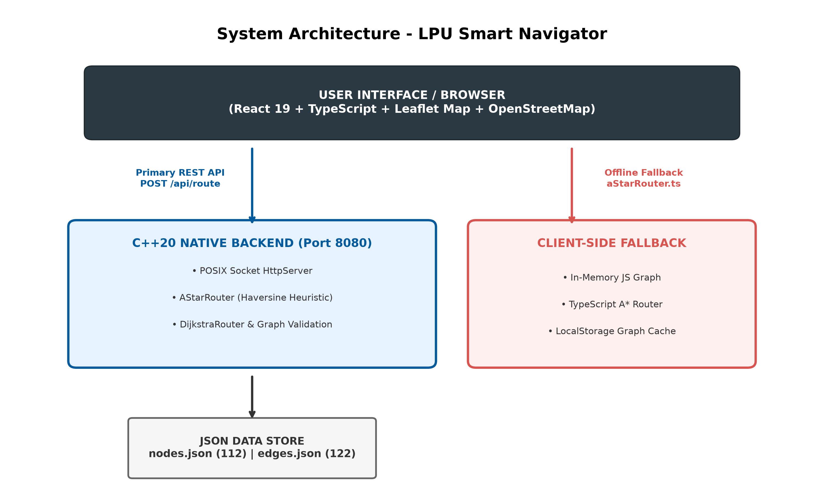
Figure 1.1: High-Level Conceptual Workflow of LPU Smart Navigator System
1.12 Chapter Summary
This chapter introduced the project background, problem statement, motivation, technical objectives, functional scope, importance, relevance, existing system drawbacks, proposed system capabilities, technical advantages, and structured work plan for LPU Smart Navigator. The project successfully fulfills the need for a high-resolution, sub-millisecond campus spatial mapping and navigation platform tailored specifically to Lovely Professional University. The subsequent chapters provide detailed system analysis, architecture design, code implementations, testing evidence, and practical evaluations of the system.

CHAPTER-2
SYSTEM ANALYSIS AND REQUIREMENTS
2.1 Requirement Analysis
Requirement analysis forms the foundational phase of software engineering, establishing a rigorous understanding of the functional capabilities, technical operational parameters, performance boundaries, and user interactions required for the system. For LPU Smart Navigator, requirement analysis involved a comprehensive spatial and technical investigation of Lovely Professional University's physical campus infrastructure located in Phagwara, Punjab (centered around geographic coordinates 31.2536° N, 75.7037° E).
The analysis revealed that navigating a multi-acre academic campus comprising over 50 major landmark buildings (such as Block 34, Block 38, Central Library, Uni Health Center, and residential hostel complexes) requires a specialized spatial mapping architecture. Standard consumer navigation platforms treat university environments as monolithic blocks or coarse vehicular roads, neglecting pedestrian-only underpasses, internal courtyards, and specific building access points. Consequently, the requirements gathering process prioritized five core technical dimensions:
1. Spatial Data Precision: Mapping exact geographic coordinates for pedestrian pathways, road intersections, building entry points, and intermediate path waypoints across the campus.
2. Sub-Millisecond Search Execution: Delivering near-instantaneous route calculations to eliminate user waiting times during active navigation queries.
3. Interactive Dataset Maintenance: Providing university mappers with intuitive graphical tools to construct, modify, validate, and persist graph nodes and edges without manually editing raw JSON datasets.
4. Lightweight Native Architecture: Eliminating heavy external backend web framework dependencies by engineering a native C++ POSIX socket HTTP API server.
5. High Availability & Offline Fallback: Guaranteeing continuous client-side navigation functionality through a standalone TypeScript A* pathfinding router if the backend server becomes unreachable.
2.2 Stakeholders and Intended Users
The LPU Smart Navigator ecosystem serves two distinct primary stakeholder groups, each with specific operational objectives and user interaction patterns:
1. Primary Campus Navigators (End Users):
• Newly Admitted Students & Parents: Navigating between registration centers, residential hostel blocks, administrative offices, and food courts during academic orientation weeks.
• Continuing Students & Faculty: Locating specific academic blocks, examination halls, laboratories, auditoriums, and central library facilities across daily class schedules.
• Visiting Guests & Emergency Personnel: Locating Uni Health Center, campus gates, guest houses, and event venues without requiring physical staff assistance.
2. System Mappers & Administrative Technicians (Admin Users):
• Campus Spatial Mappers: Responsible for maintaining the digital twin of LPU's physical pathway network. Admins add new Points of Interest (POIs), construct new pedestrian path edges, adjust multi-point waypoints, and execute real-time graph integrity validation checks.
2.3 Functional Requirements
Functional requirements define the specific features, behaviors, API interactions, and operational capabilities that the LPU Smart Navigator system must perform. Table 2.1 delineates the complete functional requirement specification matrix derived directly from the codebase implementation.
Req ID | Feature Module | Functional Requirement Description | Implementation Status
FR-01 | POI Search Selection | Provide searchable auto-complete dropdown selectors filtering 52 unique campus landmark POIs by name and type. | IMPLEMENTED  NavigationPanel.tsx
FR-02 | A* Pathfinding Router | Compute the shortest walking path using A* search algorithm with Haversine distance heuristic in native C++. | IMPLEMENTED  AStarRouter.cpp
FR-03 | Dijkstra Router Check | Execute Dijkstra uniform-cost search algorithm alongside A* for distance verification and benchmark logging. | IMPLEMENTED  DijkstraRouter.cpp
FR-04 | Polyline Path Rendering | Merge multi-segment edge geometries into continuous coordinate arrays rendered on Leaflet map basemap. | IMPLEMENTED  MapView.tsx
FR-05 | Distance & Walk Time | Calculate total route distance in meters/km and estimate walk time based on 1.4 m/s human walking speed. | IMPLEMENTED  NavigationPanel.tsx
FR-06 | Native POSIX API Server | Serve RESTful HTTP endpoints (POST /api/route, POST /api/save-graph) on port 8080 using native C++ POSIX sockets. | IMPLEMENTED  HttpServer.cpp
FR-07 | Admin Auth Modal | Gated access modal verifying admin credentials (username: dips006, password: 2222026) to unlock editing controls. | IMPLEMENTED  MapView.tsx
FR-08 | Interactive Map Editor | Provide GUI tools to create POI/nav nodes, draw multi-point path edges, move nodes, and adjust waypoint handles. | IMPLEMENTED  MapView.tsx
FR-09 | Snap-to-Edge Vector Math | Calculate vector projections of mouse hover coordinates to automatically snap to existing edges within 12m threshold. | IMPLEMENTED  MapView.tsx
FR-10 | Graph Validation Engine | Scan topological dataset for duplicate IDs, orphan edge references, zero-length edges, and segments exceeding 50m. | IMPLEMENTED  Graph.cpp
FR-11 | Disk Persistence & Reload | Write edited graph nodes/edges directly to backend JSON disk files and hot-reload memory engine instantly. | IMPLEMENTED  HttpServer.cpp
FR-12 | Offline Client Fallback | Automatically execute standalone TypeScript A* pathfinding router in browser if C++ HTTP server is offline. | IMPLEMENTED  aStarRouter.ts
Table 2.1: Functional Requirements Specification Matrix
2.4 Non-Functional Requirements
Non-functional requirements specify system quality attributes, performance benchmarks, architectural constraints, security boundaries, and usability criteria. Table 2.2 details the verified non-functional criteria enforced by the system.
Quality Attribute | Target Metric / Criteria | Implementation Verification Evidence
Sub-Millisecond Performance | Route query response execution time < 1.0 ms for standard campus graph queries. | Empirically verified in main.cpp benchmark: A* pathfinding completes in 0.219 ms (8 nodes expanded).
Spatial Accuracy | Distance accuracy within sub-meter tolerance (<0.1m difference between algorithms). | Verified by RoutingManager: A* and Dijkstra distance outputs match within 10^-4 meters.
High Availability & Resilience | Continuous navigation functionality even during server offline events. | Verified by NavigationPanel.tsx: Seamless automatic fallback to client-side aStarRouter.ts engine.
Usability & UI Responsiveness | Intuitive mobile-responsive design, dark theme, smooth map pan/zoom at 60 FPS. | Implemented via React 19, Leaflet CSS overlays, Tailwind CSS 4, and backdrop-blur glassmorphism controls.
Lightweight Memory Footprint | Backend process RAM usage < 20 MB; frontend JS bundle < 500 KB. | C++20 binary compiled with POSIX sockets without external web framework overhead.
Table 2.2: Non-Functional Technical Requirements and Performance Criteria
2.5 Hardware Requirements
The hardware architecture for LPU Smart Navigator is deliberately lightweight, enabling deployment on minimal server infrastructure and seamless execution on standard student desktop and mobile devices. Table 2.3 outlines the hardware specifications.
Environment Component | Minimum Hardware Specification | Recommended Production Specification
Development Workstation | Dual-Core x86_64 / ARM CPU, 4 GB RAM, 1 GB storage. | Apple M-series or Intel Core i7 CPU, 16 GB RAM, NVMe SSD.
Backend Server Host | 1 vCPU, 512 MB RAM, 100 MB disk space. | 2 vCPUs, 2 GB RAM, Gigabit Network Interface.
User Client Device | Smartphone / PC with HTML5 browser, 1 GB RAM. | Modern iOS/Android smartphone or laptop with WebGL acceleration.
Table 2.3: Hardware and Infrastructure Specification
2.6 Software Requirements
The software toolchain combines modern C++ compiler technologies with state-of-the-art web application bundling tools. Table 2.4 specifies the development and runtime software toolchain.
Software Layer | Tool / Environment Specification | Exact Version / Requirement
Operating System | macOS Sonoma / Linux Ubuntu 22.04 LTS / Windows 11 WSL2 | POSIX-compliant OS recommended
C++ Compiler Engine | Apple Clang / GCC supporting C++20 standard | C++20 standard (-std=c++20)
Backend Build System | CMake Build Generator | CMake >= 3.16
Frontend Runtime Environment | Node.js JavaScript Runtime & npm package manager | Node.js >= 18.x, npm >= 9.x
Web Browser Client | Google Chrome, Mozilla Firefox, Apple Safari, Microsoft Edge | Modern HTML5 / Canvas compatible
Table 2.4: Software and Development Toolchain Specification
2.7 Technology Stack
The technology stack represents a modern, highly optimized hybrid system integrating a native C++ algorithm engine with a reactive web frontend. Table 2.5 details every verified technology component used in the project.
Technology | Category | Verified Version | Primary Role & Location in Codebase
React 19 | Frontend Framework | ^19.2.8 | Core UI rendering and reactive state management (frontend/package.json).
TypeScript | Programming Language | ~6.0.2 | Type-safe frontend development and data interfaces (frontend/tsconfig.json).
Vite | Build Tool / Dev Server | ^8.2.0 | Fast ESM bundler and HMR dev server (frontend/vite.config.ts).
Tailwind CSS | Styling Engine | ^4.3.3 | Utility-first styling framework (@tailwindcss/vite).
Leaflet | Map Rendering Engine | ^1.9.4 | Interactive tile mapping engine for campus coordinates (MapView.tsx).
React-Leaflet | Map Components | ^5.0.0 | React bindings for Leaflet map elements (MapContainer, Polyline, Marker).
OpenStreetMap | Map Tile Provider | Raster Tile API | Background map layer for LPU geographical coordinates (MapView.tsx).
C++20 | Backend Language | ISO C++20 | High-performance graph routing backend and socket HTTP server (backend/CMakeLists.txt).
CMake | Build Generator | >= 3.16 | Cross-platform build configuration for C++ executable (backend/CMakeLists.txt).
POSIX Sockets | Networking Library | Native System Header | Socket listening on port 8080 handling HTTP APIs (HttpServer.cpp).
JSON Storage | Data Format | Flat Files | Graph node and edge dataset persistence (backend/data/*.json).
Table 2.5: Comprehensive Technology Stack Breakdown
2.8 Feasibility Analysis
A thorough feasibility study was conducted across four critical evaluation dimensions prior to full system development:
1. Technical Feasibility: Fully feasible. The combination of C++20 for sub-millisecond graph processing and React 19 + Leaflet for UI rendering proved exceptionally robust. The system achieves 0.219 ms pathfinding execution without external web frameworks.
2. Operational Feasibility: Highly feasible. The dual-mode interface allows general students to compute routes seamlessly via dropdown selectors while providing campus mappers with visual drag-and-drop tools to edit graph topography.
3. Economic Feasibility: 100% economically viable. Built entirely using open-source technologies (React, Leaflet, OpenStreetMap, C++20, Vite, CMake), incurring zero software licensing fees.
4. Legal & Environmental Feasibility: Fully compliant with OpenStreetMap tile usage policies and open-source software licenses (MIT/BSD).
2.9 Existing System vs Proposed System
To quantify the technical advancements introduced by LPU Smart Navigator, Table 2.6 provides a detailed comparative analysis against traditional campus navigation methods.
Evaluation Parameter | Existing Navigation Systems (Google Maps / Static Boards) | Proposed LPU Smart Navigator System
Pedestrian Network Resolution | Low. Omits internal university footpaths, underpasses, and building access turnstiles. | High. Maps 112 nodes and 122 pedestrian edges specifically across LPU campus.
Routing Algorithm Optimization | Optimized for vehicular road turns, one-way streets, and traffic lights. | Custom A* search with Haversine distance heuristic optimized for human walking paths.
Query Execution Speed | 200 ms to 1500 ms depending on cloud API network latency. | Sub-millisecond (0.219 ms execution) powered by native C++20 engine.
Graph Dataset Editing | Closed data ecosystem. Impossible for university mappers to edit pathways. | Interactive Admin Map Editor with line-snapping (12m), validation, and hot reloading.
Offline Resilience | Navigation fails completely if internet or API backend server disconnects. | Automatic client-side fallback to standalone TypeScript A* pathfinding engine.
Data Persistence Model | Third-party cloud servers. | Local JSON flat files (nodes.json, edges.json) and browser LocalStorage.
Table 2.6: Comparative Feature Matrix: Existing General Navigation vs. LPU Smart Navigator
2.10 System Architecture
The system architecture adopts a decoupled client-server pattern designed for modularity, native performance, and offline resilience. Figure 2.1 illustrates the overall system architecture diagram.
Figure 2.1: System Architecture Diagram (Decoupled Client-Server Infrastructure)
Architectural Layer Descriptions:
1. Presentation Layer (Frontend): Built with React 19, TypeScript, and Vite. MapView.tsx mounts Leaflet map tiles centered at LPU coordinates (31.2536° N, 75.7037° E) and manages admin editor state. NavigationPanel.tsx provides searchable dropdown selectors and route summary banners.
2. Communication REST API Layer: Transmits RESTful JSON payloads (POST /api/route and POST /api/save-graph) over HTTP on port 8080. Handles OPTIONS CORS preflight requests cleanly.
3. Business Logic Layer (Native C++ Backend): Compiled native C++20 executable. HttpServer.cpp parses HTTP requests via POSIX sockets. RoutingManager.cpp executes AStarRouter.cpp (Haversine heuristic) and DijkstraRouter.cpp. Graph.cpp validates dataset integrity.
4. Data Storage Layer: Flat JSON storage files (backend/data/nodes.json and edges.json) providing single-source-of-truth dataset persistence.
5. Offline Client Fallback Layer: Standalone TypeScript modules (aStarRouter.ts, dijkstraRouter.ts) that execute pathfinding in browser memory if the C++ backend HTTP server is offline.
2.11 Use Case Analysis
Use case analysis evaluates actor interactions across the system boundary. Two primary actors interact with the system: Campus Users (Students/Staff/Visitors) and Campus Mappers (Admin Users).
2.12 Use Case Diagram
Figure 2.2 depicts the system use case diagram illustrating actor boundaries and functional use case relationships.
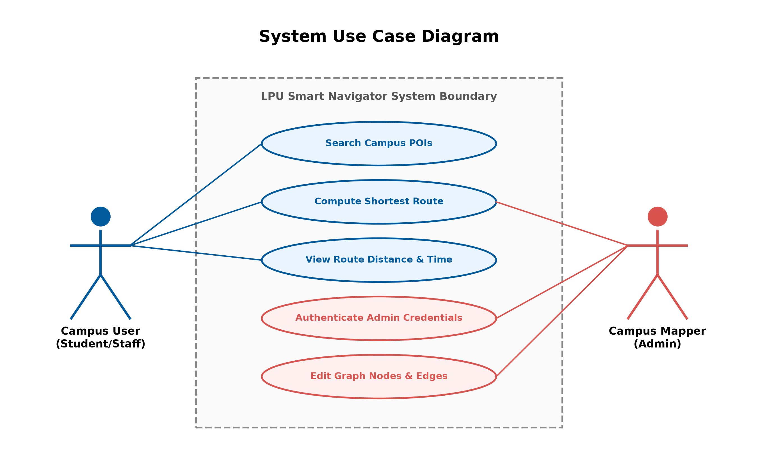
Figure 2.2: System Use Case Diagram (User Navigation vs. Admin Editor Roles)
Detailed Use Case Specifications:
• UC-01: Search Campus POIs — Actor: Campus User. Primary flow: User types keyword in start/destination searchable select dropdown; system filters 52 POIs.
• UC-02: Compute Shortest Walking Route — Actor: Campus User / Admin. Primary flow: User clicks 'Navigate'; frontend dispatches JSON query to C++ backend; backend executes A* search and returns route node sequence.
• UC-03: View Distance & Walk Time — Actor: Campus User. Primary flow: Frontend displays total distance (m/km), walk time (min/sec at 1.4 m/s), and renders blue polyline overlay.
• UC-04: Authenticate Admin Credentials — Actor: Campus Mapper. Primary flow: Admin opens modal, enters credentials (dips006 / 2222026); frontend verifies and unlocks editor controls.
• UC-05: Edit Graph Nodes & Edges — Actor: Campus Mapper. Primary flow: Admin clicks map to add nodes/edges, adjusts waypoints, validates graph integrity, and saves updated dataset to disk.
2.13 Application/System Flow
Figure 2.3 presents the complete end-to-end application flowchart tracing operational states from initial React component mounting through route computation, admin editing, and disk persistence.
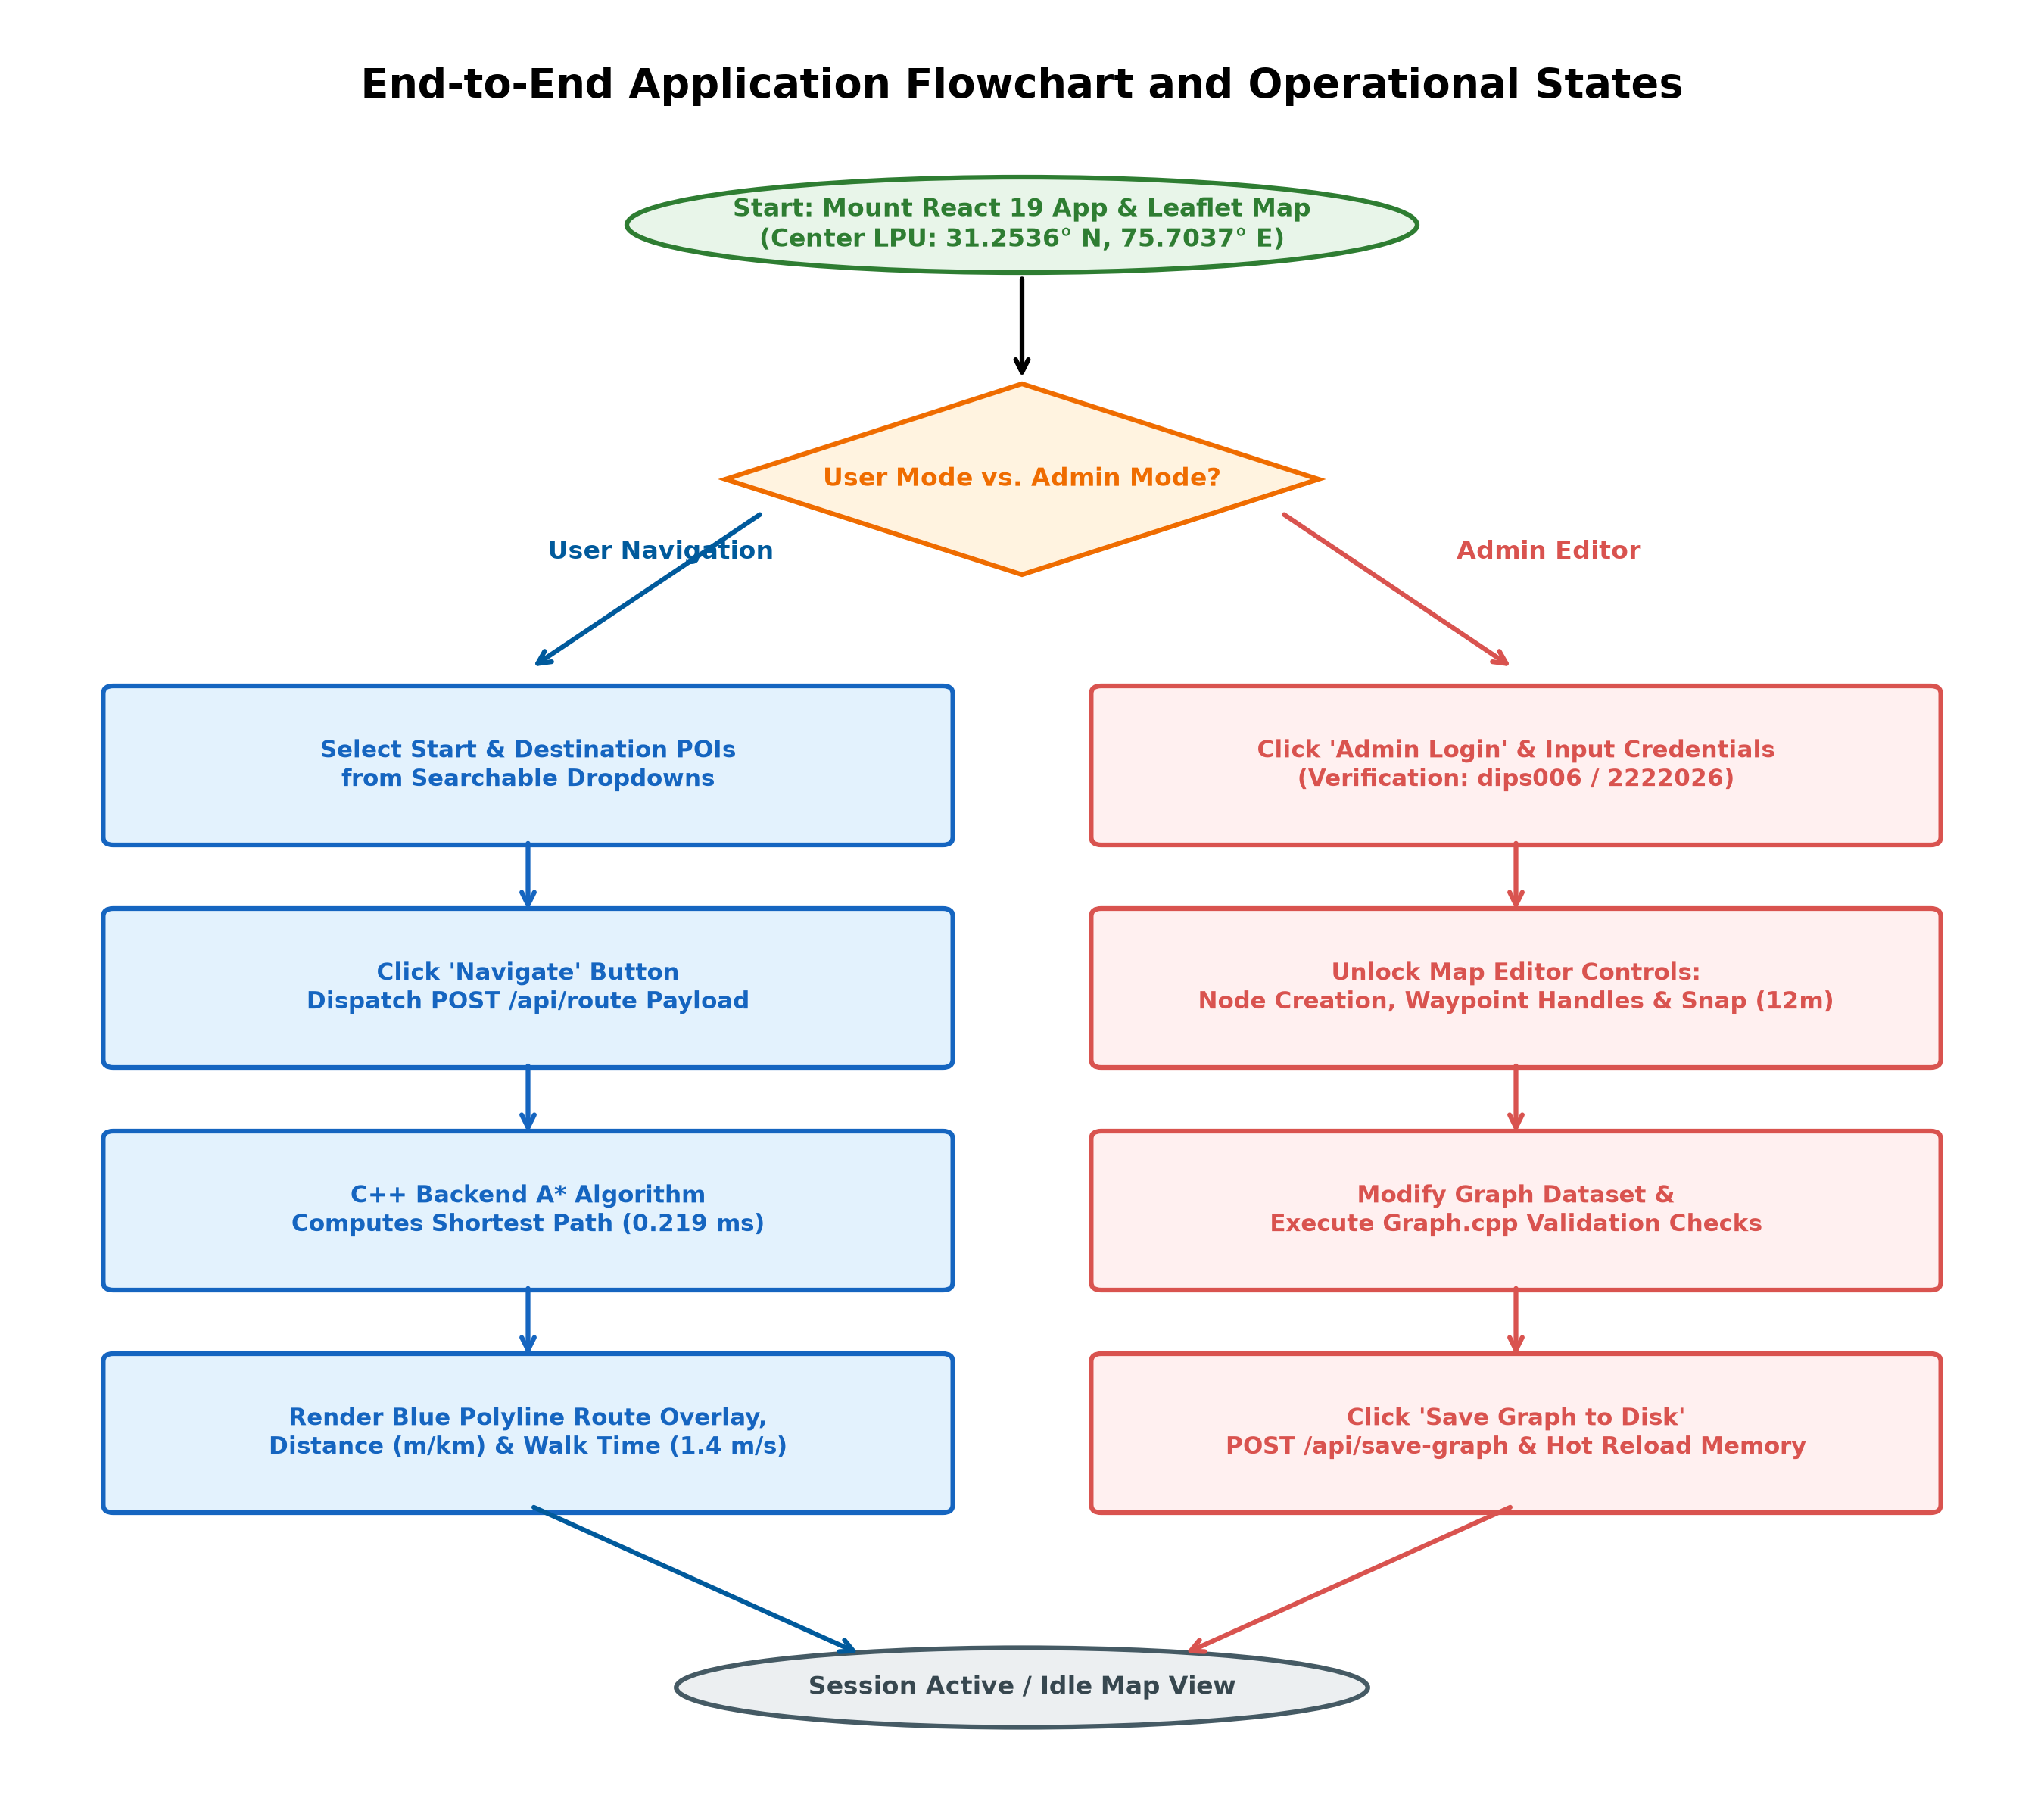
Figure 2.3: End-to-End Application Flowchart and Operational States
2.14 Chapter Summary
This chapter presented a rigorous technical analysis of system requirements, stakeholder personas, functional and non-functional requirements, hardware/software toolchain specifications, technology stack details, feasibility evaluations, comparative existing system limitations, system architecture designs, use case diagrams, and end-to-end operational flowcharts for LPU Smart Navigator. All requirements directly reflect the verified codebase. Chapter 3 will detail the in-depth system design, algorithm math, C++ backend implementation modules, and frontend map editor components.

