STATISTICS
Introduction to Statistics
Statistics is the discipline concerned with collection, organization, analysis, interpretation, and presentation of data.

Types of Data
Type | Meaning | Example
Categorical (Qualitative) | Names or Labels | Gender, City, Rank
Numerical (Quantitative) | Numbers | Age, Income, Marks
Discrete | Countable numbers | Number of students
Continuous | Measured values | Height, Weight

Levels of Measurement
- Nominal – No order (e.g., Names)
- Ordinal – Ordered categories (e.g., Rank)
- Interval – No true zero (e.g., Temperature in Celsius)
Ratio – True zero exists (e.g., Weight, Height)

- Measures of Central Tendency
Data: [90, 85, 80, 90, 95, 90]
Mean = 88.33
Median = 90.0
Mode = 90 (Most frequent value)
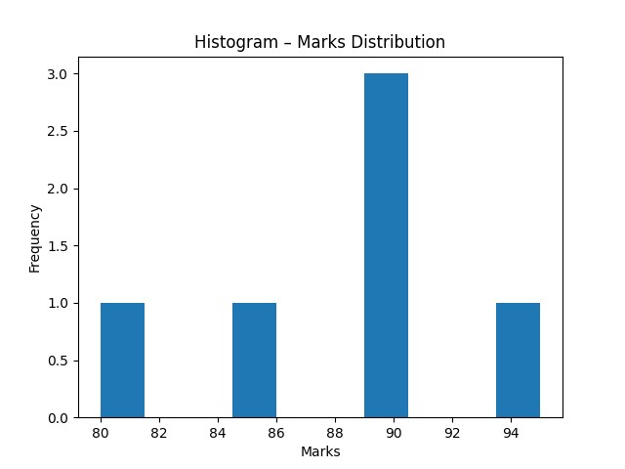

Measures of Dispersion
Variance = 22.22
Standard Deviation = 4.71
Standard deviation tells how much data deviates from mean.
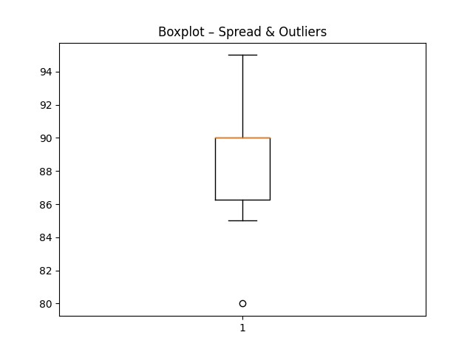

Normal Distribution & Empirical Rule
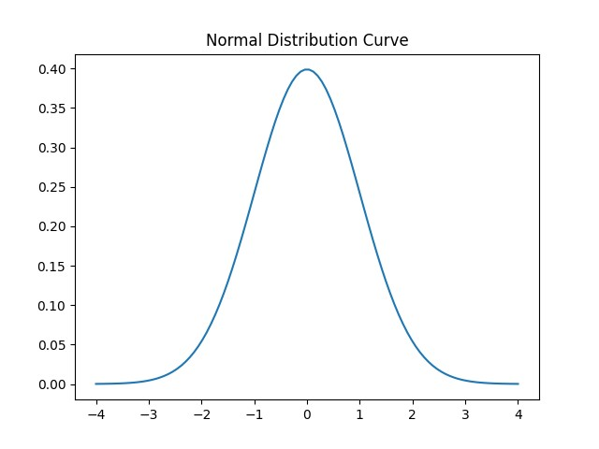
Empirical Rule: 68% within 1 SD, 95% within 2 SD, 99.7% within 3 SD.
Chebyshev Theorem: At least (1 - 1/k²) data lies within k SD.

Covariance & Correlation
Correlation Coefficient (r) = 1.0
Positive correlation means both variables move in same direction.
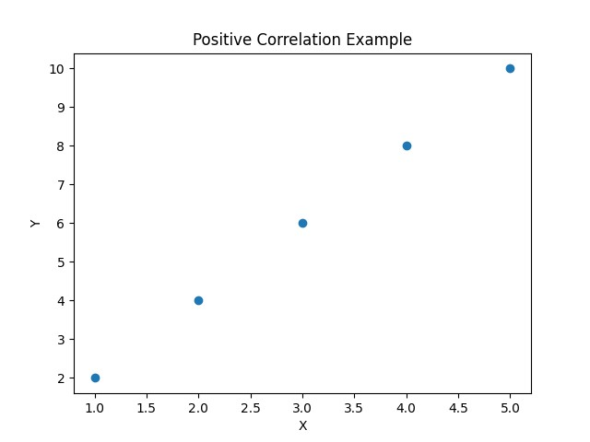

Percentiles & Quartiles
Q1 (25th Percentile) = 1739.5
Median (50th Percentile) = 2038.0
Q3 (75th Percentile) = 2151.0

Standardization (Z-Score)
Mean Age = 30.0
Standard Deviation = 1.41
Z-Scores = [-1.41 -0.71 0. 0.71 1.41]

Standardization (Z-Score)
Mean Age = 30.0
Standard Deviation = 1.41
Z-Scores = [-1.41 -0.71 0. 0.71 1.41]

Standardization (Z-Score)
Mean Age = 30.0
Standard Deviation = 1.41
Z-Scores = [-1.41 -0.71 0. 0.71 1.41]

Standardization (Z-Score)
Mean Age = 30.0
Standard Deviation = 1.41
Z-Scores = [-1.41 -0.71 0. 0.71 1.41]

Standardization (Z-Score)
Mean Age = 30.0
Standard Deviation = 1.41
Z-Scores = [-1.41 -0.71 0. 0.71 1.41]

Standardization (Z-Score)
Mean Age = 30.0
Standard Deviation = 1.41
Z-Scores = [-1.41 -0.71 0. 0.71 1.41]

Standardization (Z-Score)
Mean Age = 30.0
Standard Deviation = 1.41
Z-Scores = [-1.41 -0.71 0. 0.71 1.41]

Sampling & Central Limit Theorem
Population = Entire dataset
Sample = Subset of population
CLT: Sample means form normal distribution as sample size increases.
