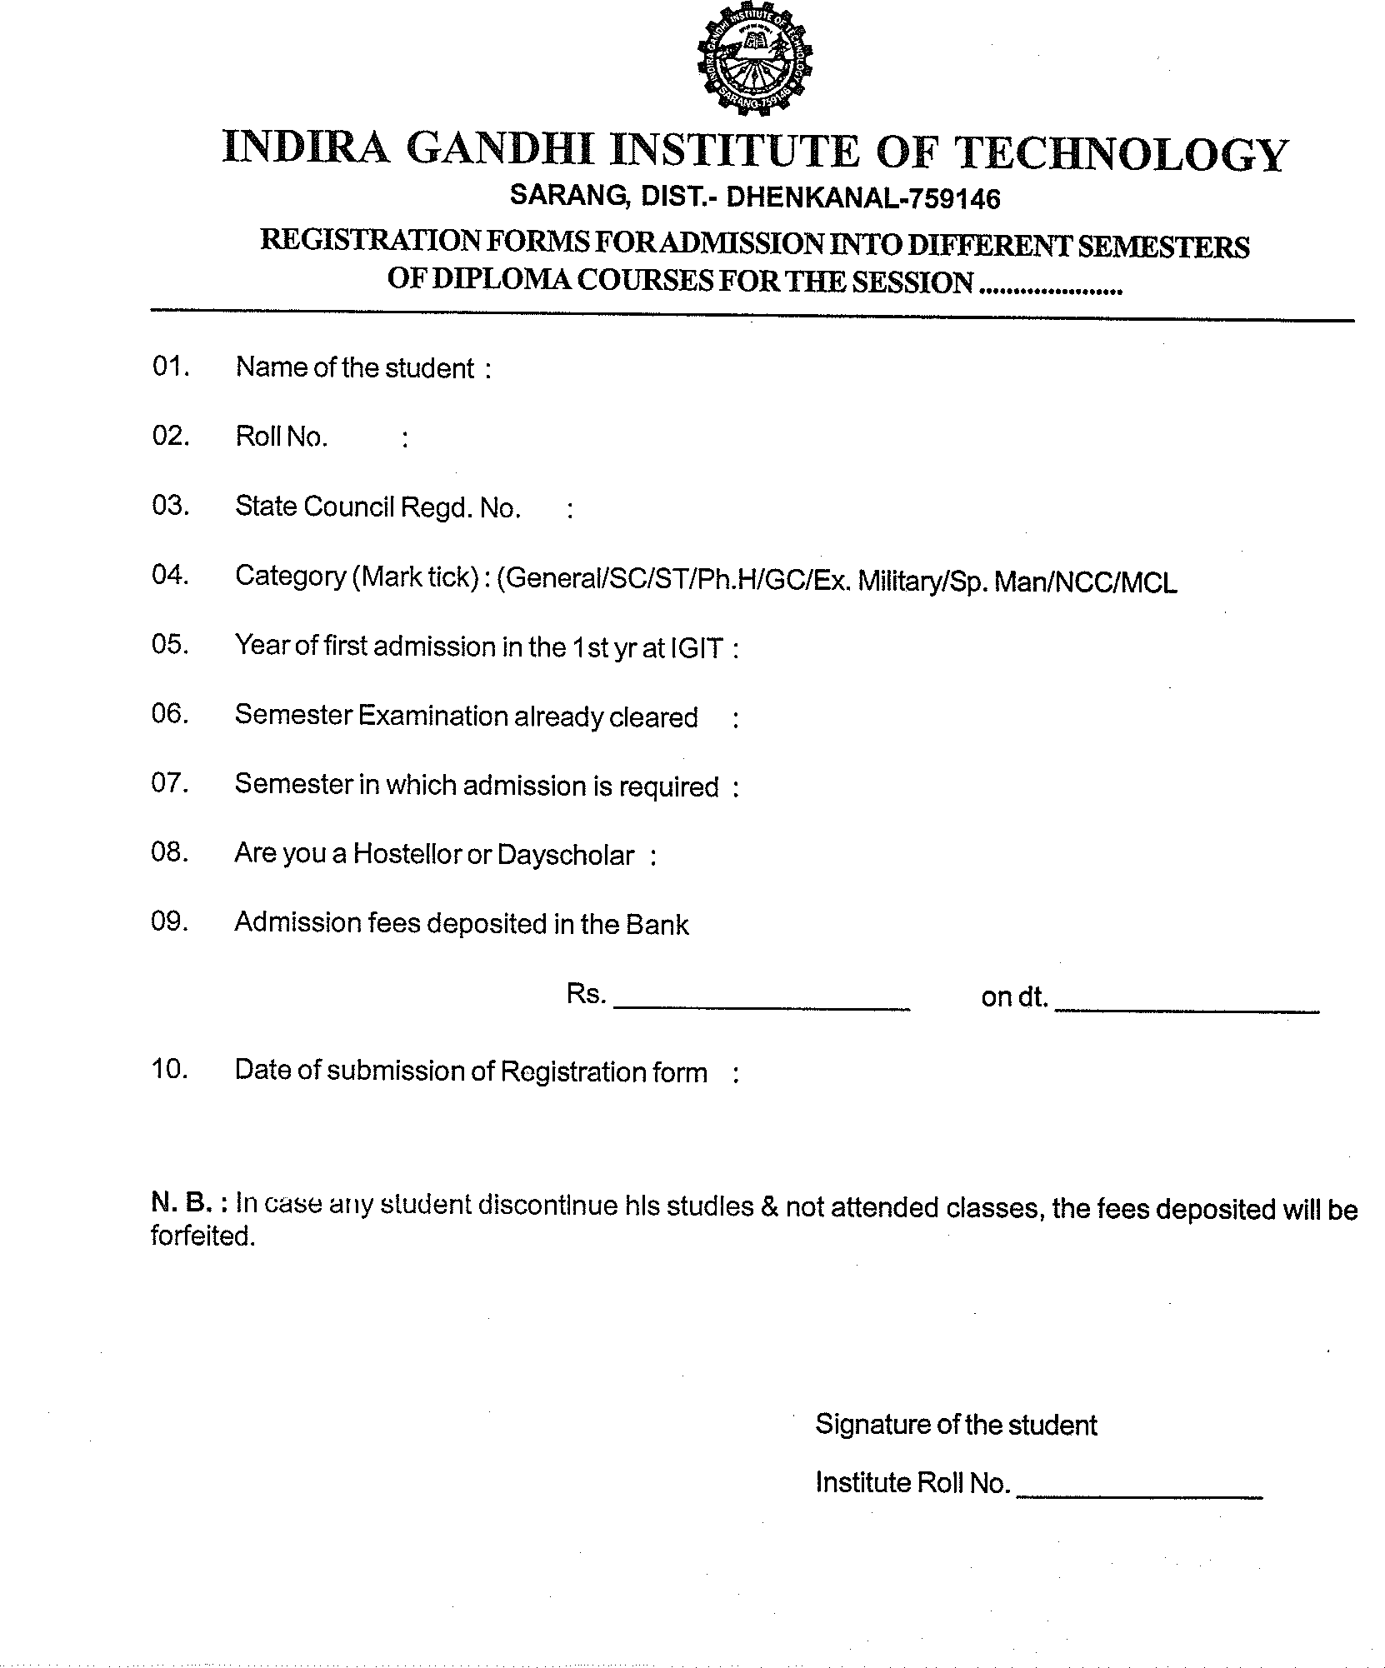

{Session}

{Institute_Roll_No}

{Date_of_Submission_of_Registration_form}

{Admission_fees_deposited_in_Bank}

{Date_of_deposit}

{Hostellor_or_Dayscholar}

{Semester_in_which_admission_is_required}

{Semester_Examination_Already_Cleared}

{Year_Of_First_Admission_In_1_st_year_at_IGIT}

{State_Council_Regd_No}

{Roll_No}

{student_name}