

**AMERICAN INTERNATIONAL UNIVERSITY-BANGLADESH (AIUB)**

**FACULTY OF SCIENCE AND TECHNOLOGY**

**INTRODUCTION TO DATABASE**

**PROJECT ON**

**BANK MANAGEMENT SYSTEM**

**Department of Computer Science**

**Faculty of Science and Technology**

**Bank Management System**

An ER diagram has to be drawn by following the steps of the scenario description.

Scenario Description:

1. The officers require a database for all customers information. Customer id, customer name, customer gender, customer phone, nationality, age, address and customer salary are mentioned.
2. The officers require a database for all branches. Branch name, branch id, branch address, branch employee number, branch manager name, branch officer name, branch start date and branch city are mentioned.

3.The officers require a database containing all accounts. Account no, customer id, account type, balance, open date, branch id and interest rate are mentioned.

1. The officers require a databse for all deposits. Customer id, account number, initial amount, interest rate, interested amount, current balance, open date, close date and year are mentioned.
2. The officers require a database for all transactions. Account no., transaction type, transaction id, transaction city, transaction date, amount, current balance and purchase id are mentioned.
3. The officers require a database for all loans. Account no, loan id, date of loan, close date of loan, total amount, remaining amount and customer address are mentioned.
4. The officers require a database containing all officers in the bank. Officer's employee id, name, branch id, email, salary and branch name are mentioned.
5. Officers employ managers. The managers require a database containing all managers in the bank. Officer's employee id, name, age, email, salary, branch name and officer no are mentioned.

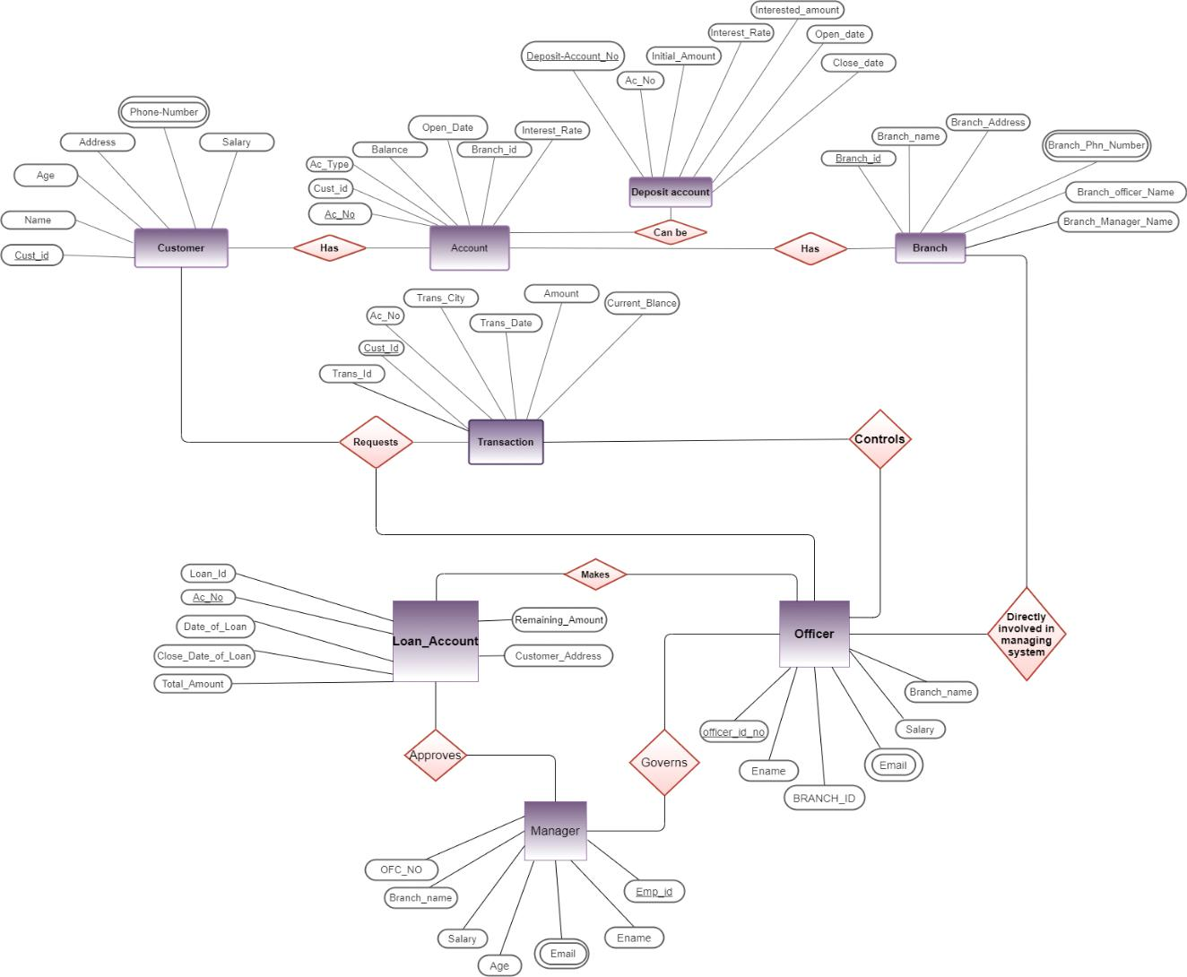

**NORMALIZATION**

CUSTOMER-BRANCH-ACCOUNT HAS:

CUST_ID , CUSTOMER_NAME ,AGE ,ADDRESS , CUSTOMER_PHONE

,CUSTOMER_SALARY,BRANCH_ID , BRANCH_NAME

,BRANCH_ADDRESS, BRANCH_PHN_NUMBER,

BRANCH_OFFICER_NAME,BRANCH_MANAGER_NAME,AC_NO,CUST_ID

,AC_TYPE ,BALANCE ,OPEN_DATE ,, BRANCH_ID ,INTEREST_RATE

1NF: Already normalized

2NF:

1.CUST_ID , CUSTOMER_NAME ,AGE ,ADDRESS , CUSTOMER_PHONE ,CUSTOMER_SALARY,BRANCH_ID

2.BRANCH_NAME ,BRANCH_ADDRESS, BRANCH_PHN_NUMBER, BRANCH_OFFICER_NAME, BRANCH_MANAGER_NAME,

3.AC_NO, AC_TYPE ,BALANCE ,OPEN_DATE ,, BRANCH_ID ,INTEREST_RATE

TABLE LIST:

1.CUST_ID , CUSTOMER_NAME ,AGE ,ADDRESS , CUSTOMER_PHONE ,CUSTOMER_SALARY,BRANCH_ID

2.BRANCH_NAME ,BRANCH_ADDRESS, BRANCH_PHN_NUMBER, BRANCH_OFFICER_NAME, BRANCH_MANAGER_NAME,

3.AC_NO, AC_TYPE ,BALANCE ,OPEN_DATE ,BRANCH_ID ,INTEREST_RATE,CUST_ID(FOREIGN KEY)

**Creating Tables and Queries**

In the Bank Management Database system we create 8 tables . The tables name and it’s creating queries are given below,

**Tables are**

* CUSTOMER
* BRANCH
* ACCOUNT
* DEPOSIT-- ACCOUNT
* TRANSACTION
* LOAN ACCOUNT
* OFFICER
* MANAGER

**Creating tables ,queries**

**and**

**inserting values into the particular tables**

**CUSTOMER>**

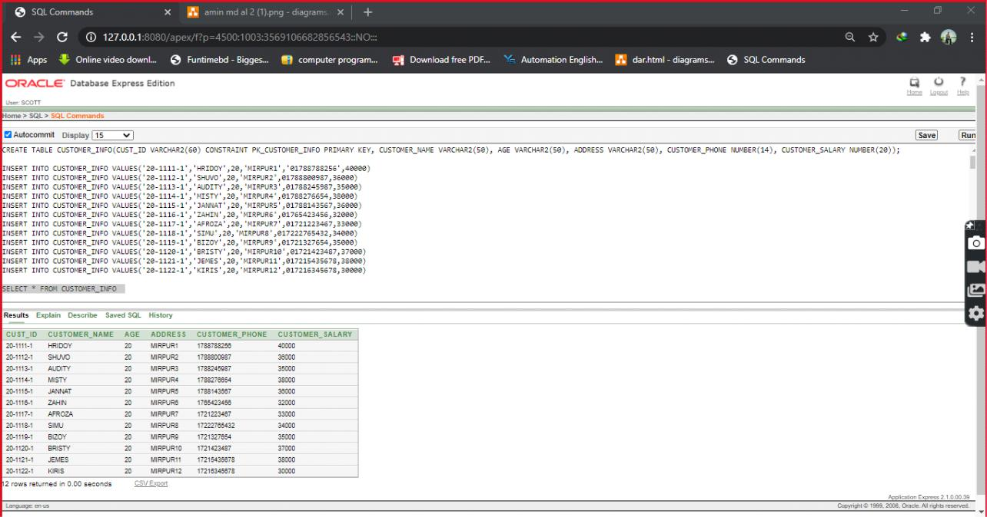

**BRANCH>**

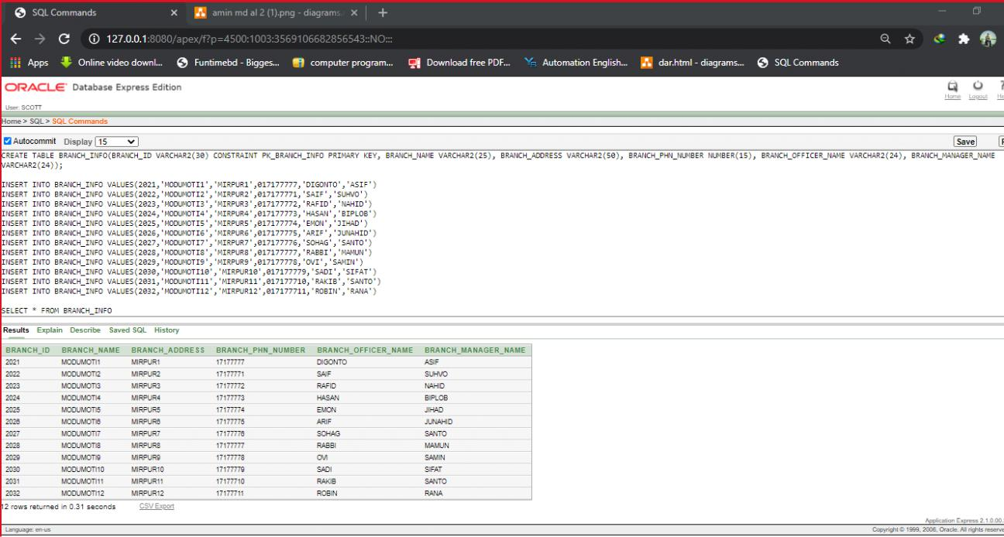

**ACCOUNT>**

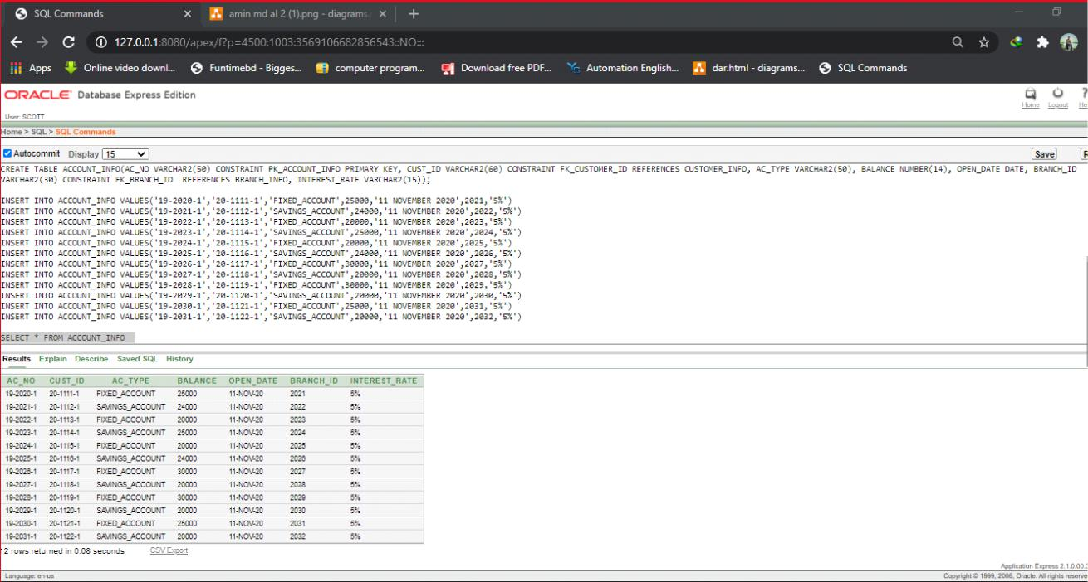

**DEPOSIT-- ACCOUNT>**

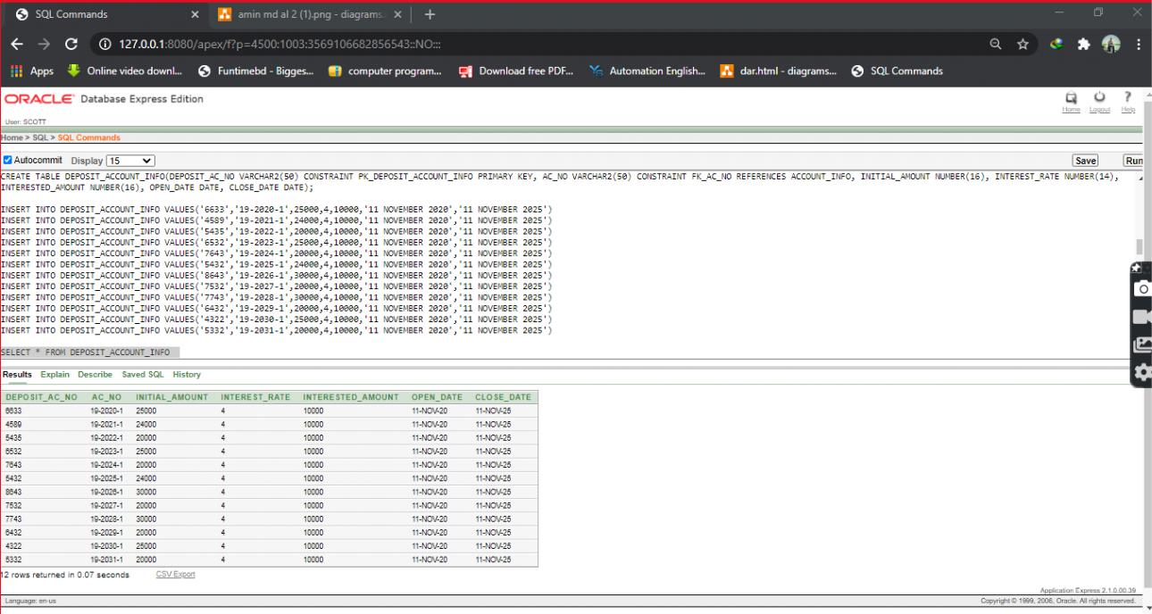

**TRANSACTION>**

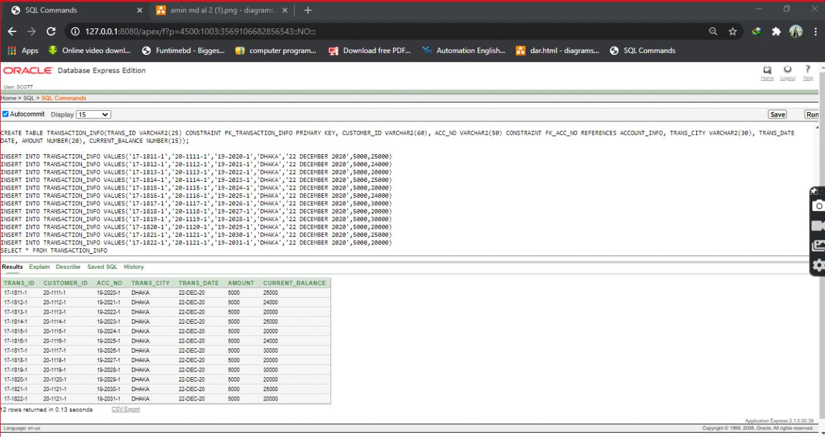

**LOAN ACCOUNT>**

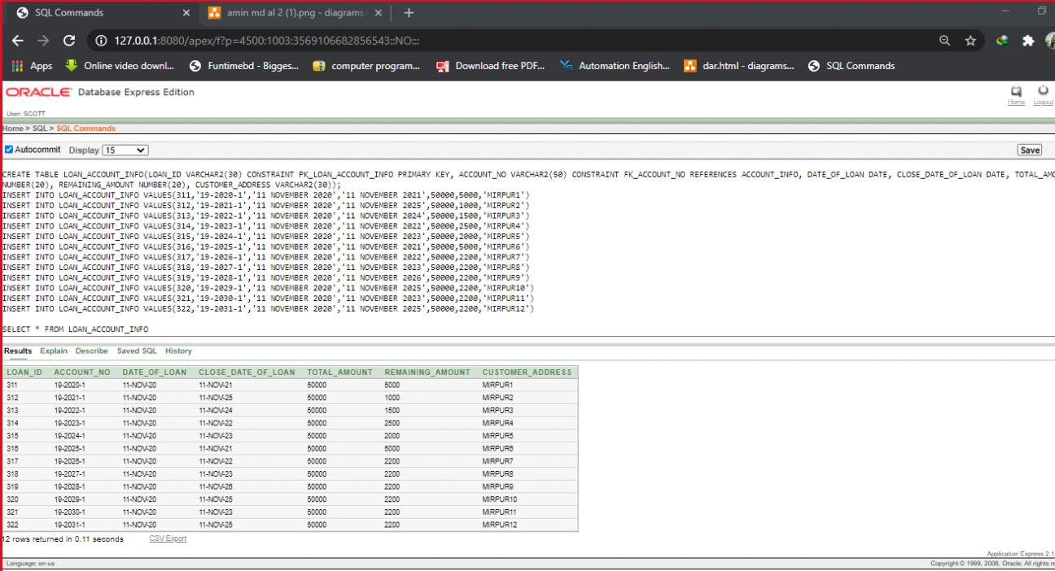

**OFFICER>**

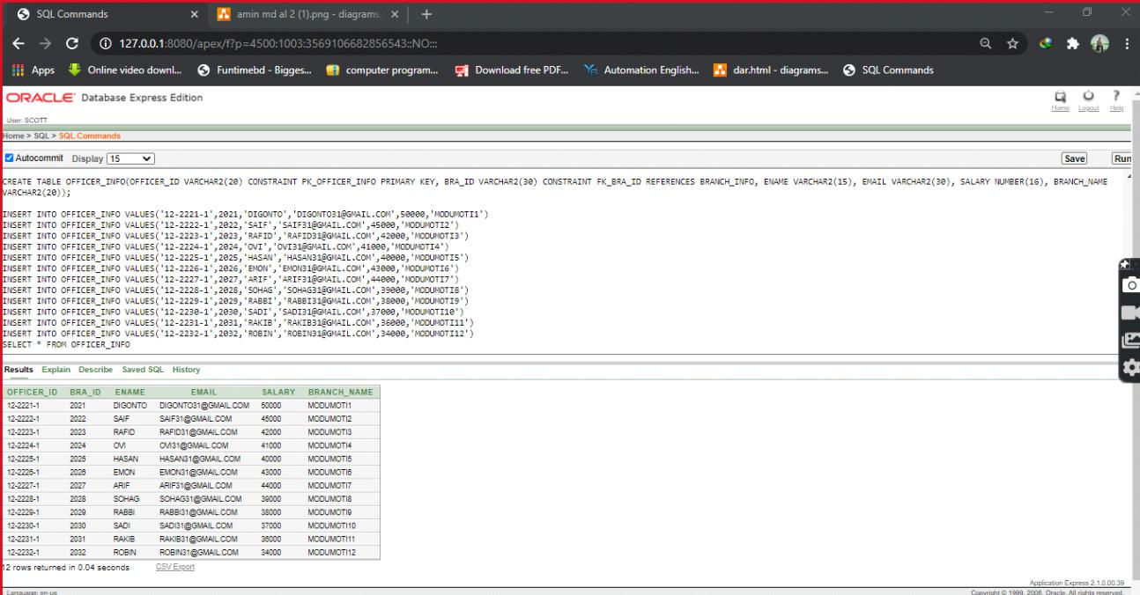

**MANAGER>**

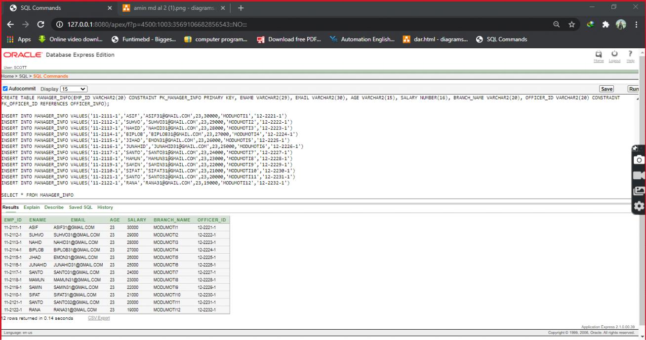

**SOURCE CODE**

CREATE TABLE CUSTOMER_INFO(CUST_ID VARCHAR2(60) CONSTRAINT PK_CUSTOMER_INFO PRIMARY KEY, CUSTOMER_NAME VARCHAR2(50), AGE VARCHAR2(50), ADDRESS VARCHAR2(50), CUSTOMER_PHONE NUMBER(14), CUSTOMER_SALARY NUMBER(20));

INSERT INTO CUSTOMER_INFO VALUES('20-1111-1','HRIDOY',20,'MIRPUR1','01788788256',40000)

INSERT INTO CUSTOMER_INFO VALUES('20-1112-1','SHUVO',20,'MIRPUR2',01788800987,36000)

INSERT INTO CUSTOMER_INFO VALUES('20-1113-1','AUDITY',20,'MIRPUR3',01788245987,35000)

INSERT INTO CUSTOMER_INFO VALUES('20-1114-1','MISTY',20,'MIRPUR4',01788276654,38000)

INSERT INTO CUSTOMER_INFO VALUES('20-1115-1','JANNAT',20,'MIRPUR5',01788143567,36000)

INSERT INTO CUSTOMER_INFO VALUES('20-1116-1','ZAHIN',20,'MIRPUR6',01765423456,32000)

INSERT INTO CUSTOMER_INFO VALUES('20-1117-1','AFROZA',20,'MIRPUR7',01721223467,33000)

INSERT INTO CUSTOMER_INFO VALUES('20-1118-1','SIMU',20,'MIRPUR8',017222765432,34000)

INSERT INTO CUSTOMER_INFO VALUES('20-1119-1','BIZOY',20,'MIRPUR9',01721327654,35000)

INSERT INTO CUSTOMER_INFO VALUES('20-1120-1','BRISTY',20,'MIRPUR10',01721423487,37000)

INSERT INTO CUSTOMER_INFO VALUES('20-1121-1','JEMES',20,'MIRPUR11',017215435678,38000)

INSERT INTO CUSTOMER_INFO VALUES('20-1122-1','KIRIS',20,'MIRPUR12',017216345678,30000)

SELECT * FROM CUSTOMER_INFO

CREATE TABLE BRANCH_INFO(BRANCH_ID VARCHAR2(30) CONSTRAINT PK_BRANCH_INFO PRIMARY KEY, BRANCH_NAME VARCHAR2(25), BRANCH_ADDRESS VARCHAR2(50), BRANCH_PHN_NUMBER NUMBER(15), BRANCH_OFFICER_NAME VARCHAR2(24), BRANCH_MANAGER_NAME VARCHAR2(24));

INSERT INTO BRANCH_INFO

VALUES(2021,'MODUMOTI1','MIRPUR1',017177777,'DIGONTO','ASIF')

INSERT INTO BRANCH_INFO

VALUES(2022,'MODUMOTI2','MIRPUR2',017177771,'SAIF','SUHVO')

INSERT INTO BRANCH_INFO

VALUES(2023,'MODUMOTI3','MIRPUR3',017177772,'RAFID','NAHID')

INSERT INTO BRANCH_INFO

VALUES(2024,'MODUMOTI4','MIRPUR4',017177773,'HASAN','BIPLOB')

INSERT INTO BRANCH_INFO

VALUES(2025,'MODUMOTI5','MIRPUR5',017177774,'EMON','JIHAD')

INSERT INTO BRANCH_INFO

VALUES(2026,'MODUMOTI6','MIRPUR6',017177775,'ARIF','JUNAHID')

INSERT INTO BRANCH_INFO

VALUES(2027,'MODUMOTI7','MIRPUR7',017177776,'SOHAG','SANTO')

INSERT INTO BRANCH_INFO

VALUES(2028,'MODUMOTI8','MIRPUR8',017177777,'RABBI','MAMUN')

INSERT INTO BRANCH_INFO

VALUES(2029,'MODUMOTI9','MIRPUR9',017177778,'OVI','SAMIN')

INSERT INTO BRANCH_INFO

VALUES(2030,'MODUMOTI10','MIRPUR10',017177779,'SADI','SIFAT')

INSERT INTO BRANCH_INFO

VALUES(2031,'MODUMOTI11','MIRPUR11',017177710,'RAKIB','SANTO')

INSERT INTO BRANCH_INFO

VALUES(2032,'MODUMOTI12','MIRPUR12',017177711,'ROBIN','RANA')

SELECT * FROM BRANCH_INFO

CREATE TABLE ACCOUNT_INFO(AC_NO VARCHAR2(50) CONSTRAINT PK_ACCOUNT_INFO PRIMARY KEY, CUST_ID VARCHAR2(60) CONSTRAINT

FK_CUSTOMER_ID REFERENCES CUSTOMER_INFO, AC_TYPE VARCHAR2(50), BALANCE NUMBER(14), OPEN_DATE DATE, BRANCH_ID VARCHAR2(30)

CONSTRAINT FK_BRANCH_ID REFERENCES BRANCH_INFO, INTEREST_RATE VARCHAR2(15));

INSERT INTO ACCOUNT_INFO VALUES('19-2020-1','20-1111-1','FIXED_ACCOUNT',25000,'11 NOVEMBER 2020',2021,'5%')

INSERT INTO ACCOUNT_INFO VALUES('19-2021-1','20-1112-1','SAVINGS_ACCOUNT',24000,'11 NOVEMBER 2020',2022,'5%')

INSERT INTO ACCOUNT_INFO VALUES('19-2022-1','20-1113-1','FIXED_ACCOUNT',20000,'11 NOVEMBER 2020',2023,'5%')

INSERT INTO ACCOUNT_INFO VALUES('19-2023-1','20-1114-1','SAVINGS_ACCOUNT',25000,'11 NOVEMBER 2020',2024,'5%')

INSERT INTO ACCOUNT_INFO VALUES('19-2024-1','20-1115-1','FIXED_ACCOUNT',20000,'11 NOVEMBER 2020',2025,'5%')

INSERT INTO ACCOUNT_INFO VALUES('19-2025-1','20-1116-1','SAVINGS_ACCOUNT',24000,'11 NOVEMBER 2020',2026,'5%')

INSERT INTO ACCOUNT_INFO VALUES('19-2026-1','20-1117-1','FIXED_ACCOUNT',30000,'11 NOVEMBER 2020',2027,'5%')

INSERT INTO ACCOUNT_INFO VALUES('19-2027-1','20-1118-1','SAVINGS_ACCOUNT',20000,'11 NOVEMBER 2020',2028,'5%')

INSERT INTO ACCOUNT_INFO VALUES('19-2028-1','20-1119-1','FIXED_ACCOUNT',30000,'11 NOVEMBER 2020',2029,'5%')

INSERT INTO ACCOUNT_INFO VALUES('19-2029-1','20-1120-1','SAVINGS_ACCOUNT',20000,'11 NOVEMBER 2020',2030,'5%')

INSERT INTO ACCOUNT_INFO VALUES('19-2030-1','20-1121-1','FIXED_ACCOUNT',25000,'11 NOVEMBER 2020',2031,'5%')

INSERT INTO ACCOUNT_INFO VALUES('19-2031-1','20-1122-1','SAVINGS_ACCOUNT',20000,'11 NOVEMBER 2020',2032,'5%')

SELECT * FROM ACCOUNT_INFO

CREATE TABLE DEPOSIT_ACCOUNT_INFO(DEPOSIT_AC_NO VARCHAR2(50) CONSTRAINT PK_DEPOSIT_ACCOUNT_INFO PRIMARY KEY, AC_NO VARCHAR2(50) CONSTRAINT FK_AC_NO REFERENCES ACCOUNT_INFO, INITIAL_AMOUNT NUMBER(16), INTEREST_RATE NUMBER(14),

INTERESTED_AMOUNT NUMBER(16), OPEN_DATE DATE, CLOSE_DATE DATE);

INSERT INTO DEPOSIT_ACCOUNT_INFO VALUES('6633','19-2020-1',25000,4,10000,'11 NOVEMBER 2020','11 NOVEMBER 2025')

INSERT INTO DEPOSIT_ACCOUNT_INFO VALUES('4589','19-2021-1',24000,4,10000,'11 NOVEMBER 2020','11 NOVEMBER 2025')

INSERT INTO DEPOSIT_ACCOUNT_INFO VALUES('5435','19-2022-1',20000,4,10000,'11 NOVEMBER 2020','11 NOVEMBER 2025')

INSERT INTO DEPOSIT_ACCOUNT_INFO VALUES('6532','19-2023-1',25000,4,10000,'11 NOVEMBER 2020','11 NOVEMBER 2025')

INSERT INTO DEPOSIT_ACCOUNT_INFO VALUES('7643','19-2024-1',20000,4,10000,'11 NOVEMBER 2020','11 NOVEMBER 2025')

INSERT INTO DEPOSIT_ACCOUNT_INFO VALUES('5432','19-2025-1',24000,4,10000,'11 NOVEMBER 2020','11 NOVEMBER 2025')

INSERT INTO DEPOSIT_ACCOUNT_INFO VALUES('8643','19-2026-1',30000,4,10000,'11 NOVEMBER 2020','11 NOVEMBER 2025')

INSERT INTO DEPOSIT_ACCOUNT_INFO VALUES('7532','19-2027-1',20000,4,10000,'11 NOVEMBER 2020','11 NOVEMBER 2025')

INSERT INTO DEPOSIT_ACCOUNT_INFO VALUES('7743','19-2028-1',30000,4,10000,'11 NOVEMBER 2020','11 NOVEMBER 2025')

INSERT INTO DEPOSIT_ACCOUNT_INFO VALUES('6432','19-2029-1',20000,4,10000,'11 NOVEMBER 2020','11 NOVEMBER 2025')

INSERT INTO DEPOSIT_ACCOUNT_INFO VALUES('4322','19-2030-1',25000,4,10000,'11 NOVEMBER 2020','11 NOVEMBER 2025')

INSERT INTO DEPOSIT_ACCOUNT_INFO VALUES('5332','19-2031-1',20000,4,10000,'11 NOVEMBER 2020','11 NOVEMBER 2025')

SELECT * FROM DEPOSIT_ACCOUNT_INFO

CREATE TABLE TRANSACTION_INFO(TRANS_ID VARCHAR2(25) CONSTRAINT PK_TRANSACTION_INFO PRIMARY KEY, CUSTOMER_ID VARCHAR2(60), ACC_NO VARCHAR2(50) CONSTRAINT FK_ACC_NO REFERENCES ACCOUNT_INFO, TRANS_CITY VARCHAR2(30), TRANS_DATE DATE, AMOUNT NUMBER(20), CURRENT_BALANCE NUMBER(15));

INSERT INTO TRANSACTION_INFO VALUES('17-1811-1','20-1111-1','19-2020-1','DHAKA','22 DECEMBER 2020',5000,25000)

INSERT INTO TRANSACTION_INFO VALUES('17-1812-1','20-1112-1','19-2021-1','DHAKA','22 DECEMBER 2020',5000,24000)

INSERT INTO TRANSACTION_INFO VALUES('17-1813-1','20-1113-1','19-2022-1','DHAKA','22 DECEMBER 2020',5000,20000)

INSERT INTO TRANSACTION_INFO VALUES('17-1814-1','20-1114-1','19-2023-1','DHAKA','22 DECEMBER 2020',5000,25000)

INSERT INTO TRANSACTION_INFO VALUES('17-1815-1','20-1115-1','19-2024-1','DHAKA','22 DECEMBER 2020',5000,20000)

INSERT INTO TRANSACTION_INFO VALUES('17-1816-1','20-1116-1','19-2025-1','DHAKA','22 DECEMBER 2020',5000,24000)

INSERT INTO TRANSACTION_INFO VALUES('17-1817-1','20-1117-1','19-2026-1','DHAKA','22 DECEMBER 2020',5000,30000)

INSERT INTO TRANSACTION_INFO VALUES('17-1818-1','20-1118-1','19-2027-1','DHAKA','22 DECEMBER 2020',5000,20000)

INSERT INTO TRANSACTION_INFO VALUES('17-1819-1','20-1119-1','19-2028-1','DHAKA','22 DECEMBER 2020',5000,30000)

INSERT INTO TRANSACTION_INFO VALUES('17-1820-1','20-1120-1','19-2029-1','DHAKA','22 DECEMBER 2020',5000,20000)

INSERT INTO TRANSACTION_INFO VALUES('17-1821-1','20-1121-1','19-2030-1','DHAKA','22 DECEMBER 2020',5000,25000)

INSERT INTO TRANSACTION_INFO VALUES('17-1822-1','20-1121-1','19-2031-1','DHAKA','22 DECEMBER 2020',5000,20000)

SELECT * FROM TRANSACTION_INFO

CREATE TABLE LOAN_ACCOUNT_INFO(LOAN_ID VARCHAR2(30) CONSTRAINT PK_LOAN_ACCOUNT_INFO PRIMARY KEY, ACCOUNT_NO VARCHAR2(50) CONSTRAINT FK_ACCOUNT_NO REFERENCES ACCOUNT_INFO, DATE_OF_LOAN DATE, CLOSE_DATE_OF_LOAN DATE,

TOTAL_AMOUNT NUMBER(20), REMAINING_AMOUNT NUMBER(20), CUSTOMER_ADDRESS VARCHAR2(30));

INSERT INTO LOAN_ACCOUNT_INFO VALUES(311,'19-2020-1','11 NOVEMBER 2020','11 NOVEMBER 2021',50000,5000,'MIRPUR1')

INSERT INTO LOAN_ACCOUNT_INFO VALUES(312,'19-2021-1','11 NOVEMBER 2020','11 NOVEMBER 2025',50000,1000,'MIRPUR2')

INSERT INTO LOAN_ACCOUNT_INFO VALUES(313,'19-2022-1','11 NOVEMBER 2020','11 NOVEMBER 2024',50000,1500,'MIRPUR3')

INSERT INTO LOAN_ACCOUNT_INFO VALUES(314,'19-2023-1','11 NOVEMBER 2020','11 NOVEMBER 2022',50000,2500,'MIRPUR4')

INSERT INTO LOAN_ACCOUNT_INFO VALUES(315,'19-2024-1','11 NOVEMBER 2020','11 NOVEMBER 2023',50000,2000,'MIRPUR5')

INSERT INTO LOAN_ACCOUNT_INFO VALUES(316,'19-2025-1','11 NOVEMBER 2020','11 NOVEMBER 2021',50000,5000,'MIRPUR6')

INSERT INTO LOAN_ACCOUNT_INFO VALUES(317,'19-2026-1','11 NOVEMBER 2020','11 NOVEMBER 2022',50000,2200,'MIRPUR7')

INSERT INTO LOAN_ACCOUNT_INFO VALUES(318,'19-2027-1','11 NOVEMBER 2020','11 NOVEMBER 2023',50000,2200,'MIRPUR8')

INSERT INTO LOAN_ACCOUNT_INFO VALUES(319,'19-2028-1','11 NOVEMBER 2020','11 NOVEMBER 2026',50000,2200,'MIRPUR9')

INSERT INTO LOAN_ACCOUNT_INFO VALUES(320,'19-2029-1','11 NOVEMBER 2020','11 NOVEMBER 2025',50000,2200,'MIRPUR10')

INSERT INTO LOAN_ACCOUNT_INFO VALUES(321,'19-2030-1','11 NOVEMBER 2020','11 NOVEMBER 2023',50000,2200,'MIRPUR11')

INSERT INTO LOAN_ACCOUNT_INFO VALUES(322,'19-2031-1','11 NOVEMBER 2020','11 NOVEMBER 2025',50000,2200,'MIRPUR12')

SELECT * FROM LOAN_ACCOUNT_INFO

CREATE TABLE OFFICER_INFO(OFFICER_ID VARCHAR2(20) CONSTRAINT PK_OFFICER_INFO PRIMARY KEY, BRA_ID VARCHAR2(30) CONSTRAINT FK_BRA_ID REFERENCES BRANCH_INFO, ENAME VARCHAR2(15), EMAIL VARCHAR2(30), SALARY NUMBER(16), BRANCH_NAME VARCHAR2(20));

INSERT INTO OFFICER_INFO VALUES('12-2221-1',2021,'DIGONTO','DIGONTO31@GMAIL.COM',50000,'MODUMOTI1')

INSERT INTO OFFICER_INFO VALUES('12-2222-1',2022,'SAIF','SAIF31@GMAIL.COM',45000,'MODUMOTI2')

INSERT INTO OFFICER_INFO VALUES('12-2223-1',2023,'RAFID','RAFID31@GMAIL.COM',42000,'MODUMOTI3')

INSERT INTO OFFICER_INFO VALUES('12-2224-1',2024,'OVI','OVI31@GMAIL.COM',41000,'MODUMOTI4')

INSERT INTO OFFICER_INFO VALUES('12-2225-1',2025,'HASAN','HASAN31@GMAIL.COM',40000,'MODUMOTI5')

INSERT INTO OFFICER_INFO VALUES('12-2226-1',2026,'EMON','EMON31@GMAIL.COM',43000,'MODUMOTI6')

INSERT INTO OFFICER_INFO VALUES('12-2227-1',2027,'ARIF','ARIF31@GMAIL.COM',44000,'MODUMOTI7')

INSERT INTO OFFICER_INFO VALUES('12-2228-1',2028,'SOHAG','SOHAG31@GMAIL.COM',39000,'MODUMOTI8')

INSERT INTO OFFICER_INFO VALUES('12-2229-1',2029,'RABBI','RABBI31@GMAIL.COM',38000,'MODUMOTI9')

INSERT INTO OFFICER_INFO VALUES('12-2230-1',2030,'SADI','SADI31@GMAIL.COM',37000,'MODUMOTI10')

INSERT INTO OFFICER_INFO VALUES('12-2231-1',2031,'RAKIB','RAKIB31@GMAIL.COM',36000,'MODUMOTI11')

INSERT INTO OFFICER_INFO VALUES('12-2232-1',2032,'ROBIN','ROBIN31@GMAIL.COM',34000,'MODUMOTI12')

SELECT * FROM OFFICER_INFO

CREATE TABLE MANAGER_INFO(EMP_ID VARCHAR2(20) CONSTRAINT PK_MANAGER_INFO PRIMARY KEY, ENAME VARCHAR2(29), EMAIL VARCHAR2(30), AGE VARCHAR2(15), SALARY NUMBER(16), BRANCH_NAME VARCHAR2(20), OFFICER_ID VARCHAR2(20) CONSTRAINT FK_OFFICER_ID REFERENCES OFFICER_INFO);

INSERT INTO MANAGER_INFO VALUES('11-2111-1','ASIF','ASIF31@GMAIL.COM',23,30000,'MODUMOTI1','12-2221-1')

INSERT INTO MANAGER_INFO VALUES('11-2112-1','SUHVO','SUHVO31@GMAIL.COM',23,29000,'MODUMOTI2','12-2222-1')

INSERT INTO MANAGER_INFO VALUES('11-2113-1','NAHID','NAHID31@GMAIL.COM',23,28000,'MODUMOTI3','12-2223-1')

INSERT INTO MANAGER_INFO VALUES('11-2114-1','BIPLOB','BIPLOB31@GMAIL.COM',23,27000,'MODUMOTI4','12-2224-1')

INSERT INTO MANAGER_INFO VALUES('11-2115-1','JIHAD','EMON31@GMAIL.COM',23,26000,'MODUMOTI5','12-2225-1')

INSERT INTO MANAGER_INFO VALUES('11-2116-1','JUNAHID','JUNAHID31@GMAIL.COM',23,25000,'MODUMOTI6','12-2226-1')

INSERT INTO MANAGER_INFO VALUES('11-2117-1','SANTO','SANTO31@GMAIL.COM',23,24000,'MODUMOTI7','12-2227-1')

INSERT INTO MANAGER_INFO VALUES('11-2118-1','MAMUN','MAMUN31@GMAIL.COM',23,23000,'MODUMOTI8','12-2228-1')

INSERT INTO MANAGER_INFO VALUES('11-2119-1','SAMIN','SAMIN31@GMAIL.COM',23,22000,'MODUMOTI9','12-2229-1')

INSERT INTO MANAGER_INFO VALUES('11-2110-1','SIFAT','SIFAT31@GMAIL.COM',23,21000,'MODUMOTI10','12-2230-1')

INSERT INTO MANAGER_INFO VALUES('11-2121-1','SANTO','SANTO32@GMAIL.COM',23,20000,'MODUMOTI11','12-2231-1')

INSERT INTO MANAGER_INFO VALUES('11-2122-1','RANA','RANA31@GMAIL.COM',23,19000,'MODUMOTI12','12-2232-1')

SELECT * FROM MANAGER_INFO

**View Tables Data**

* SELECT * FROM CUSTOMER_INFO
* SELECT * FROM BRANCH_INFO
* SELECT * FROM ACCOUNT_INFO
* SELECT * FROM DEPOSIT_ACCOUNT_INFO
* SELECT * FROM TRANSACTION_INFO
* SELECT * FROM LOAN_ACCOUNT_INFO
* SELECT * FROM OFFICER_INFO
* SELECT * FROM MANAGER_INFO

**THE END**

**THANK YOU**