**INTRODUCTION TO DATABASE**

**COURSE TEACHER: Taslimur Rahman**

**SECTION : C**

**Group Number: 9**

**Submitted by**

|  |  |
| --- | --- |
| NAME | ID |
| **Dipto Roy** | 20-42529-1 |
| Sadik Saleh | 21-45570-3 |
|  |  |
|  |  |

**PROJECT:** RAILWAY MANAGEMENT SYSTEM

Introduction : This is a Simple project of Railway management system. Where we have used several entities set to achieve our ultimate goal to represent a railway management system.

Objective with specific aim :

* Maintain the history of all the users of the railway using USER_INFO table.
* Maintain the passenger info of day-to-day services of railway using Passenger table.
* Manage the train schedule using Train table.
* Mange the ticket shop management using Ticket table.
* Maintain all the information about trains using Station table.

Scenario description : We will work with a project including some features like Er diagram, table creation, insertion and implementation of some queries of database management system. We will create all about five tables such as USER_INFO, Passenger,

Train, Ticket and Station. These tables will work with all the primary level information we will insert in the tables. These tables are about to manage all the works of a railway management.

ER Diagram :

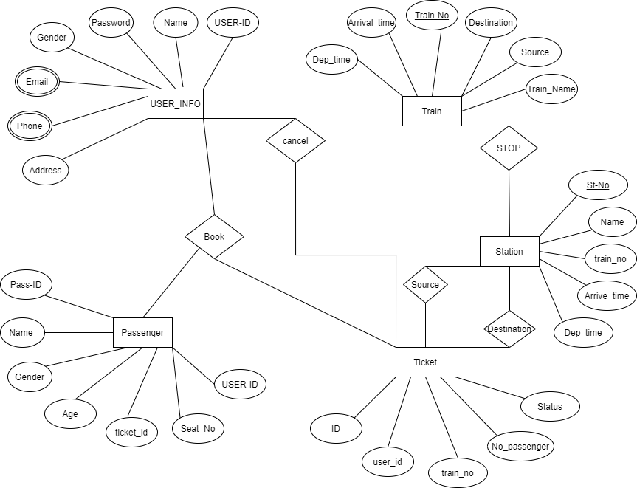

Normalization :

**BOOK** :

UNF :

BOOK (USER-ID, NAME ,PASSWORD,GENDER,EMAIL,PHONE ,

ADDRESS,PASS-ID,NAME,AGE,GENDER,SEAT_NO,ID,TRAIN_NO, NO_PASSENGER,STATUS) 1NF :

Phone and Email are multivalued attribute.

1. USER-ID, NAME ,PASSWORD,GENDER,EMAIL,PHONE , ADDRESS,PASS-ID,NAME,AGE,GENDER,SEAT_NO,TICKET_ID, USER_ID,ID,TRAIN_NO, USER_ID,NO_PASSENGER,STATUS .

2NF

1. USER-ID, NAME ,PASSWORD,GENDER,EMAIL,PHONE , ADDRESS
2. PASS-ID,NAME,AGE,GENDER,SEAT_NO,USER_ID,TICKET_ID, ID,TRAIN_NO, NO_PASSENGER,STATUS ,USER_ID.

3NF

1. USER-ID, NAME ,PASSWORD,GENDER,EMAIL,PHONE , ADDRESS
2. PASS-ID,NAME,AGE,GENDER,SEAT_NO,**USER_ID**,**TICKET_ID**
3. ID, TRAIN_NO, NO_PASSENGER, STATUS,**USER_ID** Table Creation:
4. USER-ID, NAME ,PASSWORD,GENDER,EMAIL,PHONE , ADDRESS
5. PASS-ID,NAME,AGE,GENDER,SEAT_NO, **USER_ID**,**TICKET_ID**
6. ID, TRAIN_NO, NO_PASSENGER,STATUS , **USER_ID**.

**CANCEL** :

UNF :

CANCEL (USER-ID,NAME ,PASSWORD,GENDER,EMAIL,PHONE , ADDRESS, ID,TRAIN_NO, NO_PASSENGER,STATUS ,USER_ID) 1NF :

Phone and Email are multivalued attribute.

1. USER-ID, NAME ,PASSWORD,GENDER,EMAIL,PHONE , ADDRESS, ID,TRAIN_NO, NO_PASSENGER,STATUS,USER_ID .

2NF

1. USER-ID, NAME ,PASSWORD,GENDER,EMAIL,PHONE , ADDRESS
2. ID,TRAIN_NO, NO_PASSENGER,STATUS,USER_ID

3NF

There is no transitive dependency.Relation already in 3NF

1. USER-ID, NAME ,PASSWORD,GENDER,EMAIL,PHONE , ADDRESS
2. ID,TRAIN_NO, NO_PASSENGER,STATUS,**USER_ID**

Table Creation:

1. USER-ID, NAME ,PASSWORD,GENDER,EMAIL,PHONE , ADDRESS
2. ID,TRAIN_NO, NO_PASSENGER,STATUS,**USER_ID**

**STOP :**

UNF:

STOP(TRAIN-NO,TRAIN_NAME ,SOURCE ,DESTINATION , ARRIVAL_TIME, DEP_TIME,ST-NO,NAME,ARRIVE_TIME ,DEP_TIME,TRAIN_NO)

1NF:

1. TRAIN-NO,TRAIN_NAME ,SOURCE ,DESTINATION , ARRIVAL_TIME , DEP_TIME,ST-NO,NAME,ARRIVE_TIME ,DEP_TIME,TRAIN_NO 2NF :

1. TRAIN-NO,TRAIN_NAME ,SOURCE ,DESTINATION , ARRIVAL_TIME ,

DEP_TIME

1. ST-NO, NAME, ARRIVE_TIME, DEP_TIME,TRAIN_NO 3NF :

There is no transitive dependency. Relation already in 3NF

1. TRAIN-NO,TRAIN_NAME ,SOURCE ,DESTINATION , ARRIVAL_TIME ,

DEP_TIME

1. ST-NO, NAME, ARRIVE_TIME, DEP_TIME, **TRAIN_NO** Table Creation:
2. TRAIN-NO,TRAIN_NAME ,SOURCE ,DESTINATION , ARRIVAL_TIME ,

DEP_TIME

1. ST-NO, NAME, ARRIVE_TIME, DEP_TIME, **TRAIN_NO**

**SOURCE :**

UNF :

SOURCE (ID,NO_PASSENGER ,USER_ID,TRAIN_NO,STATUS, ST-NO, NAME, ARRIVE_TIME, DEP_TIME,TRAIN_NO) 1NF :

1. ID,NO_PASSENGER ,STATUS,USER_ID,TRAIN_NO, ST-NO, NAME, ARRIVE_TIME, DEP_TIME, TRAIN_NO 2NF :

1. ID,NO_PASSENGER ,STATUS,USER_ID,TRAIN_NO 2. ST-NO, NAME, ARRIVE_TIME, DEP_TIME, TRAIN_NO 3NF:

There is no transitive dependency. Relation already in 3NF

1. ID,NO_PASSENGER ,STATUS,USER_ID,**TRAIN_NO** 2. ST-NO, NAME, ARRIVE_TIME, DEP_TIME, **TRAIN_NO** Table Creation:

1. ID,NO_PASSENGER ,STATUS, USER_ID,**TRAIN_NO**
2. ST-NO, NAME, ARRIVE_TIME, DEP_TIME, **TRAIN_NO**

**DESTINATION** :

UNF :

SOURCE (ID,NO_PASSENGER ,USER_ID,TRAIN_NO,STATUS, ST-NO, NAME, ARRIVE_TIME, DEP_TIME,TRAIN_NO)

1NF :

1. ID,NO_PASSENGER ,USER_ID,TRAIN_NO,STATUS, ST-NO, NAME, ARRIVE_TIME, DEP_TIME,TRAIN_NO 2NF :

1. ID,NO_PASSENGER ,STATUS,USER_ID,TRAIN_NO
2. ST-NO, NAME, ARRIVE_TIME, DEP_TIME, TRAIN_NO

3NF:

There is no transitive dependency. Relation already in 3NF

1. ID,NO_PASSENGER ,STATUS,USER_ID,**TRAIN_NO**
2. ST-NO, NAME, ARRIVE_TIME, DEP_TIME, **TRAIN_NO**

Table Creation:

1. ID,NO_PASSENGER ,STATUS,USER_ID,**TRAIN_NO**
2. ST-NO, NAME, ARRIVE_TIME, DEP_TIME, **TRAIN_NO**

**Temporary Tables:**

1. USER-ID, NAME ,PASSWORD,GENDER,EMAIL,PHONE , ADDRESS
2. PASS-ID,NAME,AGE,GENDER,SEAT_NO, **USER_ID**,**TICKET_ID**
3. ID, TRAIN_NO, NO_PASSENGER,STATUS , **USER_ID**.
4. USER-ID, NAME ,PASSWORD,GENDER,EMAIL,PHONE , ADDRESS
5. ID,TRAIN_NO, NO_PASSENGER,STATUS, **USER_ID** .
6. TRAIN-NO, TRAIN_NAME, SOURCE, DESTINATION, ARRIVAL_TIME, DEP_TIME
7. ST-NO, NAME, ARRIVE_TIME, DEP_TIME **,TRAIN_NO**
8. ID,NO_PASSENGER ,STATUS,USER_ID,**TRAIN_NO**
9. ST-NO, NAME, ARRIVE_TIME, DEP_TIME, **TRAIN_NO**
10. ID,NO_PASSENGER ,STATUS,USER_ID,**TRAIN_NO**
11. ST-NO, NAME, ARRIVE_TIME, DEP_TIME, **TRAIN_NO**

**Final Table :**

1.USER-ID, NAME,PASSWORD,GENDER, EMAIL,PHONE,ADDRESS

2.PASS-ID,NAME,GENDER,AGE,SEAT_NO,**TICKET-ID**,**USER-ID**

3.ID, NUMBER_PASSENGER, STATUS, **USER_ID**, **TRAIN_NO**

4.ST-NO, NAME, DEP_TIME, ARRIVE_TIME, **TRAIN_NO**

5.TRAIN-NO, SOURCE, DESTINATION, TRAIN_NAME, ARRIVAL_TIME, DEP_TIME

Query for table creation :

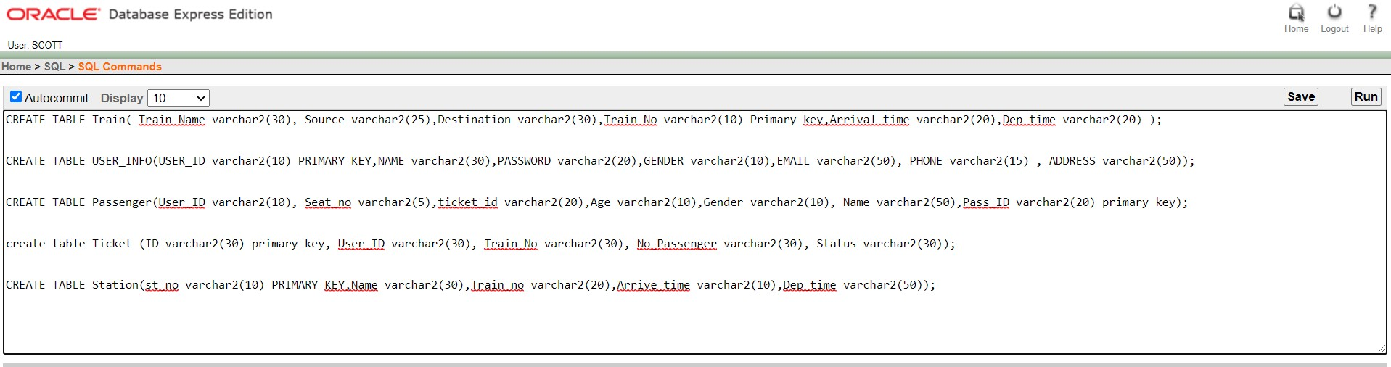

1. CREATE TABLE Train( Train_Name varchar2(30), Source varchar2(25),Destination varchar2(30),Train_No varchar2(10) Primary key,Arrival_time varchar2(20),Dep_time varchar2(20) );

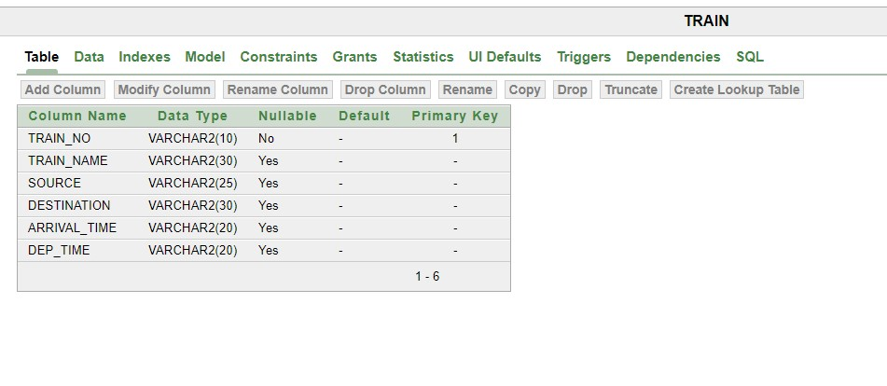

1. CREATE TABLE USER_INFO(USER_ID varchar2(10) PRIMARY KEY,NAME varchar2(30),PASSWORD varchar2(20),GENDER varchar2(10),EMAIL varchar2(50), PHONE varchar2(15) ,

ADDRESS varchar2(50));

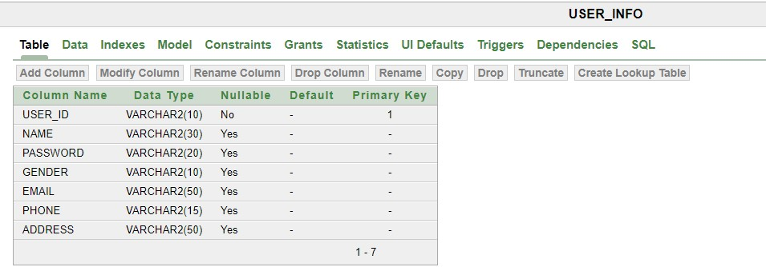

1. CREATE TABLE Passenger(User_ID varchar2(10), Seat_no varchar2(5),ticket_id varchar2(20),Age varchar2(10),Gender varchar2(10), Name varchar2(50),Pass_ID varchar2(20) primary key);

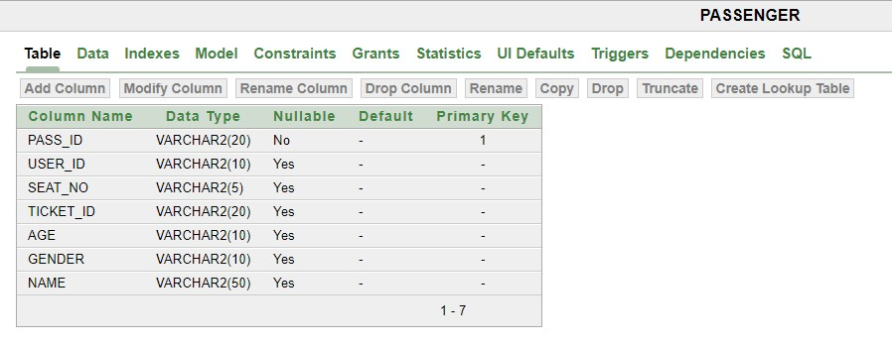

1. create table Ticket (ID varchar2(30) primary key, User_ID varchar2(30), Train_No varchar2(30), No_Passenger varchar2(30), Status varchar2(30));

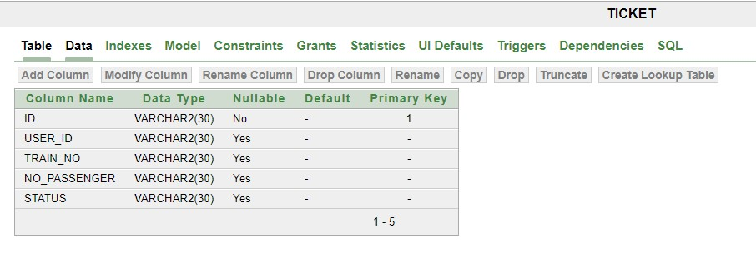

1. CREATE TABLE Station(st_no varchar2(10) PRIMARY KEY,Name varchar2(30),Train_no varchar2(20),Arrive_time varchar2(10),Dep_time varchar2(50));

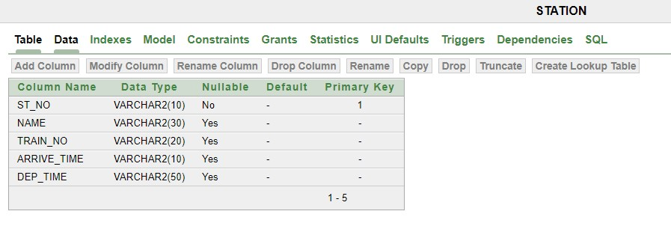

Data Insertion :

1. For Train Table :

insert into Train values ('Turna_Nisita', 'Chattogram','Dhaka','18','6.00-am','11.00pm');

insert into Train values ('Mohanogor_provati', 'Chattogram','Dhaka','19','8.00pm','2.00-pm');

insert into Train values ('Bonolota', 'Rajshahi','Dhaka','20','8.00-pm','1.00-pm'); insert into Train values ('Dhumketu', 'Rajshahi','Dhaka','21','10.00-pm','4.00-pm'); insert into Train values ('Silk_City', 'Rajshahi','Dhaka','22','11.00-pm','5.00-pm'); insert into Train values ('Upakul', 'Noakhali','Dhaka','23','11.00-pm','5.00-pm'); insert into Train values ('Sundarban', 'Khulna','Dhaka','24','8.00-pm','3.00-pm'); insert into Train values ('Udayan', 'Comilla','Sylhet','25','12.10-pm','7.00-am'); insert into Train values ('Rangpur_Express', 'Rangpur','Dhaka','26','8.00-pm','3.00pm');

insert into Train values ('Sylhet_Express', 'Sylhet','Dhaka','27','12.20-pm','6.00am');

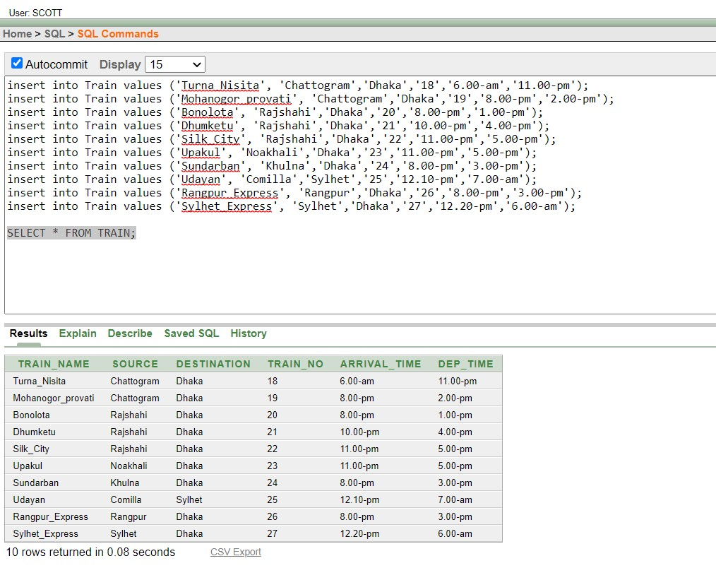

2.For USER_INFO Table :

insert into USER_INFO values ( '101', 'Protik', 'pro777', 'Male','protik123@gmail.com','01799999999','Rajshahi'); insert into USER_INFO values ( '102', 'Mehedi', 'mehedi12', 'Male','mehedi23@gmail.com','01795444149','Dhaka'); insert into USER_INFO values ( '103', 'Nafi', 'Nafi55', 'Male','nafi33@gmail.com','01732312429','Dinajpur'); insert into USER_INFO values ( '104', 'Tawhid', 'Tawhid454', 'Male','tawhid55@gmail.com','01712435537','Rangpur'); insert into USER_INFO values ( '105', 'Audty', 'Audty546', 'Famale','audty12@gmail.com','01823494549','Chittagong'); insert into USER_INFO values ( '106', 'Jayem', 'Jayem784', 'Male','jayem98@gmail.com','01757156752','Barishal'); insert into USER_INFO values ( '107', 'Elma', 'Elma4', 'Female','elmaaa@gmail.com','01745765454','Dhaka'); insert into USER_INFO values ( '108', 'Bondhon', 'Bondhon12', 'Male','bondhon77@gmail.com','01753875765','Natore'); insert into USER_INFO values ( '109', 'Niloy', 'Niloy8754', 'Male','niloy07@gmail.com','01742654673','Noakhali'); insert into USER_INFO values ( '110', 'Amartya', 'Amartya1',

'Male','amartya69@gmail.com','01754456454','Bogura');

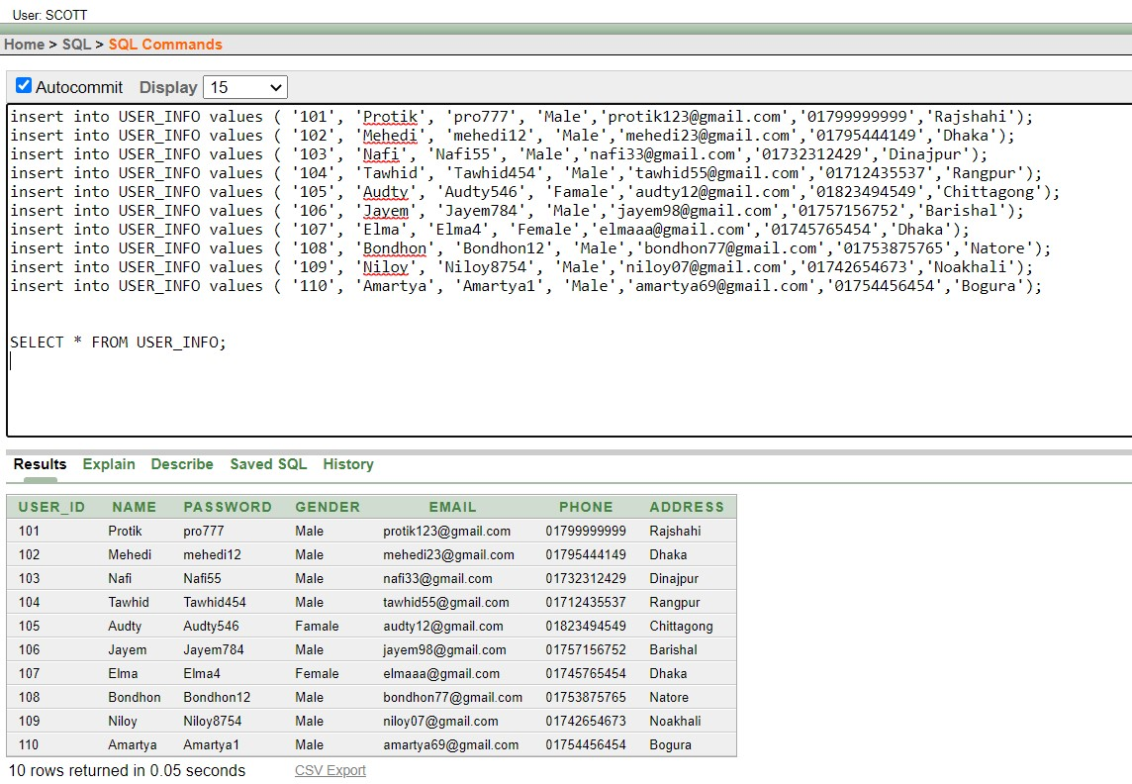

1. For Passenger Table :

insert into Passenger values ( '101', '12', '22202', '22','Male','Protik','201'); insert into Passenger values ( '102', '50', '22203', '18','Male','Mehedi','202'); insert into Passenger values ( '103', '70', '22204', '23','Male','Nafi','203'); insert into Passenger values ( '104', '46', '22205', '33','Male','Tawhid','204'); insert into Passenger values ( '105', '95', '22206', '17','Female','Audty','205'); insert into Passenger values ( '106', '11', '22207', '25','Male','Jayem','206'); insert into Passenger values ( '107', '80', '22208', '35','Female','Elma','207'); insert into Passenger values ( '108', '69', '22209', '19','Male','Bondhon','208'); insert into Passenger values ( '109', '66', '22210', '21','Male','Niloy','209'); insert into Passenger values ( '110', '33', '22211', '21','Male','Amartya','210');

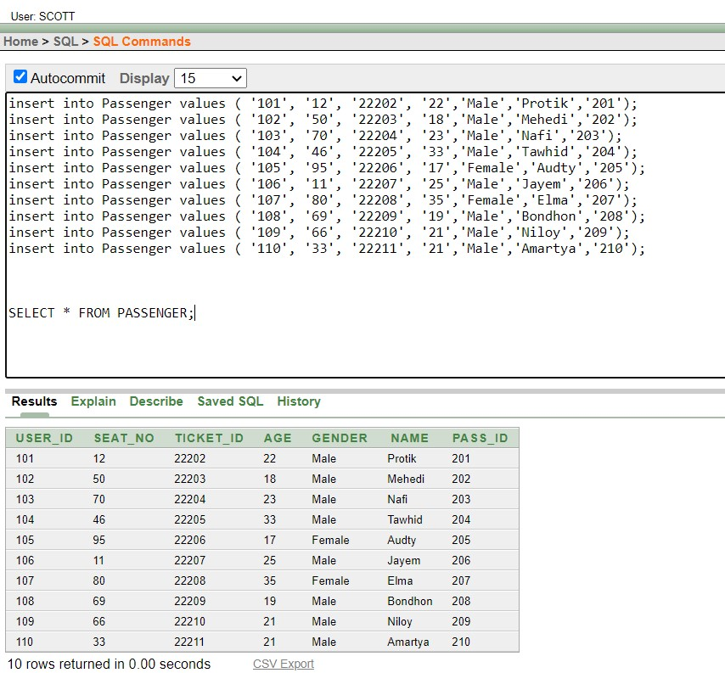

1. For Ticket Table :

insert into Ticket values ( '22202','101','18','01','Valid'); insert into Ticket values ( '22203','102','19','01','Valid'); insert into Ticket values ( '22204','103','20','01','Valid'); insert into Ticket values ( '22205','104','21','01','Valid'); insert into Ticket values ( '22206','105','22','01','Valid'); insert into Ticket values ( '22207','106','23','01','Valid'); insert into Ticket values ( '22208','107','24','01','Valid'); insert into Ticket values ( '22209','108','25','01','Valid'); insert into Ticket values ( '22210','109','26','01','Valid'); insert into Ticket values ( '22211','110','27','01','Valid');

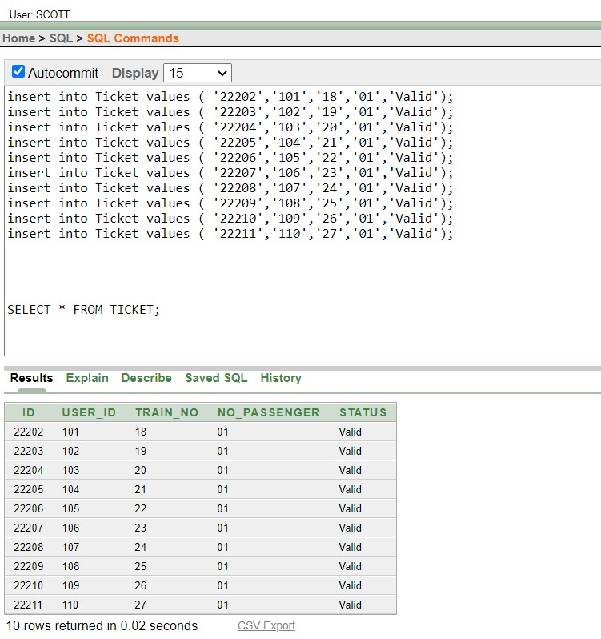

1. For Station Table :

insert into station values ('3', 'Chattogram','18','9.00-pm','11.00-pm'); insert into station values ('4', 'Dhaka','19','11.00-am','2.00-pm'); insert into station values ('5', 'Rajshahi','20','11.00-am','1.00-pm'); insert into station values ('6', 'Abdulpur','21','5.00-pm','5.30-pm'); insert into station values ('7', 'tongi','22','10.00-pm','10.15-pm'); insert into station values ('8', 'Noakhali','23','3.00-pm','5.00-pm'); insert into station values ('9', 'Khulna','24','1.00-pm','3.00-pm'); insert into station values ('10', 'Comilla','25','6.00-am','7.00-am'); insert into station values ('11', 'Rangpur','26','1.00-pm','3.00-pm'); insert into station values ('12', 'Sylhet','27','5.00-am','6.00-am');

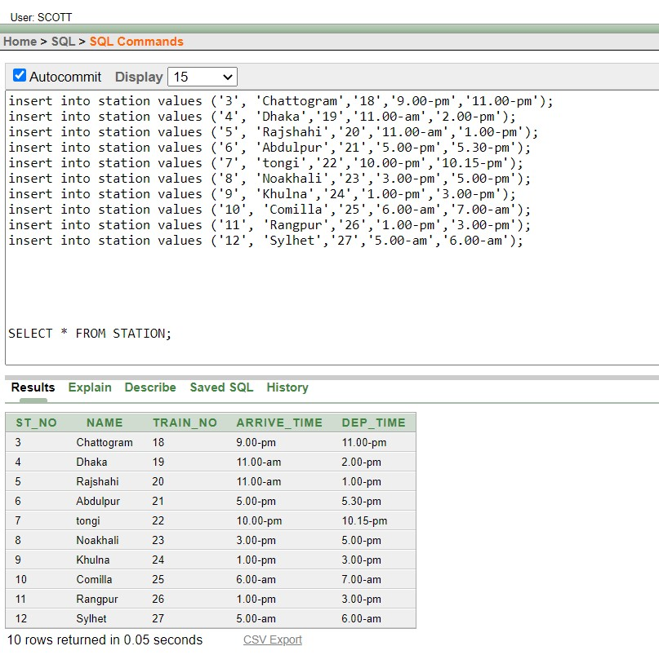

QUERY Writing :

1. Single row function :

* Write a query to display the Passenger Name in lowercase letter

Ans : SELECT LOWER (NAME ) FROM PASSENGER ;

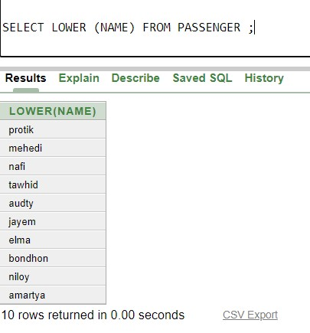

* Display the Passenger Name and ID by joining the columns using concatenation function and show the length size of Passenger Name.

Ans : SELECT CONCAT(NAME,PASS_ID),LENGTH(NAME)FROM PASSENGER

2

.

**Group Functio**

**n :**

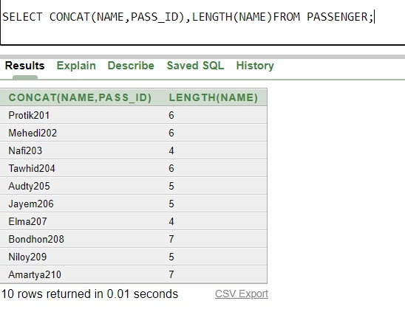

* Find the average,minimum and maximum AGE according to Passenger ID .

ANS : SELECT PASS_ID,AVG(AGE), MAX(AGE), MIN(AGE) from

PASSENGER Group by PASS_ID ;

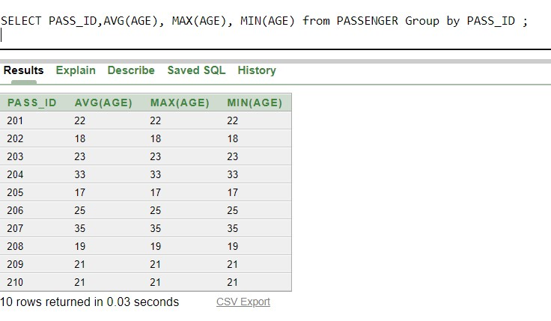

• Display the number of passenger ID whose AGE =’21’

Ans : Select Count(PASS_ID) from PASSENGER Where AGE='21';

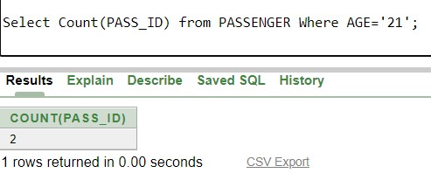

3. Sub-query :

* Display the Passenger ID whose age is maximum using subquery in a group function.

**Ans :** SELECT PASS_ID , NAME FROM PASSENGER WHERE AGE= (SELECT

MAX(AGE)FROM PASSENGER);

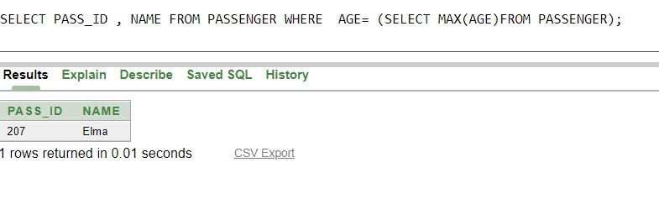

* Display the USER Name whose Email_address is mehedi23@gmail.com using subquery

Ans : SELECT NAME ,ADDRESS FROM USER_INFO WHERE USER_ID=ANY(SELECT

USER_ID FROM USER_INFO WHERE EMAIL= ' mehedi23@gmail.com ');

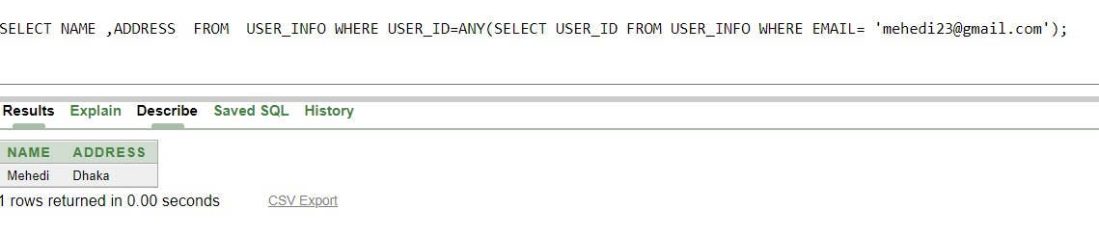

Joining :

* Write a query the user name, user id, address and passenger name, passenger id for all user and passenger

Ans : SELECT U. NAME, U.USER_ID ,U.ADDRESS ,P. NAME, P.PASS_ID FROM

USER_INFO U,PASSENGER P WHERE U.USER_ID=P.USER_ID;

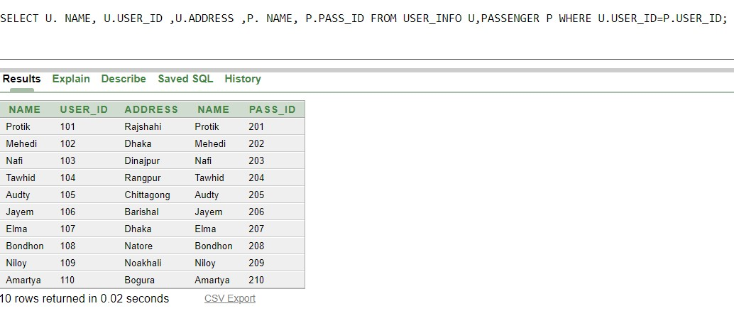

**Conclusion:** This is a small application of management of Railway management system. The limitation of this application is that we couldn’t add many features because of our primary level knowledge of database management system. We can use this prototype as a small railway management system. It will provide somewhat every information of a railway. So, the project is just an instance of the original railway management system.