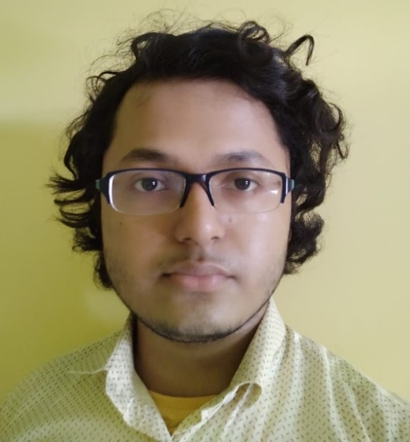

**Skills**

* Skilled in building Frontend using HTML, CSS, JS & React JS
* Skilled in building Backend using Node JS & Python (Flask)
* Skilled in Data Analysis (Pandas) & other applications of Python
* Understanding of Databases, SQL, MongoDB, etc.
* Understanding of basic Cloud concepts in Azure
* Understanding of Java & .NET code
* Understanding of PowerShell script & commands
* Understanding of Data Structures & Algorithms

**Projects**

* Personal Portfolio Website. Link: [Portfolio Website](https://diptobiswasanime4.github.io/Beginner-JavaScript-Projects/Portfolio-website/portfolio-website-1/)
* Project using Node JS, HTML, CSS & JS. Link: [Simple Realtime Chatroom](https://simple-real-time-chat-app-1.herokuapp.com/)
* Vanilla JS apps I made & still making. Link: [JS Apps](https://diptobiswasanime4.github.io/Beginner-JavaScript-Projects/)
* Built a website to display charts, based on real-time data from a SharePoint List, and other sources, using HTML, CSS & Vanilla JS as Frontend, and Python (Flask) as Backend, deployed using Microsoft IIS as part of Office project. The website gives a bird’s-eye view of the daily, monthly & yearly usage of a SharePoint App used in Office.

**Education & Experience**

* Working in *Capgemini* from September, 2020 till now (Designation while joining – **Senior Analyst**, Designation now – **Associate Consultant**)
* Graduated from *Jadavpur University* in Civil Engineering with 1st Class, CGPA – 7.5, marks – 65%, in 2020
* Passed Higher Secondary Examination from *Barrackpore Govt. High School* with 91% marks in 2016
* Passed Secondary Examination from *Ramakrishna Mission, Rahara* with 83% marks in 2014

**Summary**

Software developer with 2+ years of experience. Working in Web development. Skilled in Python, HTML, CSS, Vanilla JS, React JS, Node JS, MongoDB, Express JS, SQL, etc. Always interested to learn new Tech.

**Hobbies**

* Reading Books
* Listening to podcasts
* Singing and playing Music
* Making Coding videos

**Technical Interests**

* Blockchain, Web3, DeFi, etc.
* Machine Learning, AI, etc.
* Mobile Development
* Scale & Marketing

**DIPTO BISWAS**

**Contact Info**

+91 9330417172



[diptobiswas1998@gmail.com](mailto:diptobiswas1998@gmail.com)



India



[](https://twitter.com/DiptoBiswas2k14) [@DiptoBiswas2k14](https://twitter.com/DiptoBiswas2k14)

[](https://www.linkedin.com/in/dipto-biswas-bb2162175/) [LinkedIn](https://www.linkedin.com/in/dipto-biswas-bb2162175/)

[GitHub](https://github.com/diptobiswasanime4)



[](https://www.youtube.com/channel/UCZq1gYy6v7bm48BNpCJP-uA/featured) [YouTube](https://www.youtube.com/channel/UCZq1gYy6v7bm48BNpCJP-uA/featured)

[](https://diptobiswasanime4.github.io/Beginner-JavaScript-Projects/Portfolio-website/portfolio-website-1/) [Portfolio Website](https://diptobiswasanime4.github.io/Beginner-JavaScript-Projects/Portfolio-website/portfolio-website-1/)