  Geetika Sachdeva | photo
Tel: 8920419460
E-mail: sachdevageetika88@gmail.com

Objective

To work in learning and challenging environment , utilizing my skill and knowledge to be the best of abilities and contribute and contribute positively to my personal growth as well as growth of the organization.

Education

 | Year | Examination | Institution | Aggregate
 | 2017 – pursuing | Bachelor of ComputerScience and Engineering | Aravali College of Engineering And Management | 67%
 | 2013-2016 | Diploma in Computer Science and Engineering | Govt. Polytechnic For Women | 60%
 | 2013 | 10th | Saint Micah Christian High School | 72%

Key Technical Skills


Programming Languages Basic Knowledge about C and C++,
Beginner of Python Language

Web Relate HTML, CSS, PHP

Operating System Windows 7/8/10, Linux

Development Tools Visual Studio, Netbeans, Sublime

Field of Interests

1 .Web Development & Internet of Things.

Academic Projects

B.Tech 3rd Sememster Project:

- Aravali College Patriika
- Description : The project focused on building a news portal for Aravali College of Engineering & Management. I used HTML and PHP for developing the project.



Academic Seminars

These are the name of seminars which were attended by me:

- Big Data Hadoop
- Hybrid Mobile Application Development
- Careers in CSE
- Machine Learning using Python
- Cisco Networking

Awards and Achievements

- Secured 2nd Position in Group Stage Play in Diploma.

Hobbies

- Reading Novels
- Watching Constructive Videos which can help in building my career.
- Learning new things about Computers.
- Listening soft music
- Sharing the knowledge.

Personal Information

Full Name Geetika Sachdeva

Father’s Name Mr. Chander Bhushan Sachdeva

Gender Female

Date of Birth 20 Sep 1997

Nationality Indian

Permanent Address B Block 212 Dabua Colony N.I.T Faridabad

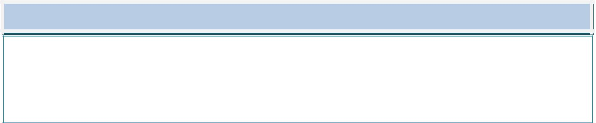
Declaration

I hereby declare that the information provided above is true to the best of my knowledge and belief.

Date :

Place :

Signature :

