

**Supply Chain Management**

Submitted to

Sadia Rahman

ENGINEERING MANAGEMENT[L]

Project Members:

Parthib Takitazwar 18-36345-1

Abdur Rahman 18-36340-1

Tabassum, Anika 18-37604-1

Dipu hasan 18-36364-1

**Content**

Abstract……………………………………………………………………………….…………….3

1.Introduction………………………………………………………………………….………..4

2.Supply Chain System…………………………………………………………….…………5

2.1 Raw materials of garments factory …………………………………………………………….………..5

2.2 Supplier.………………………………………………………………………………………………………….……6

2.3 MANUFACTURING.………………………………………………………………………………………….……6

2.4 DISTRIBUTION………………………………………………………………………………………………….…..7

2.5 RETAILER………………………………………………………………………………………………………………7

2.6 CUSTOMER……………………………………………………………………………………………………………8

3.Findings………………………………………………………………………………………….9

3.1 Supply of Raw materials………………………………………………………………………………………9

3.2 Product Manufacturing……………………………………………………………………………………….10

3.3 Quality Measurement…………………………………………………………………………………………12

3.4 Distribution and Retail………………………………………………………………………………………..14

4.Discussion………………………………………………………………………………………15

Suggestions Regarding Inventory Management……………………………………..15

Suggestions Regarding Work Environment ……………………………………………15

Suggestions Regarding Fire Safety………………………………………………………….17

Suggestions Regarding Transportation……………………………………………………18

5.Conclusion……………………………………………………………..…………………..….18

6. Reference……………………………………………………………………..………….…..18

**Abstract**

Supply Chain Management is very important to an organization as it will allow growth and management control. It is necessary for an organization to follow an effective supply chains in order to be successful in the competitive market. Though most of the industries in the developed countries has already acquired an organized and profitable supply chain, Bangladeshi industries lag behind those. Without the required supply chain, they fail to enter the global competitive market. To solve this problem, some new method of supply chain is needed which will be suitable for this country. By applying proper management and policy strategies our country will take the apex position in future.

1. **Introduction:**

The garment industry of Bangladesh has been the key export division and a main source of foreign exchange for the last 25 years. At present, the country generates about $5 billion worth of products each year by exporting garment. The industry provides employment to about 3 million workers of whom 90% are women.

A garments factory is a place where clothing is prod

used on an industrial scale using (usually) mass production processes and standard sized pattern pieces to make many items to a set design.

Garment production is an organized activity consisting of sequential processes such as laying, marking, cutting, stitching, checking, finishing, pressing and packaging. This is a process of converting raw materials into finished product.

Bangladesh's major export item is readymade-garments and others include shrimps, jute, leather goods and tea. Main export destinations are the United States and the EU. Bangladesh imports mostly fuel, capital goods and foodstuff originating in China, India, the EU and Kuwait.

According to BGMEA total 3503 factories are registered. But actually around 6000 garment factories in Bangladesh at present. The growth of this industry has been dramatic, increasing from 30 factories in 1980, to over 6000 in 2014. The RMG sector provides direct employment to around 4.4 million people, 80% of whom are women. Bangladesh is the world's second largest Readymade Garment (RMG) exporter, just behind China. Country's 81% of exports come from the RMG sector and the textile and Apparel sector contributes around 20% to Bangladesh's GDP.

For our project we visited Ferdous Fashion Ltd. Around 420 workers work there. They use various machineries like Metal detector, fire safety door etc. their maid products are women’s cloth, baby cloth and jacket. They export their products to India, UK, and Africa.

1. **Supply Chain System:**

A STANDARD CHAIN OF A GARMENTS FACTORY

* RAW METERIALS
* SUPPLIER
* MANUFACTURING
* DISTRIBUTION
* RETAILER
* CUSTOMER

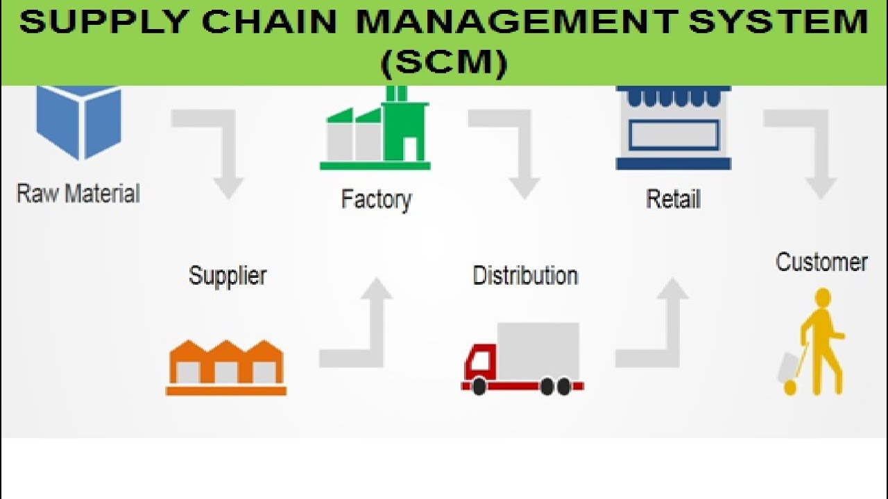

Visual Diagram

**2.1 Raw materials of garments factory:**

Raw material is the primary substance which is used as an input to a production process for subsequent modification and finally modified into a finished good. Raw material is a unique substance in any production-oriented garment industry. Such businesses include textile fabrics, lining and garment materials, shirts, denim, functional materials, as well as fiber raw materials such as yarn and cotton. One of good examples that can be found in the raw material field is our environment-friendly production.

**2.2 Supplier:**

Supplier supplies and delivers raw materials (dressed fabrics and additional components like buttons, labels) to production plants. These materials are used by manufacturers to produce goods and sell them. With the increase demand, suppliers have to increase the supply of raw material. In addition, suppliers could use manufacturers' production schedules to better prepare their own production and inventory control, which would ultimately help ensure reliable supplies to the manufacturers.

**2.3 MANUFACTURING:**

A manufacturing project report is a document that lists down the items and processes that are involved in a specific manufacturing project. It also includes updates on the operations of the business and the current status of the procedures and systems that will be applied in the manufacturing project. Manufacturers get their raw materials from the suppliers. The type of manufacturing process depends on the facility, the staff, and the information systems available. Each process has its advantages and some are best at certain tasks, for example, large batches of finished goods, or small numbers of custom items. When the decision is being considered about which manufacturing process to use, there are a number of questions that should be asked; what are the volumes to be produced, what are the requirements to make the product, and does the company manufacture a similar product? There are a number of basic manufacturing processes that they can select from; production line, continuous flow, custom manufacturing, and fixed position manufacturing. If a company manufactures a wide range of products that can be modified based on the customers' requirements, then a custom manufacturing process is a good fit. The custom manufacturing facility has a number of skilled employees and a range of equipment that can be used to manufacture and modify a wide range of items. The facility should be set up with a number of dedicated areas such as a welding area, lathe shop, paint spray area, and packaging area. The custom manufacturing facility is not designed for high volume products but is ideal for customized products.

**2.4 DISTRIBUTION:**

Distribution management refers to the process of overseeing the movement of goods from supplier or manufacturer to point of sale. It is an overarching term that refers to numerous activities and processes such as packaging, inventory, warehousing, supply chain, and logistics. The profit margins of businesses depend on how quickly they can turn over their goods. The more they sell, the more they earn, which means a better future for the business. Having a successful distribution management system is also important for businesses to remain competitive and to keep customers satisfied. Distribution management is critical to a company's financial success and corporate longevity. Executing it successfully requires effective management of the entire distribution process. The larger a corporation, or the greater the number of supplies points a company has, the more it will need to rely on automation to effectively manage the distribution process. Modern distribution management encompasses more than just moving products from point A to point B. It also involves gathering and sharing relevant information that can be used to identify key opportunities for growth and competitiveness in the market. Most progressive companies now use their distribution forces to obtain market intelligence which is vital in assessing their competitive position.

**2.5 RETAILER:**

A retailer is a company that sells goods to consumers for a profit. Retailers primarily sell goods, but some retailers may also offer services. For example, many shops that sell computers also offer insurance or repair services. Traditionally, retailers needed to have a physical location such as a shop, a vending machine, or a market stall; today, it is common for retailers to sell online. It is also common for retailers to sell through multiple channels. When a retailer combines both online and offline channels, it is known as a click and mortar business. Some of the main types of retailers include: Food retailers, which sell perishable, edible products. For example, a greengrocer or butcher. Softline retailers. which sell goods that have a limited lifespan (usually less than three years), such as clothes, stationary, toiletries, medicines, or cosmetics. For example, a clothing store. Hardline retailers, which sell goods that are more durable and have a longer lifespan such as furniture, electronics, automobiles, or appliances. For example, a car dealership. Retailers are the final link in the supply chain between manufacturers and consumers. Retailing is important because it allows manufacturers to focus on producing goods without having to be distracted by the enormous amount of effort that it takes to interact with the end-user customers who want to purchase those goods.

**2.6 CUSTOMER**

Customer is an individual, group of individuals or an organization who receive or may receive goods, services, products or ideas from another individual or a company in return of value which can be money or anything of equivalent value. Customer forms the backbone of business. Usually more is the number of customers, more is the business thriving and vice versa. Business need customers to buy their products. A customer may not buy product right away now but may buy it in future but still remains part of target customer group. A customer will pay for the offerings made by business and keep it going. It is very important for a business to manage the customer really well as the same customer can become loyal and repeat translating into more business. These happy customers would advocate and refer your business to other potential customers bringing in more business. In short, a business cannot operate without business hence customer is of paramount importance to any business.

Customers can be of various types depending upon their ability to buy products or services.

1. Potential Customer: Kind of customer who is very likely to buy the product or service offered by the business

2. Loyal Customers: The customers who are loyal to one business and repeat the purchases irrespective of minor changes in parameters like price, quantity etc.

3. New Customer: The customers who have used the product or service for the first time.

1. **Findings:**

Supply chain of the visited organization can be separated in various module to analyses it with ease. This modulation can be done by comparing the supply methods with theoretical approach.

**3.1 Supply of Raw materials:**

In the organization where we visited, the supply chain was quite different from the typical Supply chain. The design of the product is sent by the buyer through computer simulation. Some cardboards are shaped same as the product to use it as the design pattern. According to the Inventory manager, the raw materials are supplied by the buyer most of the time. The buyers send the raw materials from their stock. Sometimes, the organization buy the fabrics itself from the market. After collecting the raw materials, the design cardboard is on the fabrics. There is a cutter machine which cuts the fabrics around the cardboard. With this process, hundreds of the fabrics are cropped at once as the intended product design. Then the clipped fabrics are shifted onto the next floor for the next process. Suppliers can be any organization with proper validation paper. Most of the supplier are from foreign country for this Ferdous Fashion Ltd.

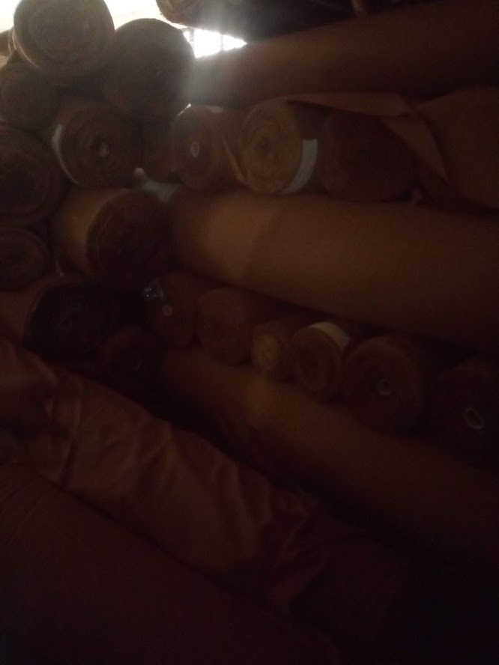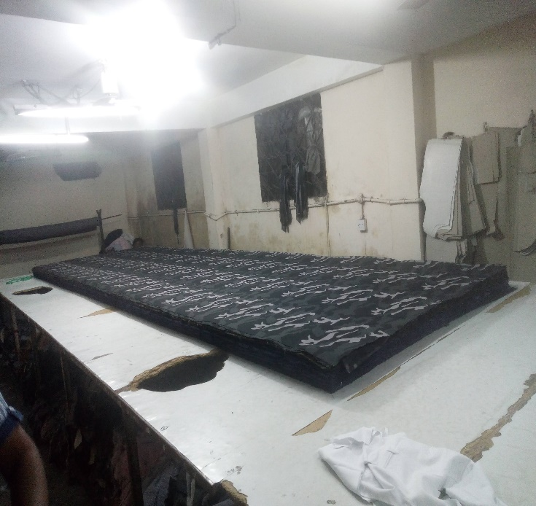

Picture-1: Stored Fabrics Picture-2: Ready for crop

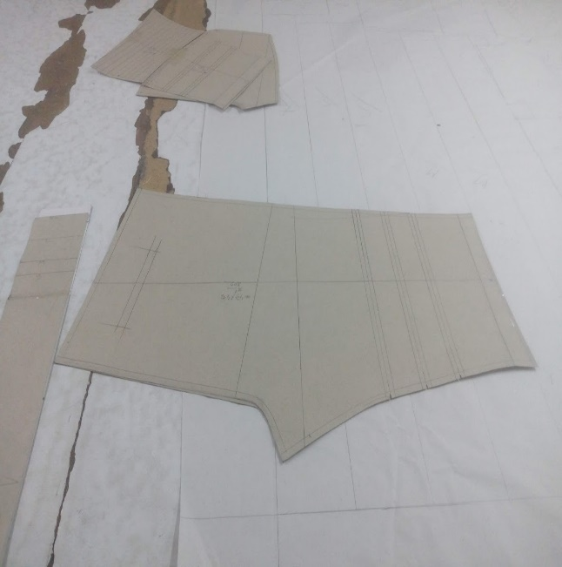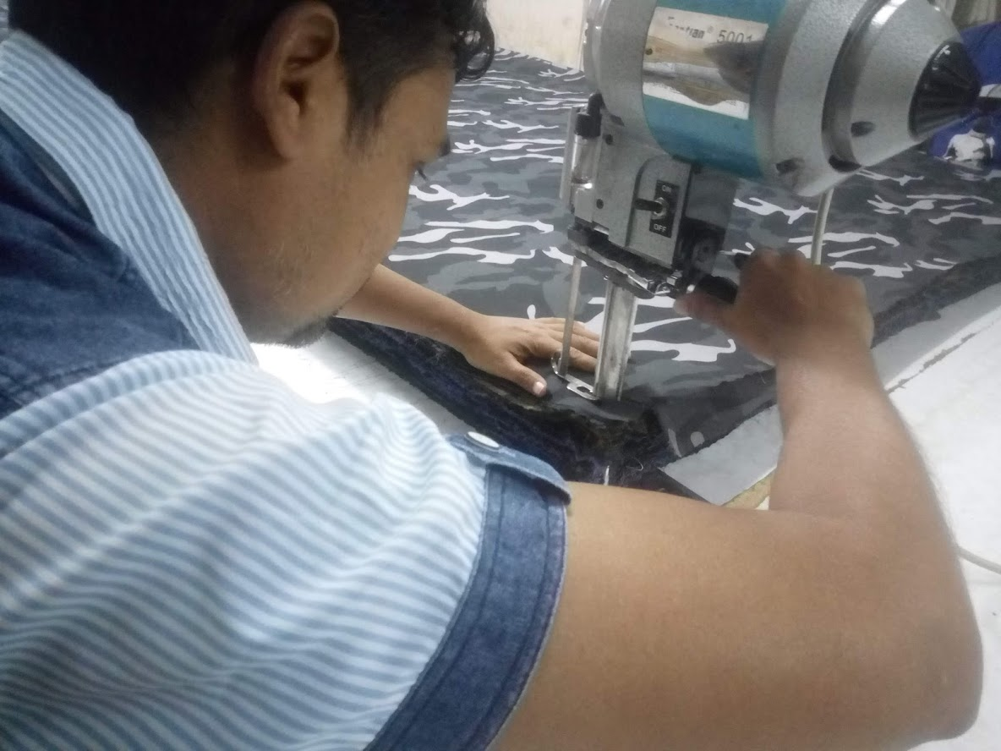

Picture-3: Pant shaped Cardboard Picture4: Cutting the fabric

**3.2 Product Manufacturing:**

As a Softline product manufacturer, the organization maintain their manufacturing process very well. The 3rd and the 4th floor is called sewing floor. Here, approximately 50 machines are used in each floor for sewing the side parts of the product. The basic part of the product is sewed in 3rd floor. Workers uses electrical sewing machine for sewing pants properly. The total sewing process carried on through 56 individual sewing process. In the 4th floor the pocket and other accessories are sewed with the product. All the product is evaluated and any extra thread left after the sewing process is removed from the product. Machines are distributed in row inside room.

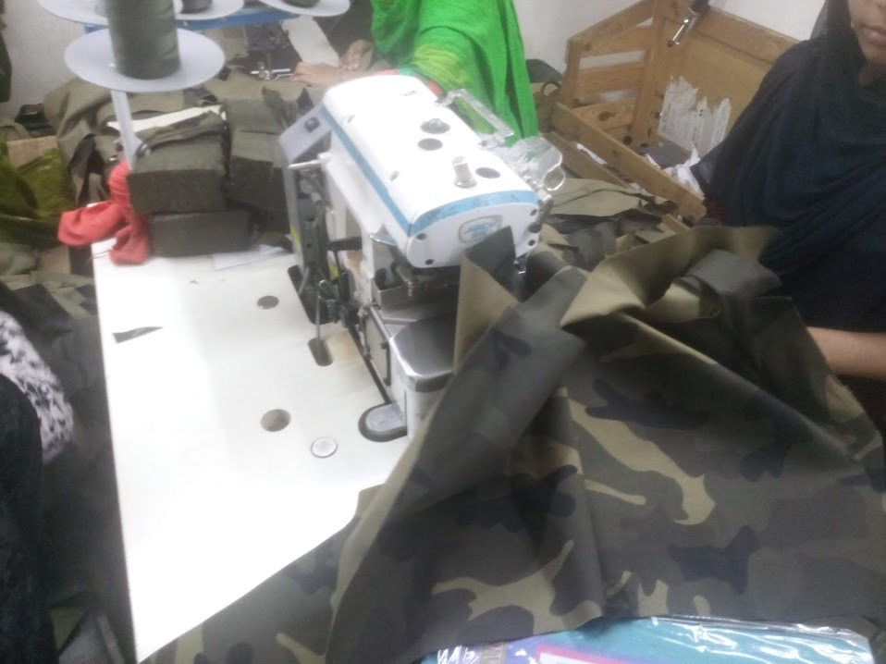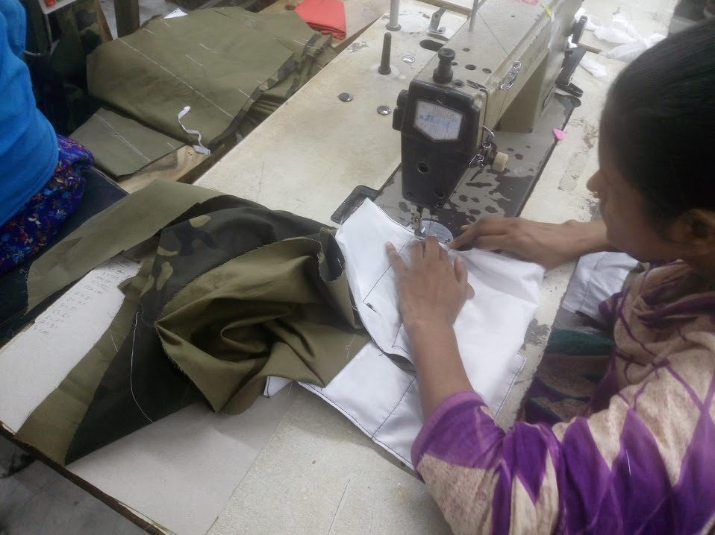

Picture-5: Sewing the side parts Picture-6: Pockets are sewed

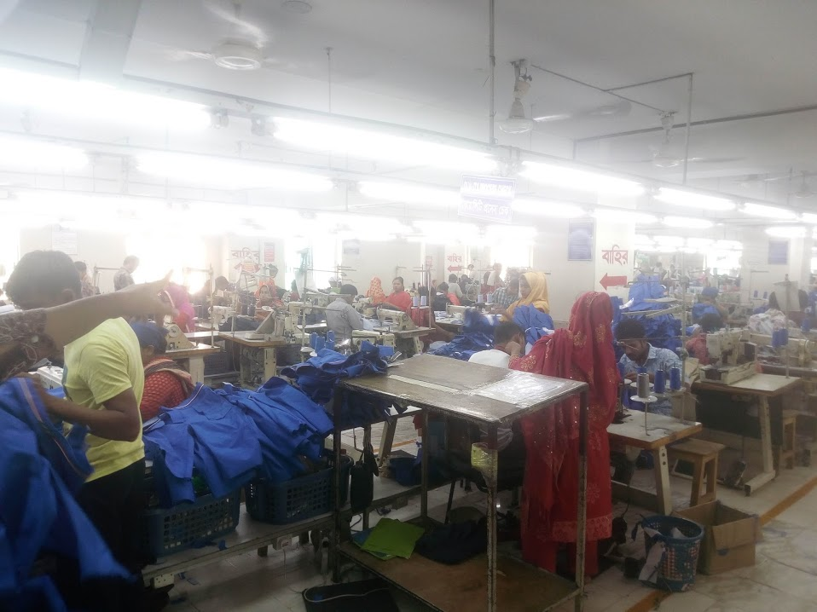 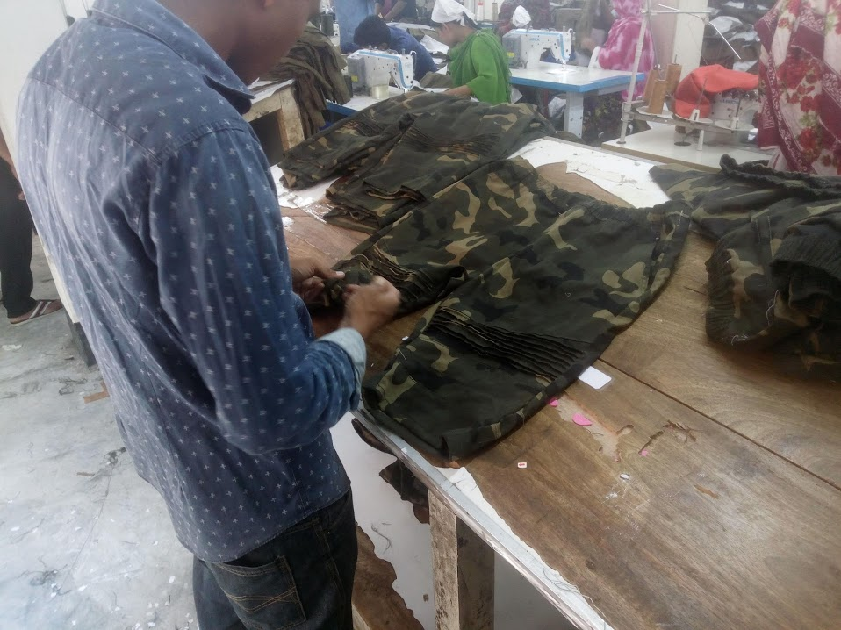

Picture-7: Workers works in row Picture-8: Removing extra threads

**3.3 Quality Measurement:**

After the sewing part, the product goes through a quality checking process in 5th floor. The product goes through a metal detector to check if there is anything attached with it. Disqualified product is labeled with Sticker and get discarded. Items that pass quality checking are labeled with the company tags which are provided by the buyers. After that, product go through washing. The washed products are dried with a drier machine. Next, the product wrapped with wrapped in polyethene bag to save it from outer environment. This Polyethene bags are stored inside cardboard cartoon which are stored inside the inventory inside the inventory. Every cartoon has its own unique id. These ids can be used to keep track of the stored items. This organization does not use any barcode-based inventory system.

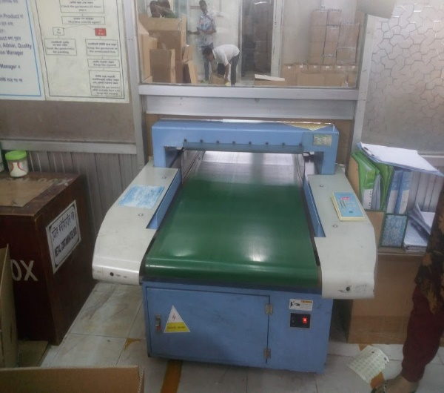 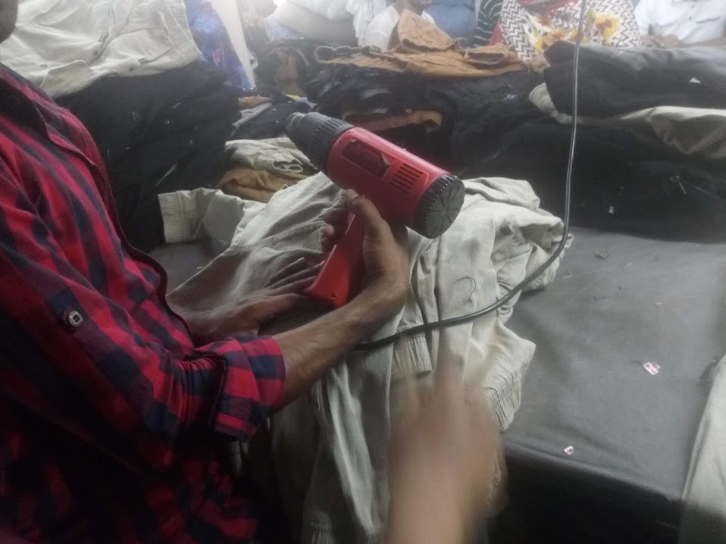

Picture-9: Metal Detector Picture-10: Drying the product

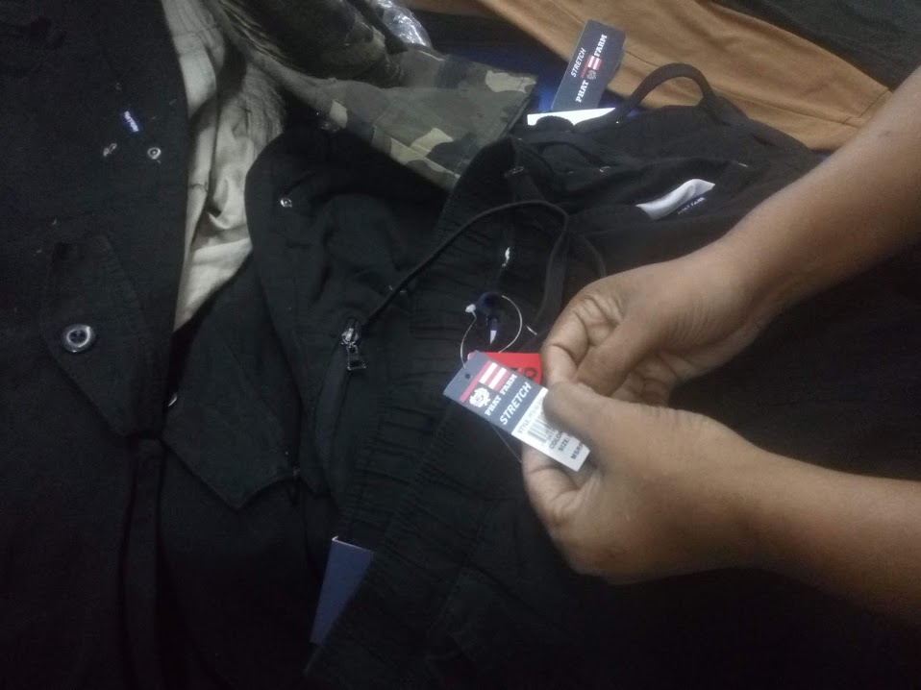 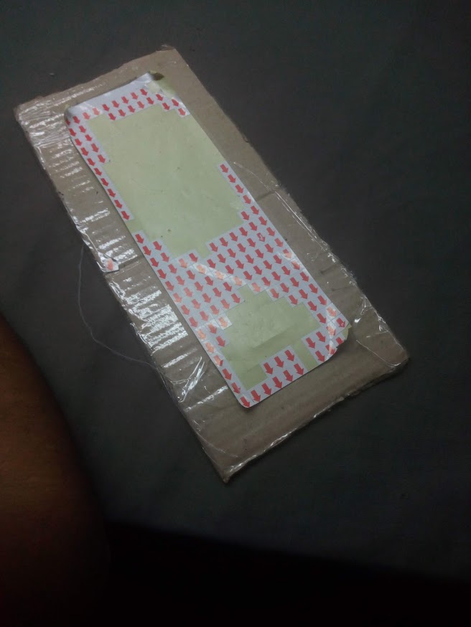

Picture-11: Labeling the product Picture-12: Disqualified Sticker

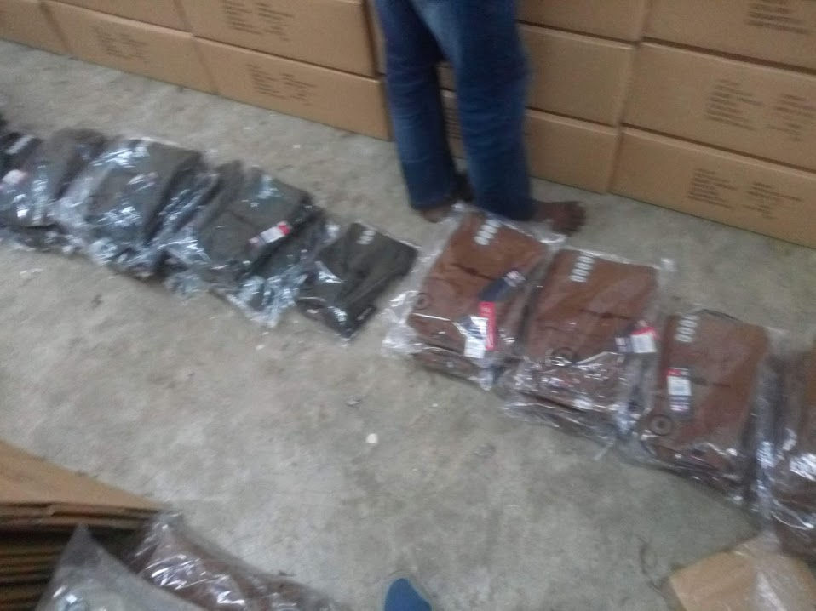 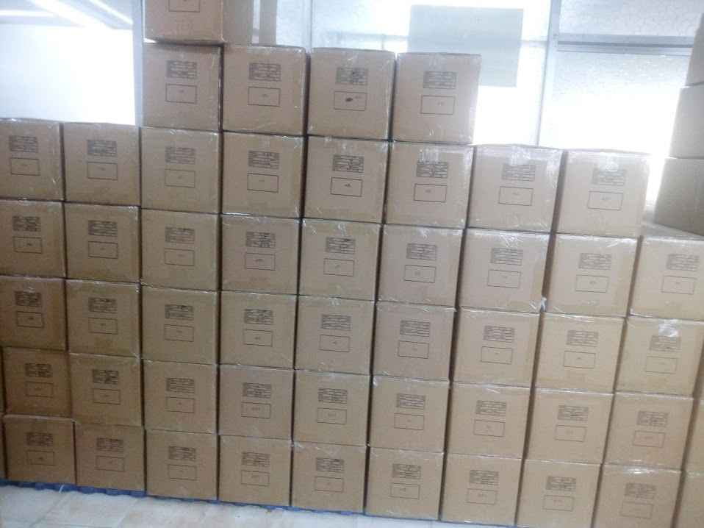

Picture-12: Wrapped Product Picture-13: Inventory

**3.4 Distribution and Retail:**

When working with distributors, the company have a responsibility to oversee the process. Distributer acts as a medium between the company and the retailers. Ferdous Fashion Ltd has its own transportation system. Most of their products are being shipped to abroad. So, it has to be transported to Chittagong sea port. The transportation is done by their own vehicle. After reaching the port, the product is stored inside cargo for shipment. Once the ship leaves the port, the organization is not responsible for the transportation anymore. Buyers themselves carry the cost of shipping. The buyer of the product is the distributor here. They are buying the product from the organization, storing the product in their own inventory and then selling it to retailers. According to the organization, there are 3 tiers of distributor for their product. First tier consists of the people who order the product. Product with highest quality are served to them. Next, they sell remaining product to the medium class shops across the country. The discarded product from the quality section are sold separately to the low-level distributor with fairly low price.

On the other hand, the first-tier distributor sells the product to the branded retailers. Only certified retailers have access to these products. These products ensure highest possible quality. Customer satisfaction is first priority for these retailers the second-tier distributors sell the products to non-branded shops. Here the products are in reasonable price for any customer. The last distributors distribute the product to low level retailers like hawkers. The quality of these product is not guaranteed.

1. **Discussion:**

Our Garments Industries can improve their position in the world map by reducing the overall problems. Such as management labor conflict, proper management policy, efficiency of the manager, maintainable time schedule for the product, proper strategic plan etc. Ferdous Fashion LTD is heading towards the right way to becoming a leading industry. They follow the typical supply chain in a well manner. But by tweaking their structure by a little margin, huge improvement can be possible.

**Suggestions Regarding Inventory Management**

Inventory management is crucial part for any management system. The organization does use a stack up storage structure which is really helpful for proper storing. Because if the cartoon boxes are stored in row-wise it will eat up a lot of space. But the organization should use a computerized inventory system. In the system, every box will have a unique ID. This will be helpful to check if the box is available. Also, it will help to calculate total available product. Keeping information in a machine is a lot easier than keeping it in pen-paper.

**Suggestions Regarding Work Environment**

The noticeable thing in the organization was that the workplace was a lot messy. This may affect productivity of the workers. To fix this issue, the organization can apply 5S method. It is originally a Japanese method.

|  |  |  |
| --- | --- | --- |
| 1.Seiri | Sort | Sort through materials, keeping only the essential items needed to complete tasks. (This action involves going through all the contents of a workspace to determine which are needed and which can be removed. Everything that is not used to complete a work process should leave the work area.) |
| 2.Seiton | Set in Order | Ensure that all items are organized and each item has a designated place. Organize all the items left in the workplace in a logical way so they make tasks easier for workers to complete. This often involves placing items in ergonomic locations where people will not need to bend or make extra movements to reach them. |
| 3.Seiso | Shine | Proactive efforts to keep workplace areas clean and orderly to ensure purpose-driven work. This means cleaning and maintaining the newly organized workspace. It can involve routine tasks such as mopping, dusting, etc. or performing maintenance on machinery, tools, and other equipment. |
| 4.Seiketsu | Standardize | Create a set of standards for both organization and processes. In essence, this is where you take the first three S's and make rules for how and when these tasks will be performed. These standards can involve schedules, charts, lists, etc. |
| 5.Shitsuke | Sustain | Sustain new practices and conduct audits to maintain discipline. This means the previous four S's must be continued over time. This is achieved by developing a sense of self-discipline in employees who will participate in 5S. |

**Suggestions Regarding Fire Safety**  
We need to remember that when there is a fire, the first thing one should do is to run away from it. The organization has already fireproof door. Few more steps can help them to improve this facility. Precautionary should need to be adopted are given below:  
  
1. Adequate exits and proper escape routes should be designed  
2. Protection against fire and smoke should be ensured  
3. Electrical wiring must be properly designed, installed and maintained  
4. Smoke/Fire alarm systems must be installed  
5. adequate number of extinguishers should be provided

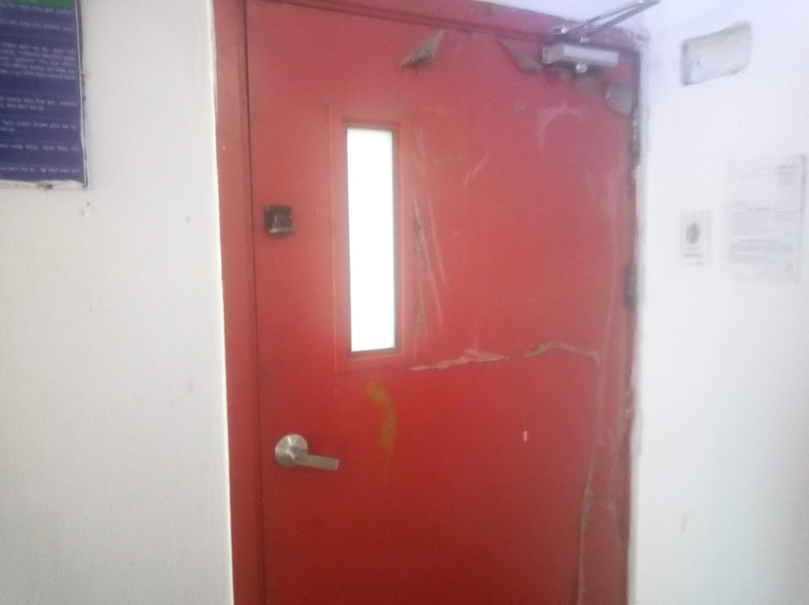

Picture-14: Fire-Proof Door

**Suggestions Regarding Transportation**

Buyers today are forced to carefully select the type of products to source from Bangladesh since congested roads. Reliable and fast transport is extremely important. The transport issues need to be solved quickly in order to avoid a collapse in the transport network as volumes continue to grow.

1. The highway is often congested as capacity planning falls behind demand increasing transport time from Dhaka to Chittagong up to 20 hours.
2. Productivity at Chittagong port suffers from inefficient processes limited crane capacity and strike that sometimes span several days at a time.

So, Garments should try to schedule their distribution properly to avoid above mentioned circumstances. They should have an emergency delivery system where the product can be delivered through air. Also, the Govt. should take necessary steps as early as possible to solve this problem. Thus, the Garments Industry will go ahead.

1. **Conclusion:**

The Ready-Made Garments Industry occupies a unique position in the Bangladesh economy. It is the largest exporting industry in Bangladesh, which experienced phenomenal growth during the last 25 years. By taking advantage of an organized supply chain, it can attain a high profile in terms of foreign exchange earnings, exports, industrialization and contribution to GDP. Proper supply chain can reduce the manufacturing time and cost which can be used to maximize the profit. The government and the RMG sector would have to jointly work together to maintain competitiveness in the global RMG market. Given the good quality raw material, structural manufacturing and organized distribution Bangladesh can look forward to advancing its share of the global RMG market.

1. **Reference:**

1. Abdullah, Md. Abu Yousuf, 1997, “International Trade Implications and Future of Ready-Made Garments Sector of Bangladesh” Journal of Business Administration, Vol. 23, No. 3 & 4, Page 41-69.

2. <https://www.5stoday.com/what-is-5s/>