**CSE207 – Data Structures**

**Project 15: Resolving overbooked flight**

**Project Description:**

An airline company uses the formula shown below to determine the priority of passengers on the waiting list for overbooked flights. Priority number = A / 1000 + B – C where,

A is the customer’s total mileage in the past year

B is the number of years in his or her frequent flier program

C is a sequence number representing the customer’s arrival position when he or she booked the flight.

Given a file of overbooked customers as shown in below Table, write a program that reads the file and determines each customer’s priority number. You have to build an application for the airline company that builds a priority queue using the priority number and prints a list of waiting customers in priority sequence.

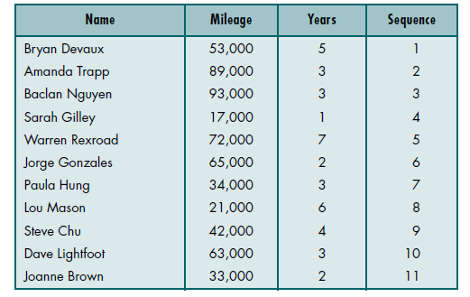

For constructing the application you have to do the following:

1. Build a priority queue( binary heap) based on the priority number
2. Build a stack to store information of customer who will get flight ticket later

In the project you have to do the following:

1. Builds a priority queue using the priority number

2. Prints a list of waiting customers in priority sequence.

3. Print details of customer who took flight ticket later