**Instruments used**

LED Marix(8x8) – 4 pcs

Decoder(74HC138) – 2 pcs

Male-Male, Male-Female wires – a lot

Atmega32 – 1

Push Buttons- 9

Voltage Adapter – 1

Voltage controller gate (7805)– 1

Used Libraries: We used no mentionable libraries

**Description of LED matrix used:**

We needed 8x8 led matrix for our project which should be single colored. But we did not find that. So we bought bi color led matrix. We used that according to our requirements. Bi color led matrix has 3 pins for each dot. There are two pins for color selection. We used the pin for green light. So there were 3*8=24 pins, but we used 16 and neglected the other 8 pins because we never used red light.

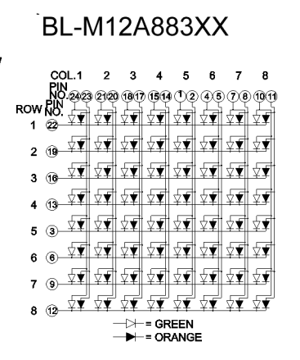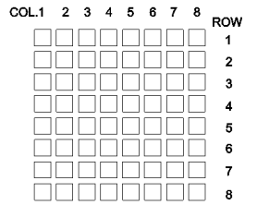

**Block Diagram:**

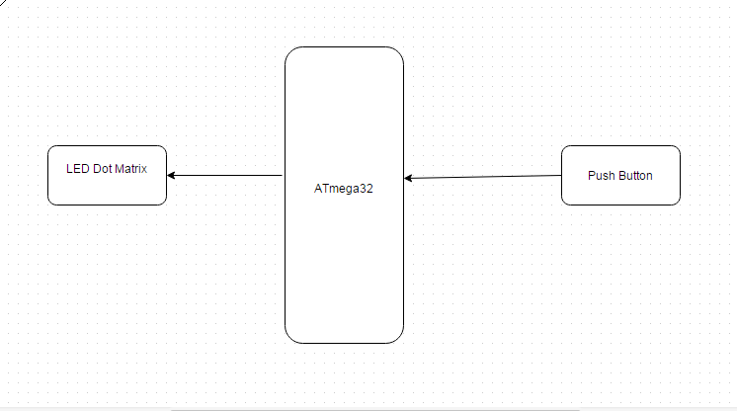

**Circuit Diagram:**

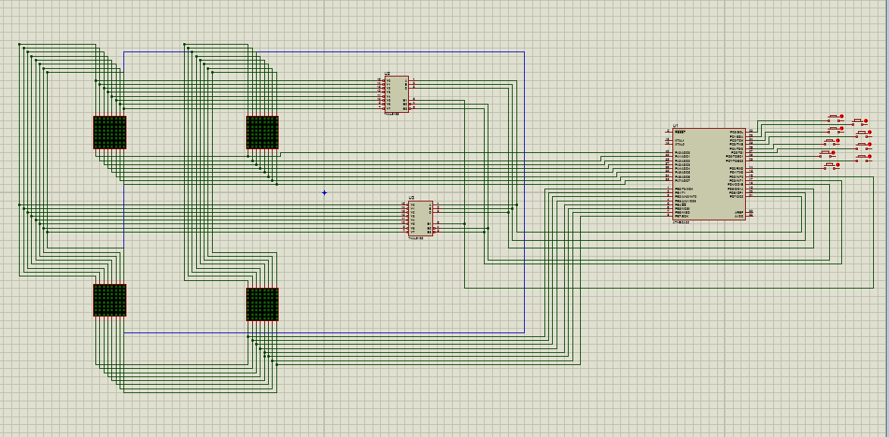

**Fig: Circuit Design**

**Description of the whole project:**

**Circuit Analysis:**

As mentioned above we have used two decoder(74138), 4 LED 8X8 dot matrix.

We assumed the top-left LED as no.1 , top-right as 2. Then bottom-left as 3 and rest one is 4 . The row connections of the upper two LED are connected as short-circuit according to their position(firstLED(i) connected with secondLED(i)). In the circuit diagram we can see only 8 connections as we used only single color in the project though the LED was bi-color.

Those 8 connections directly connected with the ATmega32‘s port A pins. Row 0 with PA0, row 1 with PA­1 and so on.

Similarly, the LED 3 and LED 4 s’ rows are connected as short-circuit and directly connected with the Port B pins of ATmega32 from PB0 to PB7.

The columns of LED 1 with LED 2 and LED 3 with LED 4 are connected together. The first 8 columns connections are connected with the decoder 1(upper decoder) and the lower 8 columns connections are connected with the second decoder with its 8 output pins.

Here at a time one decoder will function and that’s why we connected the 3 input pins of each decoder in the same PORT of ATmega32. Here 3(pin 1,2,3) input decoder pins are connected with the PORTD’s PD7, PD6, PD5  pins. Enable pin 4,5 of both decoder with PD4, PD3 and enable pin(both) 6 are with PD2 .

To take input, there are 8 push buttons here connected with PORTC’s 8 pin accordingly and 9th push button is with PD0 as we ran out of PORTC pin while the other end of the buttons are connected with VCC.

There is a purpose of using 9 push buttons as input. Here we divided the whole 16x16 LED matrix by 3X3. To do so equally we draw line lightening column and row of 1,6,11,16 both. Like this:

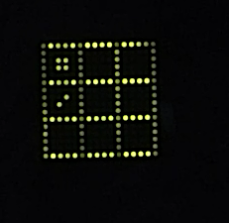

Power connection:

ATmega32: Pin No. 10 to VCC

Pin 11 to ground

It is better to have an extra power connection with **“AVCC”** pin(30) of ATmega32

This is how we connected our whole circuit. The power connection was controlled by a chip 7805-voltage gate. Male-male and male-female wires are better for secure connection in the circuit. Using them make sure that they will not be internally, unintentionally connected.

Here is a close view of ATmega32 with connection and pin-config:

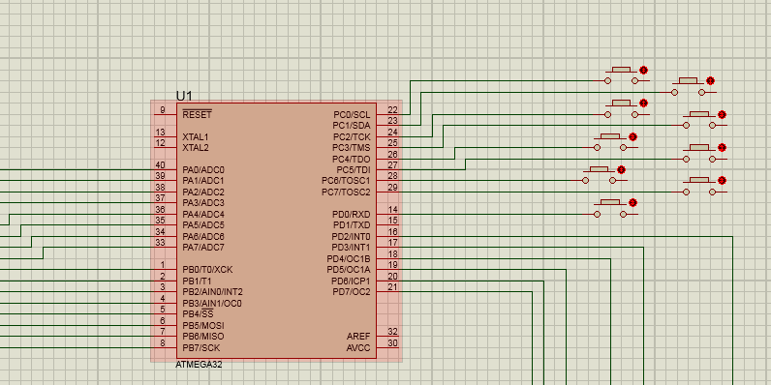

**Problems we faced and solutions:**

1. The very first problem we faced was detecting the pin configuration of the LED dot matrix. Then by trial and error method we tested and lit LED we figured that 3 pins works together, first one is as row(vcc), second pin as red light(we didn’t use red color, so ignored it), third one green light(column).

To find out which one is pin1 of the led, hold the side toward you which has written on the edge of it and leftmost is pin1 and so on.

1. Some pins of Port A of ATmega 32 were not working properly as some of them were low altime. Then we connected AVCC(30) with VCC and our code worked fine.
2. PORT C ‘s some pins have to configure while coding by adding these two lines inside the main function:

MCUCSR=(1<<JTD);

MCUCSR=(1<<JTD);