# Indian Institute of Technology, Guwahati



Department of Computer Science and Engineering Project report

On

# “Voice Based Search Contact List”

Based on

### Speech recognition system

Course: CS566 Speech Processing

Submitted to Prof. P. K Das

Submitted by:

Divyanshu Nuani (214101063)

Ritik Shrivastava (214101065)

**TABLE OF CONTENT**

1. Abstract
2. Introduction
3. Proposed Methodology
4. Experimental Setup
5. Result

## ABSTRACT

#### Our project allows users to search for contacts using voice. This report defines the flow of the program and accuracy achieved in the project. It also shows how user can add new contacts and retrain the already saved names for better accuracy.

**INTRODUCTION**

Our project consists of a voice based search , where user can speak contact name and application will display its contact info. User can add new contact using the app. The app will use HMM to detect voice

Hidden Markov Model (HMM) is a statistical Markov model in which the system being modeled is expected to be a Markov process. As part of the description, HMM needs that there be an observable process Y whose results are "influenced" by the consequences of X in a known way. Since X cannot be observed directly, the goal is to learn about of Y at time t=0 may be "influenced" totally by the consequence of X at t=0 and that the outcomes of X and Y at t=0 must not affect the outcome of Y at t=0.

## PROPOSED METHODOLOGY

Basic requirements to develop this project are as follows:

* VS code 2010
* Recording module.exe
* CoolEdit
* HMM implementation

Concepts used in the project

* HMM
* Viterbi
* Forward procedure
* Backward procedure
* Reestimation algorithm

Flow Chart

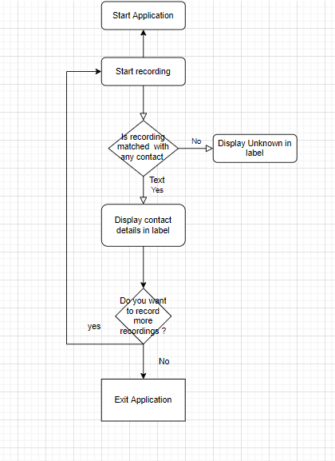

## EXPERIMENTAL SETUP

This project is divided into following modules:

1. Add New Contact(Training)
2. Get Contact By voice(Testing)
3. Rerecord already saved contact (Live Training)
4. Add New Contact

The flow for adding new contact is as follows:

* 1. Enter new name and contact number and click on start Recording New Contact Button
  2. Record the data as 20 utterance of the new name
  3. Extract frames from the stable part of the recordings
  4. Generate obs sequence
  5. Init lambda as Feed forward model
  6. Now use Reestimation algorithm to generate better lambda

1. Get Contact By voice

The flow of testing is as follows:

* 1. Click on PressToRecord Button
  2. User should speak the contact name
  3. The application will calculate Probability of each save names and return the name with highest probability
  4. If no name is matched then label will display Unknown
  5. Else the details of the contact will be displayed
  6. If wrong contact is shown please Press the button again

## RESULT

After saving 10 names in the Contact list we are getting accuracy as follows

* >80% : for names Vishal, Ayush, Suresh
* >70% : for Divyaanshu
* >50%: for Pradeep, Naruto
* >40% for Ritik