**Lab Report N0 :** 02

**Name of the Lab Report :** Basic Linux Command.

**Name :** MD. Aminul Islam .

**ID :** IT-17025

**Objective** : On Linux operating system the command line is very easy to use and also very useful to the user.

From this lab we know some basic command of Linux operating system.I take screenshot of my every work.

**Q-1 :** What is Linux Command ?

Ans : Linux is a Unix like operating system. All the Linux commands are run in the terminal provided by the Linux system. This terminal is just like command prompt of Windows operating system. Linux commands are case-sensitive. The terminal can be used to accomplish all Administrative tasks. This includes package installation, file manipulation, and user management. Linux terminal is user-interactive. The terminal outputs the results of commands which are specified by the user itself. Execution of typed command is done only after you press the Enter key.

**Q-2:** Write 15 Commands of Linux operating system.

Ans :

ls command

pwd command

uptime command

cd command

sudo command

du command

cat command

df command

finger command

uname command

hostname command

echo command

arch command

date command

exit command

**Q-3 :** Describe the basic operation of Linux commands.

**ls command :**

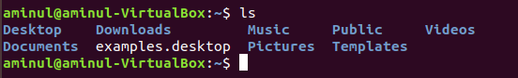

This might be the first command. It list the files and folders in the directory I am staying. By default it looks the current directory.

**Pwd command :**



It is very nice and simple. The pwd command prints the working directory from the root.

**uptime command :**



The uptime command shows the time when we open our pc, how many times we use it.

**cd command :**



The cd command changes my current directory. In other words, it moves you to a new place in the filesystem.

**sudo command :**

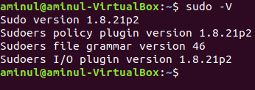

The sudo command is required when performing action that require root or superuser permissions, such as changing the password for another user.

**du command :**



The du command shows number of documents file stored in the hard disk.

**cat command :**

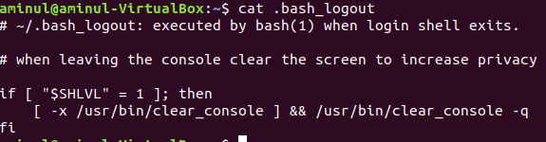

The cat command list the contents of files to the terminal window. This is faster than opening the file in an editor.

**df command :**

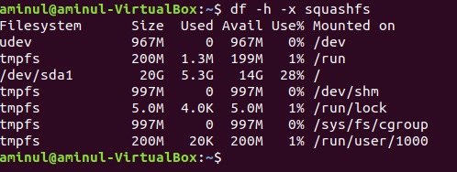

The df command show the size, used space, and available space on the mounted filesystem of my computer.

**finger command :**

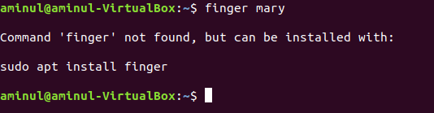

The finger command gives a short dump of information about a user including the time of the user last login.

**uname command :**

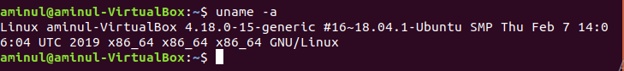

I can obtain some system information regarding the Linux computer I am working on with the uname command.

**hostname command :**

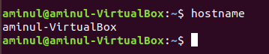

Show the real Linux user or owner of the pc name.

**arch command :**



**arch** is a simple command for displaying machine architecture or hardware name .

**date command :**



**date** command displays/sets the system date and time like this.

**exit command** :



**exit command** is used to exit a shell like so.

**Conclusion :**

All of these basic command running in my current OS shows some interesting scenario which is feel very ease to me. I think all those commands are pretty helpful for me to learn Linux OS. I take some help from the internet .