Lesson: Limit and continuity:
Learning objective: The learning objective for the "Limits and Continuity" lesson is to formalize the intuitive concept of a limit, learn to evaluate limits algebraically, distinguish between one-sided and two-sided limits, and utilize limits to define and classify function continuity.
Introduction:
In earlier lessons you learned to find the slope of a straight line and to describe curves algebraically. But many real situations involve values that change smoothly, and engineers often need to know what a quantity is heading toward at a specific instant — even if they cannot (or should not) measure it exactly at that instant.
Consider a roller-coaster design team modeling the height of a track above the ground as a function of horizontal distance. Suppose the height, in meters, is given by
h(x) = −0.09(x − 6)² + 8
where x is the horizontal distance in meters from the start of the ride. The design team wants to know what height the track is heading toward as a cart approaches a particular point, say x = 8 — perhaps because that is where a support beam must be installed and its height has to match the track exactly.
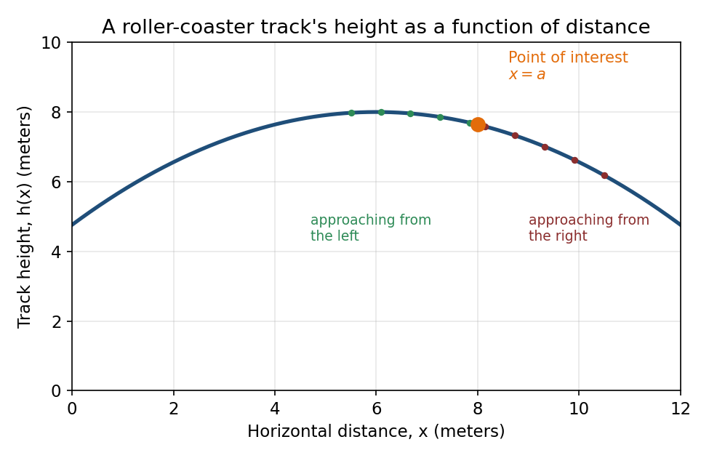
Figure 1.3.1: A roller-coaster track's height as a function of horizontal distance.
Visual Description
A smooth, downward-opening parabolic curve rises from left, peaks near the center, then descends. A single orange point marks x = 8 on the curve. Small green dots to its left and small dark-red dots to its right mark values of x moving progressively closer to 8 from each side, illustrating the idea of ‘approaching’ a point along the curve.

Rather than asking for h(8) directly, we can ask a subtly different question: as x gets closer and closer to 8 — from both sides — what value does h(x) get closer and closer to? The table below tracks this.
x | 7.5 | 7.9 | 7.99 | 8 (target) | 8.01 | 8.1 | 8.5
h(x) | 7.80 | 7.68 | 7.64 | ? | 7.64 | 7.60 | 7.44

Key Insight:
As x moves toward 8 from either direction, h(x) moves toward 7.64. This target value is called the limit of h(x) as x approaches 8, and it may or may not be the same as the actual function value at that point — a distinction that turns out to matter a great deal.

Calculus allows us to answer questions such as:
- What value does a function approach near a point, even if it is undefined there?
- Does a function approach the same value from the left and from the right?
- Is there a break, jump, or hole in a function's graph — and what kind?
- Can a function be trusted to behave predictably across an entire interval?
These questions are the foundation for everything else in calculus — derivatives, integrals, and the behavior of models used in engineering, physics, economics, and data science all rest on the idea of a limit. As you work through this lesson, pay attention to the difference between what a function approaches and what a function actually equals at a point.
In this lesson you will formalize the intuitive idea of a limit, learn to evaluate limits algebraically, distinguish one-sided limits from two-sided limits, and use limits to define what it means for a function to be continuous.
1.The Idea of a Limit:
When we say the limit of f(x) as x approaches a, we are describing the value that f(x) approaches as x gets arbitrarily close to a — without ever necessarily reaching a. We write this as:
limₓ→ₐ f(x) = L

Definition 1.1: Limit of a Function(Informal)
We say that the limit of f(x) as x approaches a is L, written limₓ→ₐ f(x) = L, if the values of f(x) can be made arbitrarily close to L by choosing x sufficiently close to a (but not equal to a).
This value L does not depend on f(a) — the function need not even be defined at x = a.

Interpreting the Definition:
A limit describes behavior near a point, not necessarily at that point.
If f is a “nice” (polynomial, rational, root, or trigonometric) function and a is in its domain, the limit is usually found by direct substitution.
When direct substitution gives 0/0, the expression can often be simplified first by factoring or rationalizing.

Example 1.1: Evaluating Limits Algebraically
Evaluate each limit.
- $a. \lim_{x→3}\frac{x^{2}-9}{x-3}$
- b. $\lim_{x→4}\frac{\sqrt{x}-2}{x-4}$
- c. $\lim_{x→-1}\frac{x^{3}+1}{x+1}$
Challenge yourself: try solving these on your own before checking the solution below.
Solution
a. Direct substitution gives 0/0. Factor: ${\left(x²-9\right)}/(\left.x-3\right)=\left(x+3\right){\left(x-3\right)}/(\left.x-3\right)=x+3$, for $x ≠ 3$. So the limit equals 3 + 3 = 6.
b. Direct substitution gives 0/0. Rationalize the numerator by multiplying by ${\left(√x+2\right)}/(\left.√x+2\right):$the expression becomes $1/(\left.√x+2\right). x=4$Substituting gives 1/4.
c. Direct substitution gives 0/0. Factor using the sum of cubes: $x³+1=\left(x+1\right)\left(x²-x+1\right).$Cancel $\left(x+1\right)$to get $x²-x+1$, which equals 1+1+1 = 3 at $x=-1$.

2. One-Sided Limits:
Sometimes a function approaches different values depending on the direction from which x approaches a. The left-hand limit considers only x-values less than a; the right-hand limit considers only x-values greater than a.
Definition 1.2: One-Sided Limits:
$\lim_{x→a^{-}}f\left(x\right)=L_{1}$(left-hand limit: x approaches a with x < a)
$\lim_{x→a^{+}}f\left(x\right)=L_{2}$(right-hand limit: x approaches a with x > a)
The two-sided limit $limₓ→ₐf\left(x\right)$exists if and only if both one-sided limits exist and are equal ($L₁=L₂).$

Example 1.2: A Track With a Design Flaw
During inspection, engineers model one problem section of track with the piecewise function:
f(x) = { x² − 1, x < 1; 3, x = 1; 2x + 1, x > 1 }
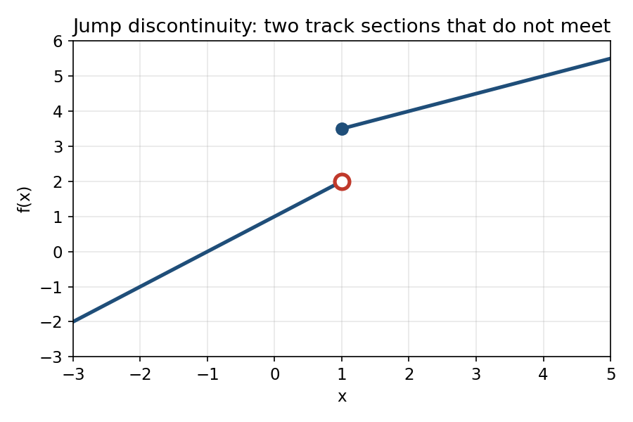
Figure 1.3.2: Two track sections that fail to meet at x = 1.
Find the left-hand limit, the right-hand limit, and determine whether limₓ→1 f(x) exists.
Solution
Left-hand limit: as $x→1⁻,$ use$x²-1$, which gives 1² − 1 = 0.
Right-hand limit: as x → 1⁺, use $2x+1$, which gives 2(1) + 1 = 3.
Since the left-hand $limit\left(0\right)$does not equal the right-hand $limit\left(3\right), limₓ→1f\left(x\right)$does not exist — even though $f\left(1\right)=3$is perfectly well defined. The track sections genuinely fail to line up.

3. Continuity:
A function whose graph can be traced without lifting your pencil across an interval is continuous there. This intuitive idea is made precise using limits.
Definition 1.3: Continuity at a point
A function f is continuous at $x=a$if all three conditions hold:
- 1. $f\left(a\right)$is defined.
- 2. $limₓ→ₐf\left(x\right)$exists (left-hand limit = right-hand limit).
- 3. $limₓ→ₐf\left(x\right)=f\left(a\right).$

Key Insight:
If any one of the three conditions fails, f is discontinuous at x = a. Which condition fails tells you what kind of discontinuity you are looking at.

Example 1.3: Classifying Discontinuities
Classify the discontinuity of each function below at the indicated point.
(a) $f\left(x\right) = {\left(x² - 4\right)}/(\left.x - 2\right)$at $x=2$
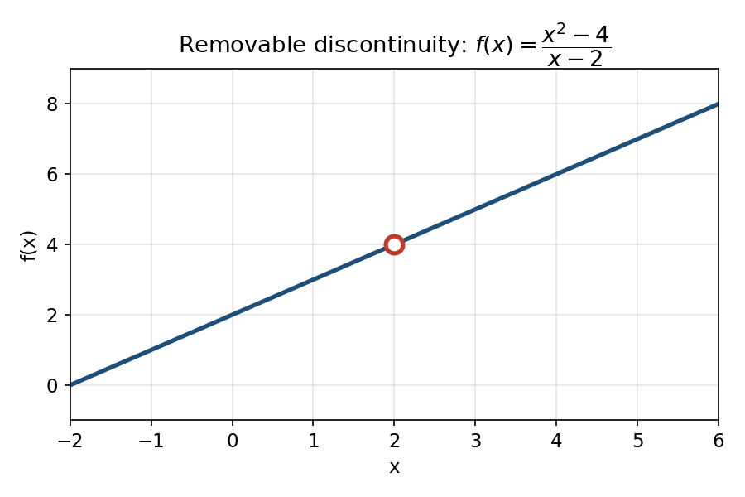
Figure 1.3.3: A hole in the graph at x = 2.
f(2) is undefined — condition 1 fails. However, for x ≠ 2, f(x) simplifies to x + 2, so limₓ→2 f(x) = 4 exists. Because the limit exists but does not match a defined function value, this is a removable discontinuity: redefining f(2) = 4 would make f continuous at x = 2.

(b) The track function from Example 1.2 at x = 1
f(1) = 3 is defined (condition 1 holds), but limₓ→1 f(x) does not exist because the one-sided limits disagree (condition 2 fails). This is a jump discontinuity — the graph genuinely steps from one value to another.

(c) $h\left(x\right)=1/(\left.x-3\right)$ at x=3
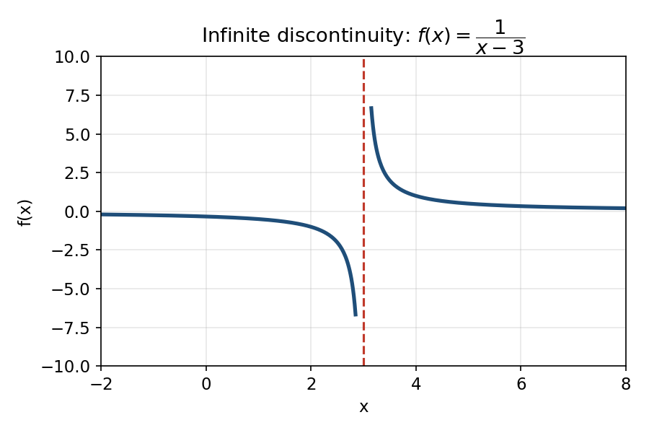
Figure 1.3.4: Values grow without bound near x = 3.
h(3) is undefined, and as x → 3 from either side, h(x) grows without bound rather than approaching a finite number — neither one-sided limit exists as a real number. This is an infinite discontinuity, associated with a vertical asymptote at x = 3.

Key Takeaways
- A limit describes what a function approaches near a point — it does not require, or even reference, the function's value at that point.
- The two-sided limit exists only when the left-hand and right-hand limits agree.
- Many limits of algebraic expressions can be found by direct substitution; when that yields 0/0, factor or rationalize first.
- Continuity at a point requires the function value, the limit, and their equality — all three conditions must hold.
- Discontinuities are classified by which condition fails: removable (fixable hole), jump (mismatched one-sided limits), or infinite (unbounded behavior near an asymptote).

Assignment 1.3
Assignment 1.3: Limits and Continuity:
Instructions
This assignment is descriptive — answer every question in complete sentences and show all work where calculations are involved.
Questions are arranged from foundational recall through open-ended design, following Bloom's Taxonomy. Aim for depth of explanation, not just a final numeric answer.
Number of Questions: 6 Suggested Time: 45–60 minutes

Question 1 — Cognitive Level: Remember / Understand
In your own words, explain what it means for limₓ→ₐ f(x) to exist. Using the roller-coaster scenario from the lesson, describe what it would mean physically for this limit to fail to exist at some point a on the track.

Question 2 — Cognitive Level: Understand / Apply
Construct a table of x-values approaching 5 from both sides (three values from each side) for the function $g\left(x\right)={\left(x²-25\right)}/(\left.x-5\right).$Use your table to estimate limₓ→5 g(x), then confirm your estimate algebraically. Explain why g(5) is undefined even though the limit exists.

Question 3 — Cognitive Level: Apply
Evaluate the following limits, showing every algebraic step:
- a. $\lim_{x→2}\frac{x^{2}+x-6}{x-2}$
- b. $\lim_{x→9}{\frac{\sqrt{x}-3}{x-9}}$
- c. $\lim_{x→0}\frac{x^{2}+3x}{x}$

Question 4 — Cognitive Level: Analyze
A function is defined piecewise as $k\left(x\right)=x+2$for x < 3, k(3) = 4, and $k\left(x\right)=8-x$for x > 3. Determine the left-hand limit, the right-hand limit, and k(3). State clearly which of the three conditions in Definition 1.3 hold and which fail, and classify the discontinuity (if any) at x = 3. Justify each step of your reasoning.

Question 5 — Cognitive Level: Evaluate
A classmate argues: “Since f(2) is undefined for $f\left(x\right)=\frac{x^{2}-4}{x-2 }$the limit as x approaches 2 cannot exist either.” Critique this claim. Is it true, partially true, or false? Support your evaluation with a specific counter-example or calculation, and explain the conceptual distinction the classmate is missing.

Question 6 — Cognitive Level: Create
Design your own rational or piecewise function that has exactly one removable discontinuity and exactly one jump discontinuity (two different x-values). Write the function explicitly, sketch or describe its graph, and explain — using Definition 1.3 — why each discontinuity is of the type you claim.

Quiz 1.3
Quiz 1.3: Limits and Continuity
Instructions
Topics covered: Lesson 1.3 – Limits and Continuity
The quiz has Multiple-Choice Questions (3 points each).
Attempts Allowed: 1 Number of Questions: 5 Total Points: 15

Question 1 3 pts
What does $\lim_{x→a}f\left(x\right)=L$mean?

○ f(a) is always equal to L
○ f(x) gets arbitrarily close to L as x gets close to a, regardless of f(a)
○ f(x) equals L for all values of x
○ The graph of f has a hole at x = a

Question 2 3 pts
Evaluate: $limₓ→5{\left(x²-25\right)}/(\left.x-5\right)$

○ 0
○ 5
○ 10
○ The limit does not exist

Question 3 3 pts
A function f satisfies limₓ→2⁻ f(x) = 3 and limₓ→2⁺ f(x) = 7. What can you conclude about limₓ→2 f(x)?

○ It equals 3
○ It equals 7
○ It equals 5 (the average)
○ It does not exist

Question 4 3 pts
The function $g\left(x\right)=1/(\left.x-4\right)$has what type of discontinuity at x = 4?

○ Removable
○ Jump
○ Infinite
○ g is actually continuous at x = 4

Question 5 3 pts
Which condition is NOT required for f to be continuous at x = a?

○ f(a) is defined
○ limₓ→ₐ f(x) exists
○ f is differentiable at x = a
○ $limₓ→ₐf\left(x\right)=f\left(a\right)$

Answer Key (Instructor Copy)
1. B 2. C 3. D 4. C 5. C

