WEEK 4 TASK REPORT
Predictive Modeling and Optimization in Logistics Systems
QuickShip Logistics: predicting delivery time and finding ways to improve operations
Item | Details
Intern name | Deepu Verma
Internship | Logistics Data Analyst Intern, YuvaIntern (Remote)
Internship period | 06-Oct-2026 to 03-Nov-2026 (4 weeks)
Task | Week 4 - Predictive Modeling and Optimization in Logistics Systems
Case study | QuickShip Logistics (fictional e-commerce courier company)
Tools used | Python (pandas, numpy, matplotlib, seaborn, scikit-learn), MS Word, GitHub

1. Introduction
In the first three weeks I planned the project, cleaned the QuickShip data and studied it with charts. In this last task I build a model that can predict how many days an order will take to reach the customer. After that I use the model to test some "what if" ideas, like what would happen if the slow Kolkata warehouse worked as fast as Delhi. In the end I give clear recommendations to improve the logistics operation.
This report follows the full flow: define the problem, prepare the data, choose and train models, test them, tune the best one, understand the result, and suggest optimization steps. The Python code and its output are included.

2. Problem Definition and Data

2.1 What I want to predict
The problem: "When a customer books an order, how many days will the delivery take?" If QuickShip can answer this well, it can promise a delivery date that it can really keep. It can also see which orders are at risk of being late. Because the answer is a number (days), this is a regression problem.

2.2 The hypothetical dataset
I use the simulated QuickShip dataset that I created in Week 2 and cleaned. It has 964 orders of the year 2025. It is not real company data. The target (the thing to predict) is delivery_days. The features (the inputs) are:
Role | Column | Type | What it means
Target | delivery_days | Number | Real delivery time in days
Feature | distance_km | Number | Distance to the customer
Feature | weight_kg | Number | Weight of the parcel
Feature | is_festive | 0 or 1 | 1 if the order is in October or November, otherwise 0
Feature | vehicle | Category | Bike, Van or Truck
Feature | warehouse | Category | Delhi, Mumbai, Kolkata or Chennai
Feature | package_type | Category | Documents, Electronics, Clothing, Grocery or Furniture

- Why a festival flag and not the month number: in Week 3 I saw that only October and November are slow. If I use month as a number from 1 to 12, the model thinks the delay grows slowly month by month, which is wrong. A 0/1 flag shows the real pattern.
- One-hot encoding: a model cannot read words like "Kolkata". So each category becomes its own 0/1 column (for example warehouse_Kolkata). This gives 15 input columns in total.
- Train and test split: I used 771 orders (80%) for training and kept 193 orders (20%) hidden for testing. The hidden orders work like an exam: the model never sees them while learning.

3. Choosing the Models
I tried three types of models, from simple to complex. Then I tuned the best tree-based one. Trying more than one model shows if the extra complexity is really needed.
Model | How it works (simple words) | Why I chose it
Linear Regression | Draws the best straight-line relationship. Every input gets a number (coefficient) that shows how many days it adds or removes. | It is simple, fast and easy to explain. Distance and delivery time are close to a straight-line relationship.
Decision Tree (depth 5) | Asks a series of yes/no questions, like "is the distance more than 300 km?", and ends with an answer. | It can catch patterns that are not straight lines. I limited the depth to 5 so it does not just memorise the data.
Random Forest | Builds many decision trees and takes the average of their answers. | Usually more stable and accurate than one tree, and it tells which inputs matter the most.

4. Python Code
The complete program is week4_model.py. These are the main parts.

4.1 Preparing the data
df["is_festive"] = df["month"].isin([10, 11]).astype(int)

feature_cols = ["distance_km", "weight_kg", "is_festive", "vehicle", "warehouse", "package_type"]
X = pd.get_dummies(df[feature_cols], columns=["vehicle", "warehouse", "package_type"])
y = df["delivery_days"]

X_train, X_test, y_train, y_test = train_test_split(X, y, test_size=0.2, random_state=42)

4.2 Training, testing and validation
models = {
"Linear Regression": LinearRegression(),
"Decision Tree (max_depth=5)": DecisionTreeRegressor(max_depth=5, random_state=42),
"Random Forest (default)": RandomForestRegressor(n_estimators=100, random_state=42),
}

for name, model in models.items():
model.fit(X_train, y_train) # training
pred = model.predict(X_test) # testing on unseen orders
rmse = np.sqrt(mean_squared_error(y_test, pred))
mae = mean_absolute_error(y_test, pred)
r2 = r2_score(y_test, pred)
cv = cross_val_score(model, X_train, y_train, cv=5, scoring="r2") # 5-fold validation

4.3 Tuning the Random Forest
param_grid = {"n_estimators": [100, 200],
"max_depth": [5, 8, None],
"min_samples_leaf": [1, 3]}
grid = GridSearchCV(RandomForestRegressor(random_state=42), param_grid, cv=5, scoring="r2")
grid.fit(X_train, y_train)
best_rf = grid.best_estimator_

GridSearchCV tried 12 combinations of settings, each checked with 5-fold cross-validation. The best settings were max_depth = 5, min_samples_leaf = 1 and n_estimators = 200.
Output of my program:
=== Model results on test data ===
model RMSE MAE R2 CV_R2_mean CV_R2_std
Linear Regression 0.421 0.336 0.778 0.748 0.031
Decision Tree (max_depth=5) 0.514 0.416 0.669 0.626 0.051
Random Forest (default) 0.489 0.393 0.700 0.674 0.04
Random Forest (tuned) 0.487 0.390 0.703 0.694 -

Best parameters (Random Forest): {'max_depth': 5, 'min_samples_leaf': 1,
'n_estimators': 200}

=== Top factors (Random Forest importance) ===
distance_km 0.597
warehouse_Kolkata 0.234
is_festive 0.076
package_type_Furniture 0.041
weight_kg 0.037
package_type_Electronics 0.004
warehouse_Delhi 0.003
package_type_Grocery 0.002

=== What-if scenarios (predicted, all orders) ===
scenario avg_days avg_saved ontime_pct
Current situation 2.37 0.00 85.4
A: Kolkata like Delhi 2.18 0.19 95.1
B: festival rush managed 2.27 0.10 89.4
C: both A and B 2.09 0.28 98.7

5. Evaluation and Validation

5.1 The metrics in simple words
- RMSE: the typical size of the prediction mistake, in days. Big mistakes are punished more. Lower is better.
- MAE: the average size of the mistake, in days. Lower is better.
- R-squared (R2): how much of the ups and downs of delivery time the model explains. 1.0 is perfect and 0 means no better than always guessing the average.
- Cross-validation: the training data is cut into 5 parts. The model learns from 4 parts and is checked on the 5th, and this is repeated 5 times. If the 5 results are close to each other, the model is stable.

5.2 Results
Model | RMSE (days) | MAE (days) | R2 | CV R2 (average)
Linear Regression | 0.421 | 0.336 | 0.778 | 0.748
Decision Tree (max_depth=5) | 0.514 | 0.416 | 0.669 | 0.626
Random Forest (default) | 0.489 | 0.393 | 0.700 | 0.674
Random Forest (tuned) | 0.487 | 0.390 | 0.703 | 0.694

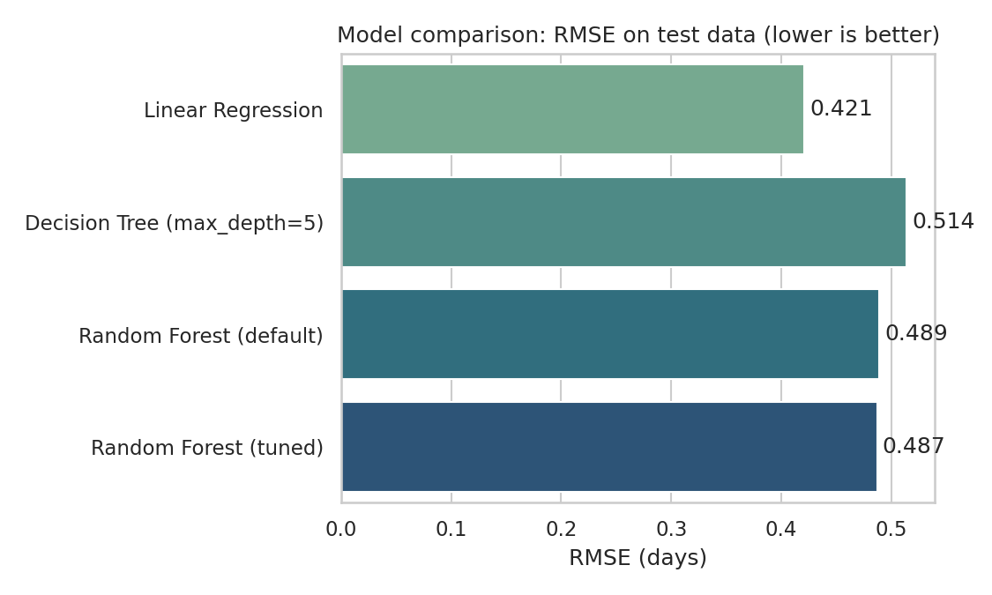
Figure 1: Model comparison by RMSE (lower is better)
- Linear Regression is the best. It has the lowest RMSE (0.421 days) and MAE (0.336 days) and the highest R2 (0.778). On average its prediction is wrong by about 0.34 days, which is roughly 8 hours. It explains about 78% of the changes in delivery time.
- The Decision Tree is the weakest (R2 0.669). The Random Forest (R2 0.700) and the tuned Random Forest (R2 0.703) are better than the tree but still behind Linear Regression. Tuning gave only a very small gain (0.700 to 0.703).
- Cross-validation check: for Linear Regression the cross-validation R2 is 0.748 (spread 0.031), close to the test R2 of 0.778. So the model gives similar results on different parts of the data and is not just lucky on one split.
- Why the simple model wins: in this dataset delivery time mostly follows straight-line rules (more distance means more days, Kolkata adds a delay, festival months add a delay). A straight-line model matches that well. With real data, tree models can sometimes do better, so I would test all of them again. For now I choose Linear Regression as the final model, because it is the most accurate here and also the easiest to explain to a manager.
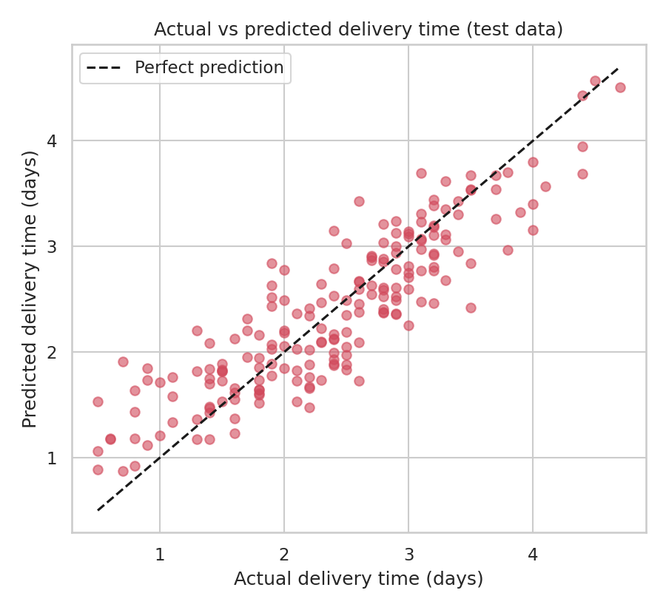
Figure 2: Actual vs predicted delivery time on the test orders (Linear Regression)
In this chart each dot is one test order. If the model was perfect, all dots would sit on the dashed line. Most dots are close to the line. The remaining difference (about 22% of the variation) comes from things that are not in my data, like traffic, weather or a driver being absent.

6. What Affects Delivery Time?
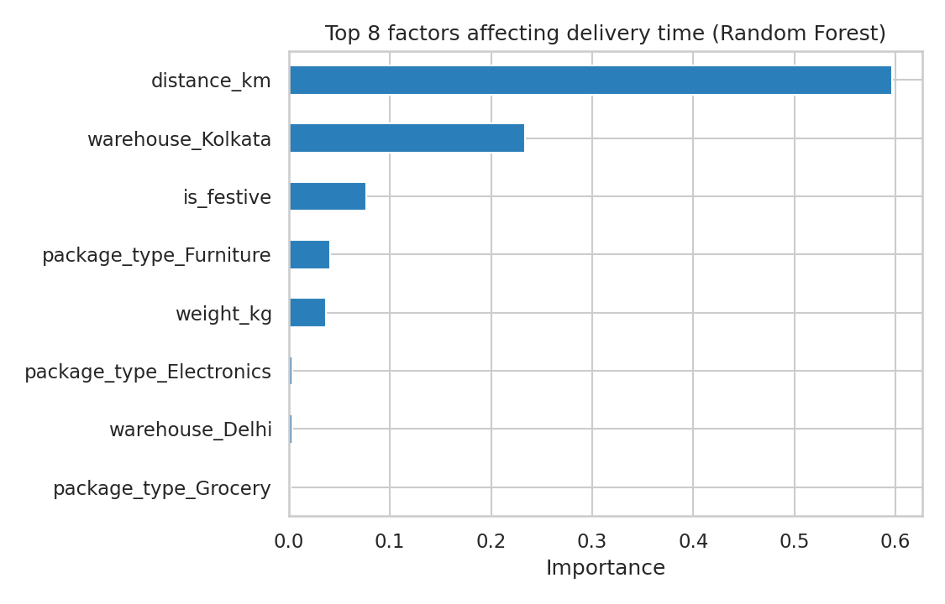
Figure 3: Top factors affecting delivery time (Random Forest importance)
The Random Forest ranks the factors by importance. The Linear Regression numbers tell how many days each factor adds. Both tell the same story:
Factor | Importance (Random Forest) | Effect in the linear model
Distance | 0.597 | About +0.25 days for every 100 km
Kolkata warehouse | 0.234 | About +1.01 day compared with Delhi, for the same order
Festival season (Oct-Nov) | 0.076 | About +0.60 days
Furniture parcel | 0.041 | About +0.49 days compared with other package types
Weight | 0.037 | About +0.14 days for every 10 kg

The vehicle type has only a small effect once the distance is known, because the vehicle is chosen according to the distance.

7. Optimization Strategies
A prediction is useful only when it helps in a decision. So I used the model to test three what-if scenarios on all orders. In each scenario I change one thing in the input data and ask the model to predict again. I used all orders and not only the test orders, so that the scenarios have more orders to work with (178 Kolkata orders and 157 festival-season orders).
# Scenario A: Kolkata orders are handled as fast as Delhi orders
XA = X.copy()
XA.loc[is_kol, "warehouse_Kolkata"] = False
XA.loc[is_kol, "warehouse_Delhi"] = True

# Scenario B: festival-season orders behave like normal-month orders
XB = X.copy()
XB.loc[is_fest, "is_festive"] = 0

predicted = lr.predict(XA) # same for XB and for both together (Scenario C)

Scenario | Average predicted days | Days saved per order (all orders) | Orders predicted on time
Current situation | 2.37 | 0.00 | 85.4%
A: Kolkata like Delhi | 2.18 | 0.19 | 95.1%
B: festival rush managed | 2.27 | 0.10 | 89.4%
C: both A and B | 2.09 | 0.28 | 98.7%

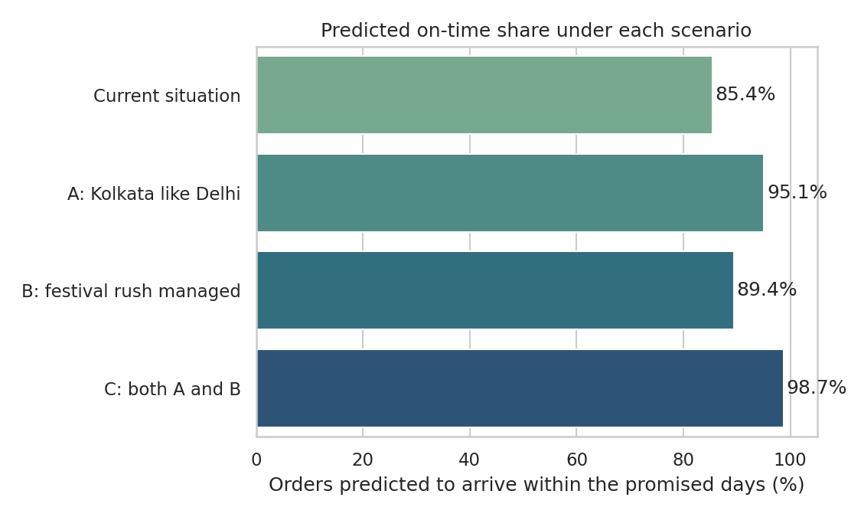
Figure 4: Predicted on-time share under each scenario
- Scenario A (fix Kolkata): each Kolkata order would be about 1.01 day faster. Over the whole network the predicted on-time share goes from 85.4% to 95.1%.
- Scenario B (manage the festival rush): each festival-season order would be about 0.60 days faster. The network on-time share goes up to 89.4%.
- Scenario C (both): the average order is 0.28 days faster and the predicted on-time share reaches 98.7%, which is above the 90% target.
- A note on honesty: these "on-time" numbers come from the average prediction of the model, so they are a little more positive than the real 82.5% from Week 3. I use them to compare scenarios with each other, not as exact promises.

7.1 Using the model to give a realistic delivery promise
The model can also be used when a customer books an order. Here are three examples. The "old promise" is the rule I used so far (based only on distance).
Order | Details | Old promise (days) | Model prediction (days)
Order A | 300 km, 10 kg, Van, Delhi, Clothing, month 6 | 2 | 1.63
Order B | 300 km, 10 kg, Van, Kolkata, Furniture, month 11 | 2 | 3.73
Order C | 700 km, 20 kg, Truck, Mumbai, Electronics, month 3 | 4 | 2.75

Order B (Kolkata, furniture, November) is predicted to take 3.73 days, but the old promise was only 2 days. This order would very likely be late. With the model, QuickShip can promise 4 days for such an order, or give it extra attention.

7.2 Recommended actions
- Resource allocation: fix the Kolkata warehouse first. Check staff numbers, loading time and dispatch time there. This is the single biggest gain in the model.
- Festival-season planning. Orders in October and November took 2.93 days on average against 2.26 days in other months, and the on-time rate fell to 61.1% from 86.6%. Extra vehicles and staff should be arranged before the rush.
- Better delivery promises. Use the model at booking time, so that customers get a date that includes the Kolkata and festival effects.
- Special handling for furniture parcels. They add extra days. Keep vehicle space for them or give a longer promise.
- Route planning and cost minimization. The cost per km is Rs 5.95 for bikes, Rs 3.07 for vans and Rs 2.64 for trucks. Short trips are costly per km because the fixed charges are spread over few kilometres. So nearby orders should be grouped into one route, and trucks should be filled well before dispatch.
- Review van promises. Vans have the lowest on-time rate (69.4%) among the vehicles with many orders, so their promised days should be checked.

8. Final Report Summary

8.1 Flow of the analysis
Step | What I did | Result
1. Problem | Predict delivery days of an order | Regression problem
2. Data | 964 cleaned orders, 6 features and 1 target | 15 input columns after encoding
3. Models | Linear Regression, Decision Tree, Random Forest, tuned Random Forest | Four models compared
4. Evaluation | RMSE, MAE, R2 and 5-fold cross-validation | Best: Linear Regression (R2 0.78, MAE 0.34 days)
5. Insights | Importance and coefficients | Distance, Kolkata warehouse and festival season matter most
6. Optimization | Three what-if scenarios | Predicted on-time share can reach 98.7%

9. Limitations
- The data is simulated. Real data will be noisier, so the numbers in this report show the method and not the real performance of a company.
- The model uses only six inputs. In real life traffic, weather, road conditions and driver availability also matter.
- The what-if scenarios show what the model predicts. They are not proof. A small pilot test (for example in Kolkata) should confirm the real effect before a big decision.
- The model was trained on one year of data. Future years may behave differently.

10. Conclusion
I built and compared four models to predict the delivery time of QuickShip orders. The simple Linear Regression model was the best (R2 0.78 and an average mistake of about 0.34 days) and the cross-validation showed that the result is stable. The model and the what-if scenarios show that distance is the main factor, but the things the company can really change are the Kolkata warehouse and the festival-season planning. If both are improved, the predicted on-time share goes from 85.4% to 98.7%. Together with Weeks 1 to 3, this completes the full cycle of a data analytics project: planning, cleaning data, exploring it, predicting and suggesting actions.

11. Files for This Week
- week4_model.py: complete code for the model, tuning, evaluation and what-if scenarios
- model_results.json: all numbers used in this report
- week4_output.txt: output of the program
- charts folder: model_comparison.png, actual_vs_predicted.png, feature_importance.png and scenario_comparison.png
- The data comes from data/quickship_clean.csv (made in Week 2)

