WEEK 2 TASK REPORT
Data Collection, Cleaning, and Preprocessing for Logistics Analysis
QuickShip Logistics: getting the data ready for analysis in Python
Item | Details
Intern name | Deepu Verma
Internship | Logistics Data Analyst Intern, YuvaIntern (Remote)
Internship period | 06-Oct-2026 to 03-Nov-2026 (4 weeks)
Task | Week 2 - Data Collection, Cleaning, and Preprocessing for Logistics Analysis
Case study | QuickShip Logistics (fictional e-commerce courier company)
Tools used | Python (pandas, numpy, matplotlib, seaborn, scikit-learn), MS Word, GitHub

1. Introduction
In Week 1 I made a plan for the QuickShip Logistics case. This week I work on the data. There is a saying in data analysis: "garbage in, garbage out". It means that if the data is bad, the result will also be bad, however good the model is. So before any analysis, the data must be checked and cleaned.
In this report I show the full process step by step. First I collect (create) a logistics dataset. Then I find the problems in it, like missing values, repeated rows and wrong values. Then I fix each problem with Python (pandas) and explain why I chose that method. In the end I scale the numbers (normalization) and check the data again. I have also written what I learned about the effect of data quality on business decisions.

2. Data Collection

2.1 Public datasets I used as reference
The task says to choose a public logistics dataset as a reference. I studied two datasets on Kaggle:
- DataCo Smart Supply Chain for Customer Analytics. It has orders with the planned shipping days, the real shipping days, shipping mode, region, sales and a late-delivery column.
- Olist Brazilian E-Commerce Public Dataset. It has real online orders with order date, estimated delivery date, actual delivery date, freight (shipping) cost and product weight.
Both datasets are very big and they are not about our QuickShip case. So I did not use them directly. I used them only to decide which columns a logistics dataset should have, such as distance, weight, vehicle, promised days, delivery days and cost.

2.2 How I collected (simulated) the data
The task also says to simulate the data collection. So I wrote a Python program (generate_data.py) that creates 1000 QuickShip orders for the year 2025. I used a fixed random seed (42), so the same data comes every time the program runs. I made the data behave like real life:
- Longer distance means more delivery days and more cost.
- Bikes are used for short trips, vans for medium trips and trucks for long trips.
- Heavy parcels and furniture take more time.
- October and November (festival season) are slower.
- The Kolkata warehouse has some extra delay.
Real data always has mistakes, so I added some common mistakes on purpose (missing values, repeated rows, wrong spelling and very big wrong numbers). This lets me show the cleaning work properly.
Important: this is a simulated dataset made for learning. It is not real company data, and I have not shown it as real data anywhere in this report.

2.3 Dataset characteristics
The raw file (quickship_raw.csv) has 1012 rows and 10 columns. That is 1000 orders plus 12 repeated rows. The columns are:
Column | Type | What it means
order_id | Number | Unique number of the order
order_date | Date (text in raw file) | Date when the order was booked
warehouse | Text | Warehouse that sent the parcel: Delhi, Mumbai, Kolkata or Chennai
vehicle | Text | Bike, Van or Truck
package_type | Text | Documents, Electronics, Clothing, Grocery or Furniture
distance_km | Number | Distance to the customer in km
weight_kg | Decimal number | Weight of the parcel in kg
promised_days | Number | Delivery time promised to the customer
delivery_days | Decimal number | Real delivery time in days
shipping_cost | Decimal number | Shipping cost in rupees

First 5 rows of the raw data:
order_id | order_date | warehouse | vehicle | package_type | distance_km | weight_kg | promised_days | delivery_days | shipping_cost
1 | 2025-02-02 | Kolkata | Van | Clothing | 186 | 20.6 | 2 | 2.7 | 636
2 | 2025-10-10 | Chennai | Bike | Furniture | 40 | 25.5 | 2 | 3.1 | 421
3 | 2025-08-27 | Chennai | Truck | Electronics | 568 | 5.2 | 3 | 3.0 | 1509
4 | 2025-06-10 | Mumbai | Truck | Clothing | 617 | 23.3 | 4 | 2.7 | 1652
5 | 2025-06-08 | Mumbai | Truck | Grocery | 697 | 7.9 | 4 | 2.8 | 1812

3. Finding the Data Quality Problems
Before cleaning, I first looked at the data to find the problems. I used these simple pandas checks: shape (rows and columns), isnull().sum() (missing values), duplicated().sum() (repeated rows), unique() (different spellings) and describe() (minimum and maximum values). The min and max values are very useful, because a strange number shows up there at once. For example, in the raw data the smallest distance is -5 km, the largest delivery time is 60 days and the largest shipping cost is Rs 15,416, while the middle (median) cost is only Rs 1,266. These numbers are clearly wrong.
Problem | How I found it | Number of rows | How I fixed it
Missing weight | isnull().sum() | 50 | Filled with the median weight of the same package type
Missing delivery days | isnull().sum() | 20 | Removed the rows
Repeated (duplicate) rows | duplicated().sum() | 12 | drop_duplicates()
Wrong spelling of warehouse (like "delhi ", "MUMBAI") | unique() showed 15 names for only 4 warehouses | 40 | str.strip() and str.title()
Distance zero or negative | Rule: distance_km <= 0 | 3 | Removed the rows
Delivery time more than 30 days | Rule: delivery_days > 30 (describe() showed a max of 60) | 4 | Removed the rows
Very big shipping cost (outlier) | IQR rule for each vehicle type | 9 | Removed the rows

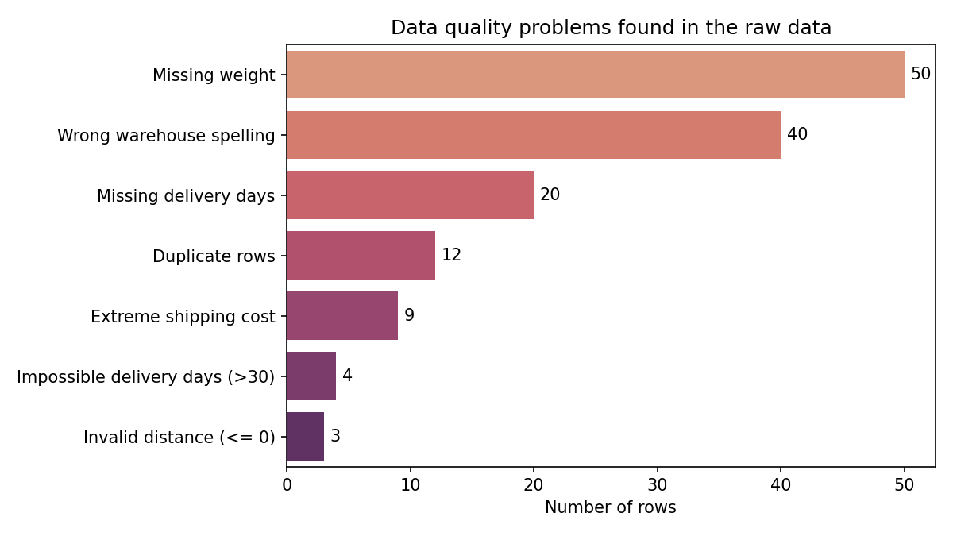
Figure 1: Number of rows with each type of problem in the raw data
Output of my inspection code:
Raw shape: (1012, 10)

Missing values:
order_id 0
order_date 0
warehouse 0
vehicle 0
package_type 0
distance_km 0
weight_kg 50
promised_days 0
delivery_days 20
shipping_cost 0
dtype: int64

Duplicate rows: 12

Warehouse names (raw): [' Chennai ', ' Delhi ', ' Kolkata ', ' Mumbai ', 'CHENNAI',
'Chennai', 'DELHI', 'Delhi', 'KOLKATA', 'Kolkata', 'MUMBAI', 'Mumbai', 'chennai',
'delhi', 'mumbai']

This output shows that the weight column has 50 missing values and the delivery_days column has 20. It also shows 12 repeated rows, and that the 4 warehouses are written in 15 different ways.

4. Cleaning Steps and Reasons
For every step I have written what the problem is, what I did, why I did it, and how it helps the later analysis.

Step 1: Fix the wrong spelling (text format)
- Problem: the same warehouse is written as "delhi", "DELHI", " Delhi " and "Delhi". Python thinks these are different warehouses.
- What I did: removed the extra spaces with str.strip() and made the first letter capital with str.title().
- Why: a group-wise result needs one name for one warehouse. Before this step there were 15 names. After it there are 4. I changed 40 rows.
- Effect on analysis: without this, the Kolkata warehouse would be split into many small groups, and its real delay would be hidden.

Step 2: Remove repeated (duplicate) rows
- Problem: the same order is present two times.
- What I did: drop_duplicates() removed 12 repeated rows.
- Why: if an order is counted twice, the number of orders, the averages and the on-time rate all become wrong.
- Effect on analysis: every order now counts exactly once.

Step 3: Remove wrong (invalid) values
- Problem: 3 rows have a distance of zero or less, and 4 rows have a delivery time of 45 to 60 days.
- What I did: I removed these rows, because they break common sense rules. A distance cannot be zero or negative, and no QuickShip parcel takes 45 to 60 days (the real maximum is about 5 days). These are typing mistakes.
- Why not fix them: I cannot know the right value, so a guess would create fake data.
- Effect on analysis: cost per km would give a wrong or infinite result for zero distance, and the average delivery time would go up.

Step 4: Handle the missing values
- Delivery days (20 missing): this is the value I want to study and predict in the next weeks. I should not guess it, so I removed these rows.
- Weight (50 missing): I did not remove these rows, because the other columns of the same rows are good. I filled the empty weight with the median weight of the same package type.
- Why median and not mean: the weight data is right-skewed, which means a few very heavy parcels pull the average up. The median is not affected by them.
- Why by package type: a furniture parcel is usually heavier than a document, so using the same package type gives a more realistic value.
- Effect on analysis: all 964 remaining rows are complete and no extra information was lost.

Step 5: Find and remove outliers (IQR rule)
An outlier is a value that is very far from the other values. To find it, I used the IQR method:
- Q1 is the value below which 25% of the data lies, and Q3 is the value below which 75% lies.
- IQR = Q3 - Q1. This is the width of the middle half of the data.
- A value is an outlier if it is lower than Q1 - 3 x IQR or higher than Q3 + 3 x IQR.
Two choices I made: (1) I did the calculation separately for each vehicle type, because a truck parcel naturally costs much more than a bike parcel. One common limit for all vehicles would be unfair. (2) I used 3 x IQR instead of the usual 1.5 x IQR, so that only the really extreme values are removed and the genuine heavy or long-distance parcels stay.
Result: 9 rows were removed. The highest shipping cost came down from Rs 15,416 to Rs 2,378. Eight of these rows were the wrong values I had added on purpose, and one was a natural extreme value. The cost per km changed from Rs 2.83 to Rs 2.7.
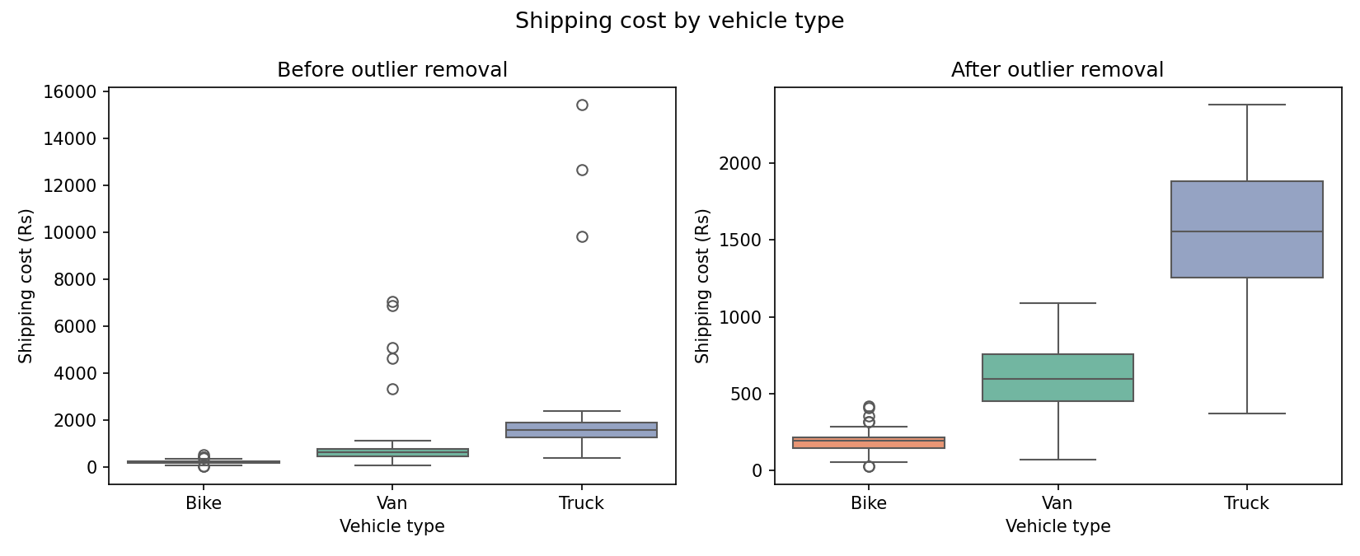
Figure 2: Shipping cost by vehicle type, before and after removing outliers
In the left chart the dots far above the boxes are the outliers. In the right chart they are gone and the boxes are easy to read.

Step 6: Make new columns (feature engineering)
I made four new columns from the existing ones, because I will need them in Week 3 and Week 4:
- month: taken from the order date, to study the festival season.
- delay_days: delivery_days minus promised_days. A positive number means the parcel was late.
- is_late: 1 if delay_days is more than 0, otherwise 0. This helps to find the on-time rate.
- cost_per_km: shipping_cost divided by distance_km.

5. Normalization
Normalization means bringing numbers of different sizes to a common scale. In my data, distance goes up to about 900, weight goes up to about 63 and cost goes up to about 2,378. Many methods (like distance-based or gradient-based models) give more importance to the column with bigger numbers. To keep things fair, I scaled the three columns between 0 and 1 using Min-Max normalization:
x_scaled = (x - min) / (max - min)

The smallest value becomes 0, the biggest becomes 1, and all others come in between. For example, the first order has a distance of 186 km. The minimum distance is 10 and the maximum is 899, so 186 becomes (186 - 10) / (899 - 10) = 0.198.
distance_km | distance_km_norm | weight_kg | weight_kg_norm | shipping_cost | shipping_cost_norm
186 | 0.1982 | 20.6 | 0.3226 | 636 | 0.2581
40 | 0.0338 | 25.5 | 0.4013 | 421 | 0.1665
568 | 0.6284 | 5.2 | 0.0754 | 1509 | 0.6299
617 | 0.6836 | 23.3 | 0.3660 | 1652 | 0.6908

After scaling, I checked that the minimum is 0.0 and the maximum is 1.0 for all three new columns. I kept the old columns too, so the original numbers are still available for charts and reports.
Other method I considered: standardization (z-score) puts the average at 0. I chose Min-Max because it is simple and it keeps the numbers between 0 and 1, which is easy to explain.

6. Python Code (pandas)
The full programs are generate_data.py and week2_cleaning.py. These are the main parts.

6.1 Look at the raw data
raw = pd.read_csv("data/quickship_raw.csv")
print(raw.shape) # rows and columns
print(raw.isnull().sum()) # missing values in each column
print(raw.duplicated().sum()) # repeated rows
print(sorted(raw["warehouse"].unique())) # different spellings
print(raw.describe()) # min and max to spot wrong values

6.2 Fix text, remove repeated rows and wrong values
df["warehouse"] = df["warehouse"].str.strip().str.title()
df["order_date"] = pd.to_datetime(df["order_date"])
df = df.drop_duplicates()
df = df[df["distance_km"] > 0] # remove zero or negative distance
df = df[df["delivery_days"].notna()] # remove rows with no delivery time
df = df[df["delivery_days"] <= 30] # remove typing mistakes

6.3 Missing values and outliers
# fill missing weight with the median of the same package type
df["weight_kg"] = df["weight_kg"].fillna(
df.groupby("package_type")["weight_kg"].transform("median"))

# IQR rule for each vehicle type (3 x IQR)
q1 = df.groupby("vehicle")["shipping_cost"].transform(lambda s: s.quantile(0.25))
q3 = df.groupby("vehicle")["shipping_cost"].transform(lambda s: s.quantile(0.75))
iqr = q3 - q1
is_outlier = (df["shipping_cost"] < q1 - 3*iqr) | (df["shipping_cost"] > q3 + 3*iqr)
df = df[~is_outlier]

6.4 New columns and normalization
df["month"] = df["order_date"].dt.month
df["delay_days"] = (df["delivery_days"] - df["promised_days"]).round(1)
df["is_late"] = (df["delay_days"] > 0).astype(int)
df["cost_per_km"] = (df["shipping_cost"] / df["distance_km"]).round(2)

for col in ["distance_km", "weight_kg", "shipping_cost"]:
df[col + "_norm"] = (df[col] - df[col].min()) / (df[col].max() - df[col].min())

df.to_csv("data/quickship_clean.csv", index=False)

7. Results: Before and After Cleaning
Check | Before cleaning | After cleaning
Number of rows | 1012 | 964
Missing values | 70 | 0
Repeated rows | 12 | 0
Different warehouse names | 15 | 4
Highest shipping cost (Rs) | 15,416 | 2,378
Average shipping cost (Rs) * | 1281.8 | 1226
Cost per km (Rs) * | 2.83 | 2.7
* "Before" means just before the outlier step, after the other cleaning steps.

In total I removed 48 rows (4.7%), and 964 rows are left in the clean file (quickship_clean.csv). Less than 5% of the data was lost, and the data is now complete, has no repeated rows, and uses one spelling for each warehouse.

7.1 Data quality checklist
Data quality is often judged on five points. This table shows how my cleaning covers each of them:
Quality point | Meaning | How I handled it
Completeness | No empty values | Filled missing weight; removed rows with no delivery time
Uniqueness | No repeated rows | drop_duplicates()
Consistency | Same thing written the same way | str.strip() and str.title() on warehouse
Validity | Values follow common sense rules | Removed distance <= 0 and delivery time > 30 days
Accuracy | Values are not extreme or wrong | IQR outlier removal for each vehicle type

8. Reflection: Why Data Quality Matters
- Wrong numbers lead to wrong decisions. A few wrong costs raised the cost per km from Rs 2.7 to Rs 2.83. A manager who sees the wrong number may start a cost-cutting plan that is not needed.
- Different spellings hide problems. The 4 warehouses were written in 15 ways. A warehouse comparison on this data would be wrong, and the slow warehouse may not be noticed.
- Repeated rows and missing values change the KPIs. If orders are counted twice, or orders with no delivery time are ignored, the on-time rate changes.
- A model learns from the data. If a model sees a 60-day delivery, it learns a wrong pattern. So the Week 4 prediction model can only be as good as this cleaning.
- Cleaning must be written down. I saved the count of every step in cleaning_summary.json, so anyone can repeat and check my work.
- What I learned: cleaning is not just deleting rows. For each problem I had to think about whether to fix it, fill it or remove it, and the choice depends on the business meaning of the column.

9. Conclusion
The raw QuickShip data had seven types of problems. I found them with simple pandas checks and fixed each one with a suitable method: spelling fix, removing repeated and wrong rows, filling missing weight with the median of the package type, removing extreme costs with the IQR rule for each vehicle type, and Min-Max normalization. I explained why I chose each method and how it helps the later analysis. The final clean dataset has 964 rows and only 4.7% of the data was removed. In Week 3 I will use this clean data to make charts and find the reasons for late deliveries.

10. Files for This Week
- generate_data.py: creates the simulated raw dataset
- week2_cleaning.py: full cleaning and preprocessing code
- cleaning_summary.json: count of rows in every cleaning step
- quickship_raw.csv and quickship_clean.csv: data before and after cleaning (in the data folder)
- charts folder: data_quality_issues.png and cost_outliers_before_after.png

