WEEK 3 TASK REPORT
Advanced Data Analysis and Visualization in Logistics
Case study: QuickShip Logistics - finding delay and cost drivers with Python
Item | Details
Intern name | Deepu Verma
Internship | Logistics Data Analyst Intern, YuvaIntern (Remote)
Internship period | 06-Oct-2026 to 03-Nov-2026 (4 weeks)
Task | Week 3 - Advanced Data Analysis and Visualization in Logistics
Case study | QuickShip Logistics (fictional e-commerce courier company)
Tools used | Python (pandas, numpy, matplotlib, seaborn, scikit-learn), MS Word, GitHub

1. Objective and Overview
This report analyses the cleaned QuickShip dataset with Exploratory Data Analysis (EDA) in Python. It calculates central tendencies, distributions and correlations, produces six visualizations, explains why each chart type was chosen, and interprets the charts to find operational efficiency problems, cost drivers and bottlenecks. The report ends with recommendations that management can act on.

2. Dataset Definition
The analysis uses the hypothetical (simulated) QuickShip dataset prepared in Week 2: 964 cleaned orders of the year 2025 from four warehouses (Delhi, Mumbai, Kolkata, Chennai). Key variables are delivery_days (actual delivery time), promised_days, distance_km, weight_kg, shipping_cost, vehicle (Bike, Van, Truck), package_type and month. Derived columns are delay_days (delivery - promised), is_late and cost_per_km. The overall baseline KPIs are:
KPI | Baseline value
On-Time Delivery Rate | 82.5% (target: 90%)
Average Delivery Time | 2.37 days
Cost per Kilometre | Rs 2.70 per km

3. Exploratory Data Analysis (EDA)

3.1 Central tendency and spread
Variable | Mean | Median | Std. dev. | Min | Max | Skewness
distance_km | 453.68 | 462.50 | 252.06 | 10.00 | 898.00 | 0.01
weight_kg | 11.91 | 10.50 | 8.23 | 0.50 | 62.80 | 1.54
delivery_days | 2.37 | 2.40 | 0.84 | 0.50 | 5.10 | 0.10
shipping_cost | 1226.01 | 1261.00 | 594.97 | 30.00 | 2378.00 | -0.06

- Delivery time has mean 2.37 and median 2.40 days with a very small skewness (0.10), so the distribution is almost symmetric. Most orders take between about 1.5 and 3.2 days (mean +/- 1 standard deviation).
- Weight is right-skewed (skewness 1.54): the median (10.50 kg) is lower than the mean (11.91 kg) because a few parcels are very heavy (up to 62.8 kg).
- Distance and shipping cost are almost symmetric (skewness close to 0), with a wide spread: orders travel from 10 to 898 km.

3.2 Correlation analysis
 | distance_km | weight_kg | delivery_days | shipping_cost
distance_km | 1.00 | -0.00 | 0.66 | 0.99
weight_kg | -0.00 | 1.00 | 0.14 | 0.08
delivery_days | 0.66 | 0.14 | 1.00 | 0.66
shipping_cost | 0.99 | 0.08 | 0.66 | 1.00

- distance and cost: 0.99 - a very strong positive relationship. Distance is the main cost driver.
- distance and delivery time: 0.66 - a strong positive relationship; longer routes take more days.
- weight and delivery time: 0.14 and weight and cost: 0.08 - weak positive relationships; weight matters, but far less than distance.
- Correlation shows a relationship, not proof of cause; the model in Week 4 separates the effect of each factor.

3.3 Group-wise summaries
By warehouse
Group | Orders | Avg delivery (days) | Avg delay (days) | On-time rate | Avg cost (Rs)
Chennai | 208 | 2.30 | -0.68 | 89.4% | 1,215
Delhi | 285 | 2.13 | -0.92 | 91.9% | 1,270
Kolkata | 178 | 3.06 | 0.13 | 44.9% | 1,184
Mumbai | 293 | 2.24 | -0.76 | 91.1% | 1,217

By vehicle type
Group | Orders | Avg delivery (days) | Avg delay (days) | On-time rate | Avg cost (Rs)
Bike | 35 | 1.49 | -0.51 | 74.3% | 195
Truck | 648 | 2.65 | -0.77 | 88.6% | 1,552
Van | 281 | 1.84 | -0.30 | 69.4% | 603

By package type
Group | Orders | Avg delivery (days) | Avg delay (days) | On-time rate | Avg cost (Rs)
Clothing | 278 | 2.29 | -0.70 | 84.5% | 1,229
Documents | 137 | 2.28 | -0.72 | 86.9% | 1,205
Electronics | 251 | 2.33 | -0.66 | 84.9% | 1,230
Furniture | 146 | 2.79 | -0.18 | 65.8% | 1,200
Grocery | 152 | 2.27 | -0.78 | 86.8% | 1,258

4. Visualizations and Interpretation
Six charts were produced with matplotlib and seaborn. For each chart the reason for choosing that chart type, the main finding and the code are given.

4.1 Histogram: distribution of delivery time
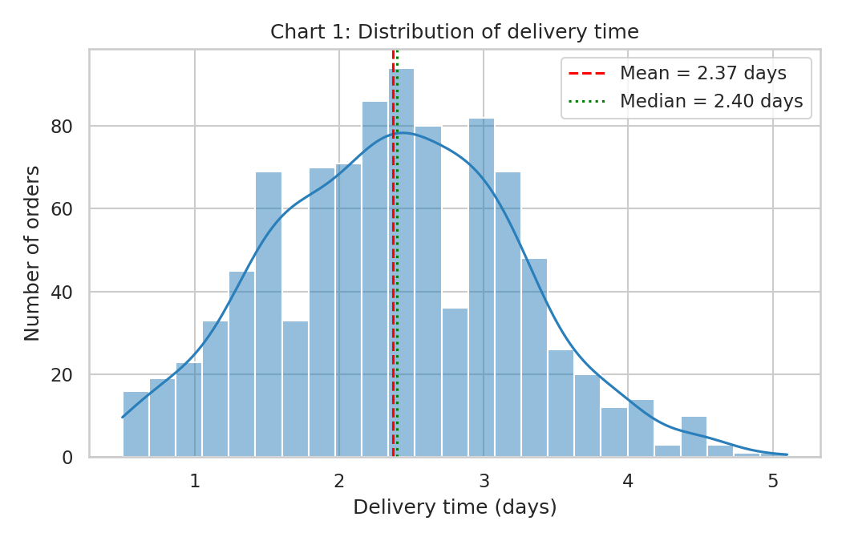
Figure 1: Distribution of delivery time
Why a histogram: it shows how a single numeric variable is spread and whether it is normal, skewed or has several peaks.
Finding: the shape is close to a bell curve with the mean (2.37 days) and median (2.40 days) almost at the same place, so the "typical" order takes about 2.4 days. A tail on the right shows a smaller group of slow orders (up to 5.1 days) which needs a separate explanation.
sns.histplot(df["delivery_days"], bins=25, kde=True)
plt.axvline(df["delivery_days"].mean(), color="red", linestyle="--")

4.2 Boxplot: delivery time by vehicle type
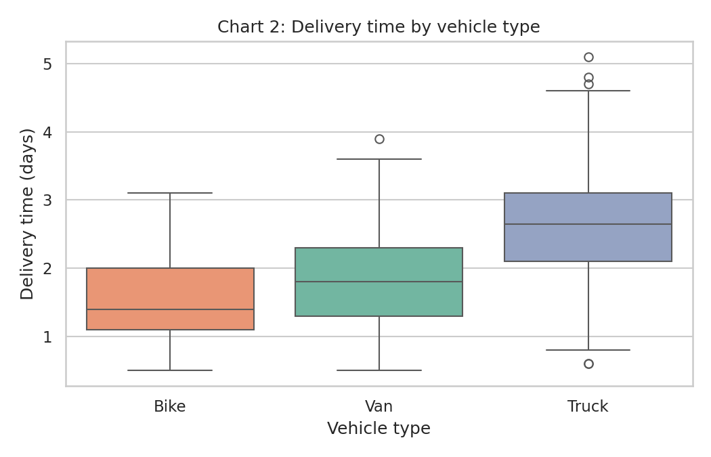
Figure 2: Delivery time by vehicle type
Why a boxplot: it compares the median, spread and extreme values of several groups side by side.
Finding: trucks have the highest median delivery time (average 2.65 days) because they are used for the longest routes; bikes are the fastest (1.49 days) for short trips and vans are in between (1.84 days). Vehicle type is therefore closely linked with distance. Vans have the lowest on-time rate (69.4%) even though they are faster than trucks; the likely reason is that the promised time for medium distances leaves less buffer, which should be checked with more data.
sns.boxplot(data=df, x="vehicle", y="delivery_days", order=["Bike", "Van", "Truck"])

4.3 Scatter plot: distance vs shipping cost
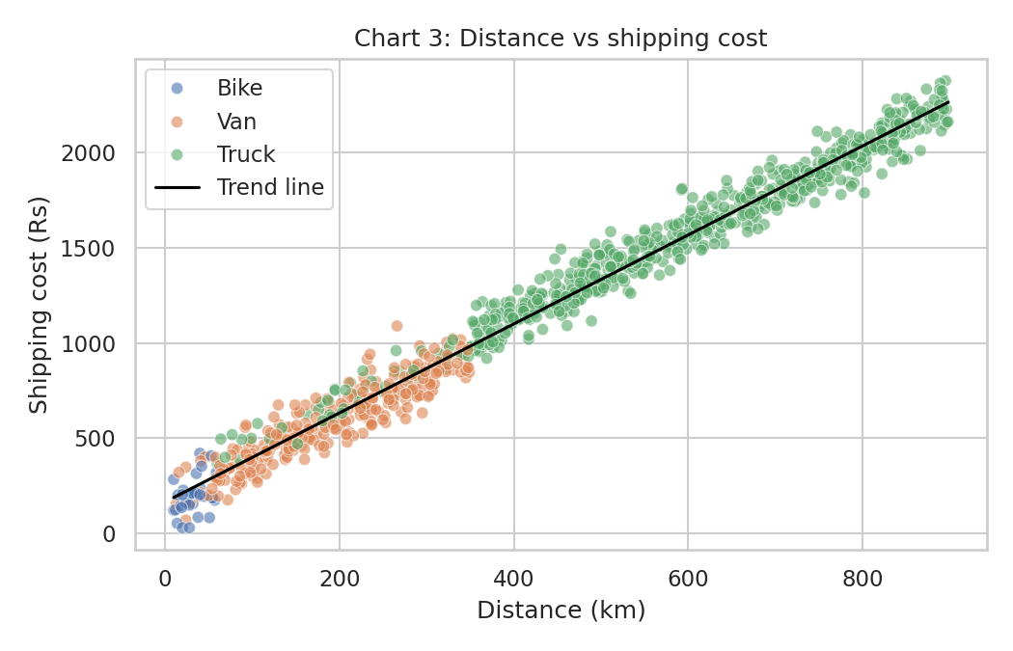
Figure 3: Distance vs shipping cost with trend line
Why a scatter plot: it shows the relationship between two numeric variables and helps to see a trend or unusual points.
Finding: the points follow a straight line (correlation 0.99). The cost rises steadily with distance, and the vehicle colours show that bikes, vans and trucks occupy different distance ranges. Because the line is so tight, distance explains almost all of the cost, and the remaining differences come from parcel weight and the vehicle type.
sns.scatterplot(data=df, x="distance_km", y="shipping_cost", hue="vehicle")
z = np.polyfit(df["distance_km"], df["shipping_cost"], 1) # trend line

4.4 Bar chart: on-time delivery rate by warehouse
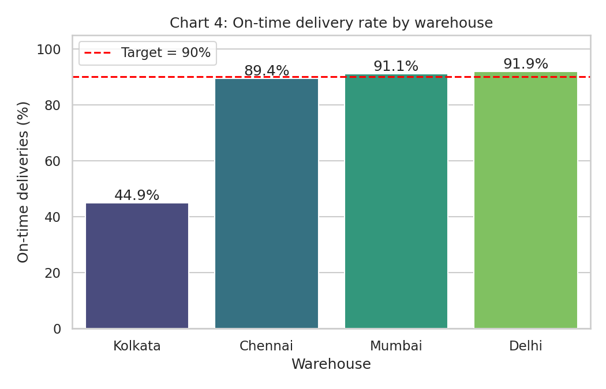
Figure 4: On-time delivery rate by warehouse
Why a bar chart: it compares one value (on-time %) across a few categories, and a target line makes the gap easy to see.
Finding: three warehouses are close to the 90% target (Delhi 91.9%, Mumbai 91.1%, Chennai 89.4%), but Kolkata is only 44.9%. Kolkata is the only warehouse with a positive average delay (0.13 days beyond the promise), while other warehouses deliver earlier than promised. This is the biggest bottleneck in the network.
sns.barplot(data=wh, x="warehouse", y="on_time_pct")
plt.axhline(90, color="red", linestyle="--", label="Target = 90%")

4.5 Line chart: monthly average delivery time
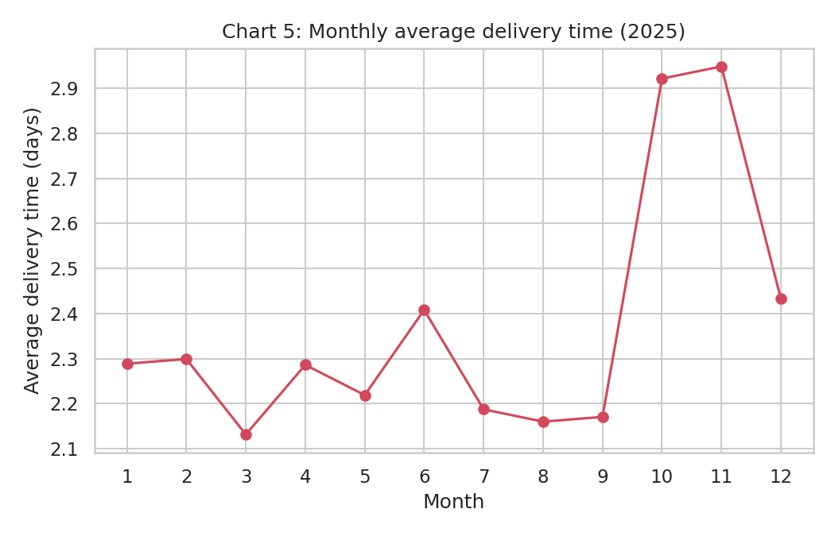
Figure 5: Monthly average delivery time in 2025
Why a line chart: it shows how a value changes over time and makes seasonal patterns visible.
Finding: delivery time is stable at about 2.1 to 2.4 days for most of the year but rises sharply in October (2.92 days) and November (2.95 days). The on-time rate falls to 60.2% and 62.5% in these two months. This is the festive-season rush: the average of these two months is 2.94 days against 2.26 days in the other ten months.
mon = df.groupby("month")["delivery_days"].mean().reset_index()
plt.plot(mon["month"], mon["delivery_days"], marker="o")

4.6 Heatmap: correlation between key variables
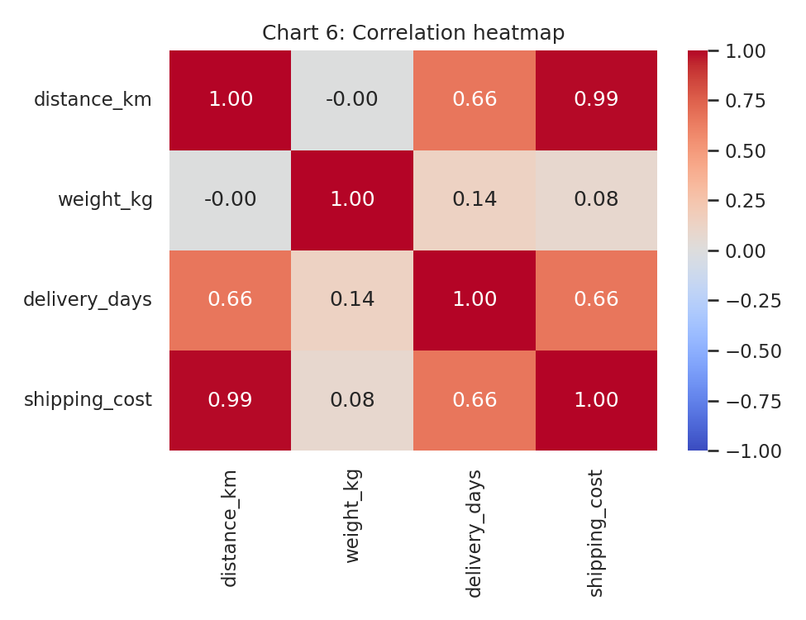
Figure 6: Correlation heatmap
Why a heatmap: it shows all pairwise correlations in one picture; strong relationships are easy to spot by colour.
Finding: the darkest cells are distance with cost (0.99) and distance with delivery time (0.66). Weight is nearly independent of distance (-0.00), which means weight adds its own small effect and is not just a copy of distance.
corr = df[["distance_km", "weight_kg", "delivery_days", "shipping_cost"]].corr()
sns.heatmap(corr, annot=True, cmap="coolwarm", vmin=-1, vmax=1)

5. Analytical Insights

5.1 Operational efficiency
- Overall on-time rate is 82.5%, which is below the 90% target. The average order takes 2.37 days.
- Excluding Kolkata, the three other warehouses are close to the target (89.4% to 91.9%), so the network gap is mainly one warehouse problem, not a general problem.

5.2 Cost drivers
- Distance is the dominant cost driver (correlation 0.99).
- Vehicle type changes the unit cost: bike orders have a high cost per km because of short routes and fixed charges, while trucks are the cheapest per km on long routes (see Week 4 vehicle summary).
- Weight has a small effect (correlation 0.08).

5.3 Bottlenecks
- Kolkata warehouse: on-time rate 44.9%, average delay +0.13 days.
- Festive season (Oct-Nov): delivery time rises by about 0.68 days compared with the rest of the year.
- Furniture parcels: average delivery 2.79 days and on-time rate only 65.8%, much lower than other package types (about 85% to 87%).
- Vans: lowest on-time rate among vehicles (69.4%), which needs a review of promised times for medium-distance orders.

6. Recommendations
- Investigate and fix the Kolkata warehouse first (staffing, dispatch timing, loading process). Bringing it near the other warehouses would raise the overall on-time rate the most.
- Plan festive-season capacity in advance: add vehicles and staff for October and November, and start dispatch earlier for these months.
- Create a special process for furniture parcels (bigger vehicle slots, separate handling, longer promised time) because they are late far more often.
- Review promised delivery times for medium-distance (van) orders so that promises match actual performance.
- Use distance-based cost planning: because distance explains almost the whole cost, route planning and consolidation of nearby orders offer the best chance of reducing cost per km.

7. Python Code Excerpts (EDA)
df = pd.read_csv("data/quickship_clean.csv", parse_dates=["order_date"])
num_cols = ["distance_km", "weight_kg", "delivery_days", "shipping_cost"]

# central tendency and spread
stats = df[num_cols].agg(["mean", "median", "std", "min", "max"]).T.round(2)
stats["skew"] = df[num_cols].skew().round(2)

# correlation
corr = df[num_cols].corr().round(3)

# on-time rate by warehouse
df.groupby("warehouse").agg(
orders=("order_id", "count"),
avg_delivery_days=("delivery_days", "mean"),
on_time_pct=("is_late", lambda s: (1 - s.mean()) * 100))

Full script: week3/week3_eda.py. It saves all six charts in week3/charts/ and the numbers in week3/eda_summary.json.

8. Conclusion
Exploratory analysis of 964 QuickShip orders showed that distance is the main driver of both delivery time and cost, that the network misses its 90% on-time target mainly because of the Kolkata warehouse, and that October and November create a seasonal peak in delays. Furniture parcels and van orders are additional weak areas. The charts were chosen to match each question (distribution, comparison, relationship, trend and correlation), and the findings led to five practical recommendations. In Week 4, these factors will be used as inputs to a prediction model and a what-if optimization analysis.

