01 / Chapter map and tutorial relevance
BBMS2006-3-VQ matching and control of breathing-23Sept2026.pdf | 21 source pages
Two connected problems
Matching: does each alveolus receive appropriate amounts of air and blood?
Control: how do sensors, brainstem circuits and respiratory muscles regulate ventilation?

Original tutorial question | Relevance to this chapter | Notes page
Q1 | Compliance always makes breathing easier | Partial overlap: regional compliance is explained here; whole-lung mechanics belongs elsewhere. | 3
Q2 | Apex versus base: capillary blood PO₂ | Direct: gravity changes V and Q unequally. | 5
Q3 | Normal saturation means normal delivery | Lecture 2; supporting distinction for content-weighted blood mixing. | 7: link only
Q4 | Altitude, hyperventilation and acidosis | Cross-topic: hypoxic drive versus respiratory alkalosis. | 12
Q5 | Right shift reduces pulmonary uptake | Lecture 2; not re-answered here. | —
Q6 | Hypoxemia versus tissue hypoxia | Lecture 2; explains why low Hb is not the same as low PaO₂. | 11: link only
Q7 | Hyperventilation at unchanged FiO₂ | Cross-topic application of alveolar ventilation. | 8
Q8 | Small bronchioles have highest resistance | Airway mechanics; do not confuse with pulmonary vascular resistance. | —
Q9 | Surfactant increases inspiratory work | Other lecture: surface tension and lung mechanics. | —
Q10 | CO decreases Hb–O₂ affinity | Lecture 2; not re-answered here. | —
Q11 | Chronic hypercapnia and ventilatory drive | Direct topic, with an adaptation mechanism supplied as an extension. | 10
Q12 | CA inhibitor and bicarbonate excretion | Cross-topic: renal bicarbonate loss and peripheral pH sensing. | 12
Q13 | Diving with unchanged nitrogen fraction | Lecture 2: Dalton and Henry. | —
Q14 | Equal minute ventilation means equal VA | Application; dead-space calculation supplied as an extension. | 8

Tutorial Q# preserves the original question wording/numbering from BBMS 2006 Tutorial.pdf, p. 1. Answers are reasoned suggestions, not an official key. Lecture references use actual PDF pages. [Extension] marks supporting material not fully developed in the slides; learning-outcome supplements are explicitly labelled. Original teaching images, labels and visible annotations are retained.

02 / V/Q: what is being matched?
Lecture PDF pp. 4, 13–14
Symbol / term | Plain meaning | Representative whole-lung value
V or V̇A: alveolar ventilation | Fresh air reaching the gas-exchanging alveoli per minute. | About 4 L/min in the slide example.
Q or Q̇: perfusion | Blood flow through pulmonary gas-exchange units per minute. | About 5 L/min.
V/Q ratio | Air supply relative to blood supply; a ratio of rates. | 4/5 = 0.8, not 4 or 5.

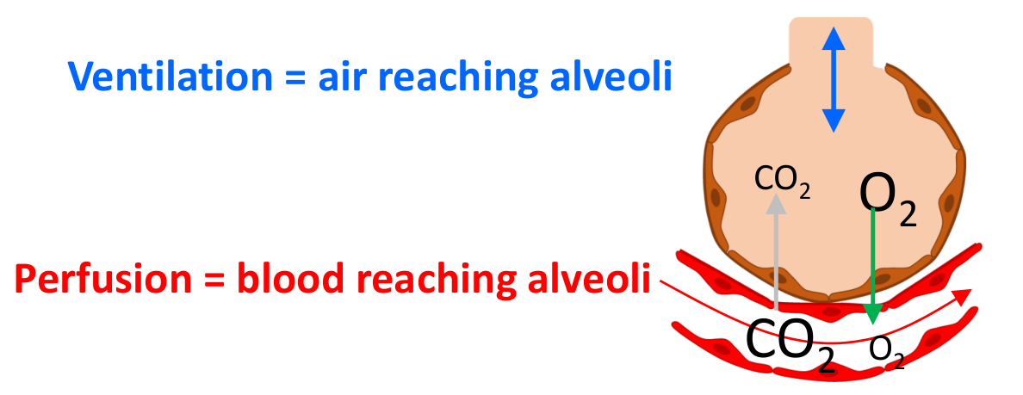
Original air/blood exchange illustration, lecture p. 4.
Unit state | What is missing? | Limiting V/Q behaviour
Shunt-like | Ventilation is inadequate relative to perfusion. | V/Q ↓; true unventilated perfusion gives V/Q = 0.
Dead-space-like | Perfusion is inadequate relative to ventilation. | V/Q ↑; no perfusion with ventilation gives V/Q → infinity.

Do not turn a whole-lung average into a rule for every alveolus
The slides use 0.8 as a resting example and about 0.8–1.2 as a broad whole-lung range. Regional ratios vary.
Both gravity and disease can create mismatch. Low V/Q is not necessarily a complete shunt; high V/Q is not necessarily complete dead space.

Notation throughout: PAO₂ / PACO₂ = alveolar gas pressures; PaO₂ / PaCO₂ = arterial blood pressures; PvO₂ / PvCO₂ = mixed venous pressures. Capital A and lower-case a are different compartments.

03 / Gravity changes regional ventilation
Lecture PDF p. 6 | Upright lung at the end of a normal expiration
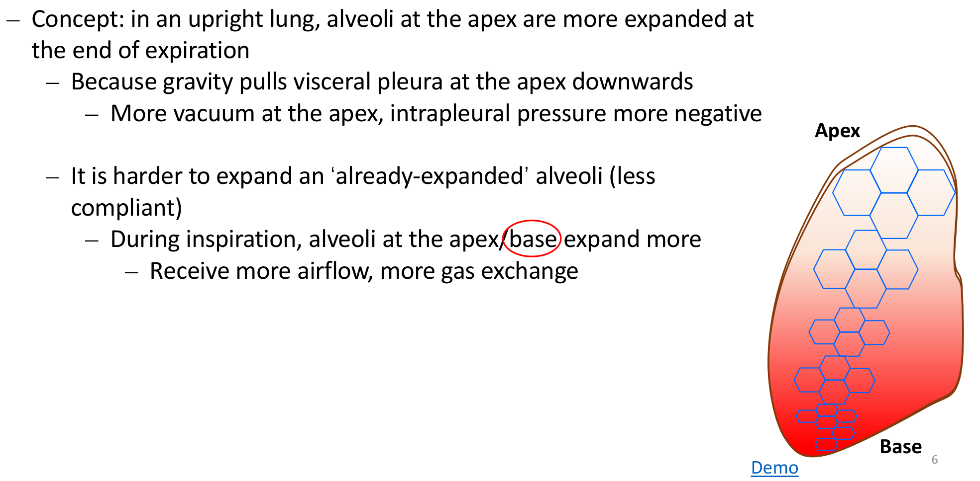
Original upright-lung explanation and the selected “base” answer, lecture p. 6.
Comparison | Apex | Base
Intrapleural pressure Ppl (PIP) | More negative. | Less negative.
Transpulmonary pressure PTP | More positive. | Less positive.
Alveolar expansion at end-expiration | Already more expanded. | Less expanded.
Local compliance: Δvolume/Δpressure | Lower on the local pressure–volume curve. | Higher; more ready to expand.
Volume increase during inspiration | Smaller → less fresh ventilation. | Larger → more fresh ventilation.

Why does a bigger resting alveolus get less inspired air?
Gravity creates a pleural-pressure gradient. Apical alveoli start more stretched, so the same inspiratory pressure change produces a smaller volume increase.
Resting size and the extra volume entering during a breath are different quantities.

PTP = alveolar pressure − pleural pressure. At end-expiration, alveolar pressure is approximately atmospheric throughout a healthy upright lung; the regional pleural-pressure difference therefore matters. This describes regional mechanics and does not prove Tutorial Q1’s word “always”.

04 / Gravity changes perfusion and vessel calibre
Lecture PDF pp. 7–8 | Low pulmonary pressure: learning-outcome supplement
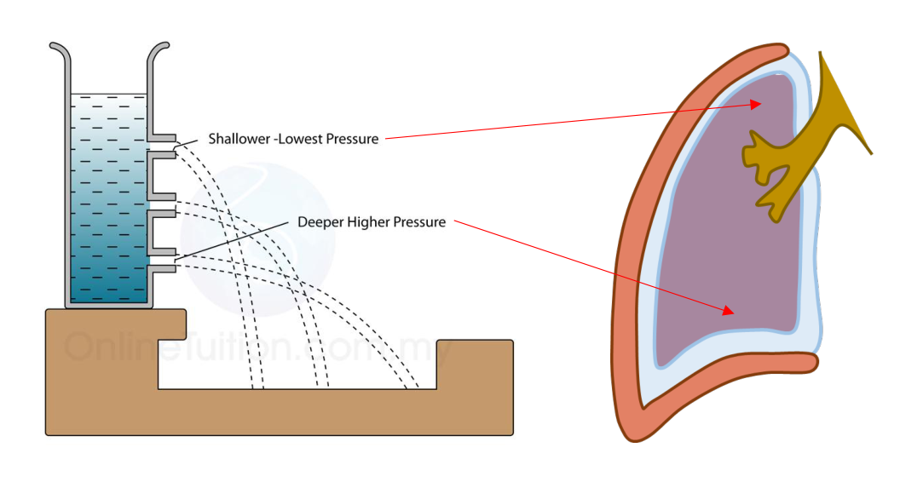
Original hydrostatic-pressure demonstration and lung diagram, lecture p. 7.
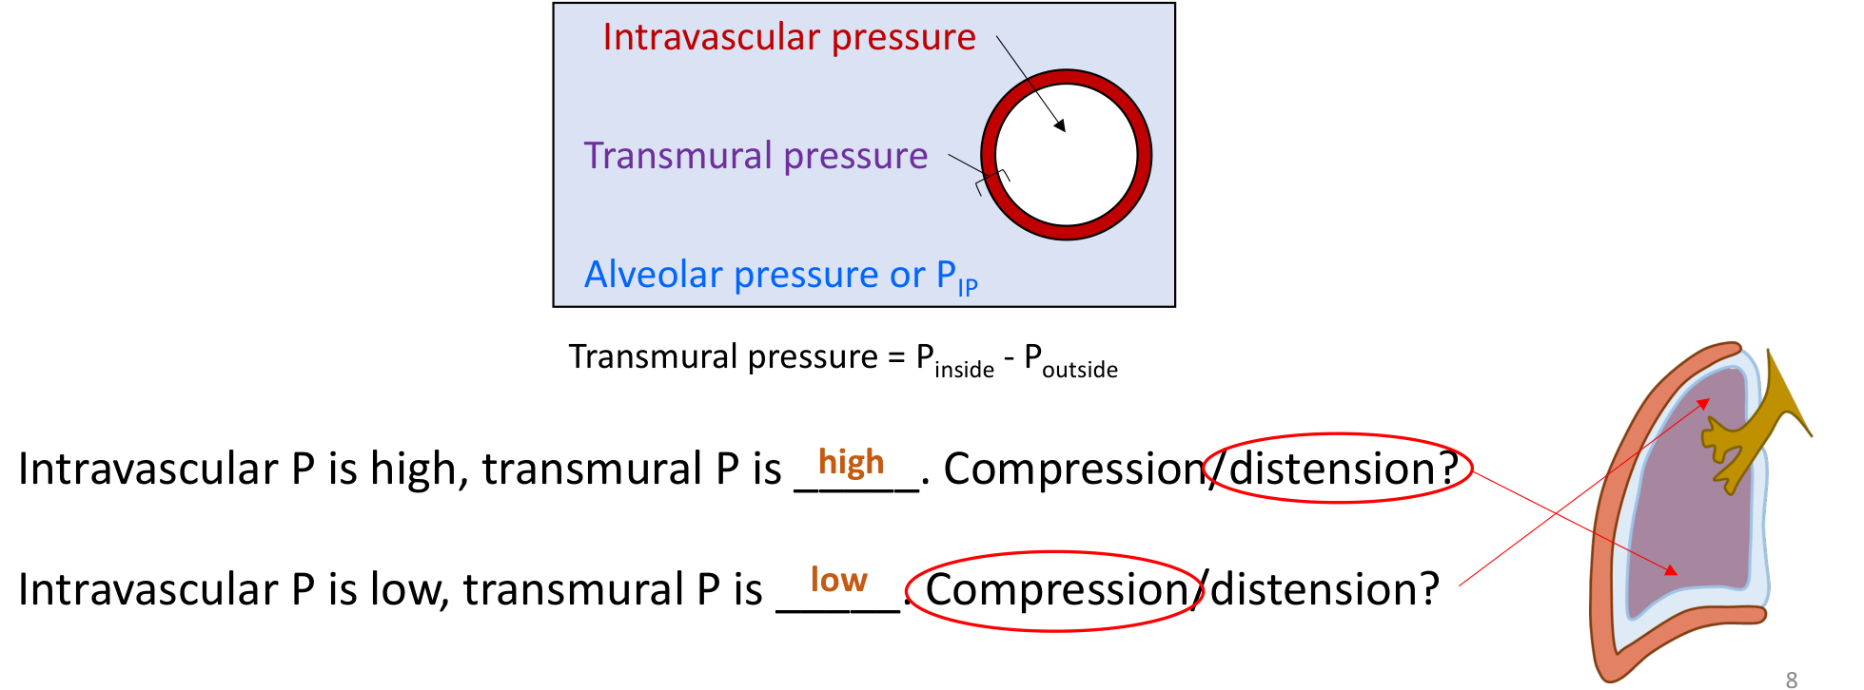
Original transmural-pressure diagram and selected distension/compression answers, lecture p. 8.
At comparable external pressure | Vessel behaviour | Effect on regional flow
Higher intravascular pressure | Higher transmural pressure → greater distension. | Lower vascular resistance → more flow.
Lower intravascular pressure | Lower transmural pressure → greater compression. | Higher resistance → less flow.

Transmural pressure = pressure inside − pressure outside the vessel. The relevant outside pressure depends on vessel location: alveolar pressure for alveolar capillaries; surrounding tissue pressure for extra-alveolar vessels. These pressures are not interchangeable in every vessel.
Why is pulmonary blood pressure low? [Learning-outcome supplement]
The lungs receive the same cardiac output as the systemic circuit, but pulmonary vascular resistance is much lower.
ΔP = Q̇ × resistance. A compliant, distensible vascular network with many parallel pathways supports the flow at low pressure; recruitment/distension can accommodate increased flow.
Typical supplemental reference: mean pulmonary arterial pressure ~15 mmHg. This is not required by the slide diagrams.

05 / Put V and Q together: apex versus base
Lecture PDF p. 9 | Tutorial Q2 | Supine position: learning-outcome supplement
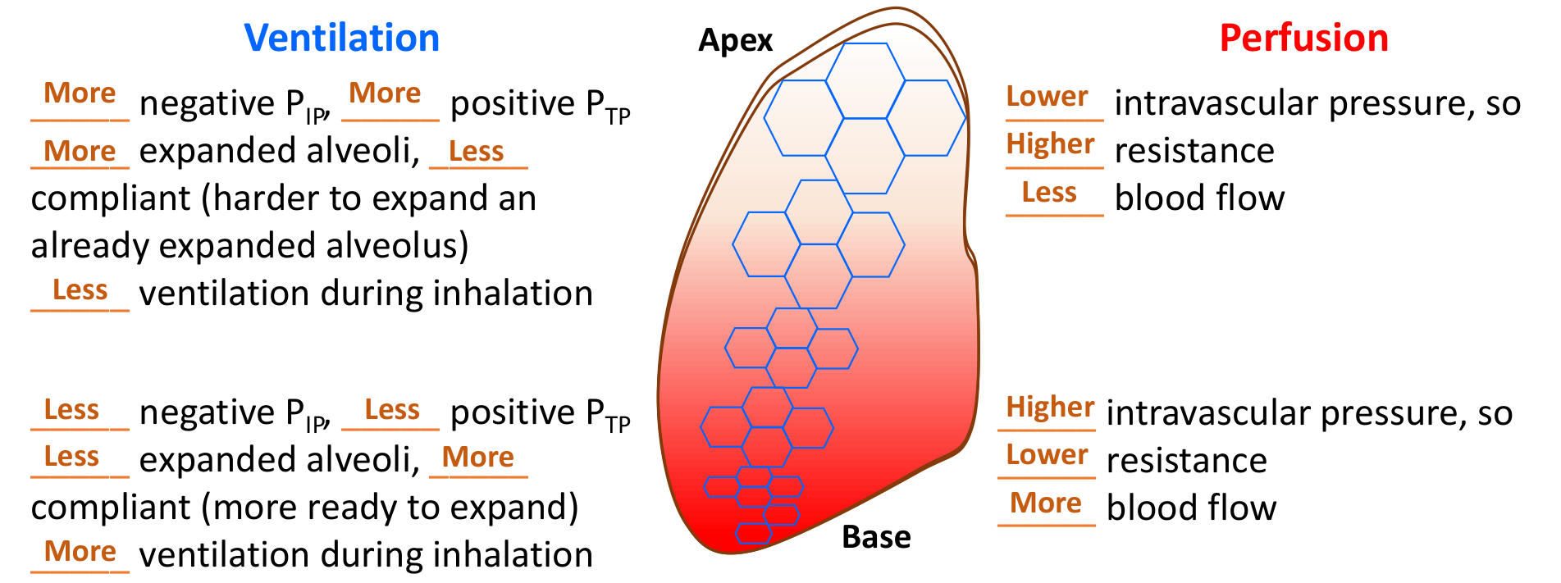
Original completed regional ventilation/perfusion exercise, lecture p. 9.
Upright comparison | Apex | Base
Ventilation V̇A | Lower. | Higher.
Perfusion Q̇ | Much lower. | Much higher.
V/Q ratio | Higher: Q falls more steeply than V. | Lower: Q increases more steeply than V.
Local alveolar / end-capillary gases | Relatively higher PO₂, lower PCO₂. | Relatively lower PO₂, higher PCO₂.

Tutorial Q2 · Original tutorial question
Blood leaving the pulmonary capillaries at the apex of an upright lung has a lower PO₂ than blood leaving the pulmonary capillaries at the base.
False | Compare the ratio, not ventilation alone
The apex receives less air, but an even greater relative reduction in blood flow → higher V/Q → higher local alveolar PO₂.
With adequate equilibration, blood leaving those capillaries has higher PO₂ than blood leaving basal capillaries. Do not confuse local end-capillary blood with mixed arterial blood.

What changes when supine? [Learning-outcome supplement]
The gravitational dependent direction becomes posterior/dorsal. Apex-to-base hydrostatic differences are smaller; the main gravity-related gradient is now back-to-front. Dependent regions generally receive more perfusion and often more ventilation during healthy spontaneous breathing.
Regional gradients are redistributed; do not copy upright apex/base rankings unchanged. Lung volume and airway closure can worsen dependent low V/Q, so posture alone does not guarantee perfect matching.

06 / V/Q determines alveolar gas composition
Lecture PDF pp. 12–13 | Source illustrations retained; intermediate cartoon numbers are conceptual
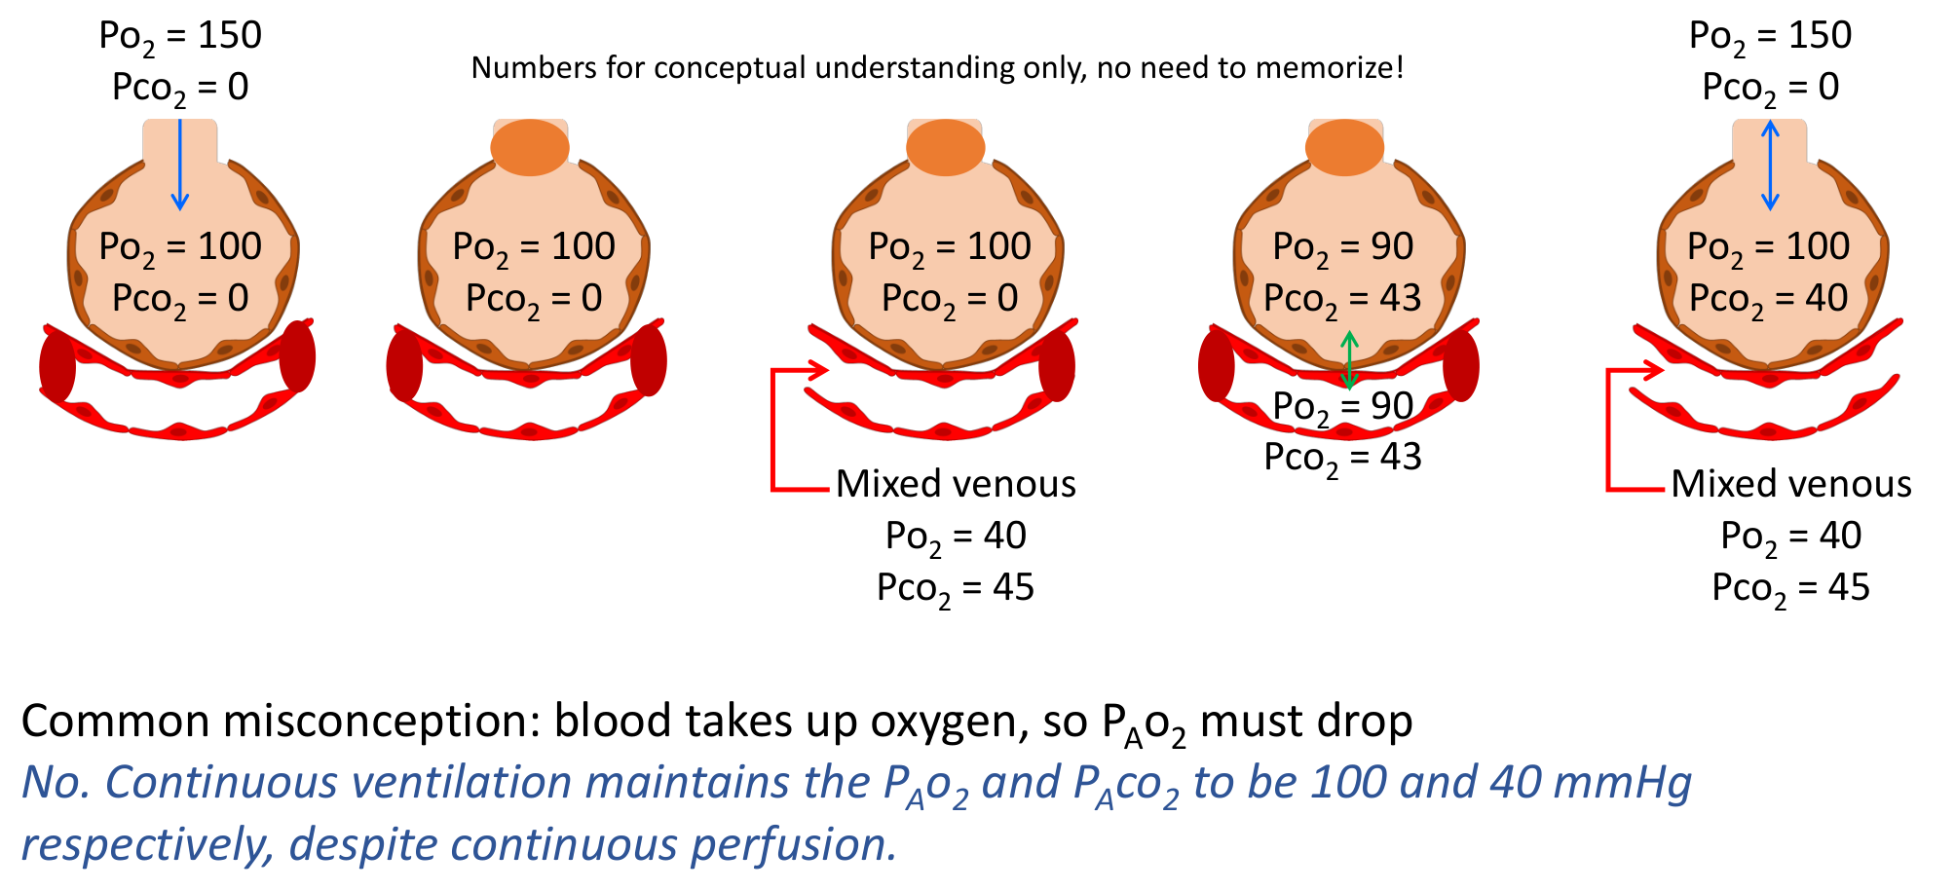
Original sequential alveolar-ventilation illustration, lecture p. 12.
Continuous exchange can have stable gas pressures
Blood continuously removes O₂ and supplies CO₂, while ventilation continuously replenishes O₂ and removes CO₂. At a matched steady state, PAO₂ and PACO₂ can stay approximately constant.
The temporary 90/43 and CO₂-free panels illustrate a changing scenario; they are not normal steady-state values to memorise.

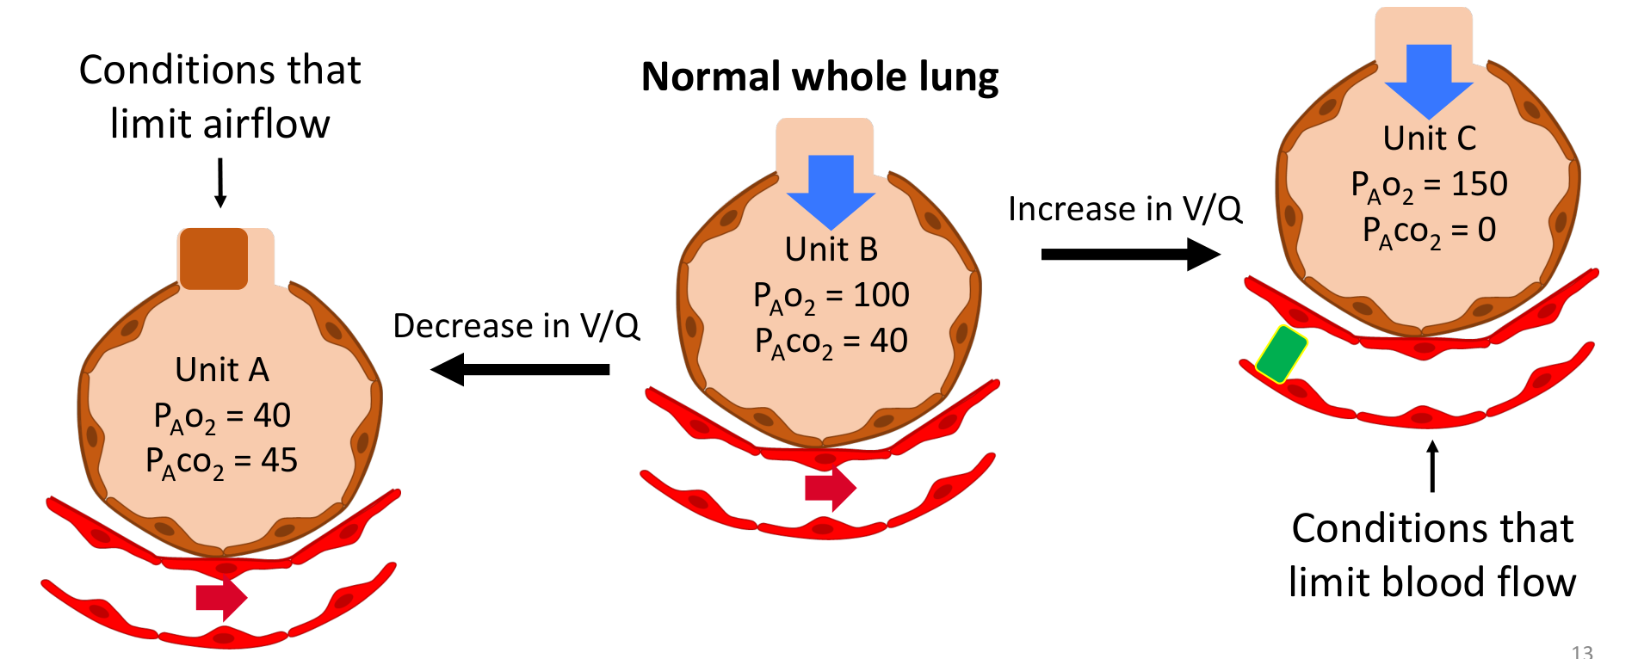
Original low-, normal- and high-V/Q units, lecture p. 13.
V/Q limit | Alveolar gas tends towards… | Illustrative PO₂ / PCO₂, mmHg
0: perfused, not ventilated | Mixed venous blood composition. | ~40 / 45.
Usual matched unit | Normal alveolar composition. | ~100 / 40.
Infinity: ventilated, not perfused | Humidified inspired gas composition. | ~150 / 0 on room air at sea level.

These are limiting examples, not fixed values for every low/high V/Q unit. Inspired pressure changes with altitude and FiO₂. A completely unperfused unit contributes no blood to the arterial mixture. Mix blood by flow and O₂ content, not a simple average of regional PO₂.

07 / Local matching: hypoxic vasoconstriction
Lecture PDF p. 10 | Blood-mixing calculation is an extension drawing on Lecture 2
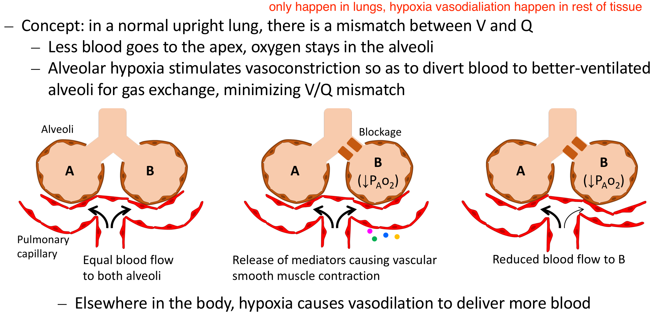
Original hypoxic vasoconstriction sequence and visible annotation, lecture p. 10.
Local pulmonary response
Airflow to unit B ↓ → PAO₂ in B ↓ → nearby pulmonary arterioles constrict
→ less blood goes to B → relatively more goes to better-ventilated units.
This helps matching; it does not remove the airway obstruction or guarantee full correction.

Where / how much hypoxia? | Expected response / significance
Local alveolar hypoxia in lung | Pulmonary vasoconstriction redistributes perfusion away from poorly ventilated alveoli.
Hypoxia in most systemic tissues | Local vasodilation generally increases O₂ delivery; opposite to the pulmonary response.
Widespread alveolar hypoxia [Extension] | Generalised pulmonary constriction can raise pulmonary vascular resistance/pressure; few better-oxygenated units may be available.

Integrated practice 1 | Self-written; not an original exam question
Two lung regions receive equal blood flow and produce end-capillary O₂ contents of 12 and 20 mL/dL. Calculate mixed content and delivery at total flow 5 L/min. Can raising PO₂ still further in the well-ventilated region fully compensate?
Reasoning: Mixed content = (12 + 20)/2 = 16 mL/dL; DO₂ = 16 × 5 × 10 = 800 mL/min (versus 1,000 if both were 20). Near-saturated Hb has little spare loading capacity; increasing high-unit PO₂ mainly adds a small amount of dissolved O₂. Mix oxygen content weighted by blood flow, not PO₂. Mismatch can cause hypoxemia without mandatory hypercapnia if other units eliminate extra CO₂.

08 / Alveolar ventilation versus minute ventilation
Lecture PDF p. 4 provides alveolar V; dead-space equations are extensions | Tutorial Q14, Q7
Term / symbol | Meaning / relationship
Tidal volume VT | Total volume of one breath.
Dead-space volume VD | Volume per breath that does not participate in effective gas exchange.
Frequency f | Breaths per minute.
Minute ventilation V̇E | VT × f: total air moved per minute.
Alveolar ventilation V̇A | (VT − VD) × f: effective fresh ventilation per minute in the simplified model.

Tutorial Q14 · Original tutorial question
Slow deep breathing and rapid shallow breathing provide the same alveolar ventilation if minute ventilation is identical.
False | Dead-space ventilation must be subtracted
Assume VD = 150 mL per breath and similar effective dead-space conditions. More small breaths waste a larger fraction of total ventilation in dead space.

Example | VT / f | V̇E | V̇A
Slower, deeper | 500 mL / 12 min⁻¹ | 6.0 L/min | (500 − 150) × 12 = 4.2 L/min
Faster, shallower | 250 mL / 24 min⁻¹ | 6.0 L/min | (250 − 150) × 24 = 2.4 L/min

Higher frequency alone does not establish higher alveolar ventilation. Physiological dead space can also increase when ventilated units lose perfusion.

Tutorial Q7 · Original tutorial question
Hyperventilation can increase arterial PO₂ even when oxygen concentration in inspired air remains unchanged.
True under usual gas-exchange conditions
At unchanged FiO₂, increasing alveolar ventilation relative to CO₂ production lowers PaCO₂.
[Extension] PAO₂ ≈ PIO₂ − PaCO₂/R (R ~0.8) → PAO₂ rises → PaO₂ can rise.
“FiO₂ unchanged” is a condition, not the cause of increased ventilation. Shunt or other severe exchange impairment can limit the oxygenation response.

09 / Controller: rhythm and motor output
Lecture PDF pp. 16, 19, 21
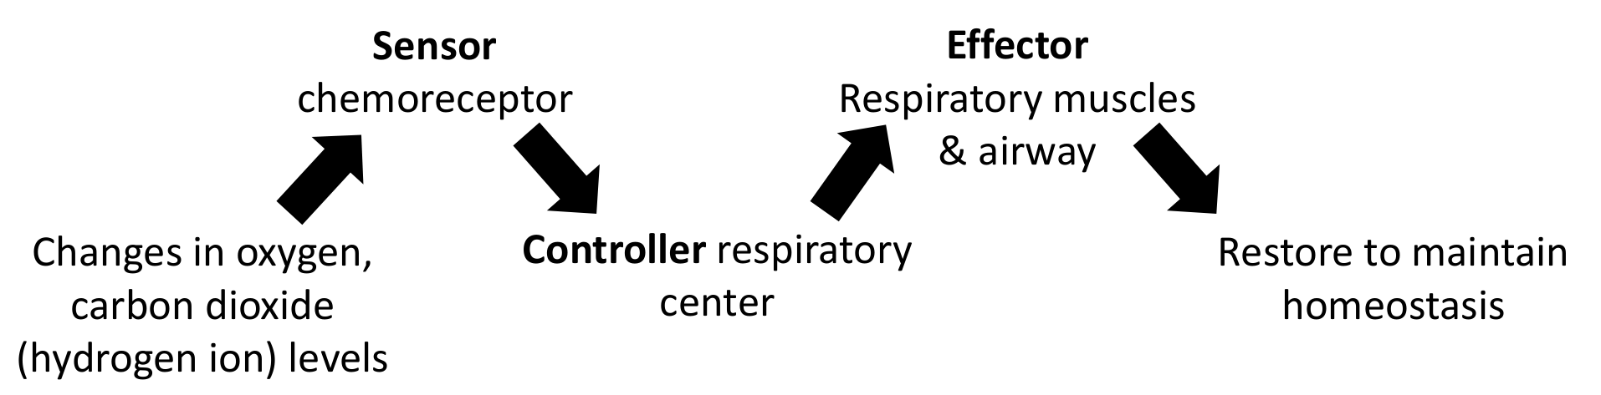
Original sensor–controller–effector model, lecture p. 16.
Component | Role
Sensors: chemoreceptors | Detect chemical changes; send signals to the brainstem.
Controller: brainstem circuits | Integrate sensory/higher-centre input and organise respiratory rhythm and motor activity.
Effectors: muscles and airway | Change airflow and alveolar ventilation → alter blood gases → feedback to sensors.

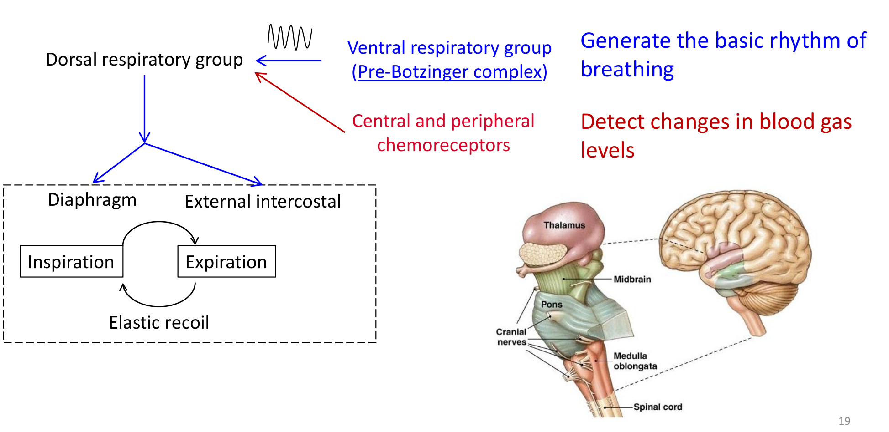
Original brainstem diagram, muscle output and elastic recoil, lecture p. 19.
Named structure / action | Main point in this lecture
Pre-Bötzinger complex within VRG | Important rhythm-generating network in the ventral medulla; not a cardiac muscle pacemaker.
DRG: dorsal respiratory group | Integrates sensory input and contributes to inspiratory output in the lecture model.
Pons and medulla | Both participate in respiratory control; pontine circuits help shape the breathing pattern.
Quiet inspiration / expiration | Diaphragm and external intercostals contract / mainly passive elastic recoil. Forced expiration recruits muscles [Extension].

VRG = ventral respiratory group. The diagram is a simplified functional model of a distributed network. Slide p. 16 compares rhythm generation with the cardiac SA node and GI interstitial cells of Cajal; respiratory muscles themselves are driven by neural output.

10 / Central chemoreceptors and chronic CO₂
Lecture PDF p. 17 | Tutorial Q11 | Adaptation and extreme hypercapnia are extensions
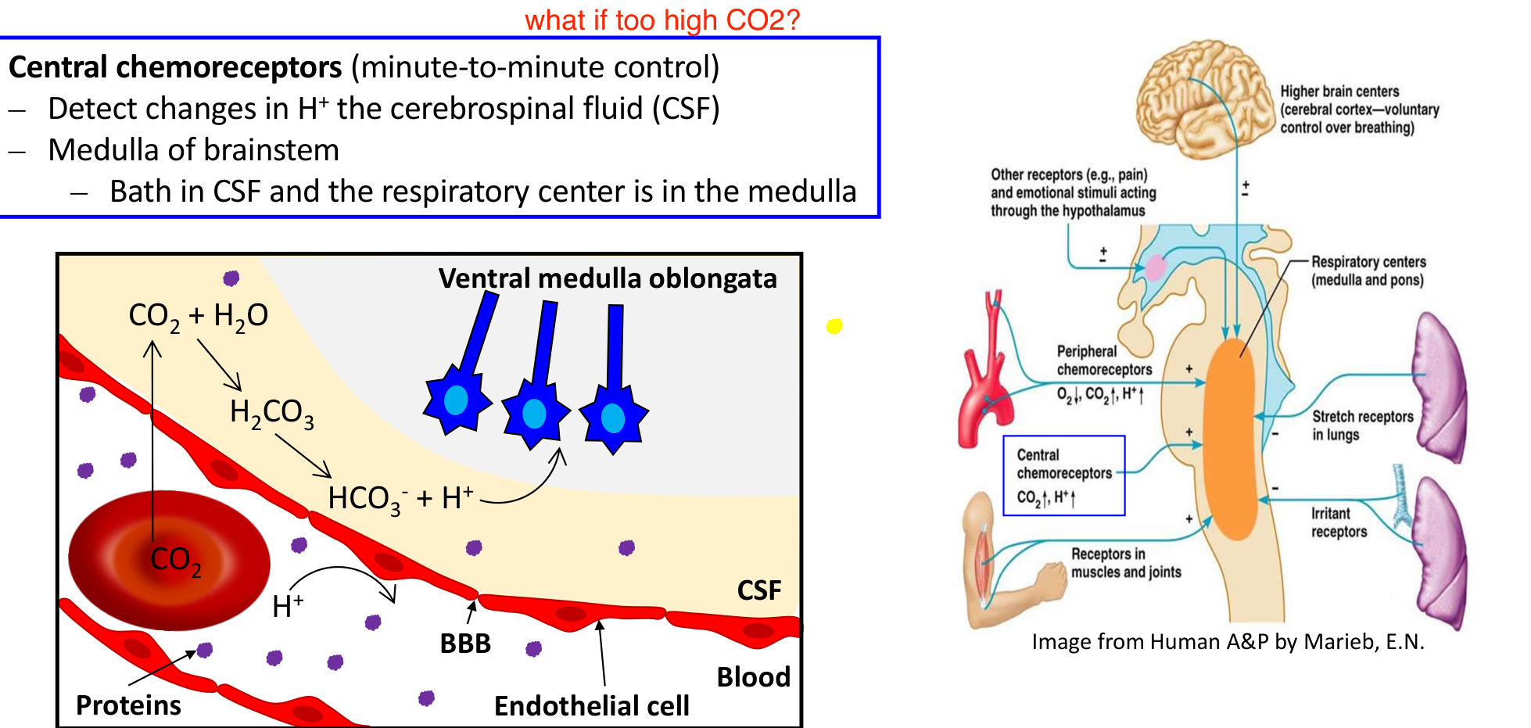
Original central chemoreceptor/BBB diagram and annotated control overview, lecture p. 17; Human A&P by Marieb.
What do central receptors actually sense?
PaCO₂ ↑ → CO₂ crosses the blood–brain barrier (BBB) → enters cerebrospinal fluid (CSF)
→ CO₂ + H₂O ⇌ H₂CO₃ ⇌ H⁺ + HCO₃⁻ → CSF H⁺ ↑ → medullary chemoreceptor stimulation
→ respiratory motor drive ↑ → alveolar ventilation ↑ → PaCO₂ falls: negative feedback.

• Central chemoreceptors respond to H⁺ in the brain extracellular fluid/CSF. CO₂ is an effective arterial signal because it crosses the BBB readily; blood H⁺ and HCO₃⁻ do not cross as freely.
• Central pathways supply much of the normal CO₂-driven, minute-to-minute feedback. Ventilatory drive means the neural stimulation that increases breathing.

Tutorial Q11 · Original tutorial question
A person with chronic hypercapnia depends more on arterial PO₂ than arterial PCO₂ as a ventilatory stimulus.
Qualified True in the usual introductory chronic-adaptation model
[Extension] Sustained PaCO₂ ↑ → renal HCO₃⁻ retention and CSF buffering adaptation → CSF pH moves back towards normal → central CO₂/H⁺ drive is attenuated.
Peripheral hypoxic stimulation can therefore contribute relatively more. This does not mean CO₂ responsiveness disappears or that every chronically hypercapnic person has an identical response.

Answer to the handwritten “what if too high CO₂?”: an acute moderate rise usually stimulates ventilation; very severe hypercapnia can depress CNS function. Do not extrapolate an indefinitely increasing response. CSF = cerebrospinal fluid; CNS = central nervous system.

11 / Peripheral sensors: pressure, not O₂ content
Lecture PDF p. 18 | Exercise discussion and receptor comparison; detailed mechanisms are extensions
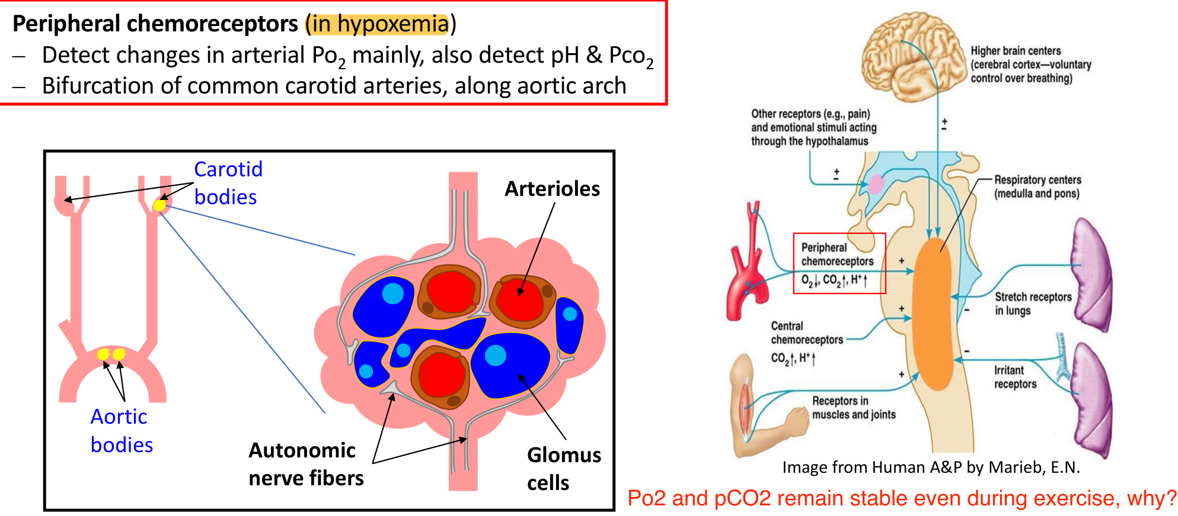
Original carotid/aortic body and glomus-cell diagram with annotations, lecture p. 18; overview from Marieb.
Compare | Central receptors | Peripheral receptors
Location | Medullary region; brain extracellular fluid/CSF. | Carotid bodies at carotid bifurcations; aortic bodies along the aortic arch.
Primary signals | CSF H⁺, strongly influenced by arterial CO₂. | Arterial PO₂, plus PCO₂ and pH; carotid bodies are especially important for the arterial pH response.
Hypoxemia | No direct main O₂-sensing role in this model. | Low PaO₂ stimulates ventilation; response becomes much stronger below ~60 mmHg [Extension].
Blood metabolic acidosis | Blood H⁺ does not rapidly act directly across the BBB. | Can stimulate ventilation even with normal PaO₂.

Glomus cells are specialised sensory cells in the peripheral chemoreceptor bodies; chemical changes alter the signals sent towards the brainstem.
Integrated practice 2 | Self-written; not an original exam question
Compare A: severe anemia with normal PaO₂; B: PaO₂ 50 mmHg with normal Hb; C: metabolic acidosis with normal PaO₂ and a compensatory fall in PaCO₂. Which signals drive ventilation, and why is “low O₂ content” not enough to predict the hypoxic chemoreflex?
Reasoning: A has reduced O₂ content but no strong low-PaO₂ signal solely from anemia. B strongly activates peripheral hypoxic sensing. C stimulates peripheral receptors through arterial H⁺; the fall in PaCO₂ can reduce central CO₂ drive. Distinguish arterial pressure, content and the compartment containing H⁺.

Slide exercise prompt: PaO₂/PaCO₂ often remain near normal during moderate exercise because ventilation rises with metabolic demand. [Extension] Feedforward motor signals and muscle/joint input help increase ventilation; stable gases do not mean breathing is unchanged.

12 / Chemoreflex applications: altitude and CA inhibition
Lecture PDF p. 20 | Tutorial Q4, Q12 | Alveolar gas/renal mechanisms are extensions
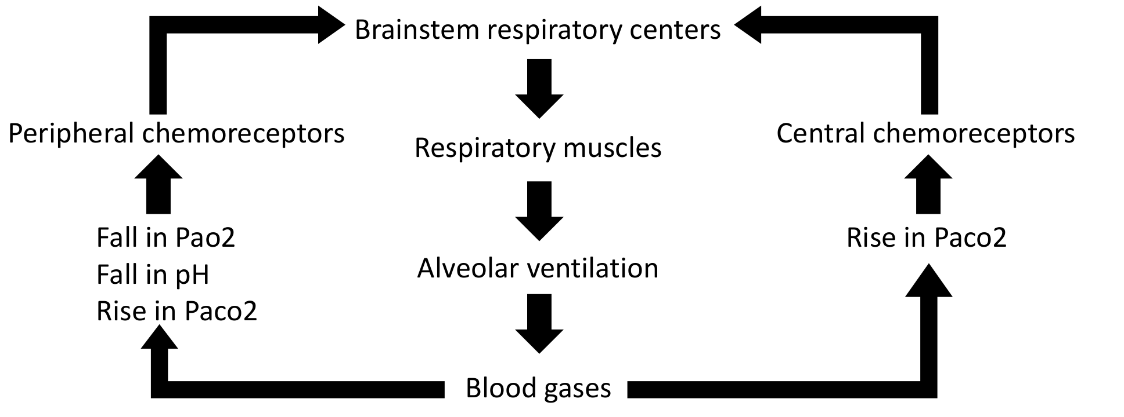
Original chemical feedback loop, lecture p. 20.

Tutorial Q4 · Original tutorial question
Hyperventilation at high altitude helps improve oxygenation even though it causes respiratory acidosis.
False | The acid–base label is wrong
Altitude: PB ↓ → inspired/alveolar PO₂ ↓ → peripheral hypoxic stimulation → ventilation ↑.
Acute hyperventilation → PaCO₂ ↓ → pH ↑: respiratory alkalosis, not acidosis. Reduced central CO₂/H⁺ drive opposes the hypoxic stimulus.
[Extension] Over time, bicarbonate loss/buffering adaptation reduces the alkalotic brake and permits sustained increased ventilation.

Tutorial Q12 · Original tutorial question
Carbonic anhydrase inhibitor stimulates hyperventilation by promoting bicarbonate ion excretion.
True | Link a renal change to a respiratory response [Extension]
Acetazolamide → renal tubular carbonic anhydrase (CA) inhibition → HCO₃⁻ reabsorption ↓
→ urinary HCO₃⁻ loss ↑ → metabolic acidosis → chiefly peripheral pH stimulation → ventilation ↑.
At altitude this can reduce the inhibition caused by respiratory alkalosis. The primary mechanism here is renal base loss.

Why does inhibiting a reversible enzyme reduce bicarbonate recovery?
CA accelerates both directions at different sites: filtered HCO₃⁻ is converted to CO₂ in the tubular lumen; inside the cell, CO₂ is converted back to HCO₃⁻ for return to blood. Inhibition slows this recovery route.
H⁺ used in this proximal recovery cycle is largely recycled, not necessarily excreted as net acid. Reversible catalysis does not mean the enzyme is unnecessary.

PB = barometric pressure; FiO₂ = inspired oxygen fraction; HCO₃⁻ = bicarbonate, an important base. Kidney/acid–base details support the original tutorial but are not fully taught in this slide deck.

13 / Protective reflexes and the breath-hold prompt
Protective reflexes: learning outcome on lecture p. 2; discussion prompt on p. 20

Protective reflexes [Learning-outcome supplement]
Named in the learning outcomes but not developed as a separate slide. The table supplies the standard mechanisms needed to address that outcome; it is not a verbatim lecturer-provided list.
Trigger / sensor | Reflex / response | Purpose / qualification
Irritation in larynx, trachea or bronchi | Cough: coordinated inspiration, compression and forceful expiration. | Helps clear irritants, secretions or foreign material from the airway.
Irritation of nasal mucosa | Sneeze. | Expels irritants from the upper airway.
Large lung inflation; pulmonary stretch receptors | Hering–Breuer inflation reflex: vagal input inhibits further inspiration. | Limits excessive inflation; more prominent at large tidal volumes and in infants than ordinary quiet adult breathing.
Laryngeal contact/irritation | Protective glottic closure, sometimes with transient apnea. | Helps prevent material entering the lower airway.

Other inputs visible in the original overview
• Cerebral cortex: voluntary control; hypothalamic pathways: emotion and pain-related influences.
• Muscle/joint receptors: contribute to the ventilatory response during activity.
• Protective airway/stretch signals modify the rhythm; chemical blood-gas feedback is not the only input.

Original classroom discussion: interpret the physiology
“How would you increase your chance of winning a breath-holding competition using your respiratory physiology knowledge?”
Explain the mechanism without treating it as a safe technique
During a breath hold, CO₂ rises and O₂ falls. Rising CO₂/CSF H⁺ contributes strongly to the urge to breathe; falling PaO₂ increasingly activates peripheral receptors.
Pre-hold hyperventilation lowers starting PaCO₂ and can delay that urge, while adding little Hb-bound O₂ when Hb is already near saturation.
The delay can allow dangerous hypoxemia and loss of consciousness, especially in water. A delayed urge is not evidence of adequate oxygen; do not use hyperventilation to prolong breath holding.

Coverage check: matching and V/Q extremes pp. 2, 6–7; gravity and posture pp. 3–5; low pulmonary pressure p. 4; ventilation/dead space p. 8; rhythm and motor output p. 9; chemoreceptors pp. 10–12; protective reflexes p. 13. Only two self-written integrated practice problems are included.

