01 Hearing & balance: two special senses
Both use inner-ear hair cells (mechanoreceptors)
→ cranial nerve VIII (vestibulocochlear nerve) → brainstem.

System | Stimulus | Receptor region / nerve branch
Audition | Sound waves: vibrations of air. | Inner hair cells in the cochlear Organ of Corti → cochlear / auditory branch of VIII.
Vestibular sensation | Head movement and orientation relative to gravity. | Hair cells in otolith organs and semicircular canals → vestibular branch of VIII.

Sound: amplitude and frequency carry different information
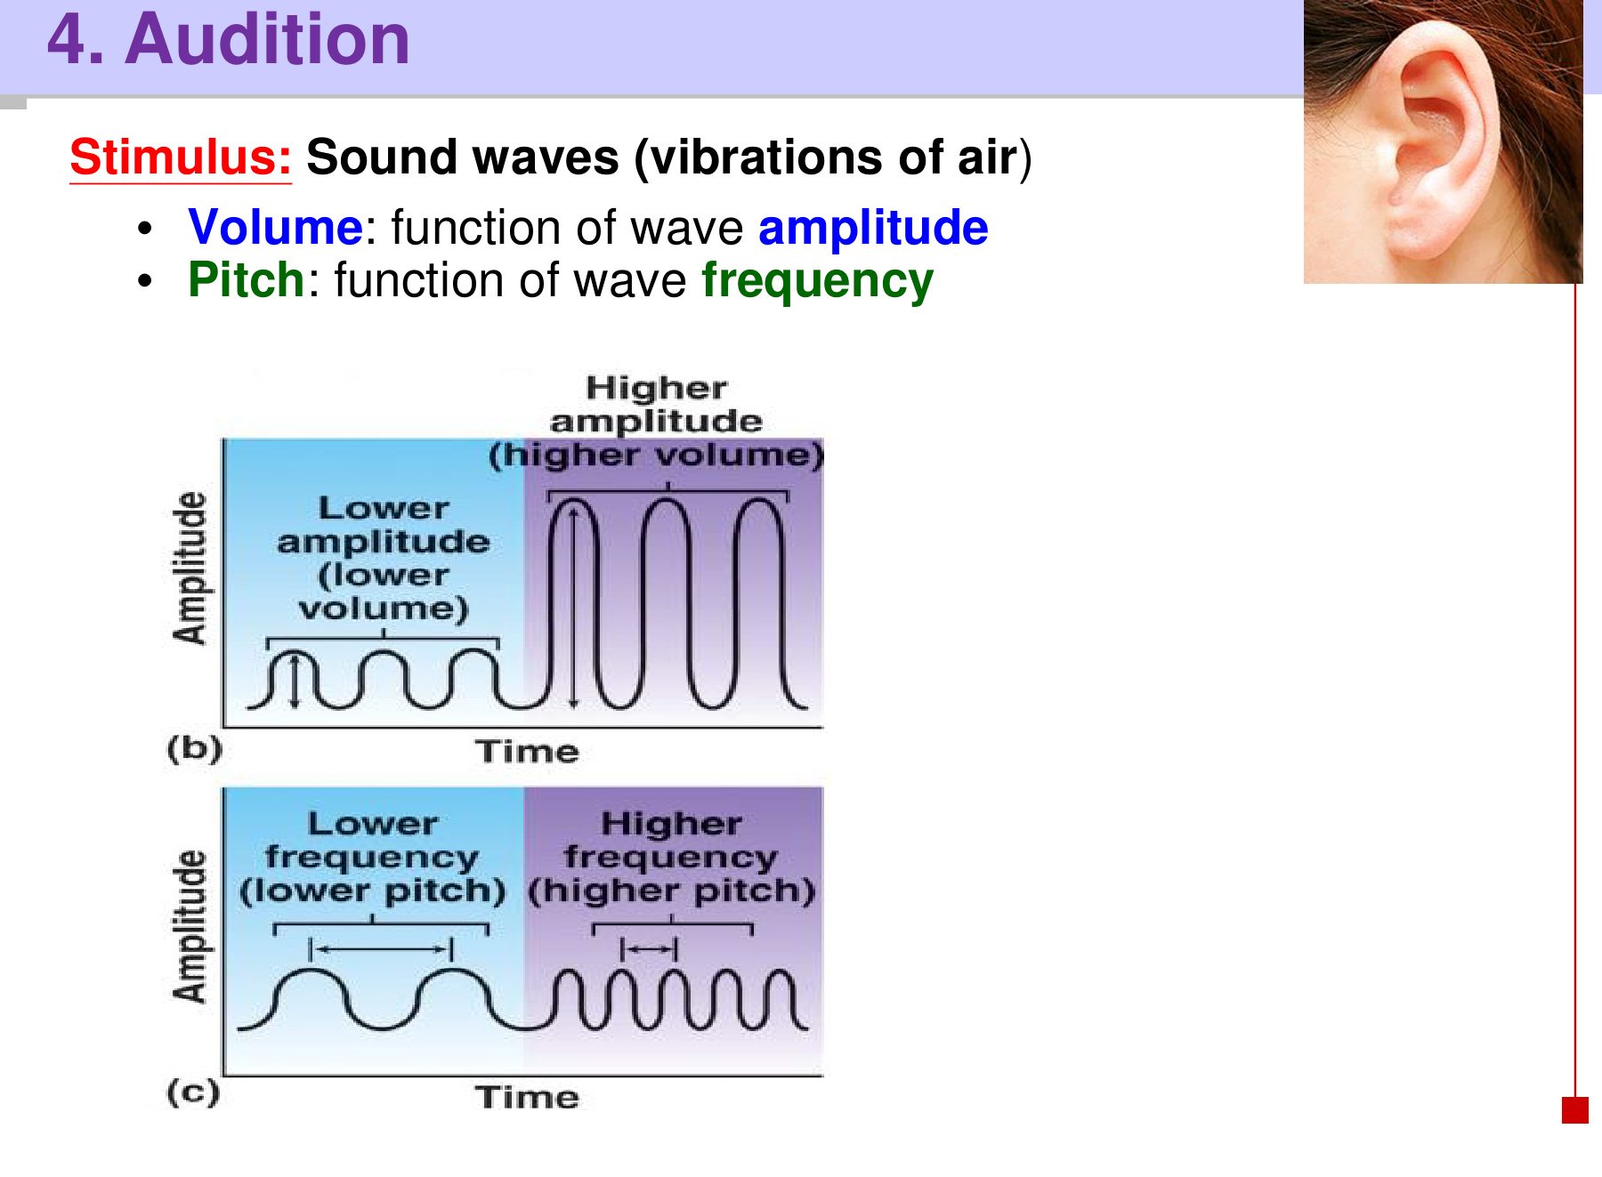
Wave property | Perceptual association
Amplitude | Greater amplitude → louder sound / greater perceived volume.
Frequency | More oscillations per second → higher pitch. Fewer oscillations per second → lower pitch.

• Changing loudness does not necessarily change pitch: amplitude and frequency are separate wave properties.
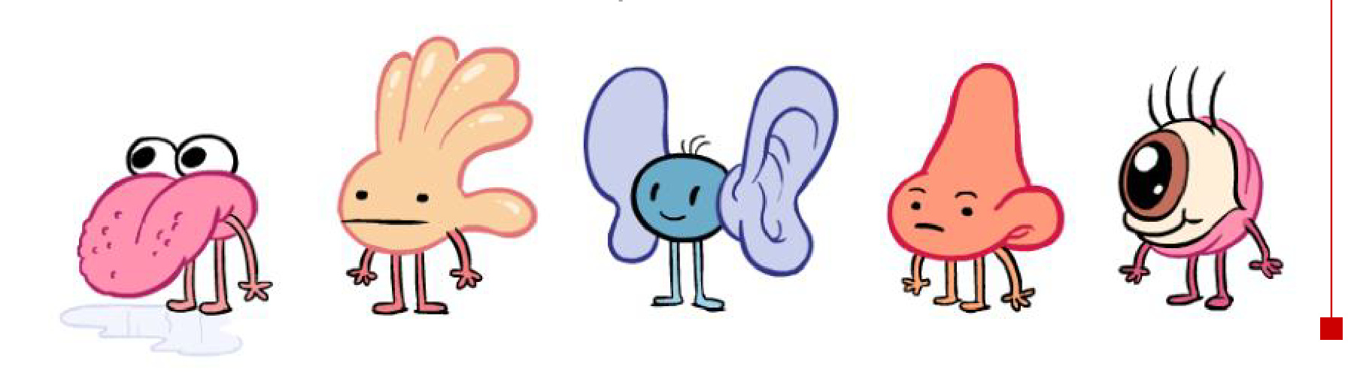

02 Outer & middle ear: deliver vibrations
Sound waves → external auditory canal → tympanic membrane (eardrum)
→ malleus → incus → stapes → oval window

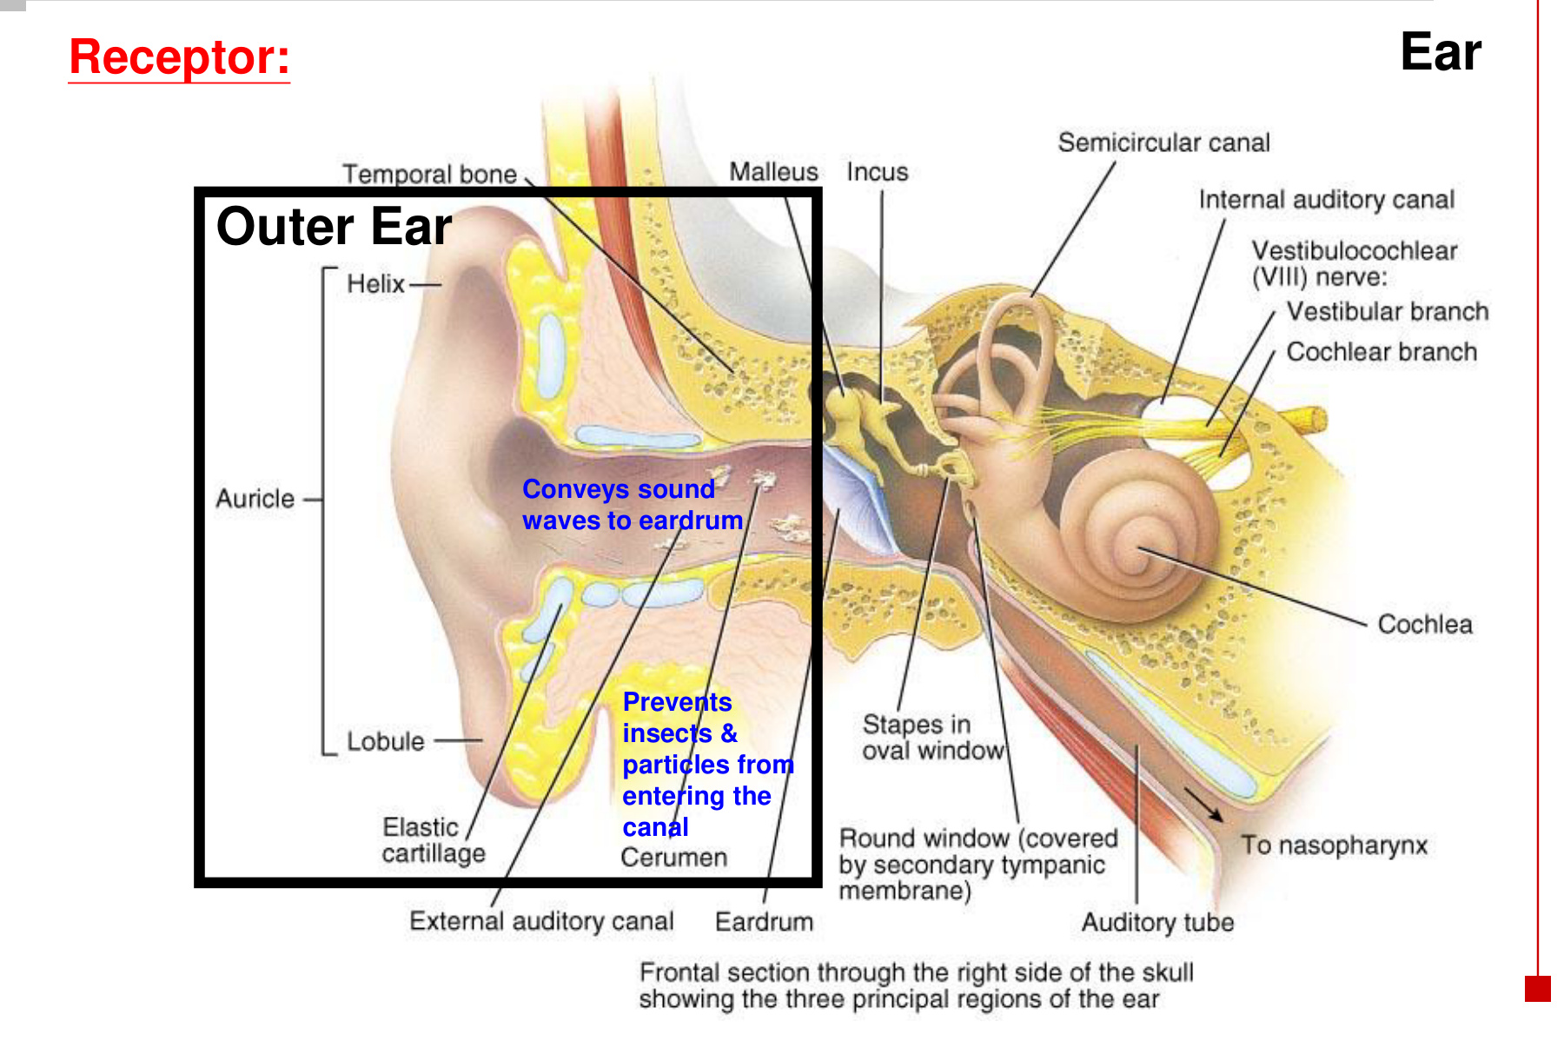  Outer ear collects and conducts sound. | 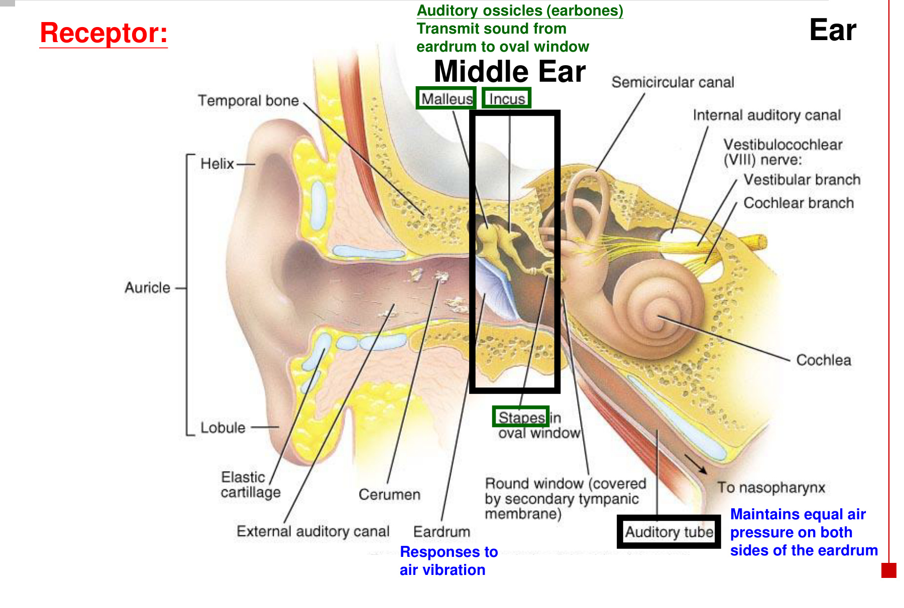  Middle-ear ossicles transmit the vibration.

Structure | Function
Auricle / pinna | Collects sound at the entrance to the outer ear.
External auditory canal | Conveys sound waves to the eardrum.
Cerumen (earwax) | Helps prevent insects and particles from entering farther into the canal.
Tympanic membrane | Vibrates in response to changes in air pressure.
Auditory ossicles | Malleus, incus and stapes → mechanical transmission from eardrum to oval window.
Auditory / Eustachian tube | Connects the middle ear with the nasopharynx → helps equalise air pressure on both sides of the eardrum.
Oval vs round window | Stapes acts at the oval window. The flexible round-window membrane accommodates pressure changes in the cochlear fluid.

• Eardrum → three ossicles → oval window links an airborne stimulus to the fluid-filled inner ear.

03 Inner ear & the three cochlear compartments
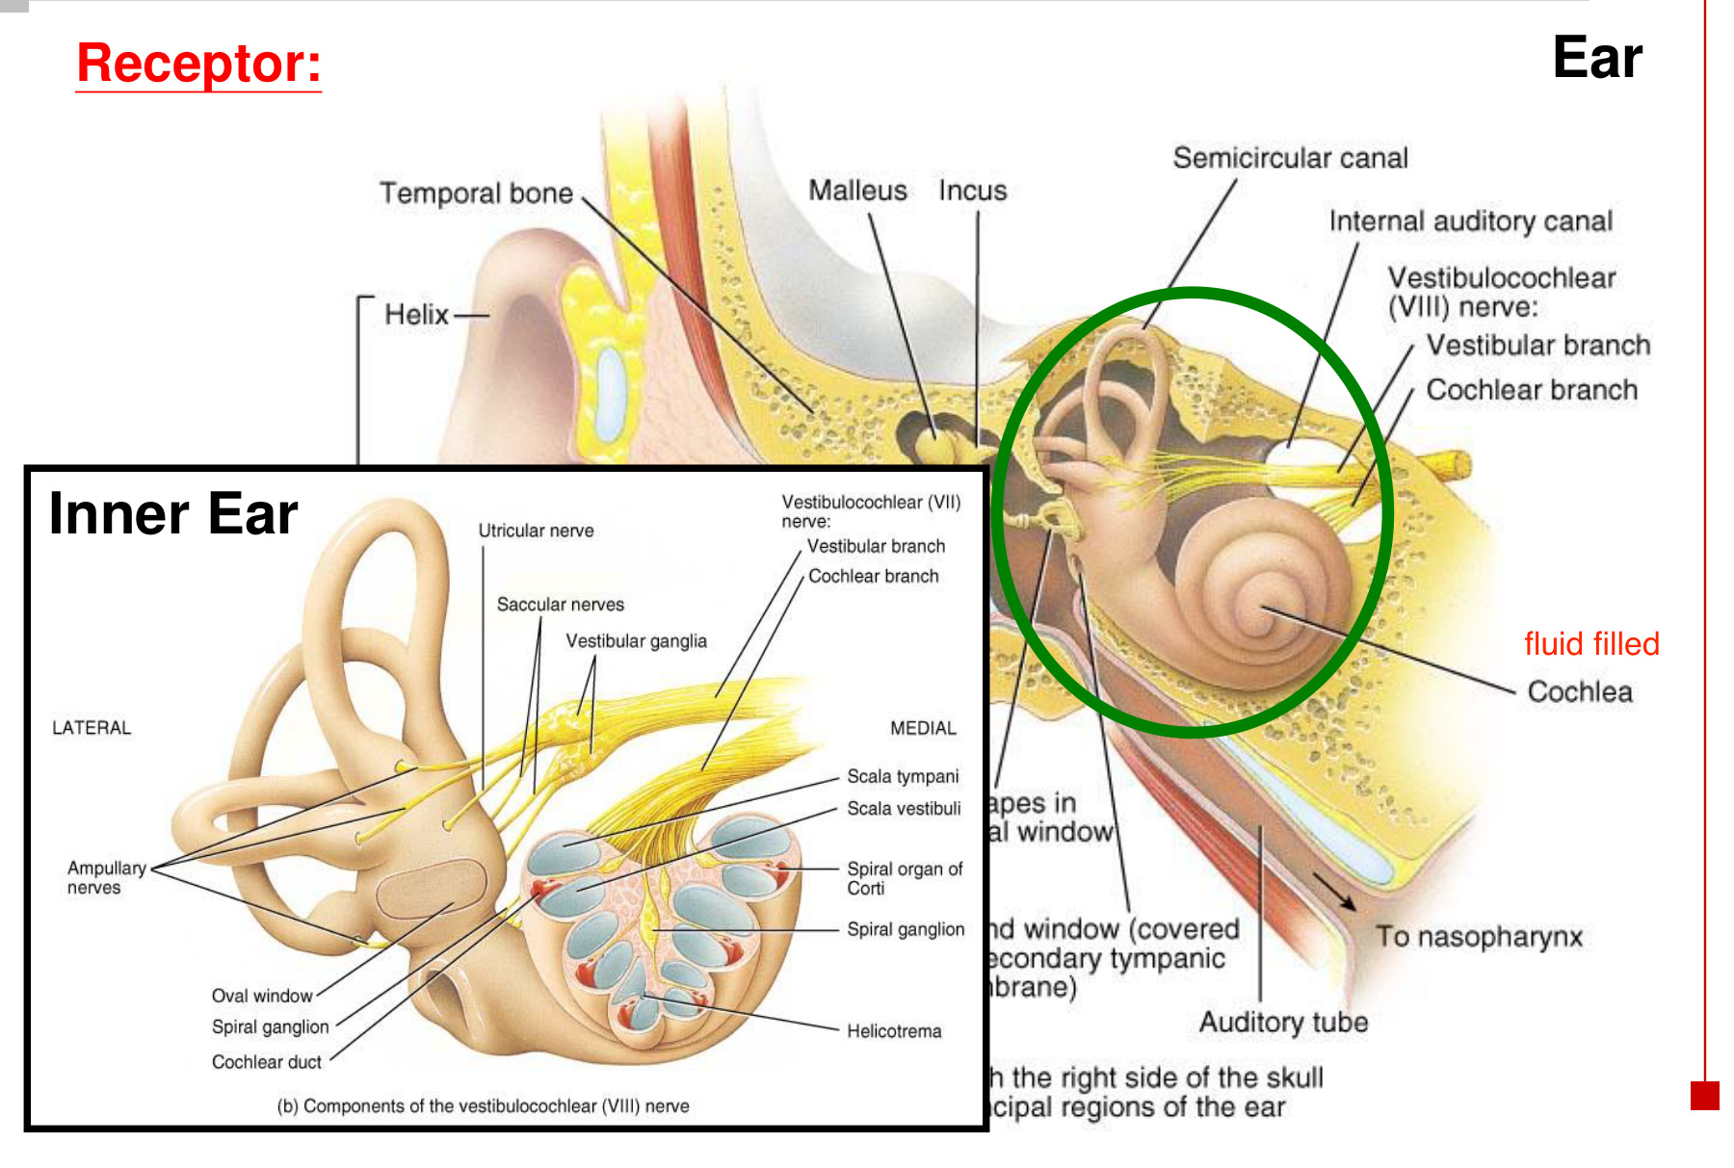  The inner ear is fluid-filled. | 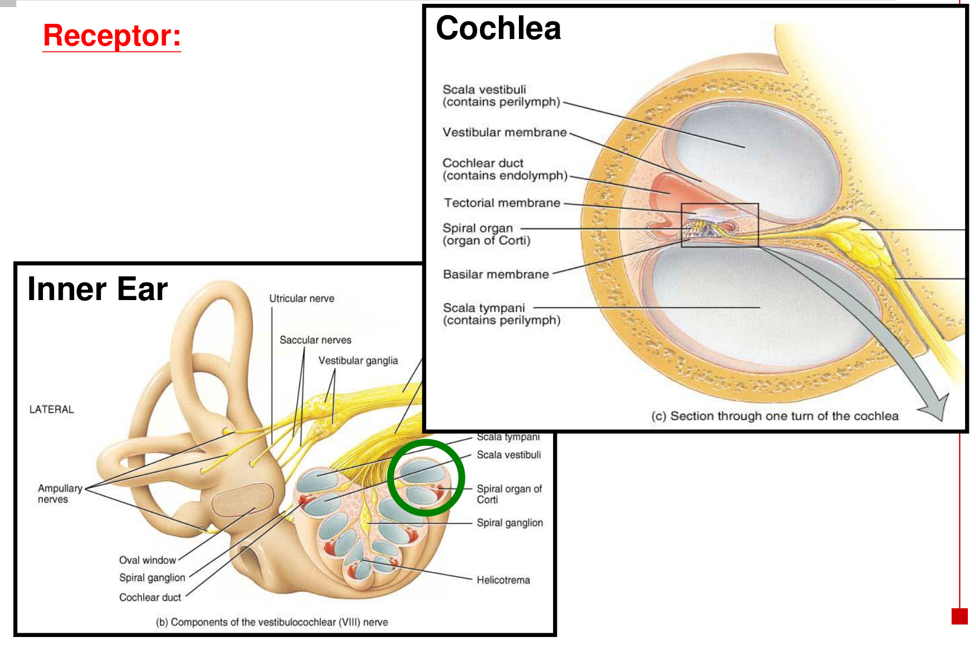  The cochlear cross-section separates three spaces.

Compartment / membrane | Location and role
Scala vestibuli | Upper cochlear compartment; contains perilymph and receives pressure changes transmitted at the oval window.
Cochlear duct / scala media | Middle compartment; contains K⁺-rich endolymph.
Scala tympani | Lower compartment; contains perilymph and communicates mechanically with the round window.
Vestibular membrane | Separates scala vestibuli from the cochlear duct.
Basilar membrane | Separates the cochlear duct from scala tympani; supports the Organ of Corti.
Tectorial membrane | Overlies the hair-cell apparatus; relative motion helps bend hair bundles.
Spiral ganglion / cochlear nerve | Sensory afferent cell bodies and fibres carry cochlear output toward the brainstem.

Perilymph: scala vestibuli + scala tympani.
Endolymph: cochlear duct → high extracellular K⁺ around the hair bundles.

• The cochlea serves hearing; the neighbouring utricle, saccule and semicircular canals serve vestibular sensation.

04 From oval window to the Organ of Corti
Stapes vibrates at the oval window → cochlear fluid-pressure waves
→ displacement of the cochlear partition / basilar membrane
→ movement of the Organ of Corti → hair-bundle deflection

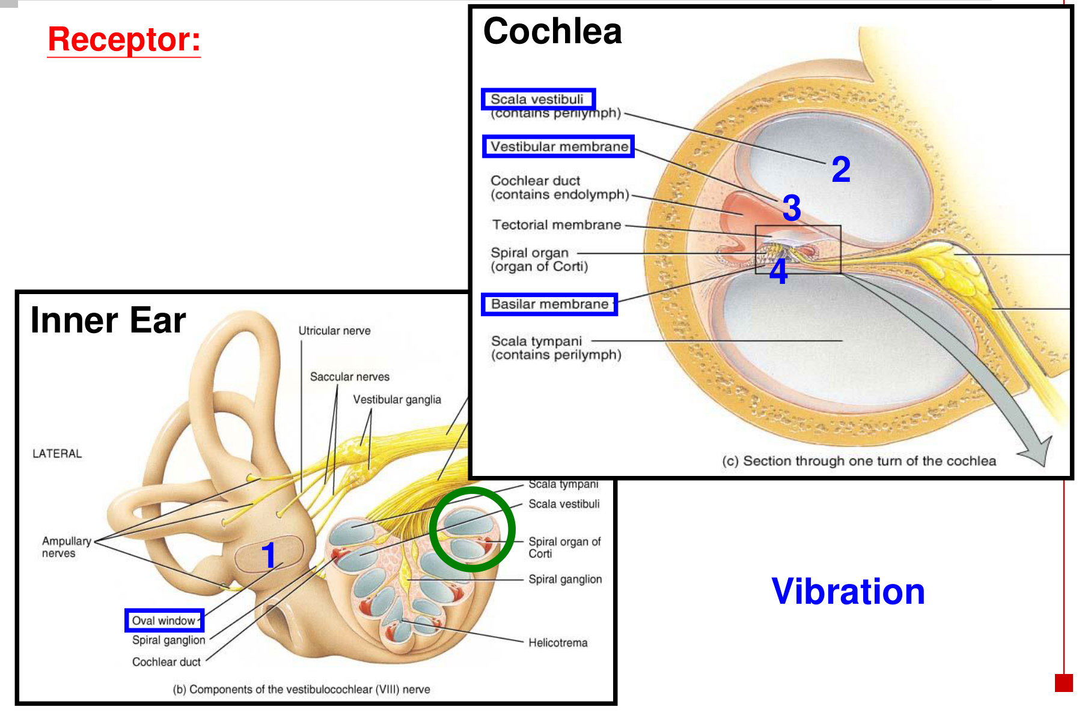
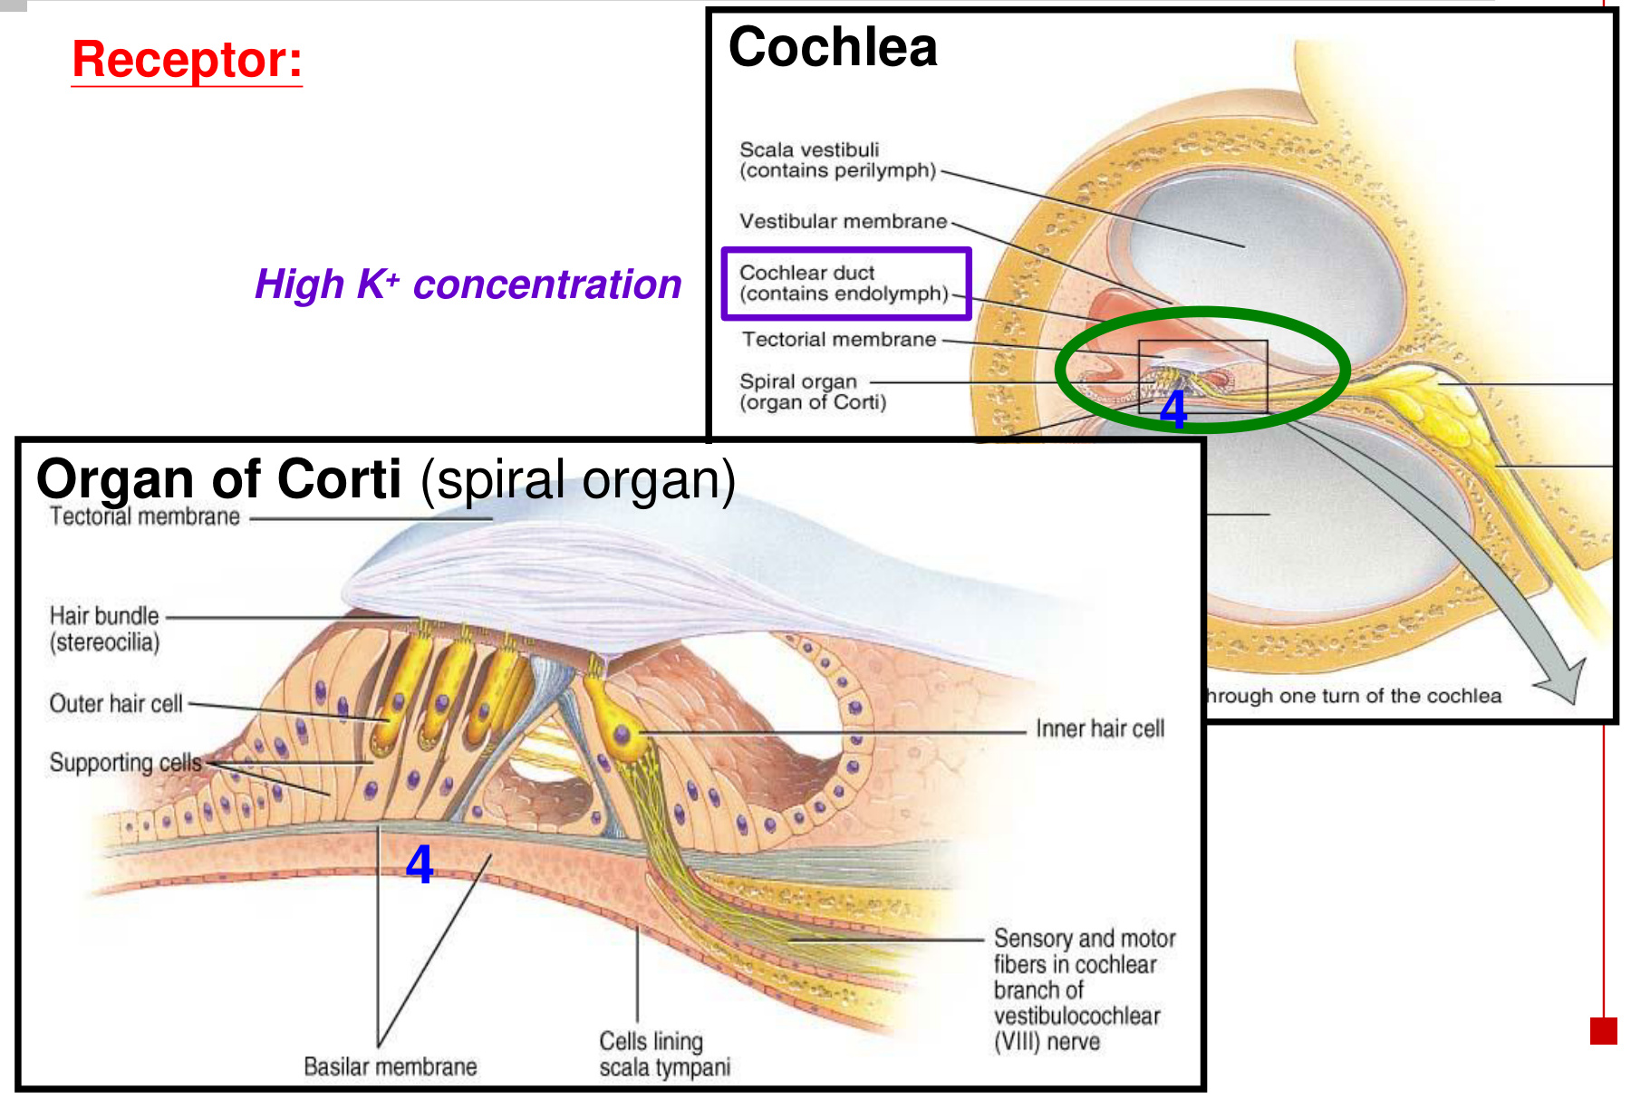
• Organ of Corti = spiral organ, the sensory structure of the cochlea.
• The basilar membrane carries the hair cells; the overlying tectorial membrane moves differently → relative shear stimulates the bundles.
• Pressure waves transfer mechanical energy. Endolymph and perilymph remain in their respective compartments; normal transduction does not require them to mix.

05 Inner vs outer hair cells
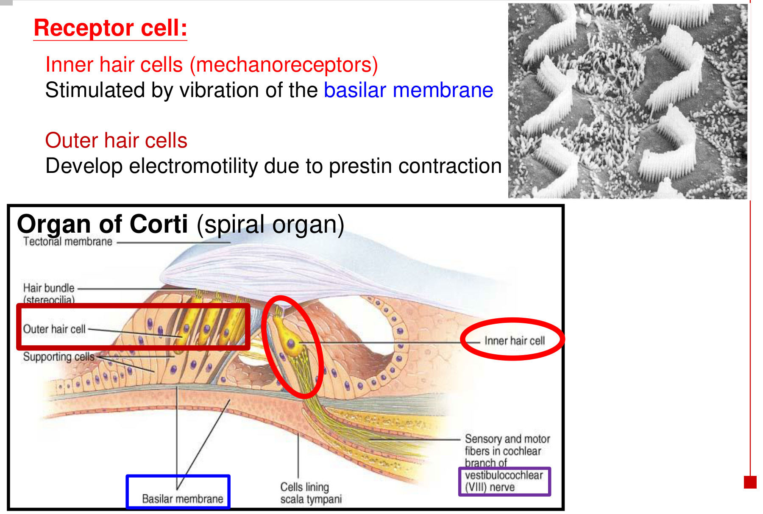
Cell type | Main role
Inner hair cells (IHCs) | Principal sensory receptors for hearing. Basilar-membrane vibration bends the bundle → receptor potential → transmitter release to auditory afferents.
Outer hair cells (OHCs) | Develop electromotility through prestin: voltage-dependent changes in cell length feed mechanical energy back into cochlear motion, enhancing sensitivity and frequency tuning.

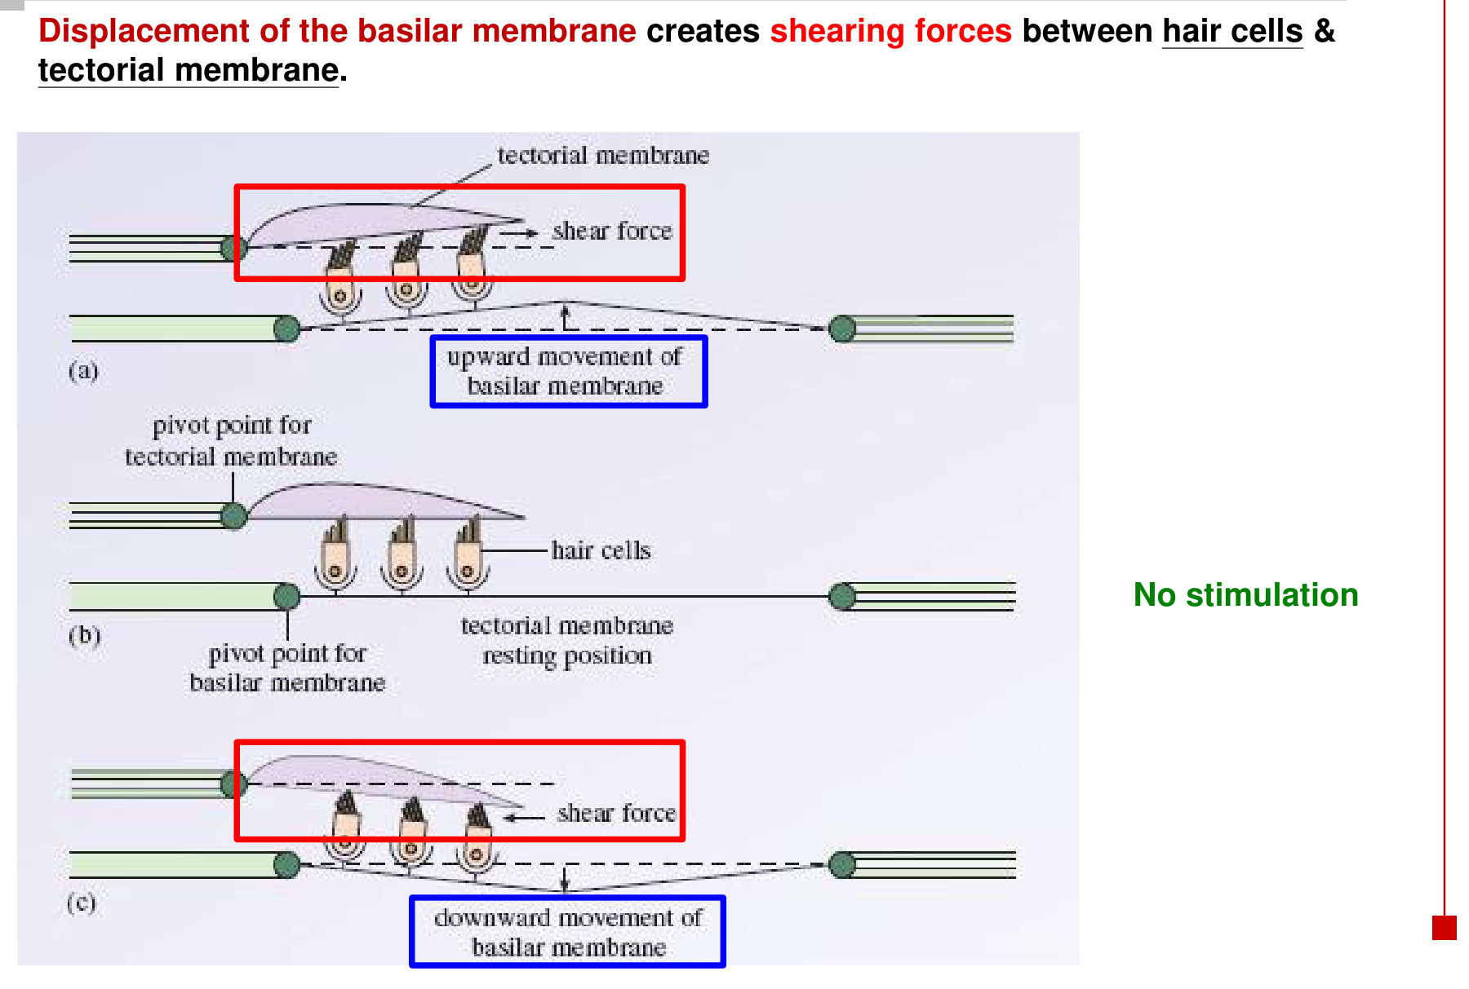
Basilar membrane moves up / down
→ shearing forces between the hair-cell apparatus and tectorial membrane
→ stereocilia deflect → hair-cell electrical activity changes

• The resting position lacks the sound-driven displacement shown by the upward and downward phases; opposite deflections have opposite electrical effects.
• IHCs chiefly encode the sound; OHCs chiefly modify and amplify the mechanics.

06 Hair-cell transduction: K⁺ first, Ca²⁺ next
Excitatory displacement of the stereocilia / hair bundle
→ mechanically gated transduction channels open
→ K⁺ influx from endolymph → hair-cell depolarisation
→ voltage-gated Ca²⁺ channels open → Ca²⁺ influx
→ neurotransmitter release ↑ → auditory afferent firing ↑

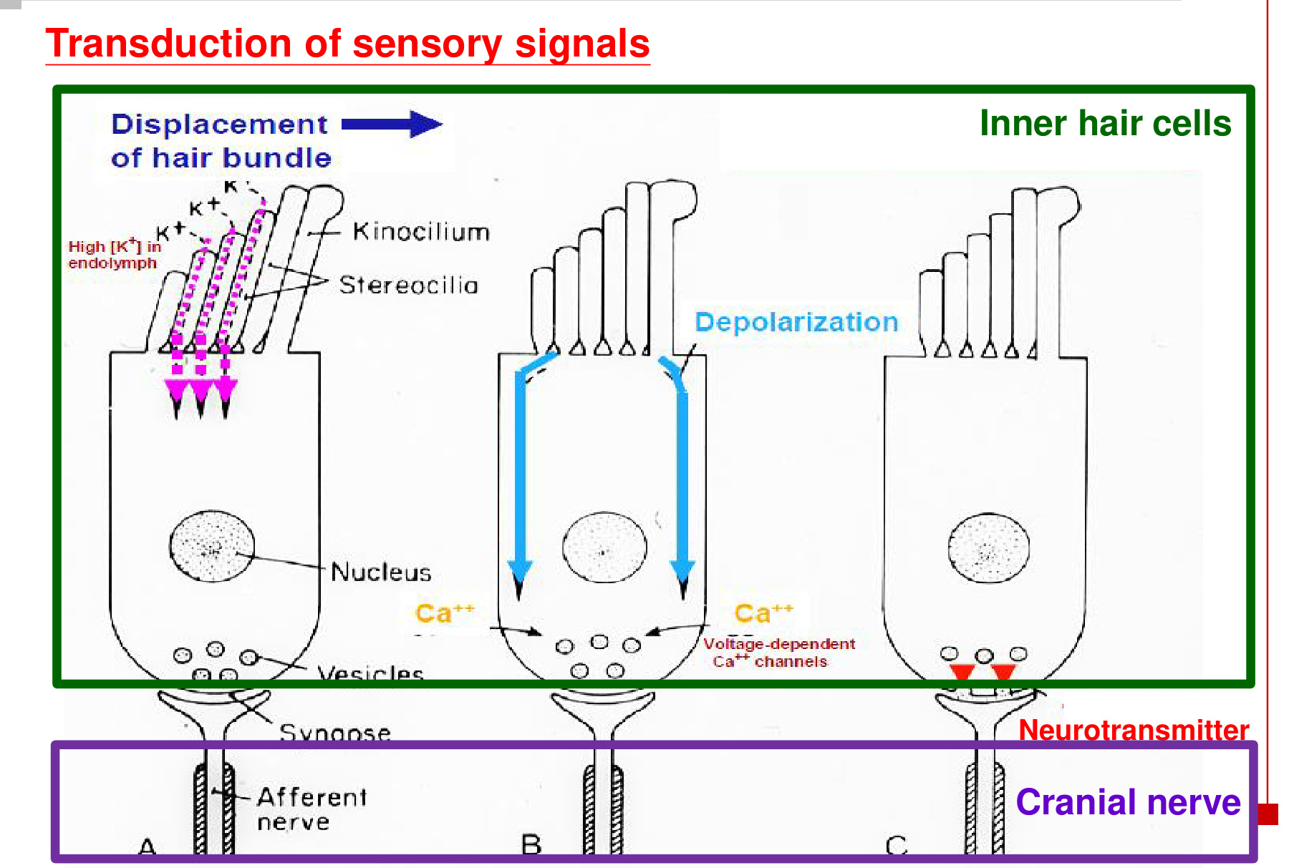
Step | Why it matters
K⁺ entry at the hair bundle | Endolymph is rich in K⁺; the electrochemical gradient favours K⁺ entry into the hair cell. Inward positive charge depolarises it.
Ca²⁺ entry near the synapse | Depolarisation opens voltage-gated Ca²⁺ channels; Ca²⁺ triggers transmitter release.
Hair cell vs nerve fibre | The hair cell produces a graded receptor potential. The afferent nerve produces action potentials.

• An inhibitory bend closes more transduction channels → less inward current → hyperpolarisation and reduced transmitter release.
In mature cochlear hair cells, excitatory bending is toward the tallest stereocilia; vestibular hair cells retain a kinocilium that provides the directional reference.

07 Cochlear tonotopy: frequency selects a place
Region | Basilar-membrane mechanics | Peak response
Base | Narrow and stiff; near the oval window. | High frequencies
Apex | Wide and floppy / compliant; toward the cochlear tip. | Low frequencies

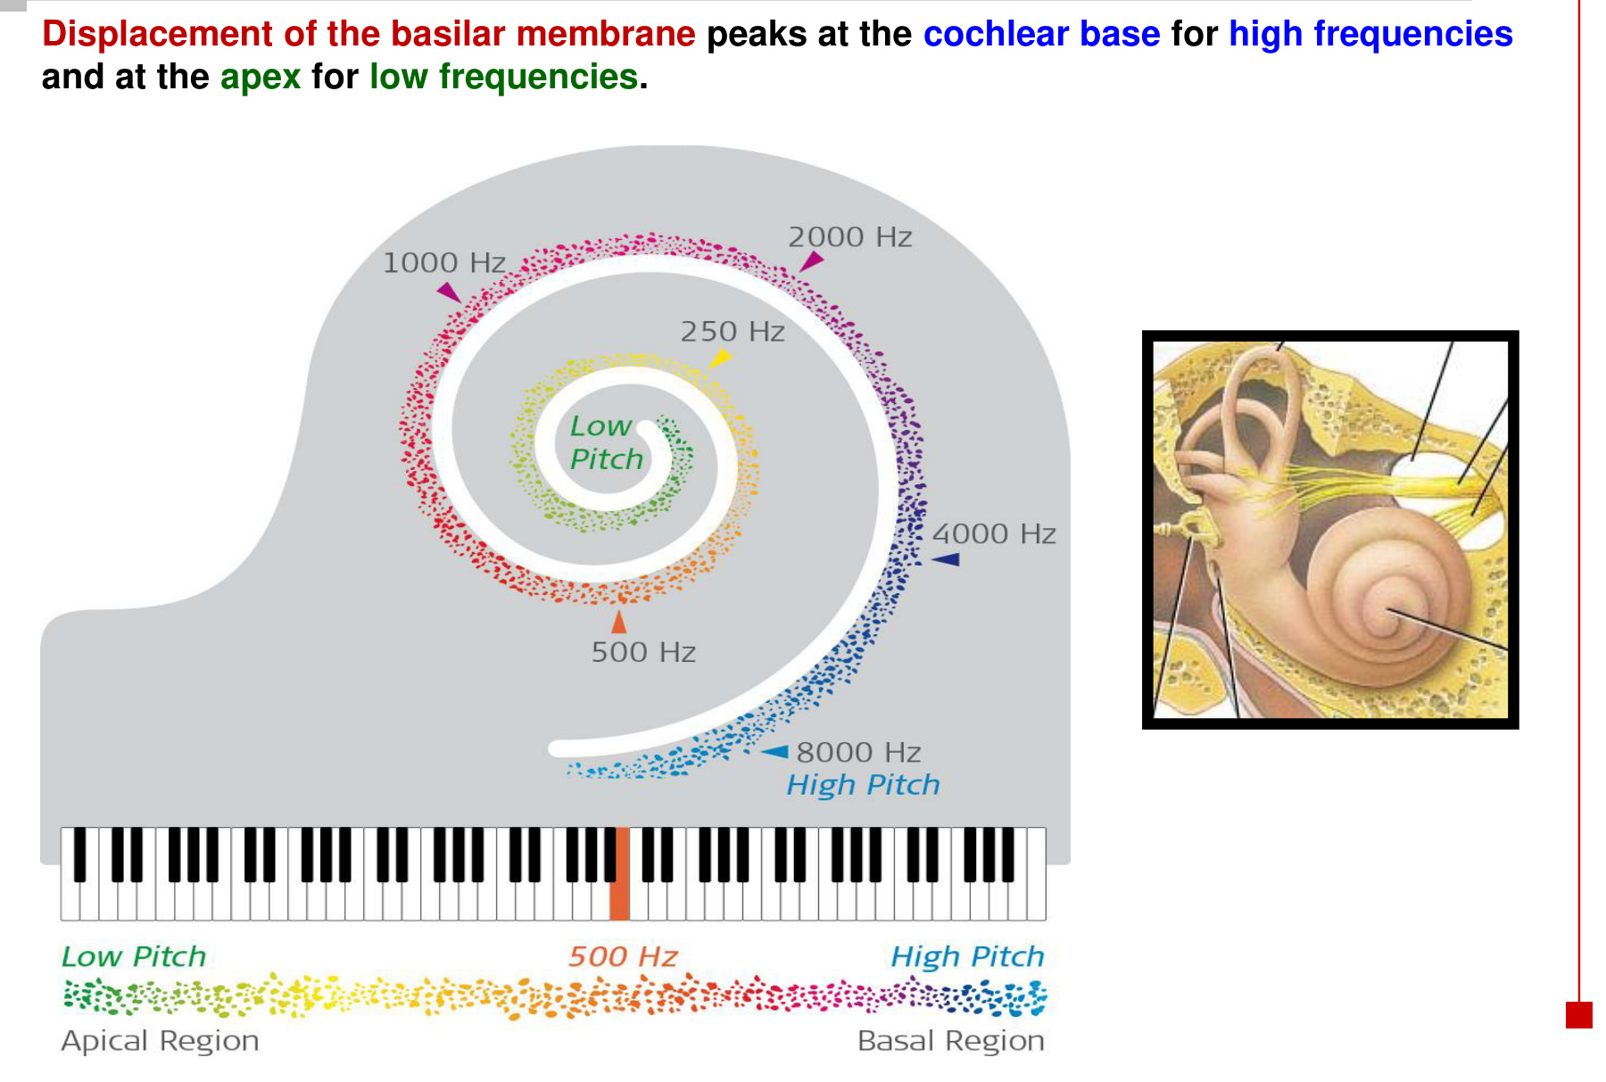  A spatial frequency map follows the cochlear spiral. | 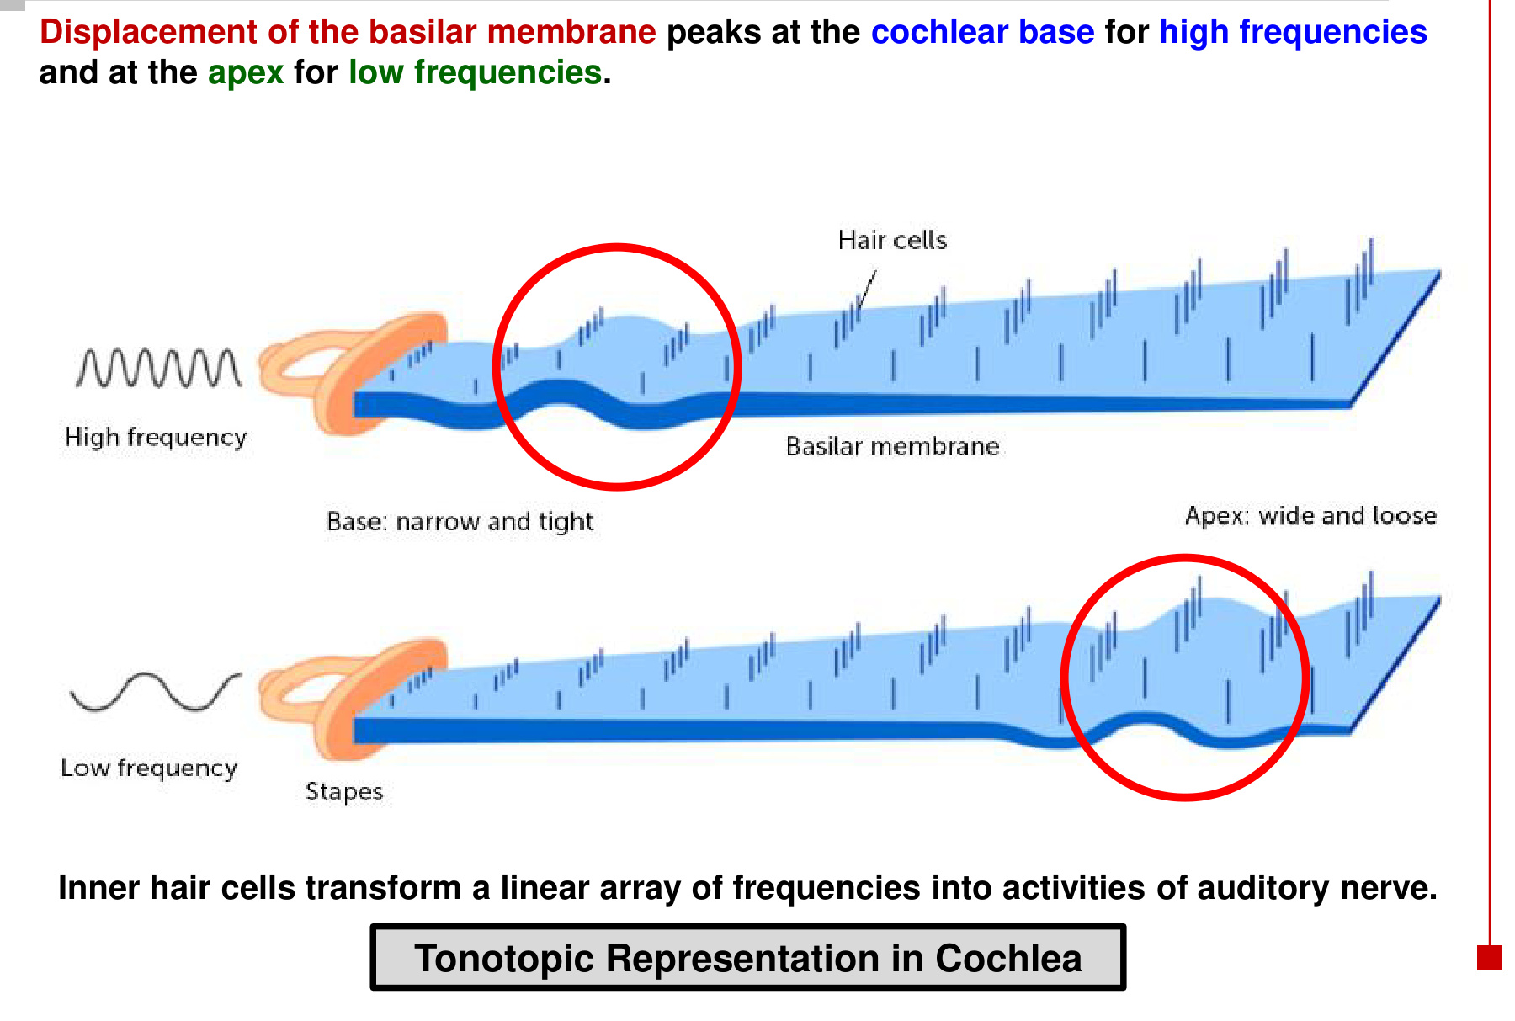  High and low frequencies peak at different positions.

Sound frequency → location of maximum basilar-membrane displacement
→ local inner hair cells are most strongly stimulated
→ activity in corresponding auditory nerve fibres

• Inner hair cells transform a linear array of frequencies into auditory nerve activity.
• High-frequency sound peaks near the stiff base; lower-frequency waves reach their greatest displacement farther toward the compliant apex.
• The frequency map is continuous: intermediate frequencies peak at intermediate locations.
Base = high pitch. Apex = low pitch.
This is tonotopic organisation: frequency is mapped onto position.

08 Auditory pathway: cochlea to temporal cortex
Inner hair cells → cochlear branch of CN VIII → cochlear nuclei
→ superior olivary complex → lateral lemniscus / its nuclei
→ inferior colliculus → medial geniculate nucleus (MGN) of the thalamus
→ auditory cortex in the temporal lobe

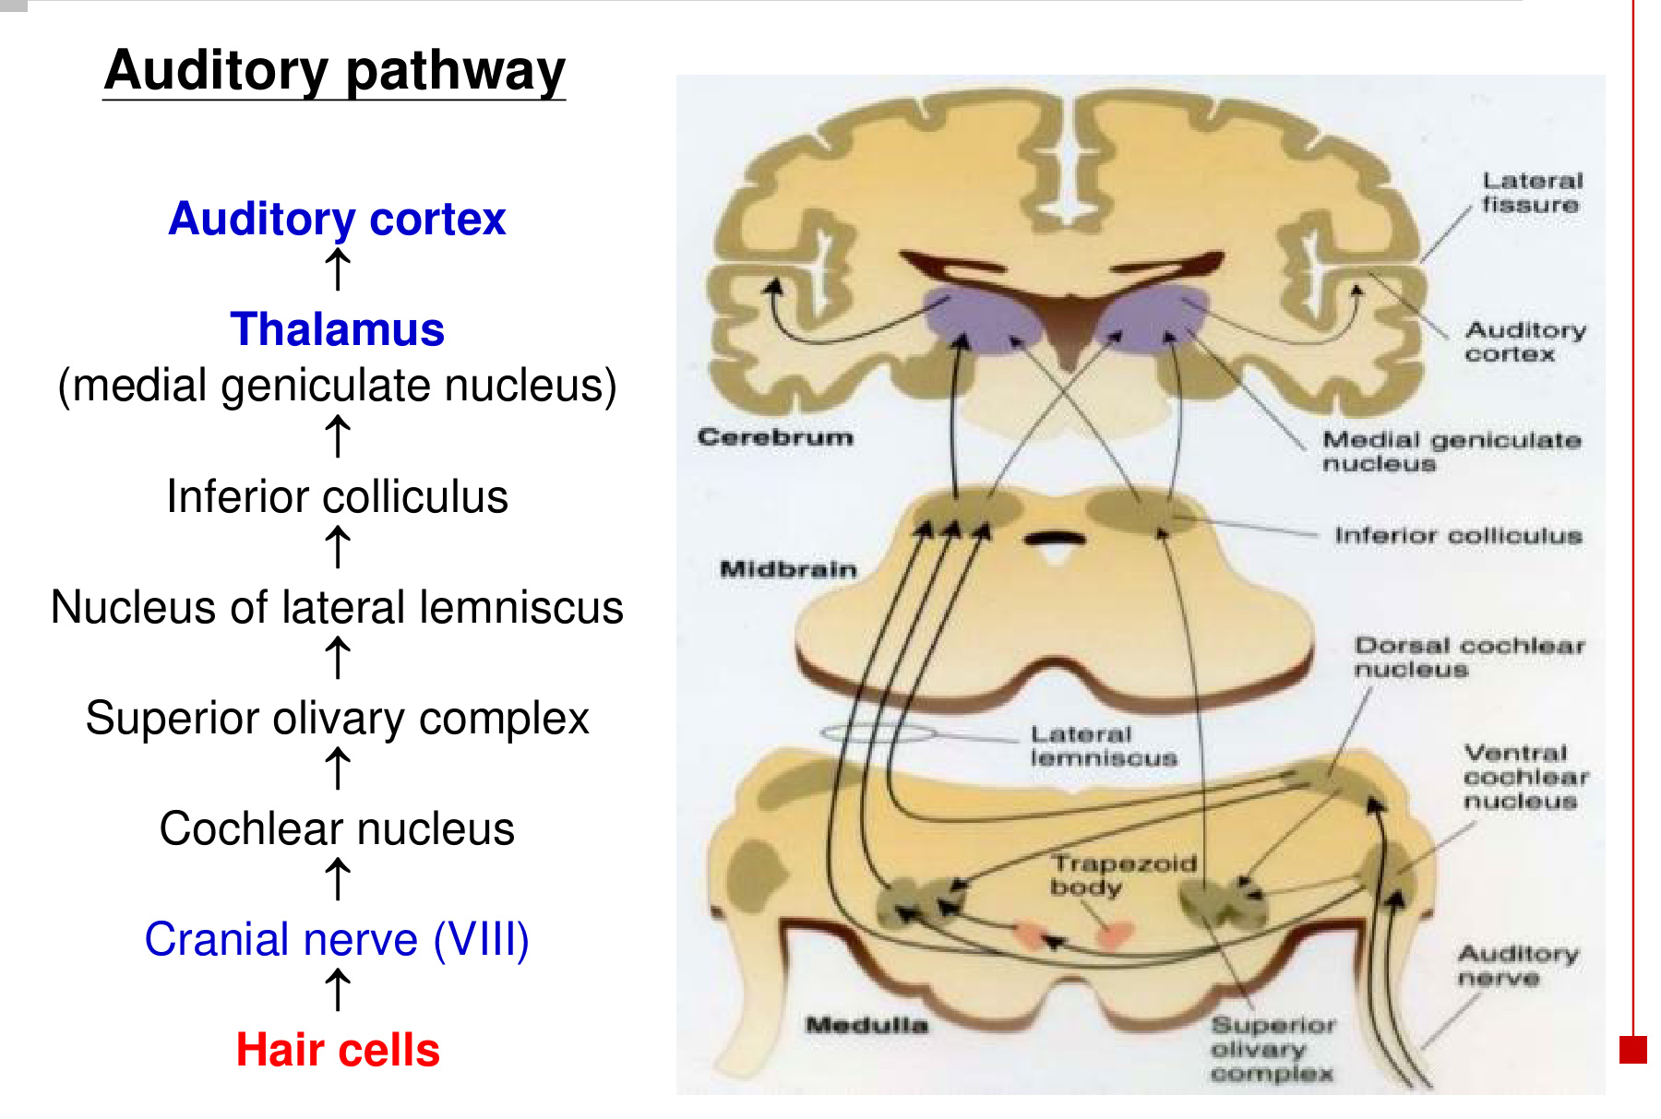  Brainstem relays → thalamus → cortex | 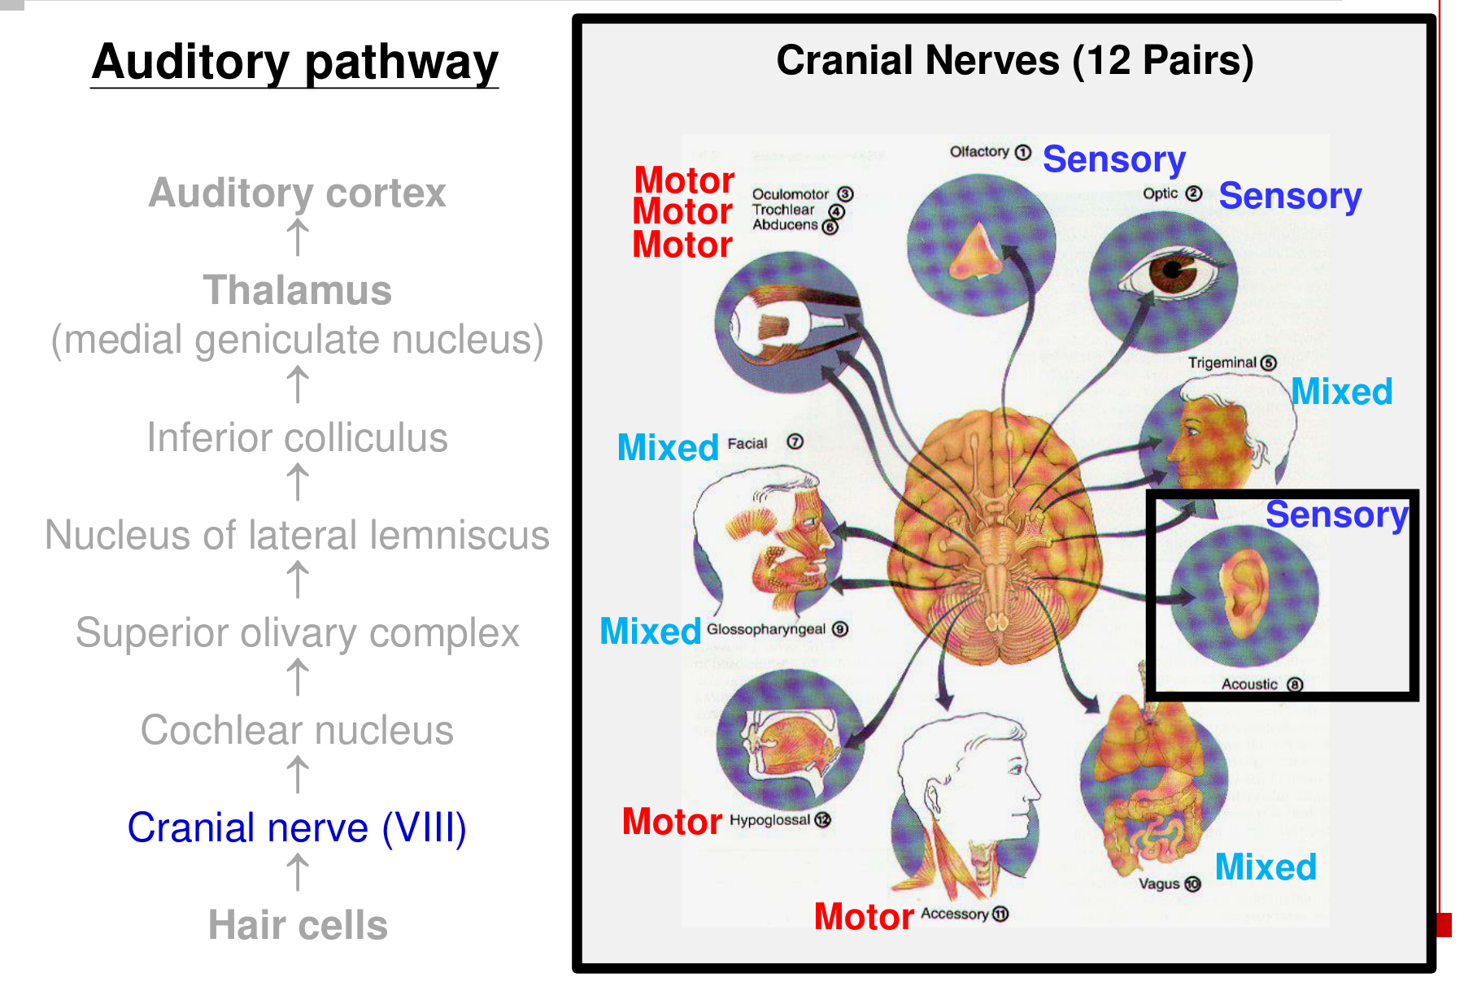  CN VIII carries sensory information.

Relay / structure | Location or role
Cochlear nuclei | First central auditory relay in the brainstem; dorsal and ventral divisions.
Superior olivary complex | Compares information from the two ears.
Lateral lemniscus | Ascending auditory pathway with associated relay nuclei.
Inferior colliculus | Midbrain auditory relay.
MGN | Thalamic auditory relay → auditory cortex.
Auditory cortex | Temporal lobe; cortical processing of sound.

• Ascending auditory pathways have extensive bilateral connections after the cochlear nuclei; the diagram includes crossing fibres and the trapezoid body.

09 Tonotopy continues into the brain
Cochlear frequency map → auditory nerve activity
→ similarly tuned neurons cluster together at successive relays
→ organised frequency representation in the auditory cortex

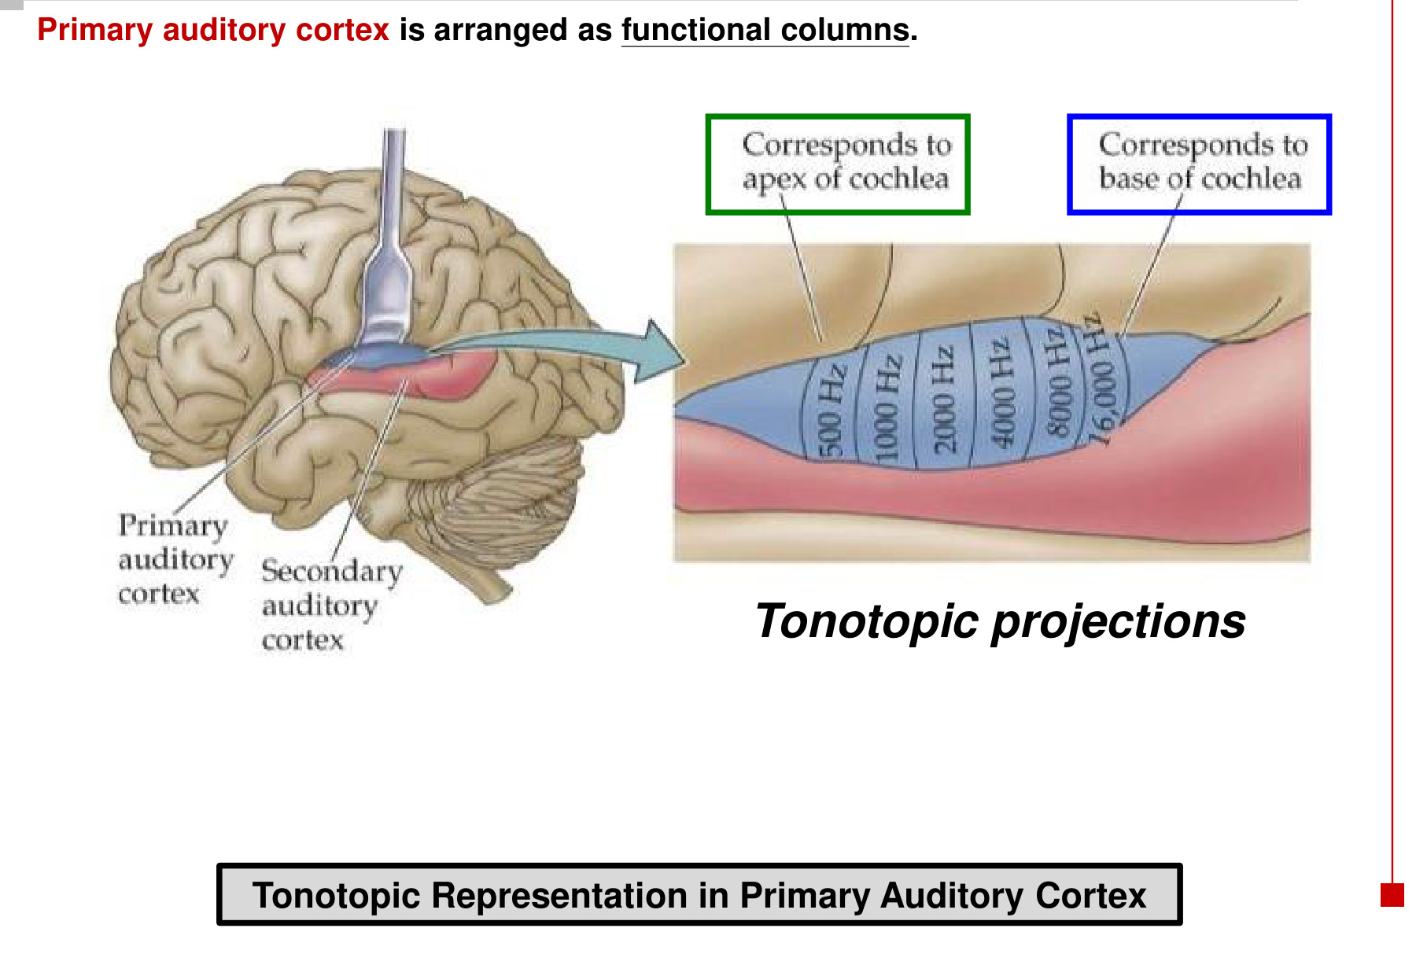
Level | Organising rule
Cochlea | Basilar-membrane position determines the frequency producing peak displacement.
Ascending auditory relays | Neurons sensitive to similar frequencies remain clustered together.
Primary auditory cortex | Arranged as functional columns according to a sound-frequency map.

• Regions representing the cochlear apex process relatively lower frequencies; those representing the base process relatively higher frequencies.
• Primary and secondary auditory cortex are neighbouring temporal-lobe processing regions.
Tonotopic organisation = an orderly map of sound frequency.
Retinotopic organisation = an orderly map of visual space.

10 Binaural processing: where is the sound?
Sound reaches the two ears → auditory signals compared
→ superior olivary complex detects inter-aural differences
→ binaural sound processing → lateralisation

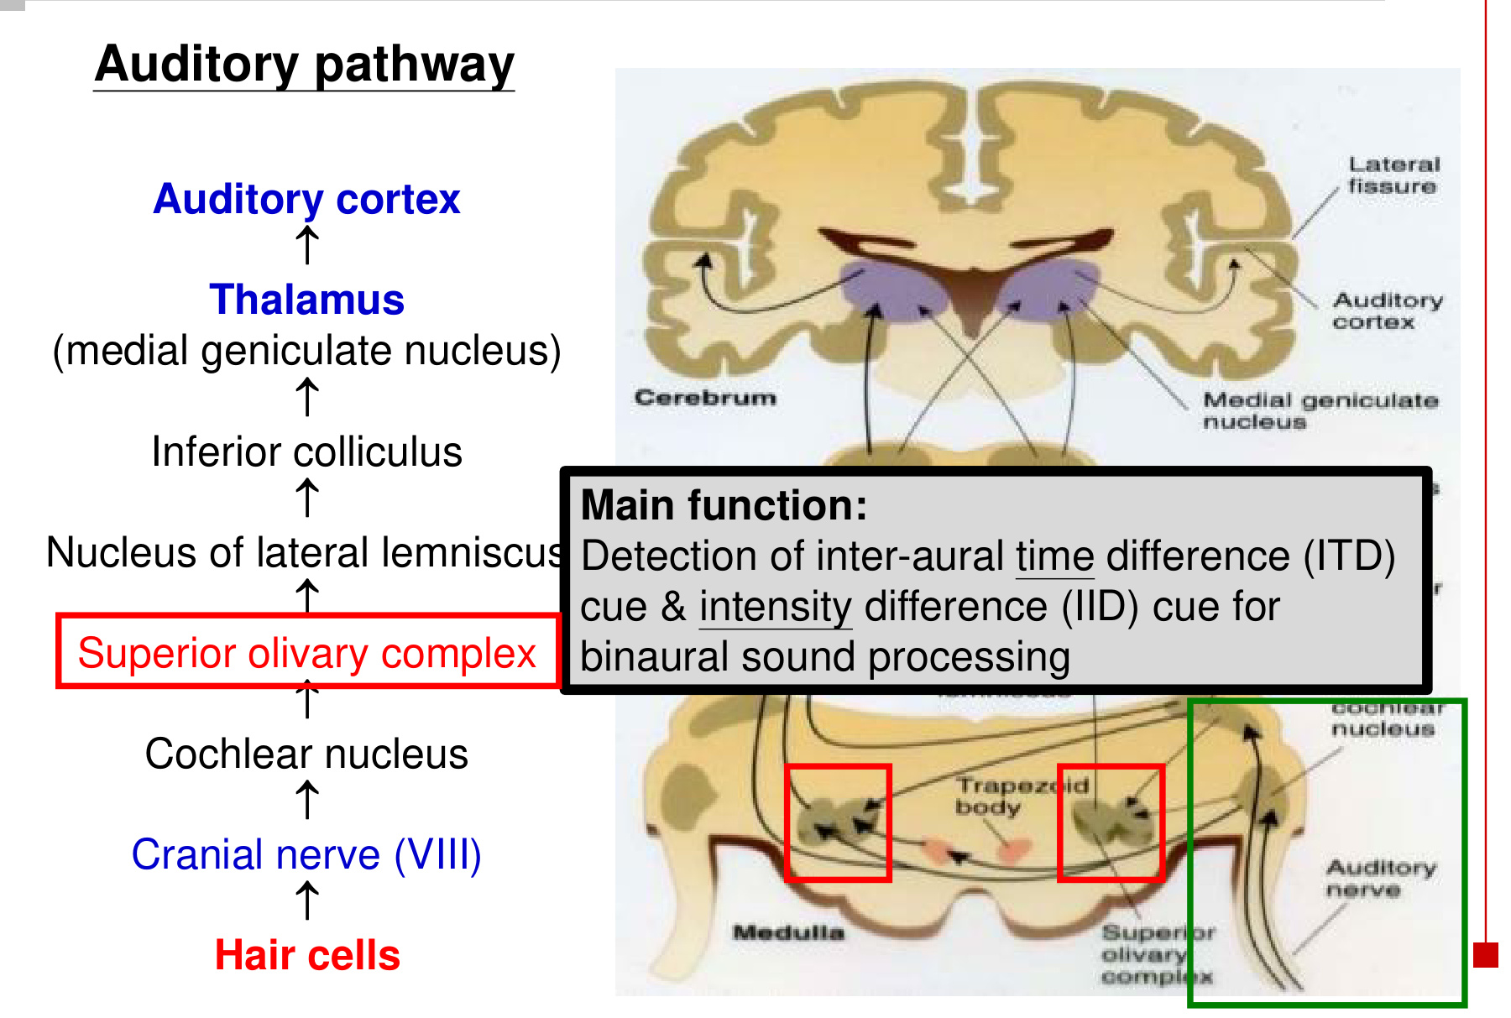
Cue | What is compared? | Example: a source on the left
ITD  Inter-aural time difference | Arrival time of sound at the two ears. | Sound reaches the left ear earlier than the right.
IID  Inter-aural intensity difference | Sound intensity at the two ears. | Sound is often stronger at the nearer left ear; the head reduces sound reaching the opposite ear.

• “Binaural” means using both ears. “Lateralisation” identifies the side from which a sound comes.
• ITD and IID help identify location; tonotopy identifies frequency. These are different features of the same sound.

11 Vestibular apparatus: organs & stimuli
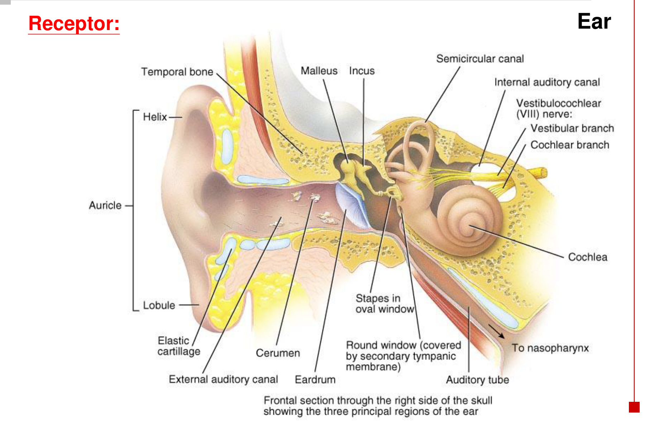  The vestibular receptors are in the inner ear. | 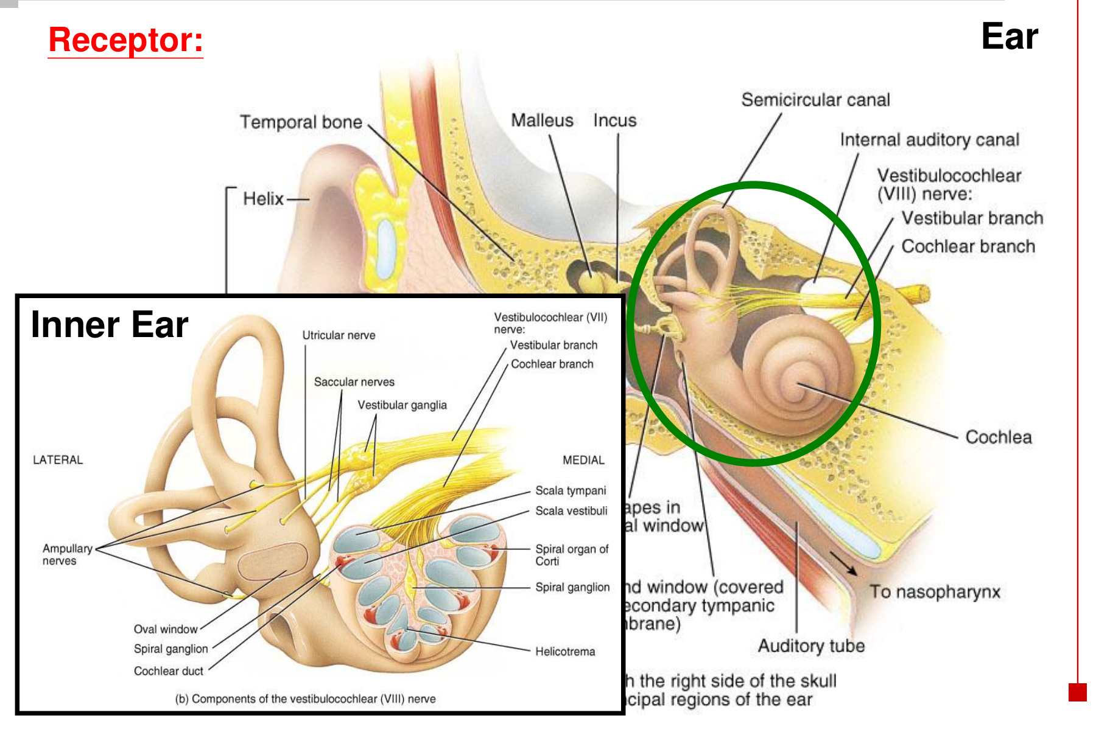  Vestibular and cochlear apparatus lie together.

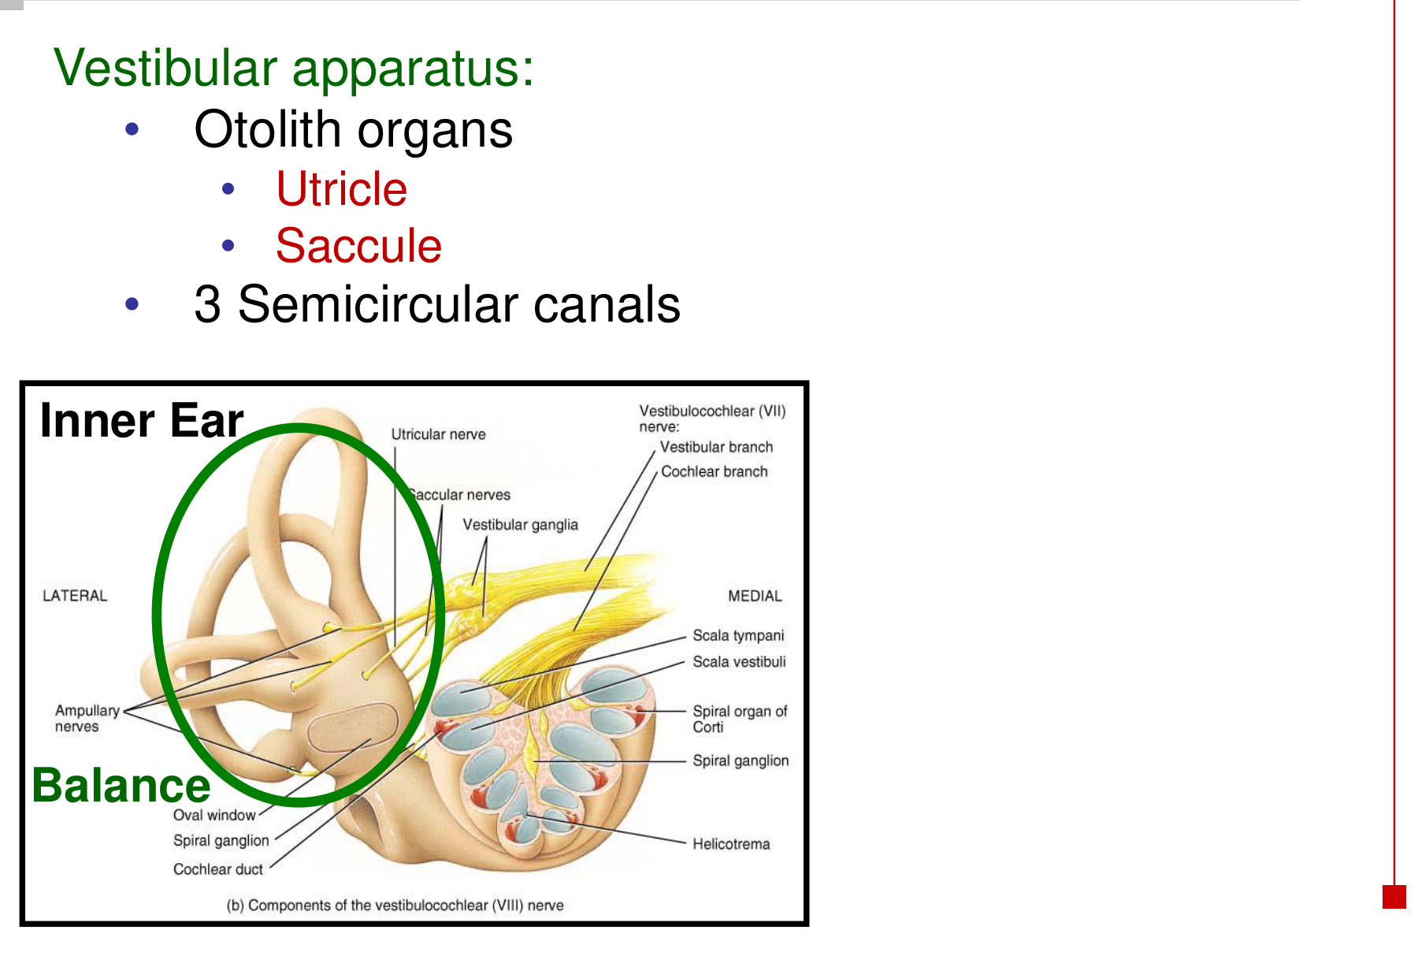  Two otolith organs + three semicircular canals | 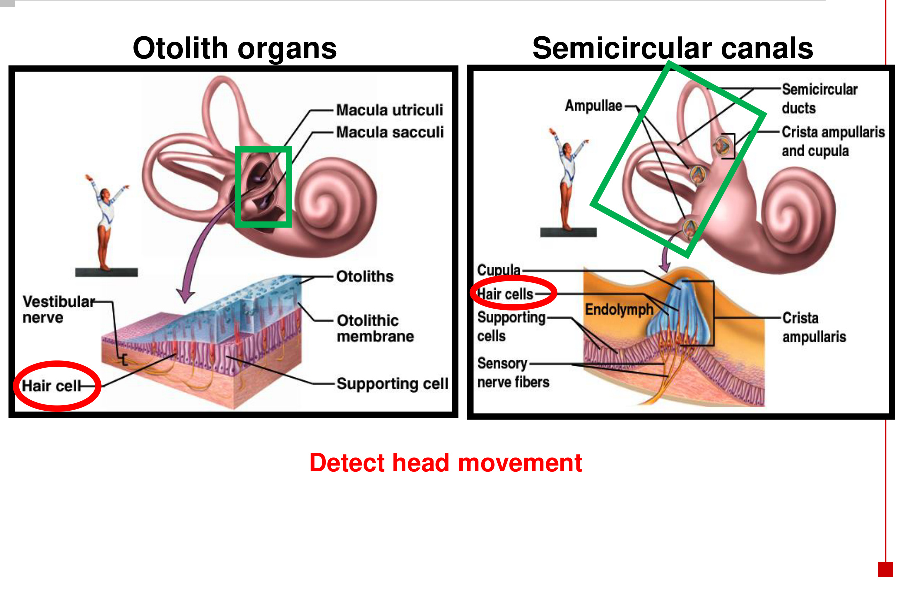  Different mechanical structures detect different movements.

Structure | Main stimulus | Receptor site
Utricle | Horizontal linear acceleration; head tilt. | Macula within an otolith organ.
Saccule | Vertical linear acceleration; head tilt. | Macula within an otolith organ.
Three semicircular canals | Angular acceleration / changes in head rotation. | Crista ampullaris within an ampulla.

Head movement → hair-cell deflection
→ vestibular branch of CN VIII → brainstem vestibular processing

• Both systems use mechanoreceptor hair cells; their surrounding structures determine which movement bends the bundles.

12 Otolith organs: macula, gel & crystals
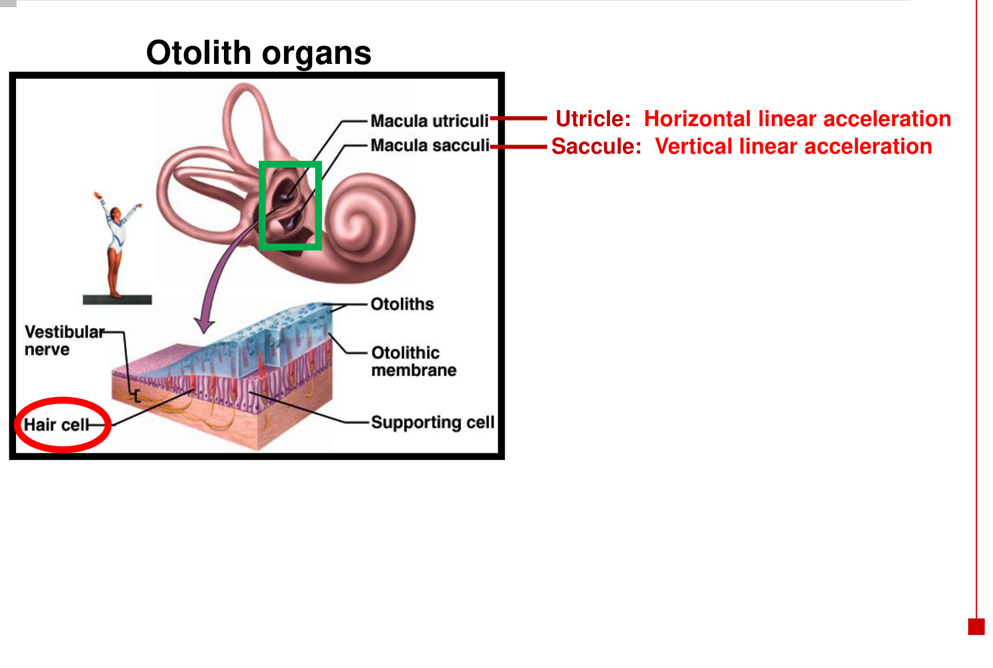  Utricle and saccule detect linear acceleration. | 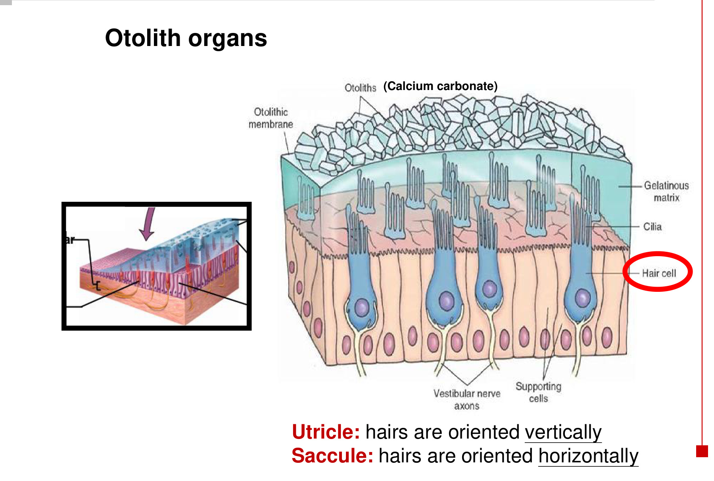  Calcium carbonate crystals add mass to the membrane.

Component | Structure → mechanical role
Macula | Sensory patch containing vestibular hair cells and supporting cells.
Otolithic membrane | Gelatinous matrix over the hair cells; hair bundles project into it.
Otoliths / otoconia | Calcium carbonate crystals on the matrix → add mass and make it responsive to inertia and gravity.
Utricular orientation | Macula is mainly horizontal in an upright head; bundles project mainly vertically → sensitive to horizontal shear / linear acceleration.
Saccular orientation | Macula is mainly vertical; bundles project mainly horizontally → sensitive to vertical shear / linear acceleration.

Hair-bundle orientation is not the same as the acceleration detected.
Movement of the overlying membrane bends the bundle sideways.

• The utricle and saccule also indicate head orientation relative to gravity.

13 Vestibular hair cells: direction changes firing
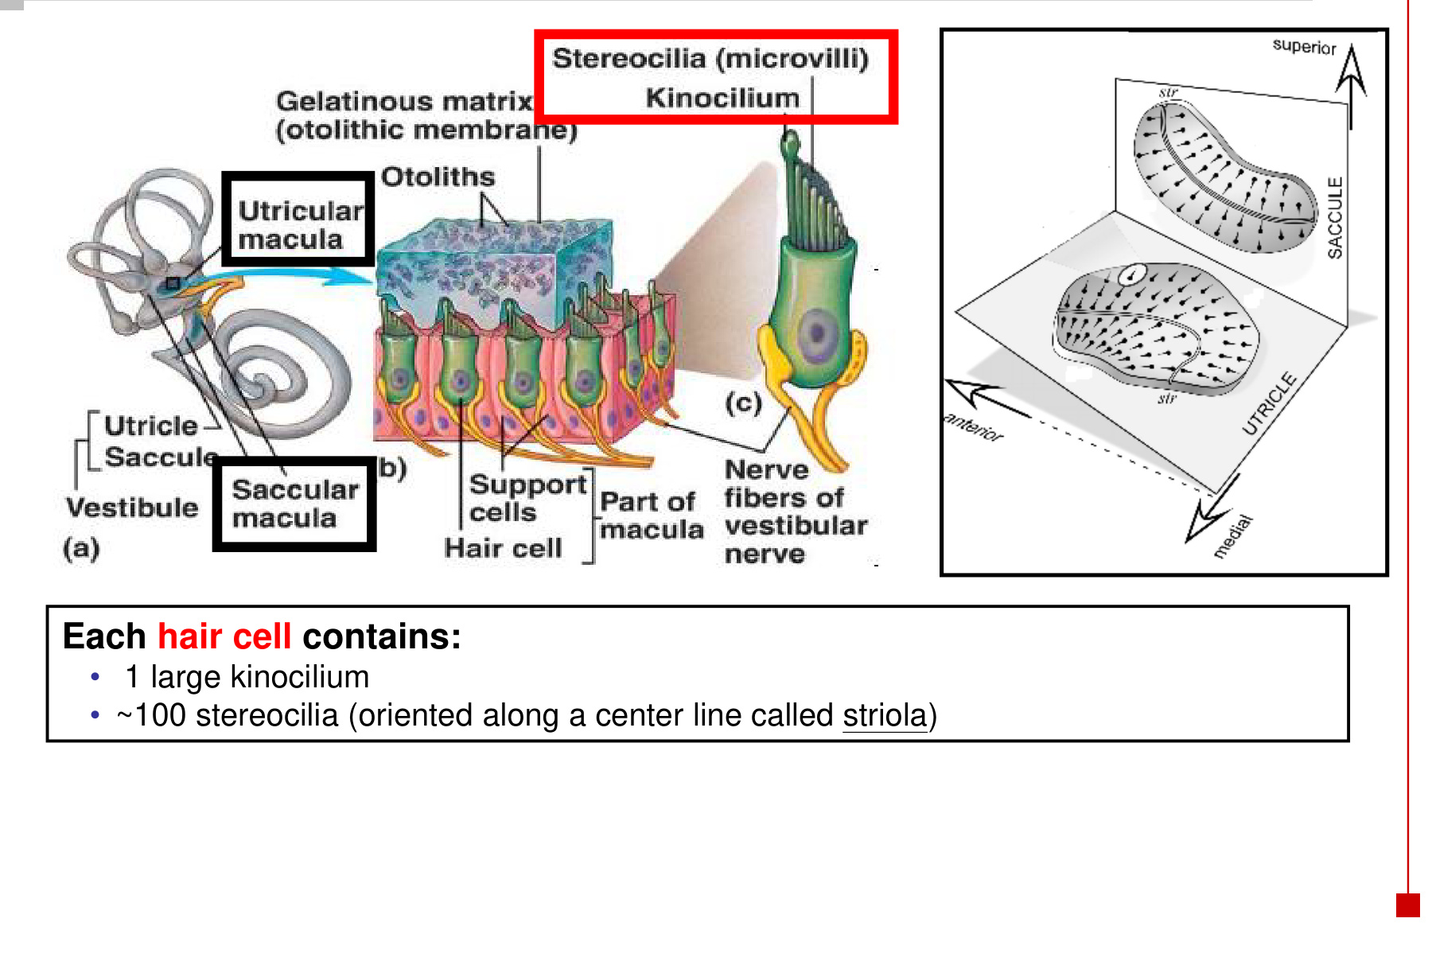  Hair bundles and macular orientation | 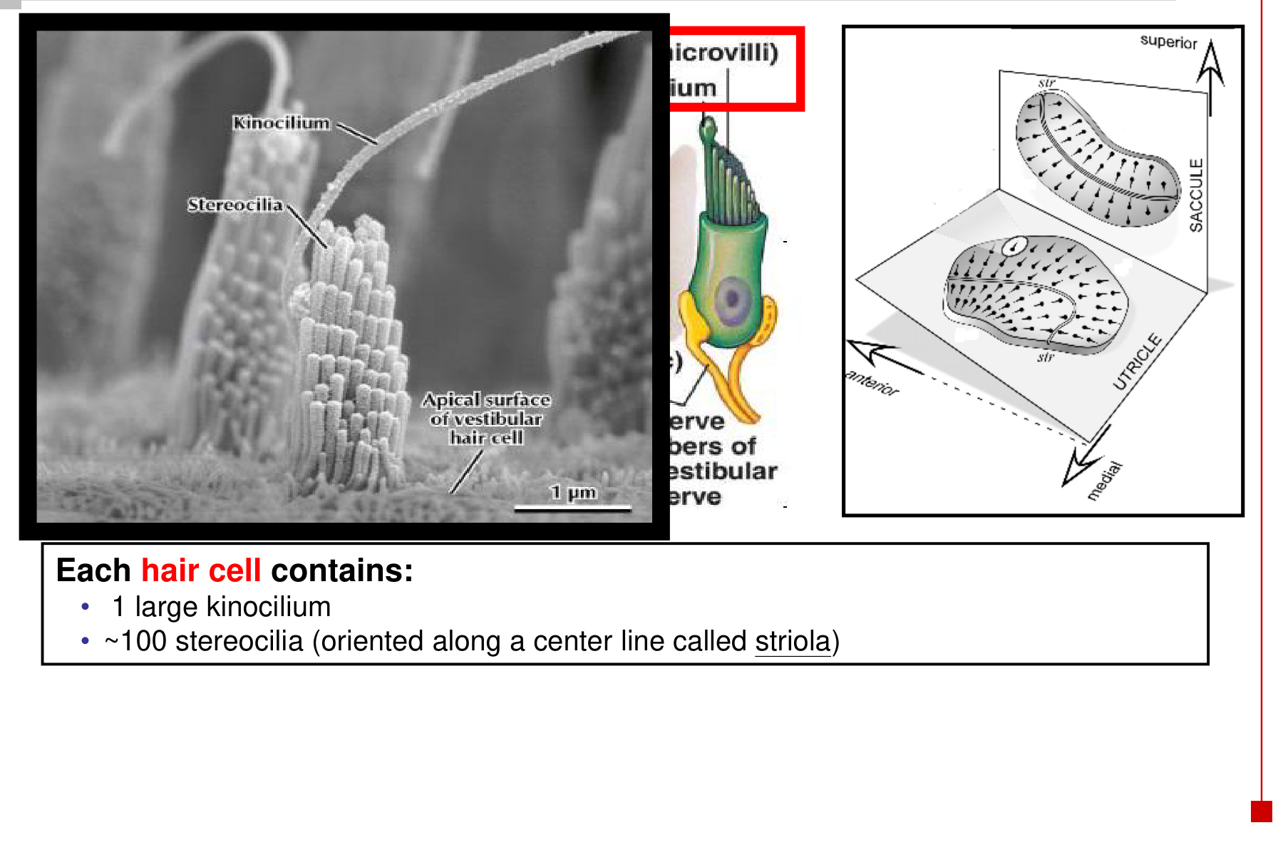  A kinocilium lies beside the stereocilia.

• A vestibular hair cell has one large kinocilium and approximately 100 stereocilia. Stereocilia are specialised microvillus-like projections.
• The striola is a curved reference line across the macula. Hair-cell polarities vary across it, allowing the organ to encode different directions.
Bundle deflection | Hair-cell response | CN VIII vestibular afferent
Toward the kinocilium | Mechanotransduction-channel opening ↑ → inward current ↑ → depolarisation → transmitter release ↑ | Firing rate ↑
Away from the kinocilium | Channel opening ↓ → inward current ↓ → hyperpolarisation → transmitter release ↓ | Firing rate ↓
Resting position | Intermediate receptor activity and tonic transmitter release. | Baseline firing allows increases AND decreases to signal direction.

Toward → depolarise → fire more.
Away → hyperpolarise → fire less.

• The receptor potential is produced by the hair cell; action-potential frequency changes in the associated vestibular nerve fibre.

14 Otolith mechanics: acceleration & tilt
Linear acceleration: head and macula move
→ inertia makes the heavy otolithic membrane lag relative to them
→ shearing force bends hair bundles toward / away from the kinocilium
→ receptor potential changes → vestibular afferent firing changes

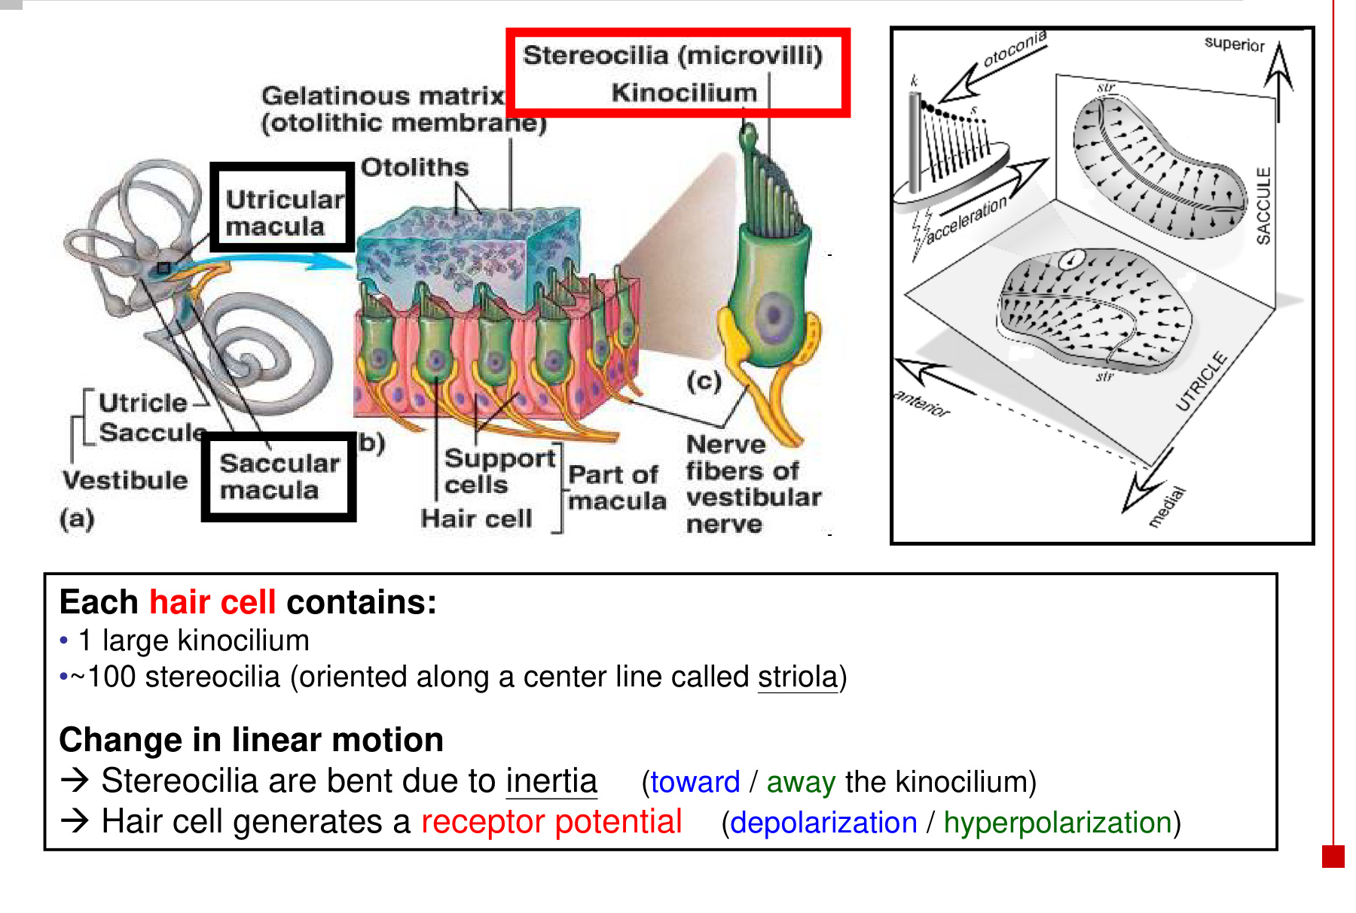
Head tilt: direction of gravity relative to the macula changes
→ weighted otolithic membrane shifts → sustained bundle deflection
→ information about head orientation relative to gravity

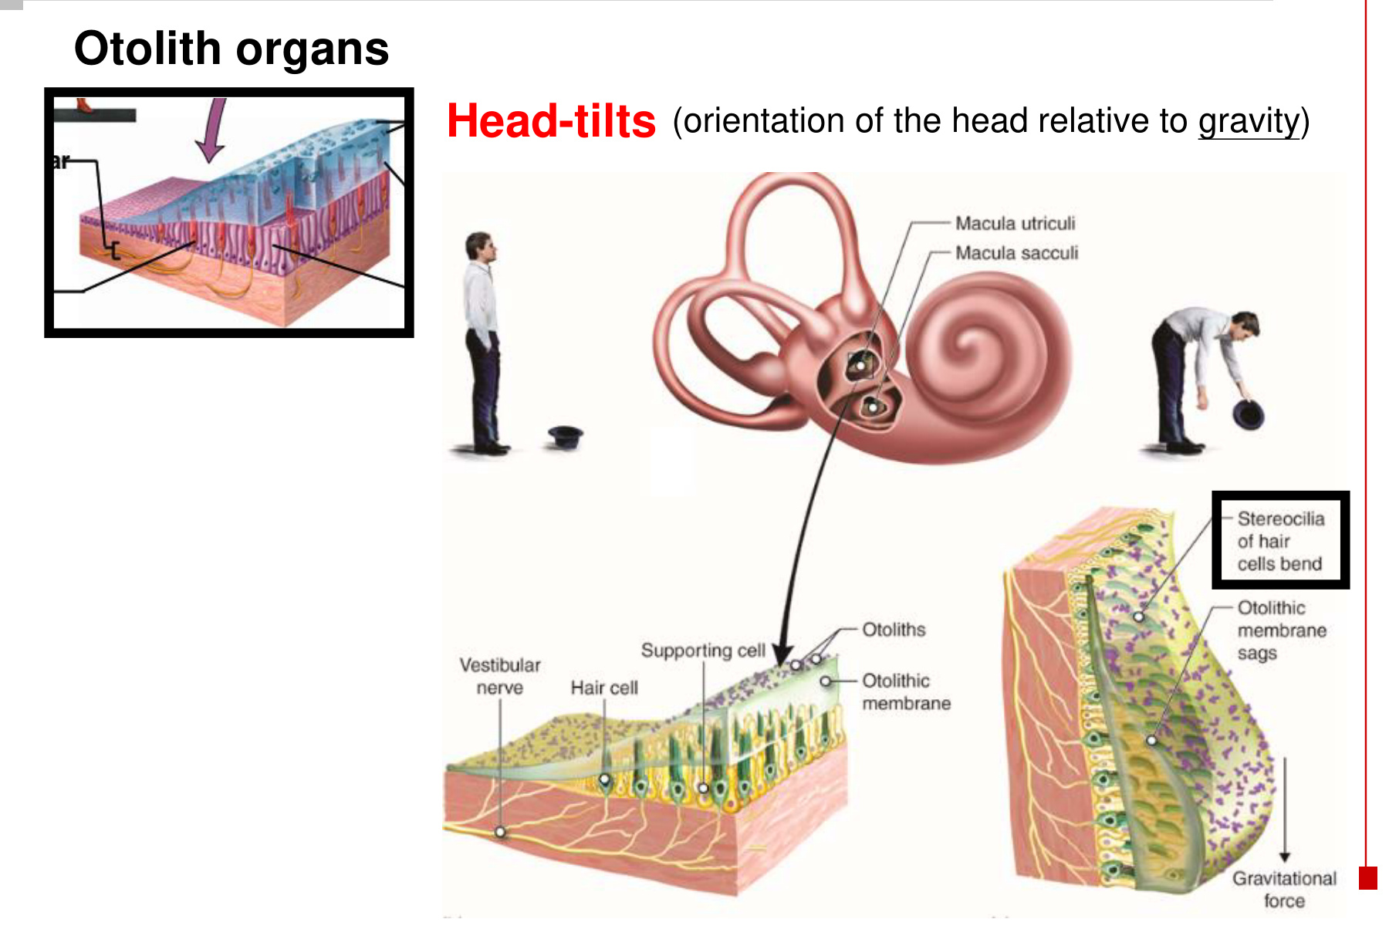  Gravity shifts the weighted membrane when the head tilts. | 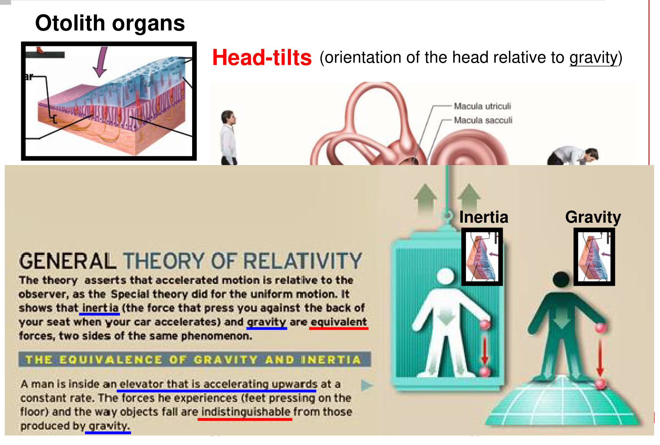  Gravity and linear acceleration can produce similar forces.

• Inertia describes resistance to a change in motion; the relative lag creates shear during acceleration.
• Gravity can create shear during a maintained tilt even without ongoing translation.
• Otolith signals alone can be ambiguous between tilt and translation. The brain combines them with canal, visual and body-position information.

15 Semicircular canals: rotation & inertia
Head angular acceleration → canal moves with the skull
→ endolymph initially lags because of inertia
→ cupula deflects → stereocilia bend toward / away from kinocilium
→ hair-cell depolarisation / hyperpolarisation
→ vestibular CN VIII firing increases / decreases

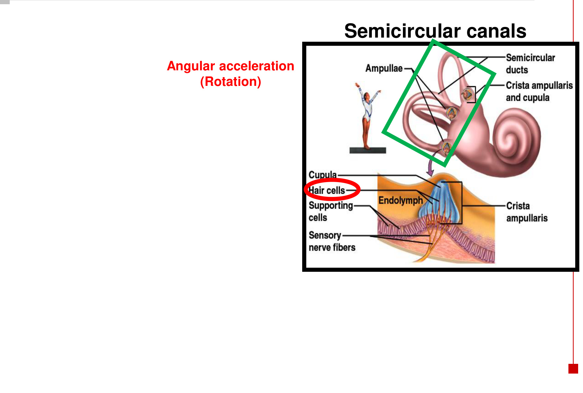  Semicircular canals detect angular acceleration. | 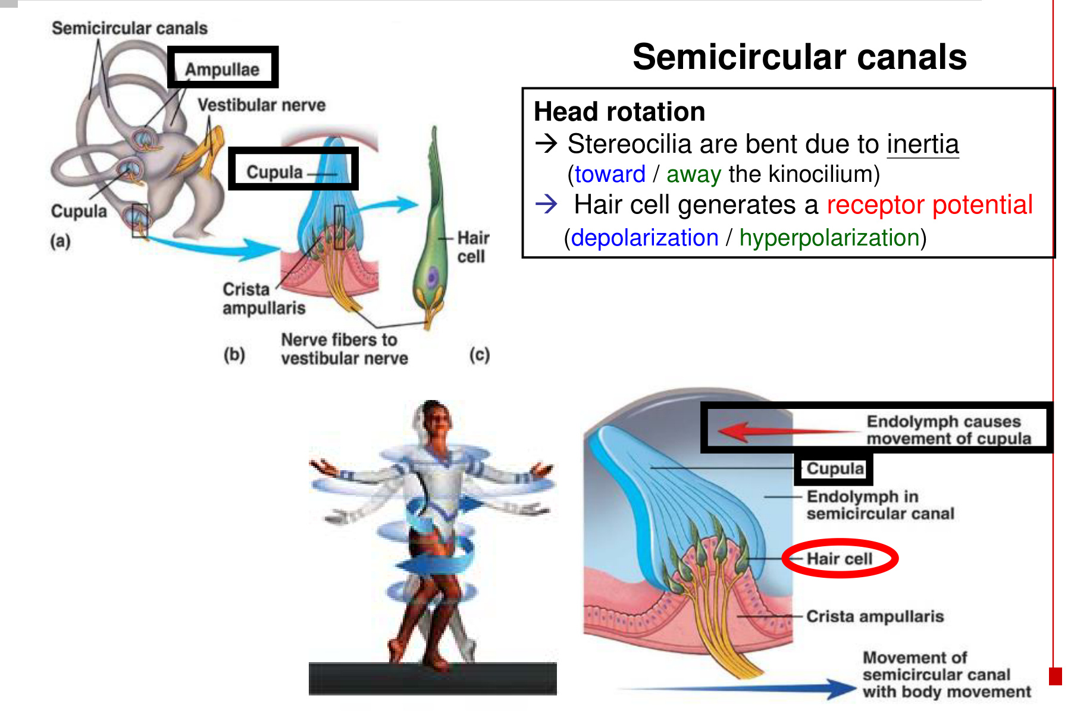  Relative fluid movement bends the cupula.

Structure | Key relationship
Three canals | Anterior / superior, posterior and lateral canals occupy different planes → detect rotation in different directions.
Ampulla | Expanded region of a semicircular duct containing the sensory apparatus.
Crista ampullaris | Sensory ridge containing hair cells and supporting cells.
Cupula | Gelatinous structure covering the hair bundles; deflected by relative endolymph movement.

• The cupula is the canal’s mechanical coupling structure; the otolith-loaded membrane belongs to the utricle and saccule.
• During prolonged constant-speed rotation, the fluid increasingly moves with the canal and the response wanes. A new change in rotational motion renews relative displacement.

16 Vestibular nerve & central functions
Hair cells in utricle / saccule / semicircular canals
→ vestibular afferents (cell bodies in Scarpa’s vestibular ganglion)
→ vestibular branch of CN VIII → vestibular nuclei in brainstem
→ connections for perception, postural control and eye stabilisation

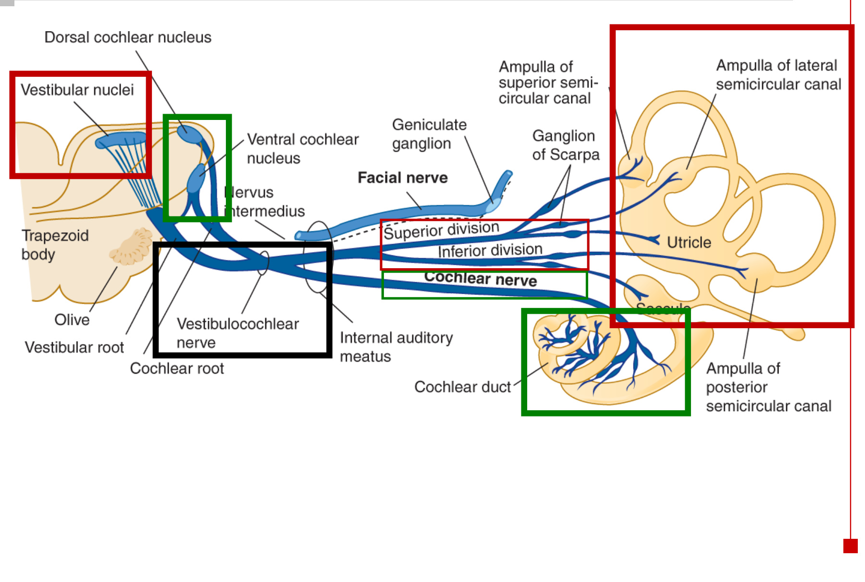
Major function | Central connection / outcome
Subjective motion & spatial orientation | Ascending pathways support conscious awareness of movement and position.
Muscle activity & posture | Vestibular connections to spinal motor circuits and the cerebellum adjust posture and help prevent falling.
Eye stabilisation | Connections to ocular motor nuclei generate the vestibulo-ocular reflex (VOR).

• The vestibular nerve has superior and inferior divisions serving different parts of the vestibular apparatus.
• The cochlear branch instead carries hearing signals from the cochlea to the dorsal / ventral cochlear nuclei.
• Both branches travel together as the vestibulocochlear nerve (VIII) through the internal auditory meatus. The nearby facial nerve is a separate cranial nerve (VII).

17 Vestibulo-ocular reflex: keep the image stable
Head turns in one direction → vestibular input changes
→ vestibular nuclei → ocular motor nuclei
→ compensating eye movement in the OPPOSITE direction
→ gaze remains stabilised on the target

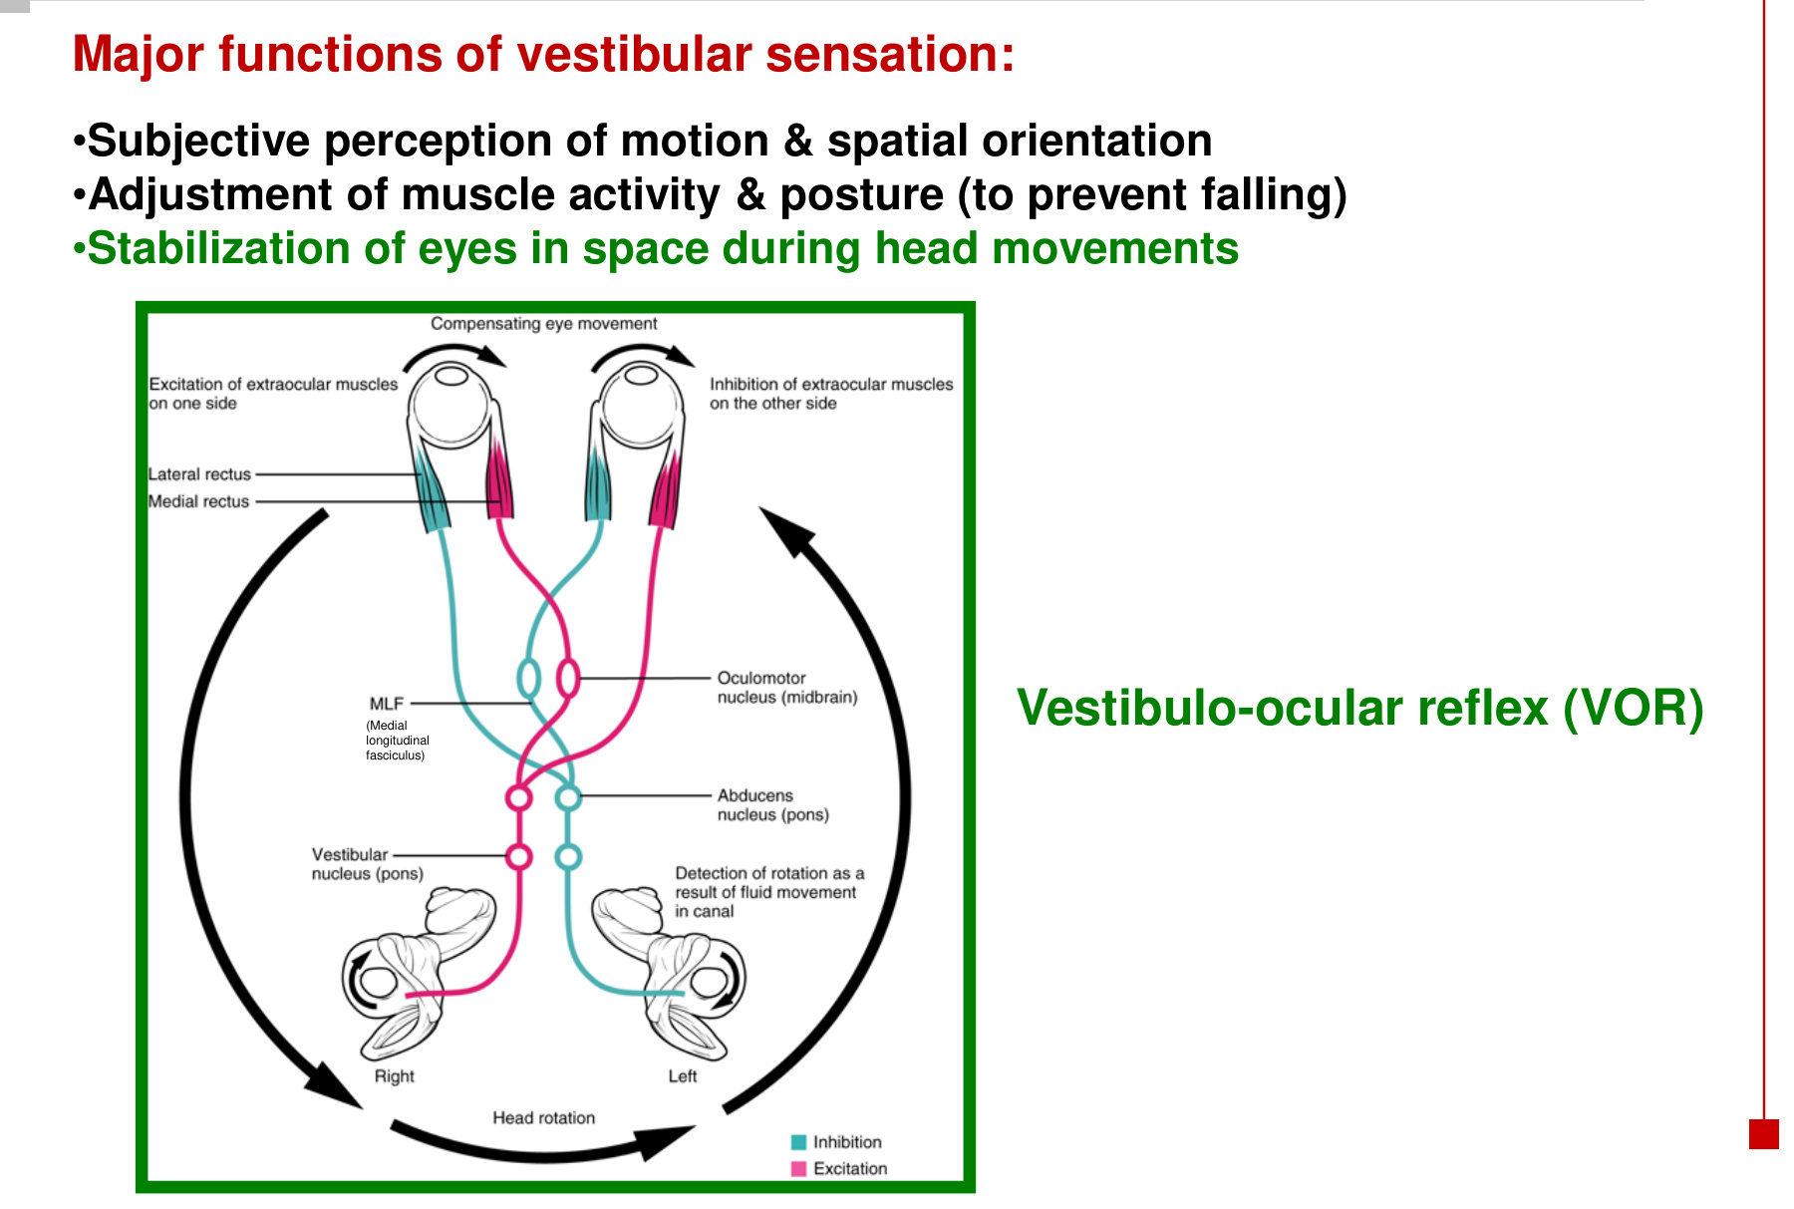

Horizontal example: turn the head to the right
Step | Coordinated response
Rightward head turn | Right horizontal-canal afferent activity ↑; left activity ↓.
Brainstem connection | Right vestibular output activates the left abducens pathway. Interneuronal connections through the MLF coordinate the opposite oculomotor nucleus.
Muscles that contract | Left lateral rectus (CN VI) + right medial rectus (CN III) → both eyes turn left.
Antagonist muscles | Right lateral rectus and left medial rectus activity decrease to permit the compensating movement.

MLF = medial longitudinal fasciculus. Abducens nucleus: pons. Oculomotor nucleus: midbrain. The horizontal circuit uses CN VI and CN III to coordinate the two eyes.

18 Sensory signals have several central destinations
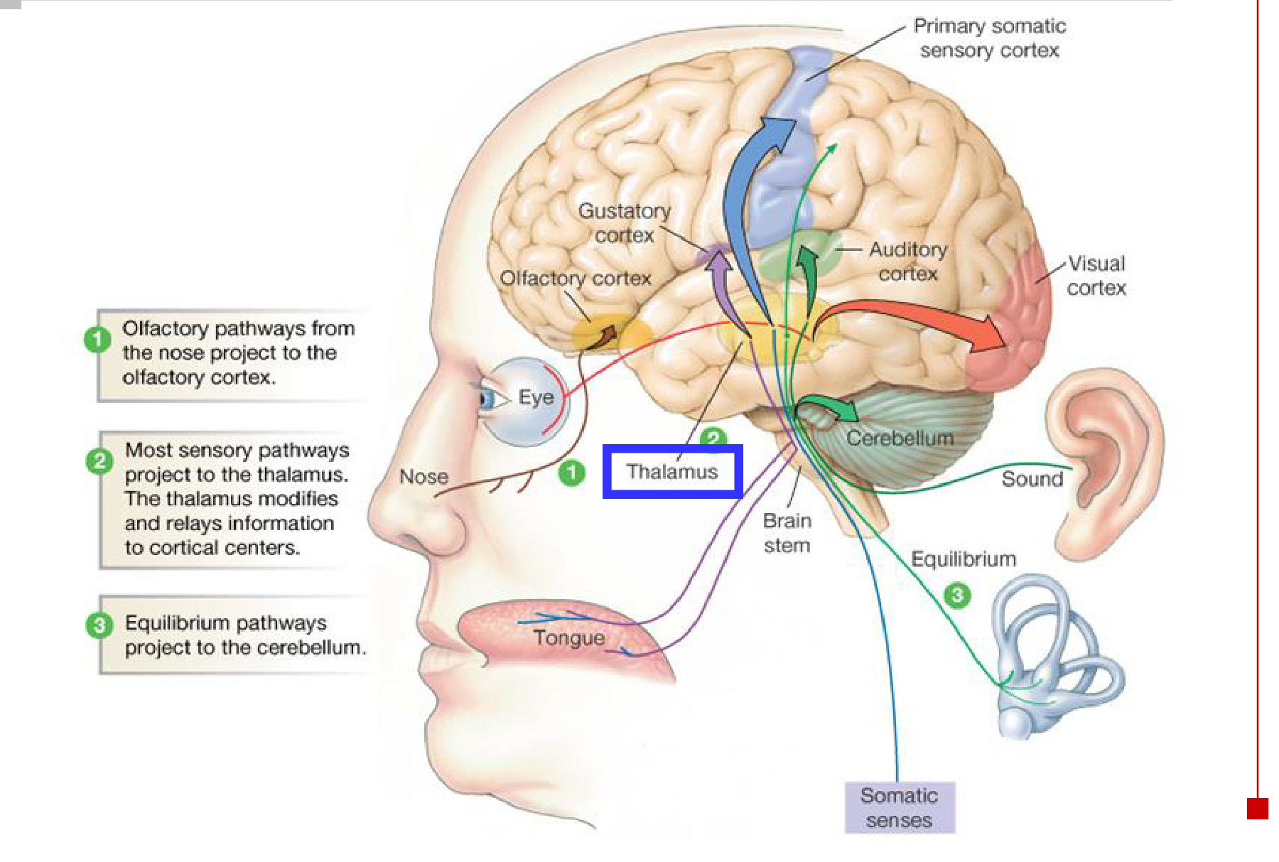
Pathway | Main relationship
Most ascending sensory pathways | Relay through the thalamus before reaching their respective cortical regions.
Olfaction | Reaches primary olfactory cortex without an obligatory initial thalamic relay.
Vestibular / equilibrium pathways | Reach brainstem and cerebellar circuits for coordination, as well as pathways for perception and eye movement.

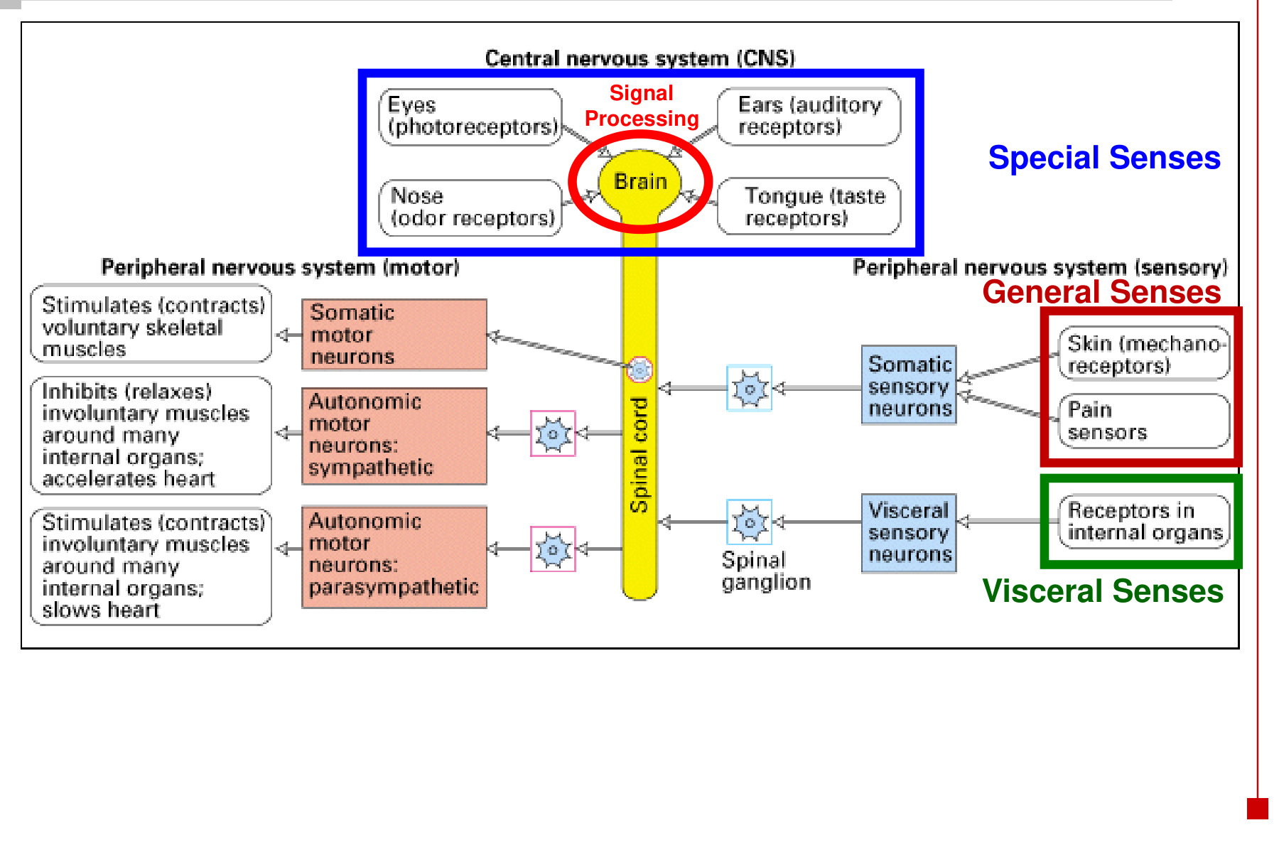
• General senses: signals from skin, muscles and body structures. Visceral senses: signals from internal organs. Special senses: specialised receptor systems such as the eye and ear.
• Sensory processing can guide somatic motor output to skeletal muscle and autonomic motor output to visceral effectors.

19 Sensation, perception & awareness
Sensation | Perception
Detect a stimulus and transmit its signal to the brain. | Interpret the sensory input and recognise what is sensed.
Begins at a receptor and its sensory pathway. | Depends on central processing and is affected by experience.

Stimulus → receptor response → action potentials in sensory afferents
→ impulses reach the brain → signals translated into information
→ information interpreted → perception / awareness

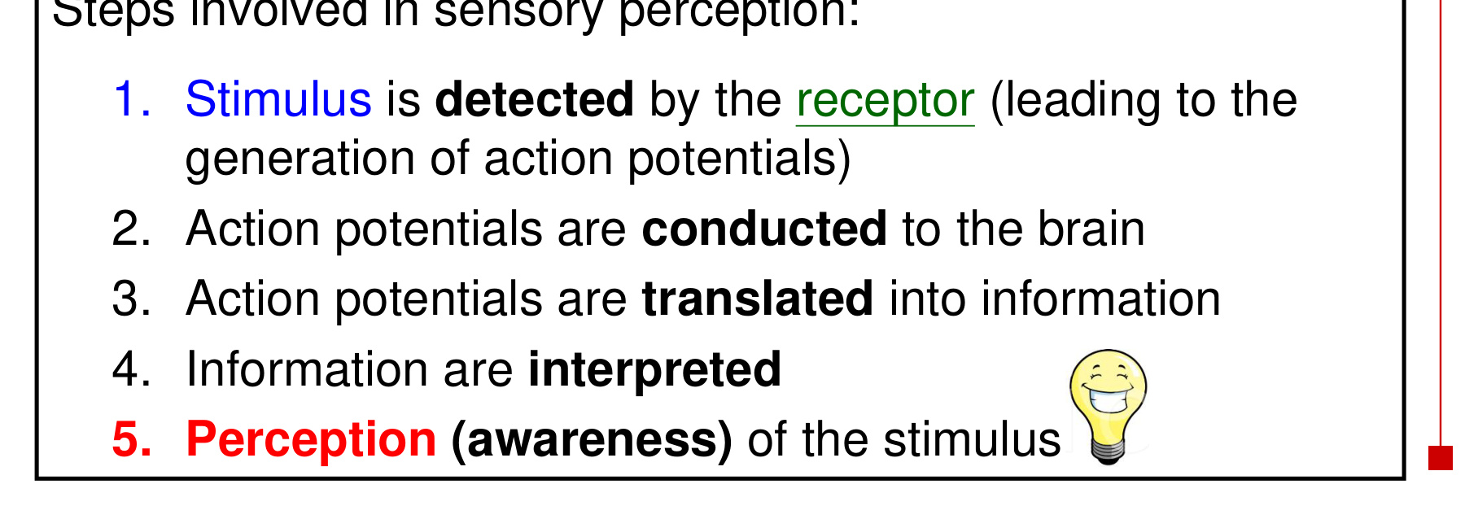  Detection and transmission precede interpretation. | 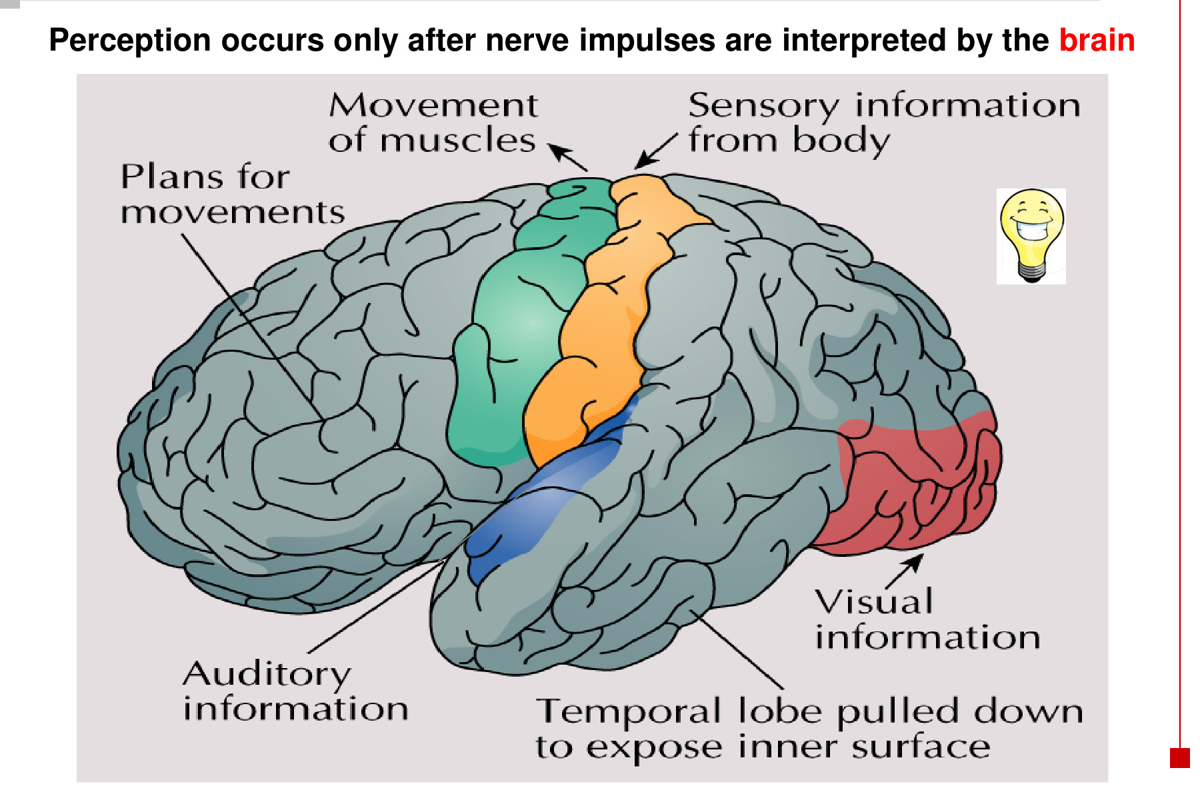  Cortical regions process different types of information.

• Perception occurs only after the brain interprets the nerve impulses.
• For hearing and balance, the hair cell generates a receptor potential and releases transmitter; the sensory nerve then carries action potentials.
• The same input can also support automatic actions, such as postural adjustment or VOR, without waiting for a conscious decision.

20 Integrated hearing & balance revision
Feature | Audition | Otolith organs | Semicircular canals
Stimulus | Sound vibration | Linear acceleration / head tilt | Angular acceleration
Receptor site | Organ of Corti | Macula | Crista in ampulla
Mechanical coupling | Basilar motion / tectorial shear | Gelatinous membrane + otoliths | Cupula + endolymph motion
Hair-cell response | Excitatory bundle bend → K⁺ influx → depolarisation | Toward kinocilium → depolarisation; away → hyperpolarisation | Toward kinocilium → depolarisation; away → hyperpolarisation
Nerve branch | Cochlear / auditory VIII | Vestibular VIII | Vestibular VIII
Central outcome | Frequency, loudness and sound location | Orientation, posture and movement perception | Rotational sensation, posture and VOR

Key arrows to retain
• Eardrum → malleus → incus → stapes → oval window → cochlear fluid → basilar membrane.
• Hair-bundle bend → K⁺ enters → depolarisation → Ca²⁺ enters → transmitter release.
• Cochlear base: narrow / stiff → high frequency. Apex: wide / floppy → low frequency.
• Superior olive: ITD + IID → binaural lateralisation. MGN → temporal auditory cortex.
• Utricle → horizontal acceleration. Saccule → vertical acceleration. Canals → angular acceleration.
• Vestibular bundle toward kinocilium → firing ↑; away → firing ↓.
• VOR: head right → eyes left; head left → eyes right.

